Supporting Information for

Dual Natural Enzyme-Tuned Biomineralized Nanoflowers for Boosting Cascade Catalytic Antibacterial Therapy and Relieving Inflammation

Hanyu Zhang,¹ Meng Hao,^{2,}* Xiao Dong,^{3,}* Gemeng Liang,⁴ Jinshuo Zou,⁴ Yongxin Li,^{1,}* Peitao Xie¹

¹ State Key Laboratory of Bio-fibers and Eco-textiles, Institute of Biochemical Engineering, College of Materials Science and Engineering, Qingdao University, Qingdao 266071, China
² Spine Surgery Department, Qingdao Municipal Hospital, Qingdao 266000, China
³ Department of Oncology, Shanghai First People's Hospital, Shanghai 201620, China
⁴ School of Chemical Engineering & Advanced Materials, The University of Adelaide, Adelaide, Australia

*Corresponding author, E-mail:
E-mail: hm1984@163.com (M. Hao) dongxiaodx@alumni.sjtu.edu.cn (X. Dong); liyx@qdu.edu.cn (Y. Li)

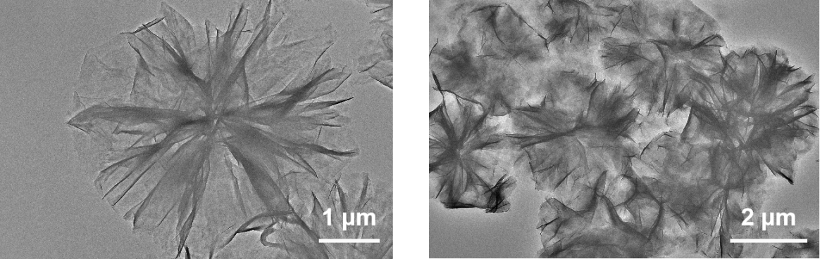

Figure S1 TEM images of Cu/Bro/Gox nanoflowers.

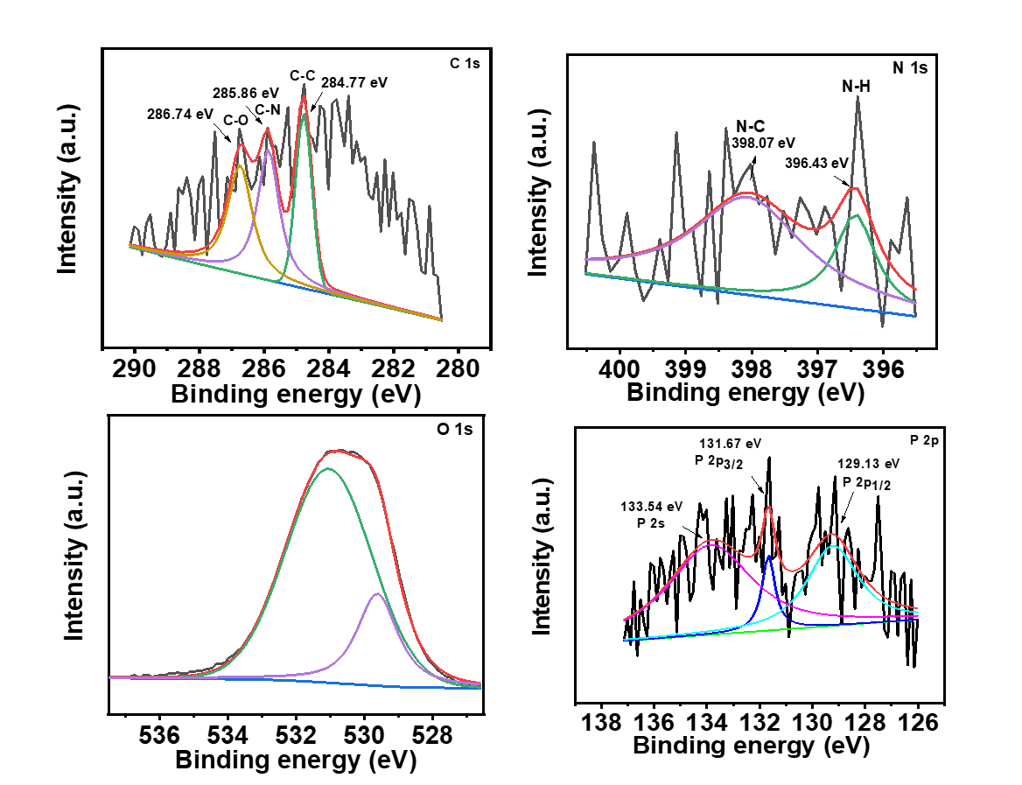

Figure S2 High resolution XPS spectra of the Cu/Bro/Gox nanoflowers.

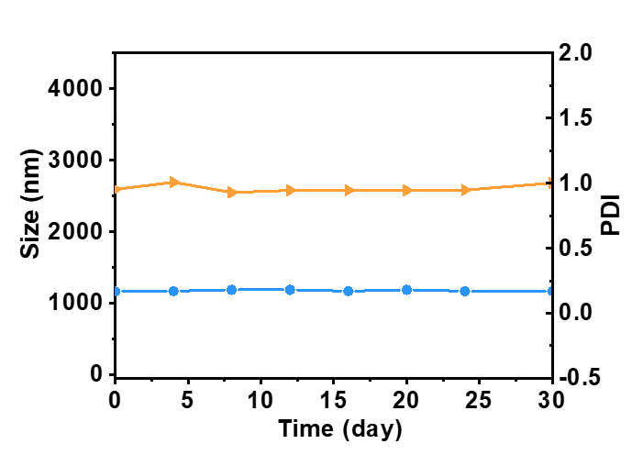

Figure S3 Change in hydrodynamic diameter () and PDI () of Cu/Bro/Gox in PBS over a period of 30 days.

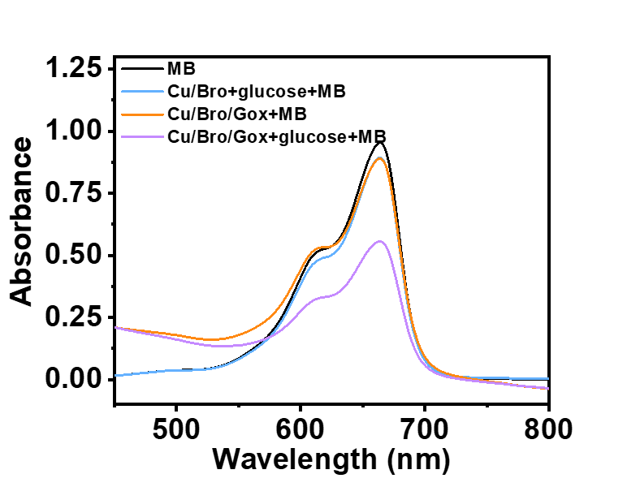
Figure S4 MB degradation showing ·OH generation in the presence Cu/Bro + glucose, Cu/Bro/Gox, Cu/Bro/Gox + glucose.

Table S1 The encapsulation efficiency of Bro with different concentrations in Cu/Bro/Gox when fixing the concentration of Gox is 0.5 mg mL⁻¹ and the encapsulation efficiency of Gox with different concentrations in Cu/Bro/Gox when fixing the concentration of Bro is 0.15 mg mL⁻¹.
