Supporting Information for:
How Ions and Pressure Affect Water Structure and Dynamics?

Zhuanfang Jing¹, Toshio Yamaguchi^{1,2*}, Takanori Hattori³, Takeshi Yamada⁴, Hiromu Tamatsukuri³, Masato Matsuura⁴, Yongquan Zhou^{1*}

¹ Key Laboratory of Comprehensive and Highly Efficient Utilization of Salt Lake Resources; Key Laboratory of Salt Lake Resources Chemistry of Qinghai Province; Qinghai Institute of Salt Lakes, Chinese Academy of Sciences, Xining, Qinghai 810008, China
² Department of Chemistry, Fukuoka University, Fukuoka, 8140180, Japan
³ J-PARC Center, Japan Atomic Energy Agency, Tokai, 319-1195, Japan
⁴ Neutron Science and Technology Center, Comprehensive Research Organization for Science and Society, 162-1 Shirakata, Tokai 319-1106, Japan

All correspondence should be sent to Prof. Toshio Yamaguchi and Prof. Yongquan Zhou,
E-mail: yamaguch@fukuoka-u.ac.jp, yongqzhou@163.com

Contribution of atom pairs
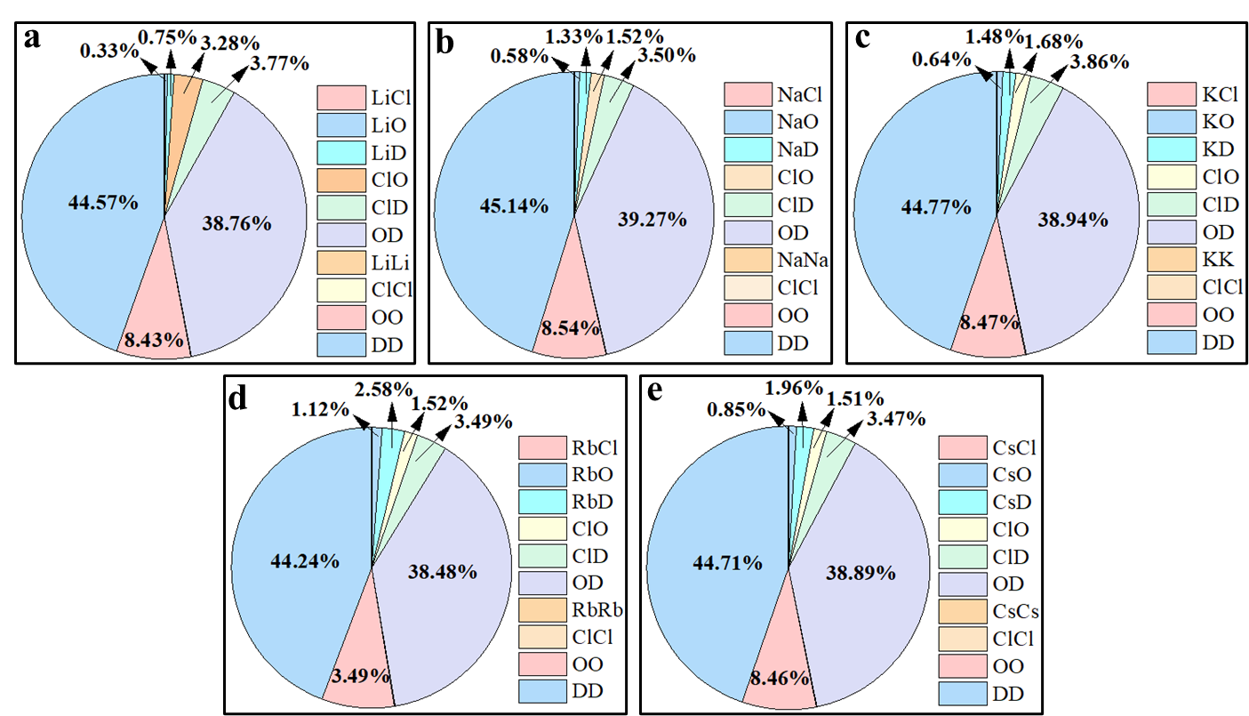
Fig. S1 Contribution of each atom pair to the total scattering intensity for 3 mol/kg alkali metal halide solutions in D₂O by neutron scattering. a LiCl. b NaCl. c KCl. d RbCl. e CsCl.
Table S1 Contribution of each atom pair to the total scattering intensity for 3 mol/kg alkali metal halide solutions in D₂O by neutron scattering.
Atom pairs | Contribution/100% (NS)
Atom pairs | LiCl | NaCl | KCl | RbCl | CsCl
M⸱⸱⸱Cl | 0.03 | 0.05 | 0.06 | 0.10 | 0.08
M⸱⸱⸱O | 0.33 | 0.58 | 0.64 | 1.12 | 0.85
M⸱⸱⸱D | 0.75 | 1.33 | 1.48 | 2.58 | 1.96
Cl⸱⸱⸱O | 3.28 | 1.52 | 1.68 | 1.52 | 1.51
Cl⸱⸱⸱D | 3.77 | 3.50 | 3.86 | 3.49 | 3.47
O⸱⸱⸱D | 38.75 | 39.26 | 38.95 | 38.47 | 38.88
M⸱⸱⸱M | 0.01 | 0.01 | 0.01 | 0.04 | 0.02
Cl⸱⸱⸱Cl | 0.08 | 0.07 | 0.08 | 0.07 | 0.07
O⸱⸱⸱O | 8.43 | 8.54 | 8.47 | 8.37 | 8.46
D⸱⸱⸱D | 44.57 | 45.14 | 44.77 | 44.24 | 44.70
*M represents Li, Na, K, Rb, and Cs.

Composition and properties of the sample solutions for neutron scattering
Table S2 Composition and properties of the sample solutions.
No. | P | c (mol/kg) | d (g/cm³) | ρ (atoms/Å³)
LiCl | 0.1 MPa | 2.948 | 1.177 | 0.09814
LiCl | 0.7 GPa | 2.948 | 1.405 | 0.11710
NaCl | 0.1 MPa | 2.698 | 1.209 | 0.09765
NaCl | 0.7 GPa | 2.698 | 1.655 | 0.13360
KCl | 0.1 MPa | 2.998 | 1.229 | 0.09427
KCl | 0.7 GPa | 2.998 | 1.480 | 0.11350
RbCl | 0.1 MPa | 2.748 | 1.322 | 0.09280
RbCl | 0.7 GPa | 2.748 | 1.642 | 0.11530
CsCl | 0.1 MPa | 2.698 | 1.416 | 0.09103
CsCl | 0.7 GPa | 2.698 | 1.693 | 0.10880
*c, concentration; d, density of sample solutions; ρ, atomic number density.

The settings and details of EPSR simulation boxes
Table S3 Reference potential parameters used in EPSR modeling.
Atoms/Ions | ε (kJ/mol) | σ (Å) | Mass | Charge
Ow¹ | 0.6500 | 3.1690 | 15.9994 | -0.8476
Dw² | 0.0000 | 0.0000 | 2.0000 | +0.4238
Li⁺³ | 2.6150 | 1.3000 | 6.9410 | +1.0000
Na⁺⁴ | 0.5144 | 2.4000 | 22.9898 | +1.0000
K⁺⁴ | 0.5216 | 3.2500 | 39.0983 | +1.0000
Rb⁺⁴ | 0.5216 | 3.5000 | 85.4680 | +1.0000
Cs⁺⁵ | 0.5216 | 3.7000 | 132.9050 | +1.0000
Cl⁻⁶ | 0.5660 | 4.4000 | 35.4530 | -1.0000
*Ow and Dw refer to the oxygen and deuterium atoms of water molecules, respectively.

Table S4 Details of EPSR modeling boxes.
No. | P | Number of particles |  | Box size (Å) | Q_{max} (Å⁻¹) | Iterations times
No. | P | D₂O | MX | Box size (Å) | Q_{max} (Å⁻¹) | Iterations times
LiCl | 0.1 MPa | 1000 | 59 | 31.67 | 39.99 | 14521
LiCl | 0.7 GPa | 1000 | 59 | 29.86 | 34.47 | 13859
NaCl | 0.1 MPa | 1000 | 54 | 31.69 | 37.97 | 13562
NaCl | 0.7 GPa | 1000 | 54 | 28.54 | 30.00 | 15120
KCl | 0.1 MPa | 1000 | 60 | 32.11 | 29.85 | 13825
KCl | 0.7 GPa | 1000 | 60 | 30.18 | 29.85 | 14012
RbCl | 0.1 MPa | 1000 | 55 | 32.24 | 39.98 | 14297
RbCl | 0.7 GPa | 1000 | 55 | 30.00 | 39.98 | 14213
CsCl | 0.1 MPa | 1000 | 54 | 32.44 | 37.63 | 14116
CsCl | 0.7 GPa | 1000 | 54 | 30.57 | 32.85 | 13925
*M = Li⁺, Na⁺, K⁺, Rb⁺, Cs⁺.

Composition and properties of the sample solutions for quasielastic neutron scattering
Table S5 Composition and properties of the sample solutions.
No. | P | c (mol/kg) | d (g/cm³)
LiCl | 0.1 MPa | 2.993 | 1.062
LiCl | 0.7 GPa | 2.993 | 1.062
NaCl | 0.1 MPa | 3.014 | 1.098
NaCl | 0.7 GPa | 3.014 | 1.098
KCl | 0.1 MPa | 3.004 | 1.121
KCl | 0.7 GPa | 3.004 | 1.121
RbCl | 0.1 MPa | 3.002 | 1.236
RbCl | 0.7 GPa | 3.002 | 1.236
CsCl | 0.1 MPa | 2.997 | 1.324
CsCl | 0.7 GPa | 2.997 | 1.324
*c, concentration; d, density of sample solutions.

Details of quasielastic neutron scattering data processing
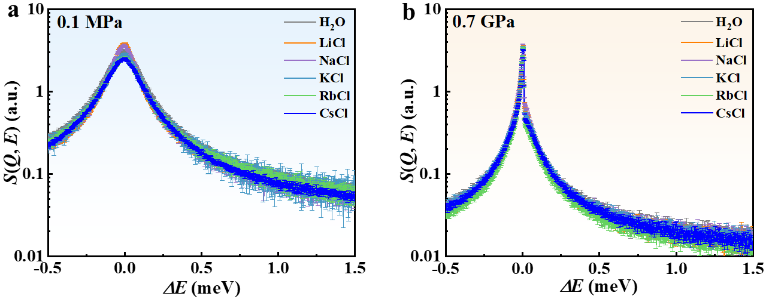
Fig. S2 QENS spectra of 3 mol/kg LiCl, NaCl, KCl, RbCl, and CsCl aqueous solutions at a wave vector Q = 0.875 Å⁻¹ at 0.1 MPa and 0.7 GPa.
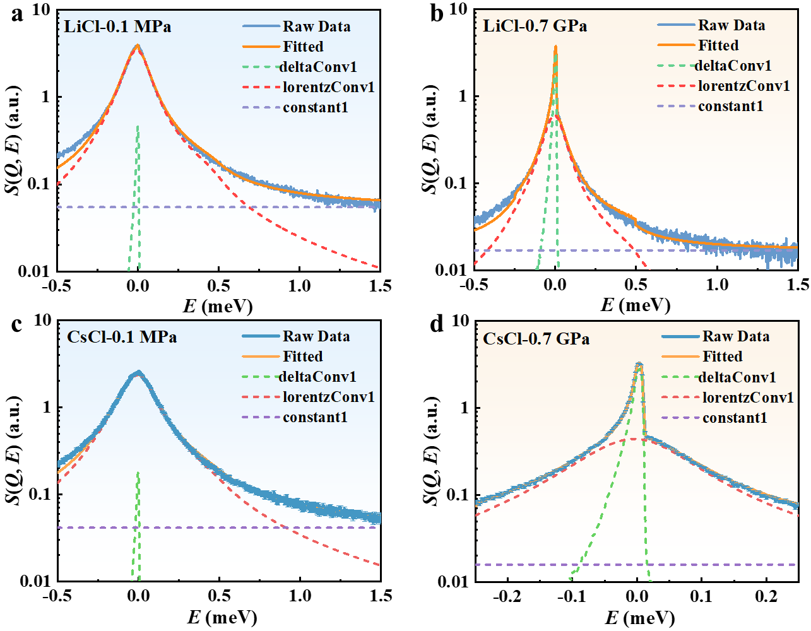
Fig. S3 Fitting results of QENS data for LiCl and CsCl aqueous solutions with Q = 0.875 Å⁻¹ at 0.1 MPa and 0.7 GPa by QENSFit program.
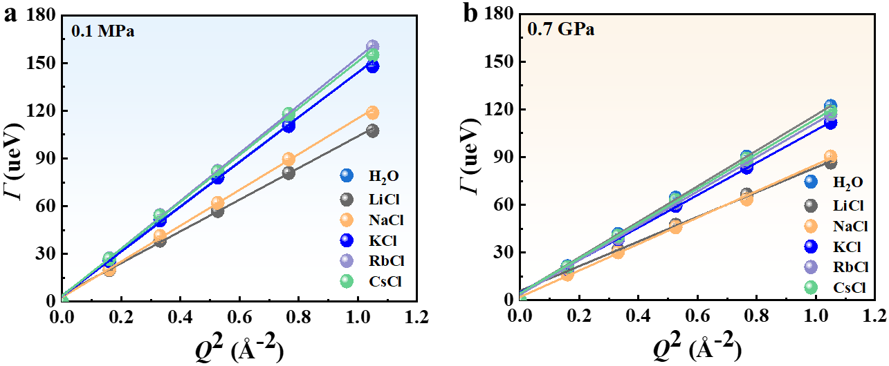
Fig. S4 Half-width at half-maximum (HWHM), Γ, of the fitted QENS signal plotted as a function of Q² at 0.1 MPa and 0.7 GPa.

Table S6 The half width at half maximum (HWHM), Г, of pure water and alkali metal chloride aqueous solutions fitted by the QENSFit program, as well as the slope and correlation coefficient (R²) obtained by linear fitting of Г-Q².
No. | P | Г-Q² |  |  |  |  | slope | R²
No. | P | 0.160 Å⁻² | 0.331 Å⁻² | 0.526 Å⁻² | 0.766 Å⁻² | 1.050 Å⁻² | slope | R²
LiCl | 0.1 MPa | 19.92±0.19 | 38.35±0.25 | 57.01±0.30 | 80.87±0.43 | 107.36±0.51 | 101.17±2.36 | 0.997
LiCl | 0.7 GPa | 16.92±0.22 | 31.59±0.31 | 47.34±0.41 | 66.39±0.52 | 86.59±0.66 | 81.67±2.52 | 0.995
NaCl | 0.1 MPa | 20.39±0.18 | 41.22±0.27 | 61.97±0.34 | 89.54±0.52 | 118.72±0.64 | 112.73±2.01 | 0.998
NaCl | 0.7 GPa | 16.23±0.21 | 30.21±0.30 | 45.96±0.39 | 63.50±0.50 | 90.22±0.82 | 83.74±1.85 | 0.998
KCl | 0.1 MPa | 25.47±0.22 | 51.17±0.34 | 78.08±0.47 | 110.42±0.73 | 148.01±0.96 | 140.15±2.43 | 0.999
KCl | 0.7 GPa | 19.81±0.20 | 38.58±0.32 | 59.41±0.44 | 83.46±0.60 | 111.65±0.78 | 105.58±2.01 | 0.998
RbCl | 0.1 MPa | 27.17±0.20 | 54.32±0.31 | 82.09±0.39 | 117.63±0.60 | 160.18±0.78 | 151.15±1.86 | 0.999
RbCl | 0.7 GPa | 20.14±0.22 | 39.01±0.35 | 61.28±0.52 | 86.32±0.68 | 116.79±0.94 | 110.49±1.51 | 0.999
CsCl | 0.1 MPa | 26.83±0.19 | 53.89±0.27 | 81.45±0.34 | 117.85±0.48 | 154.96±0.61 | 147.46±2.91 | 0.998
CsCl | 0.7 GPa | 20.77±0.20 | 40.44±0.32 | 62.86±0.46 | 88.83±0.60 | 118.98±0.80 | 110.49±1.51 | 0.999
H₂O | 0.1 MPa | 26.02±0.19 | 51.67±0.28 | 78.01±0.35 | 112.97±0.52 | 147.90±0.63 | 140.73±3.00 | 0.998
H₂O | 0.7 GPa | 21.33±0.23 | 41.58±0.37 | 64.42±0.51 | 90.20±0.71 | 121.95±0.96 | 115.15±1.90 | 0.999

The potential parameters of OPLS force field and boxes in MD simulations
Table S7 Atomic and ionic charge, mass, and Lennard-Jones parameters for the OPLS-AA force field.
Atoms/Ions | Charge | Mass | Lennard-Jones parameters
Atoms/Ions | Charge | Mass | σ (Å) | ε (kJ/mol)
Ow | -0.8576 | 15.9994 | 3.1656 | 0.6502
Hw | +0.4238 | 1.0080 | 0.0000 | 0.0000
Li⁺ | +1.0000 | 6.9410 | 1.2566 | 2.6150
Na⁺ | +0.8500 | 22.9900 | 3.3305 | 0.0116
K⁺ | +0.8500 | 39.0983 | 4.9346 | 0.0014
Rb⁺ | +0.8000 | 85.4678 | 5.6218 | 0.0007
Cs⁺ | +0.8000 | 132.9054 | 6.7160 | 0.0003
Cl⁻ | -1.0000~-0.8000 | 35.4530 | 4.4172 | 0.4928
*The charge of Cl⁻ changes according to that of cations.
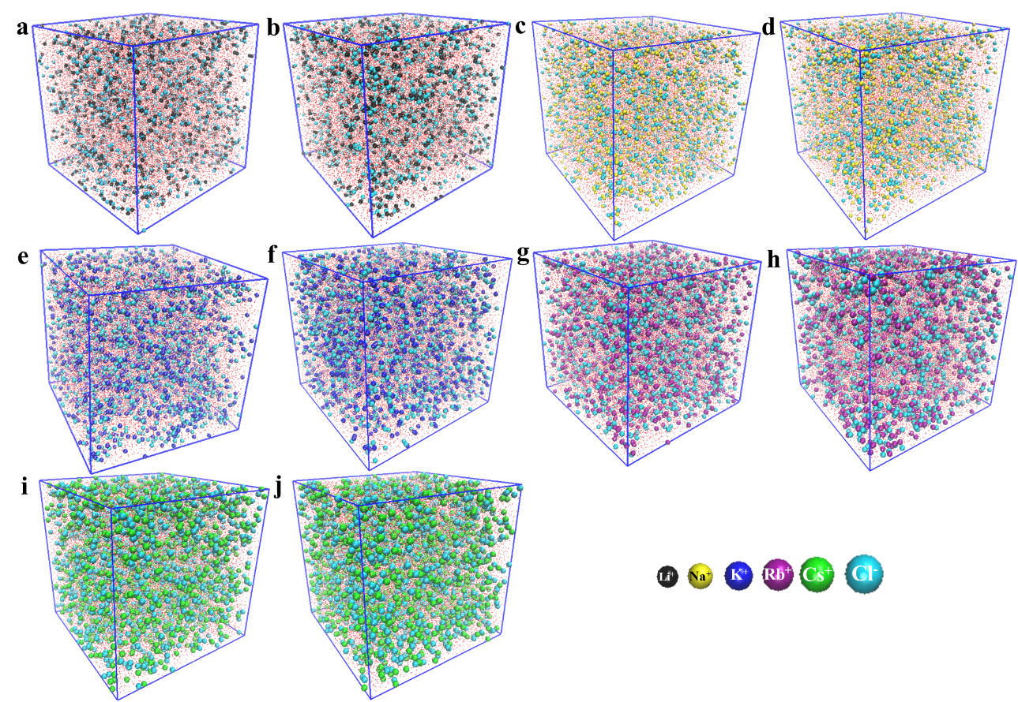
Fig. S7 MD simulation boxes. a, c, e, g, and i are LiCl, NaCl, KCl, RbCl, and CsCl aqueous solutions at 0.1 MPa. b, d, f, h, and j are LiCl, NaCl, KCl, RbCl, and CsCl aqueous solutions at 0.7 GPa.
References:
1. Yamaguchi, T., Lee, K., Yamaguchi, M., Fukuyama, R., Koji, Y. Visualization of three-dimensional structure of magnesium nitrite solution caused by Raman scattering, X-ray diffraction and empirical potential structure reform modeling. Bunseki. Kagaku. 64, 295-308 (2015).
2. Jorgensen, W. L., Maxwell, D. S., Tirado-Rives J. Development and testing of the OPLS all-atom force field on conformational energetics and properties of organic liquids. J. Am. Chem. Soc. 118, 11225-11236 (1996).
3. Mancinelli, R., Botti, A., Bruni, F., Ricci, M. A., Soper, A. K. Hydration of sodium, potassium, and chloride ions in solution and the concept of structure maker/breaker. J. Phys. Chem. B 111, 13570-13577 (2007).
4. Koneshan, S., Rasaiah, J. C., Lynden-Bell, R. M., Lee S. H. Solvent structure, dynamics, and ion mobility in aqueous solutions at 25°C. J. Phys. Chem. B 102, 4193-4204 (1998).
5. Dang, L. X. Mechanism and thermodynamics of ion selectivity in aqueous solutions of 18-crown-6 ether: a molecular dynamics study. J. Am. Chem. Soc. 117, 6954-6960 (1995).
6. Soper, A. K., Weckstrom, K. Ion solvation and water structure in potassium halide aqueous solutions. Biophys. Chem. 124, 180-91 (2006).

