Global submesoscale ocean dynamics
unveiled by wide-swath satellite altimetry

Extended Data

Matthew Archer¹, Jinbo Wang¹, Patrice Klein^{1,2,3}, Lee-Lueng Fu¹

This document presents the extended data for the paper “Global submesoscale ocean dynamics
unveiled by wide-swath satellite altimetry”.

Figure 1 illustrates the ubiquitous submesoscale ocean turbulence observed by SWOT by displaying the spatial gradient of sea surface height anomalies (SSHA), which correspond to ocean surface currents.

Figure 2 builds upon Figure 1 by providing several zoomed-in images of these submesoscale coherent eddies, highlighting their detailed structures and dynamics.

Figure 3 compares the SWOT SSHA gradient with a state-of-the-art high-resolution ocean simulation at a spatial resolution of 1/48° (~2 km grid spacing). The comparison reveals that even the highest-resolution global ocean simulations underestimate the real ocean turbulence detected by SWOT.

Figure 4 depicts the evolution of a submesoscale coherent eddy over 10.8 hours, tracked by two SWOT passes. The relative vorticity changes observed during this short period are used to estimate the amplitude of the vertical velocity through the vortex stretching principle. The vertical velocity associated with this eddy ranges between 67 and 167 meters per day, which is significantly larger than values predicted by numerical simulations but comparable to regional observations.

These extended data figures collectively demonstrate SWOT’s superior ability to capture and quantify small-scale ocean dynamics, providing invaluable insights that surpass current simulation capabilities and align closely with regional observational data.
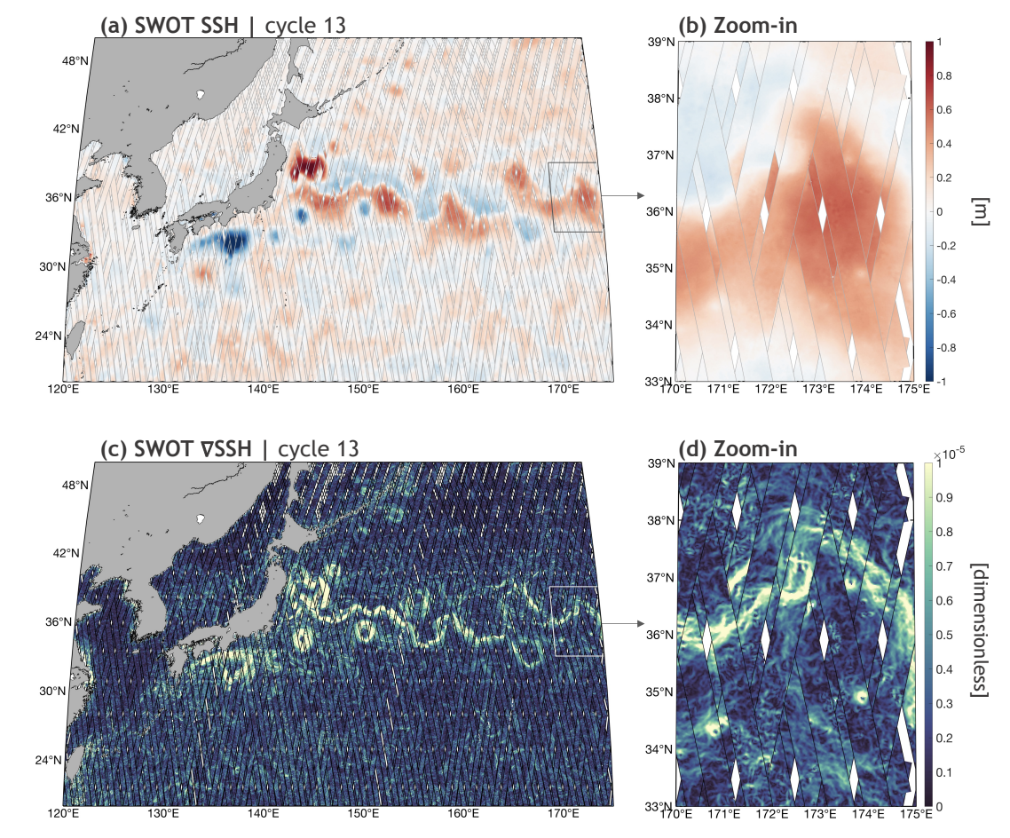
Figure 1. This figure presents the SWOT sea surface height anomaly (SSHA) in the upper panel and its spatial gradient in the lower panel, focusing on the Kuroshio Extension region in the northwest Pacific. The SSH gradient is strongly associated with ocean currents, clearly illustrating the Kuroshio currents in panel c. Additionally, coherent eddies with diameters of approximately 20 km and small-scale filament structures are distinctly identifiable in panel d. These observations highlight the detailed dynamics captured by SWOT, demonstrating its ability to resolve intricate oceanographic features in this region.

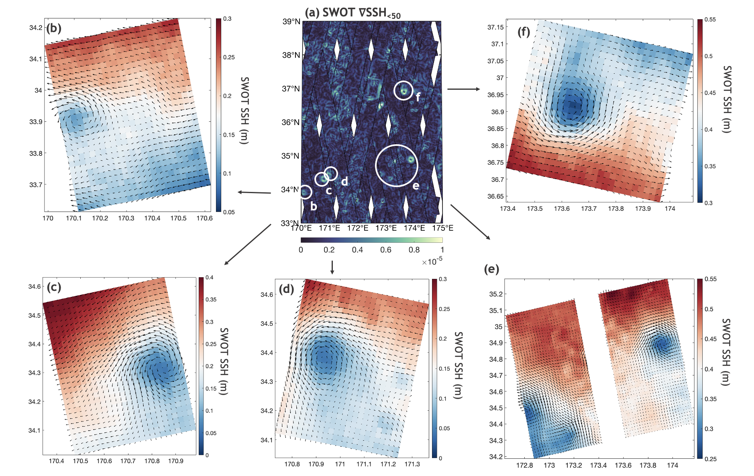
Figure 2. This figure illustrates the ubiquity of these submesoscale coherent eddies. It shows several examples of sub-50 km eddies observed in SWOT sea surface height anomalies (SSHA) depicted in color, alongside the derived geostrophic velocity vectors within a selected small sample area (panel a). Panel a corresponds to the same region as panel d in Figure 1 but focuses on the high-pass filtered SSHA gradients below 50 km. Panels b–e provide zoomed-in views of the SSHA and velocity vectors for the sampled small eddies, highlighting their detailed structures and dynamics.
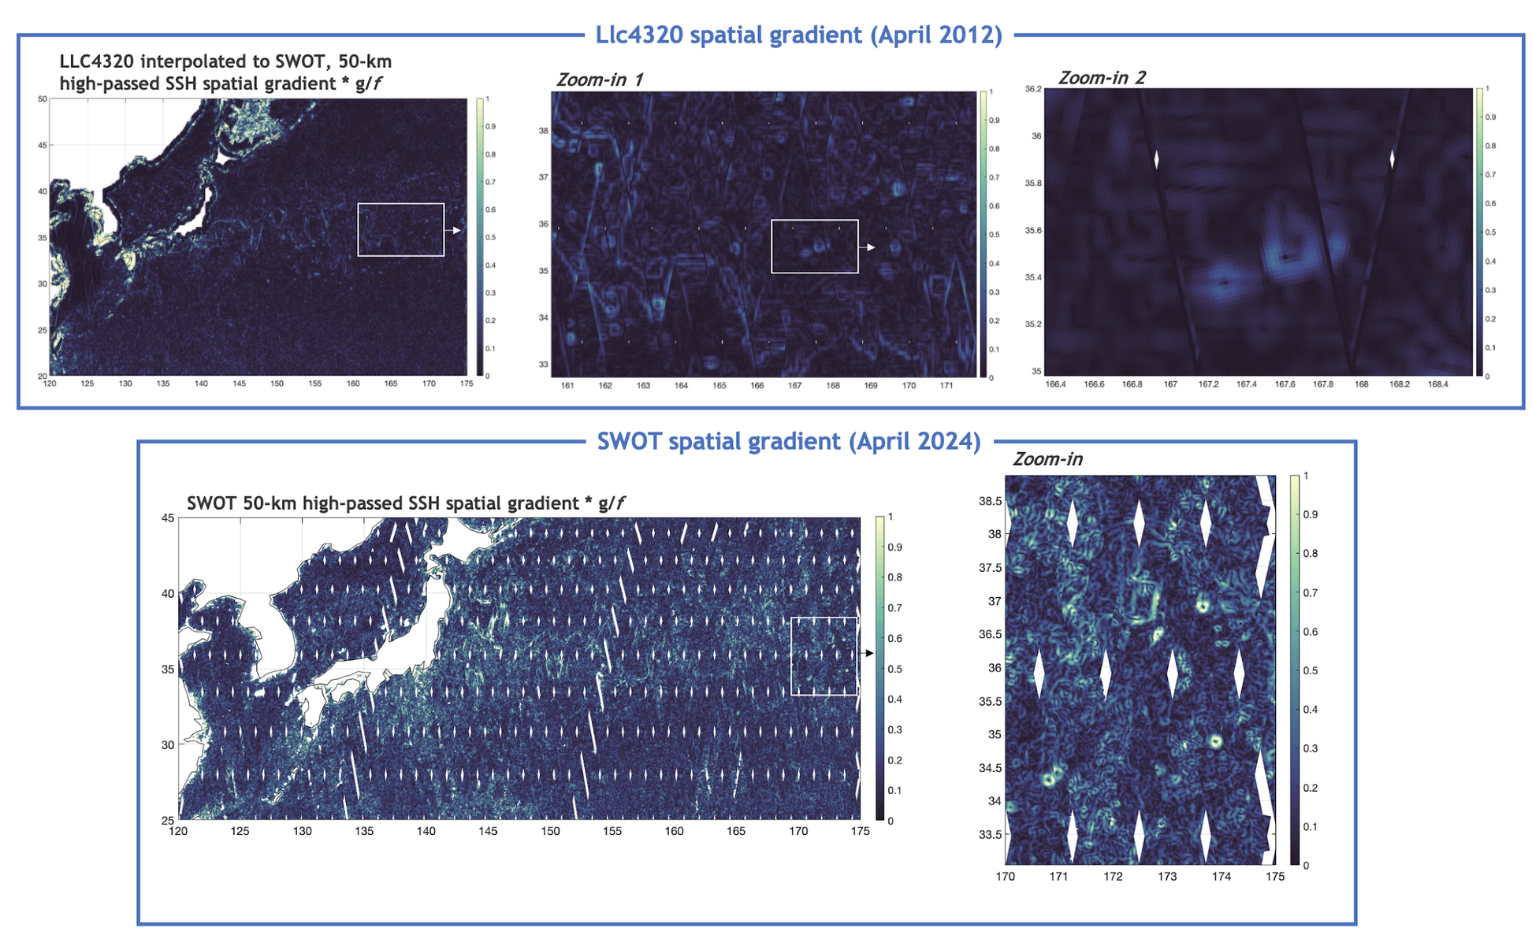
Figure 3. A direct comparison between a 1/48° global ocean simulation and SWOT observations, focusing on the spatial gradient of high-pass filtered sea surface height anomalies (SSHA) at scales below 50 km. The upper panel displays the simulation results, while the lower panel shows the corresponding SWOT data. Notably, SWOT measurements reveal SSHA gradients with amplitudes at least four times larger than those in the high-resolution simulation, indicating a significantly more energetic submesoscale turbulence field.
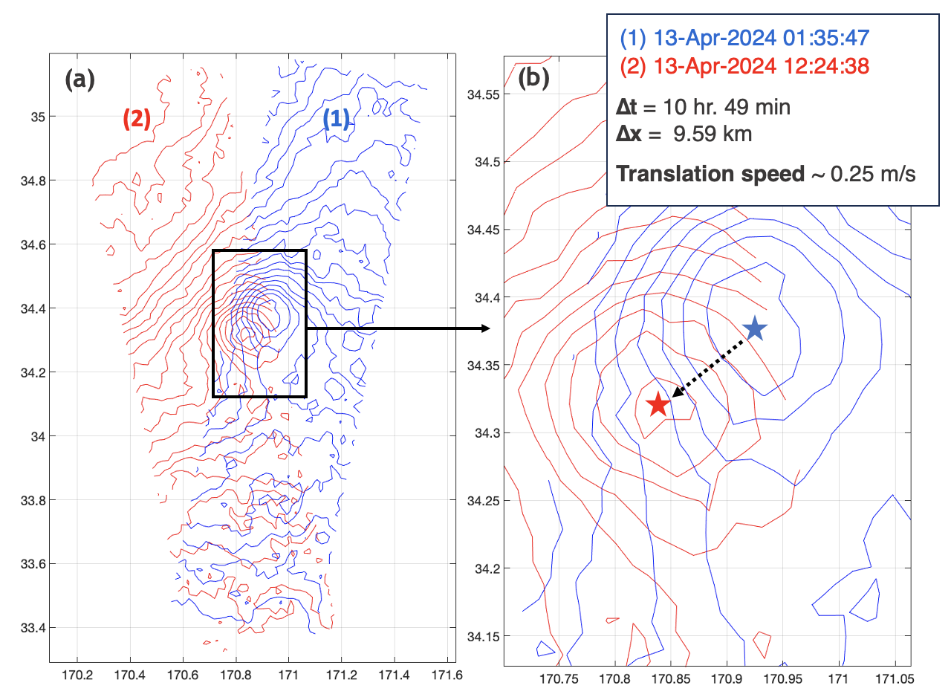
Figure 4. Two SWOT swaths, separated by 10.8 hours, captured the evolution of a coherent eddy with a diameter of 20 km. During this period, the geostrophic relative vorticity intensified by +0.6f as the eddy traveled 9.6 km (from the blue to the red star), which is also reflected in the contraction of constant vorticity contours. Assuming a mixed layer depth of 50 meters, the associated vertical velocity from vortex stretching is estimated to be downward at 67 meters per day. For a mixed layer depth of 120 meters, the downward velocity increases to 167 meters per day.

