The hydrological effects of dispersed stormwater management at the catchment scale
Congying Li, Matthew J Burns, Christopher J Walsh, Moss J Imberger, Peter J Poelsma, Robert James, Darren G Bos, and Tim D Fletcher
The School of Agriculture, Food and Ecosystem Sciences, The University of Melbourne, 500 Yarra Boulevard, Burnley Victoria 3121, Australia
Supplementary material

Supplementary material S1: Hydrographics

Description of streamflow monitoring
We established streamflow-gauging stations at 9 of the 10 catchments, along with using data from an existing station on Brushy Creek (229249A; maintained by the regional water authority [Melbourne Water; MW]).
Streamflow monitoring
We calculated streamflow at L4-e and its 3 tributaries (L1-e, Ln-e, and Ls-e) by measuring water level using a bubbler water-level sensor system (Hydrological Services WL3100 dry pressure transducer coupled with a Campbell CR800 data logger) behind a sharp crested weir. We derived low-flows using the standard equations for a sharp crested v-notch (notch angle = 60$​^{∘}$ and c = 0.585 [L4-e], or 45$​^{∘}$ and c = 0.605 [Ln-e, Ls-e, L1-e], see xlsx file all_lsc_ratings_and_upgrades_used.xlsx in the dir. data of the GitHub repository). We validated estimated low-flows to be within 5% of flow measurements made using a volumetric container and stopwatch. For high-flow conditions (i.e. when the flow rate exceeded the capacity of the v-votch), we estimated flows using a rating curve fitted to flow measurements (minimum 20) from handheld flow meters (SonTek FlowTracker and OTT MF pro). Data for these catchments were recorded every 15 min from 2009 to 2012, and subsequently every 6 min. We interpolated the older flow data to a 6-min interval.
Streamflow at Br-c was measured by the regional water authority (Melbourne Water; MW). They used a bubbler water level sensor upstream of a concrete flow control to record flow data at 6-min intervals. MW estimated all flows using rating curves fitted to manual flow measurements. They took manual flow measurements several times each year and used them to update the rating curve (station 229249A: http://www.bom.gov.au/waterdata/).
We initially estimated streamflow in the other streams by measuring water level (using Odyssey Capacitance Probes; odysseydatarecording.com) upstream of in-stream flow controls (e.g. culverts and riffles). We developed level-flow relationships for each reach (using the same handheld flow meters described above) and these were used to estimate flow. Each rating curve included at least 20 flow measurements, covering a range from the lowest recorded water level to at least the 95% percentile value. Over time, we observed that the flow controls for five of the six sites were not stable and difficult to maintain. We thus improved the flow control at these sites by either installing sharp crested weirs (stainless steel with rectangular notches [Ol-r, Sa-r, Fe-c]) or moving the water level sensor to a more stable cross section (culvert, D4-e). We then used the standard weir equations (Australian Standard 3778.4.1:2022) to estimate flows at the three sites with sharp crested weirs. And we developed a new rating curve for D4-e. Across 2016-2017,we upgraded the instruments used to measure water level to pressure transducers (Ott Ecolog 500).
We visited all streamflow gauging stations at least fortnightly for maintenance: removing any blockages in the weirs or sediment covering the sensor, and we checked the water level using a manual staff gauge. If necessary, we corrected the sensor level for drift or changes as a result of cleaning, etc. This effectively meant that the sensor was calibrated at each visit. If the water level on the day of the visit was within 5 mm of the true value, then all data recorded since the last visit were given a quality code of ‘excellent’. If an error of 5–20 mm was found, we gave prior data a quality code of ‘fair’ and corrected them to a more accurate estimate of the true value. In many cases this corrected value was likely to have been within 5 mm of the true value, but was still assessed as ‘fair’ quality data. If we found larger errors we rated any prior data as ‘poor’. Some data were missing completely due to flat batteries, replacement of instruments, vandalism, damaging storms, etc. We used only data rated as ‘excellent’ or ‘fair’ in our analyses.

Estimation of catchment rainfall and potential evapotransipiration
We estimated areal rainfall across each of the experimental catchments for the study period at 6-min intervals using a combination of 6-min (or less) data from rain gauges operated by the Bureau of Meteorology (BoM: http://www.bom.gov.au/climate/data/stations/), Melbourne Water (https://www.melbournewater.com.au/water/rainfall-and-river-levels#/), and the project team (four gauges installed over different periods in the L4-e catchment), and the BoM daily rainfall grid (http://www.bom.gov.au/climate/how/newproducts/IDCdrgrids.shtml).
The BoM grid is computed using an optimised Barnes successive correction technique that applies a weighted averaging process to the station data, where each grid-point represents an approximately square area with sides of about 5 km (0.05$​^{∘}$). We extracted daily rainfall for each catchment from the nearest grid cell, and disaggregated using the temporal pattern of sub-daily rain gauge data from nearby gauges. We assumed that the gridded daily totals were a more accurate estimate of rainfall than daily totals from the nearest gauge. We set daily gridded data with totals <0.2 mm to zero as they correspond to less than a single tip (detection limit) of the rain gauges used.
We generated a composite 6-min time series by selecting data from the nearest gauge with the highest quality, using successively more distant gauges to infill missing/unreliable data from nearer gauges. We then disaggregated the daily totals of each catchment using the resultant 6-min composite gauge data was then used to .
A different disaggregation approach was used depending on the available data. We classified each rainfall estimate by the approach used as one of the following:
- zeroTotal: The gridded daily total = 0. Every record for the day was set to zero even if the gauge data total > 0.
- temporal: The gridded daily total > 0 and there were no missing values in the gauge data. The daily total was disaggregated using the temporal pattern of the gauge data.
- semiTemporal: The gridded daily total > 0 and there were missing values in the gauge data, but the total gauge data was >= 70% of the gridded daily total. The daily total was disaggregated using the temporal pattern of the gauge data.
- mid-point: The gridded daily total > 0 and a) there were missing values in the gauge data and the total gauge data was <70% of the gridded daily total or b) gauge data = 0. The daily total was attributed to the mid-point of the rain day (i.e. 2100 h).
We estimated mean potential evapotranspiration (PET) across each of the experimental catchments or the study period at 6-min intervals using the daily Morton’s PET grid from the Scientific Information for Land Owners (SILO) database of historical climate records for Australia (https://www.longpaddock.qld.gov.au/silo/index.html). The grid was of the same spatial resolution as the BoM grid, and we extracted the daily PET value from the nearest grid cell for each catchment.
We disaggregated daily PET values to a 6-min interval using the temporal pattern of one-minute solar radiation data from BoM Station 086282 (Melbourne Airport: http://www.bom.gov.au/climate/data/oneminsolar/about-IDCJAC0022.shtml#service). The cosine of the sun’s zenith distance (i.e. the angular distance from directly overhead) is considered to be a good approximation for the distribution of ET throughout the day (Kumar et al. 2000).

References
Kumar, A., Turner, N., Singh, D., Singh, P. & Barr, M. (2000) Diurnal and seasonal patterns of water potential, photosynthesis, evapotranspiration and water use efficiency of clusterbean. Photosynthetica, 37, 601–607.

Supplementary material S2: Derivation of response variables

Overview
This appendix derives the two wet-weather flow response metrics of interest—quickflow volume (Qv) and peak flow (Qmax). The first code chunk loads catchment information (e.g. area), flow data for each site, and wet-weather event information (e.g. time-windows of rainfall and flow).
#Load relevant catchment data, flow data, and wet-weather events
#Load catchment info (e.g. catchment area)
cats <- sf::st_read(here::here("",paste("cats.gpkg",sep = "")), stringsAsFactors = FALSE, quiet = TRUE)
#Screen for the flow gauges and exclude D8
hydro_sites_all <- cats[which(cats$hydrology == 1),]
hydro_sites_reduced <- hydro_sites_all[!hydro_sites_all$sitecode == "DBS0008",]
#Add the original site name to above for flow/rainfall extraction
#I.e. remove the small letter after some of the site names
hydro_sites_reduced$orig_site_name <- substr(hydro_sites_reduced$sitecode, 1, 7)
#Source the streamflow data
flow_data <- dir(here::here("data"))[grep("flow", dir(here::here("data")))]
#Define the correct name of all the flow files
all_flow_files <- paste(hydro_sites_reduced$orig_site_name, "_flow.rda", sep = "")
#Loop through the files to load and assign names
for(i in 1:NROW(all_flow_files)) {
#Get data for site i
pos_flow <- which(flow_data == all_flow_files[i])
temp_data <- get(load(paste(here::here("data"), "/", all_flow_files[i], sep = "")))
site_int <- substr(all_flow_files[i], 1, 7)
site_f_name <- paste(site_int, "_flow", sep = "")
assign(site_f_name, temp_data) } #End the loop
#Load wet-weather events
rr_events <- get(load(paste(here::here(""), "/Wet_Weather_Events.Rdata", sep = "")))
#Make sure all dates are in UTC
rr_events$RainStart_UTC <- lubridate::ymd_hms(format(as.POSIXct(rr_events$RainStart), format = "%Y-%m-%d %T %Z"))
rr_events$FlowStart_UTC <- lubridate::ymd_hms(format(as.POSIXct(rr_events$FlowStart), format = "%Y-%m-%d %T %Z"))
rr_events$RainEnd_UTC <- lubridate::ymd_hms(format(as.POSIXct(rr_events$RainEnd), format = "%Y-%m-%d %T %Z"))
rr_events$FlowEnd_UTC <- lubridate::ymd_hms(format(as.POSIXct(rr_events$FlowEnd), format = "%Y-%m-%d %T %Z"))

Response variables
The second code chunk below calculates Qv and Qmax in units of L per event and L per 6-min respectively. Two other operations occur. Firstly, quickflow and slowflow components for three wet-weather events from site Br-c (identified as: 16, 35, 178) are saved and later used for plotting purposes (Figure S2-3). Secondly, a pdf image of each wet-weather event processed is saved in the directory log_graphs. Inspection of these images highlights the good performance of the baseflow filter across the sites. The saving of images is optional. The third code chunk below calculates Qv and Qmax in units of mm and mm per 6-min respectively, using the catchment area of each site. The response variables are saved in the data.frame rr_events. Values for these variables are illustrated in Figures S2-1 and S2-2.
#Calculates the response variables, Qr and Qmax
#Define vectors to receive total event flow, total event slow flow, and total event quick flow
new_Total_L <- NULL
new_SF_L <- NULL
new_QF_L <- NULL
#Vector for maximum discharge?
new_max_flow_L <- NULL
#For later diagnostics and indexing, define an unique identifier
rr_events$unique_event_name <- seq(1, NROW(rr_events), 1)
#Define 3 events used for the baseflow filter graph (Figure X?)
#Also define a vector which combines the data for these events
#Graph is produced below
event_plotting <- NULL
events_for_paper <- c(16, 35, 178)
#Loop through the wet-weather events to calculate Qr and Qmax
for(j in 1:NROW(rr_events)) {
#Get the site of interest
site <- as.character(rr_events$site[j])
#Based on the site of interest, need to get the flow data of interest
temp_flow_data <- get(paste(site, "_flow", sep = ""))
#Can now get the positions of the flow data based on the event selection
get_event_of_int <- temp_flow_data[which(temp_flow_data$lubri_date >= rr_events$FlowStart_UTC[j] & temp_flow_data$lubri_date <= rr_events$FlowEnd_UTC[j]),]
#Also try getting a wider set of flow data for the baseflow sep.
#The wider set is +/- 2 days
#Previous work showed that using a wider screen of data improved performance of the baseflow filter
get_event_of_int_wider_data <- temp_flow_data[which(temp_flow_data$lubri_date >= (rr_events$FlowStart_UTC[j]-(60*60*24*2)) & temp_flow_data$lubri_date <= (rr_events$FlowEnd_UTC[j]+(60*60*24*2))),]
#Flow is units of L per second, every 6 min
#Get units of L per 6 min
get_event_of_int$flow_L_six_min <- get_event_of_int$flow * 60 * 6
#Get the maximum discharge in litres over 6 minutes
max_flow_L_six_min <- max(get_event_of_int$flow_L_six_min)
#Need to also repeat for the wider set
get_event_of_int_wider_data$flow_L_six_min <- get_event_of_int_wider_data$flow * 60 * 6
#Previous work found that there was missing data in the wider window of flow data
#One work around is to simply infill missing gaps with the mean...
get_event_of_int_wider_data$flow_L_six_min[which(is.na(get_event_of_int_wider_data$flow_L_six_min))] <- mean(get_event_of_int_wider_data$flow_L_six_min, na.rm = TRUE)
#Utilize another break based on the event data of interest (just in case it has any missing )
if(is.na(sum(get_event_of_int$flow_L_six_min))) break
#Previous testing showed that 50 data points of padding is required
no.val.to.pad <- min((NROW(get_event_of_int_wider_data$flow_L_six_min)-1), 50)
slow_flow_event_of_int <- bfi_ladson(no.val.to.pad, 0.99, get_event_of_int_wider_data$flow_L_six_min)
#We have the slow flow of interest, best to join into the wider df, and then match with the other data
get_event_of_int_wider_data$slow_flow_L_six_min <- slow_flow_event_of_int
#Get slow flow from the wider set
get_event_of_int$slow_flow_L_six_min <- get_event_of_int_wider_data$slow_flow_L_six_min[match(get_event_of_int$lubri_date, get_event_of_int_wider_data$lubri_date)]
#Define the name of the hydrograph
name_of_hydrograph <- paste(site, "-", rr_events$unique_event_name[j], sep = "")
#We need the full name of the file to save...
hydrograph_file_name <- paste(here::here("log_graphs"), "/", name_of_hydrograph, ".pdf", sep = "")
#A picture of the hydrographs can be saved as a PDF if required
#Note that this is optional
#Save the hydrograph
#pdf(hydrograph_file_name), saving log graphs turned off but can be turned back on
#plot(get_event_of_int$lubri_date, get_event_of_int$flow_L_six_min, col = 'black', type = 'l', ylim = c(0, max(get_event_of_int$flow_L_six_min*1.2)), xlab = "Date", ylab = "Discharge (Litres/6-min)")
# lines(get_event_of_int$lubri_date, get_event_of_int$slow_flow_L_six_min, col = 'blue')
#legend("topright", c("Total", "Slowflow"), col = c("black", "blue"), lwd = c(1,1))
#Close the device
#dev.off(). #Can be turned back on
#Get quick flow in litres
quick_flow_event_of_int <- get_event_of_int$flow_L_six_min - get_event_of_int$slow_flow_L_six_min
#Should be able to sum now
#Get total, slow flow, and quick flow
new_Total_L <- c(new_Total_L, sum(get_event_of_int$flow_L_six_min))
new_SF_L <- c(new_SF_L, sum(get_event_of_int$slow_flow_L_six_min))
new_QF_L <- c(new_QF_L, sum(quick_flow_event_of_int))
new_max_flow_L <- c(new_max_flow_L, max_flow_L_six_min)
#Here is where event data used for plotting the performance of the baseflow filter is carried out
if(is.na(match(j, events_for_paper))) {} else {
get_plot_event <- get_event_of_int
get_plot_event$event_number <- rep(j, NROW(get_event_of_int))
event_plotting <- rbind(event_plotting, get_plot_event) }
} #~ 4 min
#Try saving now with the new three vectors into
#eventRainRunoff_no_wicks
rr_events$new_Total_L <- new_Total_L
rr_events$new_SF_L <- new_SF_L
rr_events$new_QF_L <- new_QF_L
rr_events$new_max_flow_L <- new_max_flow_L

Fig. S2-1. Response variable Qv for each site, untransformed (A) and log10 transformed (B).
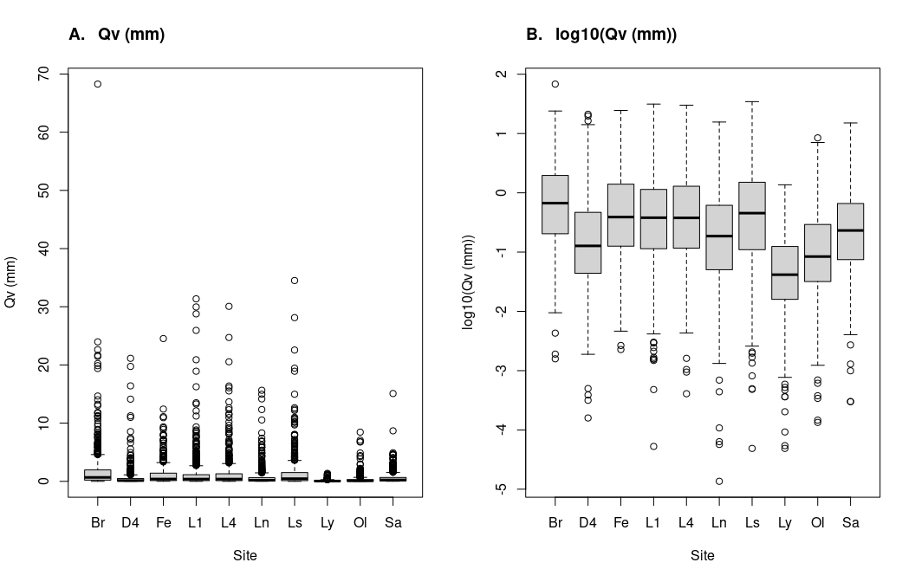

Fig. S2-2. Response variable Qmax for each site, untransformed (A) and log10 transformed (B).
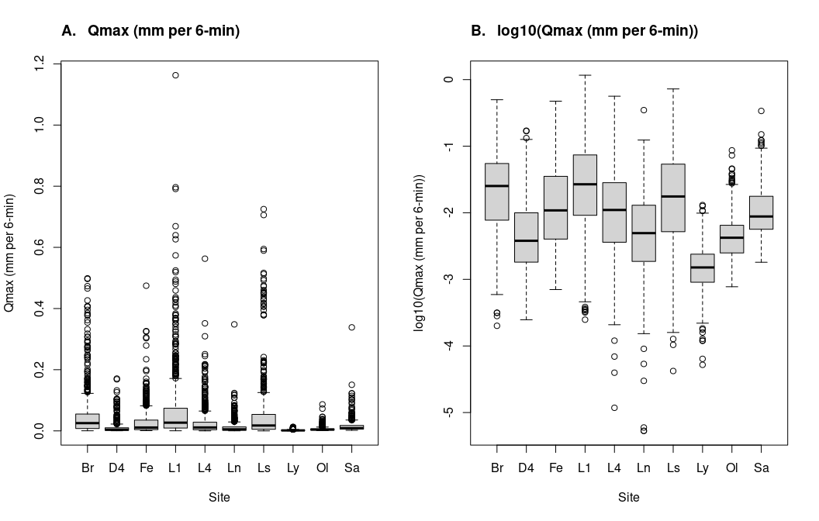

Fig. S2-3. Separation of quickflow (grey polygons) and slowflow (black polygons) from total streamflow for three wet-weather events from site Br.
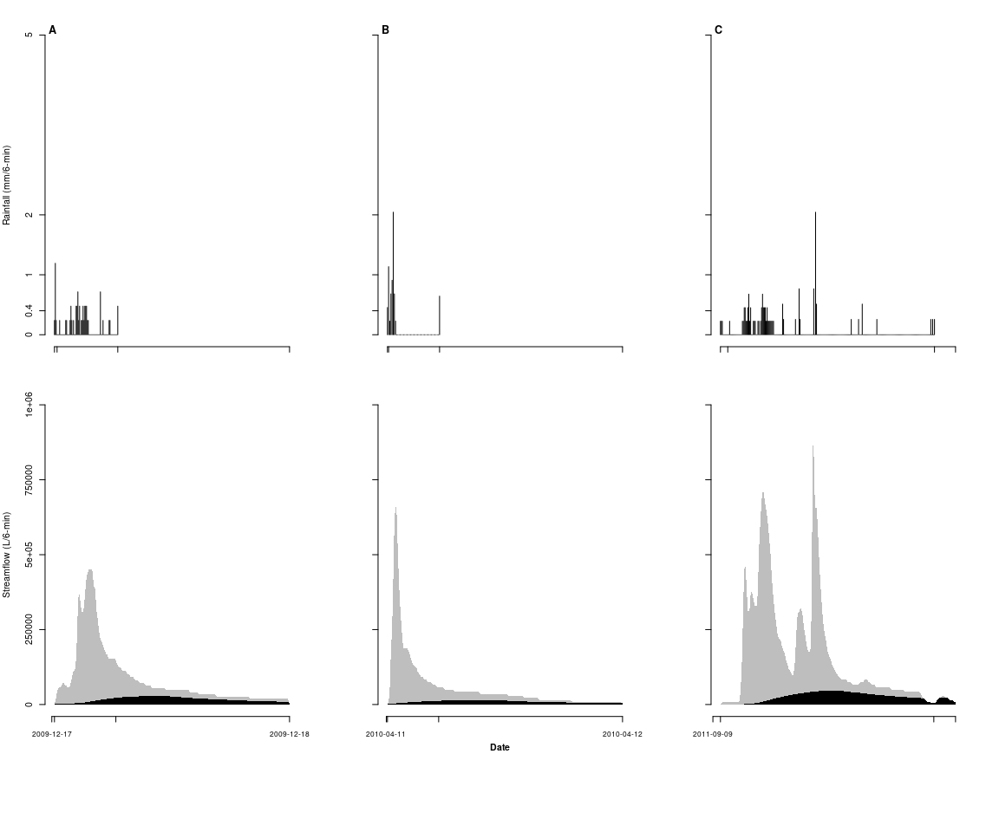

Supplementary material S3: Predictor variables and model sampling

Introduction
This appendix derives a range of predictor variables used in the statistical modelling. There were five climate related predictors, being:
- e_rain—the sum of rainfall observed over the storm event (units of mm).
- ante_r_7d—the sum of rainfall observed in the preceding 7 days of the storm event (units of mm).
- ante_r_30d—the sum of rainfall observed in the preceding 30 day of the storm event (units of mm).
- ante_e_7d—the sum of potential evapotranspiration in the 7 days prior to when rain occurred at the start of the storm event (units of mm).
- ante_sm_7d—ante_r_7d minus ante_e_7d. A measure of water deficit or surplus (in units of mm).
There was also two predictors related to impervious surfaces and Stormwater Control Measures (SCMs) being:
- degrd—log10(% EI_s1 + 0.1): EI assuming no stormwater control measures in the catchment (Walsh et al. 2021).
- restr—difference between log10(% EI_s + 0.1) (EI accounting for SCM hydrologic performance) and lei_s1 (Walsh et al. 2021).

Brief data preparation and summary
Both response variables (Qv and Qmax) were log₁₀ transformed (Figures S3-1 and S3-2). This meant 7 wet-weather events featuring zero quickflow were excluded from the analysis. The effect of time was captured using variable t—centered and scaled start time of quickflow since the first rain event (Figure S3-3). The following transformations were applied to the climate related predictors: log₁₀x+1 for e_rain, log₁₀x+1 for ante_r_7d, sqrt for ante_r_30d, log₁₀ for ante_e_7d, and asinh for ante_sm_7d. See Figure S3-4 for a graphical summary. Predictor variables degrd and restr used in the modelling are illustrated below.

Fig. S3-1. Histograms of Qv for each site based on raw and log10 transformed values.
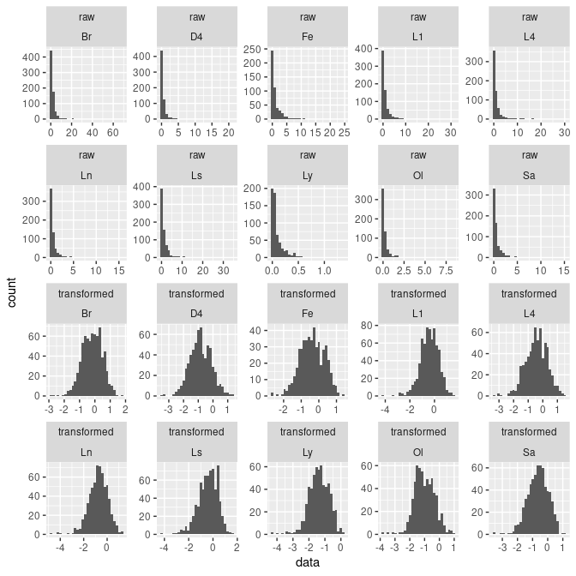

Fig. S3-2. Histograms of Qmax for each site based on raw and log10 transformed values.
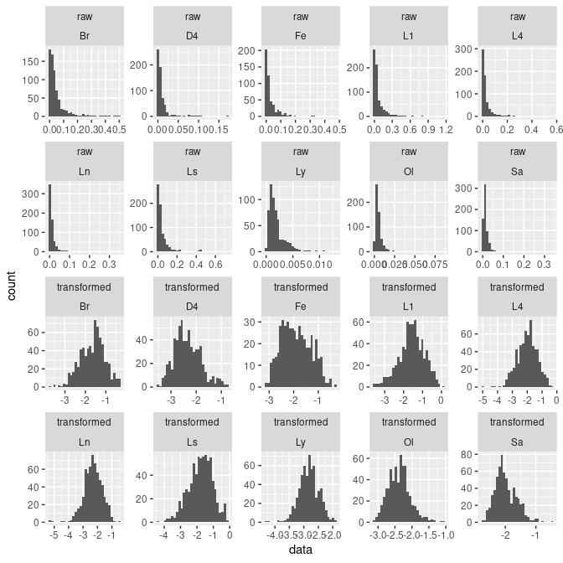

Fig. S3-3. The time variable for each site.
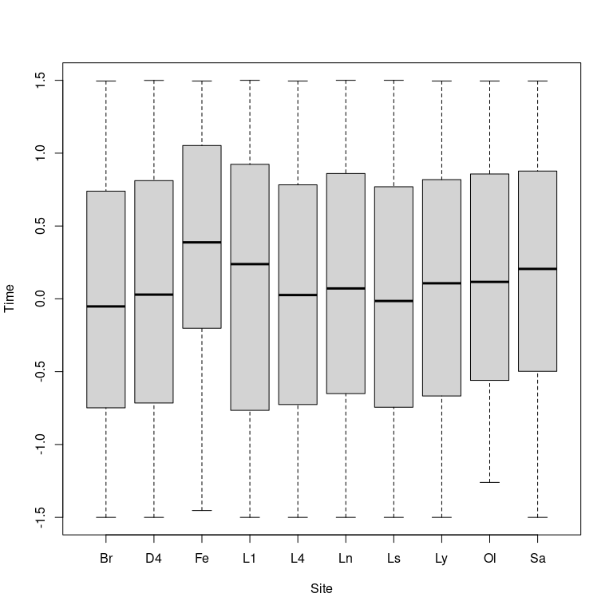

Fig. S3-4. Climate related predictors for each site, with appropriate transformations applied.
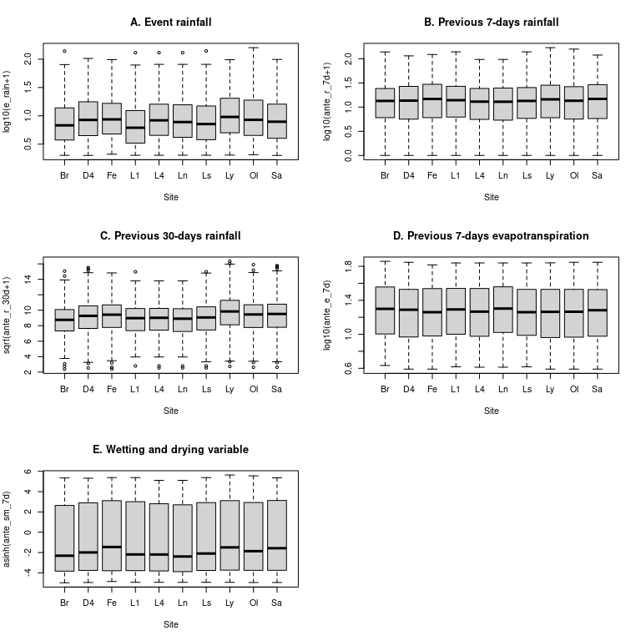

Fig. S3-5. Time-series plot of EI assuming no stormwater control measures in the catchments (variable degrd).
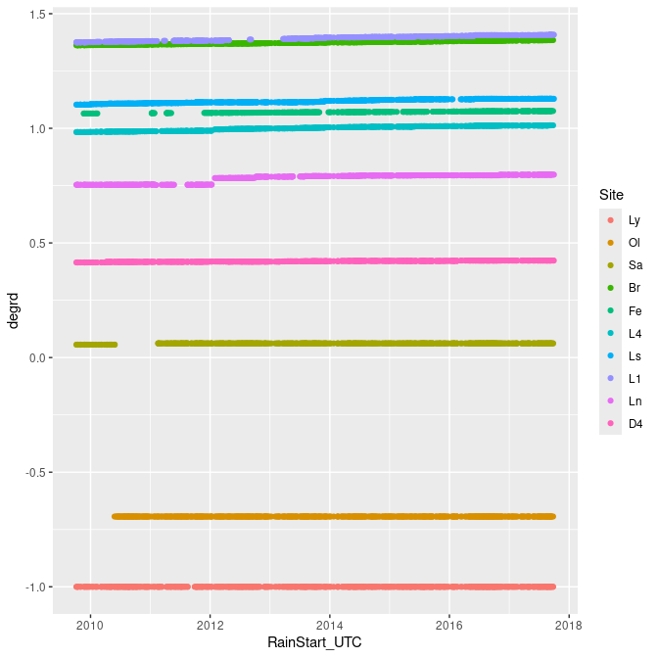

Fig. S3-5. Time-series plot variable restr which accounts for SCM performance (variable restr).
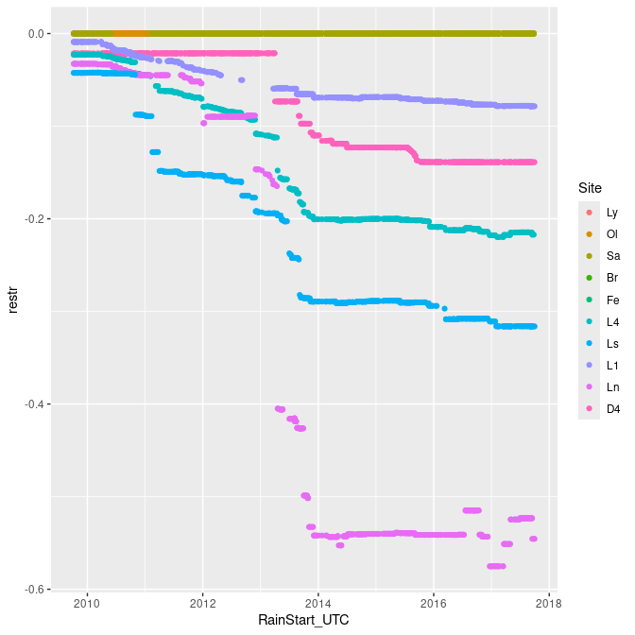

Modelling technical details
We fitted hierarchical linear models using the Markov chain Monte Carlo sampler implemented in Stan (Carpenter et al. 2017). Stan was called in R (R Core Team 2023) using the library rstan (Stan Development Team 2020). The global intercept ($α$) was drawn from a weakly informative normal distribution (mean 0, standard deviation [sd] 10). Random site variation to the global intercept ($αs$) was drawn from a normal hyper-distribution, with mean 0 and sd drawn from a half-Cauchy distribution (mean 0, sd 2). All $β$ parameters (except for time [$βt$]) were drawn from weakly informative normal distributions (mean 0, sd 5). $βt$ was drawn from a normal hyper-distribution with a mean drawn from a normal distribution with mean 0 and sd 5, and standard deviation drawn from a half-Cauchy distribution (mean 0, sd 2).
Model structure was compiled using the code M1_Hydrology_Model_Compilation.Rmd. The final model for the assessment of the effects of stormwater control measure implementation was compiled using the code M2_Hydrology_Model_Compilation_With_Prediction.Rmd. Compiling and sampling the 32 models took ~2 d on a 4-CPU core system at 2.6 Ghz. On model sampling, the number of Markov chains was set to 4, the number of iterations for each chain set to 5000, and the number of burnin iterations per chain set to 1000. We used the Gelman-Rubin statistic to evaluate MCMC convergence [with values $\hat{R}$ < 1.1 indicating convergence; Gelman et al. (2004)].
For model comparison and selection, we used differences in the Bayesian LOO estimate of the expected log pointwise predictive density (ELPDloo). ELPDloo is analogous to widely used information criteria—models with difference in ELPDloo greater than four or greater than twice the standard error of the difference have better predictive performance (Vehtari et al. 2022) and were considered more plausible.

Optimal spatial and temporal autocorrelation parameters
For both response variables (QV and Qmax), the best autoT parameter was 50 days (see Tables S3-1 and S3-2). The best autoS parameter was 10 hours for both response variables, although for QV there was some weak support for 5 hours. We adopted autoT = 50 days and autoS = 10 hours for both response variables.
Table S3-1: Summary statistics of models fitted in order to determine optimal autoS and autoT parameters. Response variable = Qv.
model_name | elpd_diff | se_diff
m_1_st_t_50day_s_10hour_autotest | 0.0 | 0.0
m_1_st_t_50day_s_5hour_autotest | -9.2 | 5.6
m_1_st_t_50day_s_2hour_autotest | -71.0 | 12.2
m_1_st_t_20day_s_10hour_autotest | -74.4 | 19.6
m_1_st_t_20day_s_5hour_autotest | -84.8 | 20.4
m_1_st_t_10day_s_10hour_autotest | -127.4 | 25.7
m_1_st_t_10day_s_5hour_autotest | -139.7 | 26.5
m_1_st_t_20day_s_2hour_autotest | -150.4 | 22.6
m_1_st_t_10day_s_2hour_autotest | -206.7 | 28.2

Table S3-2: Summary statistics of models fitted in order to determine optimal autoS and autoT parameters. Response variable = Qmax.
model_name | elpd_diff | se_diff
m_1_st_t_50day_s_10hour_autotest | 0.0 | 0.0
m_1_st_t_50day_s_5hour_autotest | -24.6 | 9.8
m_1_st_t_20day_s_10hour_autotest | -82.6 | 23.8
m_1_st_t_50day_s_2hour_autotest | -97.2 | 14.4
m_1_st_t_20day_s_5hour_autotest | -107.5 | 25.6
m_1_st_t_10day_s_10hour_autotest | -147.9 | 31.9
m_1_st_t_10day_s_5hour_autotest | -175.0 | 33.4
m_1_st_t_20day_s_2hour_autotest | -184.8 | 27.2
m_1_st_t_10day_s_2hour_autotest | -248.4 | 34.2

Optimal additional predictors
Consideration of additional predictors to the primary (or principal) model resulted in better models for both response variables (Tables S3-3 and S3-4). The best fitting model for each response variable featured the same two climatic predictor variables: ante_r_7d_l (the sum of rainfall observed in the preceding 7 days; log10(x+1) transformed) and ante_e_7d_ (the sum of potential evapotranspiration in the 7 days prior to when rain occurred at the start of the storm event; log10(x) transformed). While a different model for QV had some weak support (m_1_xx_st_add2_EXPLORE_ante_r_30d_l_ante_sm_7d_l), we adopted the additional predictors ante_r_7d_l and ante_e_7d_ for the final models.
Table S3-3: Summary statistics of models fitted in order to determine which climatic predictors are best. Response variable = Qv.
model_name | elpd_diff | se_diff
m_1_xx_st_add2_EXPLORE_ante_r_7d_l_ante_e_7d_l | 0.0 | 0.0
m_1_xx_st_add2_EXPLORE_ante_r_30d_l_ante_sm_7d_l | -23.6 | 12.2
m_1_x_st_add1_EXPLORE_ante_r_7d_l | -24.8 | 8.6
m_1_x_st_add1_EXPLORE_ante_sm_7d_l | -34.6 | 11.5
m_1_xx_st_add2_EXPLORE_ante_r_30d_l_ante_e_7d_l | -45.2 | 14.3
m_1_x_st_add1_EXPLORE_ante_e_7d_l | -80.2 | 14.4
m_1_x_st_add1_EXPLORE_ante_r_30d_l | -82.7 | 18.2
m_1_st_t_50day_s_10hour_autotest | -134.5 | 19.9

Table S3-4: Summary statistics of models fitted in order to determine which climatic predictors are best. Response variable = Qmax.
model_name | elpd_diff | se_diff
m_1_xx_st_add2_EXPLORE_ante_r_7d_l_ante_e_7d_l | 0.0 | 0.0
m_1_x_st_add1_EXPLORE_ante_r_7d_l | -23.3 | 9.2
m_1_xx_st_add2_EXPLORE_ante_r_30d_l_ante_sm_7d_l | -50.7 | 14.9
m_1_x_st_add1_EXPLORE_ante_sm_7d_l | -50.9 | 12.8
m_1_xx_st_add2_EXPLORE_ante_r_30d_l_ante_e_7d_l | -66.8 | 16.7
m_1_x_st_add1_EXPLORE_ante_e_7d_l | -90.1 | 16.0
m_1_x_st_add1_EXPLORE_ante_r_30d_l | -101.0 | 20.3
m_1_st_t_50day_s_10hour_autotest | -138.0 | 21.5

References
Carpenter, B., Gelman, A., Hoffman, M., Lee, D., Goodrich, B., Betancourt, M., Brubaker, M., Guo, J., Li, P. & Riddell, A. (2017) Stan: a probabilistic programming language. Journal of Statistical Software, Articles, 76, 1–32.
Gelman, A., Carlin, J.B., Stern, H.S. & Rubin, D.B. (2004) Bayesian Data Analysis, 2nd ed. Chapman; Hall/CRC.
R Core Team. (2023) R: A Language and Environment for Statistical Computing. R Foundation for Statistical Computing, Vienna, Austria.
Stan Development Team. (2020) RStan: The R interface to Stan.
Vehtari, A., Gabry, J., Magnusson, M., Yao, Y., Bürkner, P.-C., Paananen, T. & Gelman, A. (2022) Loo: Efficient leave-one-out cross-validation and WAIC for bayesian models.

Supplementary material S4: Final models and data prediction

Overview
This document uses the final models fitted in S3_Predictor_Variables_Sampling.Rmd. We make predictions to a new dataset to permit estimation of each response variable under specific scenarios, and interpretation of interactive effects through counter-factual plots. The work is used to interpret each response variable individually to help devise a synthetic results section in hydrology_manuscript.Rmd. The models used in the prediction are compiled in M2_Hydrology_Model_Compliation_With_Prediction.Rmd.

Prediction dataset
Values of restr (the putative restorative effect of SCMs) considered are illustrated in Figure S5-1A. The values cover the range achieved in the experiment (e.g. Ln to L1), along with the cases of ideal SCM implementation and no SCM implementation. Values of degrd (the putative degrading effect of urban stormwater runoff) used in predictions (Figure S5-1B) reflected those of the study sites. Other variables used in the predictions included storm event rainfall (e_rain; values = 1.5, 3, 6, 12, 24, and 48 mm), time (t = 1.5; i.e. end of the study), rainfall in the previous 7-days (ante_r_7d set to 17 mm; average conditions), and potential evapotranspiration in the previous 7-days (ante_e_7d set to 23 mm; average conditions).

Fig. S5-1. restr and degrd values used in the prediction data set.
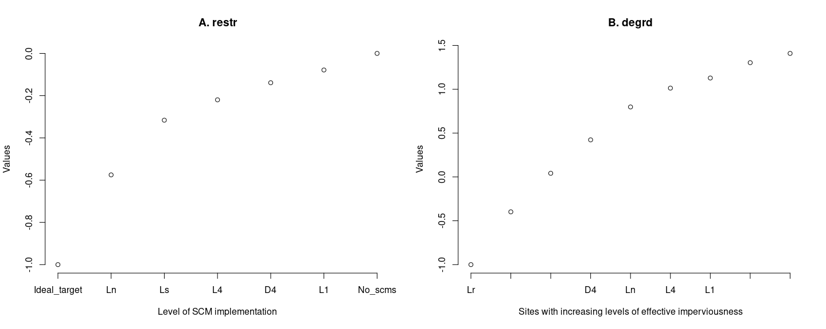

QV optimal model
Figure S5-2A shows the distributions of all parameters for the optimal model for response variable Qv (storm event quickflow). Fig. S5-2D shows the mean predicted value for each runoff event plotted against the observed value. The Pearson correlation coefficient indicates a very good model fit.
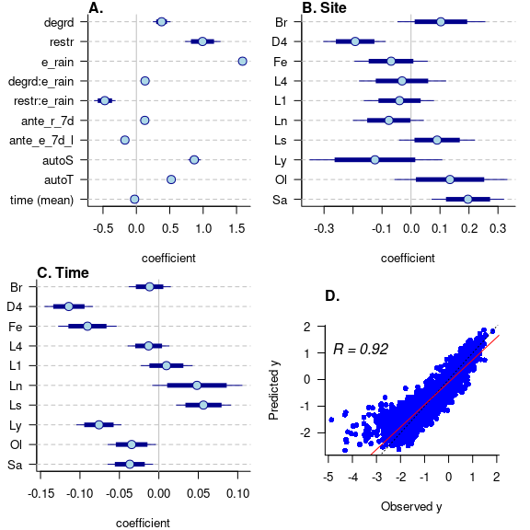
Fig. S5-2. Qv (storm event quickflow). A. Median coefficient estimates (points with thick and thin error bars representing 90% and 95% confidence intervals, respectively) for fixed effects (including mean site effect). B. Site effects. C. Time effect for the study sites. D. A plot of predicted Qv values against observed values (red line is the line of the best and the dotted black line is the 1:1 line).
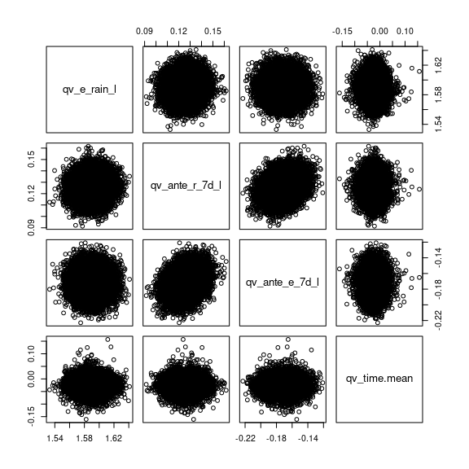
Fig. S5-3. Pair plots for the posterior samples of model parameters relating to the following predictor variables: e_rain_l, ante_r_7d_l, qv_ante_e_7d_l, and time (mean). Response variable = Qv. Little correlation is evident.

Qmax optimal model
Figure S5-4 shows the distributions of all parameters for the optimal model for response variable Qmax (storm event peak flow). Fig. S5-4D shows the mean predicted value for each runoff event plotted against the observed value. The Pearson correlation coefficient indicates a very good model fit.
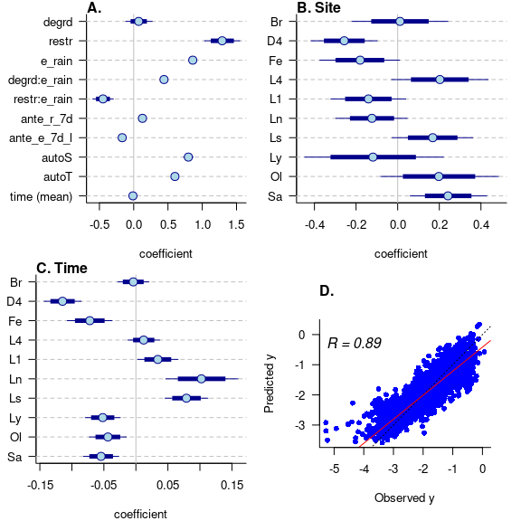
Fig. S5-4. Qmax (storm event peak flow). A. Median coefficient estimates (points with thick and thin error bars representing 90% and 95% confidence intervals, respectively) for fixed effects (including mean site effect). B. Site effects. C. Time effect for the study sites. D. A plot of predicted Qmax values against observed values (red line is the line of the best and the dotted black line is the 1:1 line).
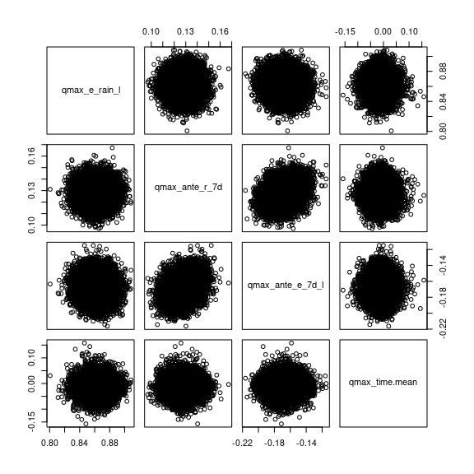
Fig. S5-5. Pair plots for the posterior samples of model parameters relating to the following predictor variables: e_rain_l, ante_r_7d_l, qv_ante_e_7d_l, and time (mean). Response variable = Qmax. Little correlation is evident.

