SUPPLEMENTAL MATERIAL

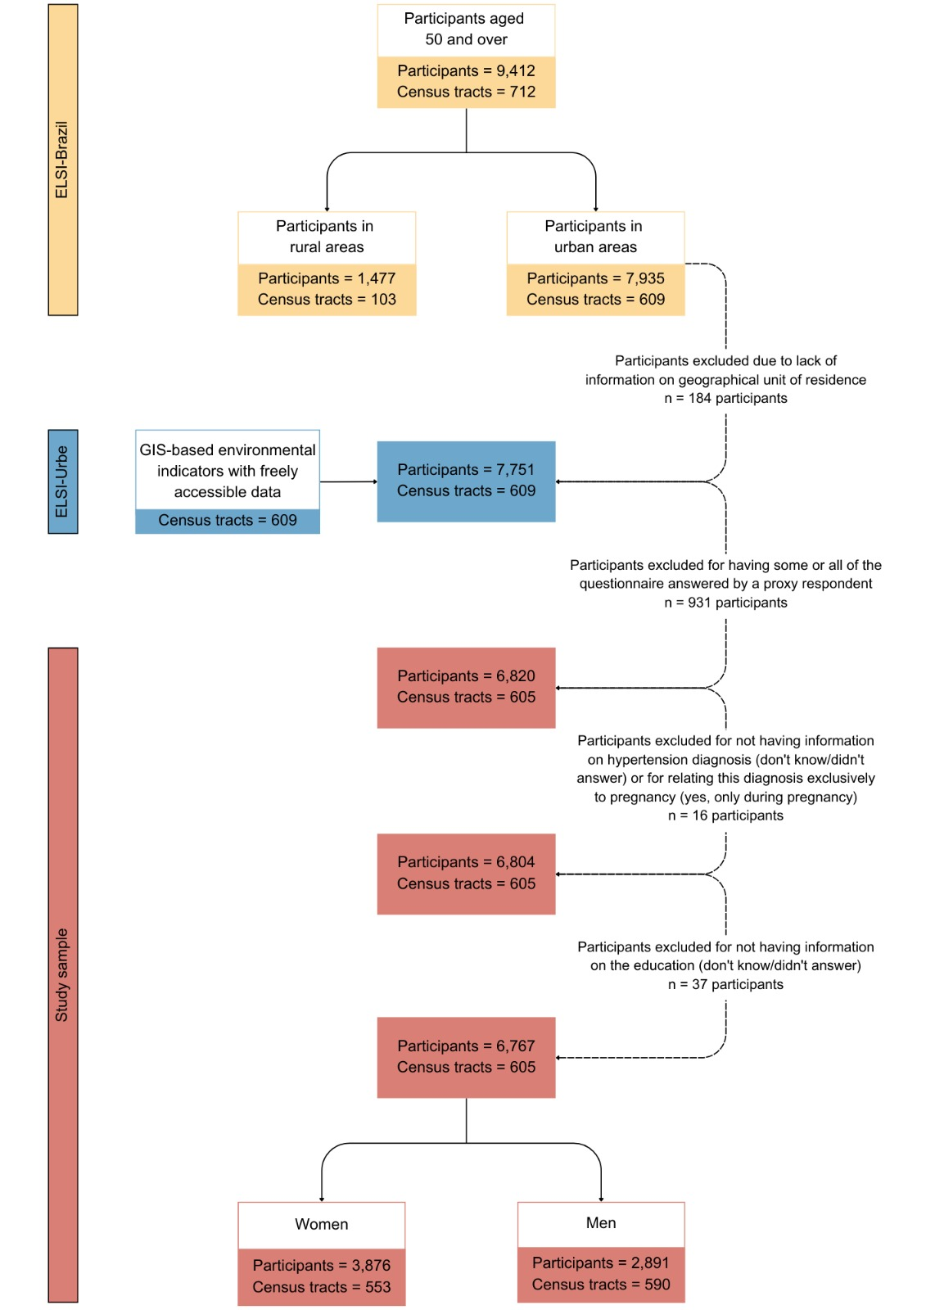
Figure S1. Flowchart depicting the process of defining the sample used in this study based on data from the first wave of ELSI-Brazil (2015–2016).
Supplementary Table 1: Adjusted associations between individual education, Brazilian Deprivation Index (IBP) of the census tract, and measured arterial hypertension¹, stratified by gender, for older Brazilian adults residing in urban areas.

 | Model 1 | Model 2 | Model 3
 | OR (95% CI) | OR (95% CI) | OR (95% CI)
WOMEN
Individual Education
≤ 4 years |  | 1.00 | 1.00
5 to 8 years |  | 1.01 (0.83-1.23) | 1.07 (0.87-1.30)
≥ 9 years |  | 0.63 (0.52-0.75)** | 0.68 (0.56-0.82)**
Brazilian Deprivation Index |  | -- | 1.07 (1.02-1.12)*
Random parameters
Variance (standard error) | 0.049 (0.044) | 0.059 (0.052) | 0.043 (0.050)
PCV | Ref. | 20% | 13%
MOR | 1,24 | 1,26 | 1,22
MEN
Individual Education
≤ 4 years |  | 1.00 | 1.00
5 to 8 years |  | 1.03 (0.83-1.26) | 1.01 (0.81-1.24)
≥ 9 years |  | 0.91 (0.75-1.10) | 0.87 (0.71-1.06)
Brazilian Deprivation Index |  | -- | 0.96 (0.91-1.01)
Random parameters
Variance (standard error) | 0.140 (0.066) | 0.086 (0.067) | 0.085 (0.067)
PCV | Ref. | 39% | 39%
MOR | 1,43 | 1,32 | 1,32
The sample used in the sensitivity analysis was the same as the main analysis (n = 6,767).
¹Arterial hypertension was defined as systolic blood pressure ≥ 140 mmHg and/or diastolic blood pressure ≥ 90 mmHg and/or use of antihypertensive drugs.
OR: odds ratio. CI: confidence interval. Significance level: *<0.05, **<0.01. PCV: Proportion change in variance. MOR: Median odds-ratio.
The Brazilian Deprivation Index of the census tract was standardized to mean 0 and standard deviation (SD) 1.
Model 1: Null model (random effect at the census tract level)
Model 2: Education, adjusted for age (random effect at the census tract level).
Model 3: Education and Brazilian Deprivation Index, adjusted for age (random effect at the census tract level).
All estimates considered the sampling weights and the complex sample design.

