Additional Files to

Sex specific differences in short term mortality after ICU-delirium
Nikolaus Schreiber¹, Michael Eichlseder², Simon Orlob¹, Christoph Klivinyi¹, Philipp Zoidl², Alexander Pichler², Michael Eichinger², Simon Fandler-Höfler³, Laura Scholz⁴, Jekaterina Baumgartner⁴, Michael Schörghuber¹ and Philipp Eller*⁴

¹Divison of Heart-, Thoracic- and Vascular Anaesthesiology and Intensive Care Medicine, Department of Anaesthesiology and Intensive Care Medicine, Medical University of Graz, Austria
²Divison of Anaesthesiology and Intensive Care Medicine, Department of Anaesthesiology and Intensive Care Medicine, Medical University of Graz, Austria
³Department of Neurology, Medical University of Graz, Austria
⁴Intensive Care Medicine, Department of Internal Medicine, Medical University of Graz, Austria

*Corresponding author: Philipp Eller
Contact: philipp.eller@medunigraz.at

Sensitivity analysis
As sensitivity analysis, we calculated the E-value to quantify the potential impact of unmeasured confounding on the observed associations (1). The E-value represents the minimum strength of association, measured on the risk ratio scale, that an unmeasured confounder would need to have with both the exposure and the outcome—while accounting for the measured covariates—to fully explain away the observed exposure-outcome relationship. In simpler terms, confounders with associations weaker than the E-value would be insufficient to eliminate the observed association.

For the hazard ratio of 1.16 (95% CI 1.071–1.267) for 30-day mortality in females, the E-value was calculated to be 1.45, indicating that any unmeasured confounder would need to have a relative risk of at least 1.45 with both gender and mortality to explain away the observed effect.

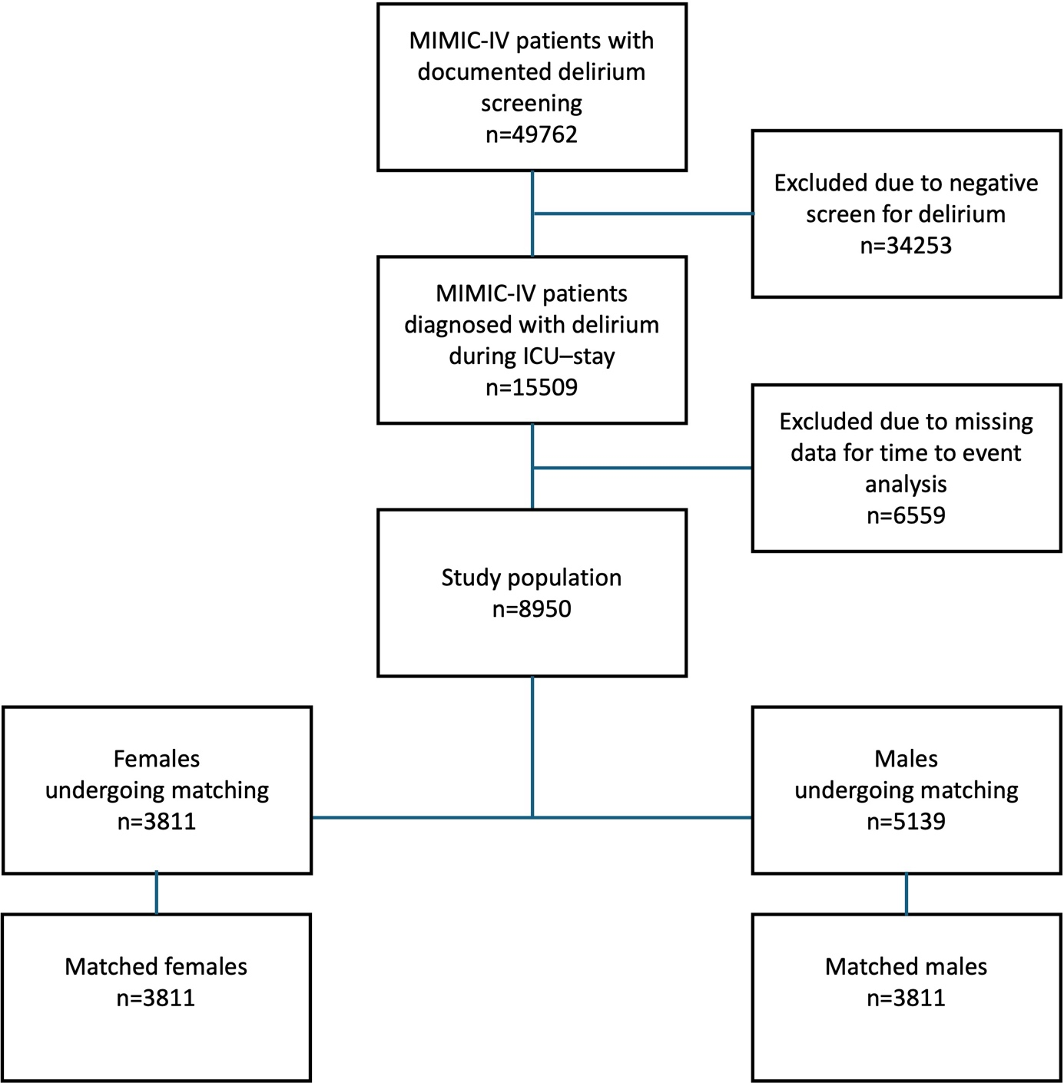
Additional Figure A1. Study Flow Chart

Abbreviations: ICU – Intensive Care Unit; MIMIC-IV - Medical Information Mart for Intensive Care-IV;

Additional Figure A2. Standardized Mean Differences before and after matching
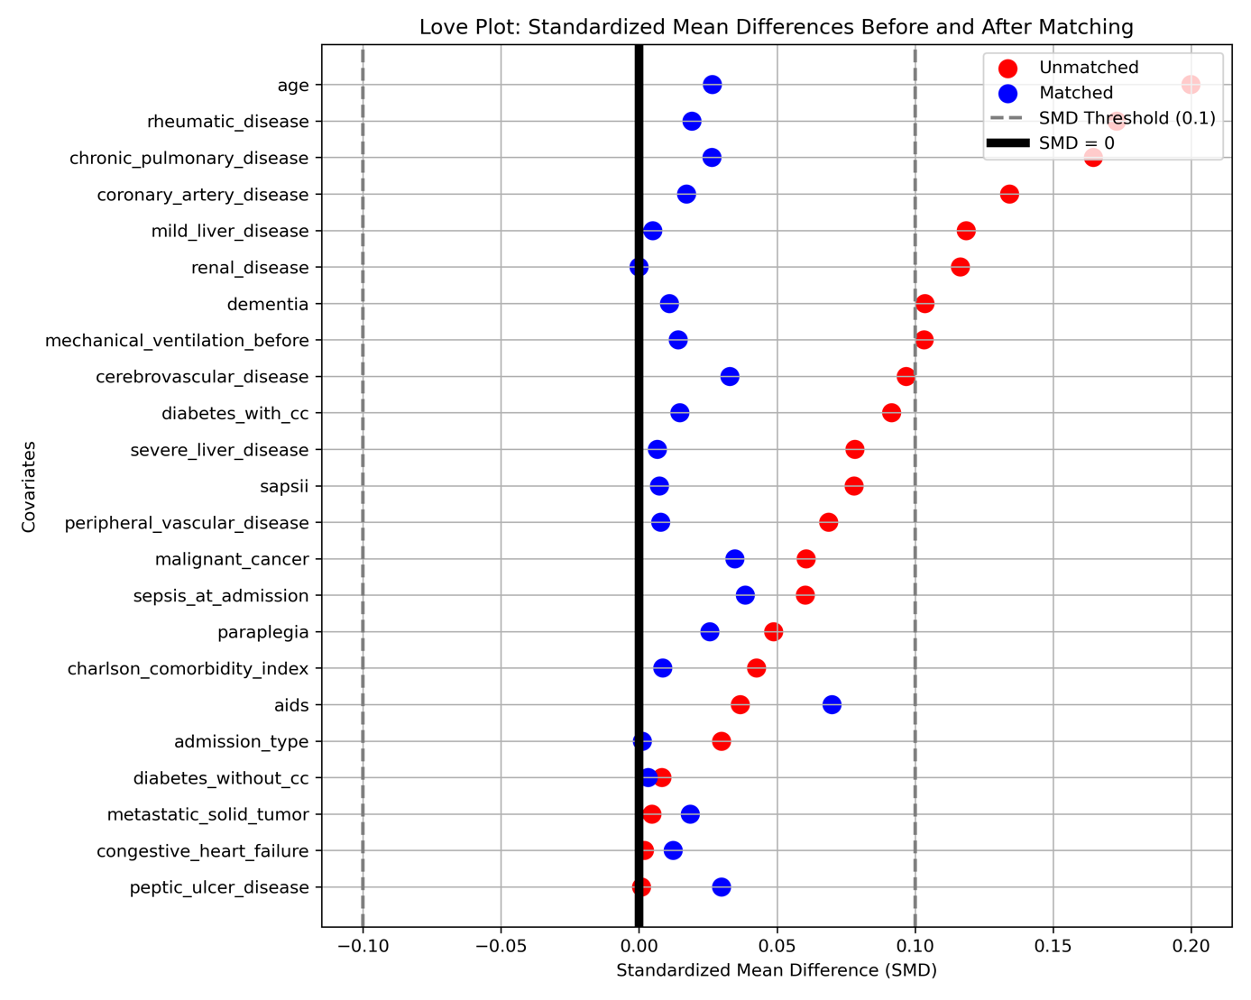
Love plot displaying the standardized mean differences (SMDs) of all covariates included in the propensity score model, comparing females and males in both the unmatched cohort (n=8950, red dots) and the matched cohort (n=7622, blue dots).
Abbreviations: SMDs – Standardized mean differences;

Additional Figure A3. Distribution of the propensity score before and after matching
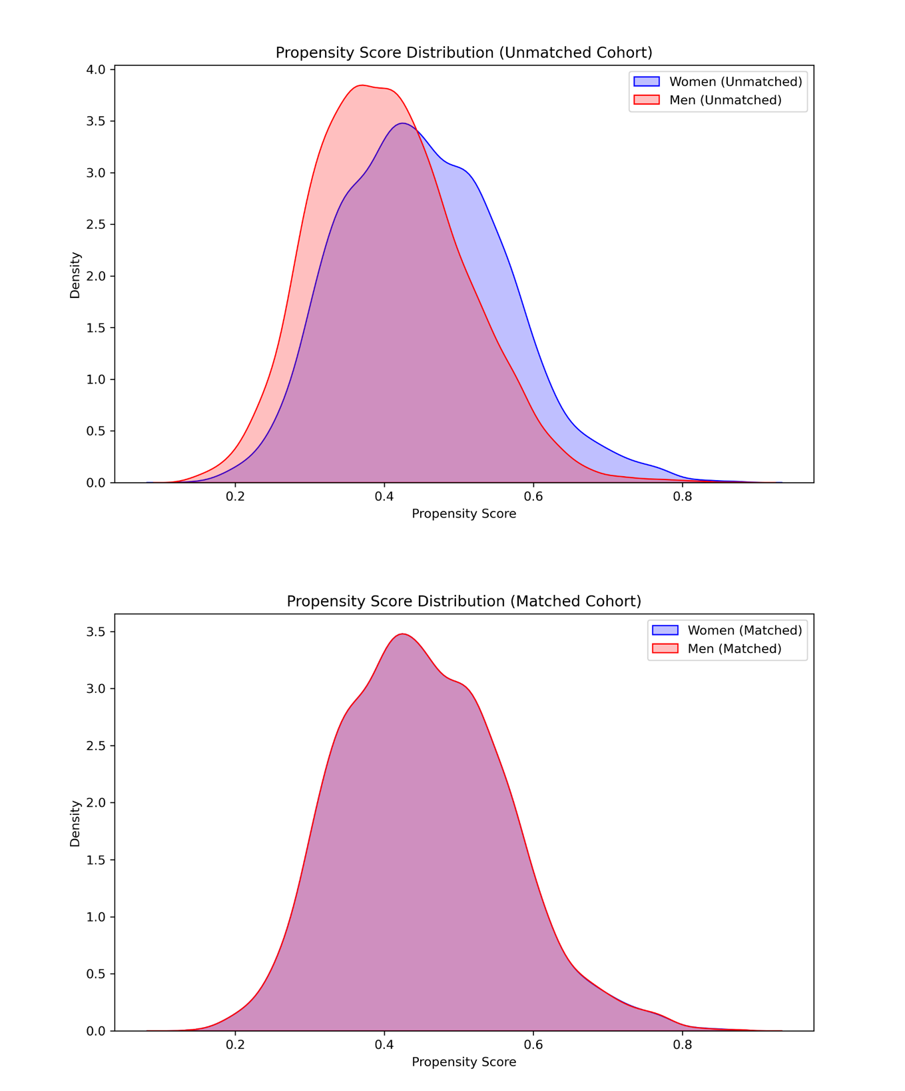
Density plots of the propensity score for female patients (blue) and male patients (red) in the unmatched cohort (upper panel) and matched cohort (lower panel). The propensity score was derived from a multivariable logistic regression model with sex as the outcome variable.

References

1. VanderWeele TJ, Ding P. Sensitivity Analysis in Observational Research: Introducing the E-Value. Ann Intern Med. 2017 Aug 15;167(4):268–74.

