Supplementary information
of
Halogen bond-modulated solid-state reordering and symmetry breaking of azahelicenes
Juncong Liang,† Fuwei Gan,† Guoli Zhang,† Chengshuo Shen,*,‡ Huibin Qiu*,†
† School of Chemistry and Chemical Engineering, Zhangjiang Institute for Advanced Study, Frontiers Science Center for Transformative Molecules, State Key Laboratory of Metal Matrix Composites, Shanghai Jiao Tong University, Shanghai 200240, China.
‡ School of Chemistry and Chemical Engineering, Zhejiang Sci-Tech University, Hangzhou 310018, China.
E-mail: shenchengshuo@zstu.edu.cn
E-mail: hbqiu@sjtu.edu.cn

1 Experimental section
1.1 Instruments
Scanning electron microscope (SEM) was performed on a JEOL JSM-7800F microscope with an accelerating voltage of 5 kV. Samples were prepared by dropping ca. 10 μL of suspension onto a cleaned silicon wafer, followed by drying and coating with a thin layer of Au to enhance the contrast. Single crystal X-ray diffraction measurements were performed on a Bruker SMART Apex II CCD-based X-ray diffractometer with Cu-K_{α} (λ = 1.54178 Å) radiation. Powder X-ray diffraction (PXRD) data were collected on a D8 Advance instrument from Bruker-AXS Company over a 2θ range of 3.0°~30.0° at room temperature. Nuclear magnetic resonance (NMR) spectra were recorded on a Bruker AVANCE III HD 500 MHz spectrometer. Fourier transform infrared spectrometer (FT-IR) was characterized on THERMO FISHER Nicolet 6700, and KBr was used as the disperse media. Raman spectra were collected on Renishaw inVia Qontor. Circular dichroism (CD) spectra were measured on a JASCO J-1500 CD spectrometer. The samples were first mixed with KBr and casted into plates, and then the plates were placed perpendicular to the light path of CD spectrometer and rotated within the plate plane to rule out the possibility of birefringence and eliminate the possible angle dependent CD signal. Differential scanning calorimeter (DSC) tests were carried out on Shimadzu DSC-60 plus under a nitrogen atmosphere. The instrument was calibrated by indium. Thermal gravimetric analyzer TGA was characterized on PerkinElmer TGA8000 under nitrogen atmosphere with a heating rate of 10 °C /min.
1.2 Materials
All starting materials and solvents were of AR grade quality, which were purchased from commercial sources and used without any further purification. P-4N6H, M-4N6H and 2N4H were synthesized according to previous reports and NMR data was in well agreement with the literatures.^{S1, S2}

2 Additional experimental data and figures
Figure S1. X-ray crystallographic structure of P-4N6H (thermal ellipsoids are shown at a 50% probability level).

Table S1. Crystal data and structure refinement for P-4N6H.
Identification code | P-4N6H
Empirical formula | C₂₅H₁₅N
Formula weight | 329.404
Temperature/K | 173.0
Crystal system | orthorhombic
Space group | P 2₁ 2₁ 2
a/Å | 13.2173(5)
b/Å | 6.7996(3)
c/Å | 9.5140(4)
α/° | 90
β/° | 90
γ/° | 90
Volume/Å³ | 855.05(6)
Z | 2
ρcalcg/cm³ | 1.279
μ/mm⁻¹ | 0.568
F(000) | 345.0
Crystal size/mm³ | 0.02 × 0.02 × 0.02
Radiation | CuK_{α} (λ = 1.54178)
2Θ range for data collection/° | 11.46 to 133.574
Index ranges | -15 ≤ h ≤ 15, -8 ≤ k ≤ 6, -11 ≤ l ≤ 11
Reflections collected | 7031
Independent reflections | 1480 [R_{int} =0.0376, R_{sigma} =0.0256]
Data/restraints/parameters | 1480/264/235
Goodness-of-fit on F² | 1.130
Final R indexes [I ≥ 2σ (I)] | R₁ = 0.0324, wR₂ = 0.0929
Final R indexes [all data] | R₁ = 0.0351, wR₂ = 0.0951
Largest diff. peak/hole / e Å⁻³ | 0.14/-0.12
Flack parameter | 0.7(6)
CCDC number | 2244514
- Explanation for the Alert A
PLAT089_ALERT_3_A Poor Data / Parameter Ratio (Zmax < 18) ........ 3.75 Note
- The Alert_3_A was majorly caused by the low quality of the single crystal. However, this would not affect the structural determination in this study.

Figure S2. X-ray crystallographic structure of M-4N6H (thermal ellipsoids are shown at a 50% probability level).

Table S2. Crystal data and structure refinement for M-4N6H.
Identification code | M-4N6H
Empirical formula | C₂₅H₁₅N
Formula weight | 329.404
Temperature/K | 173.0
Crystal system | orthorhombic
Space group | P 2₁ 2₁ 2
a/Å | 13.2330(6)
b/Å | 6.8010(3)
c/Å | 9.5295(6)
α/° | 90
β/° | 90
γ/° | 90
Volume/Å³ | 857.63(8)
Z | 2
ρcalcg/cm³ | 1.276
μ/mm⁻¹ | 0.567
F(000) | 345.0
Crystal size/mm³ | 0.02 × 0.02 × 0.02
Radiation | CuK_{α} (λ = 1.54178)
2Θ range for data collection/° | 9.28 to 136.98
Index ranges | -15 ≤ h ≤ 15, -8 ≤ k ≤ 8, -11 ≤ l ≤ 11
Reflections collected | 10283
Independent reflections | 1584 [R_{int} =0.0547, R_{sigma} =0.0351]
Data/restraints/parameters | 1584/231/235
Goodness-of-fit on F² | 1.097
Final R indexes [I ≥ 2σ (I)] | R₁ = 0.0467, wR₂ = 0.1227
Final R indexes [all data] | R₁ = 0.0534, wR₂ = 0.1291
Largest diff. peak/hole / e Å⁻³ | 0.13/-0.13
Flack parameter | 1.5(9)
CCDC number | 2244513
- Explanation for the Alert B
PLAT089_ALERT_3_B Poor Data / Parameter Ratio (Zmax < 18) ........ 4.03 Note
- The Alert_3_B was majorly caused by the low quality of the single crystal. However, this would not affect the structural determination in this study.

Figure S3. X-ray crystallographic structure of P-4N6H/1,4-2IFB (thermal ellipsoids are shown at a 50% probability level).

Table S3. Crystal data and structure refinement for P-4N6H/1,4-2IFB.
Identification code | P-4N6H/1,4-2IFB
Empirical formula | C₅₆H₃₀F₄I₂N₂
Formula weight | 1060.62
Temperature/K | 173.0
Crystal system | orthorhombic
Space group | P 2₁ 2₁ 2₁
a/Å | 4.9278(2)
b/Å | 17.1360(5)
c/Å | 49.8568(15)
α/° | 90
β/° | 90
γ/° | 90
Volume/Å³ | 4210.0(2)
Z | 4
ρcalcg/cm³ | 1.673
μ/mm⁻¹ | 12.237
F(000) | 2088.0
Crystal size/mm³ | 0.15 × 0.1× 0.15
Radiation | CuK_{α} (λ = 1.54178)
2Θ range for data collection/° | 3.544 to 130.468
Index ranges | -5 ≤ h ≤ 5, -19 ≤ k ≤ 20, -58 ≤ l ≤ 58
Reflections collected | 34726
Independent reflections | 7173 [R_{int} =0.1470, R_{sigma} =0.0970]
Data/restraints/parameters | 7173/0/577
Goodness-of-fit on F² | 1.034
Final R indexes [I ≥ 2σ (I)] | R₁ = 0.0504, wR₂ = 0.1150
Final R indexes [all data] | R₁ = 0.0765, wR₂ = 0.1278
Largest diff. peak/hole / e Å⁻³ | 0.77/-0.55
CCDC number | 2245396

Figure S4. X-ray crystallographic structure of P-4N6H/3IFB (thermal ellipsoids are shown at a 50% probability level).

Table S4. Crystal data and structure refinement for P-4N6H/3IFB.
Identification code | P-4N6H/3IFB
Empirical formula | C₃₁H₁₅F₃I₃N
Formula weight | 839.180
Temperature/K | 173.0
Crystal system | monoclinic
Space group | P 2₁
a/Å | 7.5349(12)
b/Å | 9.4531(14)
c/Å | 18.607(3)
α/° | 90
β/° | 90.258(11)
γ/° | 90
Volume/Å³ | 1325.3(4)
Z | 2
ρcalcg/cm³ | 2.013
μ/mm⁻¹ | 28.159
F(000) | 791.3
Crystal size/mm³ | 0.02 × 0.02× 0.02
Radiation | CuK_{α} (λ = 1.54178)
2Θ range for data collection/° | 9.5 to 133.18
Index ranges | -9 ≤ h ≤ 9, -11 ≤ k ≤ 11, -22 ≤ l ≤ 22
Reflections collected | 13949
Independent reflections | 4437 [R_{int} =0.0557, R_{sigma} =0.0566]
Data/restraints/parameters | 4437/1/343
Goodness-of-fit on F² | 1.016
Final R indexes [I ≥ 2σ (I)] | R₁ = 0.0473, wR₂ = 0.1217
Final R indexes [all data] | R₁ = 0.0494, wR₂ = 0.1236
Largest diff. peak/hole / e Å⁻³ | 2.63/-1.28
CCDC number | 2245477
- Explanation for the Alert B
PLAT971_ALERT_2_B Check Calcd Resid. Dens. 0.97Ang From I3 2.65 eA-3
PLAT971_ALERT_2_B Check Calcd Resid. Dens. 0.83Ang From I1 2.55 eA-3
- The Alert_2_B was majorly caused by the low quality of the single crystal. However, this would not affect the structural determination in this study.

Figure S5. X-ray crystallographic structure of P-4N6H/1,2-2IFB (thermal ellipsoids are shown at a 50% probability level).

Table S5. Crystal data and structure refinement for P-4N6H/1,2-2IFB.
Identification code | P-4N6H/1,2-2IFB
Empirical formula | C₃₁H₁₅F₄I₂N
Formula weight | 731.24
Temperature/K | 173.0
Crystal system | monoclinic
Space group | P 2₁
a/Å | 8.8211(7)
b/Å | 14.9171(13)
c/Å | 19.4934(16)
α/° | 90
β/° | 90.295(3)
γ/° | 90
Volume/Å³ | 2565.0(4)
Z | 4
ρcalcg/cm³ | 1.894
μ/mm⁻¹ | 19.705
F(000) | 1400.0
Crystal size/mm³ | 0.24 × 0.22× 0.2
Radiation | CuK_{α} (λ = 1.54178)
2Θ range for data collection/° | 4.532 to 133.716
Index ranges | -10 ≤ h ≤ 10, -17 ≤ k ≤ 17, -23 ≤ l ≤ 21
Reflections collected | 30334
Independent reflections | 8866 [R_{int} =0.0646, R_{sigma} =0.0715]
Data/restraints/parameters | 8866/743/614
Goodness-of-fit on F² | 1.059
Final R indexes [I ≥ 2σ (I)] | R₁ = 0.0517, wR₂ = 0.1153
Final R indexes [all data] | R₁ = 0.0695, wR₂ = 0.1286
Largest diff. peak/hole / e Å⁻³ | 0.83/-1.23
Flack parameter | 0.028(4)
CCDC number | 2283134

Figure S6. X-ray crystallographic structure of 2N4H/1IFB (only M enantiomer is shown). Thermal ellipsoids are shown at a 50% probability level.

Table S6. Crystal data and structure refinement for 2N4H/1IFB.
Identification code | 2N4H/1IFB
Empirical formula | C₂₃H₁₁F₅IN
Formula weight | 523.23
Temperature/K | 173.0
Crystal system | triclinic
Space group | P-1
a/Å | 7.4652(2)
b/Å | 9.1598(3)
c/Å | 14.3143(4)
α/° | 88.9760(10)
β/° | 86.3030(10)
γ/° | 80.1240(10)
Volume/Å³ | 962.27(5)
Z | 2
ρcalcg/cm³ | 1.806
μ/mm⁻¹ | 13.601
F(000) | 508.0
Crystal size/mm³ | 0.15× 0.1× 0.05
Radiation | CuK_{α} (λ = 1.54178)
2Θ range for data collection/° | 6.188 to 130.024
Index ranges | -8 ≤ h ≤ 8, -10 ≤ k ≤ 10, -16 ≤ l ≤ 16
Reflections collected | 21169
Independent reflections | 3267 [R_{int} =0.0415, R_{sigma} =0.0222]
Data/restraints/parameters | 3267/0/271
Goodness-of-fit on F² | 1.059
Final R indexes [I ≥ 2σ (I)] | R₁ = 0.0163, wR₂ = 0.0427
Final R indexes [all data] | R₁ = 0.0175, wR₂ = 0.0431
Largest diff. peak/hole / e Å⁻³ | 0.34/-0.46
CCDC number | 2245392

Figure S7. X-ray crystallographic structure of 2N4H/1,4-2IFB (only M enantiomer is shown). Thermal ellipsoids are shown at a 50% probability level.

Table S7. Crystal data and structure refinement for 2N4H/1,4-2IFB.
Identification code | 2N4H/1,4-2IFB
Empirical formula | C₂₀H₁₁F₂IN
Formula weight | 430.20
Temperature/K | 173.0
Crystal system | monoclinic
Space group | P2₁/n
a/Å | 14.0174(9)
b/Å | 4.0075(3)
c/Å | 28.2511(18)
α/° | 90
β/° | 95.233(2)
γ/° | 90
Volume/Å³ | 1580.38(19)
Z | 4
ρcalcg/cm³ | 1.808
μ/mm⁻¹ | 16.116
F(000) | 836.0
Crystal size/mm³ | 0.15× 0.1× 0.05
Radiation | CuK_{α} (λ = 1.54178)
2Θ range for data collection/° | 6.284 to 129.982
Index ranges | -16 ≤ h ≤ 16, -4 ≤ k ≤ 4, -32 ≤ l ≤ 33
Reflections collected | 13004
Independent reflections | 2670 [R_{int} =0.0530, R_{sigma} =0.0403]
Data/restraints/parameters | 2670/0/217
Goodness-of-fit on F² | 1.141
Final R indexes [I ≥ 2σ (I)] | R₁ = 0.0356, wR₂ = 0.1014
Final R indexes [all data] | R₁ = 0.0405, wR₂ = 0.1141
Largest diff. peak/hole / e Å⁻³ | 0.74/-0.80
CCDC number | 2245444

Figure S8. X-ray crystallographic structure of 2N4H/3IFB (only M enantiomer is shown). Thermal ellipsoids are shown at a 50% probability level.

Table S8. Crystal data and structure refinement for 2N4H/3IFB.
Identification code | 2N4H/3IFB
Empirical formula | C₄₀H₂₂F₃I₃N₂
Formula weight | 968.29
Temperature/K | 173.0
Crystal system | monoclinic
Space group | P2₁/n
a/Å | 16.8287(5)
b/Å | 4.72590(10)
c/Å | 41.8025(11)
α/° | 90
β/° | 90.6880(10)
γ/° | 90
Volume/Å³ | 3324.34(15)
Z | 4
ρcalcg/cm³ | 1.935
μ/mm⁻¹ | 22.567
F(000) | 1848.0
Crystal size/mm³ | 0.15× 0.1× 0.1
Radiation | CuK_{α} (λ = 1.54178)
2Θ range for data collection/° | 5.638 to 136.34
Index ranges | -20 ≤ h ≤ 20, -5 ≤ k ≤ 5, -50 ≤ l ≤ 49
Reflections collected | 39141
Independent reflections | 6083 [R_{int} =0.0449, R_{sigma} =0.0290]
Data/restraints/parameters | 6083/441/436
Goodness-of-fit on F² | 1.080
Final R indexes [I ≥ 2σ (I)] | R₁ = 0.0382, wR₂ = 0.0958
Final R indexes [all data] | R₁ = 0.0415, wR₂ = 0.0983
Largest diff. peak/hole / e Å⁻³ | 1.30/-2.11
CCDC number | 2308969

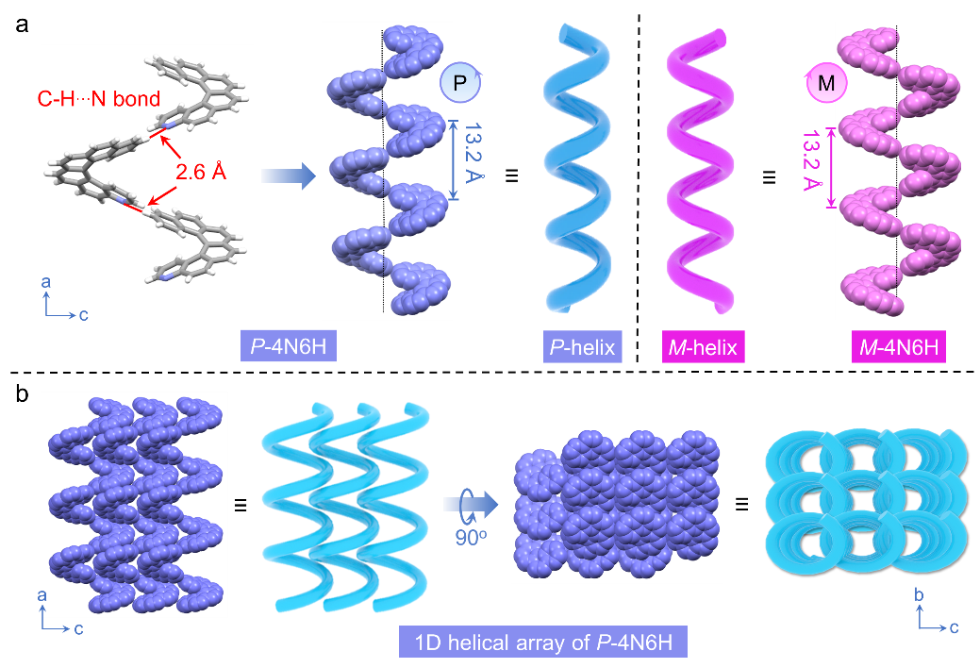
Figure S9. (a) Stacking of P-4N6H and M-4N6H molecules in crystals. (b) Illustration of the helical arrangement of P-4N6H molecules in crystal. The single crystals were grown by diffusion of n-hexane vapor into an acetone solution of P-4N6H or M-4N6H.

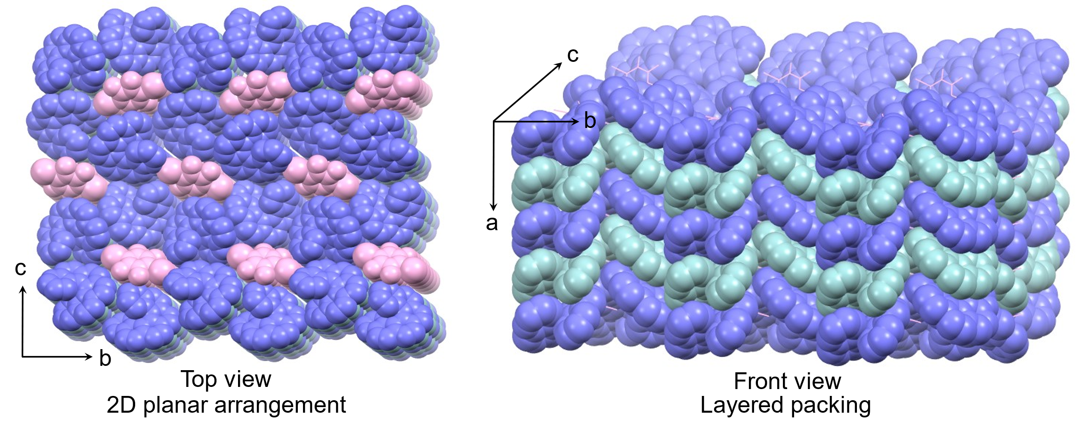
Figure S10. Stacking of P-4N6H and 1,4-2IFB molecules in P-4N6H/1,4-2IFB cocrystal. The cocrystal was grown by diffusion of n-hexane vapor into an acetone solution of P-4N6H and 1,4-2IFB.
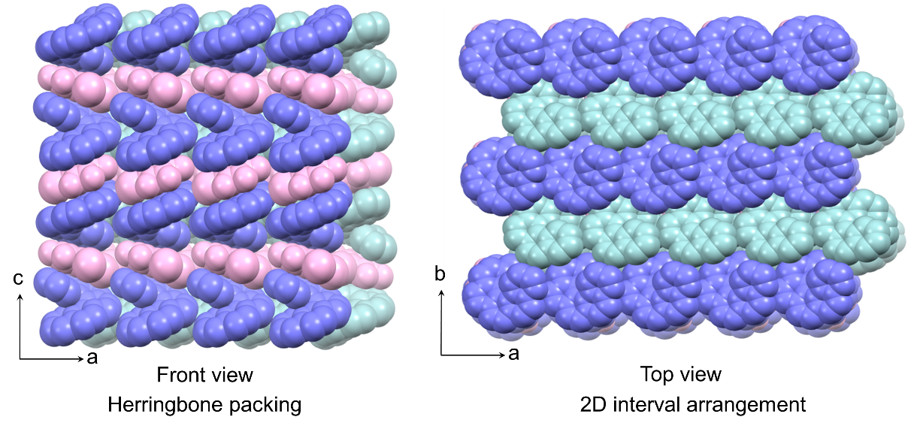
Figure S11. Stacking of P-4N6H and 1,2-2IFB molecules in P-4N6H/1,2-2IFB cocrystal. The cocrystal was grown by diffusion of n-hexane vapor into an acetone solution of P-4N6H and 1,2-2IFB.

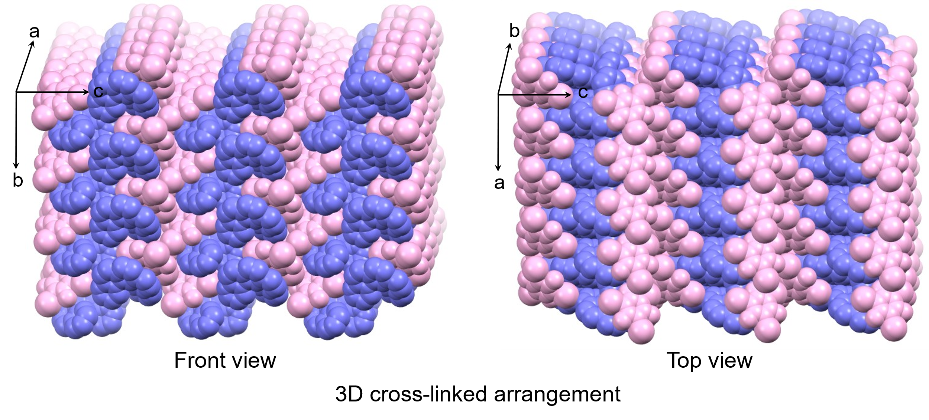
Figure S12. Stacking of P-4N6H and 3IFB molecules in P-4N6H/3IFB cocrystal. The cocrystal was grown by diffusion of n-hexane vapor into an acetone solution of P-4N6H and 3IFB.

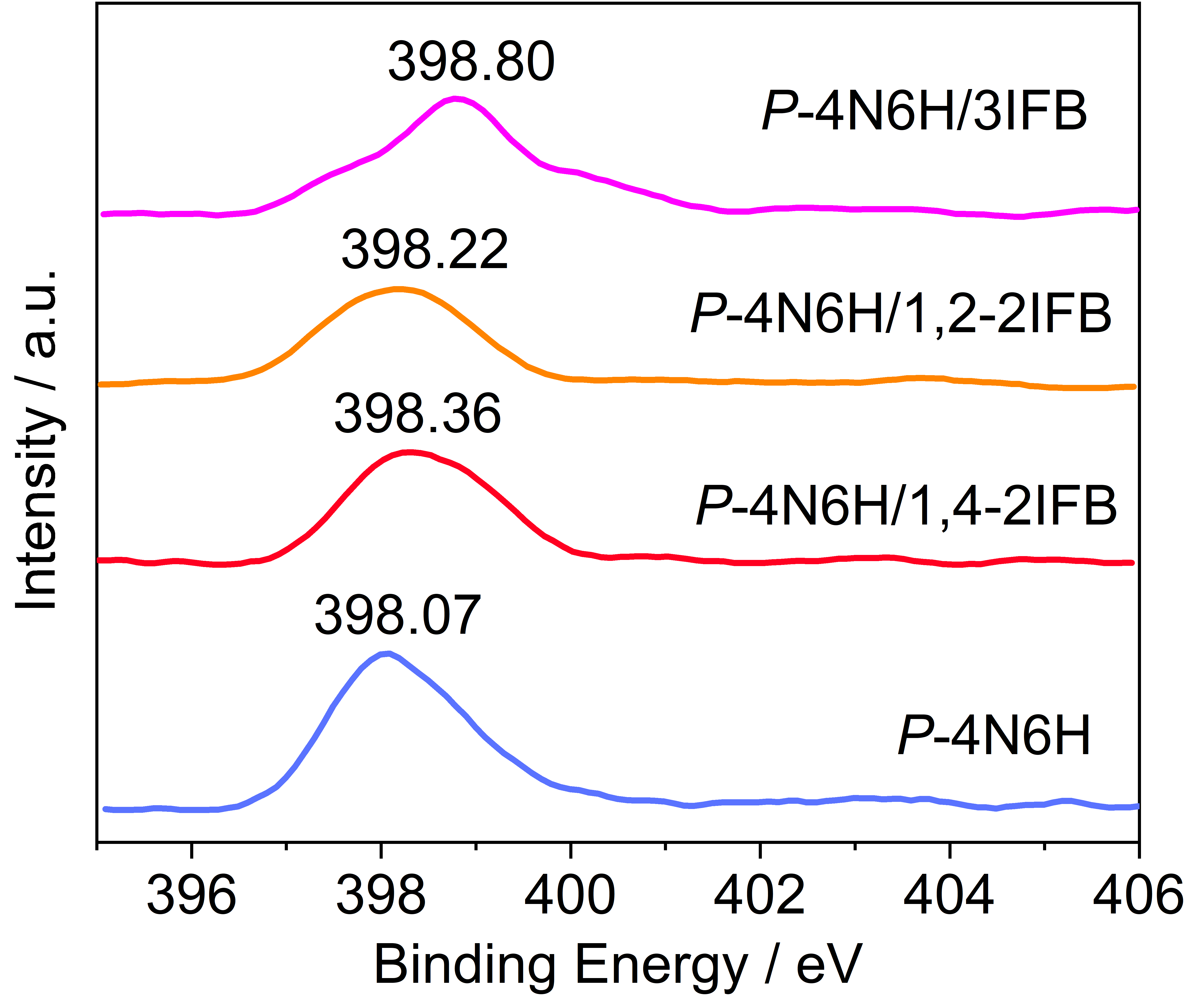
Figure S13. XPS spectra of N 1s for P-4N6H crystal, P-4N6H/1,4-2IFB cocrystal, P-4N6H/1,2-2IFB cocrystal and P-4N6H/3IFB cocrystal.

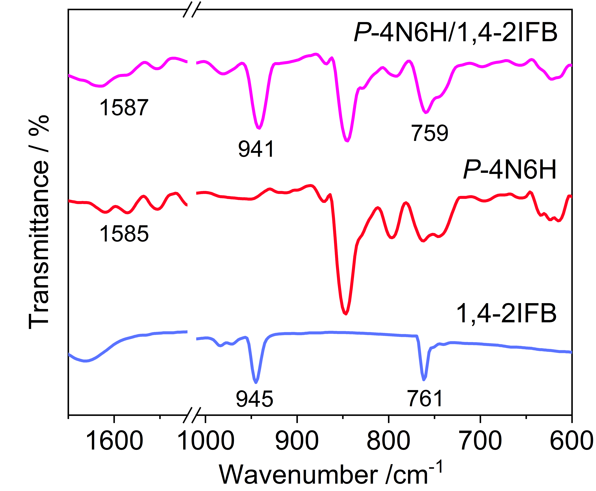
Figure S14. FT-IR spectra of 1,4-2IFB solid, P-4N6H crystal and P-4N6H/1,4-2IFB cocrystal. The samples were mixed with KBr with a mass ratio of 1 : 100.

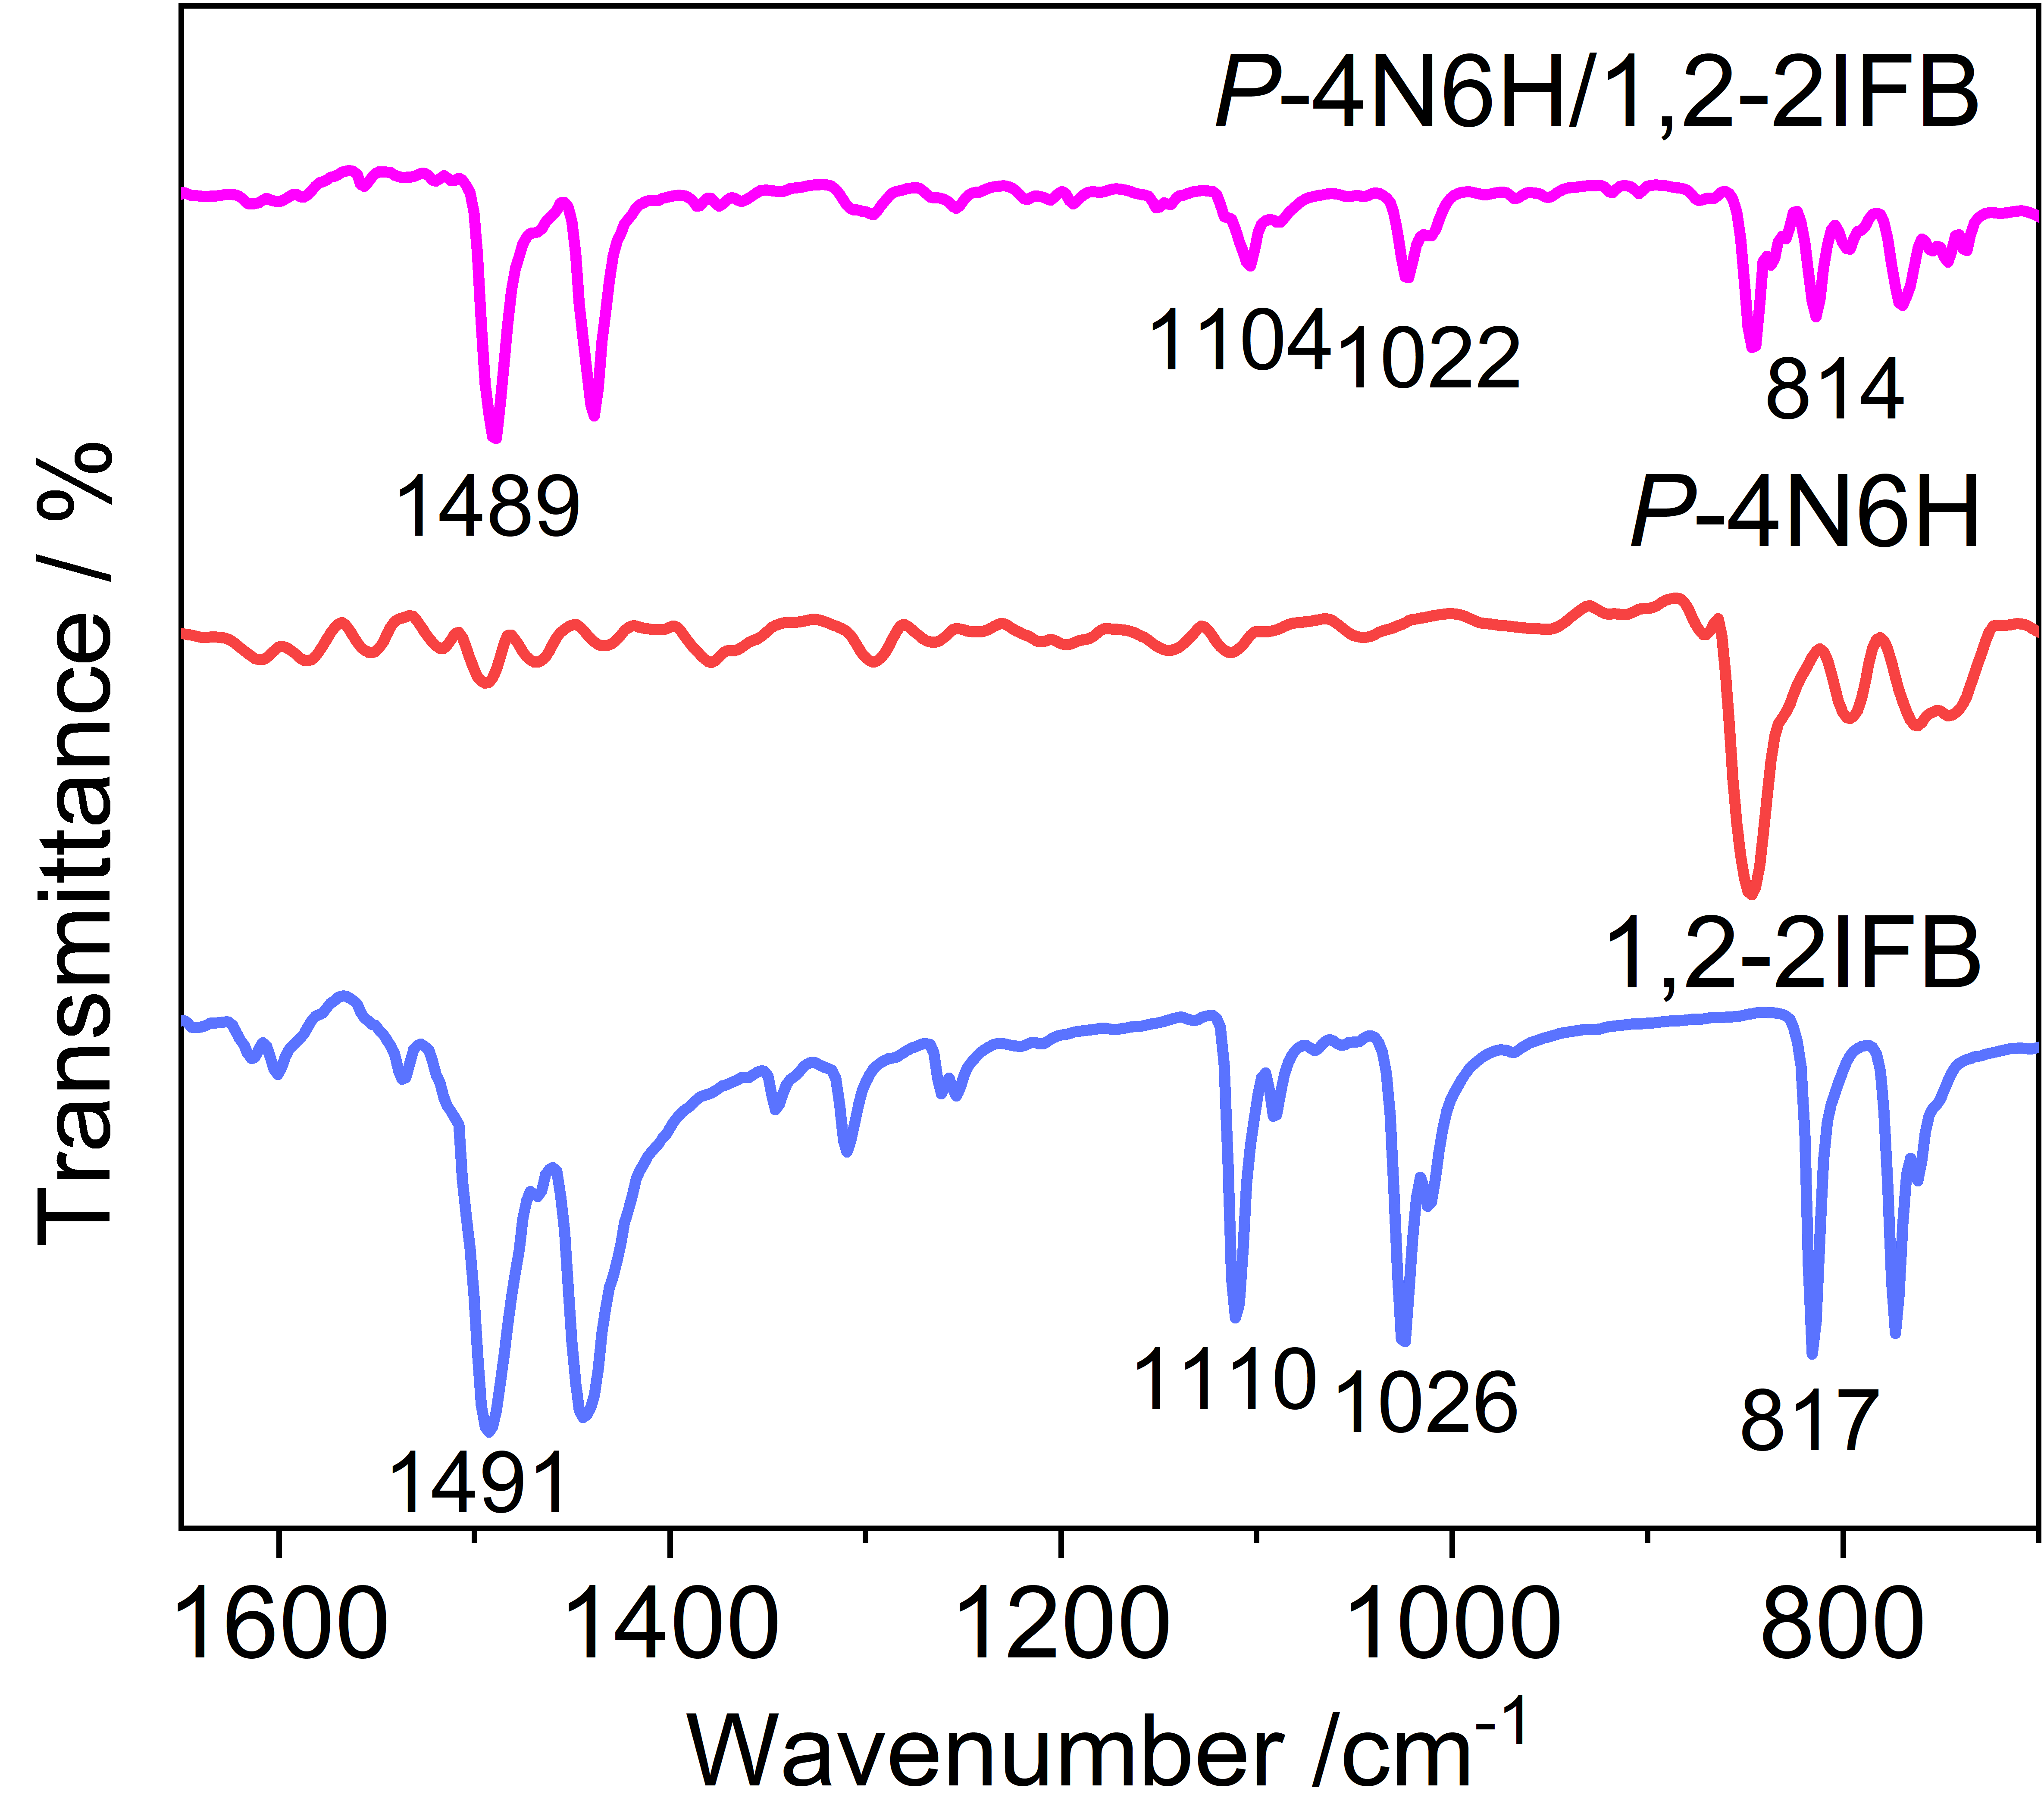
Figure S15. FT-IR spectra of 1,2-2IFB solid, P-4N6H crystal and P-4N6H/1,2-2IFB cocrystal. The samples were mixed with KBr with a mass ratio of 1 : 100.

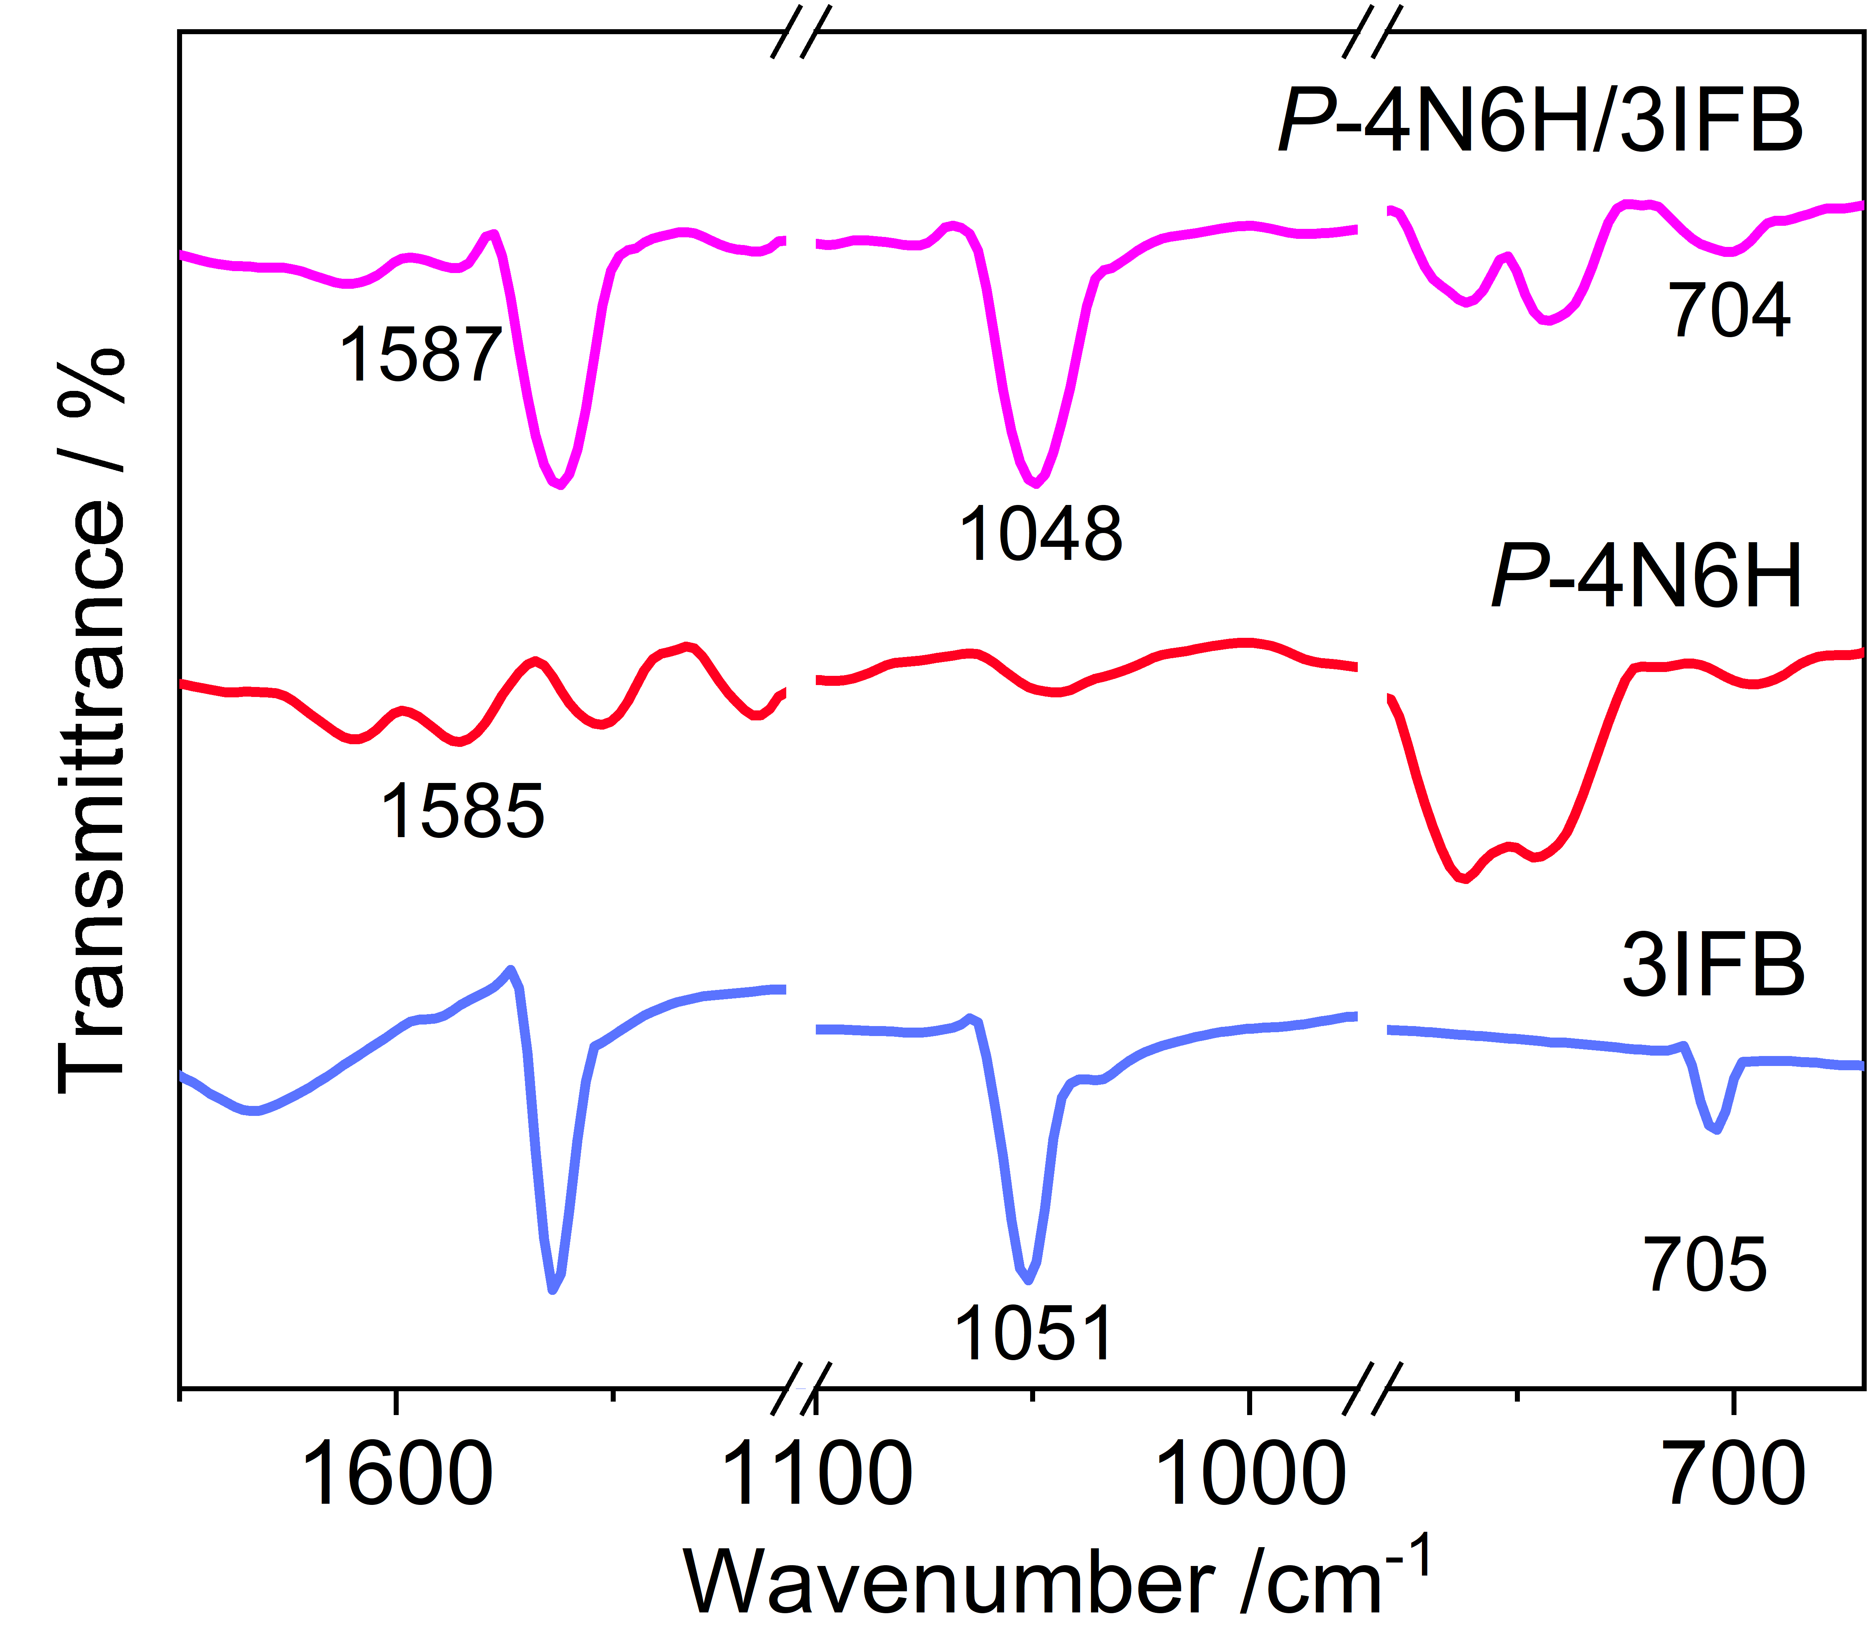
Figure S16. FT-IR spectra of 3IFB solid, P-4N6H crystal and P-4N6H/3IFB cocrystal. The samples were mixed with KBr with a mass ratio of 1 : 100.

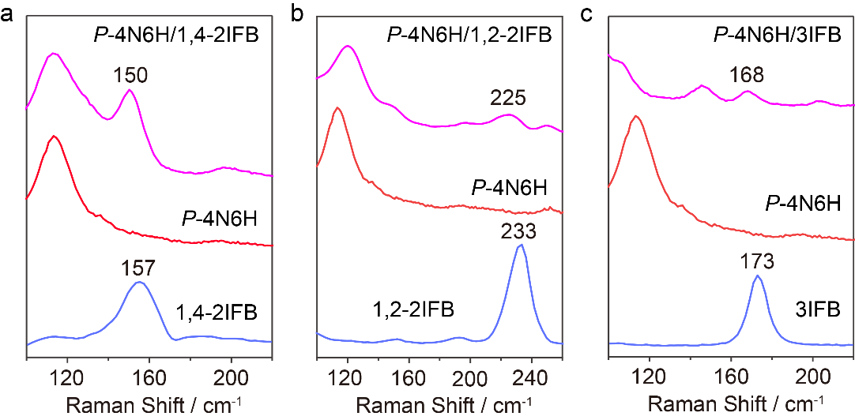
Figure S17. (a) Raman spectra of 1,4-2IFB solid, P-4N6H crystal and P-4N6H/1,4-2IFB cocrystal. (b) Raman spectra of 1,2-2IFB solid, P-4N6H crystal and P-4N6H/1,2-2IFB cocrystal. (c) Raman spectra of 3IFB solid, P-4N6H crystal and P-4N6H/3IFB cocrystal.
Figure S18. CD and corresponding UV-vis spectra of P-4N6H and M-4N6H single crystals, P-4N6H/1,4-2IFB and M-4N6H/1,4-2IFB cocrystals, P-4N6H/1,2-2IFB and M-4N6H/1,2-2IFB cocrystals, and P-4N6H/3IFB and M-4N6H/3IFB cocrystals.

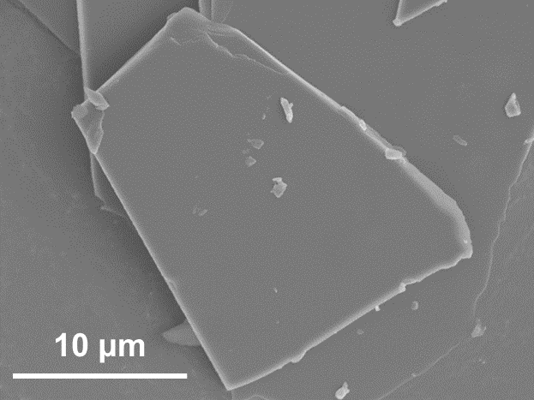
Figure S19. SEM image of P-4N6H crystal. The crystal was grown by diffusion of n-hexane vapor into an acetone solution of P-4N6H.

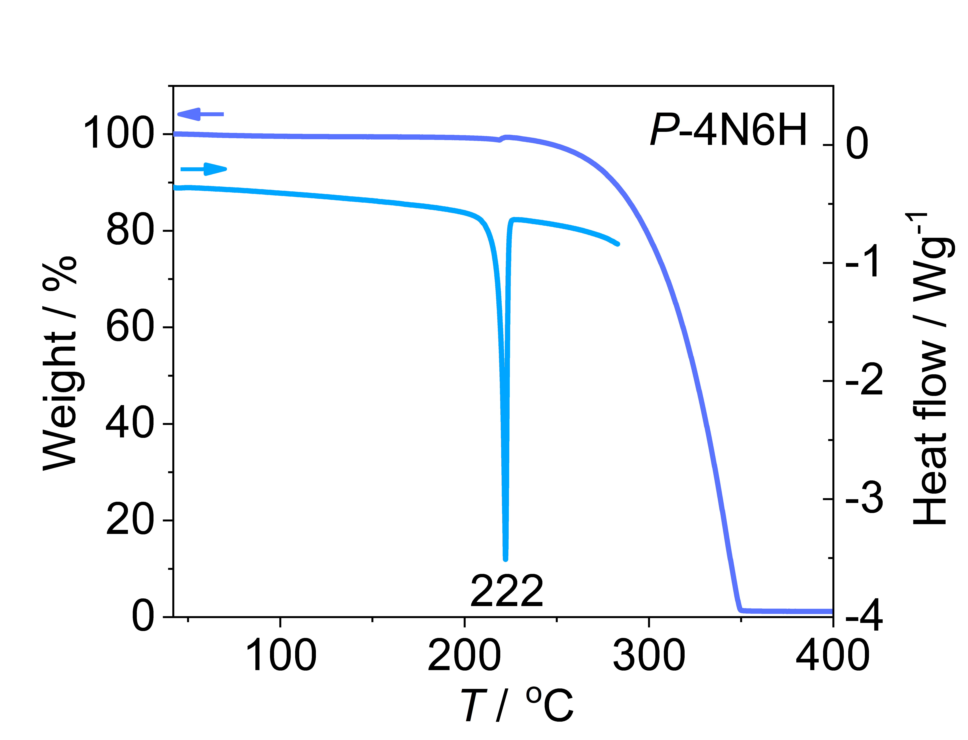
Figure S20. DSC and TGA curves of P-4N6H crystal. The crystal was grown by diffusion of n-hexane vapor into an acetone solution of P-4N6H.

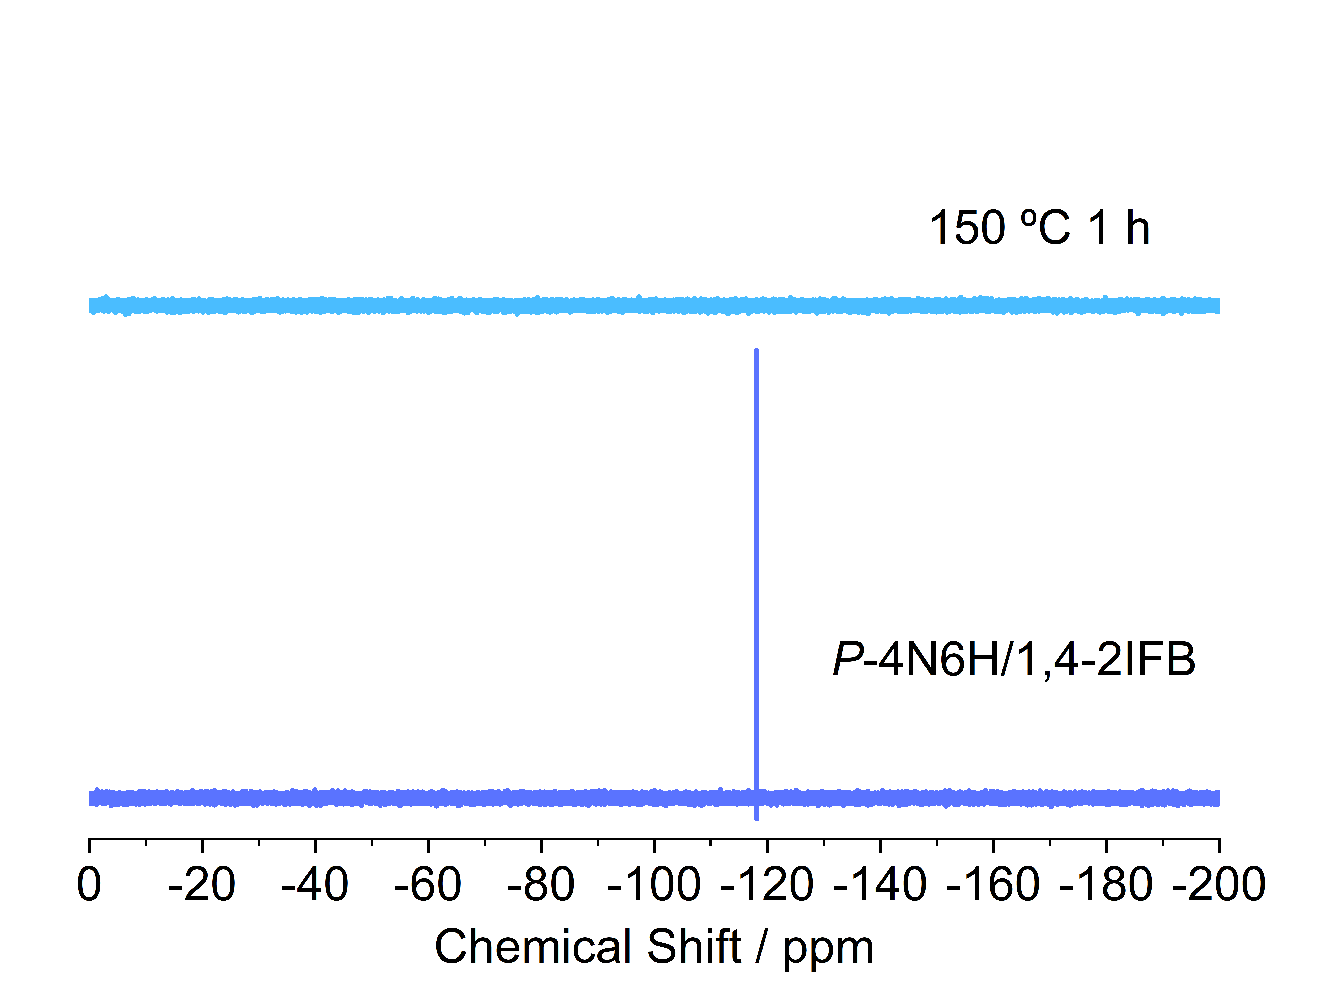
Figure S21. ¹⁹F NMR spectra of P-4N6H/1,4-2IFB cocrystal before and after heating at 150 °C for 1 h (470 MHz, CDCl₃, 298 K). It appeared that 1,4-2IFB was completely removed after the heating treatment.

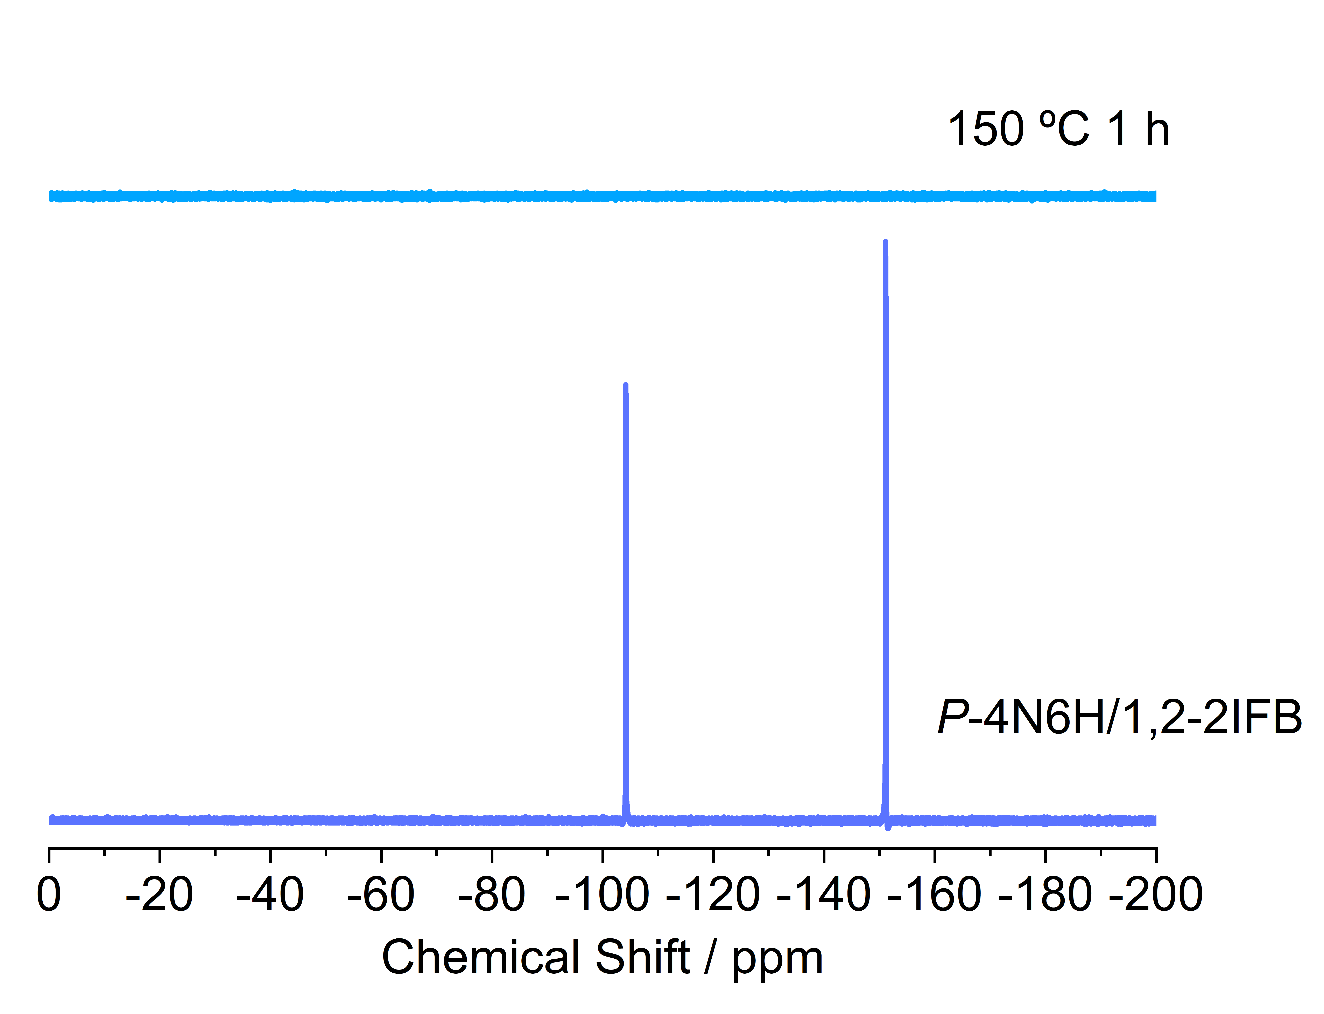
Figure S22. ¹⁹F NMR spectra of P-4N6H/1,2-2IFB cocrystal before and after heating at 150 °C for 1 h (470 MHz, CDCl₃, 298 K). It appeared that 1,2-2IFB was completely removed after the heating treatment.

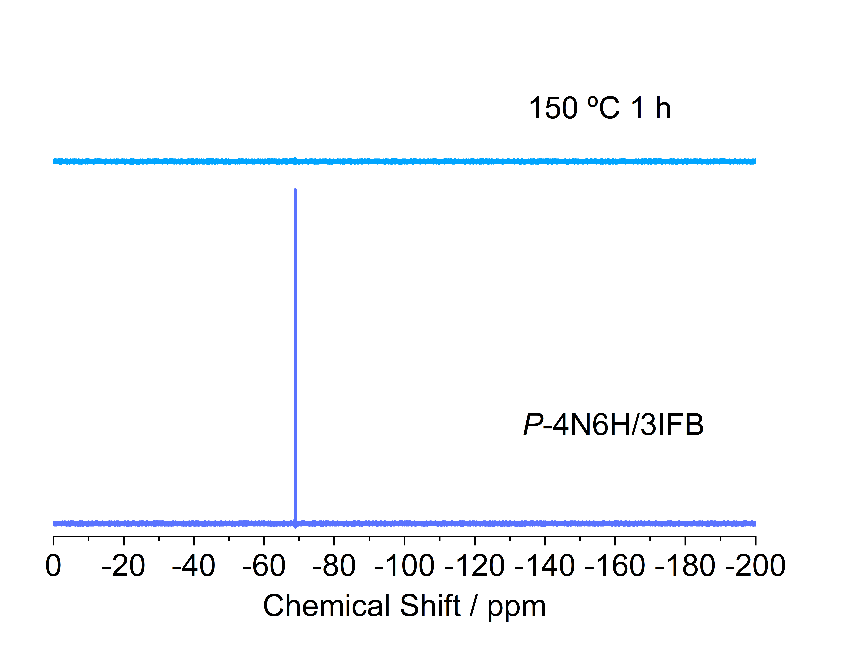
Figure S23. ¹⁹F NMR spectra of P-4N6H/3IFB cocrystal before and after heating at 150 °C for 1 h (470 MHz, CDCl₃, 298 K). It appeared that 3IFB was completely removed after the heating treatment.

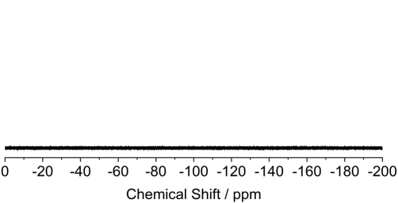
Figure S24. ¹⁹F NMR spectrum of the sample obtained after heating the P-4N6H/1,4-2IFB cocrystal at 60 °C under vacuum for 2 h (470 MHz, CDCl₃, 298 K). It appeared that 1,4-2IFB was completely removed after the vacuum–heating treatment.

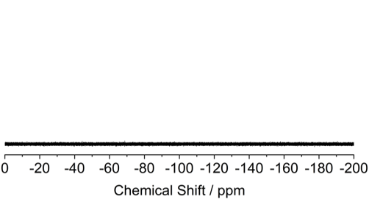
Figure S25. ¹⁹F NMR spectrum of the sample obtained after heating the P-4N6H/1,2-2IFB cocrystal at 95 °C under vacuum for 2 h (470 MHz, CDCl₃, 298 K). It appeared that 1,2-2IFB was completely removed after the vacuum–heating treatment.

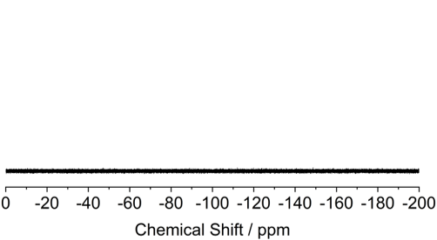
Figure S26. ¹⁹F NMR spectrum of the sample obtained after heating P-4N6H/3IFB cocrystal at 105 °C under vacuum for 2 h (470 MHz, CDCl₃, 298 K). It appeared that 3IFB was completely removed after the vacuum–heating treatment.

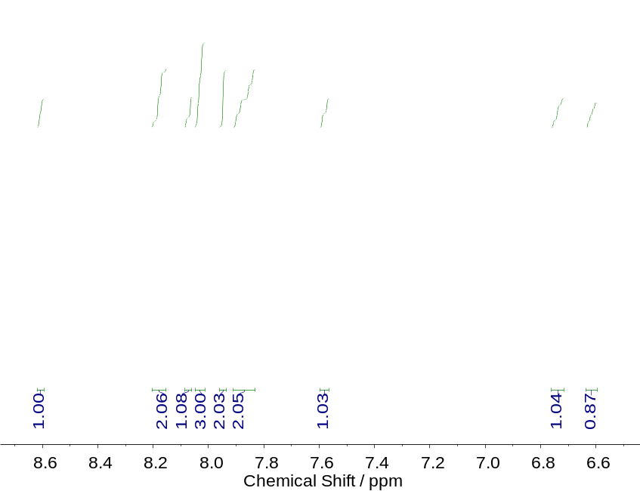
Figure S27. ¹H NMR spectrum of the sample obtained after heating P-4N6H/1,4-2IFB cocrystal at 60 °C under vacuum for 2 h (500 MHz, CDCl₃, 298 K). The spectrum is corresponding to pure P-4N6H.

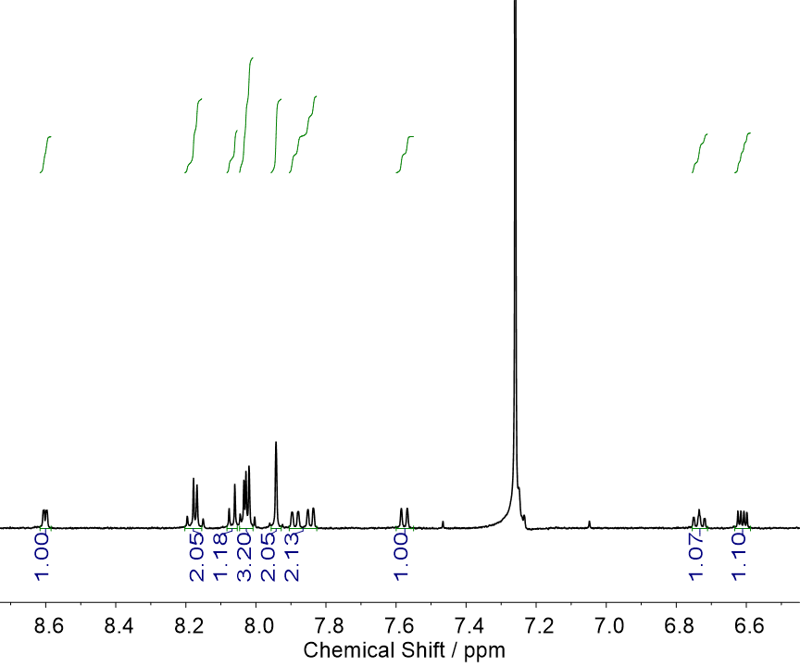
Figure S28. ¹H NMR spectrum of the sample obtained after heating P-4N6H/1,2-2IFB cocrystal at 95 °C under vacuum for 2 h (500 MHz, CDCl₃, 298 K). The spectrum is corresponding to pure P-4N6H.

Figure S29. ¹H NMR spectrum of the sample obtained after heating P-4N6H/3IFB cocrystal at 105 °C under vacuum for 2 h (500 MHz, CDCl₃, 298 K). The spectrum is corresponding to pure P-4N6H.

Figure S30. CD and corresponding UV-vis spectra of P-4N6H/1,4-2IFB cocrystal (a), P-4N6H/1,2-2IFB cocrystal (b), P-4N6H/3IFB cocrystal (c) before and after the removal of the halides.

Figure S31. (a) SEM images of P-4N6H/1,4-2IFB cocrystal before and after the removal of 1,4-2IFB. (b) SEM images of P-4N6H/1,2-2IFB cocrystal before and after the removal of 1,2-2IFB.

Figure S32. SEM images of P-4N6H/3IFB cocrystal before and after heating at 150 °C for 1 h.

Figure S33. Polarizing microscope photograph of P-4N6H/3IFB cocrystal after heating at 105 °C under vacuum for 1 h. Single crystal X-ray diffraction tests showed that the yellow region was dominated by P-4N6H/3IFB cocrystal and the gray region was mainly P-4N6H crystal.

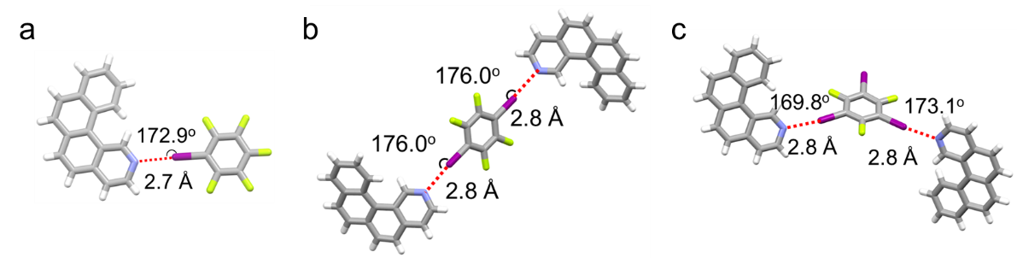
Figure S34. Illustration of C–I···N halogen bonds formed by 2N4H with 1IFB (a), 1,4-2IFB (b) and 3IFB (c) in the cocrystals.

Figure S35. DSC and TGA curves of 2N4H crystal. The crystal was grown by diffusion of n-hexane vapor into an acetone solution of 2N4H.

Figure S36. TGA curves of 2N4H/1IFB cocrystal (a), 2N4H/1,4-2IFB cocrystal (b) and 2N4H/3IFB cocrystal (c). The cocrystals were grown by diffusion of n-hexane vapor in acetone solutions of the corresponding molecules.

Figure S37. ¹⁹F NMR spectrum of the sample obtained after heating 2N4H/1IFB cocrystal at 30 °C under vacuum for 5 h (470 MHz, CDCl₃, 298 K). It appeared that 1IFB was completely removed.

Figure S38. ¹⁹F NMR spectrum of the sample obtained after heating 2N4H/1IFB cocrystal at 40 °C under vacuum for 1 h (470 MHz, CDCl₃, 298 K). It appeared that 1IFB was completely removed.

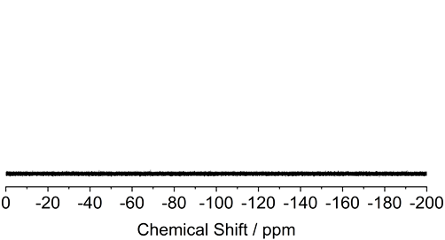
Figure S39. ¹⁹F NMR spectrum of the sample obtained after heating 2N4H/1,4-2IFB cocrystal at 95 °C under vacuum for 1 h (470 MHz, CDCl₃, 298 K). It appeared that 1,4-2IFB was completely removed.

Figure S40. ¹⁹F NMR spectrum of the sample obtained after heating 2N4H/3IFB cocrystal at 105 °C under vacuum for 1 h (470 MHz, CDCl₃, 298 K). It appeared that 3IFB was completely removed.

Figure S41. ¹H NMR spectrum of the sample obtained after heating 2N4H/1IFB cocrystal at 40 °C under vacuum for 1 h (500 MHz, CDCl₃, 298 K). The spectrum is corresponding to pure 2N4H.

Figure S42. ¹H NMR spectrum of the sample obtained after heating 2N4H/1,4-2IFB cocrystal at 95 °C under vacuum for 1 h (500 MHz, CDCl₃, 298 K). The spectrum is corresponding to pure 2N4H.

Figure S43. ¹H NMR spectrum of the sample obtained after heating 2N4H/3IFB cocrystal at 105 °C under vacuum for 1 h (500 MHz, CDCl₃, 298 K). The spectrum is corresponding to pure 2N4H.

Figure S44. Optical microscope images of 2N4H/1IFB cocrystal (a) and that after heating at 40 °C under vacuum for 1 h (b).

Figure S45. (a) SEM images of 2N4H/1,4-2IFB cocrystal and the sample formed after heating at 95 °C under vacuum for 1 h. (b) SEM images of 2N4H/3IFB cocrystal and the sample formed after heating at 105 °C under vacuum for 1 h.

Figure S46. UV-vis spectra of 2N4H/1IFB cocrystal and the derived samples with positive and negative CD signals (280~400 nm) obtained by heating at 40 °C under vacuum for 1 h.
Figure S47. XRD patterns of 2N4H/1IFB cocrystal upon heating at 40 °C under vacuum over various periods.

Figure S48. (a) Molecular structures of 2N4H and 1I24FB. (b) XRD patterns of 2N4H/1I24FB cocrystal and that formed after vacuum treatment at 50 °C for 1 h. (c) Distribution of CD signal and intensity at 330 nm for 10 parallel batches of aggregates obtained from 2N4H/1I24FB cocrystals after the vacuum–heating treatment. (d) CD spectra of 2N4H/1I24FB cocrystals after vacuum treatment at 50 °C for 1 h.

Figure S49. CD and corresponding UV-vis spectra of 2N4H crystal (a) and a physically blended mixture of 2N4H and 1IFB (b) after heating at 40 °C under vacuum for 1 h.

Figure S50. CD and corresponding UV-vis spectra of 2N4H/1IFB cocrystal after vacuum–heating treatment at different temperatures.

Figure S51. XRD patterns of 2N4H/1IFB cocrystal after vacuum heating for 1 h at different temperatures.

Figure S52. CD and corresponding UV-vis spectra of 2N4H/1,4-2IFB cocrystal before (a) and after (b) heating at 95 °C under vacuum for 1 h.

Figure S53. CD and corresponding UV-vis spectra of 2N4H/3IFB cocrystal before (a) and after (b) vacuum heating at 105 °C for 1 h.

Figure S54. (a) Optical microscope images of one 2N4H/1IFB cocrystal and CD spectrum of the derived sample formed after heating at 40 °C under vacuum for 1 h. (b) Optical microscope images of scattered 2N4H/1IFB cocrystals and CD spectrum of the derived sample formed after heating at 40 °C under vacuum for 1 h.

Figure S55. SEM images of the 2N4H/1IFB cocrystal doped with 0.01 eq. of P-4N6H and after heating at 40 °C under vacuum for 1 h.

Figure S56. UV-vis spectra of the samples of 0.01 eq. of P-4N6H and M-4N6H, and the samples derived from the 2N4H/1IFB cocrystal doped with 0.01 eq. of P-4N6H and M-4N6H, respectively, after heating at 40 °C under vacuum for 1 h.

3 Theoretical Calculations
Cartesian coordinates of the optimized geometries (in Å)
P-2N4H
a = 5.624000; b = 14.152000; c = 7.453500
α = 90.000°; β = 105.351°; γ = 90.000°

C 0.621302 0.515875 0.785301
C 0.934845 0.456077 0.052917
C 0.743782 0.467918 0.667411
H 0.655904 0.469181 0.519753
C 0.734480 0.520712 0.978236
C 0.638699 0.586875 0.086398
C 0.962996 0.422801 0.735444
H 0.058564 0.389558 0.643414
C 0.056396 0.411128 0.932264
C 0.280538 0.613464 0.819076
H 0.103686 0.646783 0.761463
C 0.008423 0.427802 0.241625
H 0.905887 0.452032 0.336790
C 0.685261 0.686393 0.359449
H 0.796653 0.714586 0.489149
C 0.403276 0.628262 0.009473
C 0.391379 0.561362 0.709619
H 0.310356 0.555509 0.561624
C 0.258978 0.352811 0.010505
H 0.359121 0.319633 0.922284
C 0.442466 0.718682 0.291779
H 0.368467 0.768592 0.372218
C 0.303521 0.690893 0.119231
H 0.123021 0.720987 0.060131
N 0.195366 0.370829 0.312883
C 0.324273 0.336251 0.198800
H 0.478659 0.290857 0.260904
C 0.780035 0.620437 0.262282
H 0.966240 0.595484 0.316920
C 0.378695 0.015880 0.214699
C 0.065157 0.956081 0.947085
C 0.256208 0.967924 0.332585
H 0.344097 0.969188 0.480247
C 0.265513 0.020717 0.021760
C 0.361294 0.086878 0.913601
C 0.037016 0.922806 0.264555
H 0.941443 0.889561 0.356588
C 0.943602 0.911129 0.067735
C 0.719452 0.113469 0.180921
H 0.896314 0.146791 0.238529
C 0.991574 0.927803 0.758373
H 0.094109 0.952035 0.663209
C 0.314722 0.186399 0.640549
H 0.203327 0.214593 0.510845
C 0.596718 0.128268 0.990521
C 0.608624 0.061368 0.290373
H 0.689644 0.055517 0.438373
C 0.741037 0.852810 0.989498
H 0.640893 0.819630 0.077722
C 0.557522 0.218688 0.708211
H 0.631515 0.268598 0.627772
C 0.696472 0.190897 0.880762
H 0.876975 0.220992 0.939862
N 0.804643 0.870828 0.687122
C 0.675738 0.836247 0.801205
H 0.521360 0.790849 0.739103
C 0.219950 0.120444 0.737714
H 0.033747 0.095489 0.683078

Figure S57. Supercell with 27 molecules of 2N4H. The central 2N4H molecule is shown in a ball-and-bond mode and the rest peripheral 2N4H molecules are shown in a wireframe mode.

Figure S58. Calculated UV-vis absorption spectrum of P-2N4H. Calculated excitation energies and oscillator strengths f are displayed as stick spectrum.

Figure S59. Calculated ECD spectrum of P-2N4H. Calculated excitation energies and rotatory strengths R_{vel} are displayed as stick spectrum.

Table S9. Selected dominant excitations and occupied (occ) – unoccupied (unocc) MO pair contributions (greater than 10%) of P-2N4H.
Excitation | E (eV) | λ (nm) | f | R_{vel} (10⁻⁴⁰ in cgs) | occ no. | unocc no. | %
1 | 3.72 | 334 | 0.0130 | −3.6 | 60 | 61 | 44.9
 |  |  |  |  | 60 | 62 | 25.8
 |  |  |  |  | 59 | 61 | 20.6
2 | 3.87 | 320 | 0.0164 | −17.8 | 60 | 61 | 42.9
 |  |  |  |  | 60 | 62 | 26.7
 |  |  |  |  | 59 | 61 | 24.3
3 | 4.34 | 286 | 0.0697 | 125.3 | 58 | 61 | 73.0
4 | 4.55 | 272 | 0.6392 | 24.5 | 59 | 61 | 43.3
 |  |  |  |  | 60 | 62 | 31.7
 |  |  |  |  | 58 | 61 | 12.4
5 | 4.63 | 268 | 0.1360 | −104.2 | 59 | 62 | 74.1
6 | 4.78 | 260 | 0.0326 | −60.7 | 58 | 62 | 81.7
7 | 4.85 | 255 | 0.0528 | 24.7 | 60 | 63 | 46.2
8 | 4.88 | 254 | 0.0090 | 2.8 | 60 | 63 | 24.3
 |  |  |  |  | 60 | 64 | 23.5
 |  |  |  |  | 56 | 61 | 11.4
 |  |  |  |  | 59 | 63 | 11.2
9 | 5.08 | 244 | 0.0488 | 57.8 | 57 | 61 | 72.9
10 | 5.26 | 236 | 0.0664 | 14.6 | 59 | 63 | 35.1
 |  |  |  |  | 57 | 62 | 31.1
 |  |  |  |  | 60 | 64 | 16.3
 |  |  |  |  | 56 | 61 | 12.9

MO64 | MO63 | MO62
−0.12 eV | −0.39 eV | −1.32 eV
 |  | 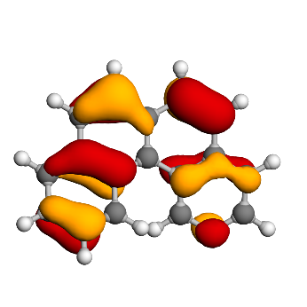
MO61 (LUMO) | MO60 (HOMO) | MO59
−1.62 eV | −6.13 eV | −6.55 eV
MO58 | MO57 | MO56
−7.23 eV | −7.51 eV | −7.82 eV

Figure S60. Isosurfaces of MOs involved in the selected transitions of P-2N4H.

4 References
S1. Mendola, D. et al. Aza[6]helicene platinum complexes: chirality control of cis–trans isomerism. Angew. Chem. Int. Ed. 53, 5786–5790 (2014).
S2. Hewlins, M. J. E. & Salter, R. The photochemical cyclodehydrogenation route to polycyclic azaarenes. Synthesis 14, 2164–2174 (2007).

