Appendix A
Below is the Likert scale survey which was filled out by the observers during the duration of the study, with questions adapted from Greenleaf and Berger and colleagues (Greenleaf, 2018; Berger et al., 2016).
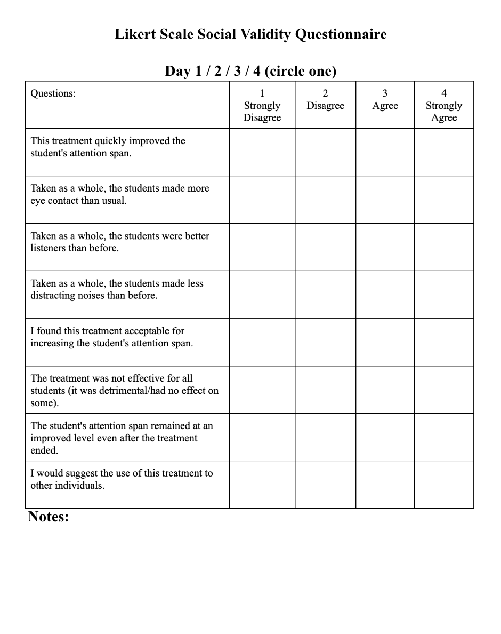
Figure A1. The Likert scale survey.

Appendix B
A redacted portion of the Informed Consent Form signed by the participants and observers who participated in my study.
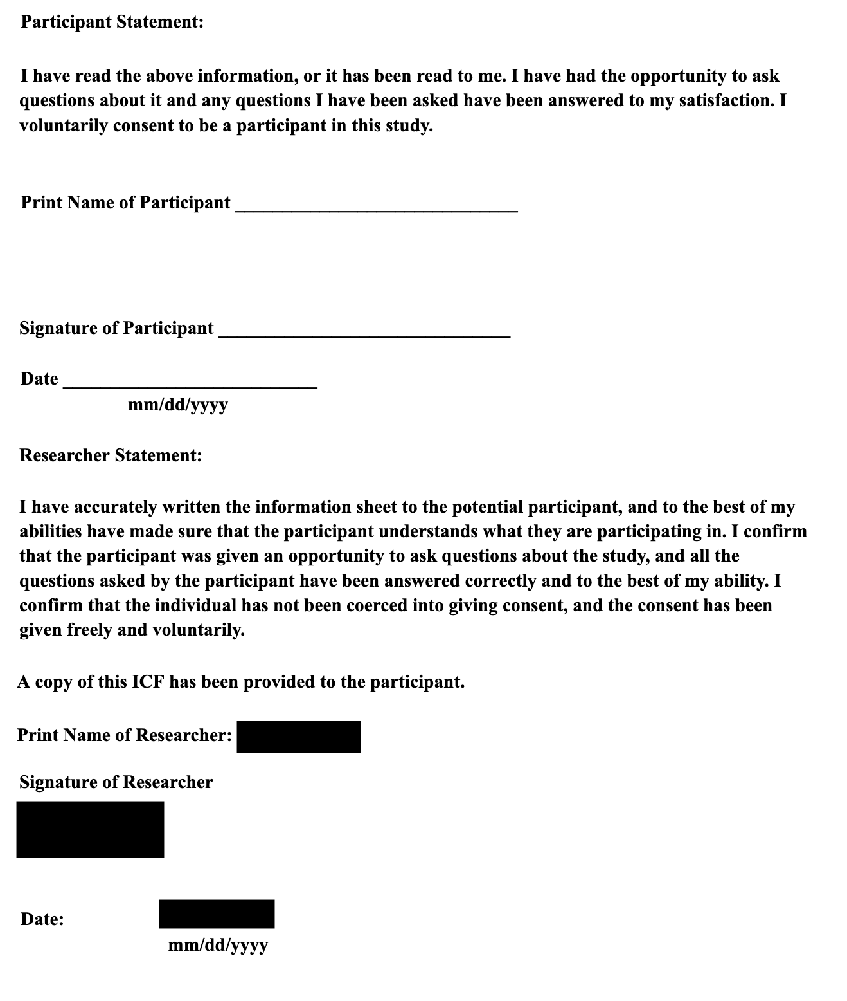
Figure B1. The informed Consent Form.

Appendix C
Below are the Likert scale responses of the observers on all three days
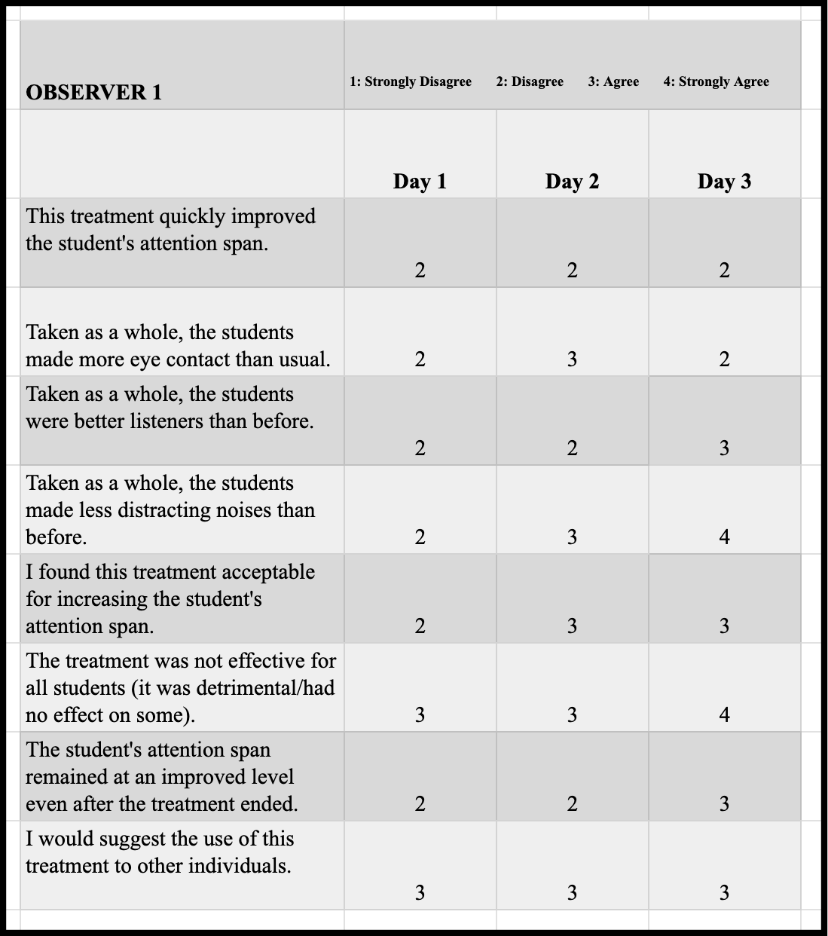
Figure C1. The Likert scale responses for Observer 1.

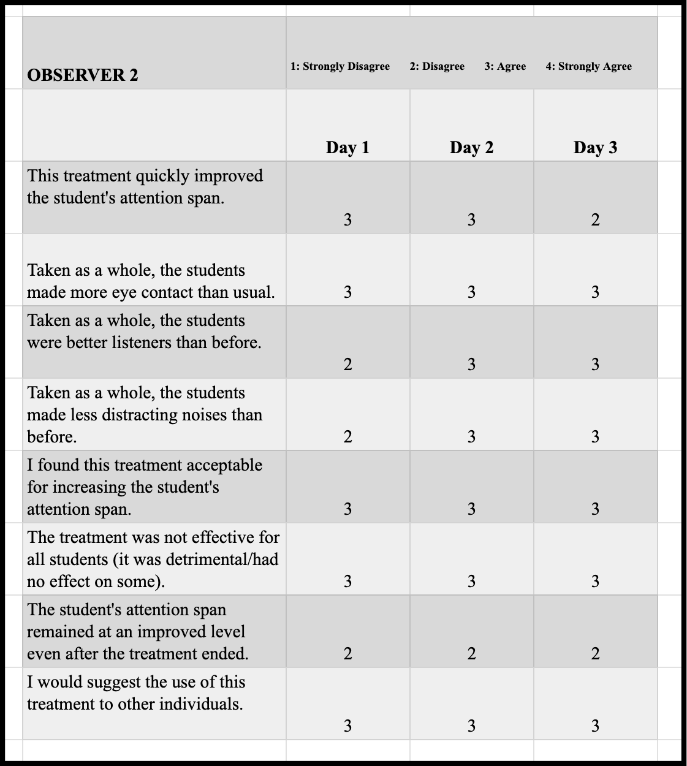
Figure C2. The Likert scale responses for Observer 2.
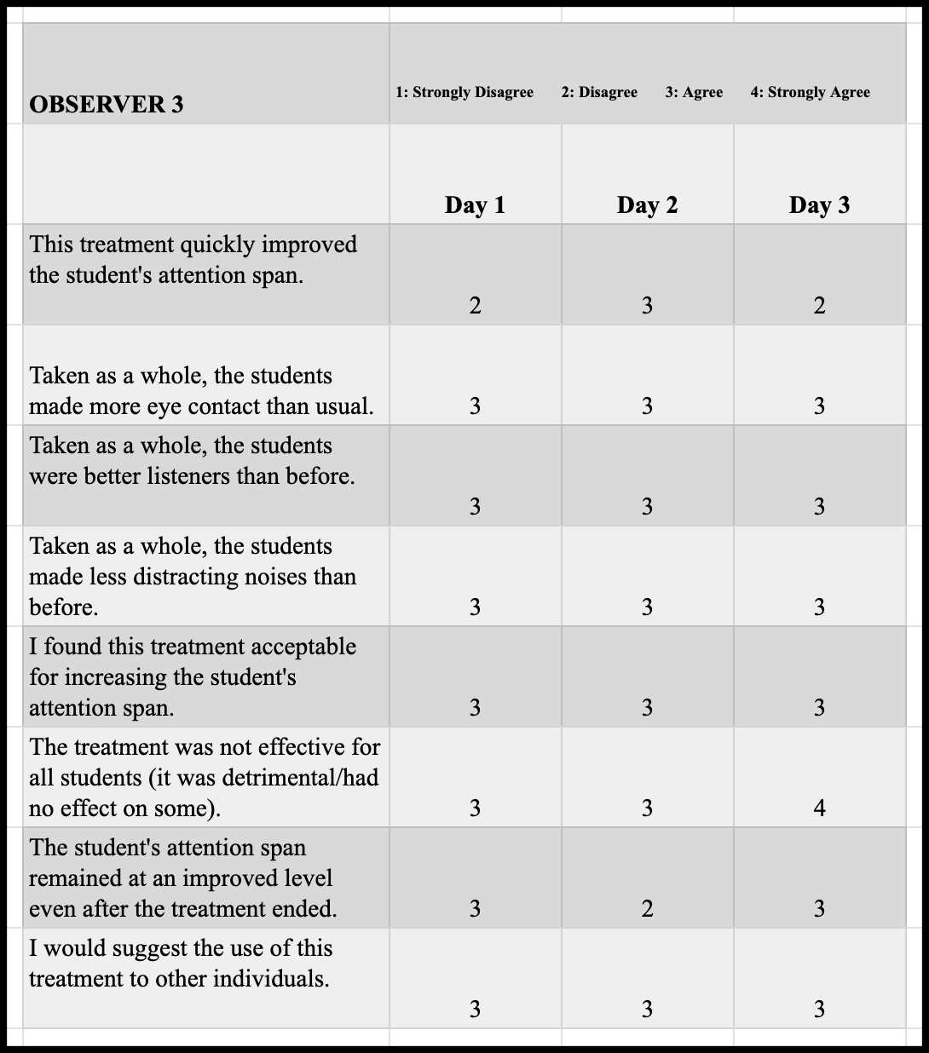
Figure C3. The Likert scale responses for Observer 3.

Appendix D
In addition to the Likert scale survey, the observers were given the option to make any qualitative observations of the teenagers during both the control and intervention stage. These results can be summarized below in figure D1.

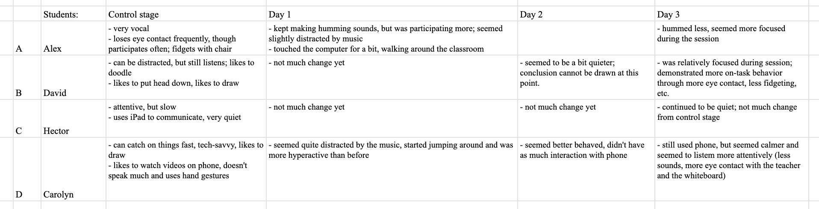
Figure D1. The qualitative observations made by the observers.

