- Supplementary information
  - Design of IUP compound to form artificial water channel by self-assemble
Inspired by the structure of the Aquaporin Water Channel (AQP) based on the results from the available literatures, we first intended to design a kind of imidazole-quartet (I-quartet) artificial water channels (AWC) due to its easy preparation procedure, significant water/proton permeabilities and the ability to interact with the polyamide (PA) layer by hydrogen bond, which has the potential to realize seamless incorporation of AWC in defect-free PA membranes. We noted that the supramolecular organization of alkylureido-ethylimidazole compounds forms I-quartet AWCs. However, we found that alkylureido-ethylimidazole compounds have poor water solubility. This makes it difficult for us to directly dissolve these compounds in water to obtain AWCs. To form a water channel, alkylureido-ethylimidazole compounds should be first dissolved in an ethanolic solution and then water needs to be added to the ethanolic solution to form AWCs. The formation of AWC was sensitive to the ethanol/water ratio. Furthermore, the addition of ethanol makes the incorporation of AWC into the PA layer complicated, and it was difficult to regulate the preparation of the AWC-PA membrane by interfacial polymerization (IP) of an amine monomer [e.g., m-phenylenediamine (MPD)] and an acyl chloride monomer [e.g., trimesoyl chloride (TMC)] at the interface of an aqueous solution and an organic solution. In addition, the addition of ethanol increases the probability of defect formation during IP according to our experience.
This motivates us to systematically study the formation of AWC by the supramolecular organization of the compounds containing both urea groups and hydrophilic and hydrophobic groups on both sides. During the supramolecular organization, both the hydrophilic and hydrophobic portions on either side of the urea group in these compounds can be harmonized so that they are oriented in the same direction. After the supramolecular organization, two types of crystals may be formed. One contains water channels and the other contains no water channels. This is dependent on the length of the hydrophobic group. In order to increase the density of channels in crystal, the length of the hydrophobic portion should be shortened. However, when the hydrophobic portion is too short, the hydrophilic portion of the compound may be staggered and stacked with the hydrophilic portion, leading to the formation of crystals without water channels. In addition, the polarity of the hydrophobic group has a great effect on the formation of AWC aggregates in an aqueous solution. Taking into account the above factors, IUP compound was designed in this study, which has a moderate length of hydrophobic portion with a phenyl tail rather than an alkyl tail. The slightly stronger polarity of phenyl suggests that IUP compounds are more soluble in polar solvents and more favorable for the formation of smaller AWC aggregates. The smaller the AWC aggregates, the higher their dispersion in the PA layer. The high dispersion of small AWC aggregates is necessary to the formation of defect-free PA layers when they are incorporated into the PA layer.
We have made a series of discoveries. First, the structure of the IUP compound is favorable for the formation of nanosized AWC aggregates in pure water solution due to the effect of π-π stacking and polarity of the phenyl group. IUP can be directly dissolved in water by heating and ultrasound. Nanosized AWC aggregates were formed after cooling the IUP aqueous solution. Secondly, with the addition of sodium dodecyl sulfate (SDS), the quantities and dispersion of AWC aggregates in water solution were significantly enhanced. Then, the role of π-π stacking of phenyl groups enhances the compatibility between AWC and PA matrix. Therefore, it is favorable for seamless incorporation of AWC with relatively high density in defect-free PA membranes.
  - Materials
Histamine, phenylethyl isocyanate, m-phenylenediamine, trimesoyl chloride, sodium dodecyl sulfate, tetrahydrofuran, ethyl acetate, acetonitrile, ethanol and n-hexane were purchased from Shanghai Aladdin Bio-Chem Technology LTD. Phosphatidylcholine (PC), cholesterol (CHL), sucrose and phosphate buffer (0.01 mol/l, pH 7.2-7.4) were Shanghai Yuanye Bio-Technology Ltd. DI water was obtained from a Water Purification Systems (Heal Force Bio-meditech Holdings LTD).
  - Methods
    - Chemical synthesis
A solution of 1.245 ml of phenethyl isocyanate (9 mmol) was prepared in a mixture of 10 ml of tetrahydrofuran, 5 ml of ethyl acetate, and 10 ml of acetonitrile. The corresponding equimolar amount of histamine (9 mmol), 1.000 g, was then added to the reaction mixture, which was stirred and heated to 80°C. The reaction was then condensed and refluxed for 3 hours. As the reaction system warmed, the histamine was gradually dissolved. Upon completion of the reaction, a white precipitate (1-(2-(1H-imidazol-4-yl)ethyl)-3-phenethylurea) appeared in the flask. The solution is distilled in order to separate as many solvents as possible, and then cooled to room temperature. The white precipitate was obtained by vacuum filtration using a PTFE filter membrane and washed with hexane and filtered. The white precipitate was subjected to freeze-drying in order to remove the solvent, thereby producing a purified white powder product.
    - Membrane fabrication
TFC membrane were fabricated using traditional interface polymerization (IP) methods on microporous PSf substrates, designated as Control membrane. Specifically, a PSf substrate with a size of 10 × 13 cm² was adhered to a metal plate and then soaked in a 2 wt% MPD aqueous solution for 2 minutes. Then the surface of the PSf substrate was wiped clean with a rubber roller to remove any residual water droplets. Subsequently, a 0.1 wt% TMC n-hexane solution was poured on the membrane surface for 1 minute. Then, the n-hexane solution was poured out. Subsequently, the surface of PA was cleaned with n-hexane in order to remove any residual TMC monomers. The reaction between MPD and TMC results in the formation of an ultra-thin polyamide selective layer. The TFC membrane was then removed from the metal plate and annealed in a 60 °C oven for 5 minutes. Finally, the membrane was repeatedly washed with deionized water and stored in deionized water until required.
The aqueous solution was subjected to the addition of SDS with varying concentrations, and the preparation of SDS-PA membranes was conducted in accordance with the established IP procedure. In order to integrate AWC aggregates into the PA layer, MPD aqueous solution was added to different concentrations of IUP ethanol solution in a ratio of 5:1 (water: ethanol) to obtain AWC aggregates, and AWC-PA membrane was prepared by the above IP procedure. For AWC-SDS-PA membrane, the IUP compound was first dissolved in an aqueous solution containing 2% MPD and 0.2% SDS by heating and ultrasound. After cooling the solution to room temperature, dispersed AWC aggregates were obtained. Then the AWC-SDS-PA membrane was prepared by the above IP procedure.
For identification, we named the SDS-PA membrane, AW-PA membrane and AWC-SDS-PA membrane as SDS-x membrane, AWC-y membrane and AWC-SDS-z membrane, respectively, where x is the concentration of SDS, y is the concentration of IUP in ethanol, and z is the concentration of IUP in water.
  - Nuclear magnetic resonance (NMR)
Nuclear magnetic resonance (NMR) spectroscopy was employed to analyze the sample, utilizing a Bruker Avance III 600 MHz NMR spectrometer. The spectra were corrected using the solvent dimethyl sulfoxide-d6 (DMSO-d6) as a reference. The atomic origin of the spectral peaks was identified and the corresponding atoms and groups were designated. The sample was confirmed as IUP compound with high purity.
1-(2-(1H-Imidazol-4-yl)ethyl)-3-phenethylurea, ¹H NMR (400 MHz, DMSO-d₆) δ 7.52 (s, 2H), 7.28 (t, J = 7.6 Hz, 5H), 7.19 (d, J = 7.3 Hz, 8H), 6.77 (s, 2H), 5.93 (q, J = 6.2 Hz, 5H), 2.67 (t, J = 7.3 Hz, 5H), 2.59 (t, J = 7.1 Hz, 5H).
1-(2-(1H-Imidazol-4-yl)ethyl)-3-phenethylurea, ¹³C NMR (151 MHz, DMSO-d₆) δ 157.95, 139.74, 134.53, 128.61, 128.24, 125.91, 40.92, 36.16.
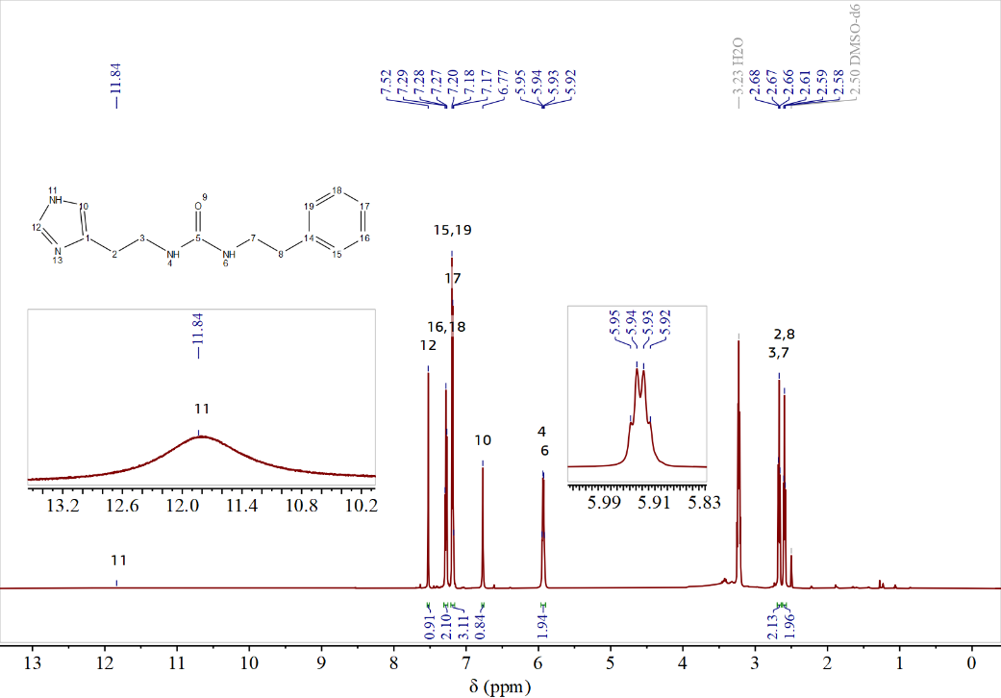
Supplementary Fig. 1 ¹H NMR spectrum of the IUP compound.

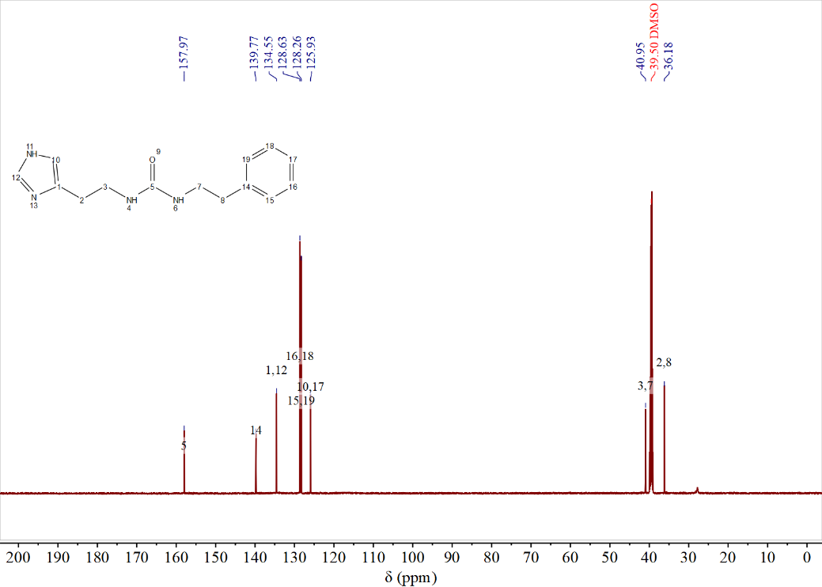
Supplementary Fig. 2 ¹³C NMR spectrum of IUP compound.
  - Single crystal X-ray diffraction（SC-XRD）
The crystals of IUP compounds were obtained via the liquid phase diffusion method in two distinct systems: an ethanol-hexane system and an ethanol-water system. These crystals were then utilized for single-crystal X-ray diffraction. A suitable crystal was selected and subjected to diffraction analysis on a Bruker D8 venture diffractometer with Cu Kα radiation (λ = 1.5418 Å). The crystal was kept at 293 K during data collection. Using Olex2 ¹, the structure was solved with the SHELXT ² structure solution program using Intrinsic Phasing and refined with the SHELXL ³ refinement package using Least Squares minimization.
The single crystal X-ray diffraction results showed that the AWC crystal structure is an I-quartet structure. All atomic displacement ellipsoids seem to fit well. Except for the IUP molecules, water molecules are present in the crystal structure. The water molecules in AWC crystal form strong H-bonds with imidazole nitrogen atoms. One 100 % occupancy H atom is bonded to imidazole N, while the other H atom is 50 % disordered over two positions (Supplementary Fig. 3).

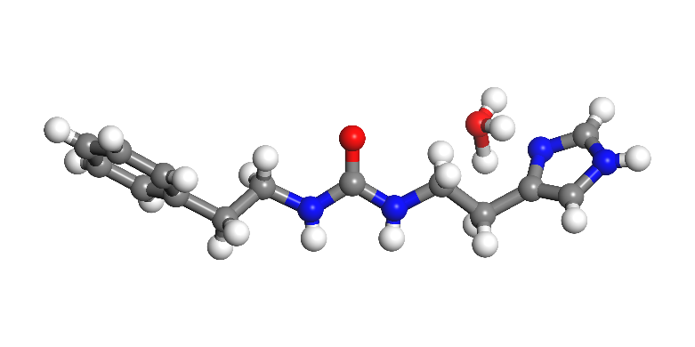
Supplementary Fig. 3 The position of hydrogen atoms in water molecule.

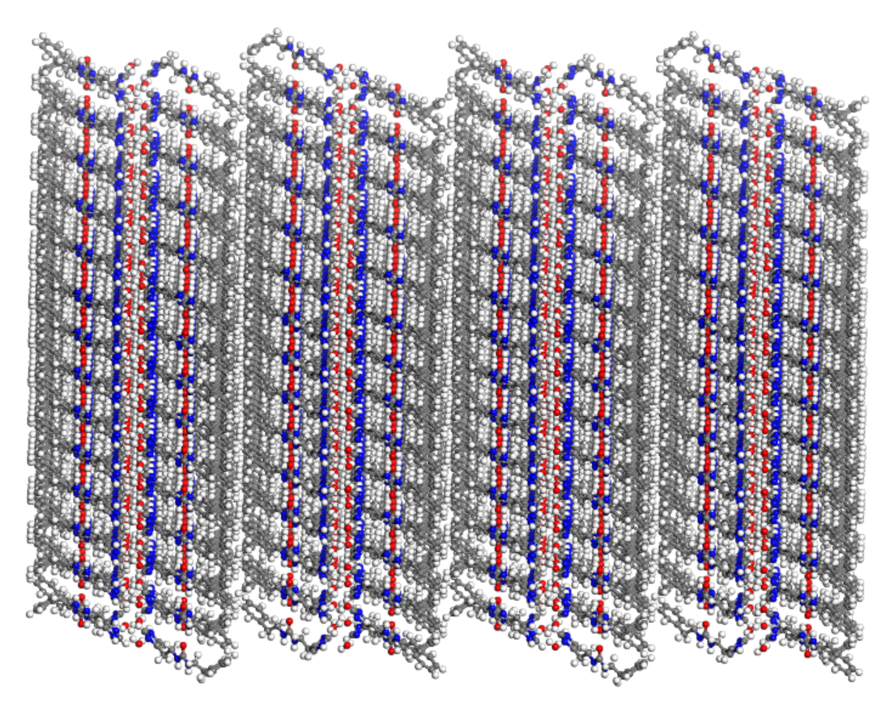
Supplementary Fig. 4 X-ray single crystal lamellar packing of I-quartet channels. (There are 960 molecules of IUP and 48 I-quartet channels within a crystal of 92.31 × 41.57 × 86.26 Å.)

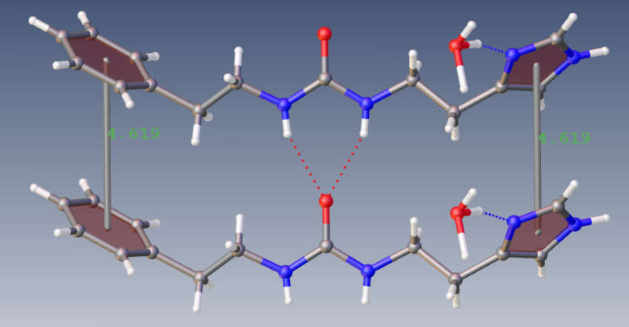
Supplementary Fig. 5 π-π stacking in AWC crystals.
π-π stacking interactions occur between phenyl groups and imidazole groups of two neighboring molecules. The centroid-centroid distance of phenyl group and imidazole group are 4.619 Å. For phenyl groups, the perpendicular distance is 3.764 Å, slippage is 2.677 Å and the displacement angle is 35.42°. For imidazole groups, the perpendicular distance is 3.429 Å, slippage is 3.096 Å and the displacement angle is 42.07°.

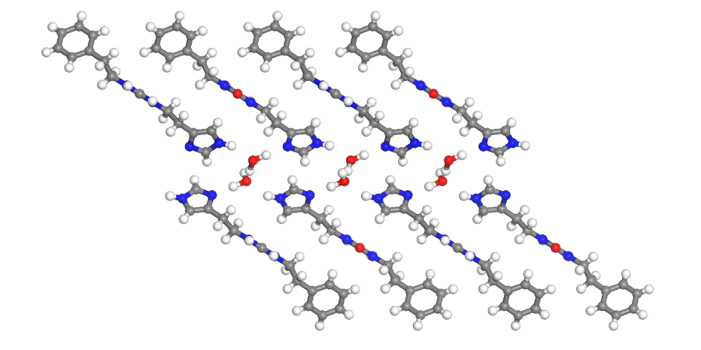
Supplementary Fig. 6 Structure of AWC crystal

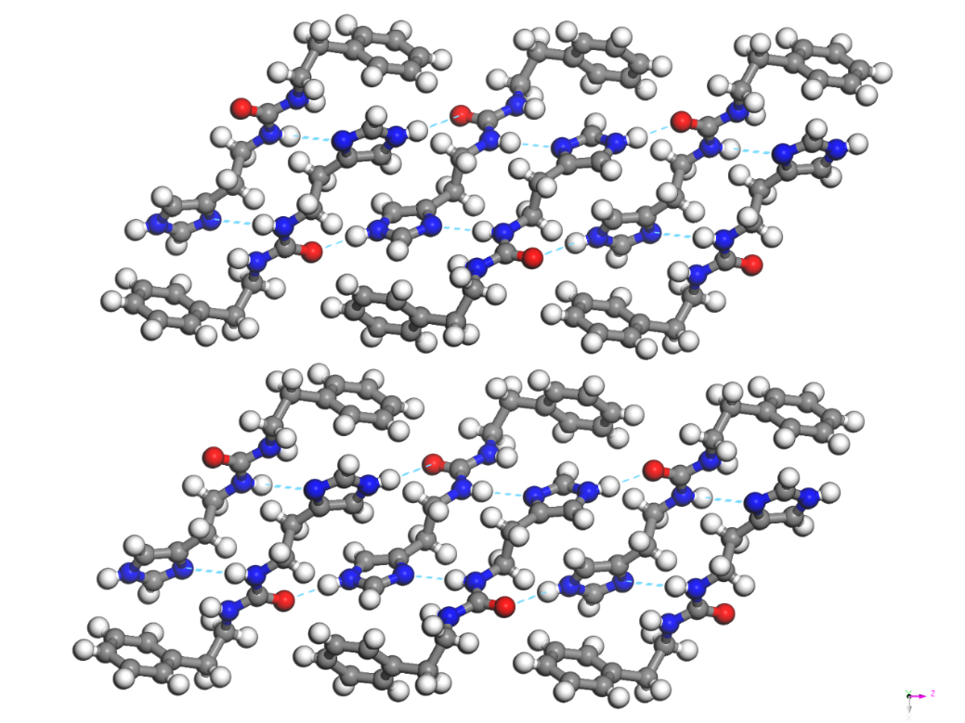
Supplementary Fig. 7 Structure of IUP crystal

Supplementary Table. 1 Crystal structure data
Name | AWC | IUP
Empirical formula | C₁₄H₂₀N₄O₂ | C₁₄H₁₈N₄O
Moiety | C₁₄H₁₈N₄O, H₂O | C₁₄H₁₈N₄O
Formula weight | 276.34 | 258.32
Temperature/K | 293(2) | 150
Crystal system | Monoclinic | monoclinic
Space group | P2₁/c | P2₁/c
a/Å | 24.1624(11) | 13.9257(3)
b/Å | 4.61940(10) | 5.68000(10)
c/Å | 14.3766(5) | 17.5128(3)
α/° | 90 | 90
β/° | 107.234(4) | 92.8520(10)
γ/° | 90 | 90
Volume/Å³ | 1532.61(10) | 1383.51(5)
Z | 4 | 4
ρ_{calc} g/cm³ | 1.198 | 1.24
μ/mm⁻¹ | 0.671 | 0.655
F(000) | 592 | 552
Radiation | Cu Kα (λ = 1.54184) | CuKα (λ = 1.54178)
2Θ range for data collection/° | 3.828 to 136.262 | 6.354 to 149.796
Index ranges | -27 ≤ h ≤ 28,  -4 ≤ k ≤ 5,  -17 ≤ l ≤ 17 | -17 ≤ h ≤ 17,  -5 ≤ k ≤ 7,  -21 ≤ l ≤ 21
Reflections collected | 10865 | 10631
Independent reflections | 2768  R_{int} = 0.0358,  R_{sigma} = 0.0382 | 2824  R_{int} = 0.0352,  R_{sigma} = 0.0427
Data/restraints/parameters | 2768/0/201 | 2824/0/172
Goodness-of-fit on F² | 1.075 | 1.112
Final R indexes [I>=2σ (I)] | R₁ = 0.0539,  wR₂ = 0.1661 | R₁ = 0.0748,  wR₂ = 0.1699
Final R indexes [all data] | R₁ = 0.0664,  wR₂ = 0.1799 | R₁ = 0.0772,  wR₂ = 0.1741
Largest diff. peak/hole / e Å⁻³ | 0.17/-0.18 | 0.46/-0.25

  - X-ray diffraction (XRD)
X-ray diffractograms of IUP powder samples and self-assembled AWC crystals were recorded using a Bruker D8 Advance diffractometer (Supplementary Fig. 8 and 9). Both samples have laminar phases. In this figures, the crystal planes corresponding to the peaks are indicated by black lines.
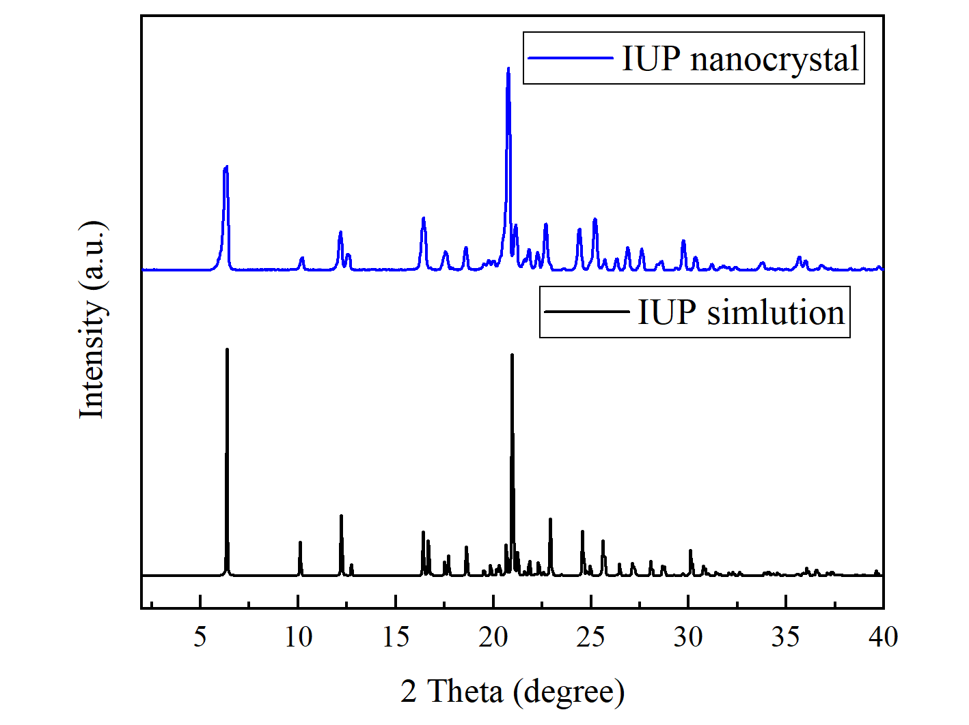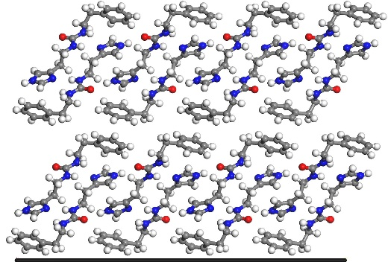
Supplementary Fig. 8 XRD pattern of IUP powder (left). The peak at 2θ of 6.36° corresponds to the crystallographic plane (1, 0, 0) (right).

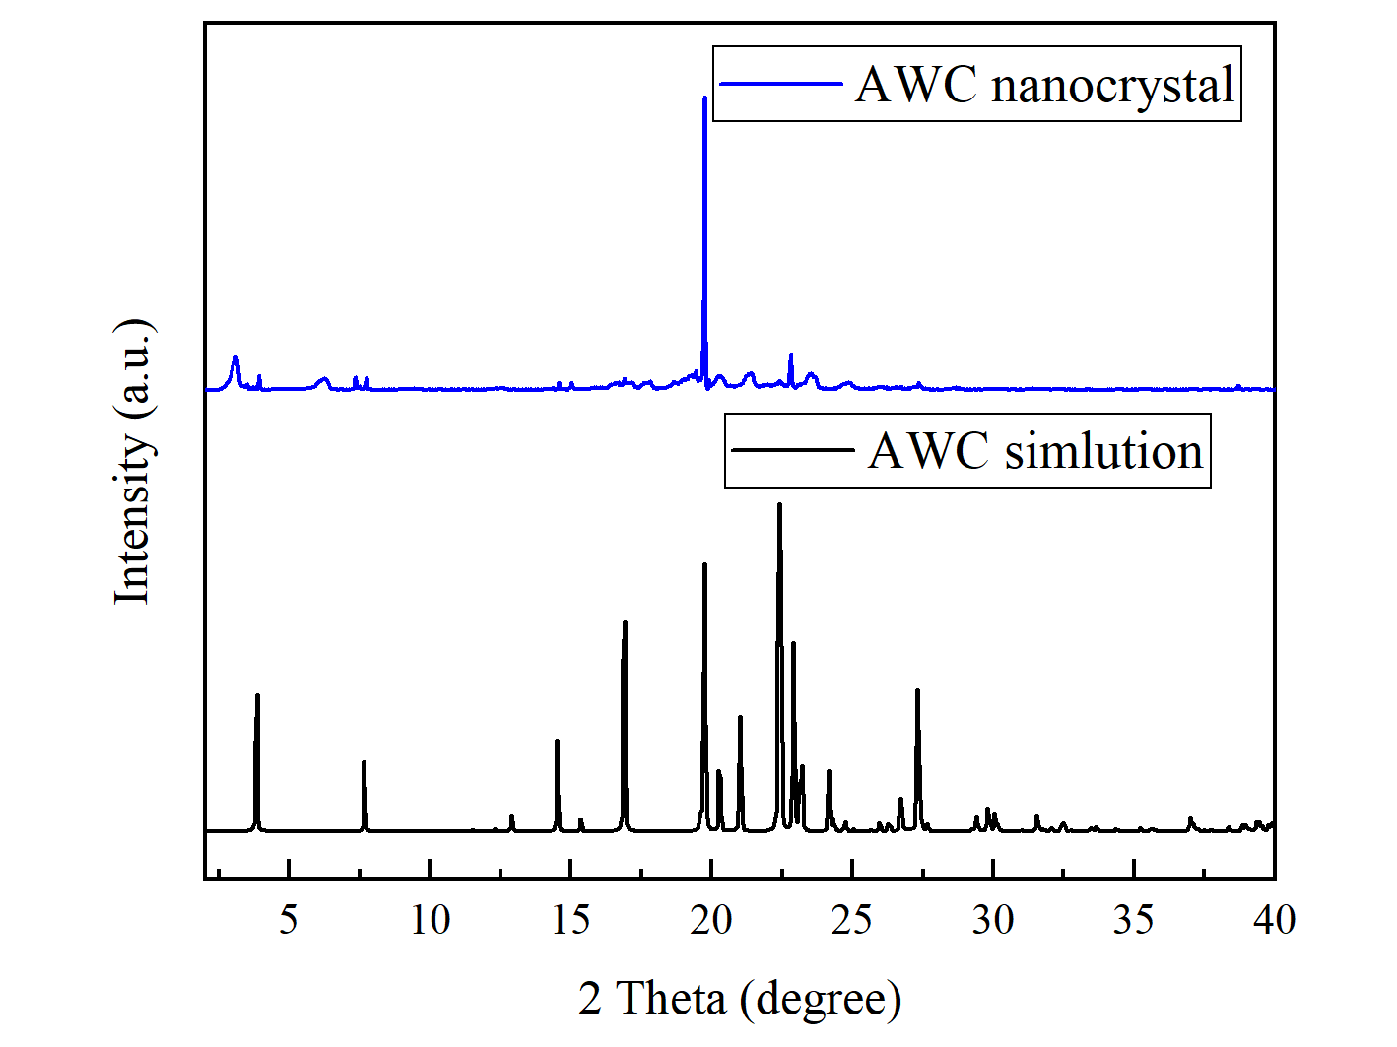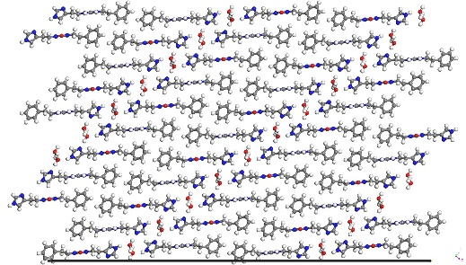
Supplementary Fig. 9 XRD pattern of AWC crystals (left). The peak at 2θ of 19.75° corresponds to the crystal plane (5, 0, -2) (right).
  - Dynamic light scattering（DLS）
By adding water to an ethanol solution of IUP molecules, IUP molecules and water molecules can self-assemble into AWC microcrystals. AWC microcrystals can also be obtained by dissolving the IUP molecules in water by heating and sonication and allowing it to cool to room temperature. The AWC microcrystals are stably dispersed in solution to form a colloidal solution that can be used for Dynamic Light Scattering (DLS) testing. Dynamic Light Scattering (DLS) testing was performed on a Nanolink S900 Nano Particle Size Analyzer using a quartz cuvette with a 10 mm square aperture at a measurement angle of 90° for DLS testing. The samples were maintained at the temperature of 25°C for 30s and then tested in the instrument. The average size was calculated using the hydrodynamic diameter (D_{h}) values obtained from at least three different measurements. Furthermore, the volume distribution of AWC aggregates was obtained. Unless otherwise specified, the D_{h} values of AWC aggregates was obtained at 5min of self-assembly.
In an ethanol-water system, the size of AWC aggregates is related to IUP concentration, self-assembly time, water/ethanol ratio, and the severity of solution mixing. The AWC aggregates increased with increasing IUP concentration and self-assembly time. However, severe mixing of water and IUP ethanol solution may reduce D_{h} values of AWC aggregates. Too many factors make it difficult to control the D_{h} values of AWC aggregates from ethanol/water solution.
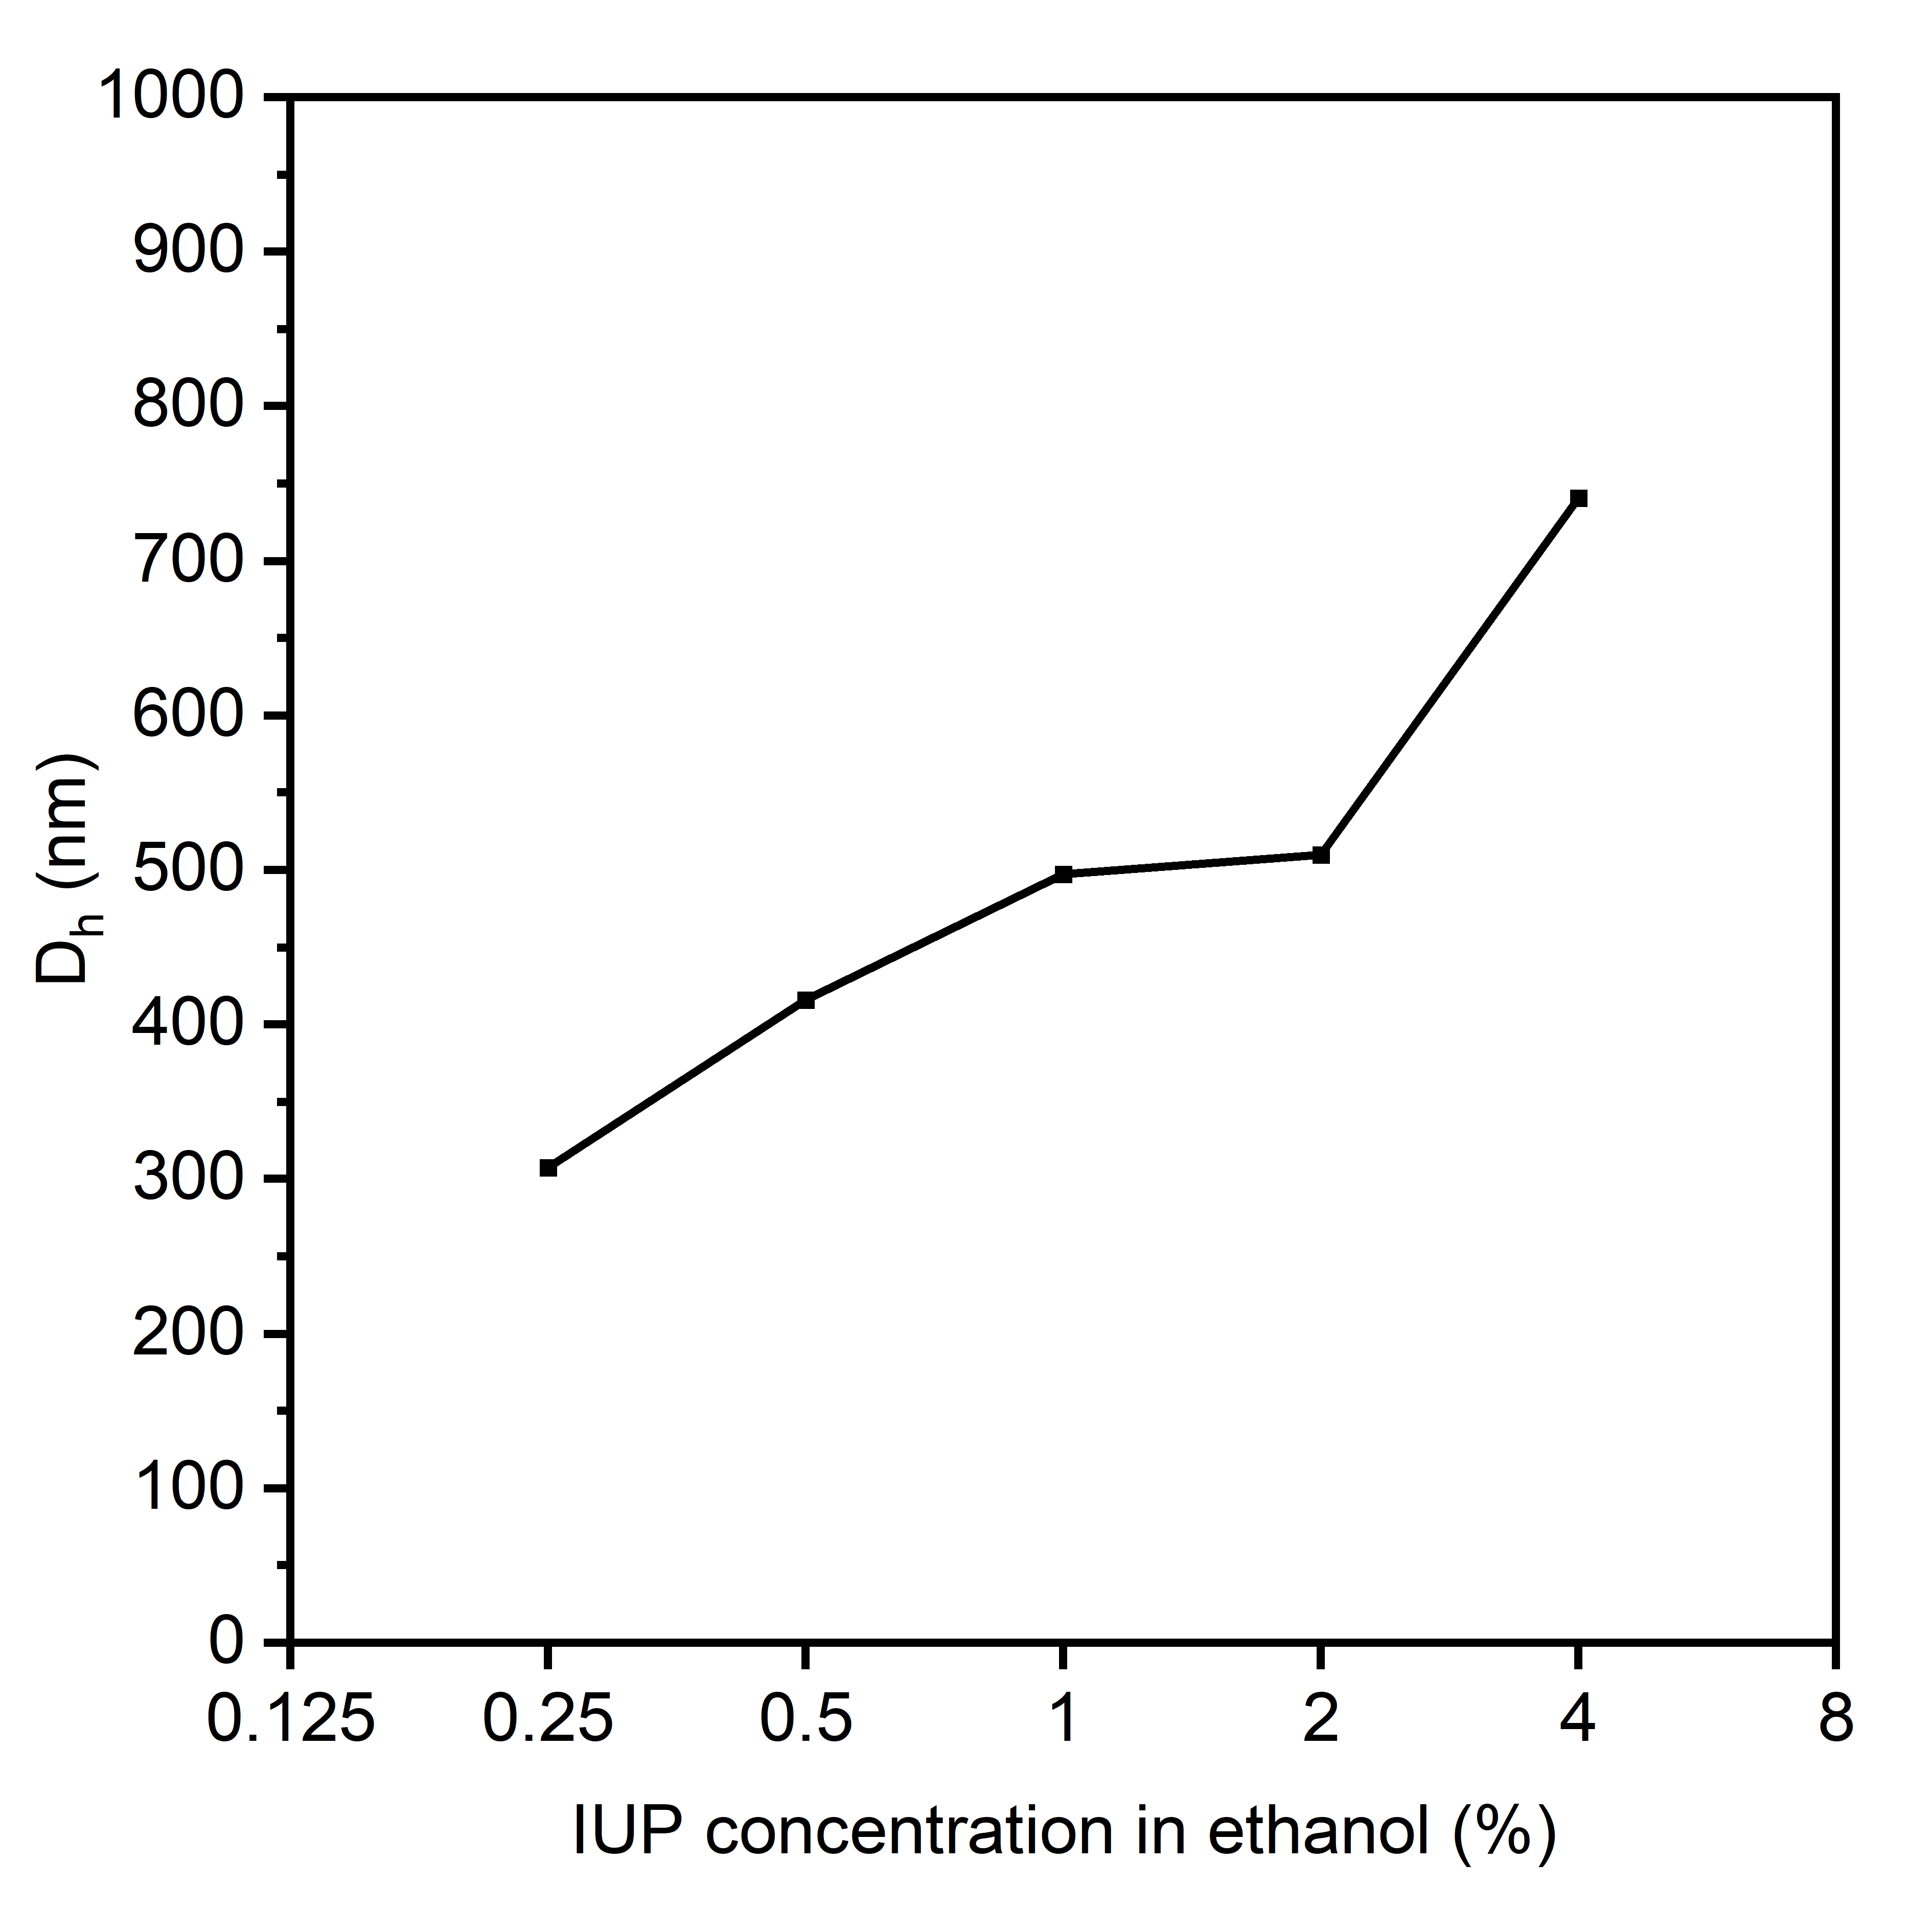
Supplementary Fig. 10 D_{h} of AWC aggregates obtained with different concentrations of IUP at water/ethanol ratio of 1.

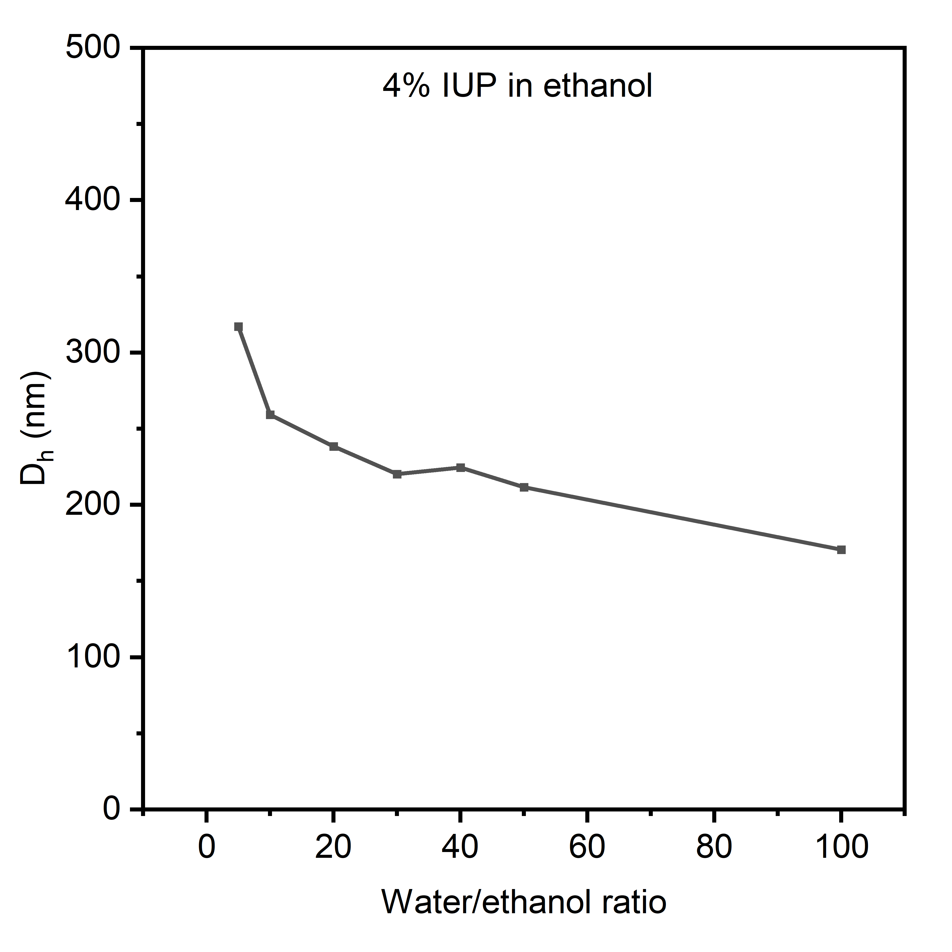
Supplementary Fig. 11 D_{h} of AWC aggregates with different water/ethanol ratios. (The IUP concentration in ethanol solution was 4%, and the water/ethanol ratio was increased from 5 to 100 by continuous water addition)

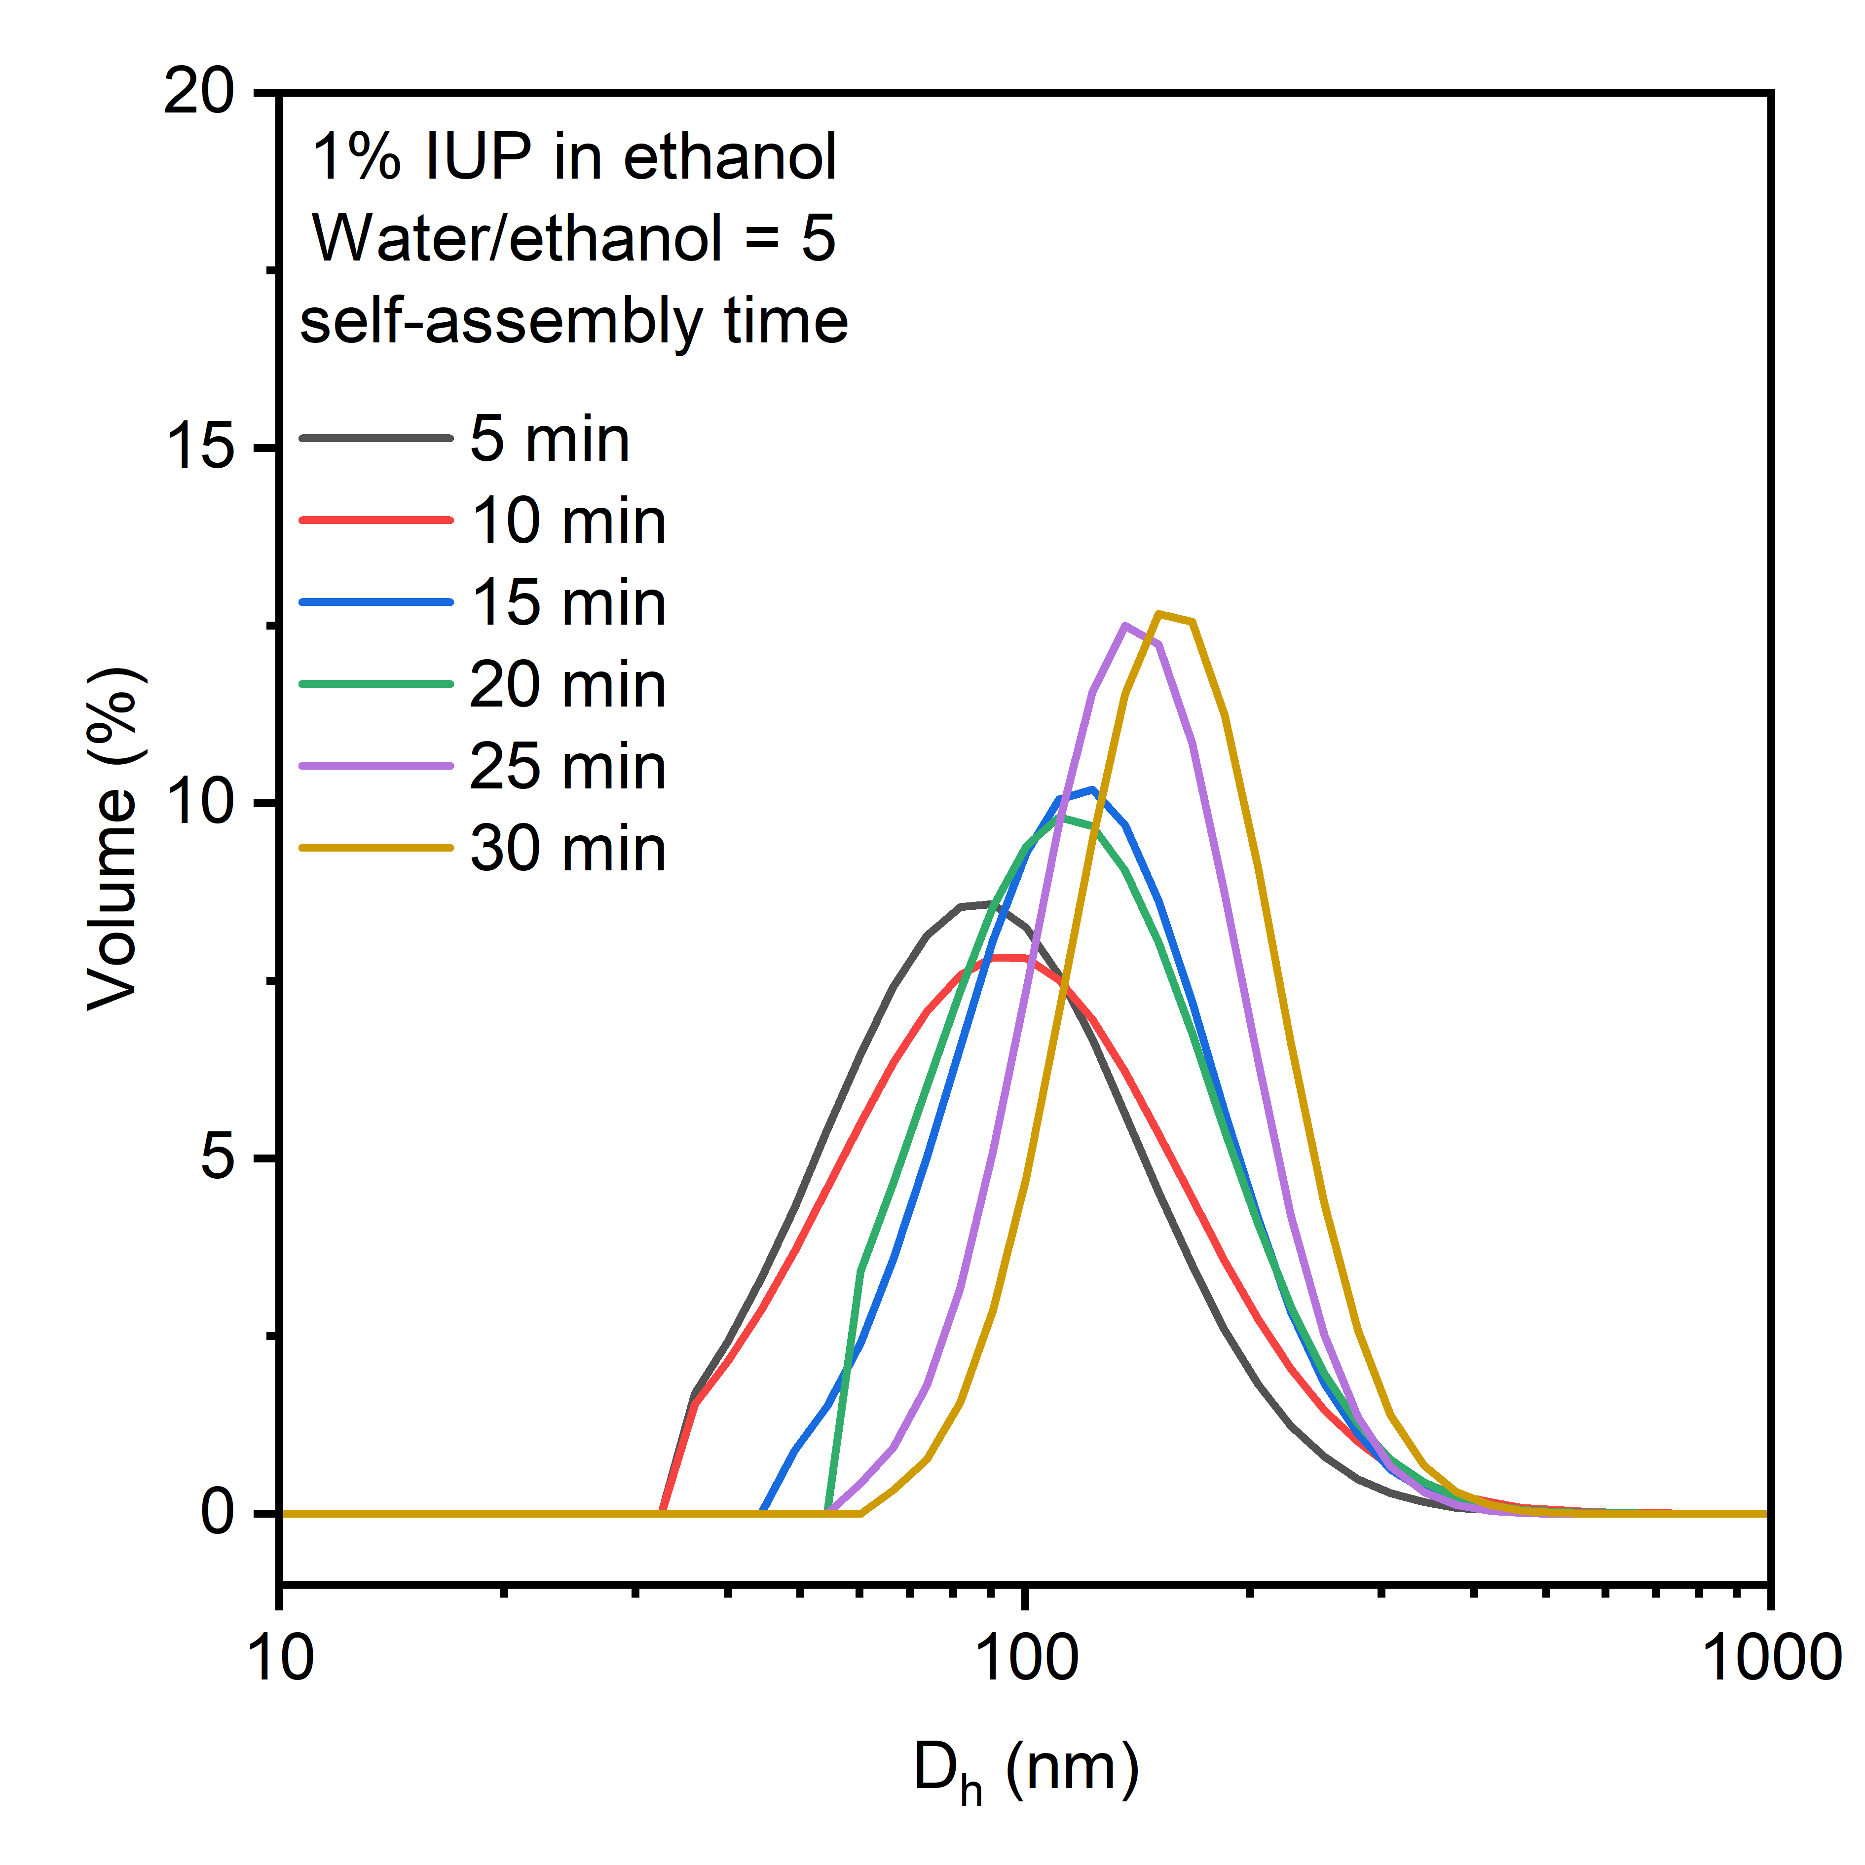
Supplementary Fig. 12 The particles size distribution of AWC aggregates obtained in ethanol/water solution for different self-assembly time (The concentration of IUP in the ethanol solution is 1%, with a water/ethanol ratio of 5.)
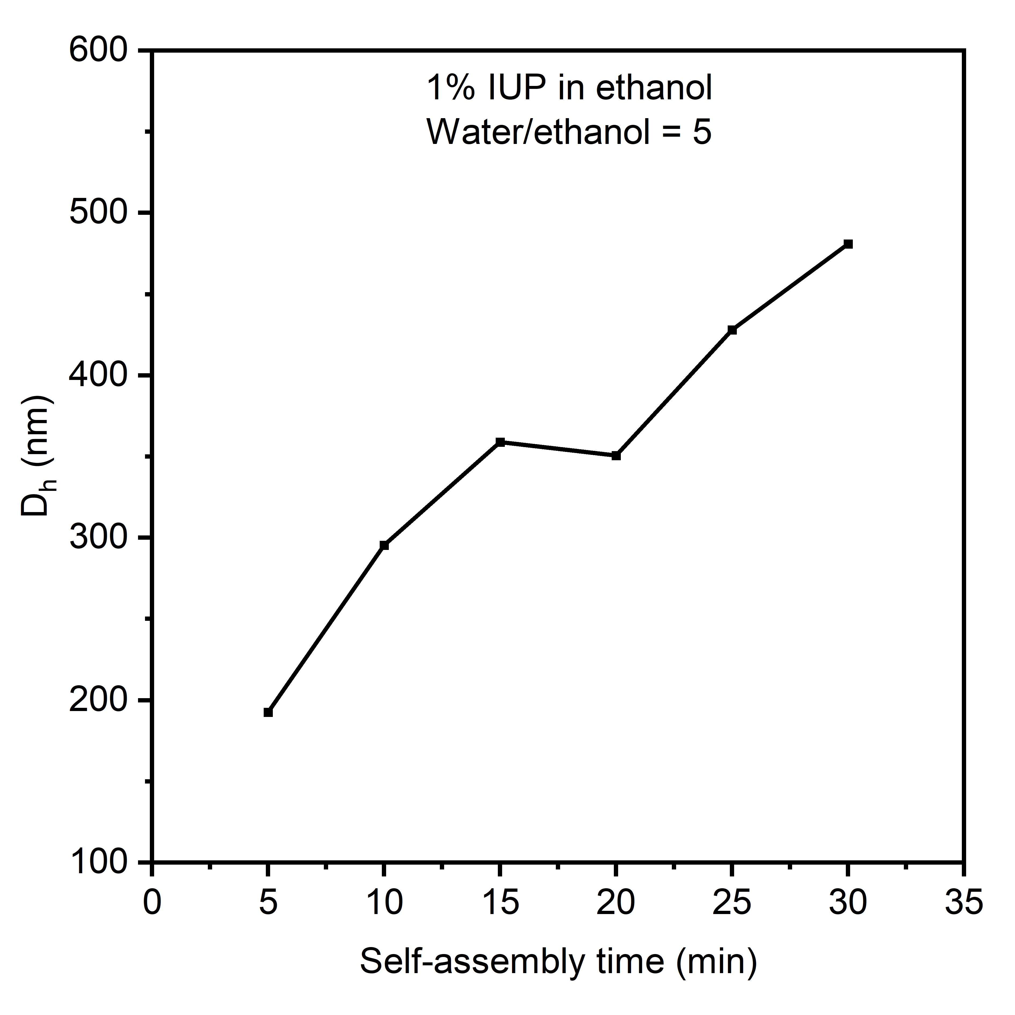
Supplementary Fig. 13 D_{h} of AWC particles obtained at different self-assembly times (The concentration of IUP in the ethanol solution is 1%, with a water/ethanol ratio of 5.)
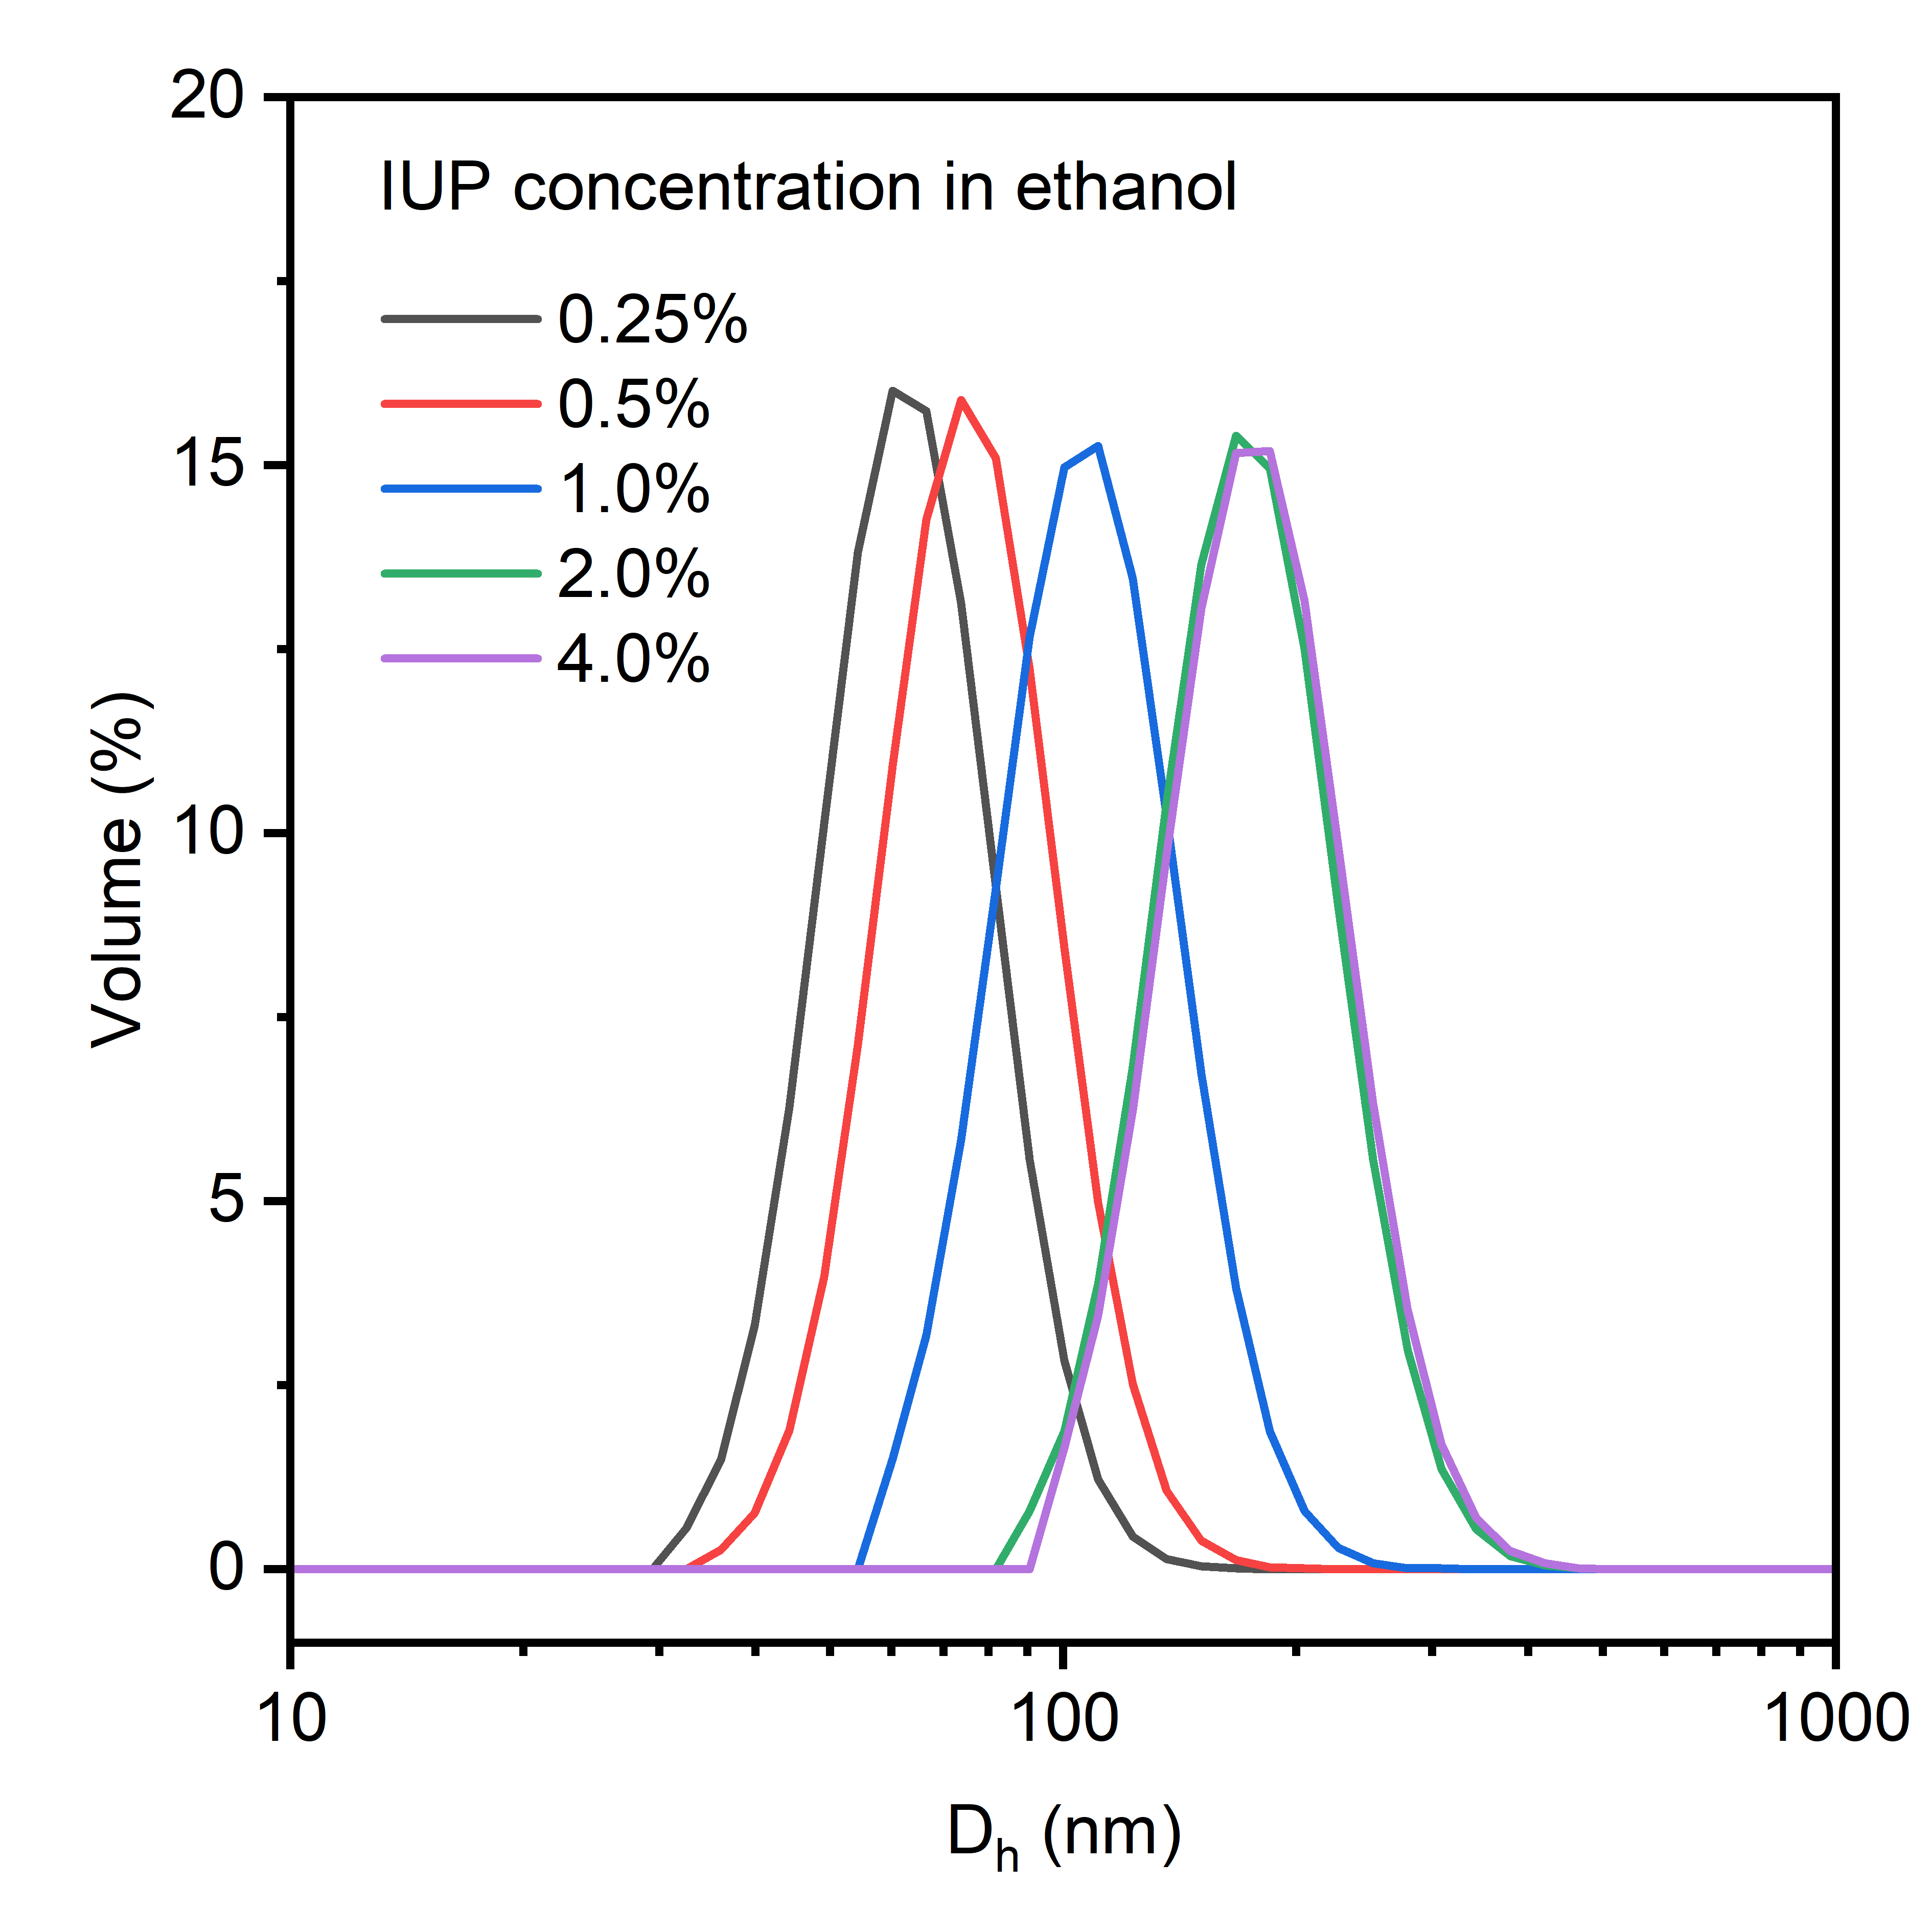
Supplementary Fig. 14 The particles size distribution of AWC aggregates obtained in ethanol/water solution by vigorous stirring with a water/ethanol ratio of 5.

  - Water transport experiments of AWC in liposomes
First, the particle size distribution of liposomes was obtained by DLS (Supplementary Fig. 15). The average particle size of the liposomes was 122.4 nm, and the polydispersity index (PI) was 0.247. Three-dimensional fluorescence scanning was performed on the liposomes (Supplementary Fig. 16). It was found that Rayleigh scattering was more pronounced within the wavelength range of 400-500 nm, and thus the wavelength of the kinetic stopped-flow light scattering tests was set at 450 nm.

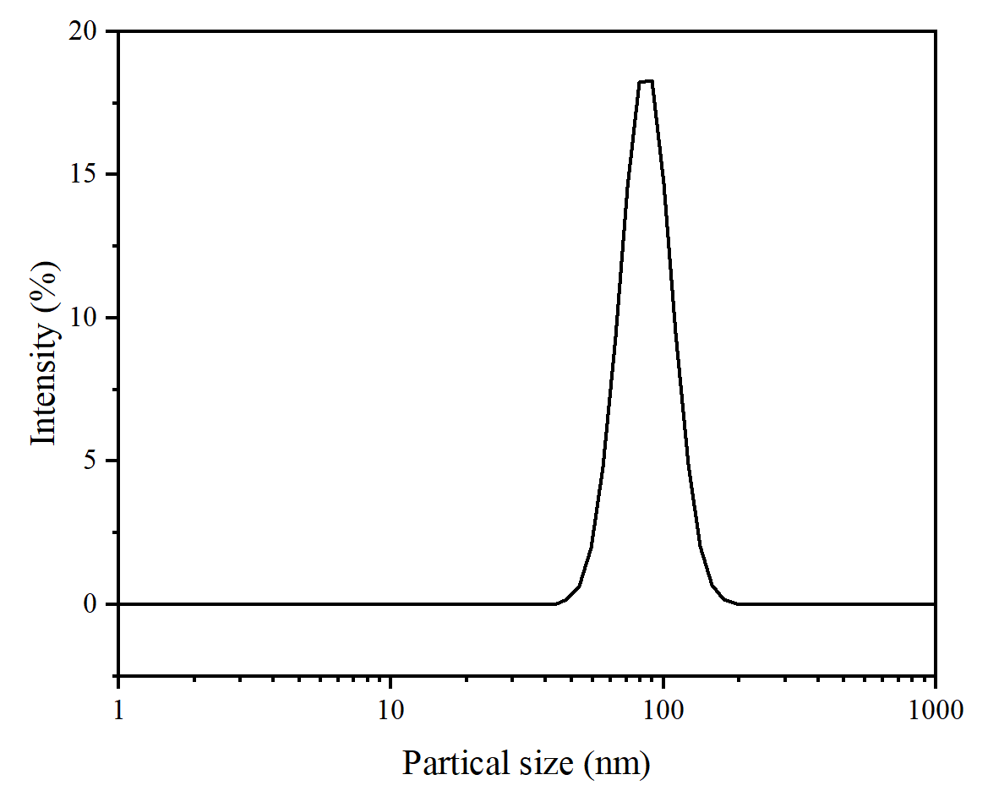
Supplementary Fig. 15 Particle size distribution of liposomes
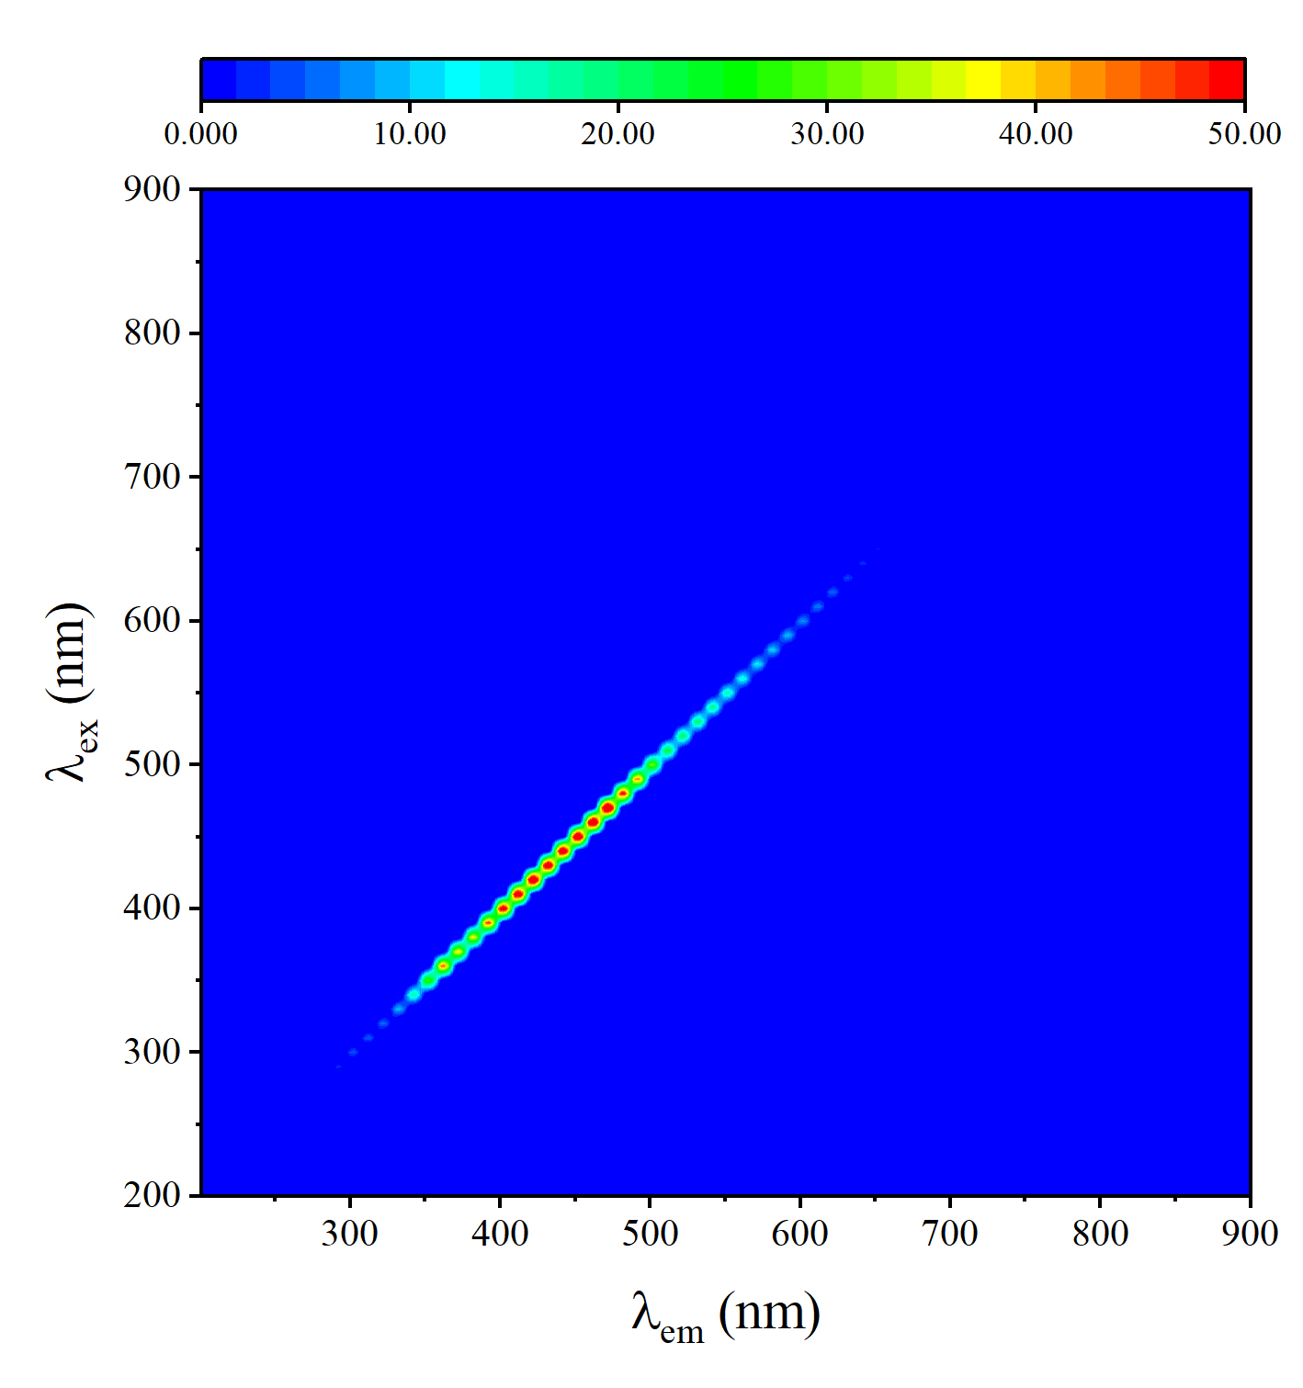
Supplementary Fig. 16 3D fluorescence of liposomes
In this experiment, liposomes were prepared by thin film rehydration and water channels were added by injection method. Briefly, 1 mg of a 1/1 molar ratio phosphatidylcholine/cholesterol (PC/Chl) mixture was dissolved in a chloroform/methanol mixture (CHCl₃/MeOH, v/v:1/1). The solution was dried on a rotary evaporator and the residual solvent was removed under high vacuum. After rehydration in 1 mL buffer containing 200 mM (6.846 wt%) sucrose and 10 mM PBS (pH = 7.2-7.4), the suspension was passed through a 100 nm radial trace-etched polycarbonate filter membrane (Whatman, UK) for 21 passes to obtain monodispersed monolayers of liposomes. IUP dissolved in dimethyl sulfoxide was then added to the liposomes.
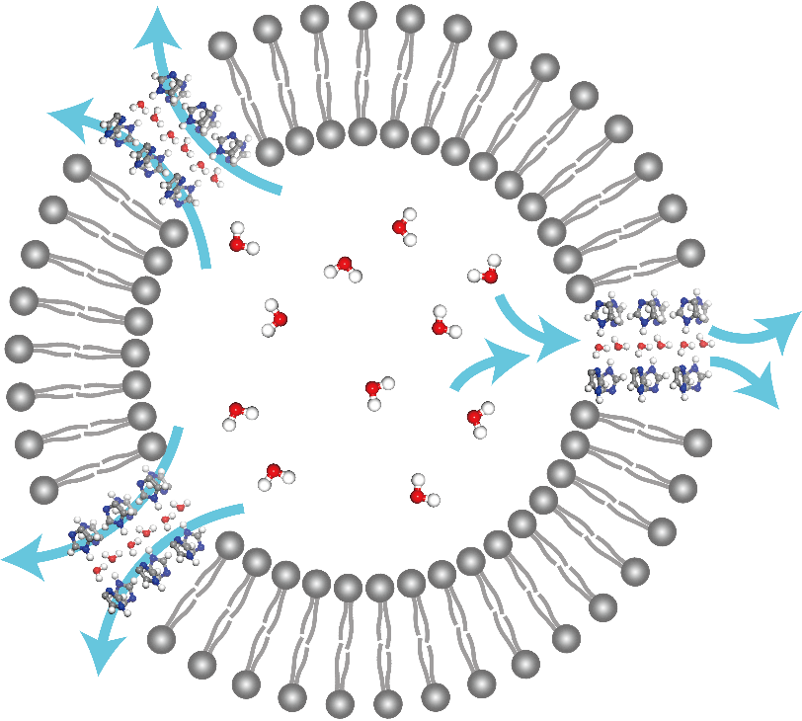
Supplementary Fig. 17 water transport across liposomes via AWC.
Liposomes exposed to a sucrose solution with a concentration of 400 mM exhibited a contraction due to the osmotic pressure exerted by the solution (Supplementary Fig. 17). The changes in the light scattering signal resulting from liposome contraction were tested at 90° using a kinetic stopped-flow spectrometer. A stopped-flow spectrometer (SFM3000+MOS450, Claix BioLogic SAS, France) was employed to record the alterations in light scattering at 450 nm, with a measured dead time of 0.5 ms and a test time of 5000 ms. The solution mixture was maintained at a temperature of 20 °C for a period of 30 minutes prior to exposure to a 400 mM sucrose solution. The data were then fitted as a sum of two exponential functions, and the exponential coefficients were calculated to obtain the initial rate of change in light scattering, k, and the water permeability (P_{f}), which was calculated using the following expression^{4,5}:
$$P_{f}=\frac{k}{\left(\frac{S}{V_{0}}\right)×V_{W}×Δ_{osm}}$$
k represents the initial rate of change in light scattering, expressed as the initial slope of the exponential function fitting equation. The variables S and V₀ correspond to the initial surface area and volume of the liposome, respectively, which are calculated from the liposome particle size. Additionally, V_{W} denotes the molar volume of water, while Δ_{osm} represents the osmotic pressure.
The k value corresponding to blank liposomes was 0.86578, and the k values corresponding to mCLR of 0.2862 and 0.5724 were 13.2358 and 18.6792, respectively. The results were corrected by subtracting the baseline observed in the blank liposome control experiment. The average particle size of the liposomes was 122.4 nm, with a radius of 61.2 nm. The light scattering signal is shown in the Supplementary Fig. 18, Initial slope of the scattered light intensity is shown in the Supplementary Fig. 19. Based on the Rayleigh-Gans theoretical formula, the water-permeable properties of the liposomes were determined. The water permeability (P_{f}) of blank liposomes was 4.90 μm/s. When the molar ratio of AWC and lipid was 0.2862 (mCLR = 0.2862), the water permeability (P_{f}) of AWC-liposomes was 75.00 μm/s. When the molar ratio of water channel and lipid was 0.5724 (mCLR = 0.5724), the water permeability (P_{f}) of AWC-liposomes was 105.85 μm/s. The results indicated a correlation between the permeability of liposomes and the mCLR.
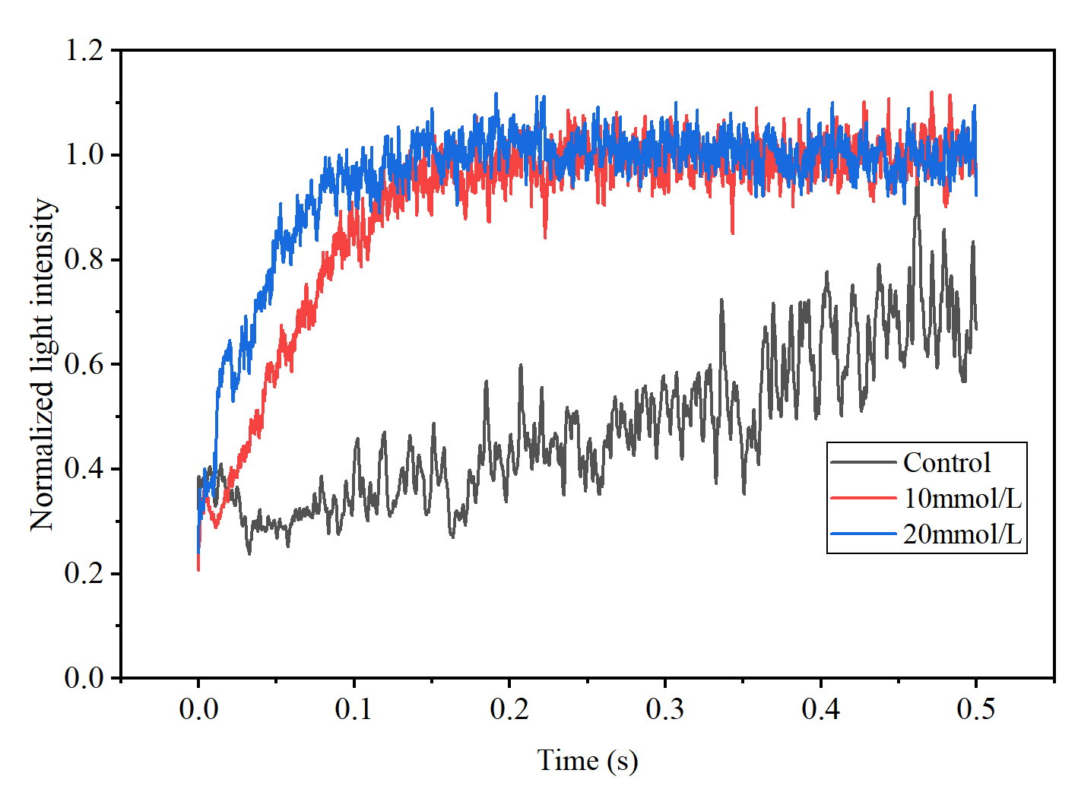
Supplementary Fig. 18 stopped-flow light scattering spectrum
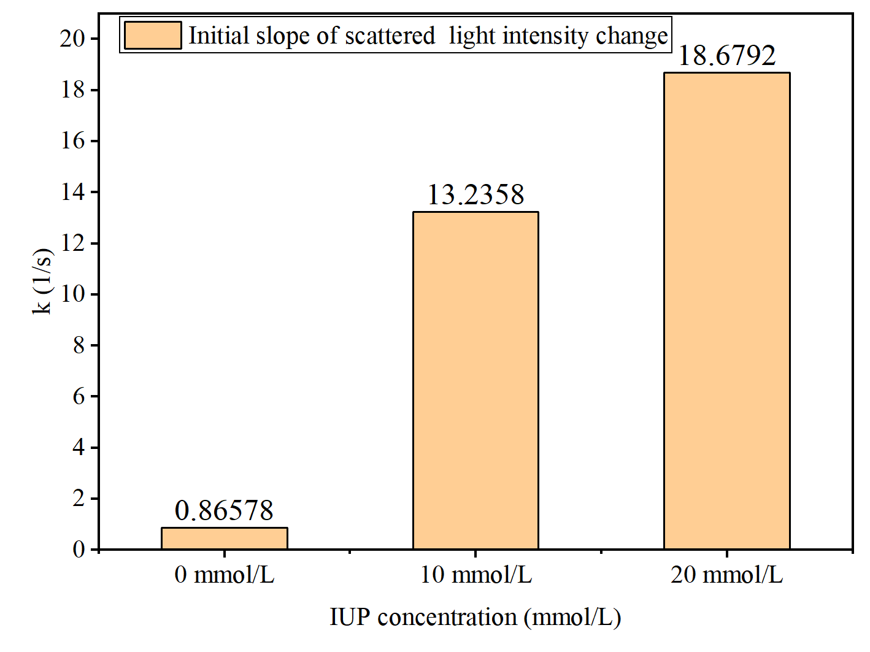
Supplementary Fig. 19 Initial slope of the scattered light intensity fitting function
The water permeability of a single channel was calculated (mCLR = 0.286). According to the dynamic light scattering (DLS) test results, the radius of the liposome is 61.2 nm. Therefore, the sum of the outer and inner surface areas is 4π×R²+4π×(R-5)²=86712.7nm². The average cross-sectional area of the lipids is 0.287nm² (the cross-sectional area of PC/Chl lipids with a molar ratio of 1/1, PC is approximately 0.35nm², and the cross-sectional area of cholesterol is 0.223nm²), and the cross-sectional area of AWC (excluding the phenethyl part) is estimated to be 0.7nm². The thickness of the phospholipid bilayer is 5nm, so every 44 IUP molecules form a channel. The number of water channels inserted into the channel of each vesicle is 1905, and the net permeability of the water channel is 57.27 μm/s. The calculated single channel permeability is 1.73×10⁻¹⁵ cm³/s, and the water conductance of a single channel in the lipid bilayer membrane is 5.79×10⁷ H₂O/s/channel, which is only one order of magnitude lower than AQP (~10⁸-10⁹ H₂O/s/channel).
  - Membrane Characterization
(1) SEM
A 5nm thick gold coating was sputtered under vacuum conditions (10⁻¹ mbar) to obtain the minimum conductivity for reliable SEM information. The PA layer on the surface of TFC membrane was observed by high-resolution scanning electron microscopy (Phenom ProX Desktop SEM) at an accelerating voltage of 15 kV (Supplementary Fig. 20, 21 and 22).
The Control membrane exhibits numerous individual bumps on its surface, while the SDS-PA membrane exhibits larger wrinkles. The surface morphology of the AWC-PA membrane is comparable to that of the Control membrane, featuring denser bumps. The surface morphology of AWC-DS-PA membrane is similar to that of SDS-PA membrane.
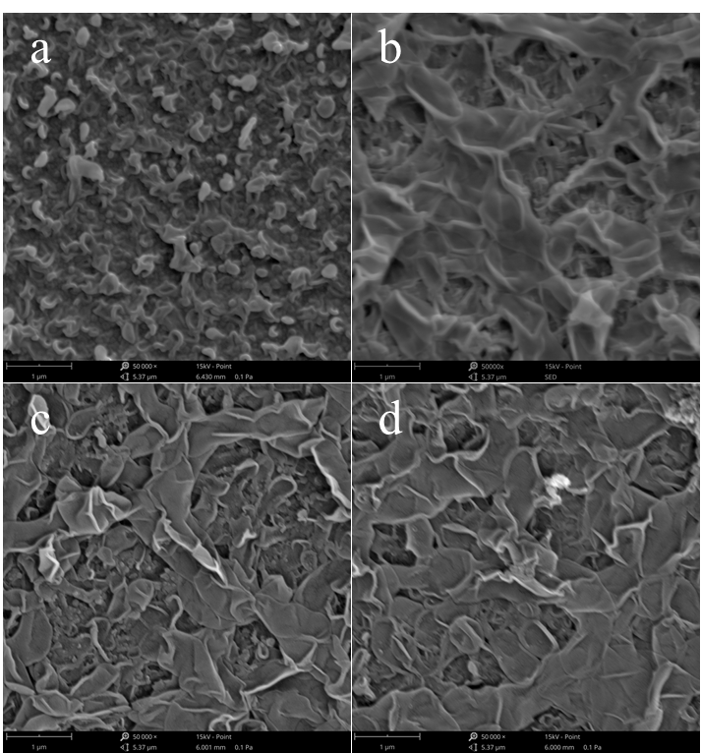
Supplementary Fig. 20 Surface morphology of Control and SDS-PA membranes. Control（a）；SDS-0.1%（b）；SDS-0.2%（c）；SDS-0.4%（d）

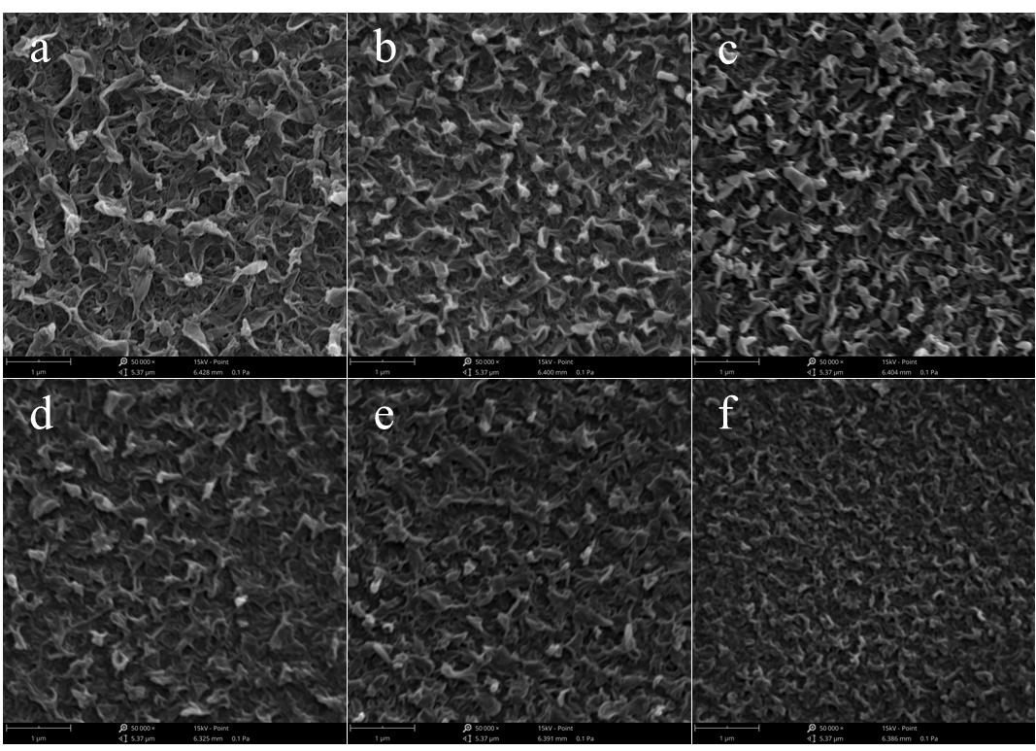
Supplementary Fig. 21 Surface morphology of AWC-PA membranes. AWC-0.125%（a）；AWC-0.25%（b）；AWC-0.5%（c）；AWC-1%（d）；AWC-2%（e）；AWC-4%（f）。
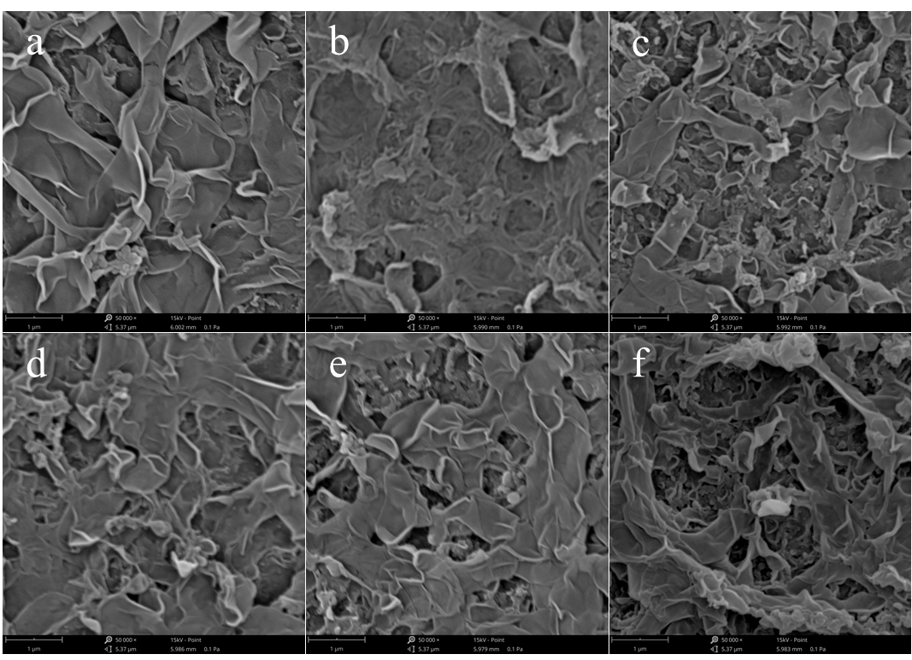
Supplementary Fig. 22 Surface morphology of AWC-SDS-PA membranes. AWC-SDS-0.025%（a）；AWC-SDS-0.05%（b）；AWC-SDS-0.1%（c）；AWC-SDS-0.2%（d）；AWC-SDS-0.4%（e）；AWC-SDS-0.8%（f）。
(2) AFM.
The thickness of the PA layer was measured using AFM (Bruker Dimension Icon). All images within a 5×5μm² region were captured using the tap mode, with a minimum sampling resolution of 256 points per 256 rows. The PA layer was peeled off from the TFC surface and loaded onto a silicon wafer for testing. Subsequently, the height of the PA layer in relation to the silicon wafer is recorded (Supplementary Fig. 23).

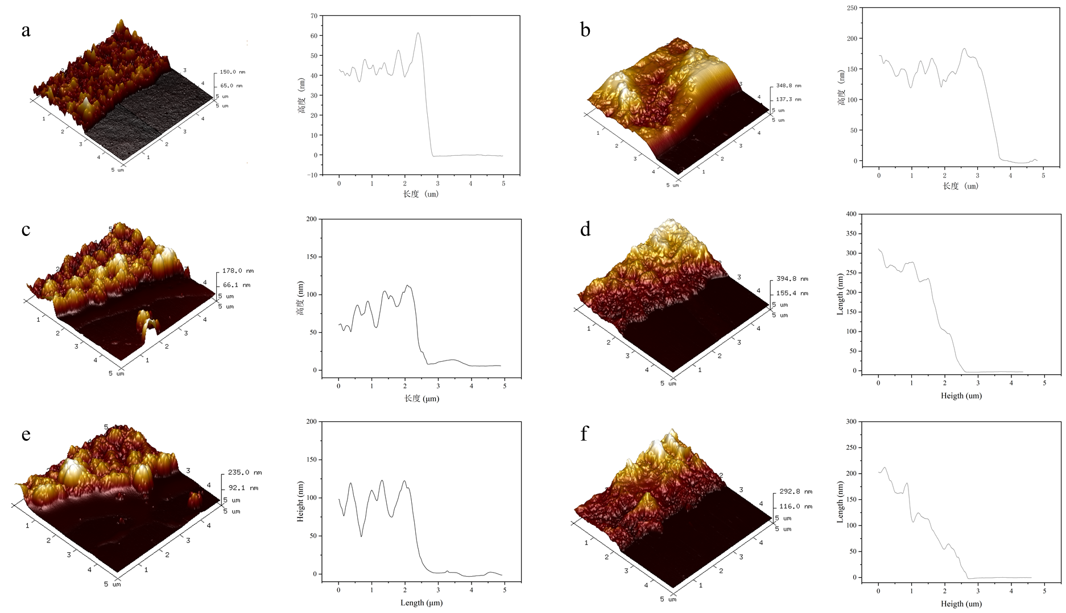
Supplementary Fig. 23 AFM image (left) and height data (right) of PA layer. (a. Control; b. SDS-0.2%; c. AWC-0.25%; d. AWC-SDS-0.25%; e. AWC-4.0%; f. AWC-SDS-0.8%.)
(3) TEM.
The membranes were embedded in epoxy resin and subsequently sectioned with an ultrathin slicer (Leica EM KMR3). The membrane cross-sectional morphology was then obtained using a transmission electron microscope (Thermo Scientific Talos F200X STEM), and the results are discussed in the manuscript.
(4) XPS.
We used XPS to quantify membrane surface elemental compositions. Prior to XPS analyses, samples were vacuum-dried for ∼24 h. High-resolution (0.1 eV) scans were collected for carbon (C1s), nitrogen (N1s), and oxygen (O1s) (Supplementary Fig. 24). In addition, the semi quantitative analysis of element components was completed (Supplementary Table. 2). To help understand the relationship between changes in polyamide composition and structure, we have provided the structure of a fully crosslinked polyamide (Supplementary Fig. 25).

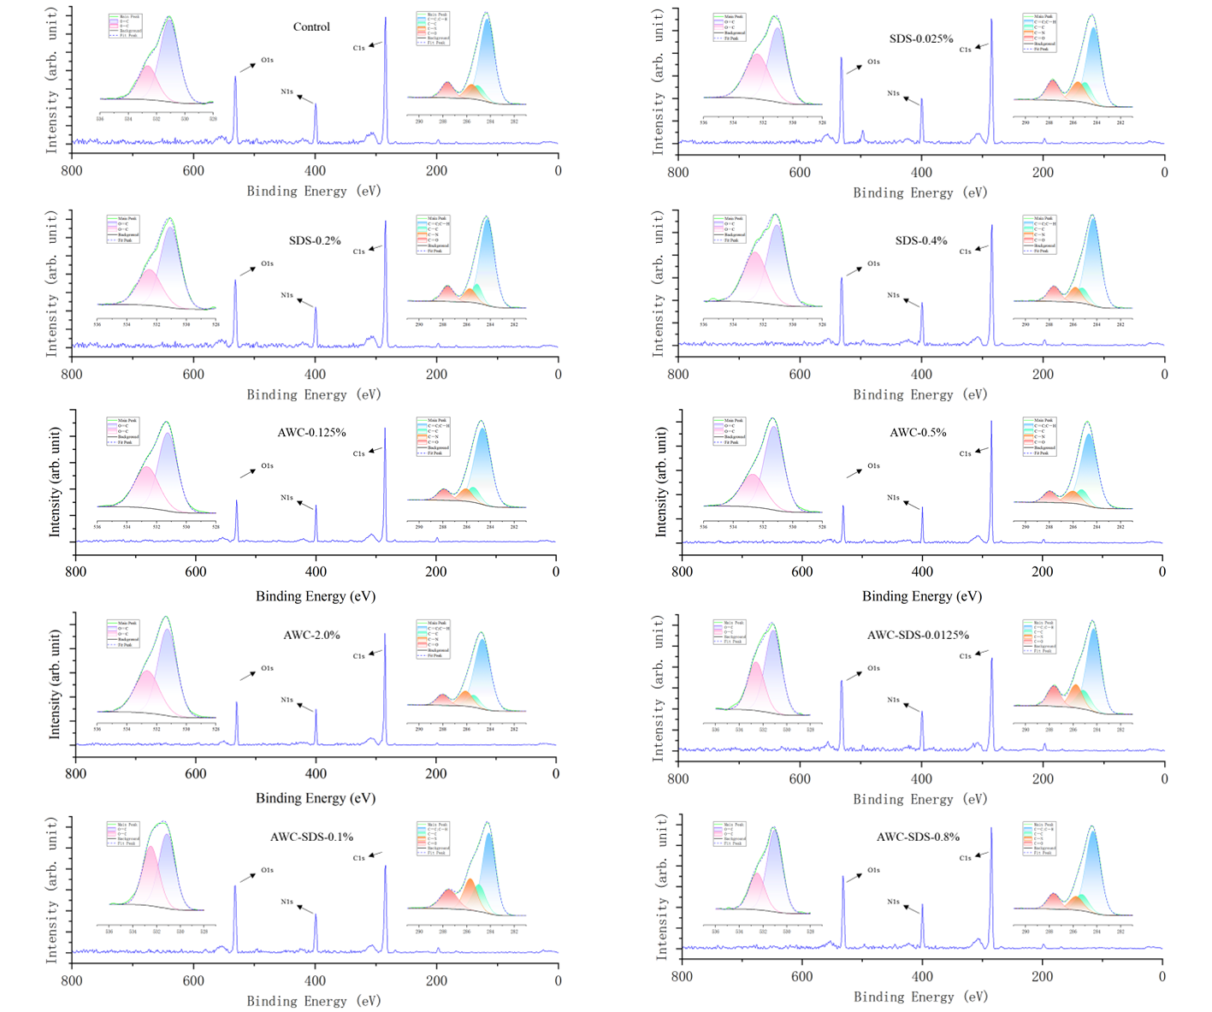
Supplementary Fig. 24. X-ray photoelectron spectra of membranes.

Supplementary Table. 2 Semi-quantitative elemental analysis of membranes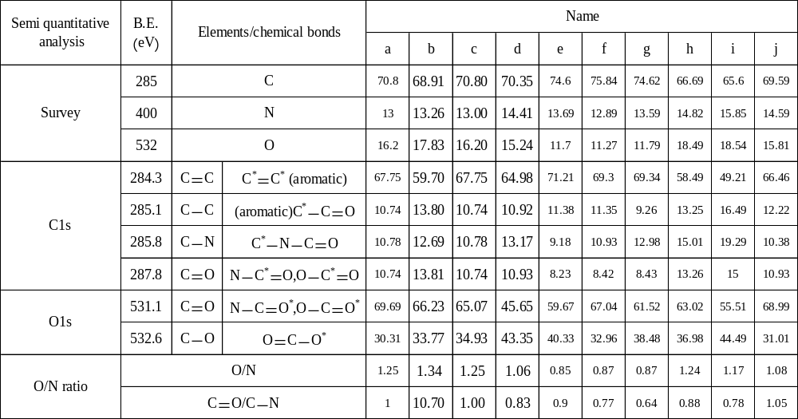
NOTE：a. Control; b. SDS-0.25%; c. SDS-0.2%; d. SDS-0.4%; e. AWC-0.125%; f. AWC-0.5%; g. AWC-2.0%; h. AWC-SDS-0.0125%; i. AWC-SDS-0.1%; j. AWC-SDS-0.8%.

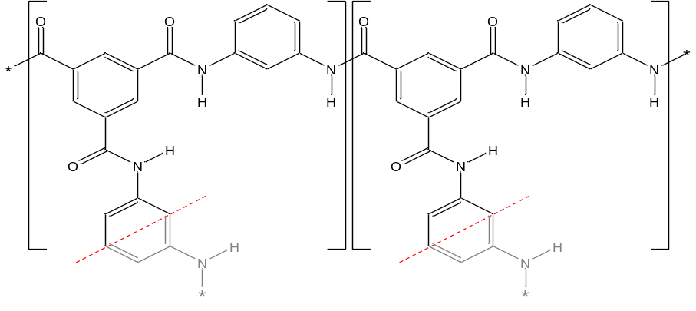
Supplementary Fig. 25. polyamide fully crosslinked network structure.

  - Membrane Performance
All filtration tests were conducted using a laboratory-scale cross-flow system, comprising a high-pressure pump, a feed vessel, and a flat-plate membrane chamber. The effective area of the membrane sample was 57 cm². Shut-off and bypass valves cooperatively controlled the operating pressure and system flow, which was monitored by a floating disk rotameter. Temperature was controlled by a circulating chiller connected to a stainless-steel coil immersed in the feed tank.
The feed solution was a 2 g/L NaCl solution at a pH of approximately 7.5. The temperature in the reverse osmosis (RO) system was 20 °C, and the crossflow velocity (averaged across the membrane channel cross-section) was approximately 0.45 m/s. Each membrane was firstly compacted for 1 h until the pure water flux was steady. Then, the permeation test was implemented at 16.0 bar. All membrane samples were taken in triplicate. Each sample was measured at least three times and then reported as an average with the mean and standard deviation of the performance given. The water permeability (A) and salt retention (R) of the membranes can be obtained by the following equations:
$$A=\frac{ΔV}{S⋅Δt⋅Δp}$$
$$R=\left(1-\frac{C_{p}}{C_{f}}\right)×100\%$$
where A is the water permeability coefficient of the membrane (L·m⁻²·h⁻¹·bar⁻¹), ∆V is the permeate volume (L), S is the effective membrane area (m²), ∆t is the measurement time (h), and ∆p is the water pressure difference (bar). R is the salt rejection, C_{p} is the NaCl concentration of the permeate, and C_{f} is the NaCl concentration of the feed solution.
The water permeability and NaCl rejection of all membranes were obtained，including SDS-PA membranes (Supplementary Fig. 26), AWC-PA membranes (Supplementary Fig. 27), and AWC-SDS-PA membranes (Supplementary Fig. 28).

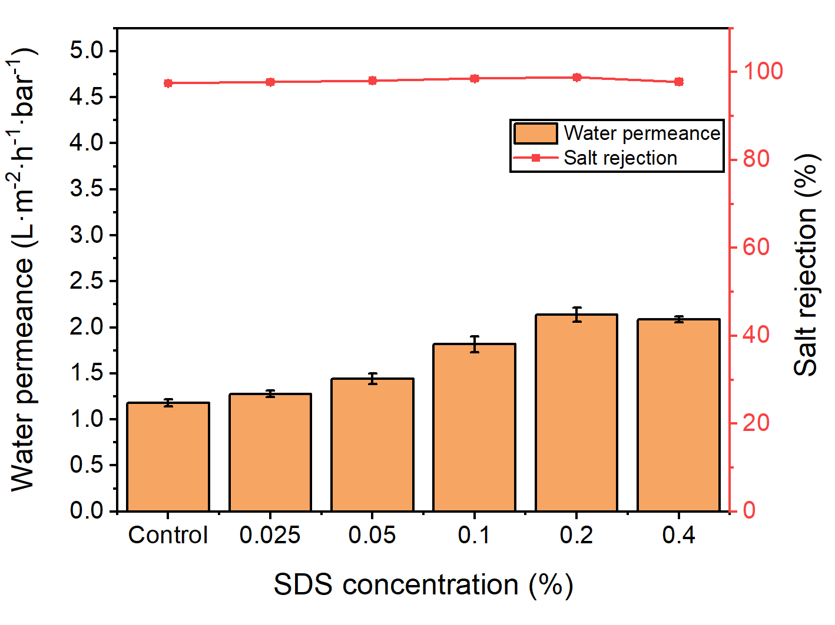
Supplementary Fig. 26 Performance of SDS-PA membranes.
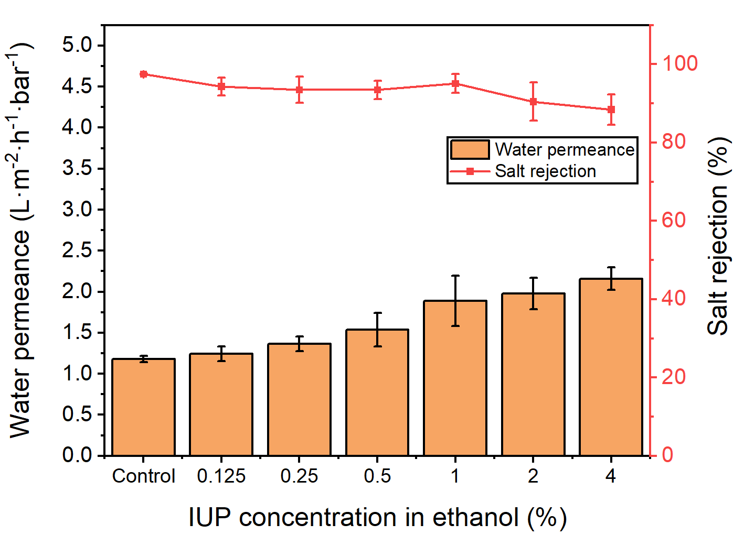
Supplementary Fig. 27 Performance of AWC-PA membranes.
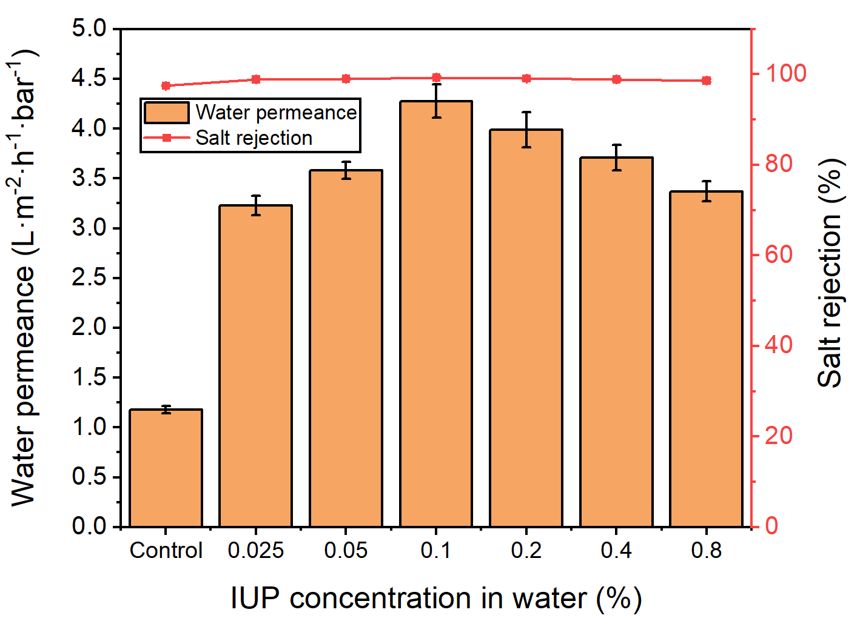
Supplementary Fig. 28 Performance of AWC-SDS-PA membranes.
  - Molecular dynamics simulation methods
MD simulations were performed using the Large-scale Atomic/ Molecular Massively Parallel Simulator ⁶. All atoms were treated as charged Lennard-Jones (LJ) sites with parameters taken from the GAFF force field^{6,7}. The charges obtained by the AM1-BCC method. The water molecules were described by TIP3P model. The interaction was calculated as the sum of the van der Waals contribution (Lennard-Jones, LJ) and the Coulomb term, with 9 Å and 10 Å being used as the internal and external cutoffs for the LJ interactions. The electrostatic term was computed by taking into account the Ewald method, with the Coulomb force computed at a cutoff of 10 Å. A time step of 1 femtosecond was used in these simulations.
The molecule models are shown in Supplementary Fig. 29. In addition, a comprehensive overview of the specific field information associated with each atom is provided, including its mass, Lennard-Jones parameters, and atomic partial charge (Supplementary Table. 3).
Supplementary Table. 3. Mass m, Lennard Jones parameters ε, σ, partial charge q for each atom type.
atom | Molecule | m (Da) | ε (Kcal.mol⁻¹) | σ (Å) | q (e)
Na | Ion | 22.990 | 0.0317 | 2.95000 | 1.000000
Cl | Ion | 35.450 | 0.6029 | 4.50400 | -1.000000
OW | Water | 16.000 | 0.1020 | 3.18800 | -0.834000
HW | Water | 1.008 | 0.0000 | 1.00000 | 0.417000
C1 | Hexane | 12.010 | 0.1094 | 3.39967 | -0.079000
H1 | Hexane | 1.008 | 0.0157 | 2.64953 | 0.027000
H2 | Hexane | 1.008 | 0.0157 | 2.64953 | 0.039000
C1 | SDS | 12.010 | 0.1094 | 3.39967 | -0.090000
C2 | SDS | 12.010 | 0.1094 | 3.39967 | -0.078000
C3 | SDS | 12.010 | 0.1094 | 3.39967 | 0.208000
O1 | SDS | 16.000 | 0.2100 | 2.95992 | -0.603000
O2 | SDS | 16.000 | 0.1700 | 3.00001 | -0.756000
S1 | SDS | 32.060 | 0.2500 | 3.56359 | 1.698000
H1 | SDS | 1.008 | 0.0157 | 2.64953 | 0.031000
H2 | SDS | 1.008 | 0.0157 | 2.64953 | 0.040000
H3 | SDS | 1.008 | 0.0157 | 2.64953 | 0.010000
C1 | MPD | 12.010 | 0.0860 | 3.39967 | 0.171600
C2 | MPD | 12.010 | 0.0860 | 3.39967 | -0.230000
C3 | MPD | 12.010 | 0.0860 | 3.39967 | -0.156500
N1 | MPD | 14.010 | 0.1700 | 3.25000 | -0.462100
H1 | MPD | 1.008 | 0.0150 | 2.59964 | 0.107450
H2 | MPD | 1.008 | 0.0150 | 2.59964 | 0.231050
C1 | TMC | 12.010 | 0.0860 | 3.39967 | 0.679700
C2 | TMC | 12.010 | 0.0860 | 3.39967 | -0.195600
C3 | TMC | 12.010 | 0.0860 | 3.39967 | 0.014000
O1 | TMC | 16.000 | 0.2100 | 2.95992 | -0.576100
H1 | TMC | 1.008 | 0.0150 | 2.59964 | 0.181600
H | PA | 1.008 | 0.0150 | 1.00000 | 0.431500
O | PA | 16.000 | 0.2104 | 3.06647 | -0.535100
N | PA | 14.010 | 0.1700 | 3.25000 | -0.398375
C | PA | 12.010 | 0.0860 | 3.39967 | 0.743425
O1 | IUP | 16.000 | 0.2100 | 2.95992 | -0.633000
N1 | IUP | 14.010 | 0.1700 | 3.25000 | -0.322000
N2 | IUP | 14.010 | 0.1700 | 3.25000 | -0.666000
N3 | IUP | 14.010 | 0.1700 | 3.25000 | -0.532000
N4 | IUP | 14.010 | 0.1700 | 3.25000 | -0.532000
C1 | IUP | 12.010 | 0.0860 | 3.39967 | 0.385000
C2 | IUP | 12.010 | 0.0860 | 3.39967 | -0.245000
C3 | IUP | 12.010 | 0.0860 | 3.39967 | 0.299000
C4 | IUP | 12.010 | 0.1094 | 3.39967 | -0.129000
C5 | IUP | 12.010 | 0.1094 | 3.39967 | 0.076000
C6 | IUP | 12.010 | 0.0860 | 3.39967 | 0.720000
C7 | IUP | 12.010 | 0.1094 | 3.39967 | 0.075000
C8 | IUP | 12.010 | 0.1094 | 3.39967 | -0.071000
C9 | IUP | 12.010 | 0.0860 | 3.39967 | -0.079000
C10 | IUP | 12.010 | 0.0860 | 3.39967 | -0.126000
C11 | IUP | 12.010 | 0.0860 | 3.39967 | -0.129000
C12 | IUP | 12.010 | 0.0860 | 3.39967 | -0.131000
C13 | IUP | 12.010 | 0.0860 | 3.39967 | -0.129000
C14 | IUP | 12.010 | 0.0860 | 3.39967 | -0.126000
H1 | IUP | 1.008 | 0.0150 | 2.59964 | 0.060000
H2 | IUP | 1.008 | 0.0157 | 1.06908 | 0.301000
H3 | IUP | 1.008 | 0.0150 | 2.59964 | 0.182000
H4 | IUP | 1.008 | 0.0157 | 2.64953 | 0.057000
H5 | IUP | 1.008 | 0.0157 | 2.64953 | 0.057000
H6 | IUP | 1.008 | 0.0157 | 2.64953 | 0.076000
H7 | IUP | 1.008 | 0.0157 | 2.64953 | 0.076000
H8 | IUP | 1.008 | 0.0157 | 1.06908 | 0.287000
H9 | IUP | 1.008 | 0.0157 | 1.06908 | 0.285000
H10 | IUP | 1.008 | 0.0157 | 2.64953 | 0.072000
H11 | IUP | 1.008 | 0.0157 | 2.64953 | 0.072000
H12 | IUP | 1.008 | 0.0157 | 2.64953 | 0.054000
H13 | IUP | 1.008 | 0.0157 | 2.64953 | 0.054000
H14 | IUP | 1.008 | 0.0150 | 2.59964 | 0.135000
H15 | IUP | 1.008 | 0.0150 | 2.59964 | 0.131000
H16 | IUP | 1.008 | 0.0150 | 2.59964 | 0.130000
H17 | IUP | 1.008 | 0.0150 | 2.59964 | 0.131000
H18 | IUP | 1.008 | 0.0150 | 2.59964 | 0.135000

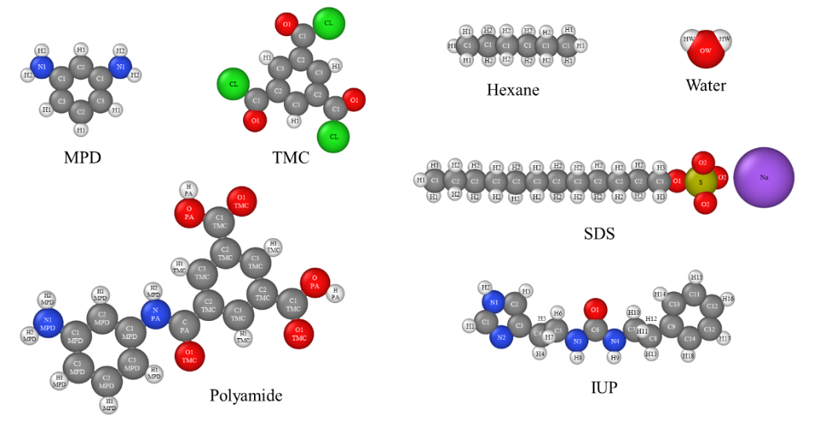
Supplementary Fig. 29 Molecular model involved in the simulation
(1) Molecular dynamics (MD) simulations for the water conductance of AWC.
The AWC slice model was constructed based on the crystal structure of AWC obtained from the results of single-crystal XRD. The AWC slice model containing 12 parallel water channels was constructed by 48 IUP molecules, resulting in a size of 4.616 nm × 0.924 nm × 4.313 nm. The AWC slice model was fixed in the center of a rectangular box with dimensions of 4.616 nm ×12 nm × 4.313 nm. 1000 water molecules were added to each side of the AWC slice. Two pieces of graphene were used as a piston to maintain the AWC slice and the water molecules within the center of the box. To simulate the permeation of salt ions, 11 Na⁺ and 11 Cl⁻ ions were added to the water chamber on the feed side.
Pressure difference between the two sides of the system was created by applying different forces to the graphene pistons. The water molecules were then driven by the pressure to pass through the water channels. Specifically, a relaxation of 100 ps was conducted at 300 K by applying a pressure of 1 bar to the graphene piston. Then, 10 ns simulations were conducted at 300 K with varying pressures applied to graphene pistons. The initial velocities of the atoms were generated with a Gaussian distribution with a mean value of 0.0 and scaled to 300 K. The state of the model is recorded during the simulation (Supplementary Fig. 30), and we use this to obtain the number of water molecules passing through the AWC (Supplementary Fig. 31).
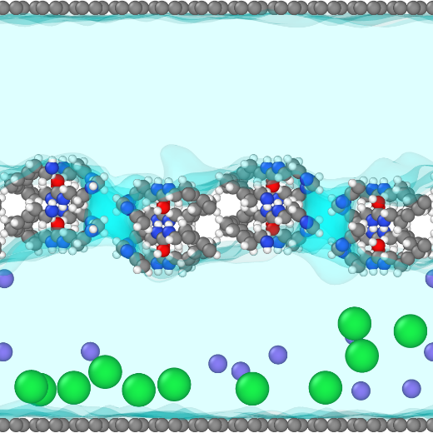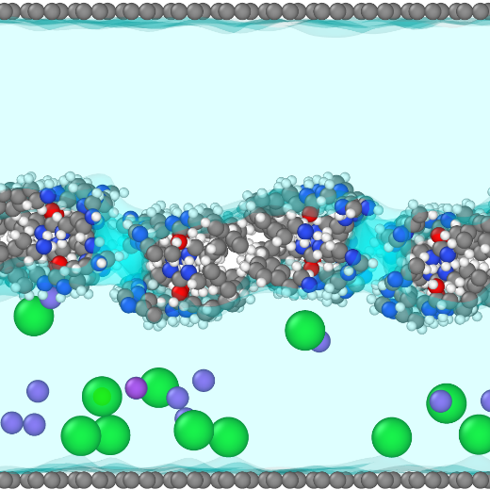
Supplementary Fig. 30 The state of the model at the beginning (left) and end (right) of the simulation（10MPa）.

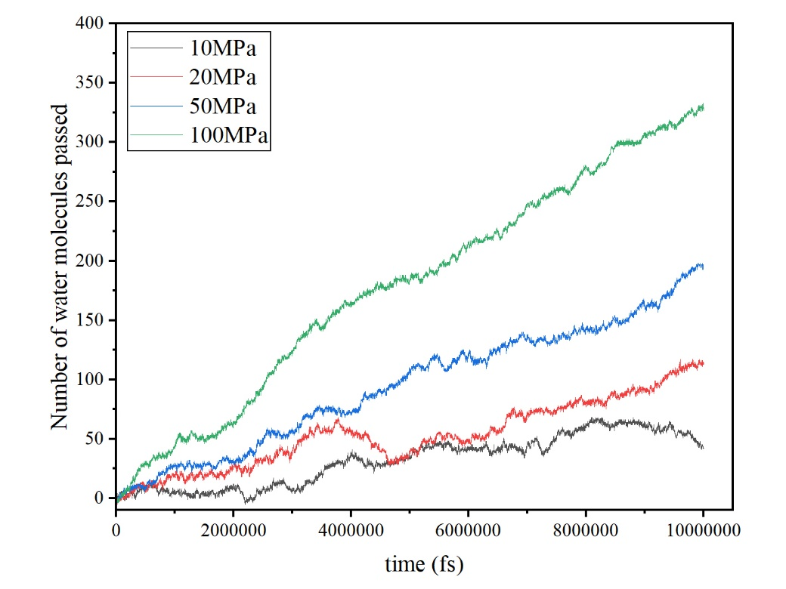
Supplementary Fig. 31 Number of water molecules through AWC.
Meanwhile, the Langevin thermostat is used to regulate the temperature of the system to 300 K. The MD system was analyzed to obtain the root-mean-square displacements (RMSD) of the water molecules and the radial distribution function (RDF) between the water molecules and their hydrogen-bonded atoms.
Controlled by a 300 K thermostat, the continuous growth of MSD is independent of pressure (Supplementary Fig. 32), and the diffusion rate was obtained based on MSD calculations. The value was constant at ~1.0×10⁻¹⁰ m²/s.
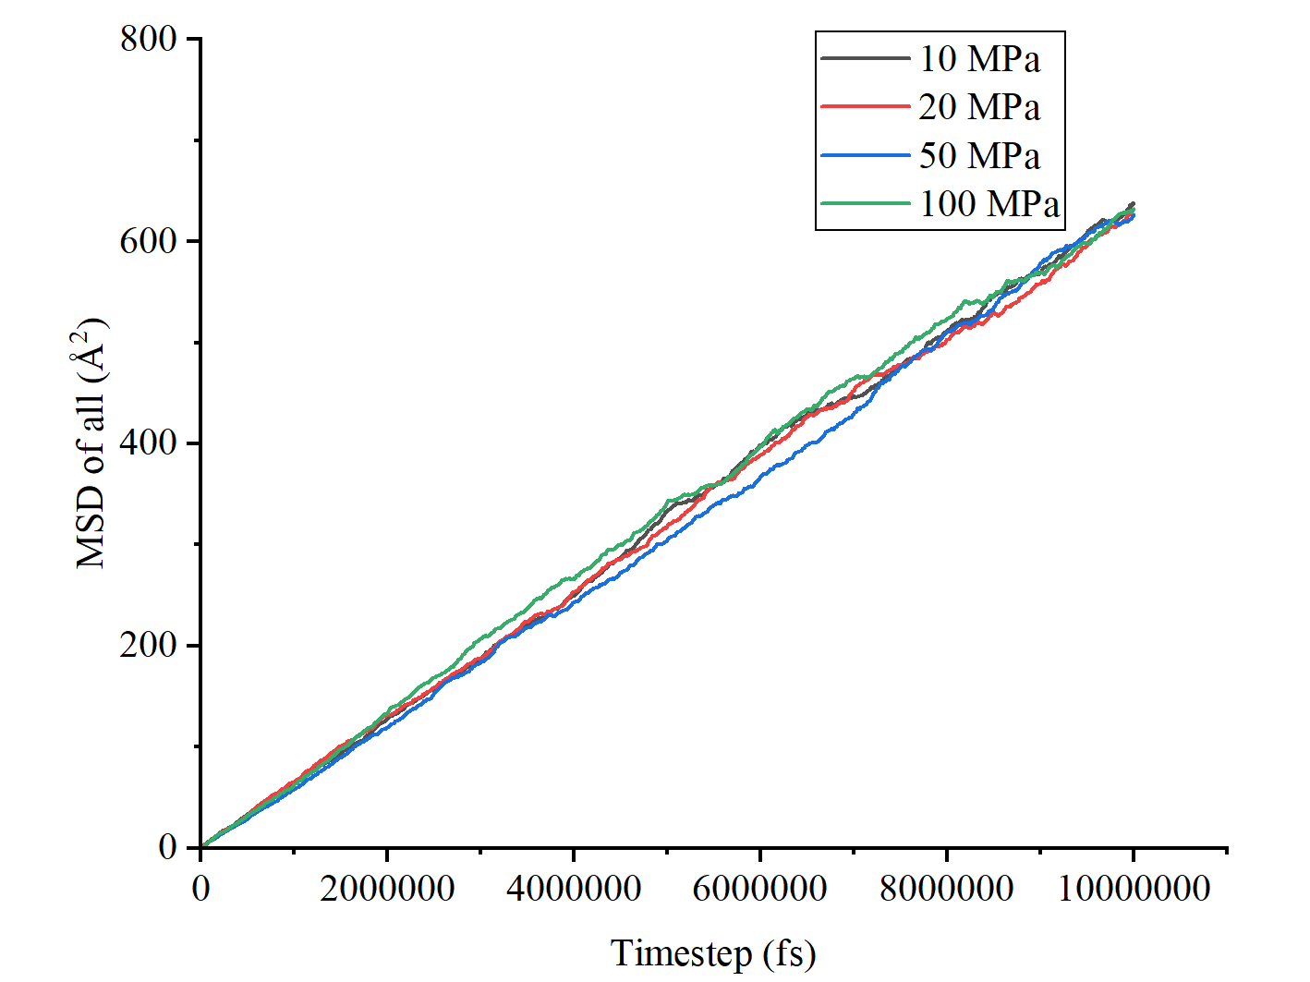
Supplementary Fig. 32 MSD of water molecules.
The RDF of O atom and H atom (H8/H9) in the urea group of IUP molecules reveals their atomic spacing distribution at ~2 Å (Supplementary Fig. 33). This corresponds to the intermolecular hydrogen bonding formed by neighboring molecules through the urea group⁸. This spacing corresponds to that of AWC crystal, which is about 2.15 Å.
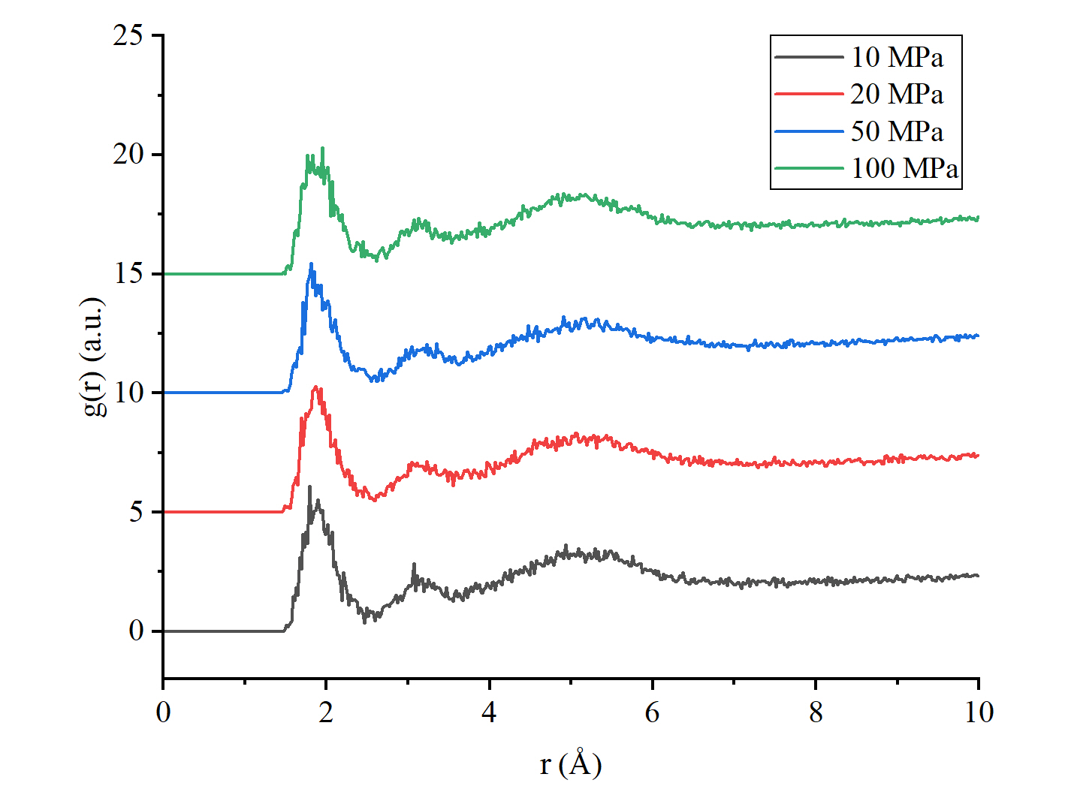
Supplementary Fig. 33 RDF of O1(IUP) atoms with H8&H9(IUP) atoms
The RDF of the N2 atom in the IUP molecule and the H atoms in the water molecule indicates atomic spacing ranging from 2 Å to 3 Å (Supplementary Fig. 34). This suggests that there are hydrogen bonds between the N2 atom in the IUP molecule and the H atoms in the water. The presence of noise in RDF plots may be attributed to the varying distance between them during the water translocation process. The flip of dipolar water molecules contributes to the separation of water molecules from ions in hydrated ions, providing a nanoscale explanation for the desalination behavior of AWC^{9,10}.
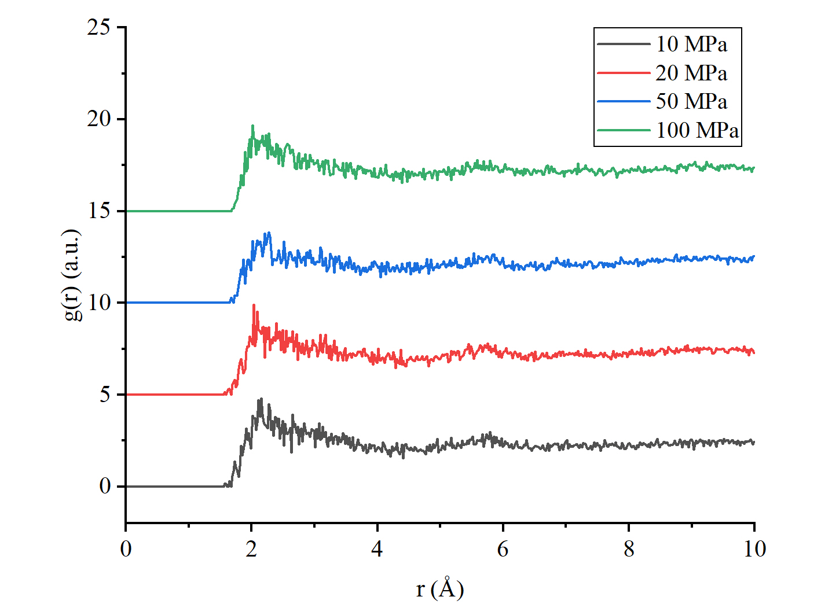
Supplementary Fig. 34 RDF of N2(IUP) atoms with H(water) atoms.
(2) MD simulation for the migration of AWC aggregates at the water-hexane interface.
An AWC particle with dimensions of 22.779 Å × 37.035 Å × 21.532 Å was placed into a box containing a mixture of water and n-hexane. The migration of the AWC particle was then recorded. To ascertain the influence of MPD and SDS on the diffusion process, 50 MPD molecules and 10 SDS molecules were introduced into the box and the process was repeated. 500 hexane molecules and 3000 water molecules were introduced into the middle of two graphene pistons. The atmospheric pressure was simulated by applying a force of 1 atm to both sides of the piston, and the system was maintained at 300 K. The time for equilibration and migration process is 1 and 2 ns, respectively.
The average kinetic energy of the particles can be calculated using the following equation:
$$\left\langle \frac{mv_{x}^{2}}{2}\right\rangle =\frac{1}{2}k_{B}T$$
With Boltzmann's constant (1.380649 × 10⁻²³ J/K), the mean thermal energy of the particles by temperature was calculated (k_{B}T(300K) = 4.142 pN·m). The molecular weight of the AWC particles is 6088.04 Da, and the mass of the AWC particles can be calculated by Avogadro's constant to be 1.077 × 10⁻²³ kg. The root mean square velocity due to thermal energy is：
$$V_{rms}=(V_{x}^{2})^{\frac{1}{2}}=19.611 m/s$$
According to the MD results, AWC particles cross the water-hexane interface if they had an initial velocity of 19.6 m/s perpendicular to the two-phase interface.
(3) MD simulation for water penetration processes in the PA and AWC-PA layers
In order to obtain a microscopic interpretation of the water permeability of the AWC in PA layer, we developed models for PA layer and AWC-PA layer, respectively. A heuristic reaction kinetics simulation was employed to polymerize 300 MPD molecules and 200 TMC molecules using REACTER ¹¹. The specific procedure involved the addition of the MPD molecules and TMC molecules in the middle of two 50n Å × 50 Å graphene sheets, with 960 water molecules preadded, to obtain a polyamide layer with a water content of 23 wt% ¹². A force of 1 atm was applied to both pistons, and the polymerization protocol was initiated after equilibrating for 200 ps at 300 K. The reticulated polyamide was obtained after 1 ns of reaction (the system was stabilized after 500 ps of reaction), and the system was annealed at 350 K for 100 ps to ensure that the polyamide reaction was complete. To obtain the AWC-PA model, an AWC particle with dimensions of 22.779 Å × 37.035 Å × 21.532 Å was added to the system and its location was confirmed to be in the center of the system.
We tested the energy changes of the interactions between phenyl groups to evaluate the effect of π - π stacking (Supplementary Fig. 35). The total interaction energy between AWC aggregates and PA matrix in the AWC-PA model was calculated to be -342.7 kcal/mol, while the interaction energy provided by π-π stacking was -71.4 kcal/mol. The π-π stacking interaction contributed about 20.8% of the total energy. The π-π stacking interaction is beneficial to enhance the affinity and adhesion between AWC aggregates and PA matrix, thereby reducing the possibility of membrane defects.
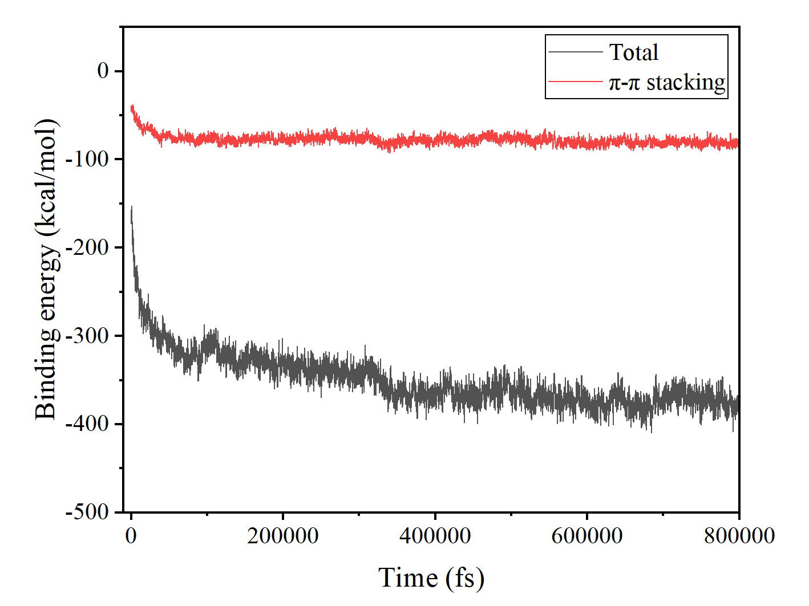
Supplementary Fig. 35 The energy for the interaction between AWC and PA layer during the equilibrium process.
MD simulations were also used to investigate water penetration processes in the PA and AWC-PA layers. For PA layer, 3,000 water molecules were added to each side of the PA. For AWC-PA layer, 3,000 water molecules were added on each side of the PA. The system was equilibrated for 2 ns by applying a force of 1 atm to the pistons on both sides. The temperature was 300 K.
Supplementary Fig. 36 and 37 shows the model used for water penetration simulation and the water transport pathways in the PA layer and AWC-PA layer. PA matrix is shown as transparent, and the van der Waals boundaries of AWC aggregates and water molecules were highlighted in red and blue, respectively. The direction of water molecule movement in the AWC-PA matrix is marked with a red dashed line.
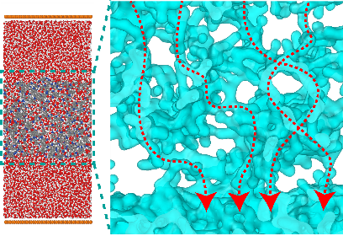
Supplementary Fig. 36 PA Model (left) and water transport pathways in of PA matrix (right).
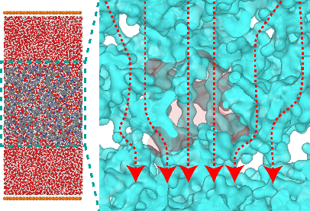
Supplementary Fig. 37 AWC-PA Model (left) and water transport pathways in of AWC-PA matrix (right).
In MD simulations of water penetration processes, the number of water molecules permeating through PA layer was recorded (Supplementary Fig. 38) and the net water permeability of PA layer were demonstrated (Supplementary Table. 4). The number of water molecules leaving the polyamide domains was determined at each time increment. This allowed the calculation of the volumetric flux of water, J_{w}, and the water permeability, K_{w}, The formulas for the calculations are provided below.
$$J_{w}=\frac{M_{W}}{ρ_{w}N_{A}A_{xy}}\frac{ΔN_{p}}{Δt}$$
where M_{W} is the molar mass of water, ρ_{w} is the density of water at 300 K and 1 bar, N_{A} is Avogadro's constant, A_{xy} is the cross-sectional area of the polyamide domains, N_{p} is the number of permeating water molecules, and t is the permeation time.
$$K_{w}=\frac{J_{w}L}{(P_{f}-P_{p})}$$
where P_{f} is the pressure in the feed tank, P_{p} is the pressure in the permeate tank, and L is the thickness of the polyamide domain (z-direction).
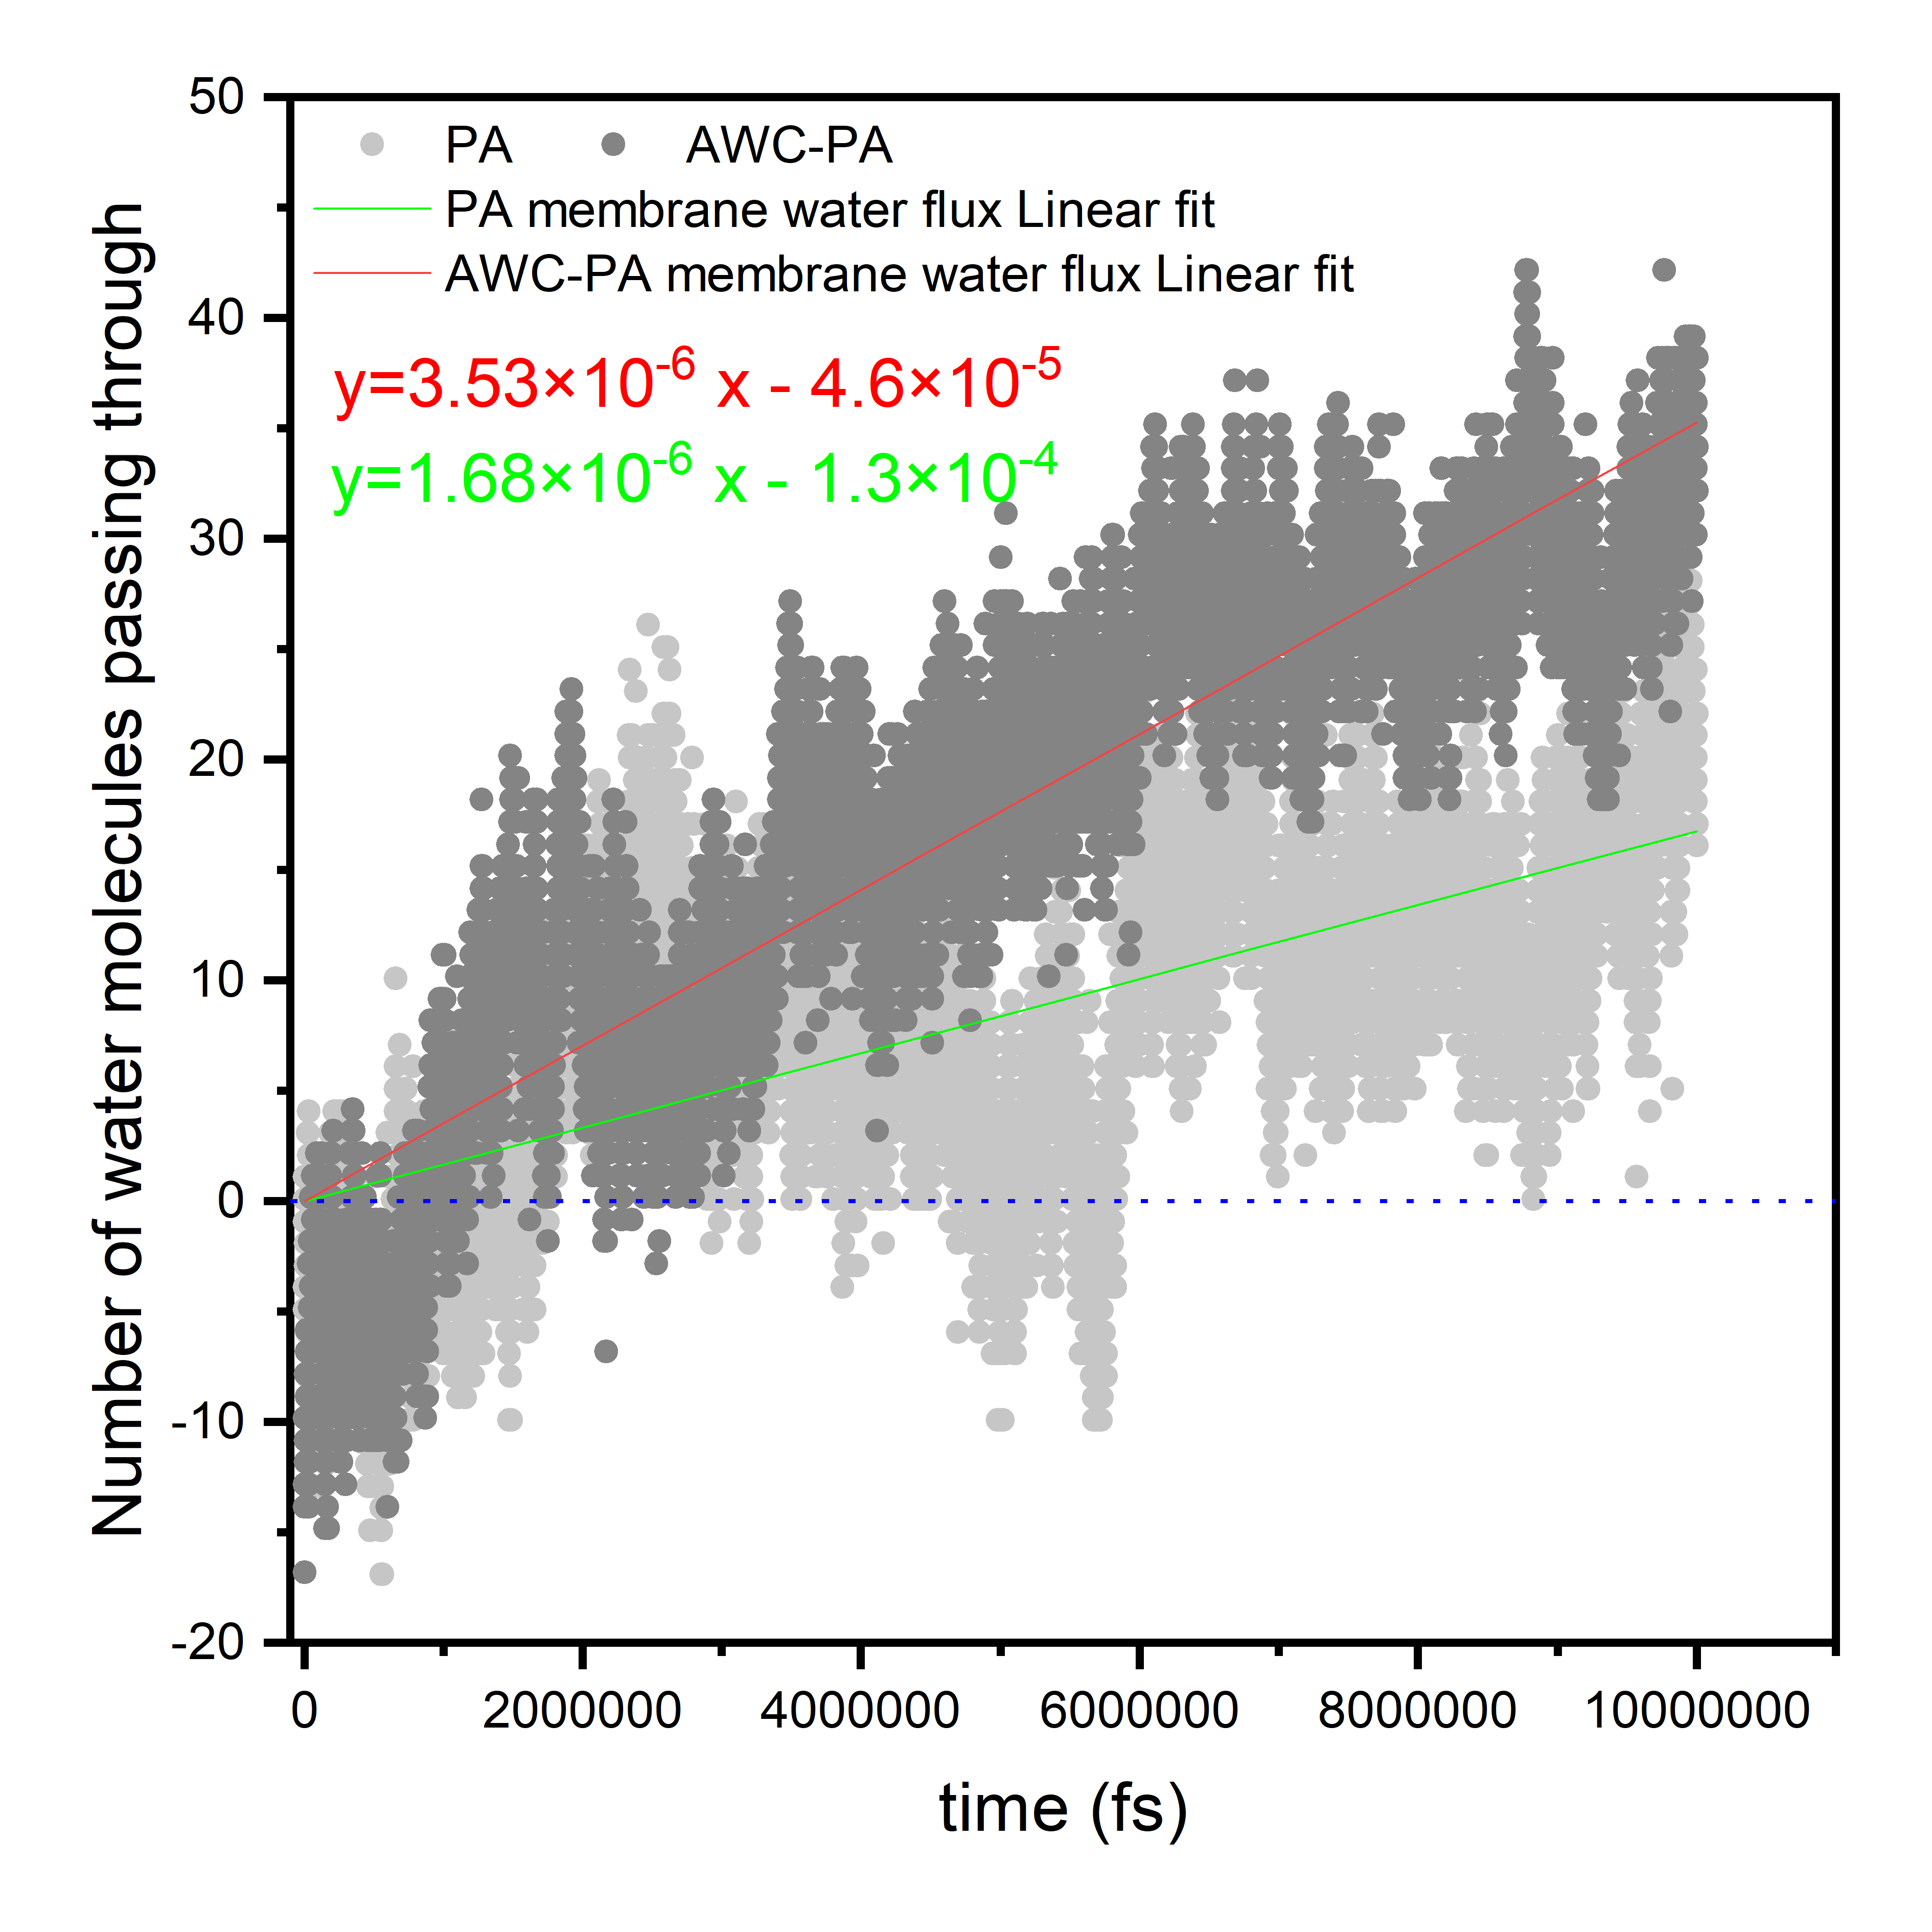
Supplementary Fig. 38 Number of water molecules passing through PA layer in 10 ns.

Supplementary Table. 4 Results obtained from the MD simulation of water penetration processes in the PA and AWC-PA layers.
Polymer Model | PA | AWC-PA
Crosslinking Degree, DC (%) | 86.33 | 89.67
Thickness, L (Å) | 49.84 | 54.55
Wet density, ρw (g/cm³) | 1.393 | 1.371
Dry density, ρd (g/cm³) | 1.073 | 1.055
Water permeability, Kw × 10⁶ (L·m⁻¹·hr⁻¹·bar⁻¹) | 0.359 | 0.827
  - Methods of the experiments for analyze the diffusion of MPD crossing the interface between water and hexane
1.5 ml of n-hexane and 1 ml of MPD aqueous solution containing different concentrations of SDS (0~4.0g/l) were successively inhaled into the syringe (2.5 ml), and MPD diffused into n-hexane through the interface between n-hexane and aqueous solution. After a period of time (5-60s), the aqueous solution was discharged from the syringe, while n-hexane was extruded into the quartz cuvette. The schematic diagram of the MPD diffusion tests is shown in Supplementary Fig. 39. The concentration of MPD in n-hexane solution was determined by UV VIS spectrophotometer at the wavelength of 252.1 nm. The results are shown in Supplementary Fig. 40.
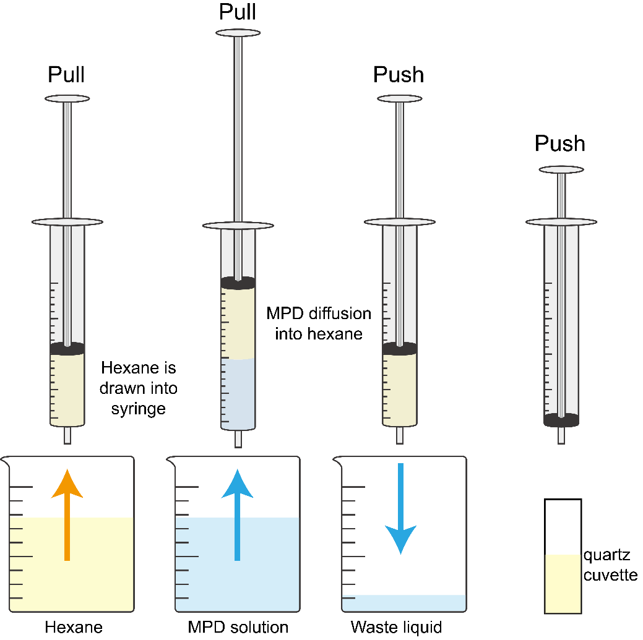
Supplementary Fig. 39 operation diagram

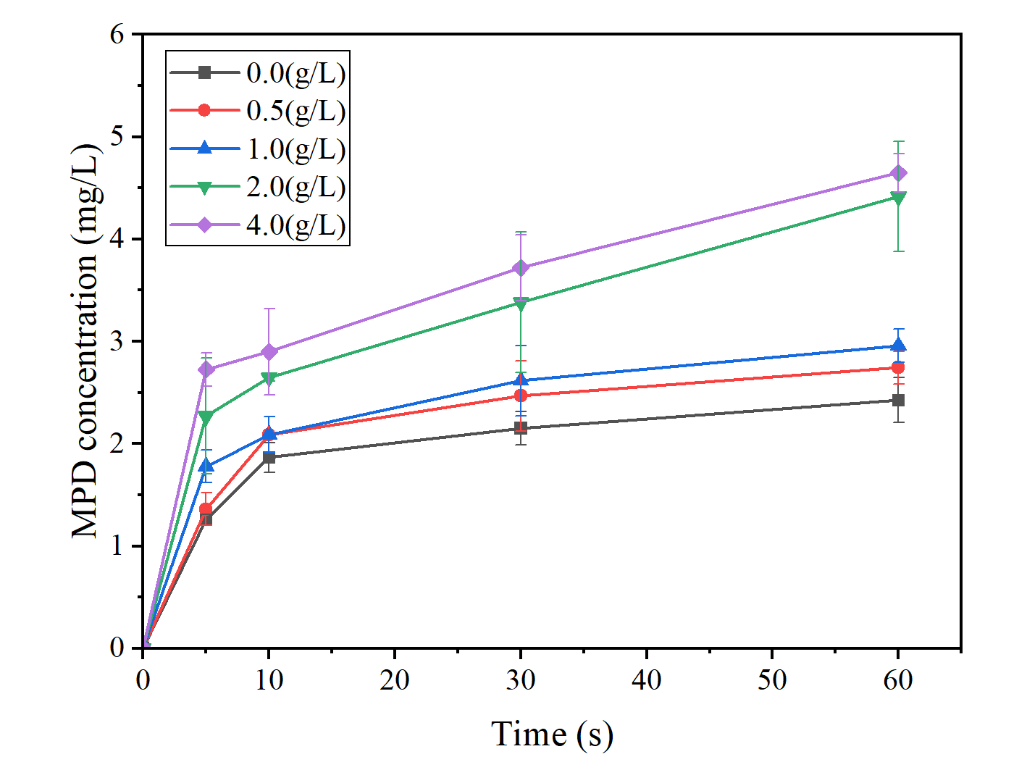
Supplementary Fig. 40 Concentration of MPD in hexane solution
  - Scaling up of membranes
In addition, we demonstrate a strategy for the preparation of industrial-standard AWC-SDS-PA membranes¹³.
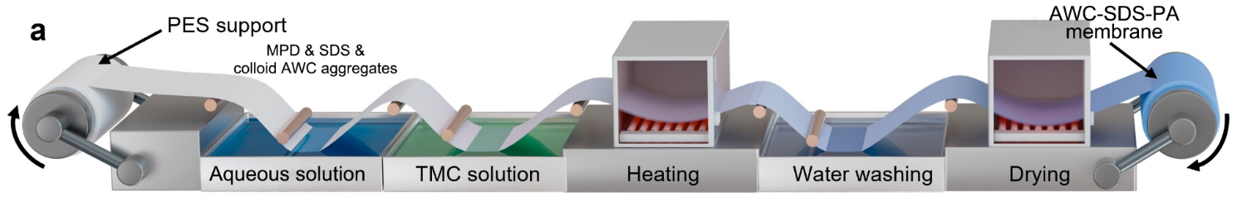
Supplementary Fig. 41 Fabrication strategy of artificial water channel membranes in industrial-standard (revised according to ref.13)

- Reference
1. Dolomanov O. V., Bourhis L. J., Gildea R. J., Howard J. a. K. & Puschmann H. OLEX2: a complete structure solution, refinement and analysis program. J. Appl. Crystallogr. 42, 339–341 (2009).
2. Kratzert D., Holstein J. J. & Krossing I. DSR: enhanced modelling and refinement of disordered structures with SHELXL. J. Appl. Crystallogr. 48, 933–938 (2015).
3. Sheldrick G. M. SHELXT – Integrated space-group and crystal-structure determination. Acta Crystallogr. Sect. A: Found. Adv. 71, 3–8 (2015).
4. Mario J Borgnia, David Kozono, Giuseppe Calamita, Peter C Maloney, & Peter Agre. Functional reconstitution and characterization of AqpZ, the E. coli water channel protein11Edited by W. baumeister. Journal of Molecular Biology 291, 1169–1179 (1999).
5. Zeidel M. L., Ambudkar S. V., Smith B. L. & Agre P. Reconstitution of functional water channels in liposomes containing purified red cell CHIP28 protein. Biochemistry 31, 7436–7440 (1992).
6. Wang J., Wang W., Kollman P. A. & Case D. A. Automatic atom type and bond type perception in molecular mechanical calculations. J. Mol. Graph. Model. 25, 247–260 (2006).
7. Wang J., Wolf R. M., Caldwell J. W., Kollman P. A. & Case D. A. Development and testing of a general amber force field. J. Comput. Chem. 25, 1157–1174 (2004).
8. Dannenberg J. J. An introduction to hydrogen bonding by george a. jeffrey (university of pittsburgh). oxford university press: New york and oxford. 1997. ix + 303 pp. $60.00. ISBN 0-19-509549-9. Journal of The American Chemical Society 120, 5604–5604 (1998).
9. M Kumar, M Grzelakowski, J Zilles, M Clark, & W Meier. Highly permeable polymeric membranes based on the incorporation of the functional water channel protein aquaporin Z. Proceedings of The National Academy Of Sciences Of The United States Of America 104, 20719–20724 (2007).
10. E Tajkhorshid et al. Control of the selectivity of the aquaporin water channel family by global orientational tuning. Science 296, 525–530 (2002).
11. Gissinger J. R., Jensen B. D. & Wise K. E. REACTER: A heuristic method for reactive molecular dynamics. Macromolecules 53, 9953–9961 (2020).
12. Hui Zhang, Mao See Wu, Kun Zhou, & Adrian Wing-Keung Law. Molecular insights into the composition–structure–property relationships of polyamide thin films for reverse osmosis desalination. Environ. Sci. Technol. 53, 6374–6382 (2019).
13. Liu, H. et al. Scalable Preparation of Ultraselective and Highly Permeable Fully Aromatic Polyamide Nanofiltration Membranes for Antibiotic Desalination. doi:10.1002/anie.202402509.

