SUPPLEMENTARY FIGURES

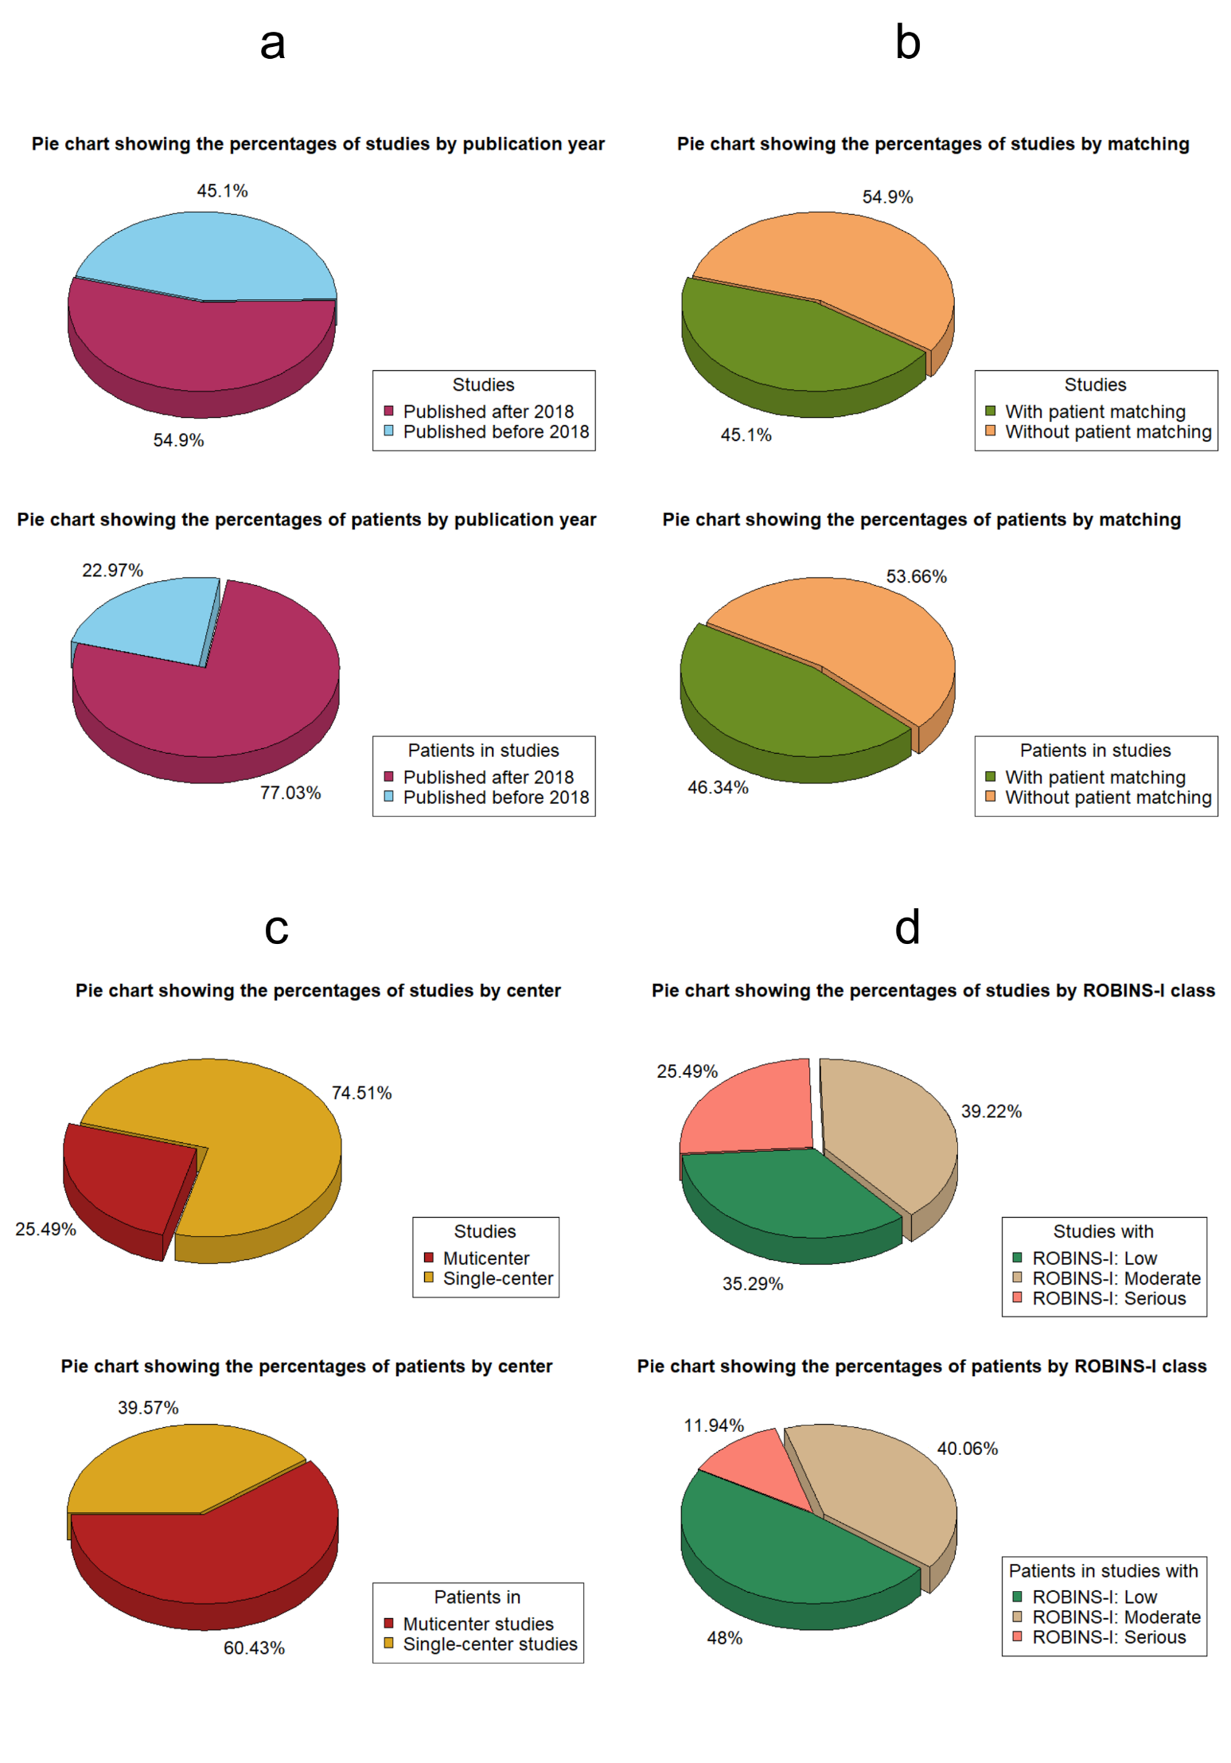

Supplementary Figure 1: Pie charts illustrating the percentages of studies and patients categorized by publication year (a), application of patient matching (b), number of referral centers (c), and class according to the ROBINS-I tool (d). Abbreviations: ROBINS-I: Risk of Bias In Non-randomized Studies of Interventions.

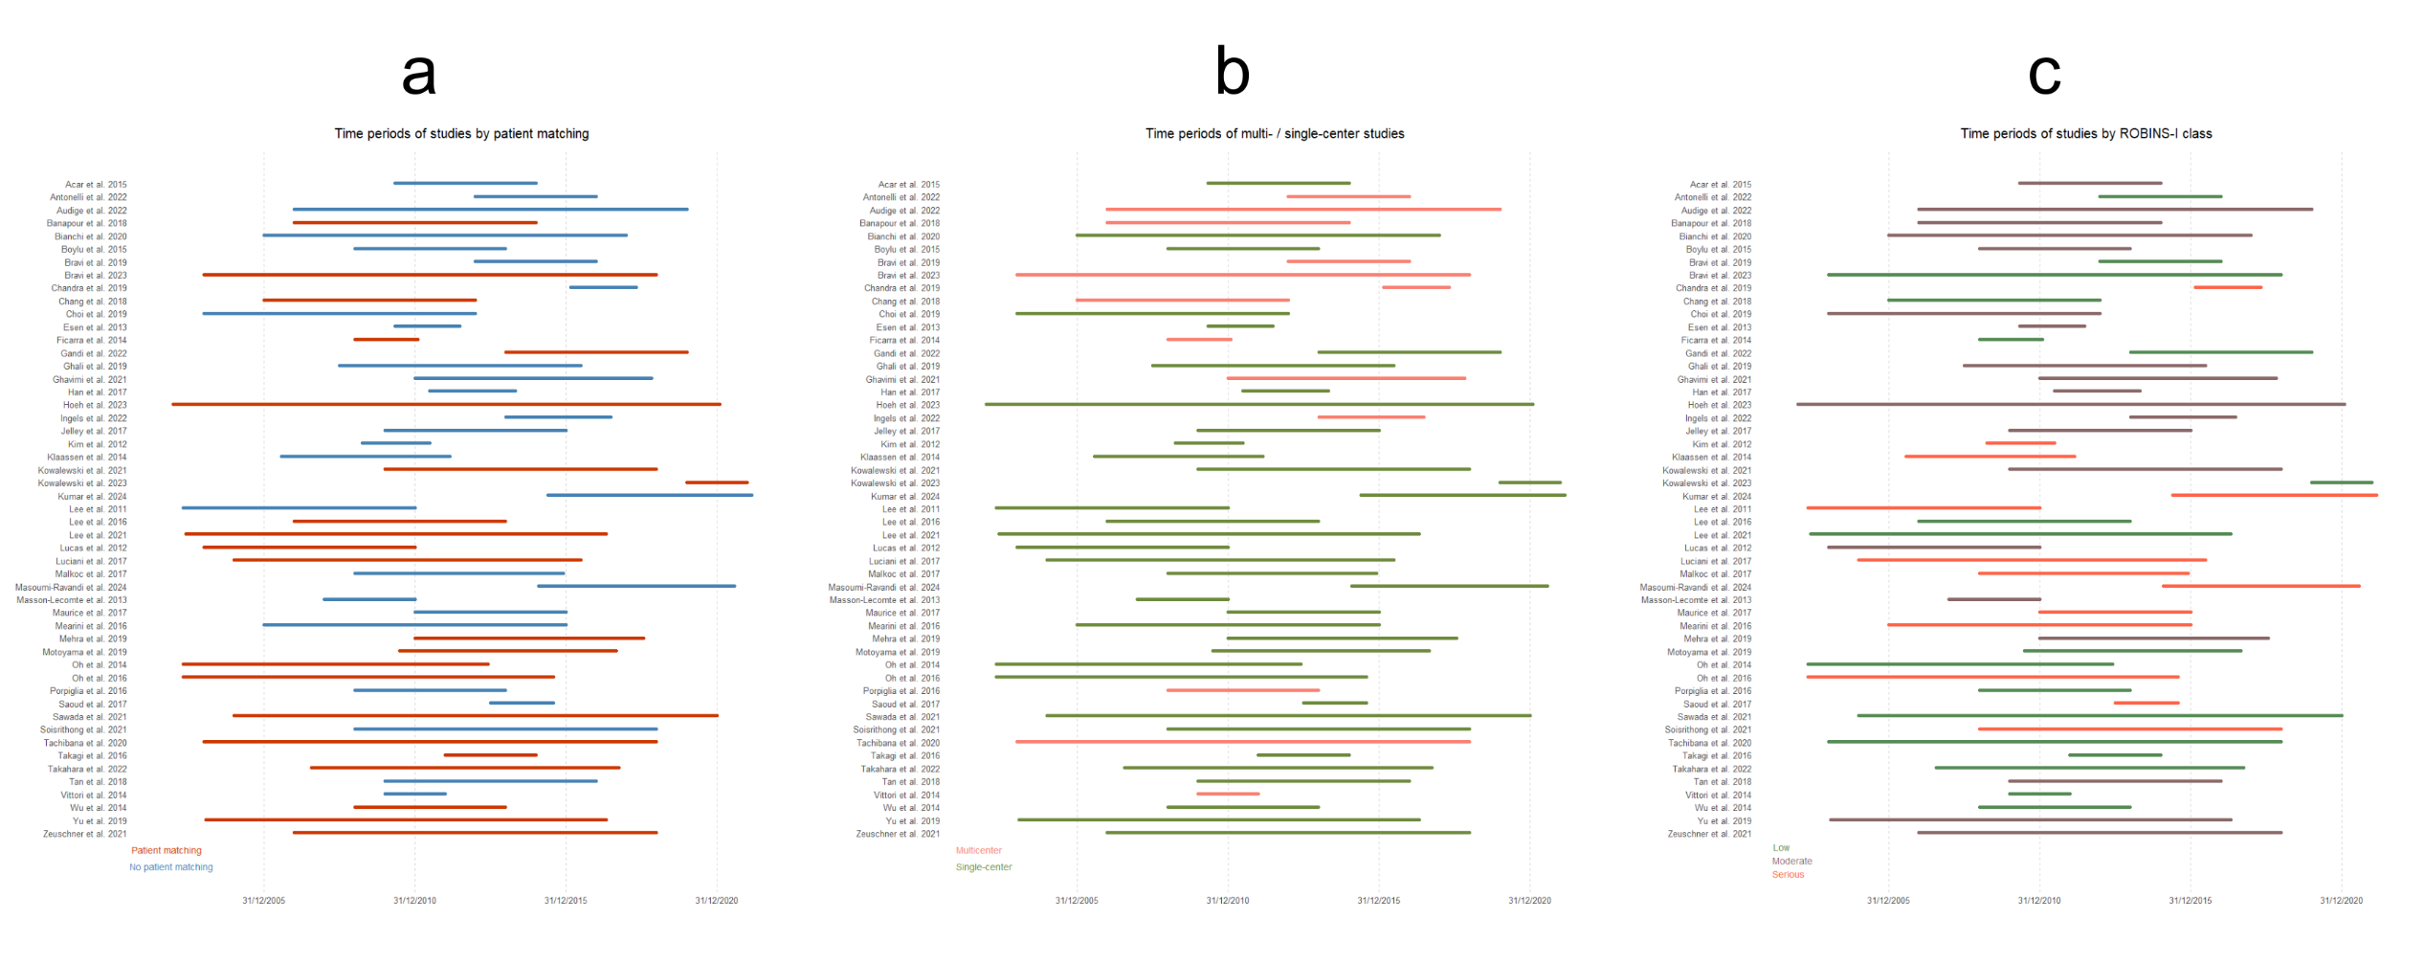
Supplementary Figure 2: Horizontal stacked bar charts illustrating the time frames of activity with respect to the subgroups based on patient matching (a), the number of referral centers involved (b), and ROB clustering according to the ROBINS-I tool (c). Abbreviations: ROB: Risk of Bias, ROBINS-I: Risk of Bias In Non-randomized Studies of Interventions.
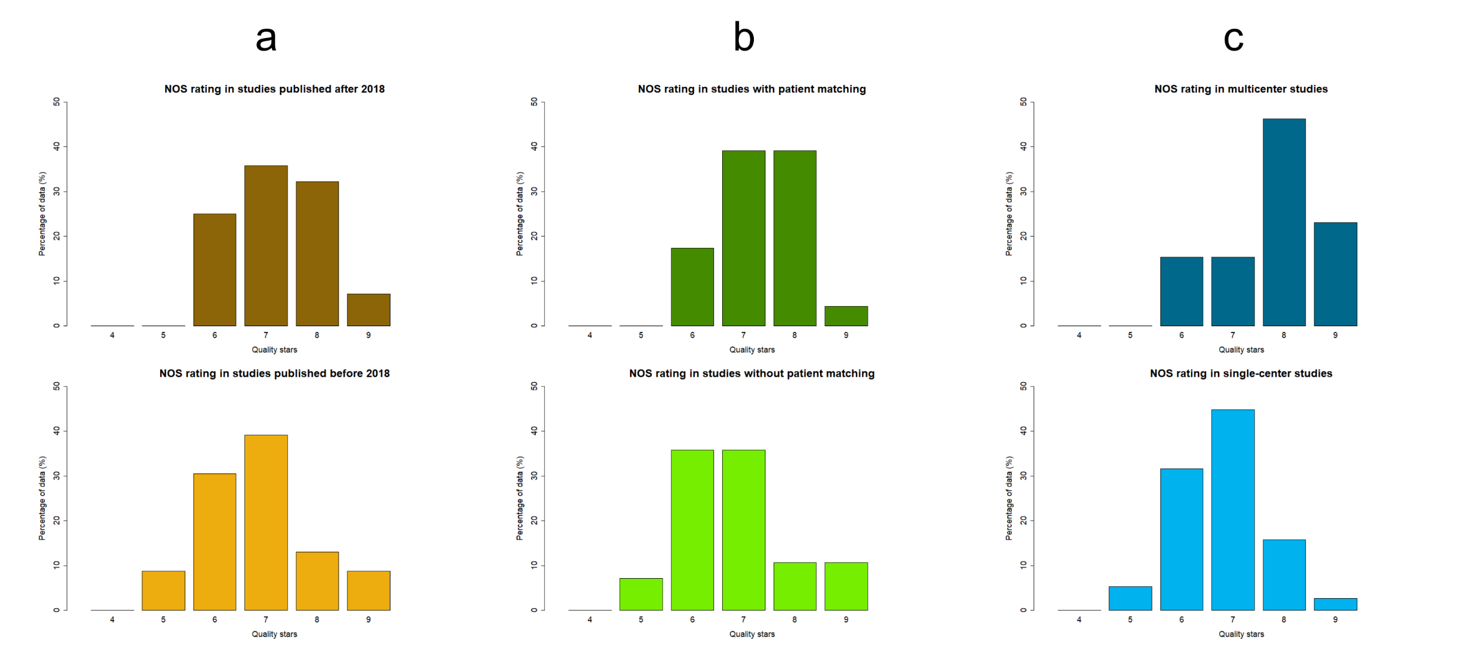
Supplementary Figure 3: Histograms depicting the percentage distributions of NOS ratings across the different subgroups, according to publication year (a), the adoption of patient matching (b), and the number of referral centers involved (c). Abbreviations: NOS: Newcastle-Ottawa Scale.

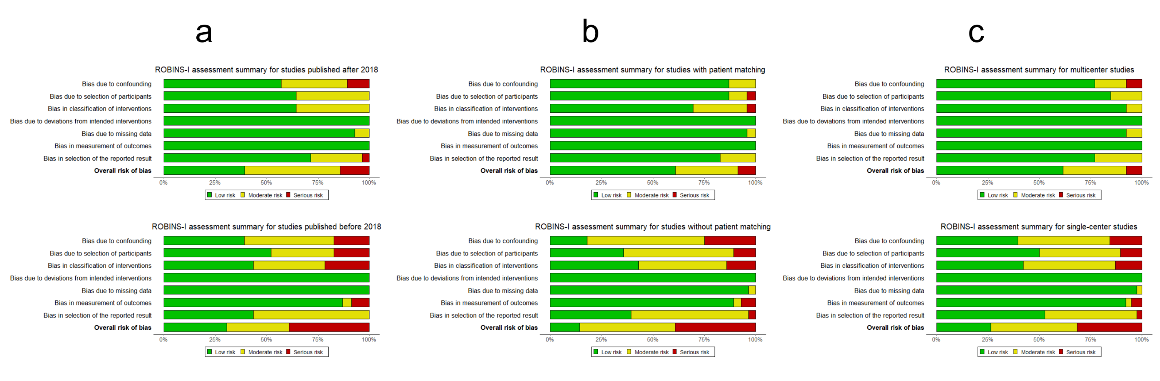
Supplementary Figure 4: Robvis summary plots illustrating the ROBINS-I assessment of subgroups by publication year (a), patient matching (b), and the number of referral centers involved (c). Abbreviations: ROBINS-I: Risk of Bias In Non-randomized Studies of Interventions.

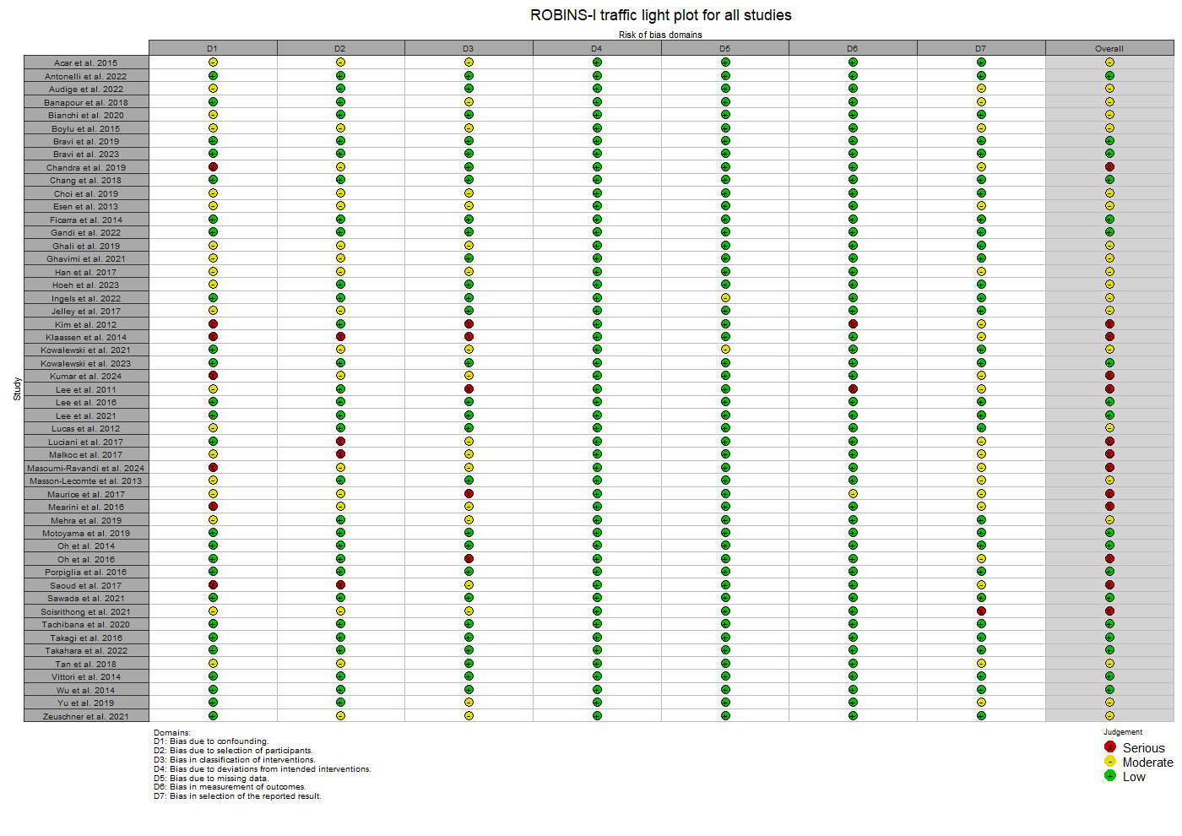

Supplementary Figure 5: Robvis traffic light plot illustrating the evaluation of all included studies using the ROBINS-I tool, presenting their ROB level within each of the seven domains of the tool. Abbreviations: ROBINS-I: Risk of Bias In Non-randomized Studies of Interventions, ROB: Risk of Bias.
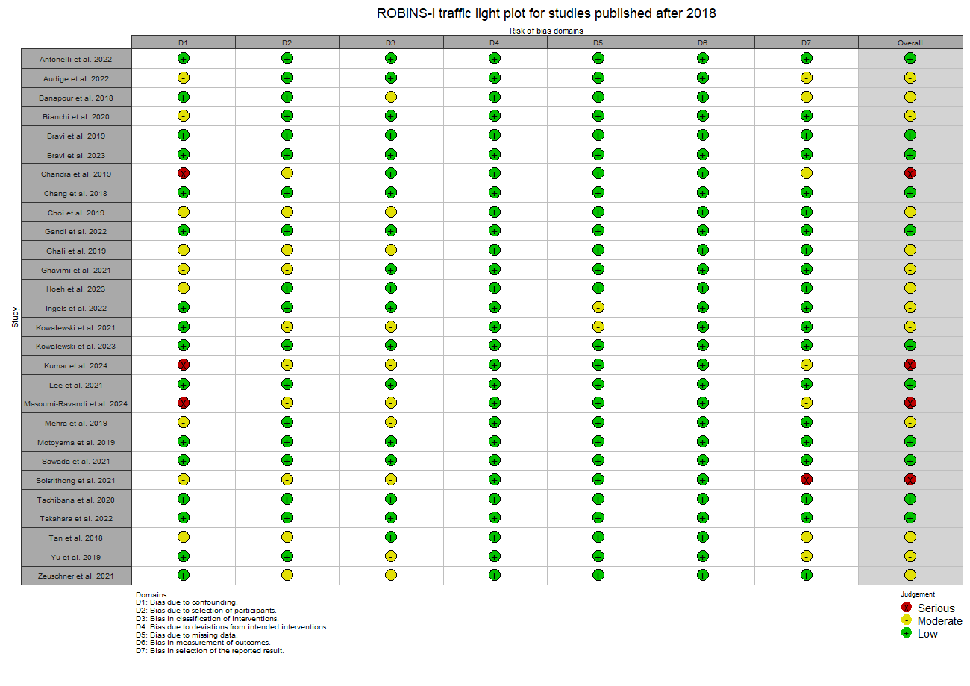

Supplementary Figure 6: Robvis traffic light plot illustrating the evaluation of studies published post-2018 using the ROBINS-I tool, presenting their ROB level within each of the seven domains of the tool. Abbreviations: ROBINS-I: Risk of Bias In Non-randomized Studies of Interventions, ROB: Risk of Bias.
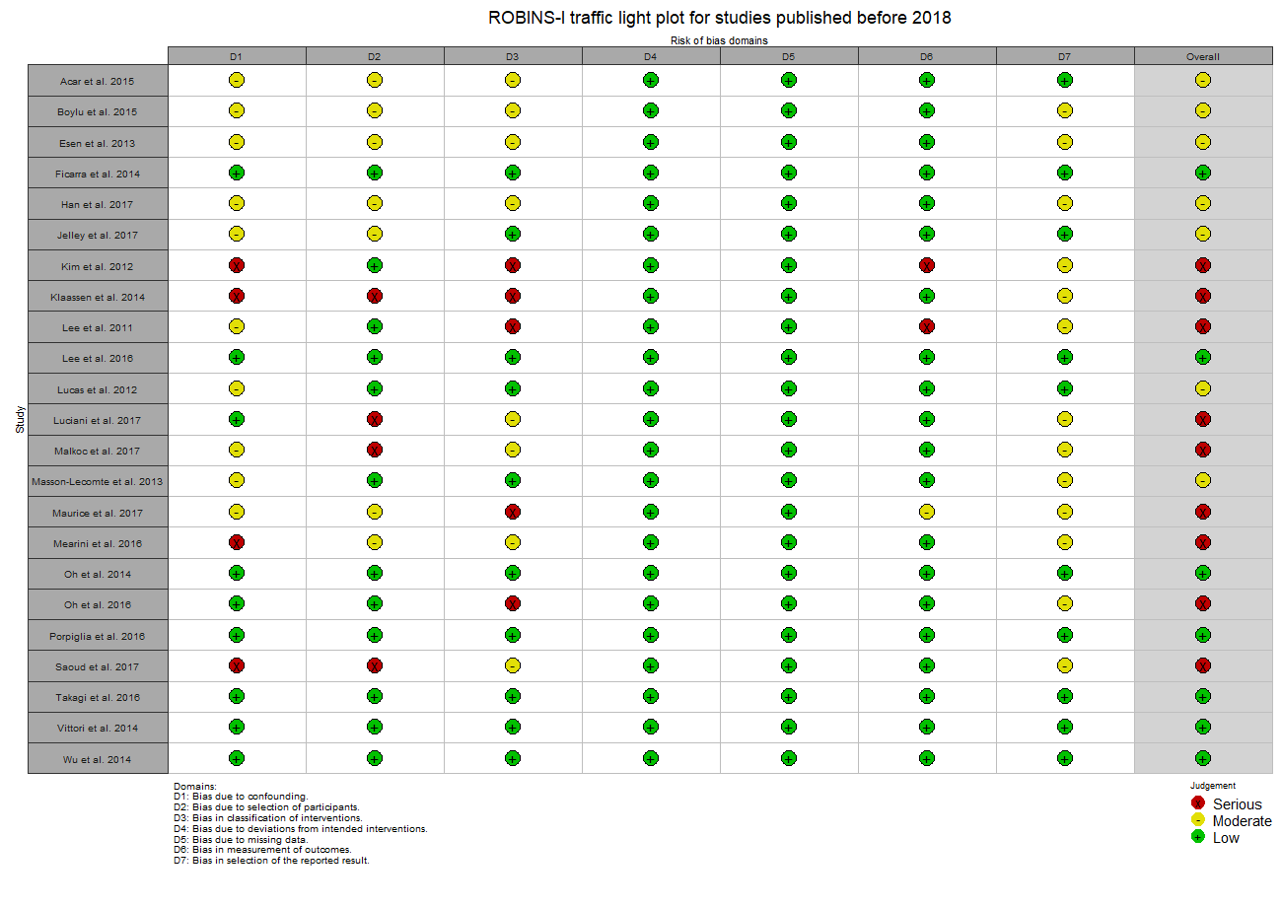
Supplementary Figure 7: Robvis traffic light plot illustrating the evaluation of studies published pre-2018 using the ROBINS-I tool, presenting their ROB level within each of the seven domains of the tool. Abbreviations: ROBINS-I: Risk of Bias In Non-randomized Studies of Interventions, ROB: Risk of Bias.

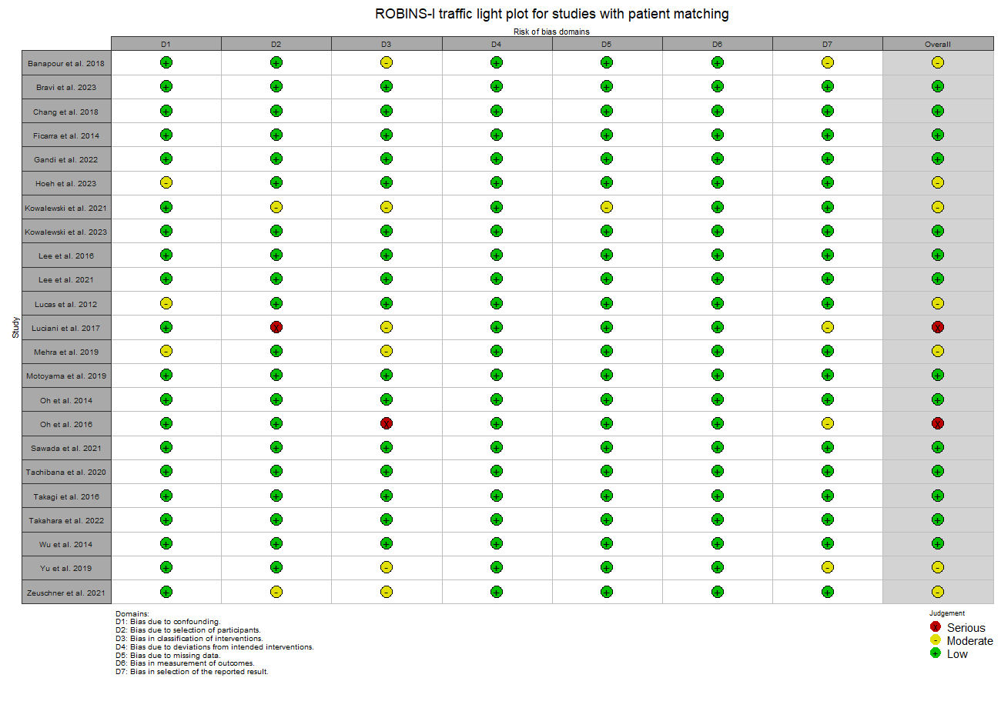
Supplementary Figure 8: Robvis traffic light plot illustrating the evaluation of matched analyses using the ROBINS-I tool, presenting their ROB level within each of the seven domains of the tool. Abbreviations: ROBINS-I: Risk of Bias In Non-randomized Studies of Interventions, ROB: Risk of Bias.
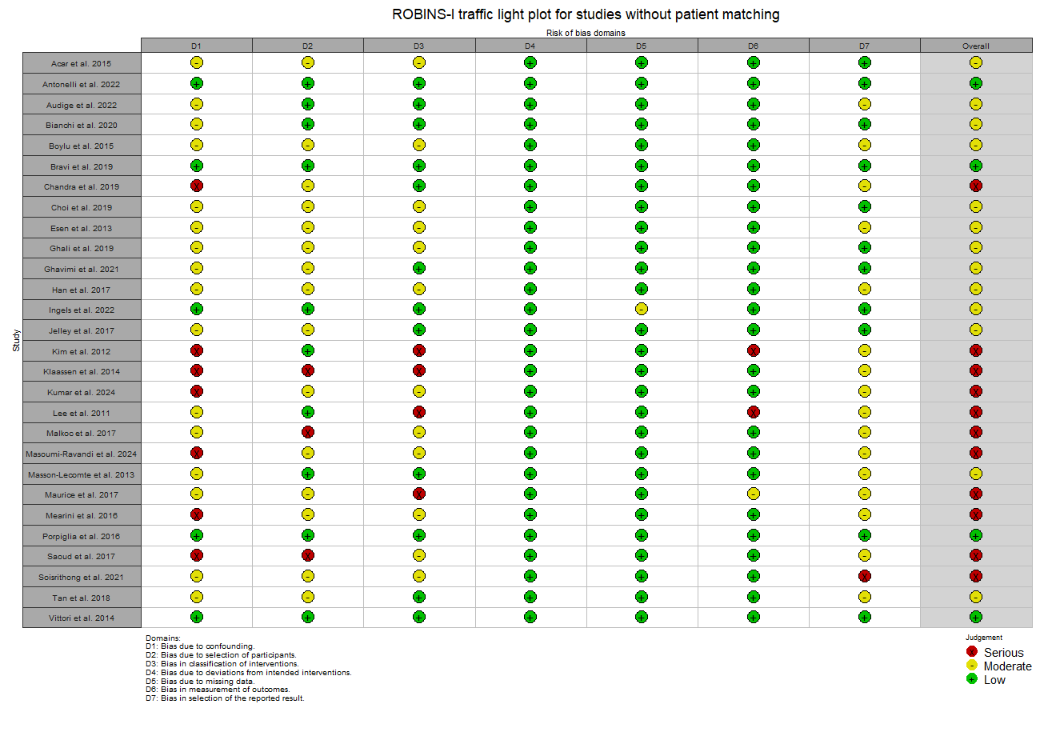
Supplementary Figure 9: Robvis traffic light plot illustrating the evaluation of non-matched analyses using the ROBINS-I tool, presenting their ROB level within each of the seven domains of the tool. Abbreviations: ROBINS-I: Risk of Bias In Non-randomized Studies of Interventions, ROB: Risk of Bias.
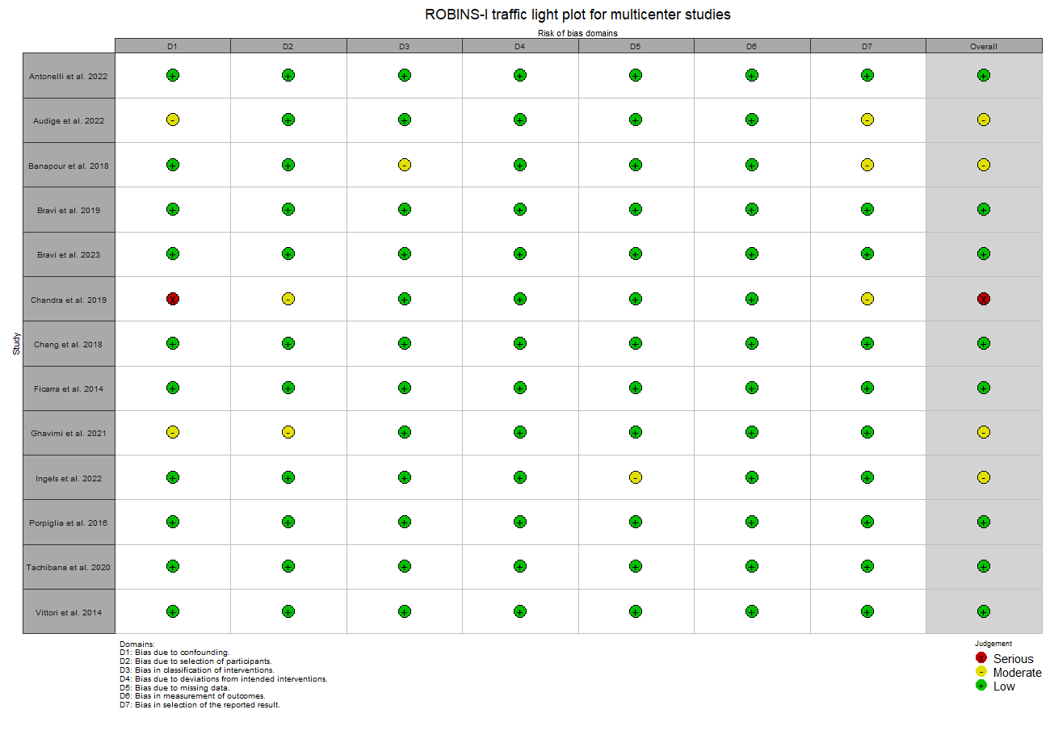
Supplementary Figure 10: Robvis traffic light plot illustrating the evaluation of multicenter studies using the ROBINS-I tool, presenting their ROB level within each of the seven domains of the tool. Abbreviations: ROBINS-I: Risk of Bias In Non-randomized Studies of Interventions, ROB: Risk of Bias.
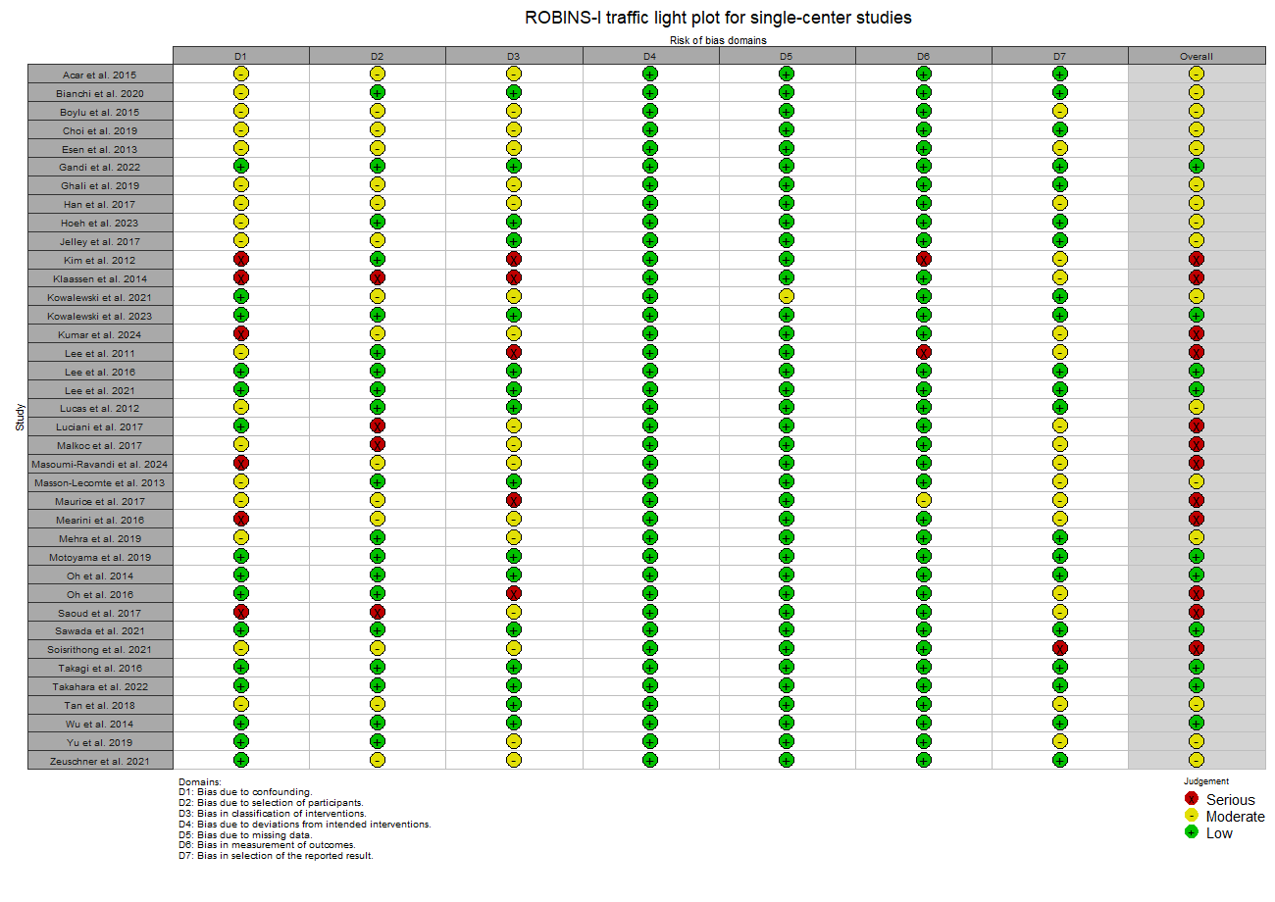
Supplementary Figure 11: Robvis traffic light plot illustrating the evaluation of single-center studies using the ROBINS-I tool, presenting their ROB level within each of the seven domains of the tool. Abbreviations: ROBINS-I: Risk of Bias In Non-randomized Studies of Interventions, ROB: Risk of Bias.

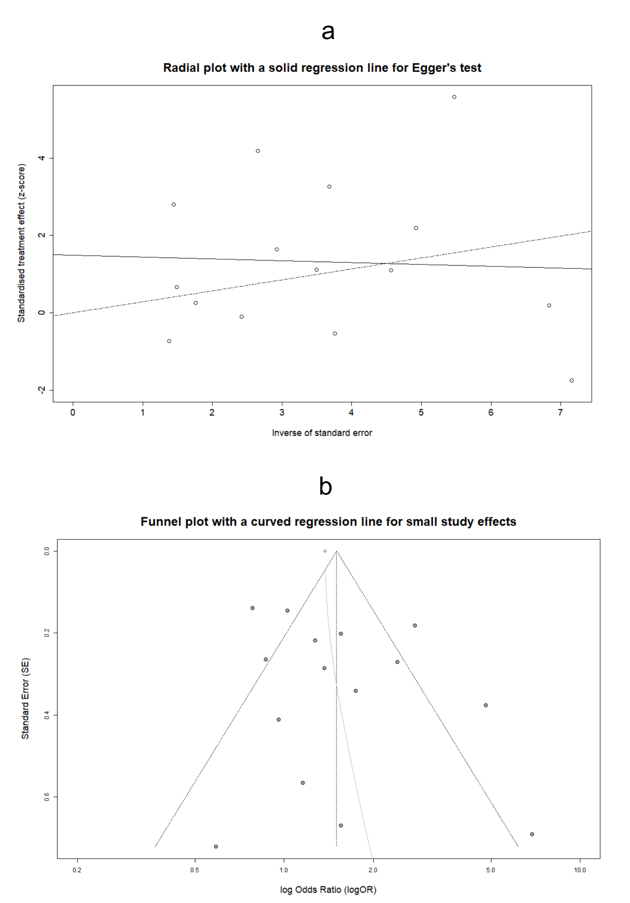
Supplementary Figure 12: Radial plot with integrated Egger’s test for the assessment of PB in estimating the OR_{Trifecta} (a). Funnel plot with graphical display of SSEs for evaluating the aforementioned PB (b). Abbreviations: PB: Publication Bias, OR: Odds Ratio, SSEs: Small Study Effects.

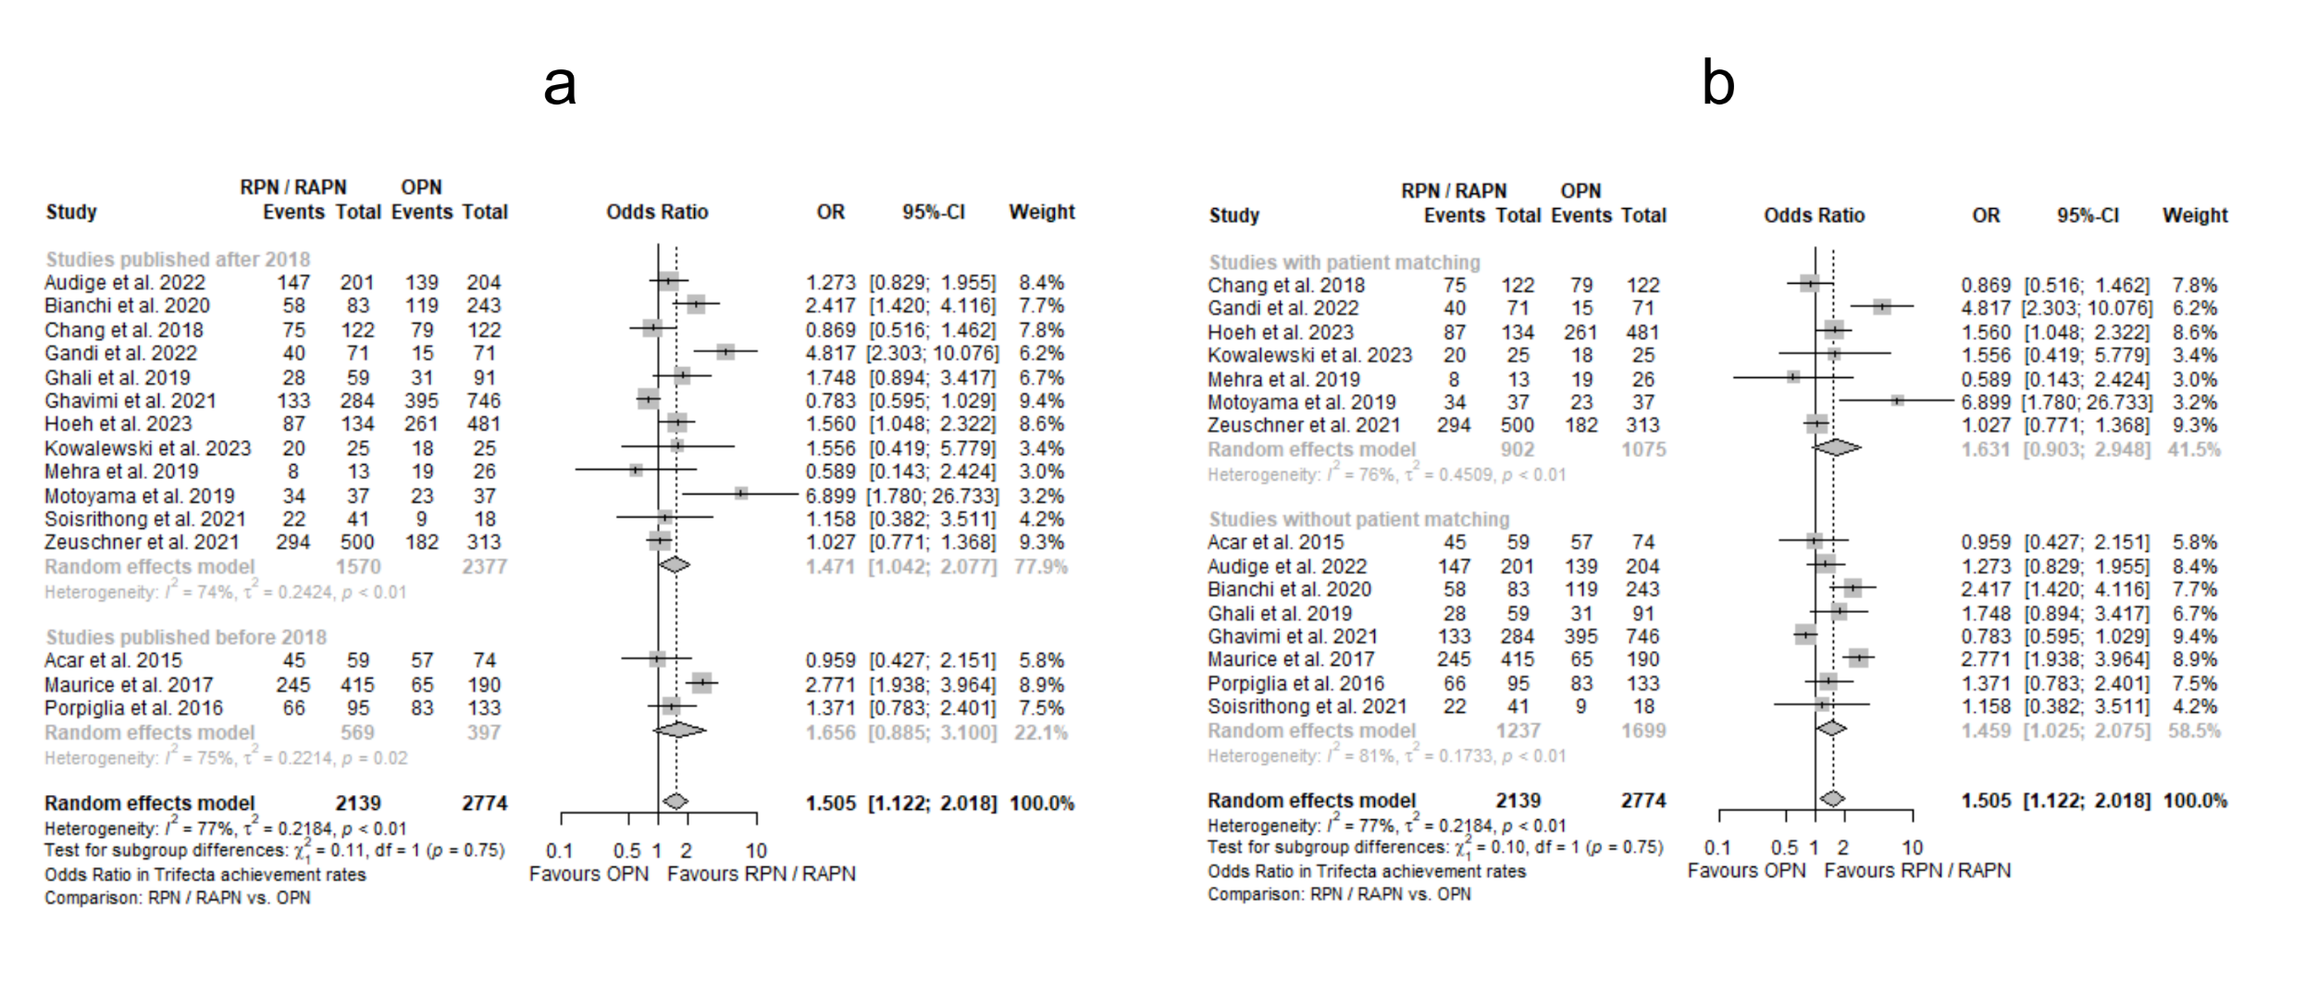
Supplementary Figure 13: Forest plots for estimating the OR_{Trifecta} in subgroups according to publication year (a), and the application of patient matching (b). Abbreviations: OR: Odds Ratio.

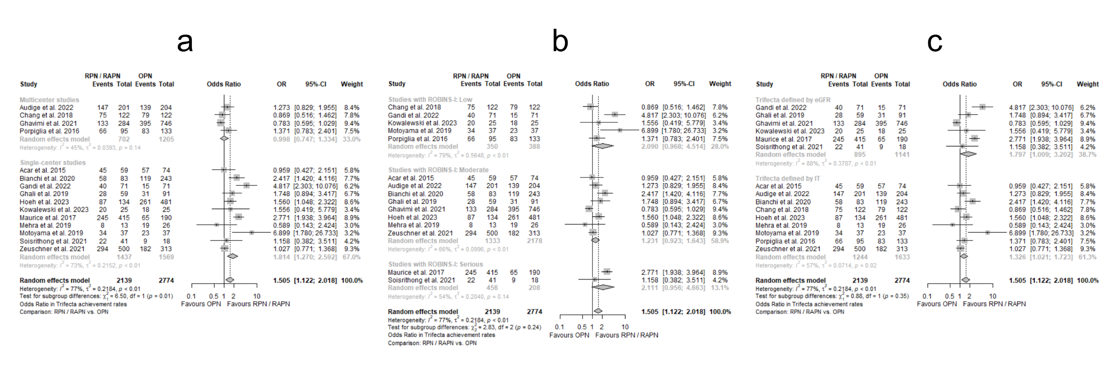
Supplementary Figure 14: Forest plots for estimating the OR_{Trifecta} in subgroups according to the number of referral centers involved (a), the ROBINS-I class (b), and the definition assigned to Trifecta (c). Abbreviations: OR: Odds Ratio, ROBINS-I: Risk of Bias In Non-randomized Studies of Interventions.

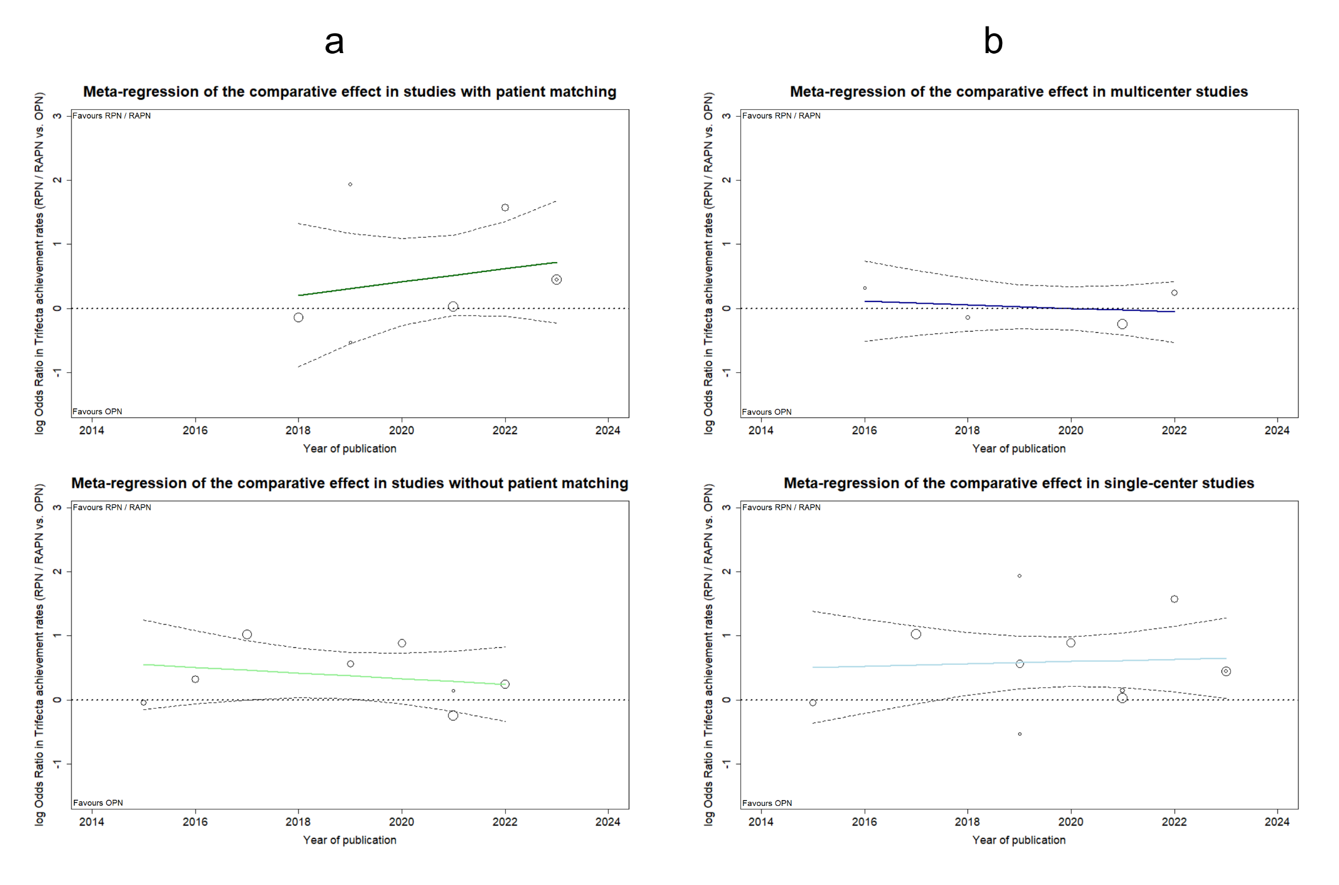
Supplementary Figure 15: MRA plots illustrating the chronological evolution of logOR_{Trifecta} by publication year, in subgroups formed based on patient matching (a), and the number of referral centers involved (b). Abbreviations: MRA: Meta-regression Analysis, logOR: decimal logarithm of Odds Ratio.
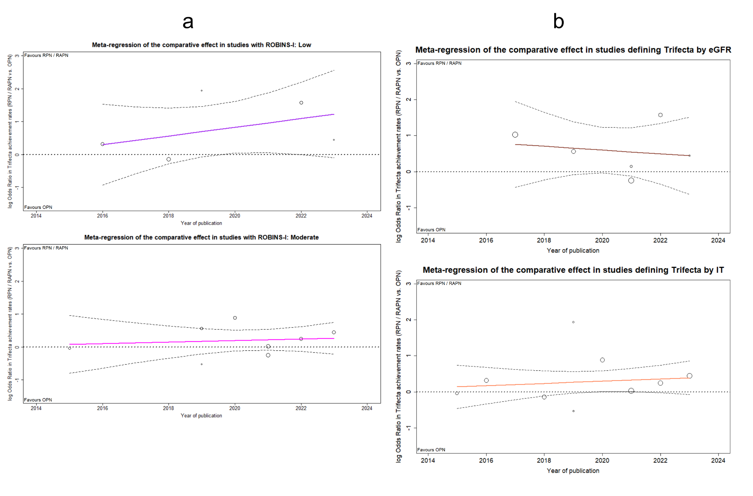
Supplementary Figure 16: MRA plots depicting the time series of logOR_{Trifecta} by publication year, for subgroups formed based on the categorization according to ROBINS-I (a), and the definition assigned to Trifecta (b). Abbreviations: MRA: Meta-regression Analysis, logOR: decimal logarithm of Odds Ratio, ROBINS-I: Risk of Bias In Non-randomized Studies of Interventions.
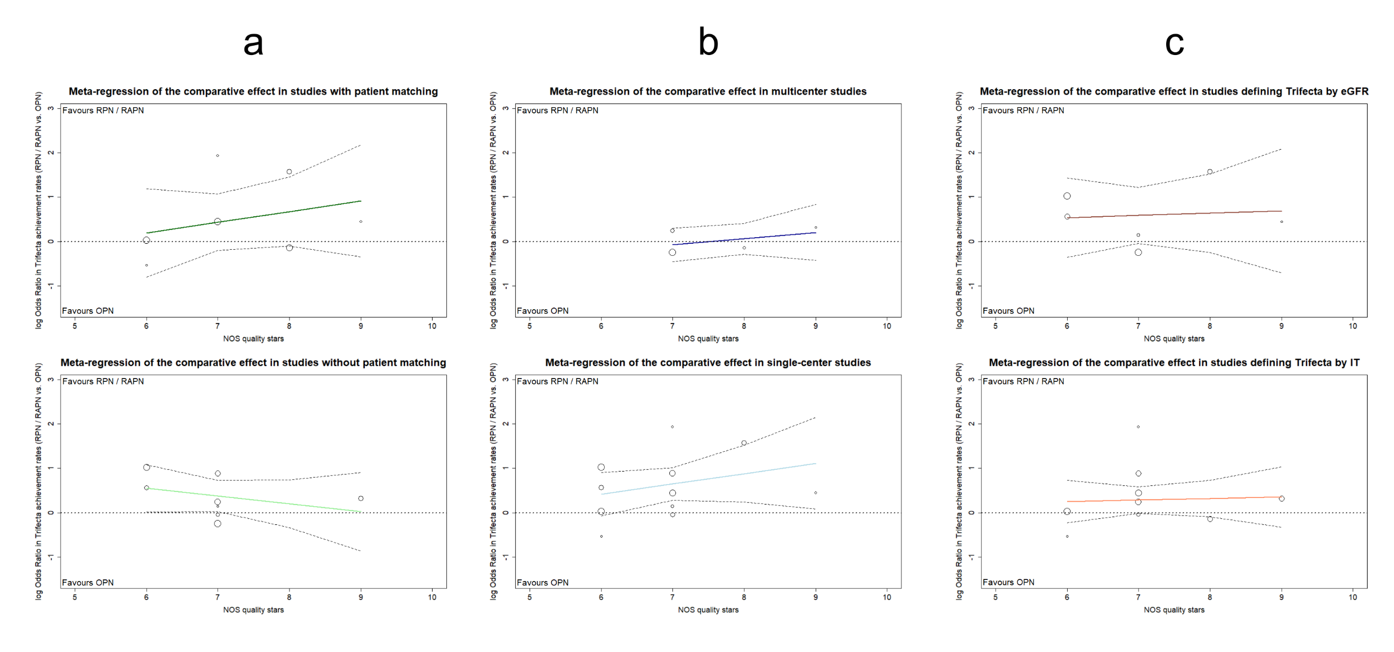
Supplementary Figure 17: MRA plots illustrating the evolution of logOR_{Trifecta} across the qualitative spectrum of included studies via NOS grading, for subgroups formed based on patient matching (a), the number of referral centers involved (b), and the definition assigned to Trifecta (c). Abbreviations: MRA: Meta-regression Analysis, logOR: decimal logarithm of Odds Ratio, NOS: Newcastle-Ottawa Scale.

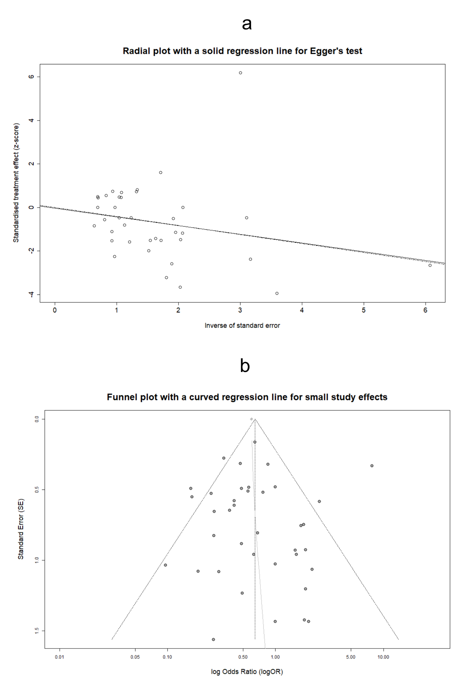
Supplementary Figure 18: Radial plot with integrated Egger’s test for the assessment of PB in estimating the OR_{CD≥3} (a). Funnel plot with graphical display of SSEs for evaluating the aforementioned PB (b). Abbreviations: PB: Publication Bias, OR: Odds Ratio, CD: Clavien-Dindo classification of postoperative complications, SSEs: Small Study Effects.

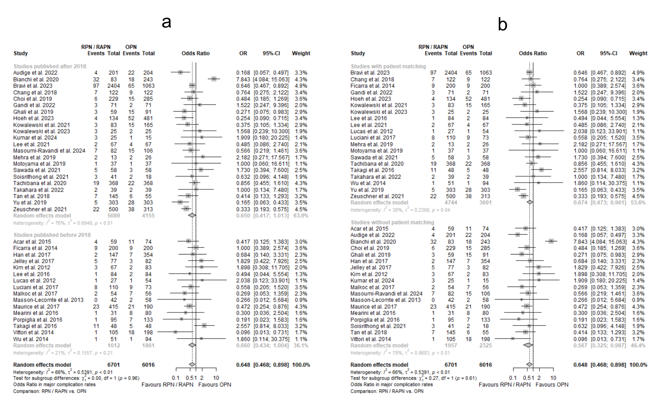
Supplementary Figure 19: Forest plots for estimating the OR_{CD≥3} in subgroups according to publication year (a), and the application of patient matching (b). Abbreviations: OR: Odds Ratio, CD: Clavien-Dindo classification of postoperative complications.
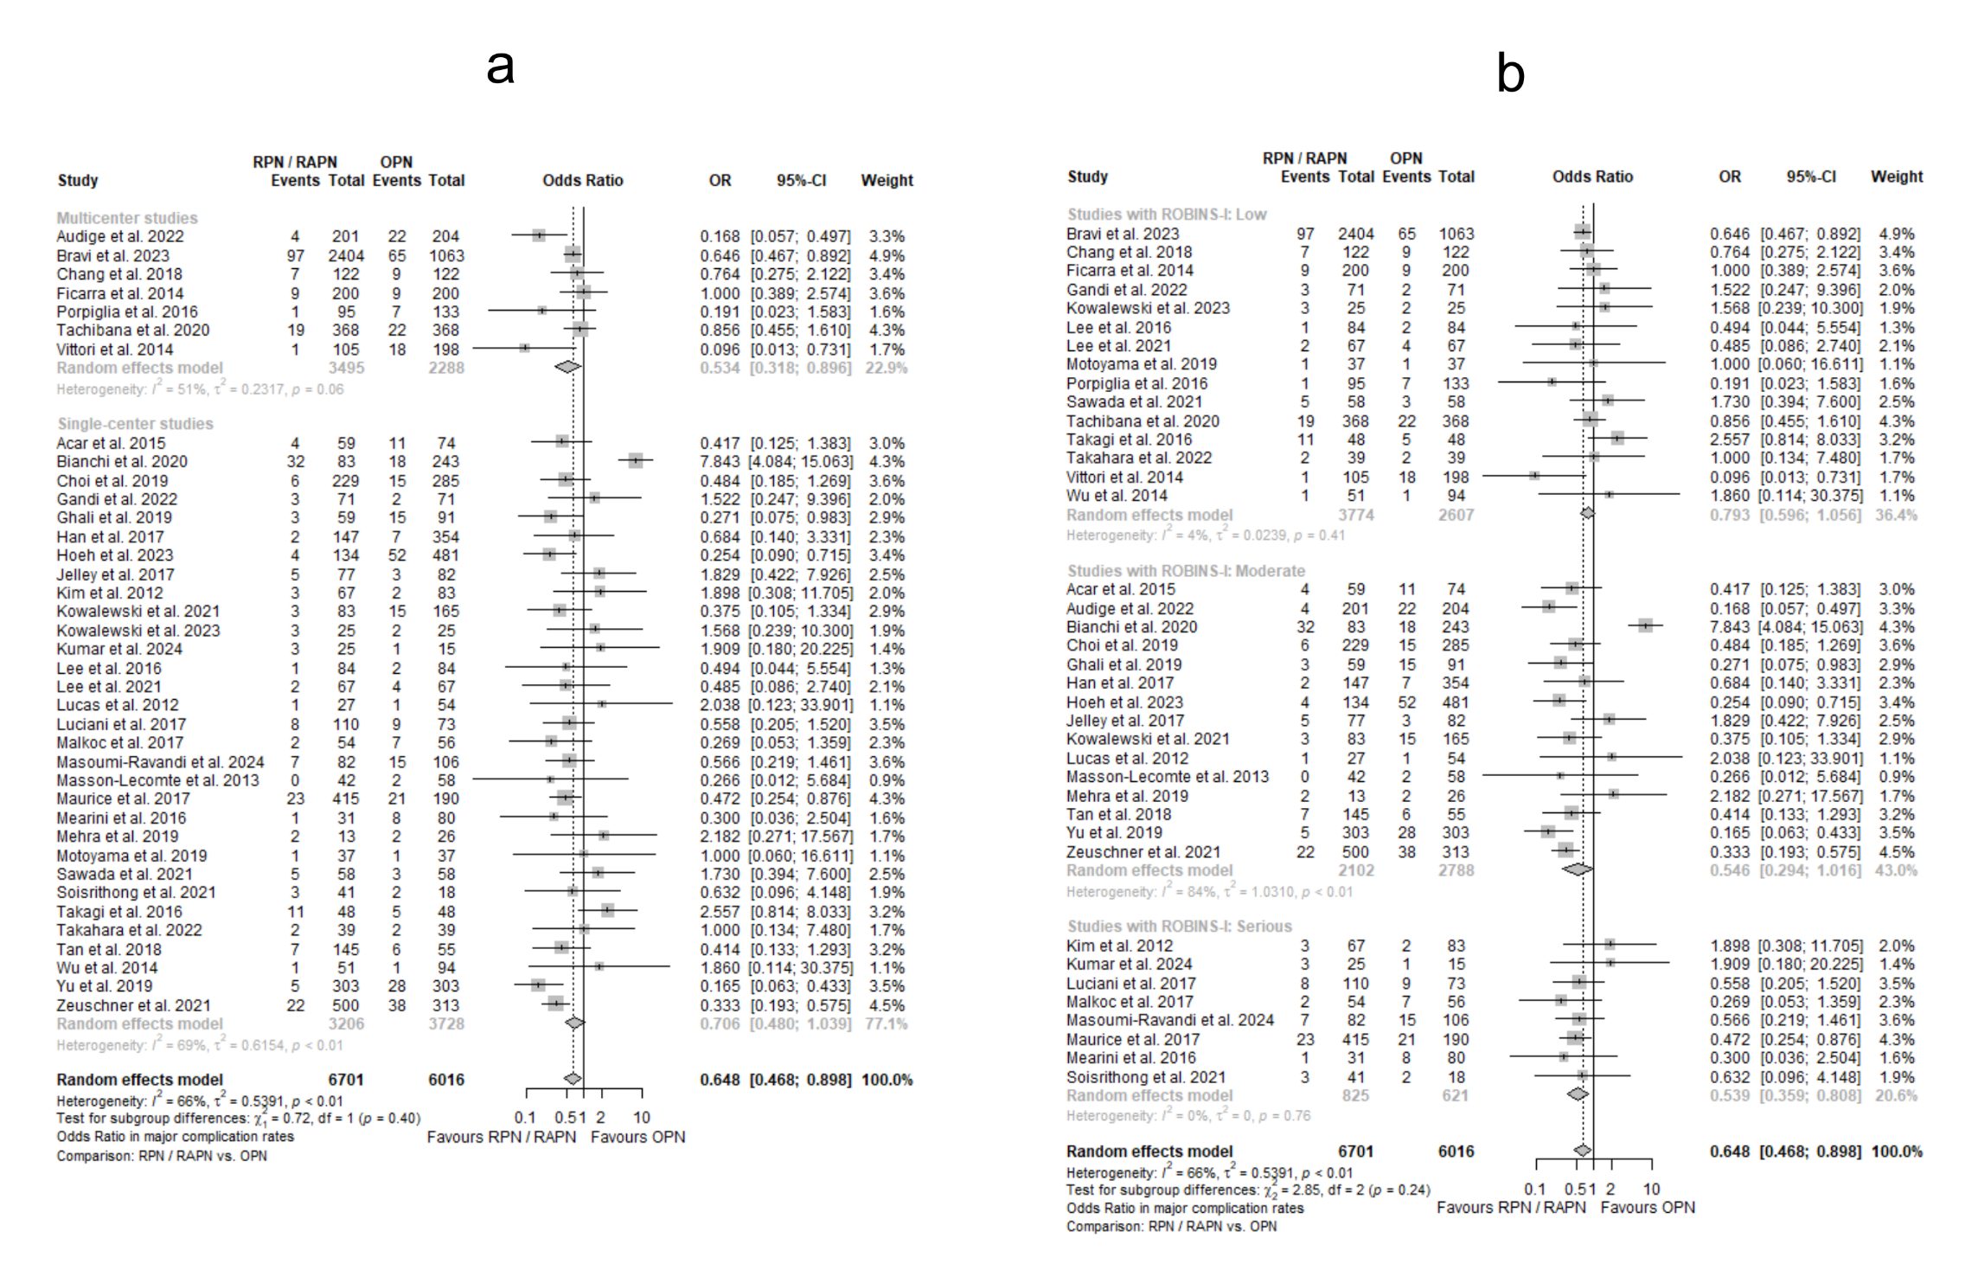
Supplementary Figure 20: Forest plots for estimating the OR_{CD≥3} in subgroups according to the number of referral centers involved (a), and the ROBINS-I class (b). Abbreviations: OR: Odds Ratio, ROBINS-I: Risk of Bias In Non-randomized Studies of Interventions, CD: Clavien-Dindo classification of postoperative complications.
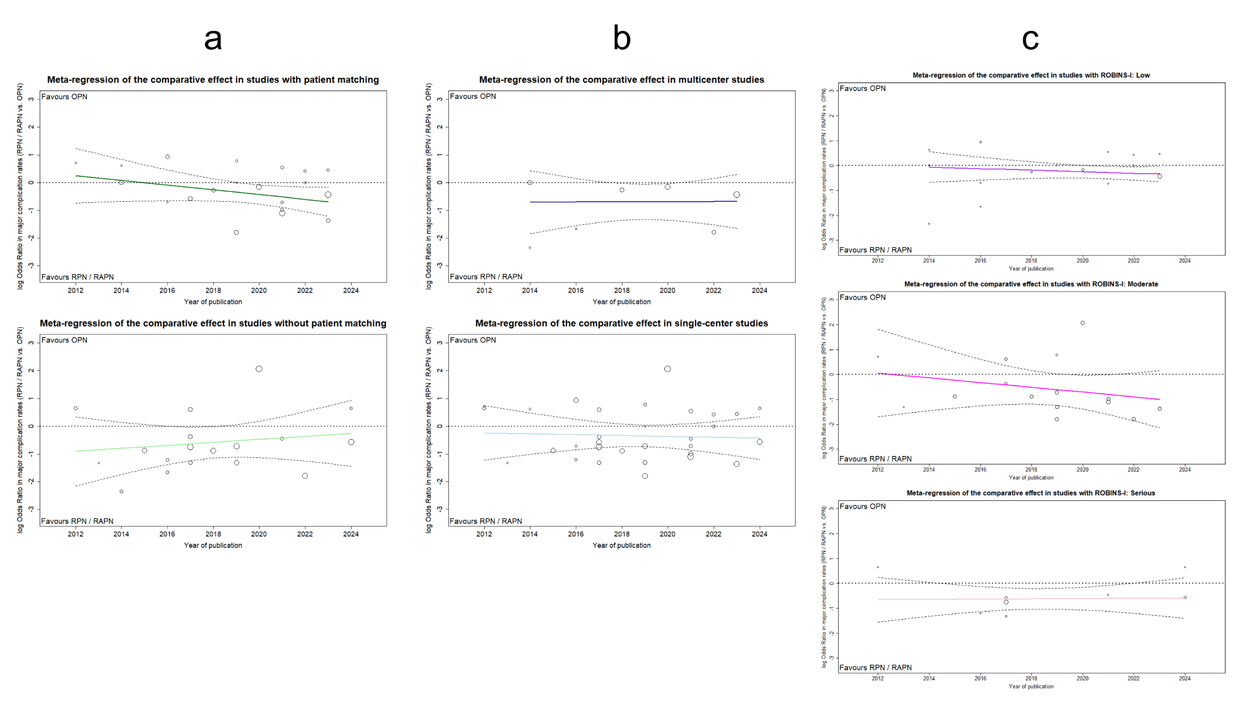
Supplementary Figure 21: MRA plots illustrating the chronological evolution of logOR_{CD≥3} by publication year, in subgroups formed based on patient matching (a), the number of referral centers involved (b), and the categorization according to ROBINS-I (c). Abbreviations: MRA: Meta-regression Analysis, logOR: decimal logarithm of Odds Ratio, CD: Clavien-Dindo classification of postoperative complications, ROBINS-I: Risk of Bias In Non-randomized Studies of Interventions.

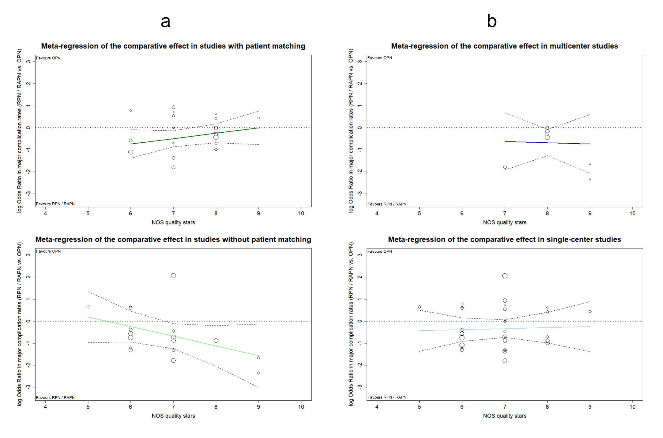
Supplementary Figure 22: MRA plots illustrating the evolution of logOR_{CD≥3} across the qualitative spectrum of included studies via NOS grading, for subgroups formed based on patient matching (a), and the number of referral centers involved (b). Abbreviations: MRA: Meta-regression Analysis, logOR: decimal logarithm of Odds Ratio, CD: Clavien-Dindo classification of postoperative complications, NOS: Newcastle-Ottawa Scale.

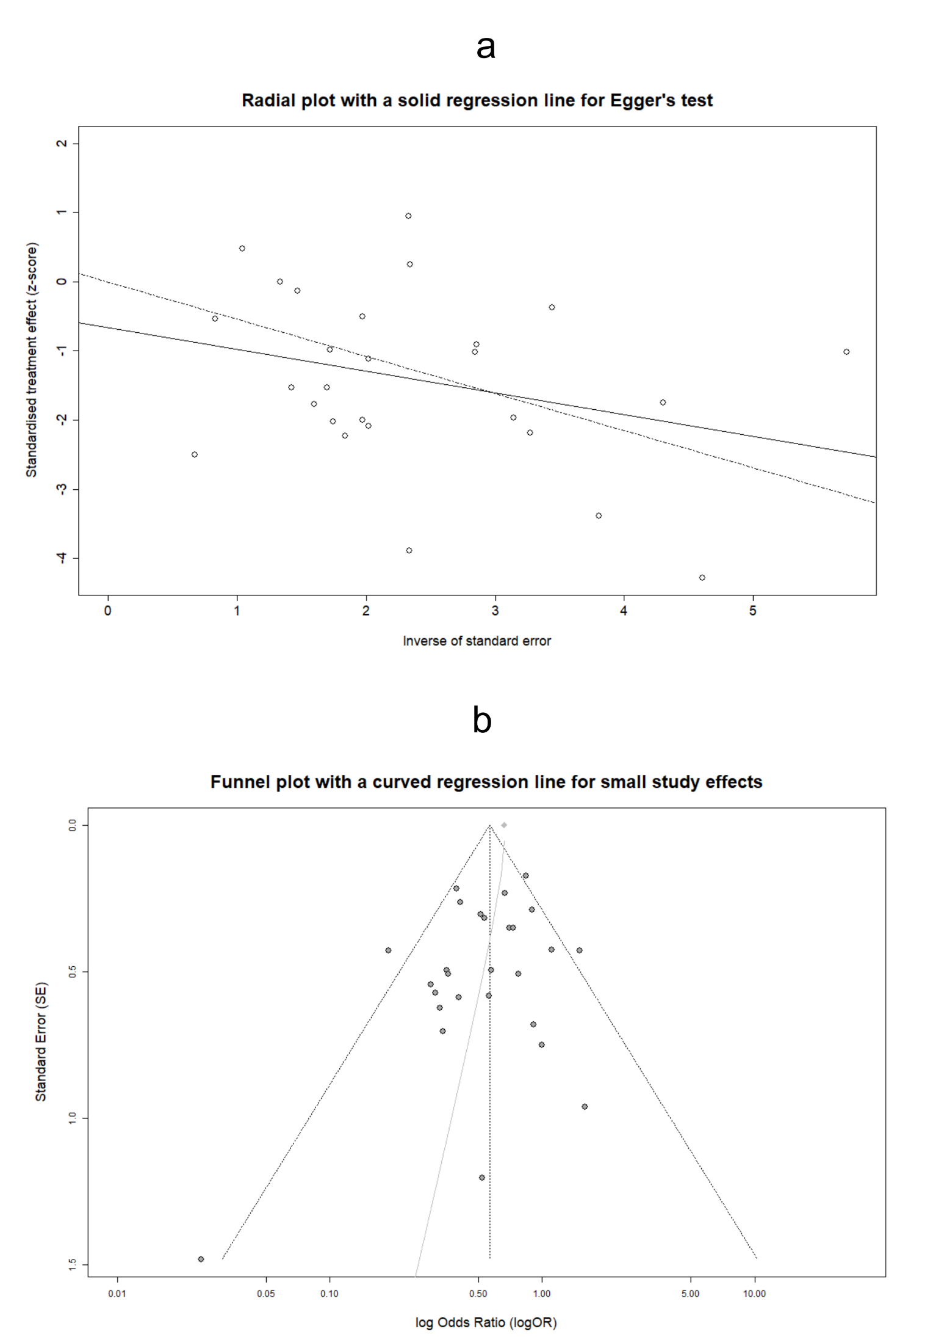
Supplementary Figure 23: Radial plot with integrated Egger’s test for the assessment of PB in estimating the OR_{CD≤2} (a). Funnel plot with graphical display of SSEs for evaluating the aforementioned PB (b). Abbreviations: PB: Publication Bias, OR: Odds Ratio, CD: Clavien-Dindo classification of postoperative complications, SSEs: Small Study Effects.

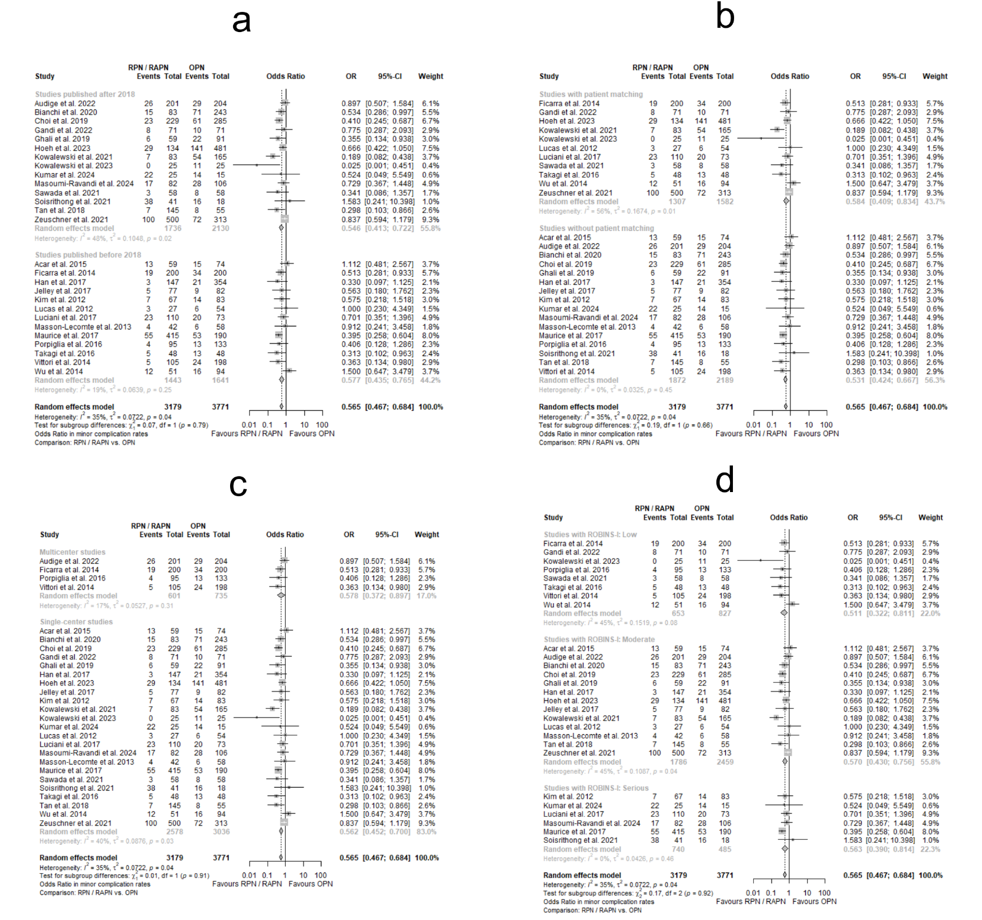
Supplementary Figure 24: Forest plots for estimating the OR_{CD≤2} in subgroups according to publication year (a), the application of patient matching (b), the number of referral centers involved (c), and the ROBINS-I class (d). Abbreviations: OR: Odds Ratio, CD: Clavien-Dindo classification of postoperative complications, ROBINS-I: Risk of Bias In Non-randomized Studies of Interventions.

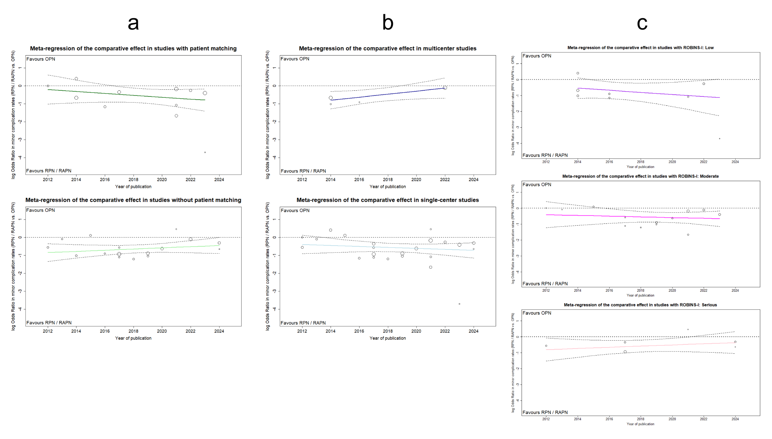
Supplementary Figure 25: MRA plots illustrating the chronological evolution of logOR_{CD≤2} by publication year, in subgroups formed based on patient matching (a), the number of referral centers involved (b), and the ROBINS-I class (c). Abbreviations: MRA: Meta-regression Analysis, logOR: decimal logarithm of Odds Ratio, CD: Clavien-Dindo classification of postoperative complications, ROBINS-I: Risk of Bias In Non-randomized Studies of Interventions.
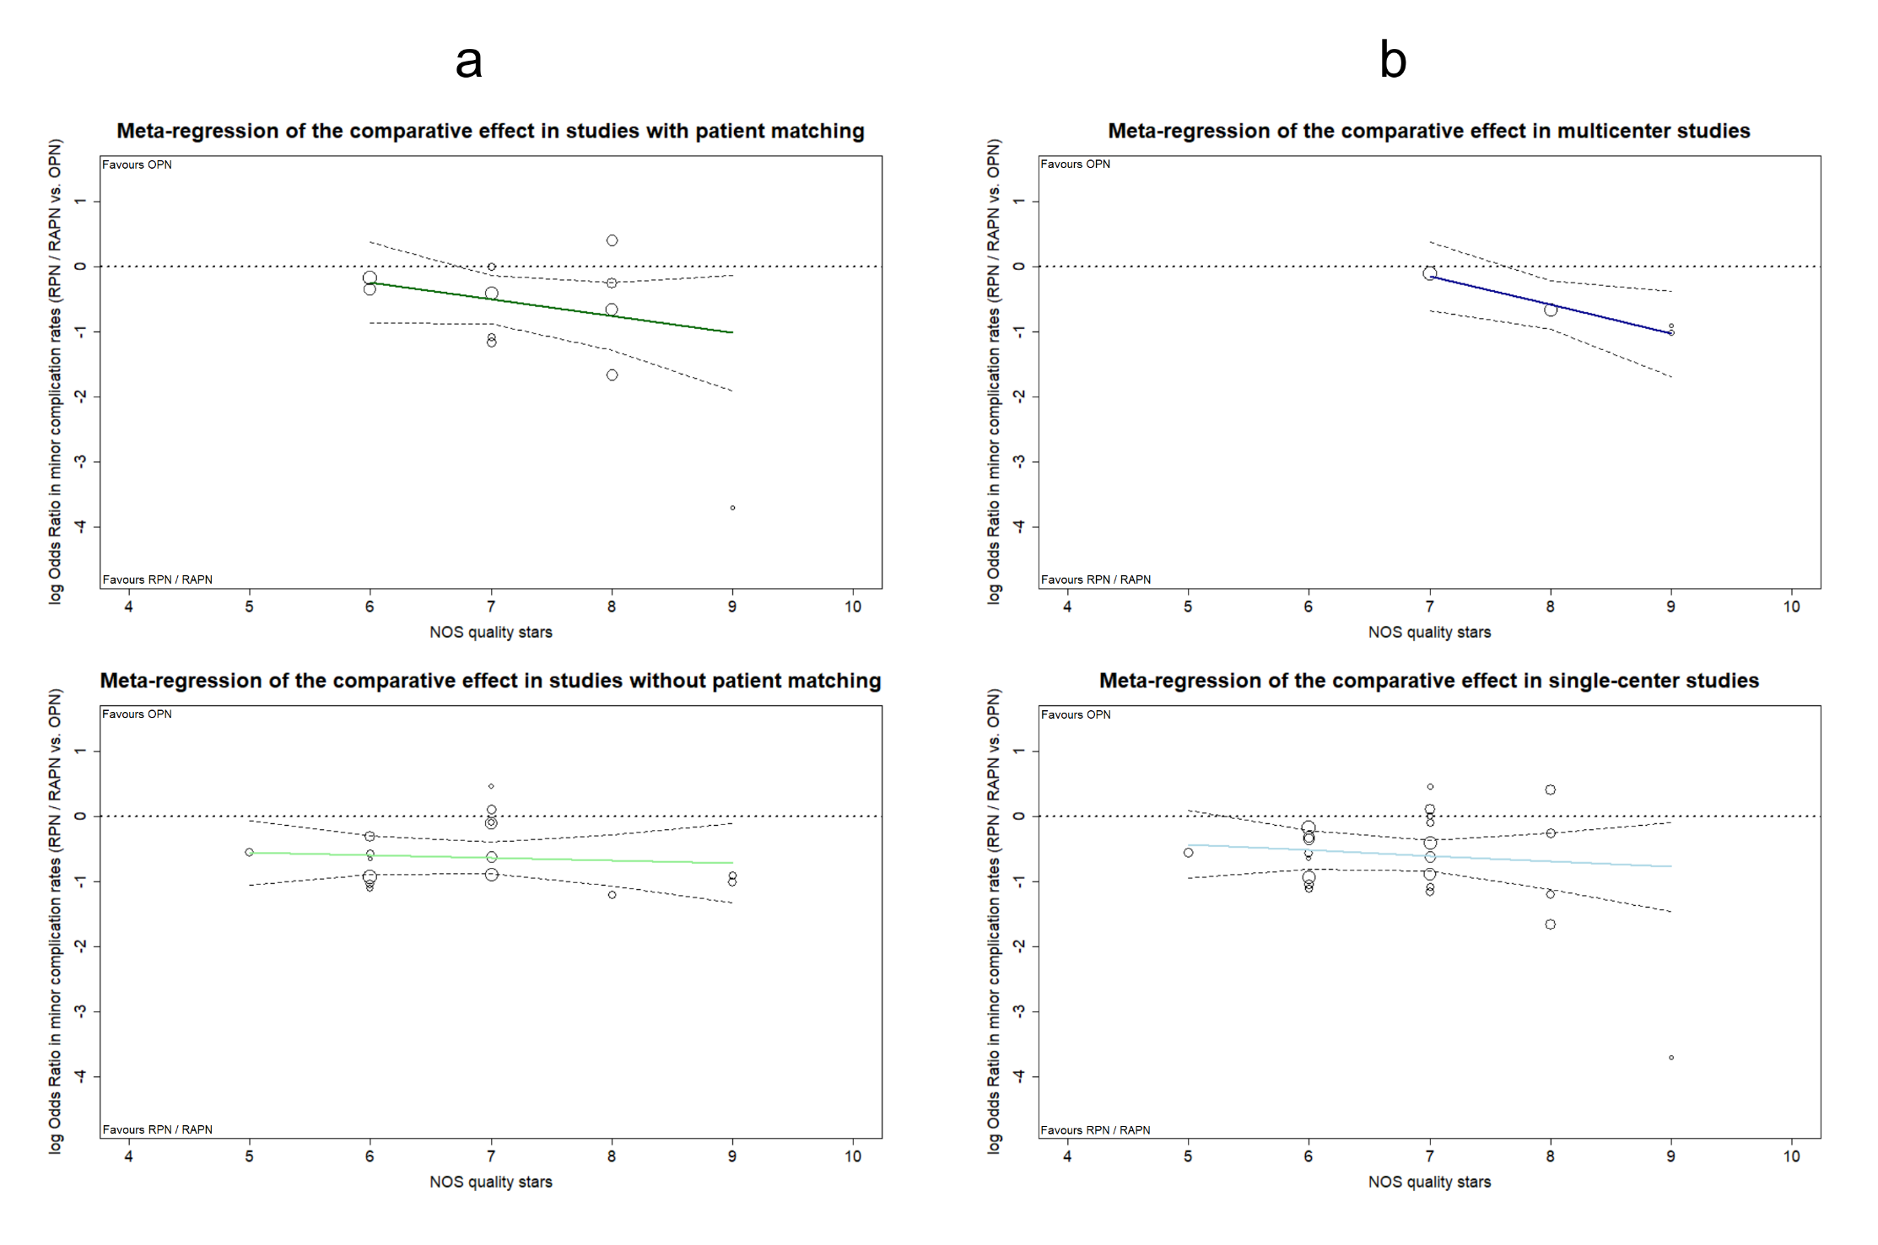
Supplementary Figure 26: MRA plots illustrating the evolution of logOR_{CD≤2} across the qualitative spectrum of included studies via NOS grading, for subgroups formed based on patient matching (a), and the number of referral centers involved (b). Abbreviations: MRA: Meta-regression Analysis, logOR: decimal logarithm of Odds Ratio, CD: Clavien-Dindo classification of postoperative complications, NOS: Newcastle-Ottawa Scale.
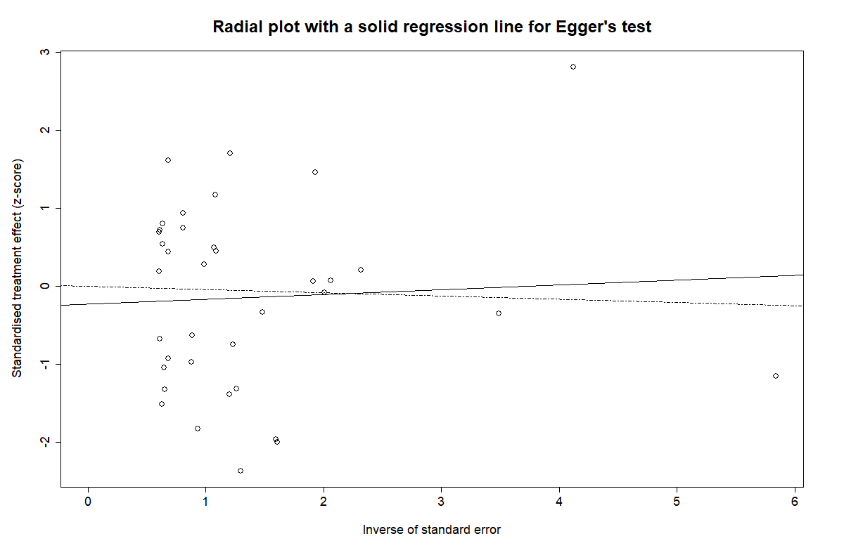
Supplementary Figure 27: Radial plot for the assessment of PB in estimating the OR_{PSM} with the integration of Egger's test as a solid regression line. Abbreviations: PB: Publication Bias, OR: Odds Ratio, PSM: Positive Surgical Margins.

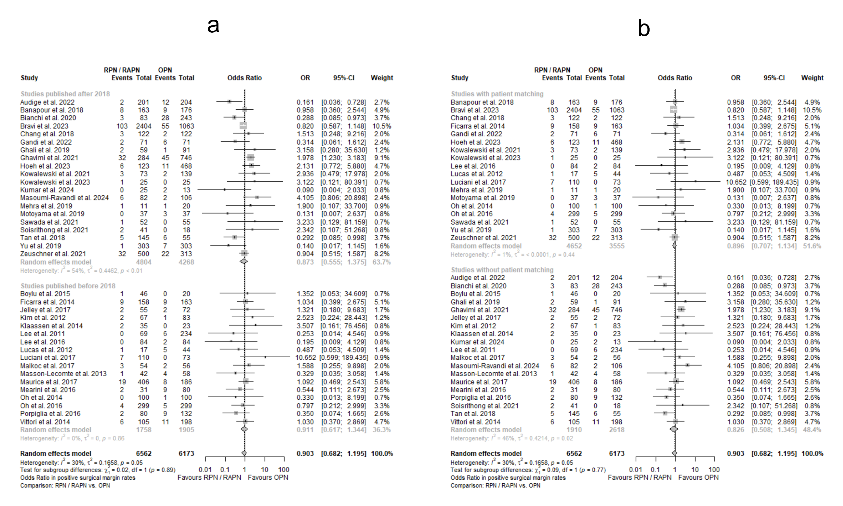
Supplementary Figure 28: Forest plots for estimating the OR_{PSM} in subgroups according to publication year (a), and the application of patient matching (b). Abbreviations: OR: Odds Ratio, PSM: Positive Surgical Margins.

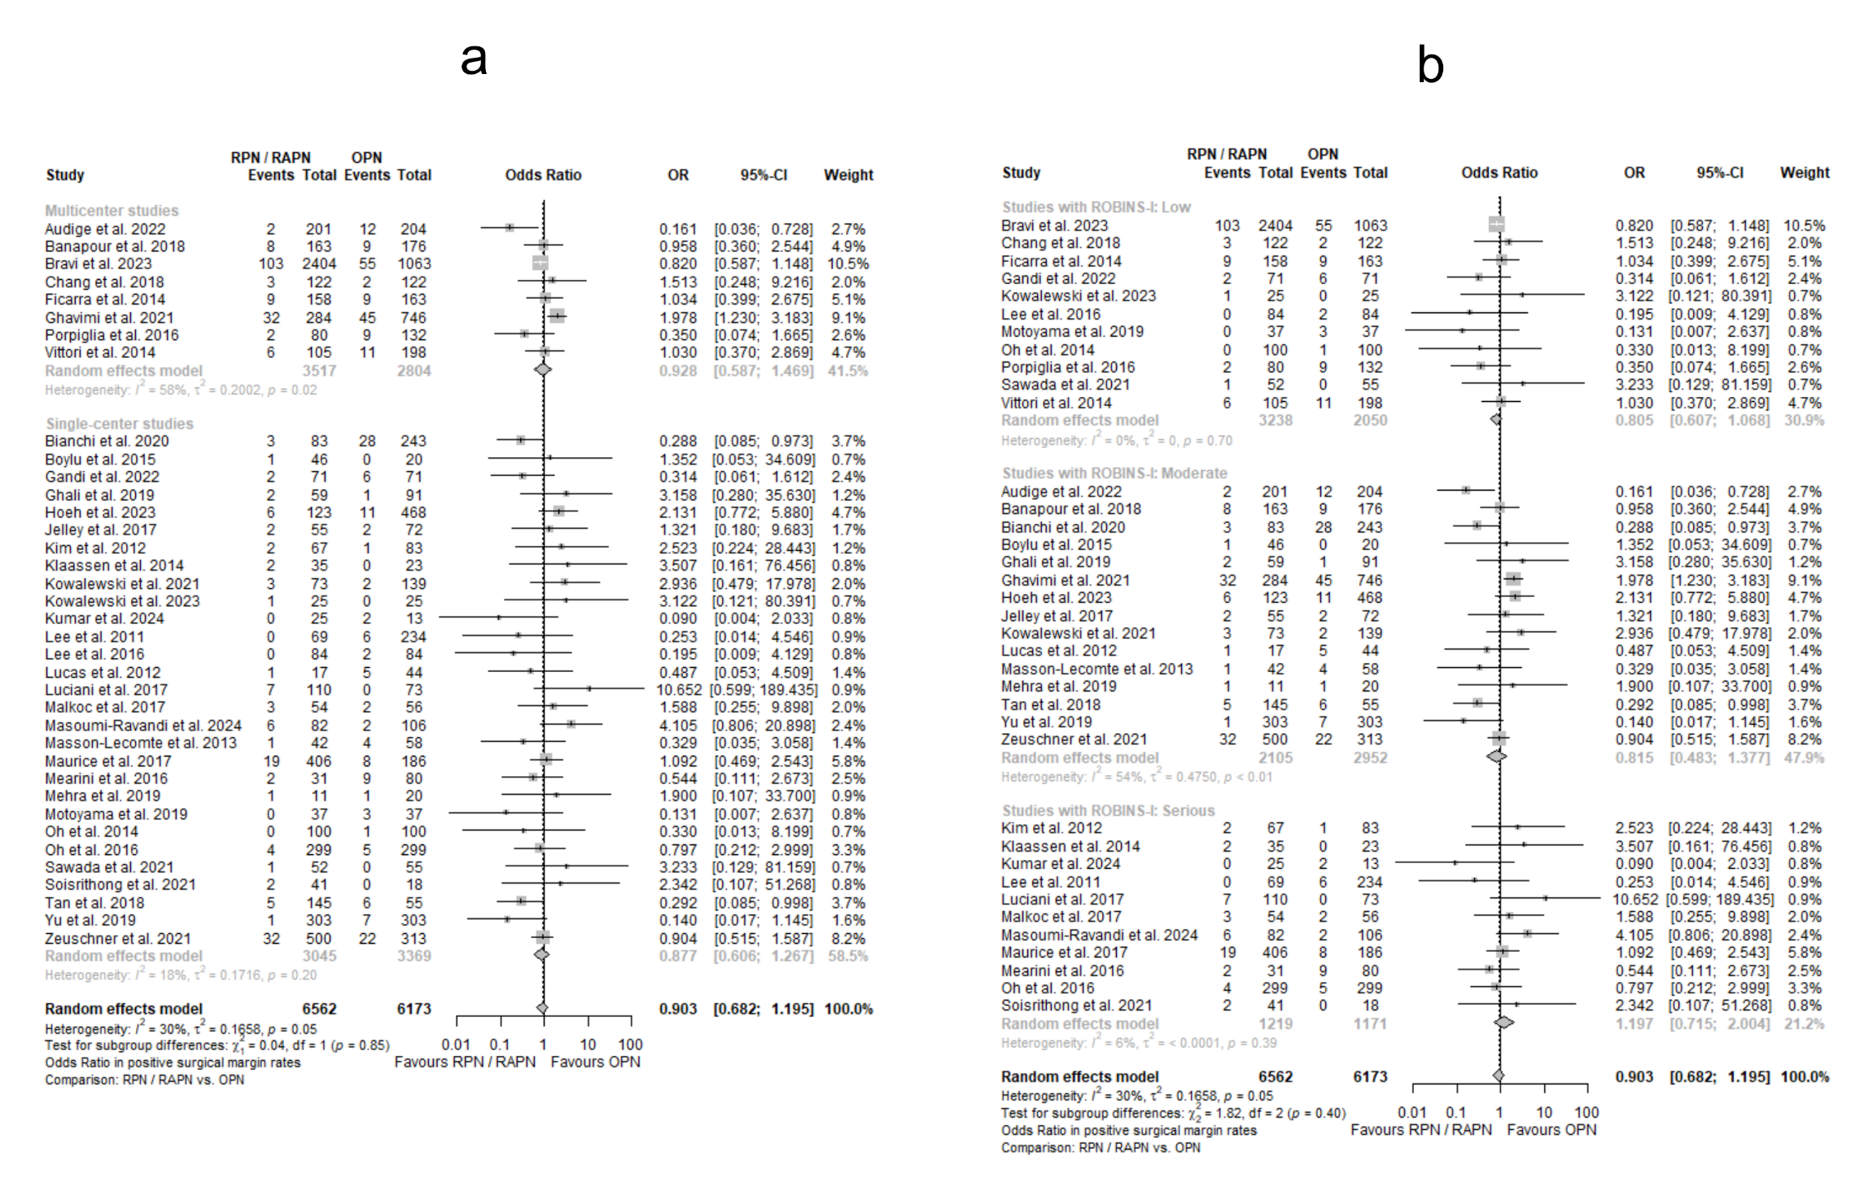
Supplementary Figure 29: Forest plots for estimating the OR_{PSM} in subgroups according to the number of referral centers involved (a), and the ROBINS-I class (b). Abbreviations: OR: Odds Ratio, PSM: Positive Surgical Margins, ROBINS-I: Risk of Bias In Non-randomized Studies of Interventions.
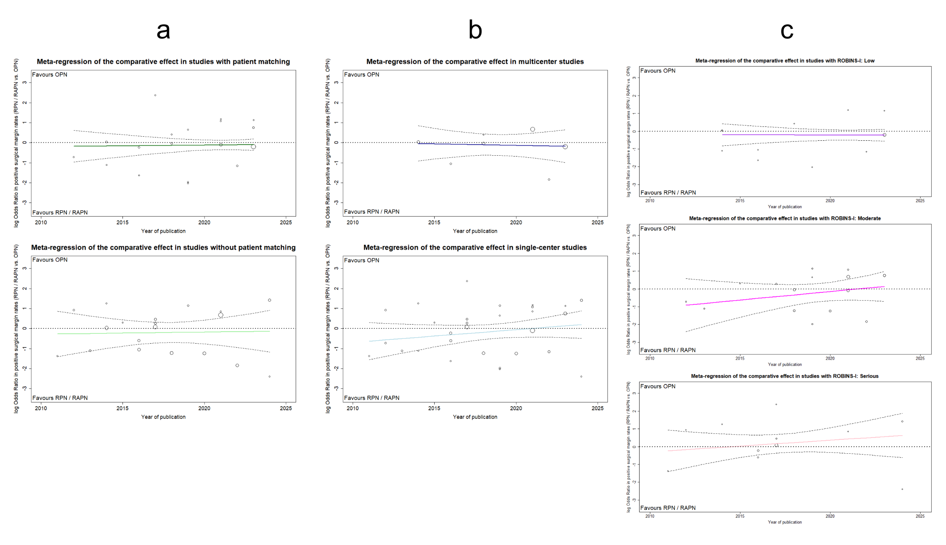
Supplementary Figure 30: MRA plots illustrating the chronological evolution of logOR_{PSM} by publication year, in subgroups formed based on patient matching (a), the number of referral centers involved (b), and the categorization according to ROBINS-I (c). Abbreviations: MRA: Meta-regression Analysis, logOR: decimal logarithm of Odds Ratio, PSM: Positive Surgical Margins, ROBINS-I: Risk of Bias In Non-randomized Studies of Interventions.

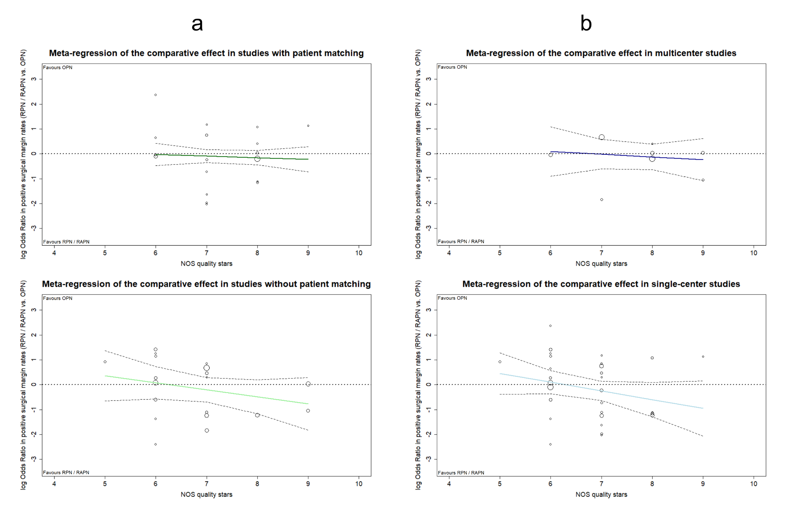
Supplementary Figure 31: MRA plots illustrating the evolution of logOR_{PSM} across the qualitative spectrum of included studies via NOS grading, for subgroups formed based on patient matching (a), and the number of referral centers involved (b). Abbreviations: MRA: Meta-regression Analysis, logOR: decimal logarithm of Odds Ratio, PSM: Positive Surgical Margins, NOS: Newcastle-Ottawa Scale.

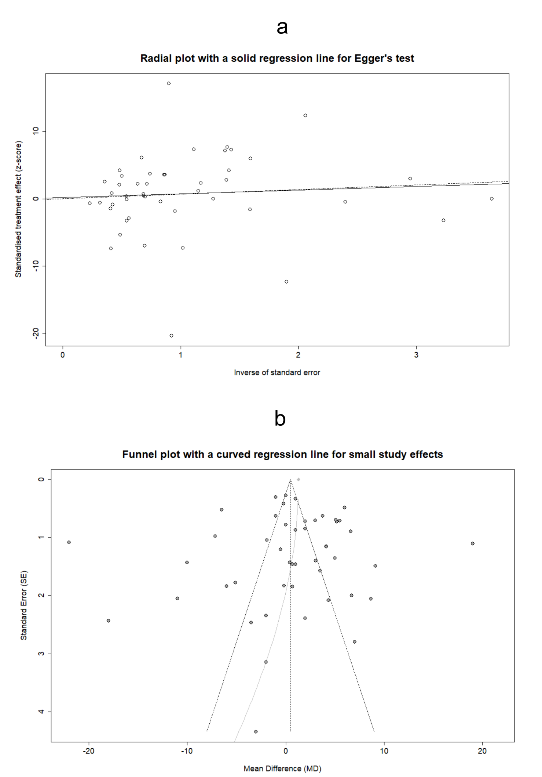
Supplementary Figure 32: Radial plot for the assessment of PB in estimating the MD_{IT} with the integration of Egger's test as a solid regression line (a). Funnel plot with graphical display of SSEs for evaluating the aforementioned PB (b). Abbreviations: PB: Publication Bias, MD: Mean Difference, IT: Ischemia Time, SSEs: Small Study Effects.

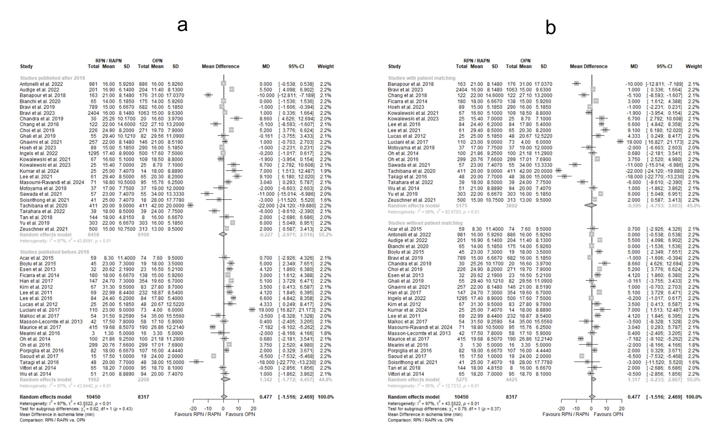
Supplementary Figure 33: Forest plots for estimating the MD_{IT} in subgroups according to publication year (a), and the application of patient matching (b). Abbreviations: MD: Mean Difference, IT: Ischemia Time.

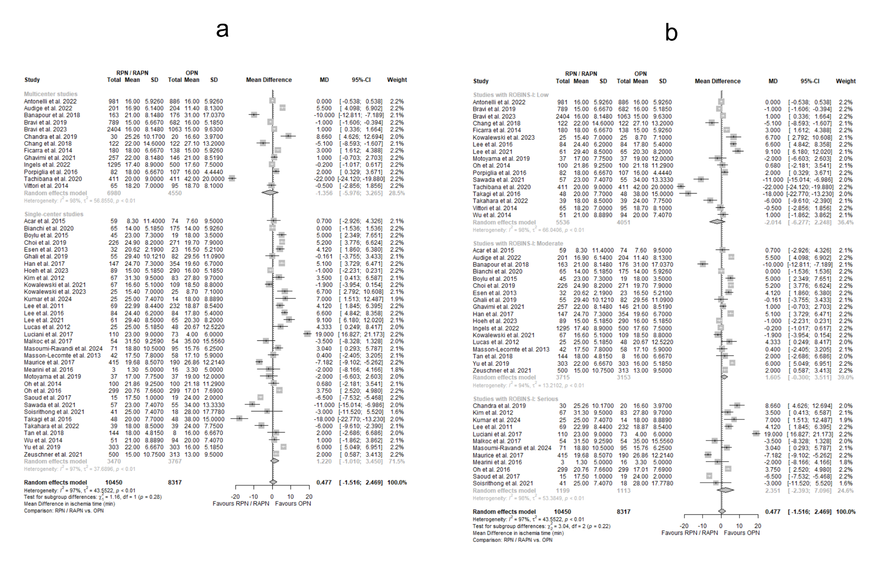
Supplementary Figure 34: Forest plots for estimating the MD_{IT} in subgroups according to the number of referral centers involved (a), and the ROBINS-I class (b). Abbreviations: MD: Mean Difference, IT: Ischemia Time, ROBINS-I: Risk of Bias In Non-randomized Studies of Interventions.

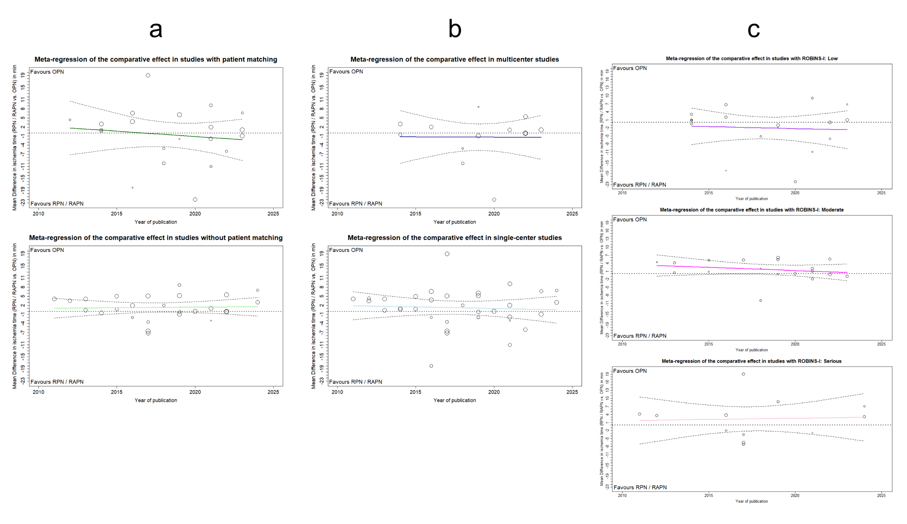
Supplementary Figure 35: MRA plots illustrating the chronological evolution of MD_{IT} by publication year, in subgroups formed based on patient matching (a), the number of referral centers involved (b), and the categorization according to ROBINS-I (c). Abbreviations: MRA: Meta-regression Analysis, MD: Mean Difference, IT: Ischemia Time, ROBINS-I: Risk of Bias In Non-randomized Studies of Interventions.

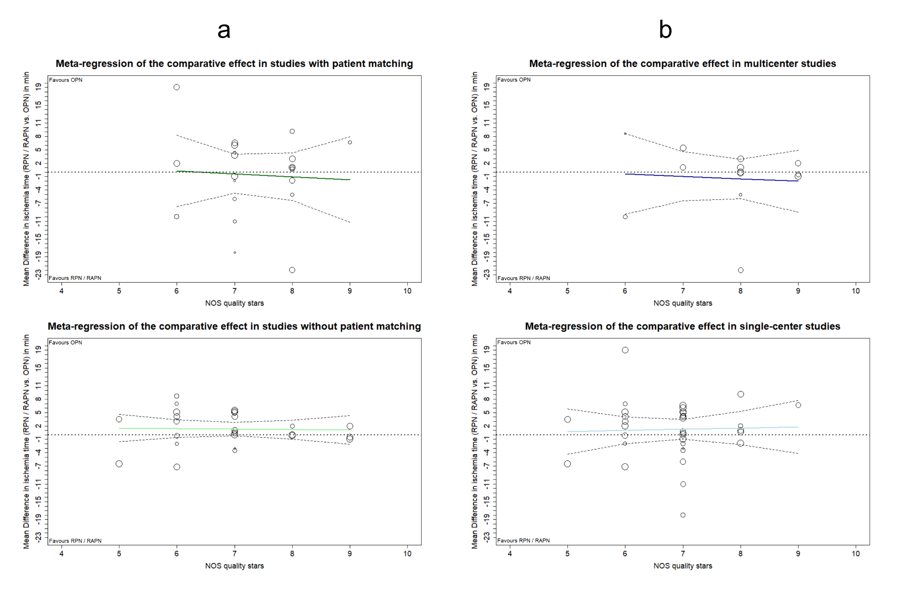
Supplementary Figure 36: MRA plots illustrating the evolution of MD_{IT} across the qualitative spectrum of included studies via NOS grading, for subgroups formed based on patient matching (a), and the number of referral centers involved (b). Abbreviations: MRA: Meta-regression Analysis, MD: Mean Difference, IT: Ischemia Time, NOS: Newcastle-Ottawa Scale.

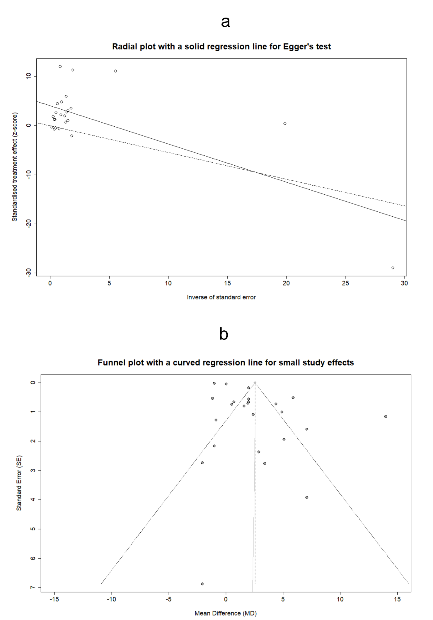
Supplementary Figure 37: Radial plot with integrated Egger’s test for the assessment of PB in estimating the MD_{ΔeGFR} (a). Funnel plot with graphical display of SSEs for evaluating the aforementioned PB (b). Abbreviations: PB: Publication Bias, MD: Mean Difference, ΔeGFR: Change (negative) from baseline in estimated Glomerular Filtration Rate, SSEs: Small Study Effects.

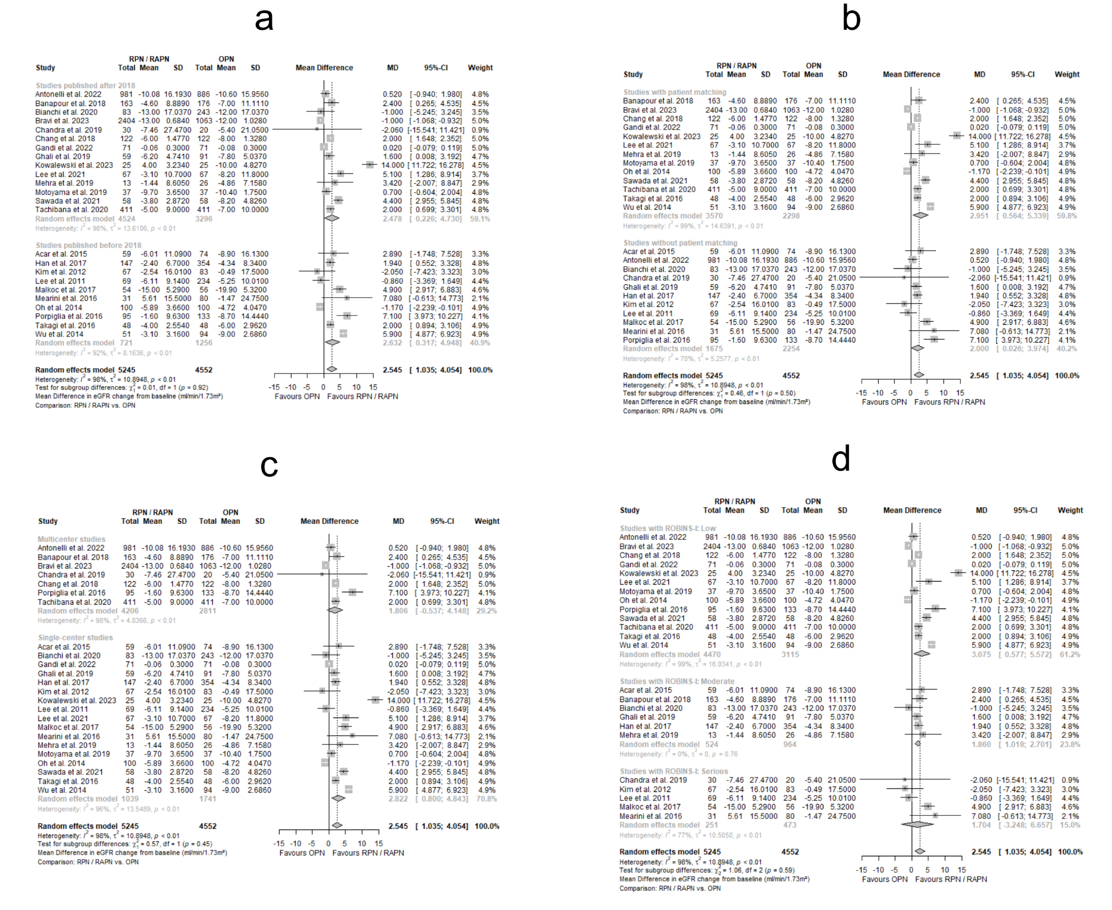
Supplementary Figure 38: Forest plots for estimating the MD_{ΔeGFR} in subgroups according to publication year (a), the application of patient matching (b), the number of referral centers involved (c), and the ROBINS-I class (d). Abbreviations: MD: Mean Difference, ΔeGFR: Change (negative) from baseline in estimated Glomerular Filtration Rate, ROBINS-I: Risk of Bias In Non-randomized Studies of Interventions.
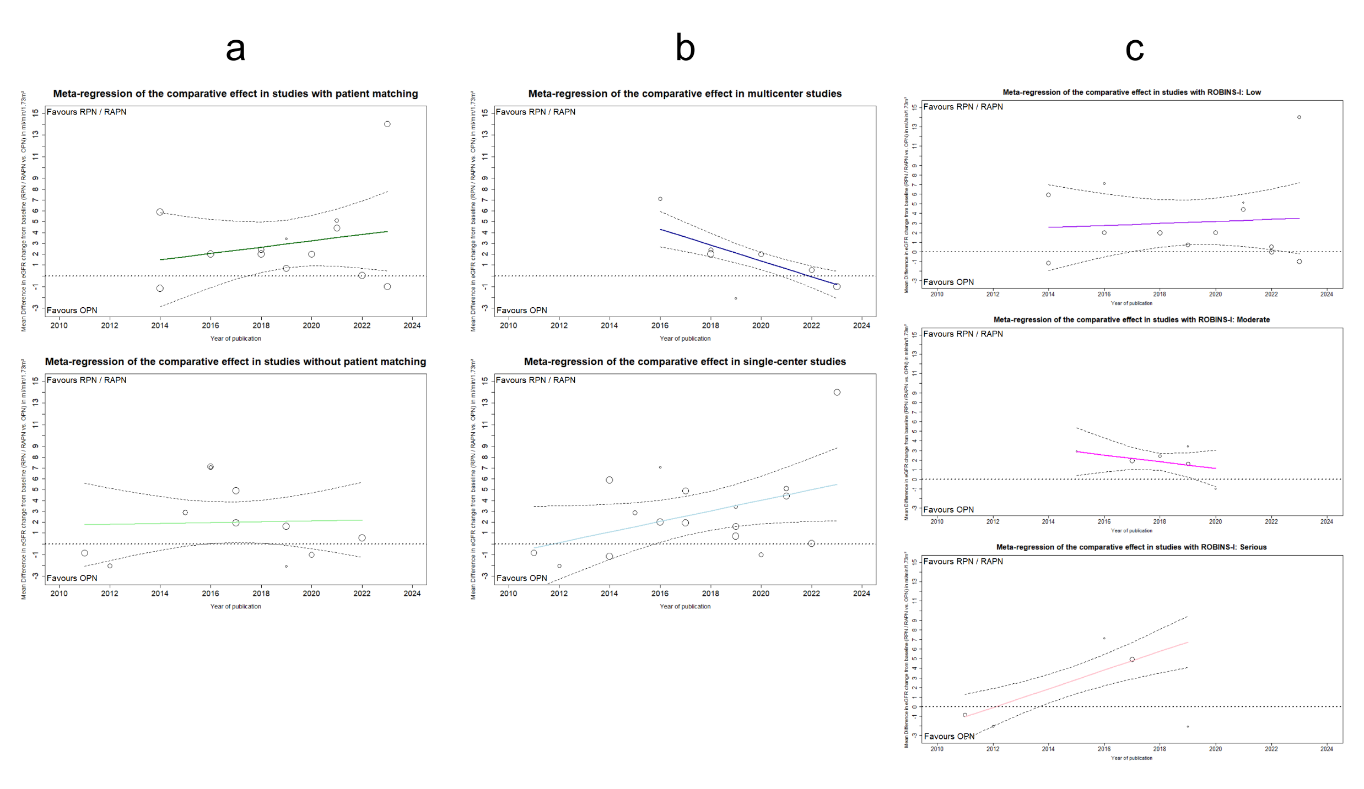
Supplementary Figure 39: MRA plots illustrating the chronological evolution of MD_{ΔeGFR} by publication year, in subgroups formed based on patient matching (a), the number of referral centers involved (b), and the categorization according to ROBINS-I (c). Abbreviations: MRA: Meta-regression Analysis, MD: Mean Difference, ΔeGFR: Change (negative) from baseline in estimated Glomerular Filtration Rate, ROBINS-I: Risk of Bias In Non-randomized Studies of Interventions.

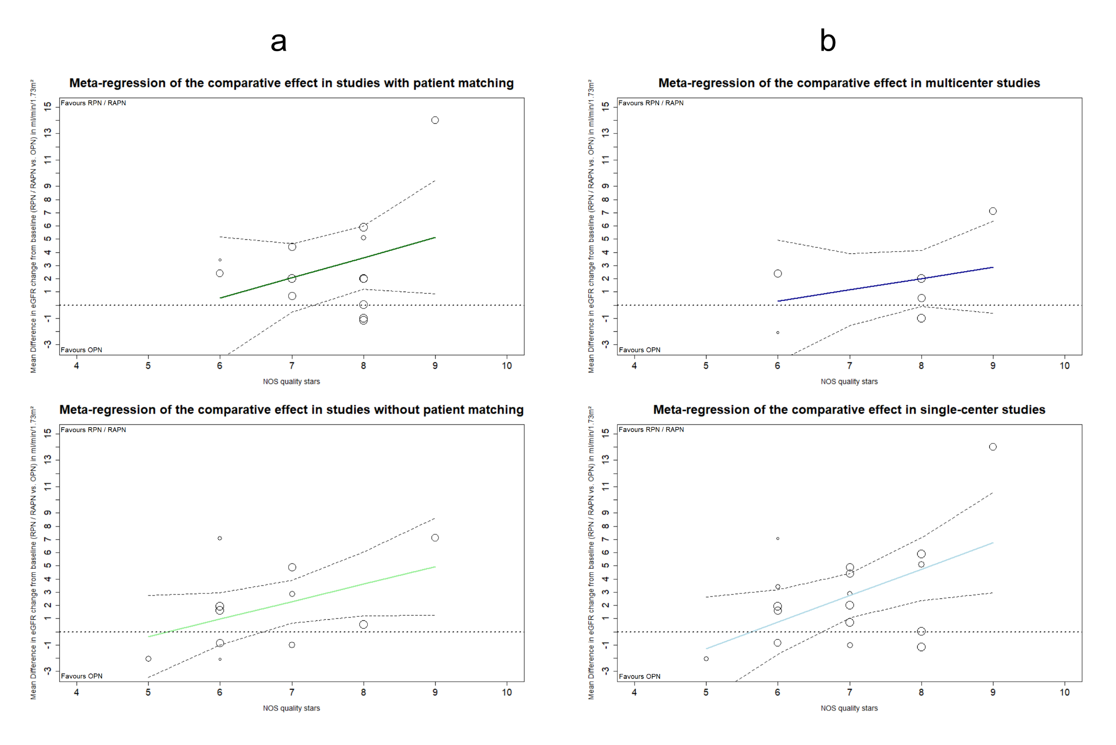
Supplementary Figure 40: MRA plots illustrating the evolution of MD_{ΔeGFR} across the qualitative spectrum of included studies via NOS grading, for subgroups formed based on patient matching (a), and the number of referral centers involved (b). Abbreviations: MRA: Meta-regression Analysis, MD: Mean Difference, NOS: Newcastle-Ottawa Scale, ΔeGFR: Change (negative) from baseline in estimated Glomerular Filtration Rate.

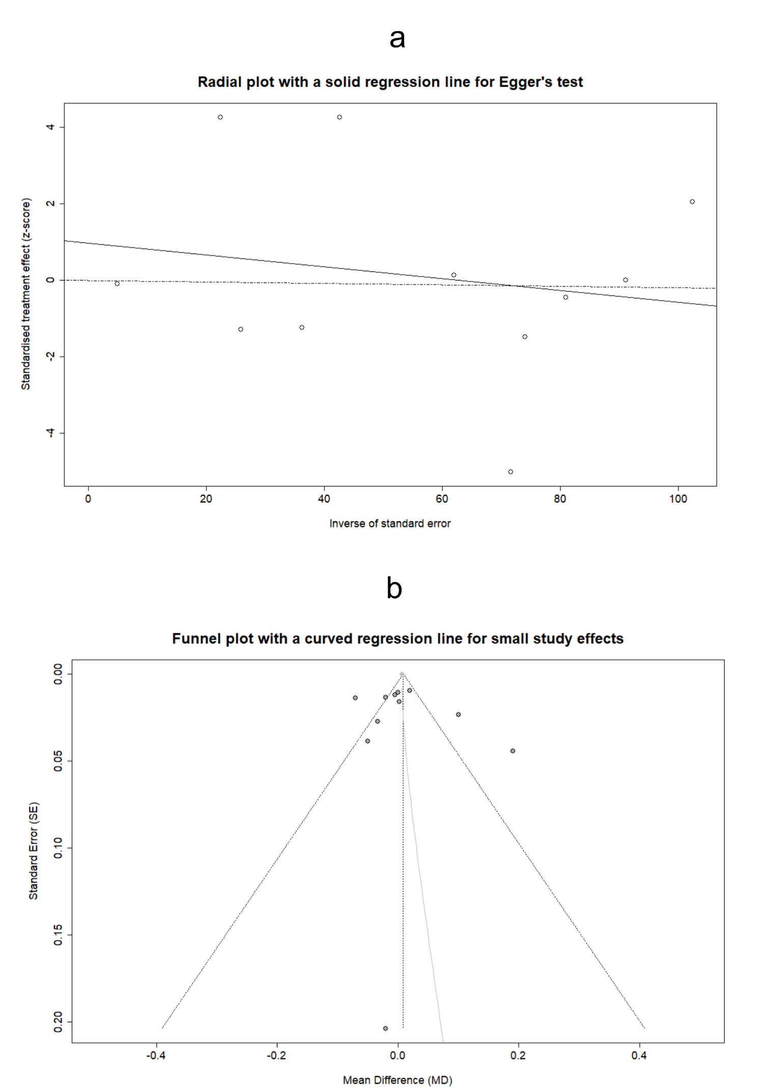
Supplementary Figure 41: Radial plot with integrated Egger’s test for the assessment of PB in estimating the MD_{ΔCr} (a). Funnel plot with graphical display of SSEs for evaluating the aforementioned PB (b). Abbreviations: PB: Publication Bias, MD: Mean Difference, ΔCr: Change (positive) from baseline in serum Creatinine levels, SSEs: Small Study Effects.

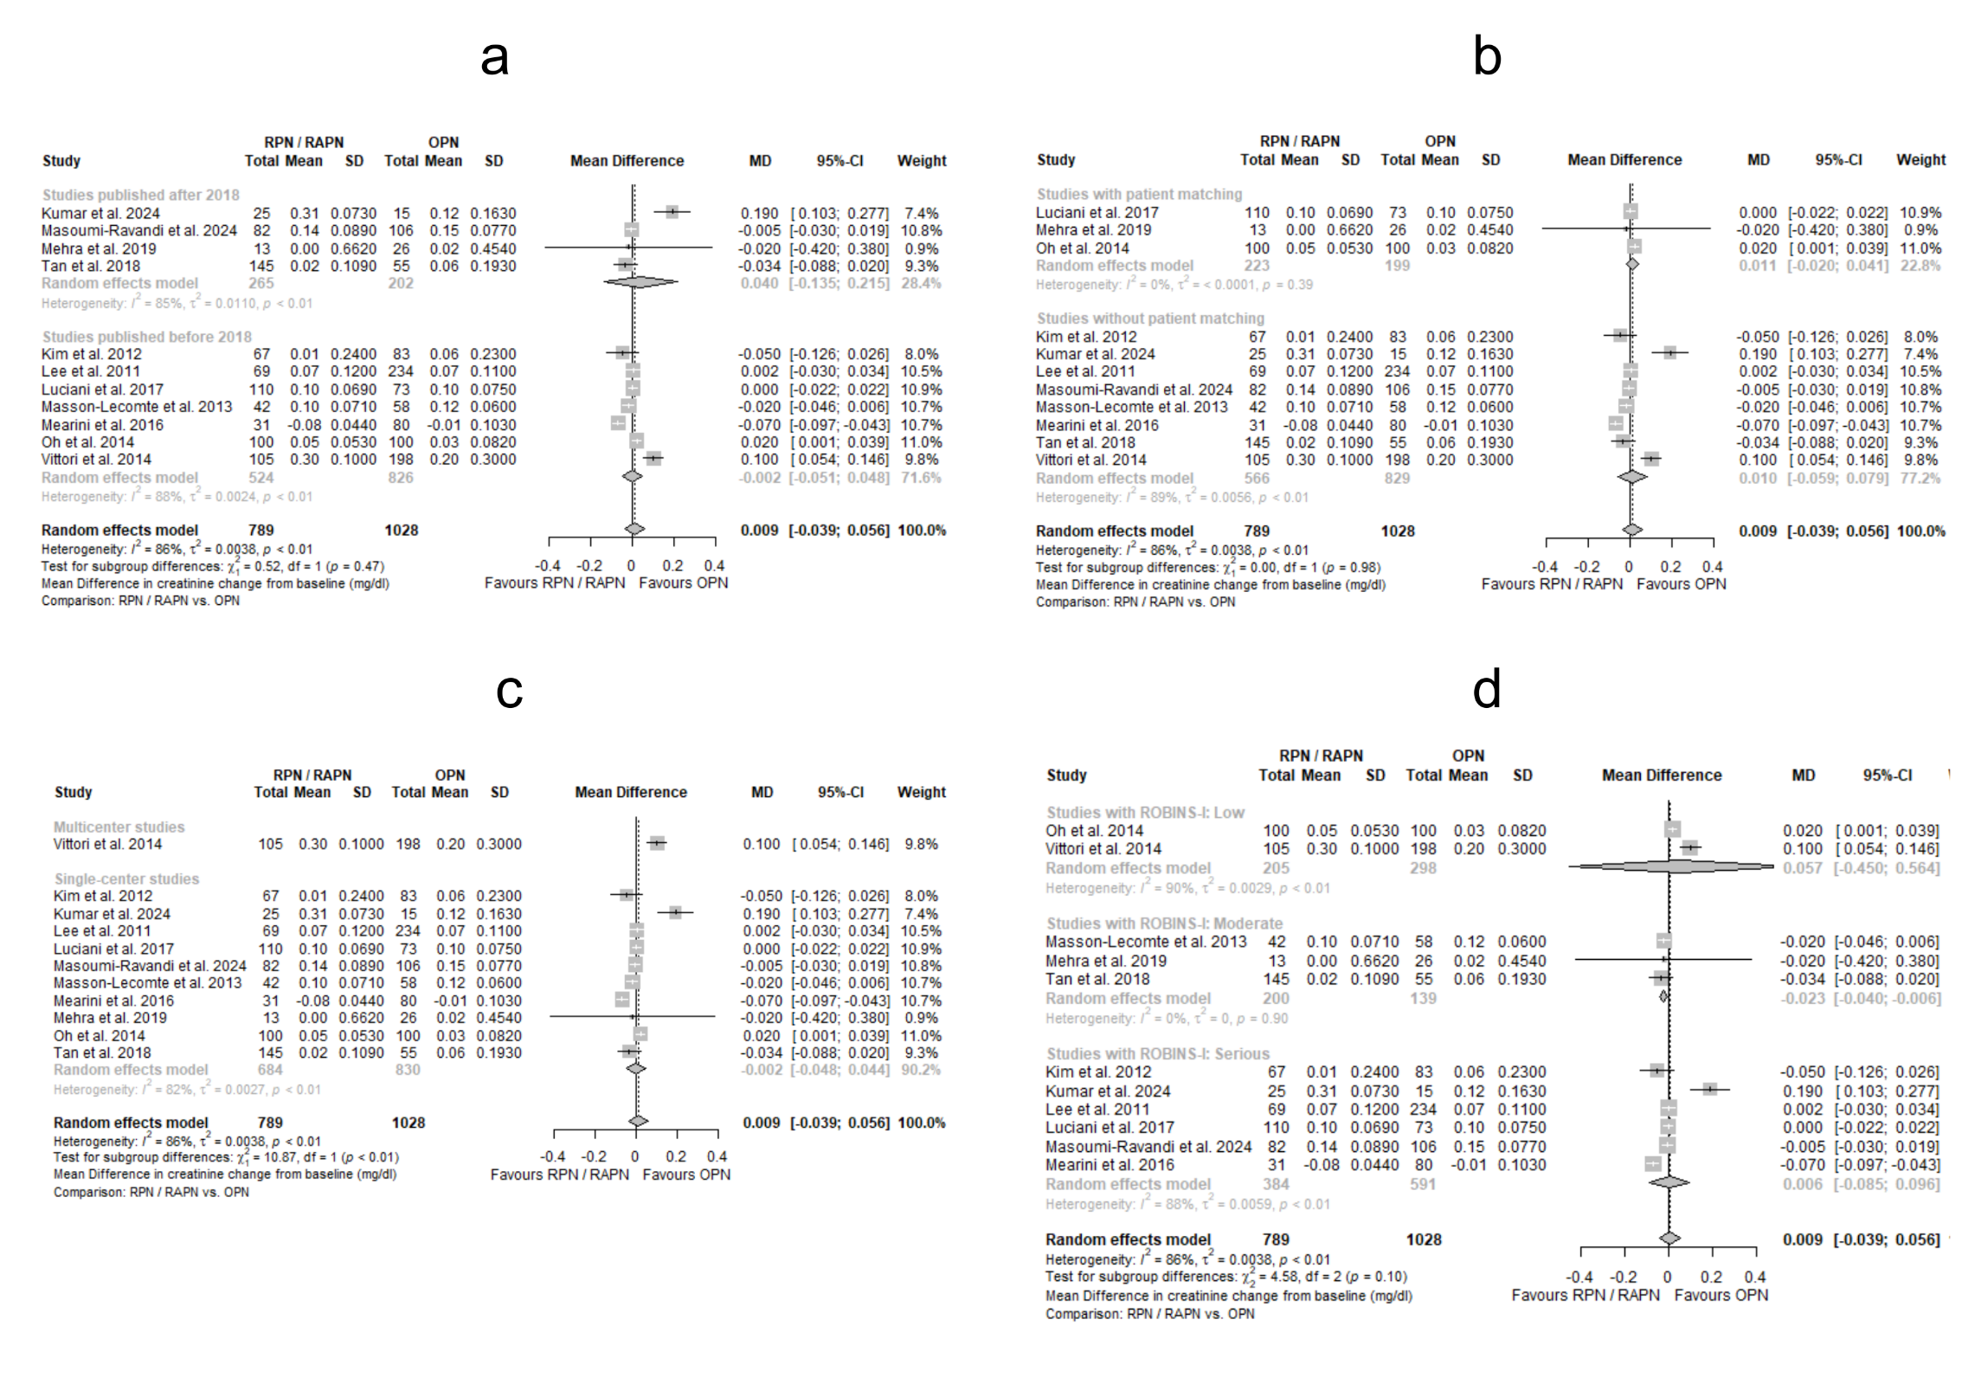
Supplementary Figure 42: Forest plots for estimating the MD_{ΔCr} in subgroups according to publication year (a), the application of patient matching (b), the number of referral centers involved (c), and the ROBINS-I class (d). Abbreviations: MD: Mean Difference, ΔCr: Change (positive) from baseline in serum Creatinine levels, ROBINS-I: Risk of Bias In Non-randomized Studies of Interventions.
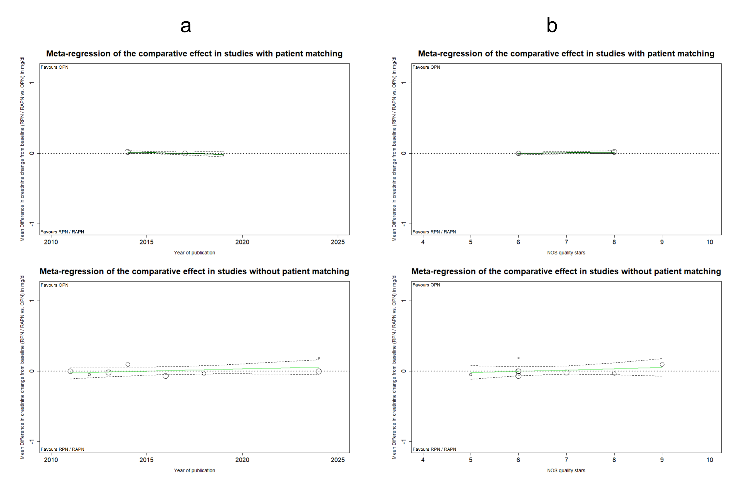
Supplementary Figure 43: MRA plots illustrating the chronological evolution of MD_{ΔCr} by publication year, in subgroups formed based on patient matching (a). MRA plots illustrating the evolution of MD_{ΔCr} across the qualitative spectrum of included studies via NOS grading, for subgroups formed based on patient matching (b). Abbreviations: MRA: Meta-regression Analysis, MD: Mean Difference, ΔCr: Change (positive) from baseline in serum Creatinine levels.
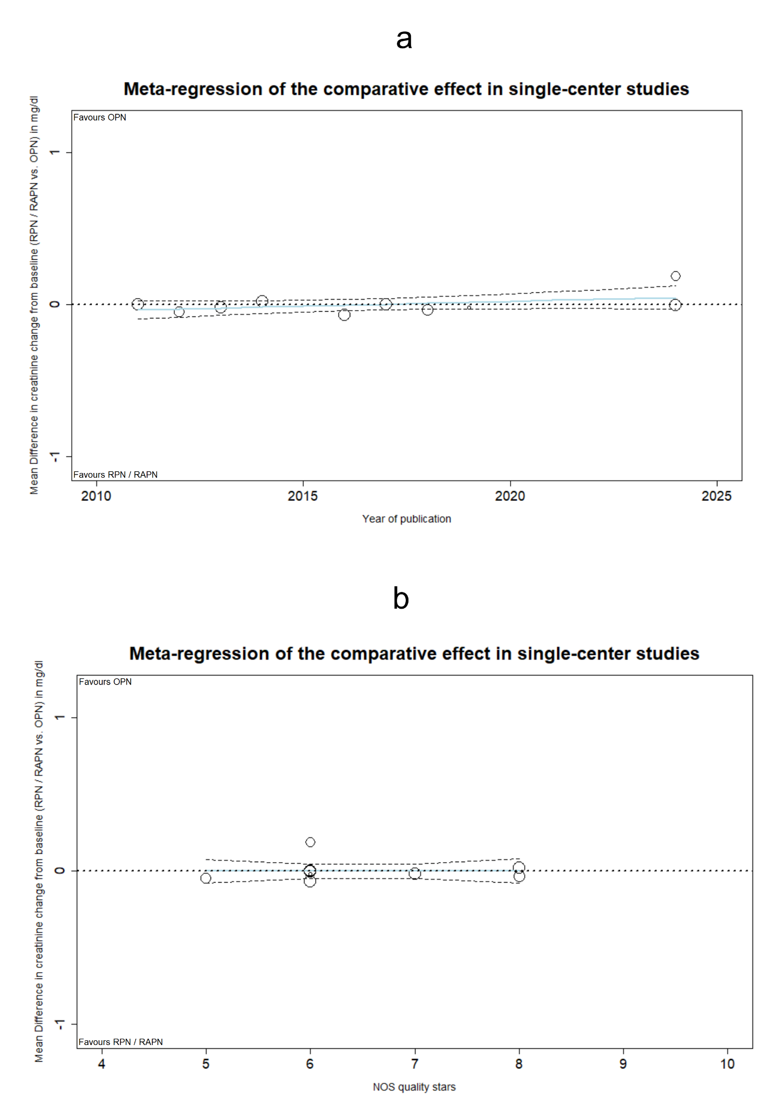
Supplementary Figure 44: MRA plot illustrating the chronological evolution of MD_{ΔCr} in single-center studies (a). MRA plot illustrating the evolution of MD_{ΔCr} across the qualitative spectrum of single-center studies via NOS grading (b). Abbreviations: MRA: Meta-regression Analysis, MD: Mean Difference, ΔCr: Change (positive) from baseline in serum Creatinine levels.
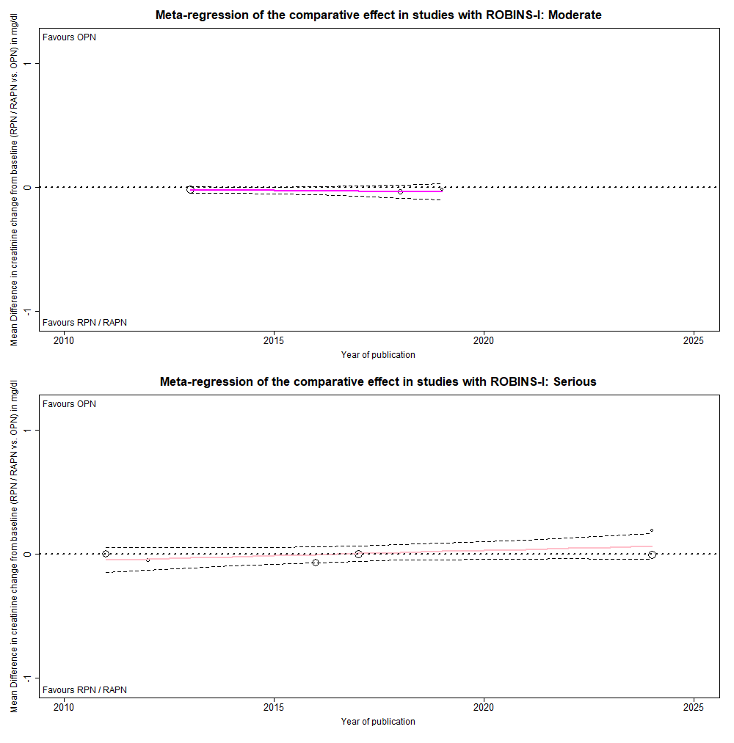
Supplementary Figure 45: MRA plots illustrating the chronological evolution of MD_{ΔCr} in studies with moderate and serious ROB. Abbreviations: MRA: Meta-regression Analysis, MD: Mean Difference, ΔCr: Change (positive) from baseline in serum Creatinine levels, ROB: Risk of Bias.
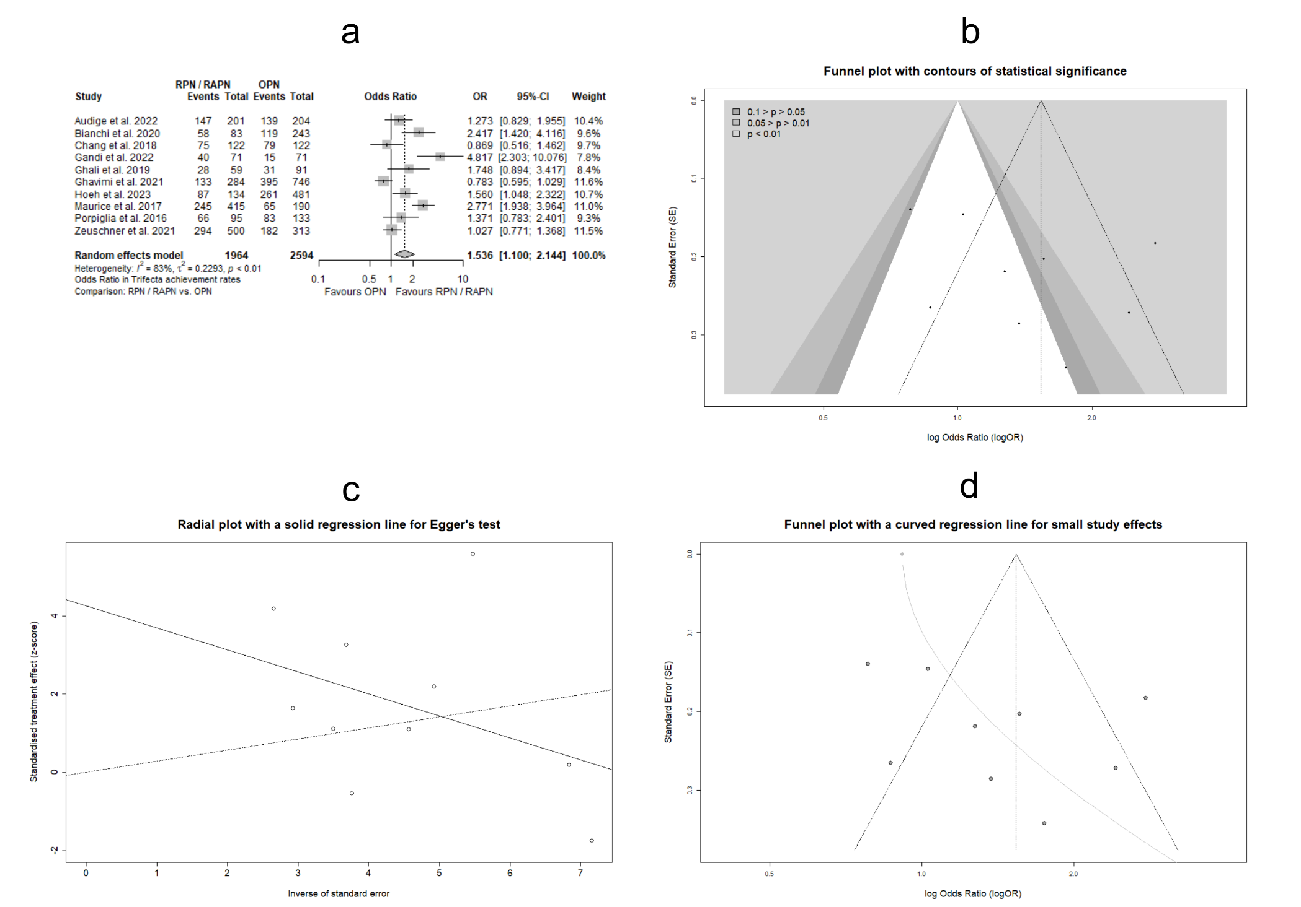

Supplementary Figure 46: Forest plot for estimating the OR_{Trifecta} in studies with enhanced accuracy in reported results (a). Funnel plot for evaluating PB in the aforementioned subset, enriched with contours of distinct significance levels (b). Radial plot with integrated Egger’s test for the assessment of PB in estimating the OR_{Trifecta} in the above study set (c). Funnel plot with graphical display of SSEs for assessing PB (d). Abbreviations: OR: Odds Ratio, PB: Publication Bias, SSEs: Small Study Effects.

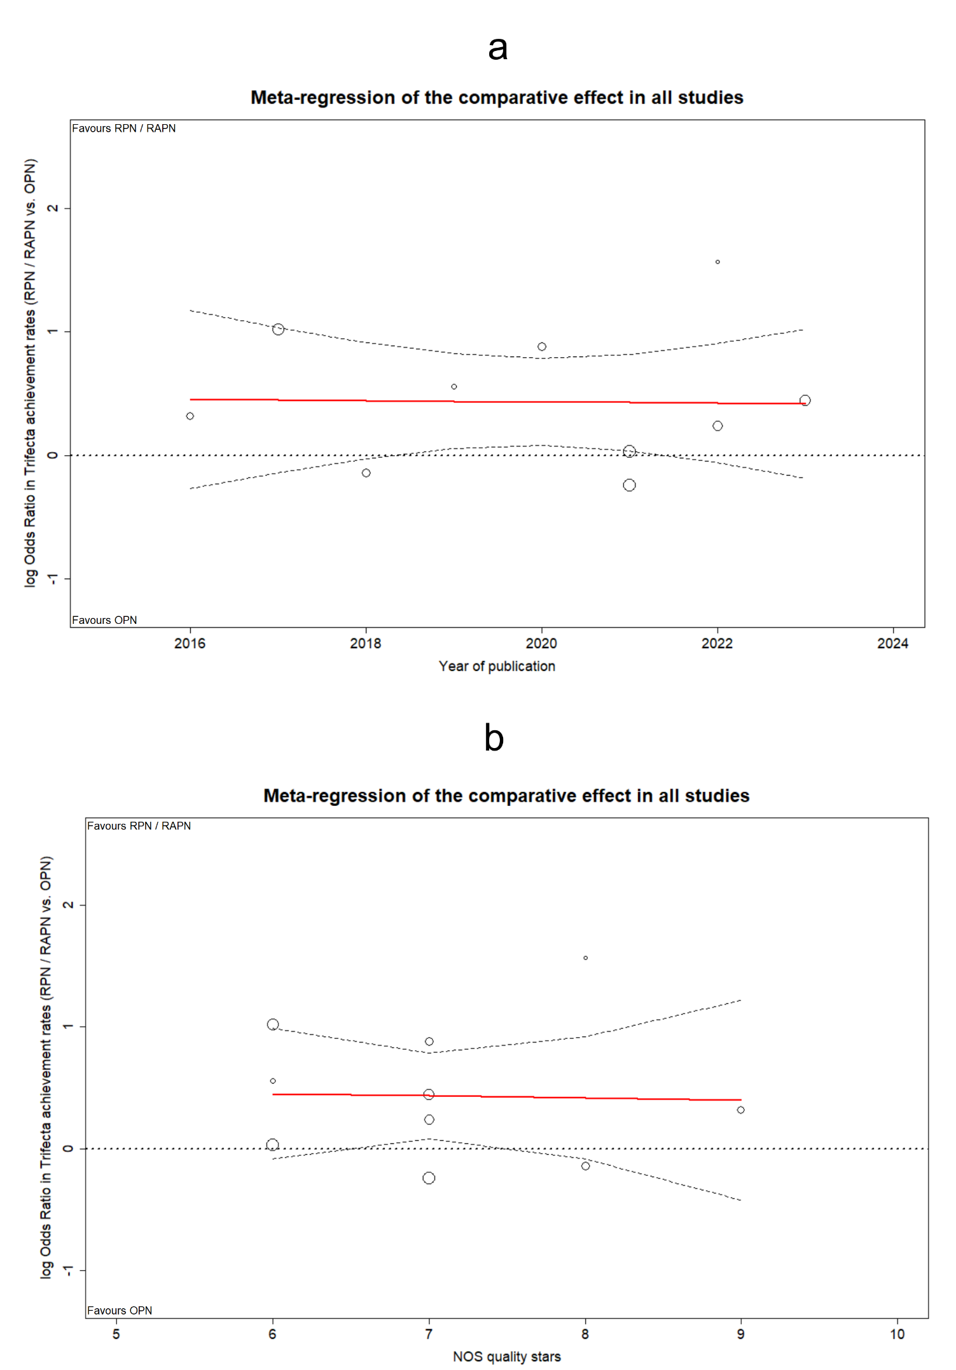
Supplementary Figure 47: MRA plots illustrating the evolution of logOR_{Trifecta} in studies with enhanced accuracy in reported results, by publication year (a), and across the qualitative spectrum of NOS grading (b). Abbreviations: MRA: Meta-regression Analysis, logOR: decimal logarithm of Odds Ratio, NOS: Newcastle-Ottawa Scale.

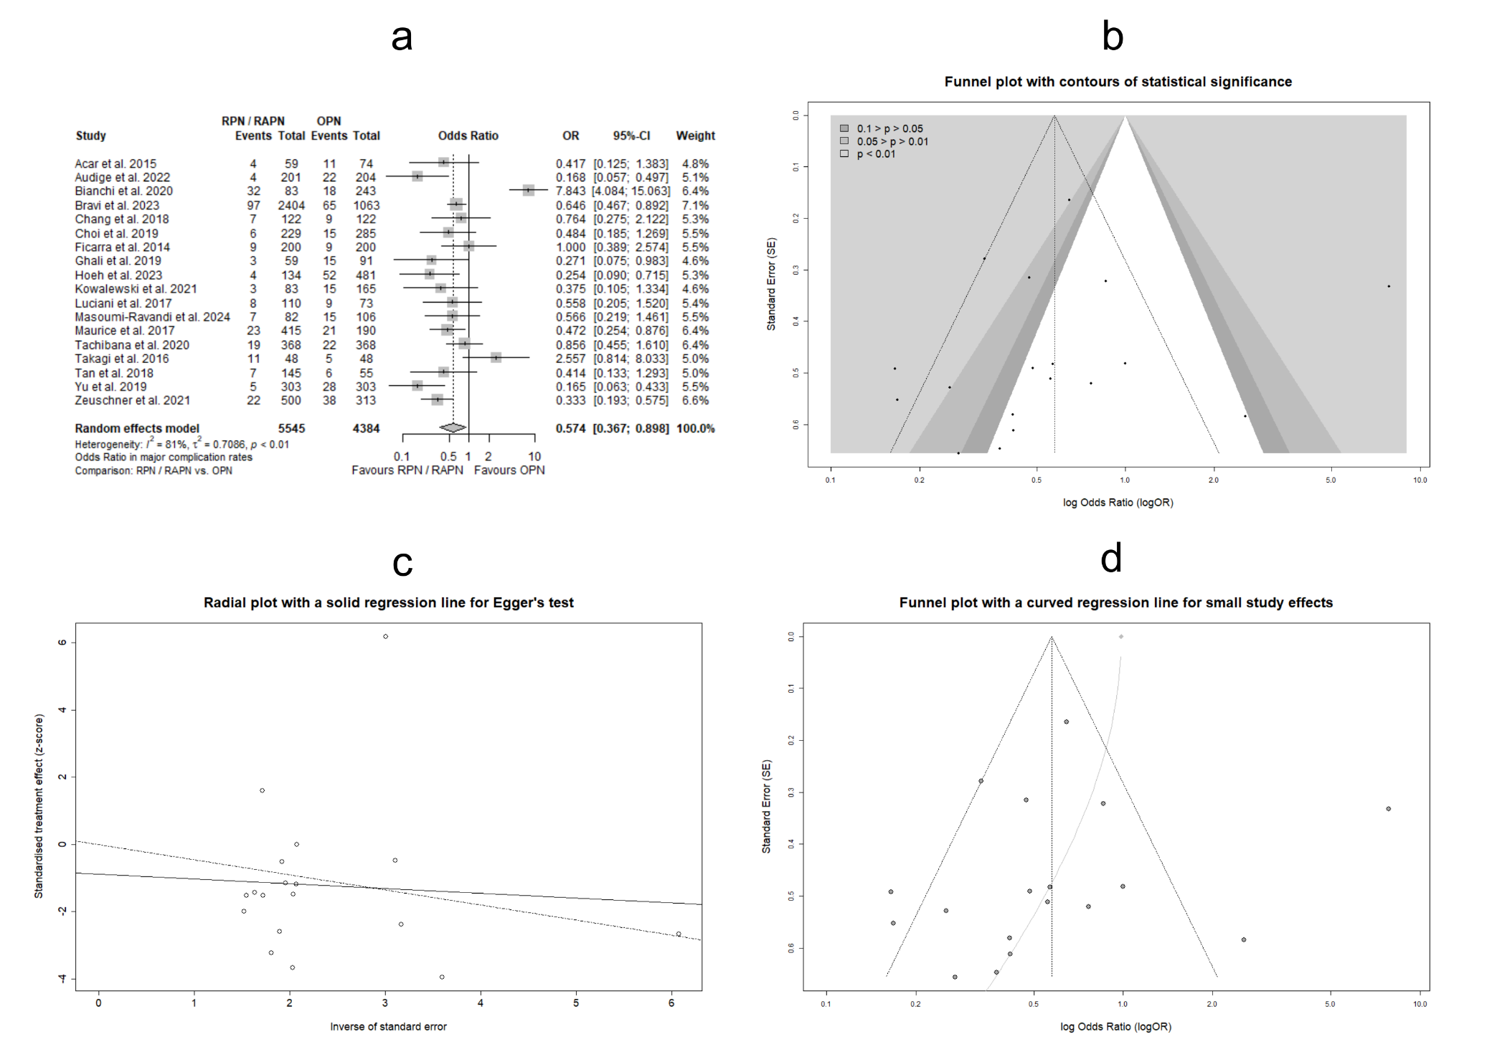
Supplementary Figure 48: Forest plot for estimating the OR_{CD≥3} in studies with enhanced accuracy in reported results (a). Funnel plot for evaluating PB in the aforementioned subset, enriched with contours of distinct significance levels (b). Radial plot with integrated Egger’s test for the assessment of PB in estimating the OR_{CD≥3} in the above study set (c). Funnel plot with graphical display of SSEs for assessing PB (d). Abbreviations: OR: Odds Ratio, CD: Clavien-Dindo classification of postoperative complications, PB: Publication Bias, SSEs: Small Study Effects.

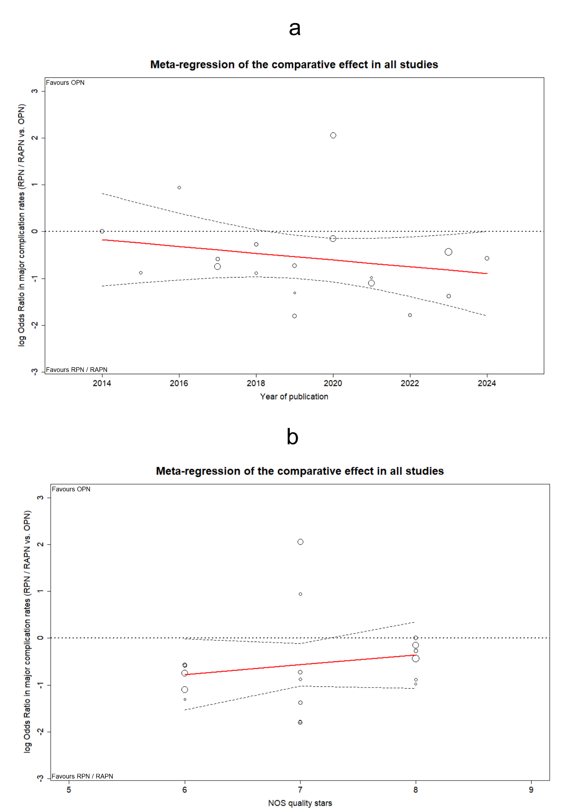
Supplementary Figure 49: MRA plots illustrating the evolution of logOR_{CD≥3} in studies with enhanced accuracy in reported results, by publication year (a), and across the qualitative spectrum of NOS grading (b). Abbreviations: MRA: Meta-regression Analysis, logOR: decimal logarithm of Odds Ratio, CD: Clavien-Dindo classification of postoperative complications, NOS: Newcastle-Ottawa Scale.

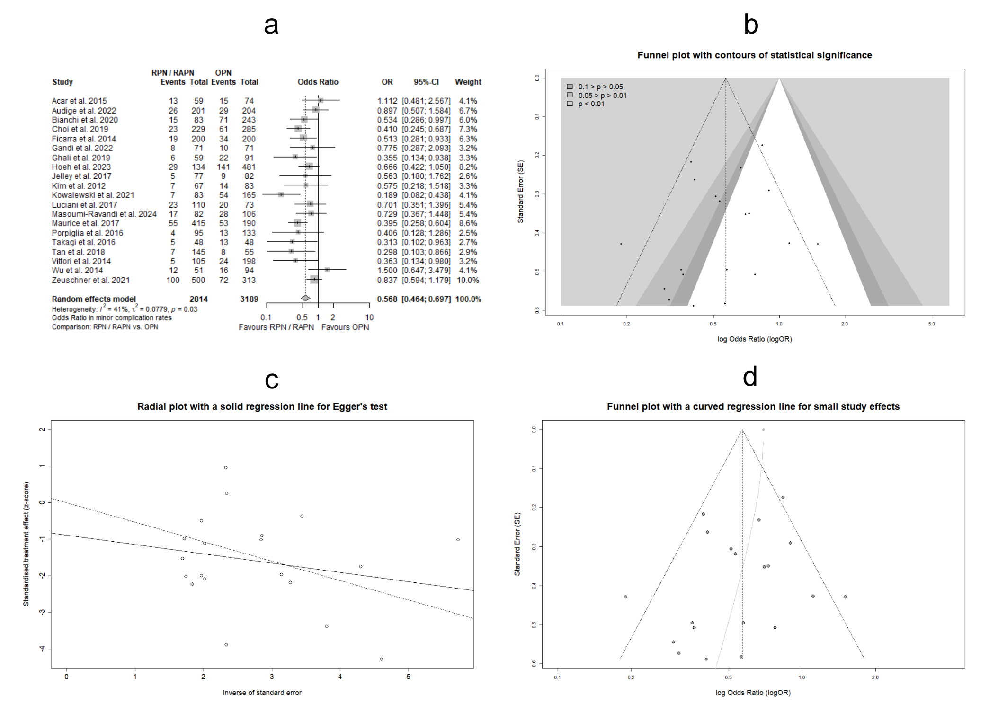
Supplementary Figure 50: Forest plot for estimating the OR_{CD≤2} in studies with enhanced accuracy in reported results (a). Funnel plot for evaluating PB in the aforementioned subset, enriched with contours of distinct significance levels (b). Radial plot with integrated Egger’s test for the assessment of PB in estimating the OR_{CD≤2} in the above study set (c). Funnel plot with graphical display of SSEs for assessing PB (d). Abbreviations: OR: Odds Ratio, CD: Clavien-Dindo classification of postoperative complications, PB: Publication Bias, SSEs: Small Study Effects.
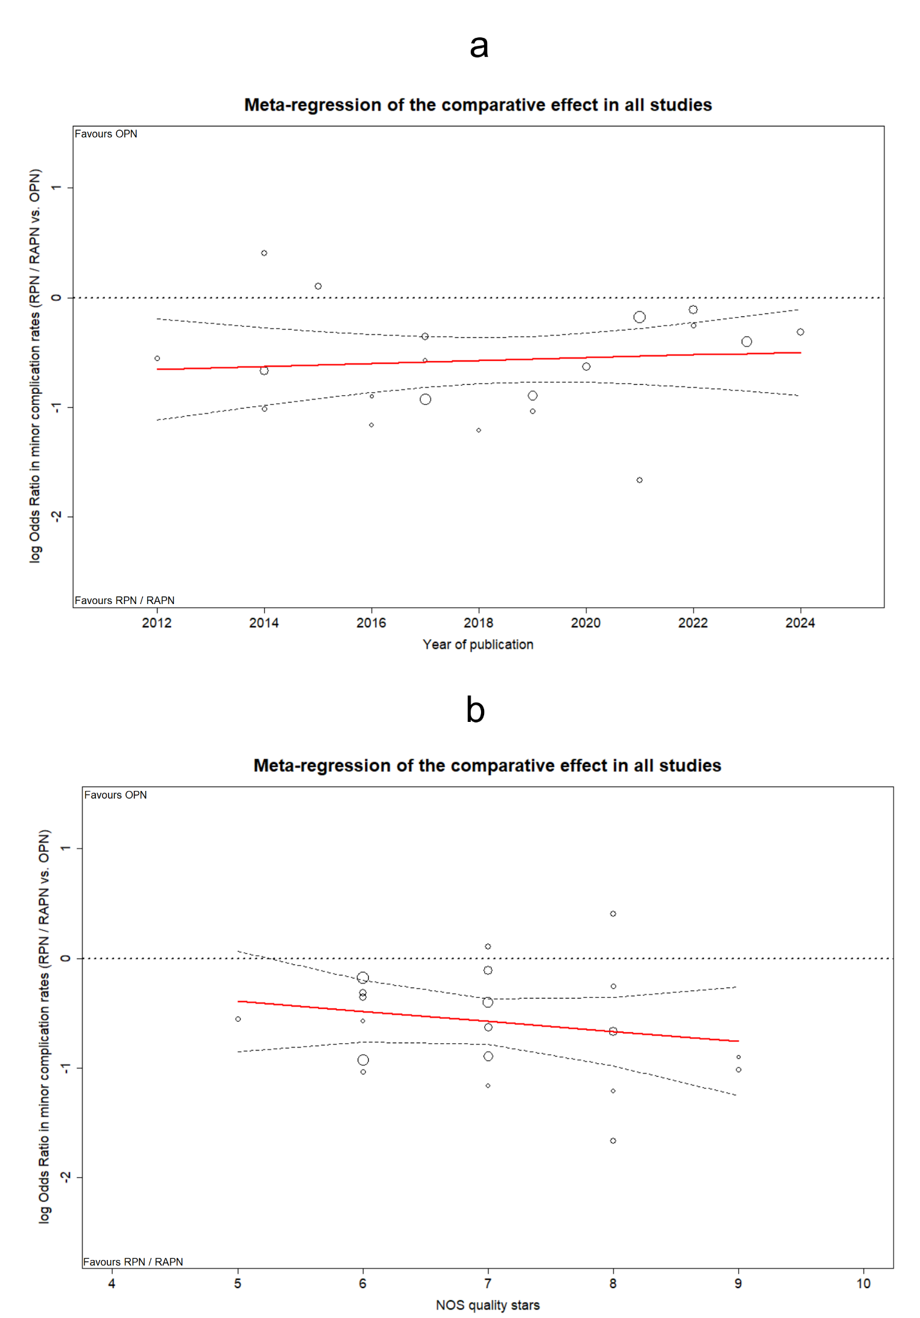
Supplementary Figure 51: MRA plots illustrating the evolution of logOR_{CD≤2} in studies with enhanced accuracy in reported results, by publication year (a), and across the qualitative spectrum of NOS grading (b). Abbreviations: MRA: Meta-regression Analysis, logOR: decimal logarithm of Odds Ratio, CD: Clavien-Dindo classification of postoperative complications, NOS: Newcastle-Ottawa Scale.

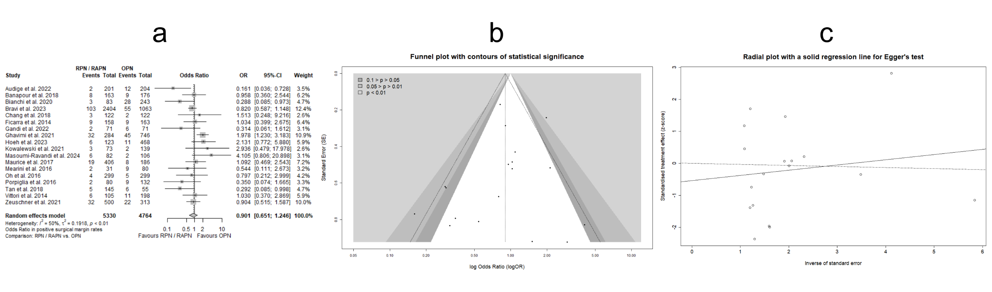
Supplementary Figure 52: Forest plot for estimating the OR_{PSM} in studies with enhanced accuracy in reported results (a). Funnel plot for evaluating PB in the aforementioned study subset, enriched with contours of distinct significance levels (b). Radial plot with integrated Egger’s test for the assessment of PB in estimating the OR_{PSM} in the above study set (c). Abbreviations: OR: Odds Ratio, PSM: Positive Surgical Margins, PB: Publication Bias.

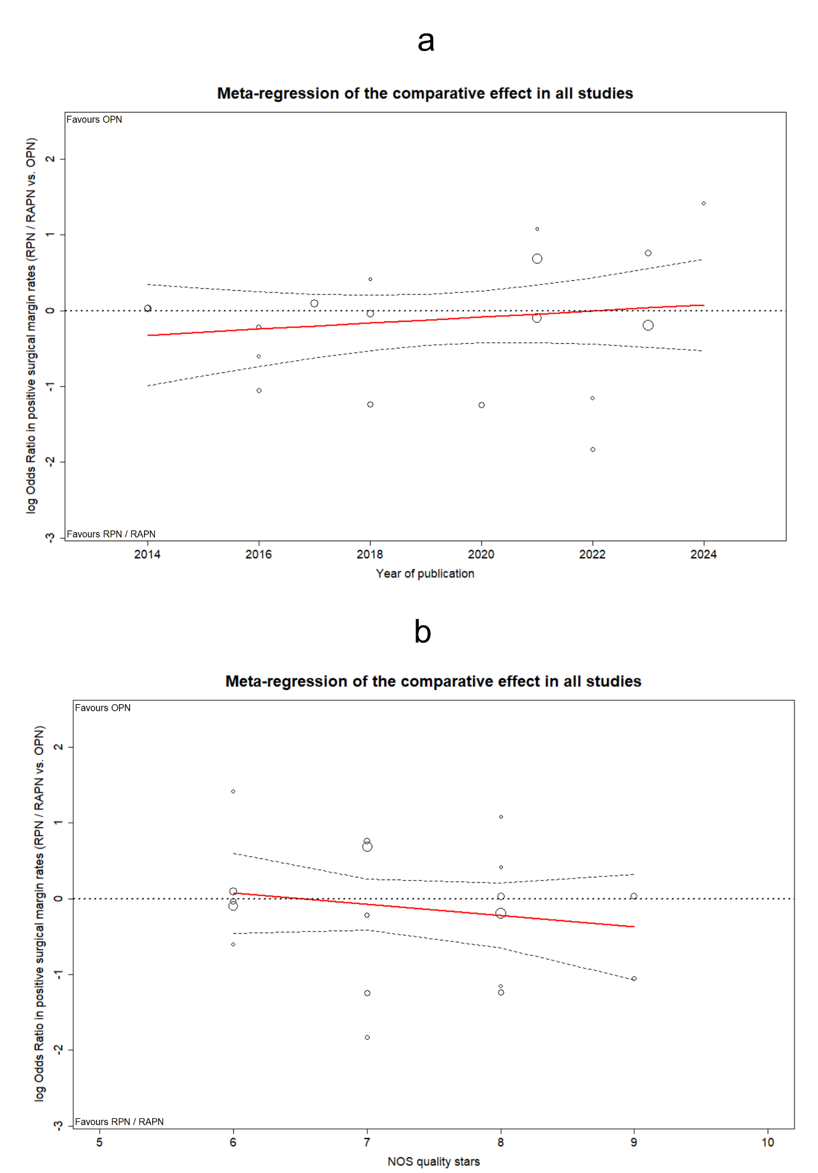
Supplementary Figure 53: MRA plots illustrating the evolution of logOR_{PSM} in studies with enhanced accuracy in reported results, by publication year (a), and across the qualitative spectrum of NOS grading (b). Abbreviations: MRA: Meta-regression Analysis, logOR: decimal logarithm of Odds Ratio, PSM: Positive Surgical Margins, NOS: Newcastle-Ottawa Scale.

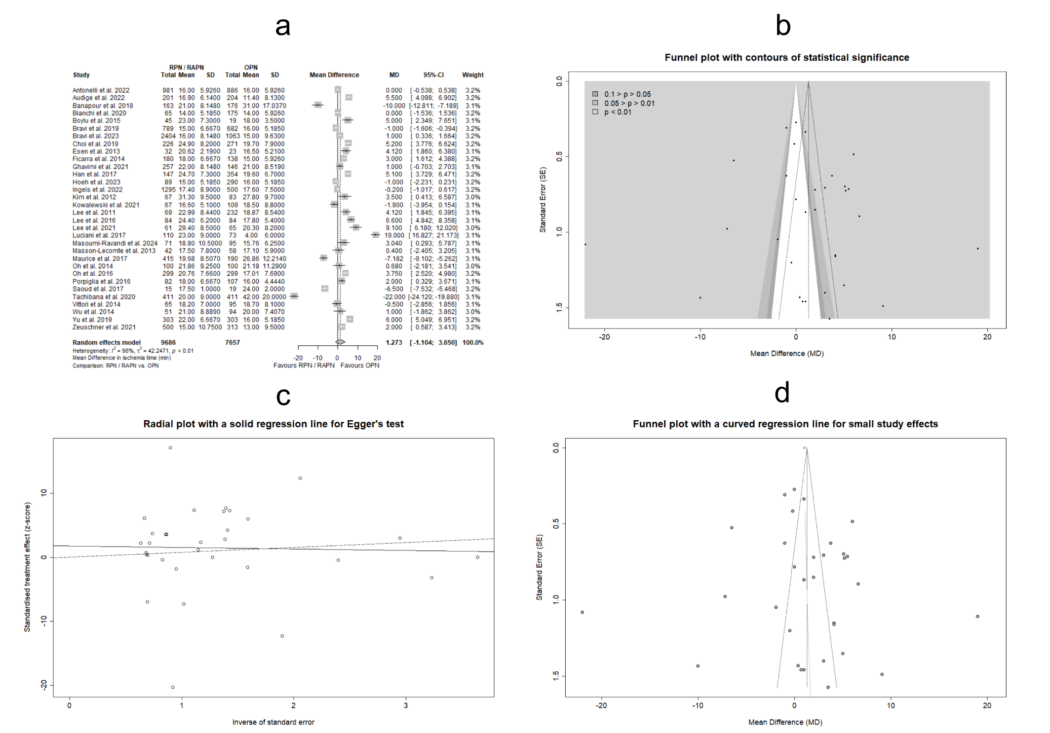
Supplementary Figure 54: Forest plot for estimating the MD_{IT} in studies with enhanced accuracy in reported results (a). Funnel plot for evaluating PB in the aforementioned study subset, enriched with contours of distinct significance levels (b). Radial plot with integrated Egger’s test for the assessment of PB in estimating the MD_{IT} in the above study set (c). Funnel plot with graphical display of SSEs for assessing PB (d). Abbreviations: MD: Mean Difference, IT: Ischemia Time, PB: Publication Bias, SSEs: Small Study Effects.

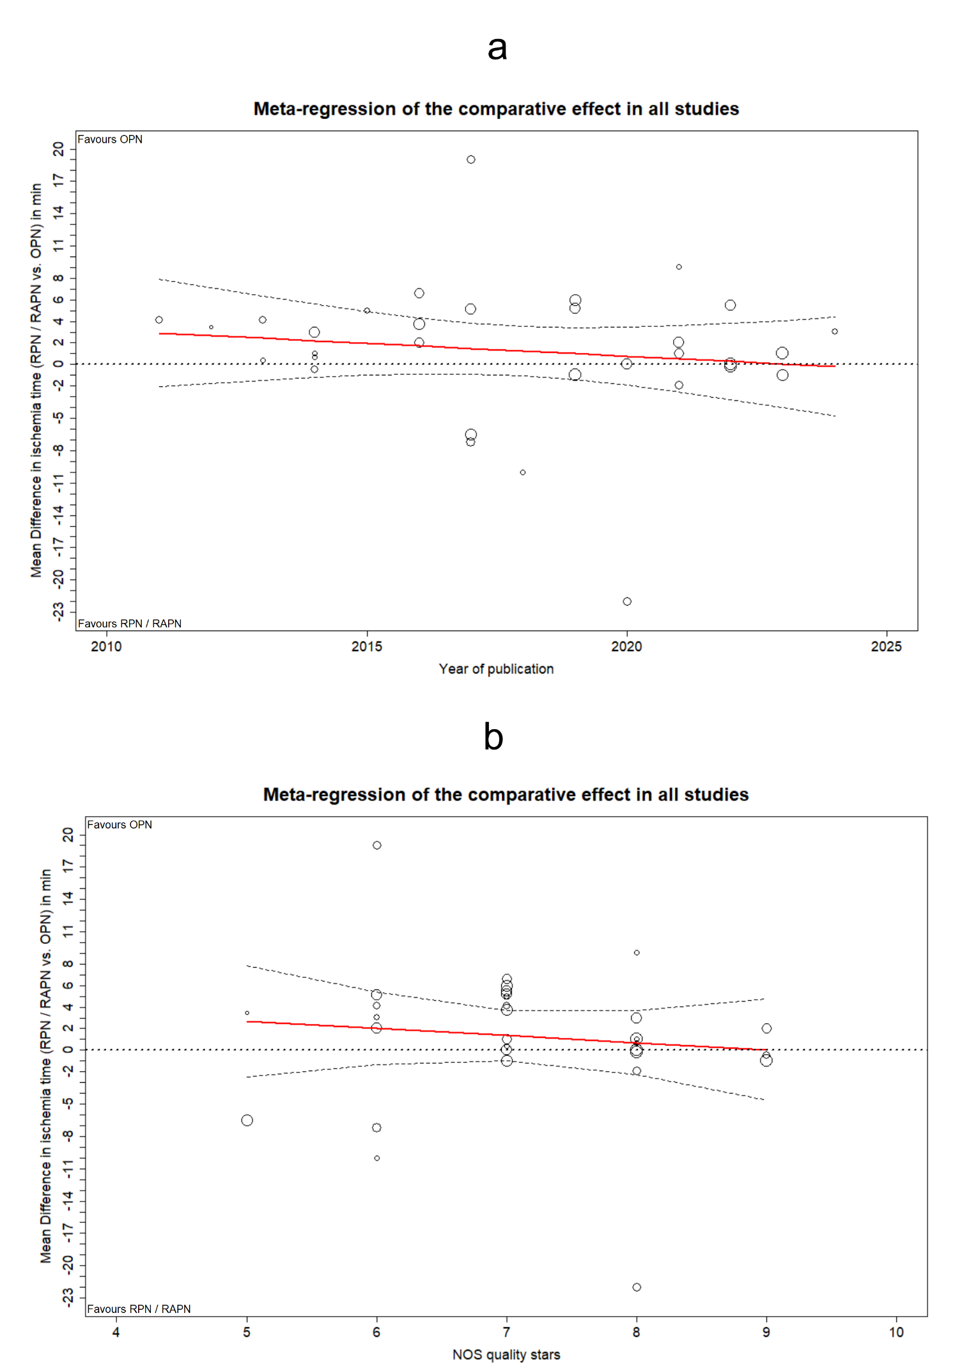
Supplementary Figure 55: MRA plots illustrating the evolution of MD_{IT} in studies with enhanced accuracy in reported results, by publication year (a), and across the qualitative spectrum of NOS grading (b). Abbreviations: MRA: Meta-regression Analysis, MD: Mean Difference, IT: Ischemia Time, NOS: Newcastle-Ottawa Scale.

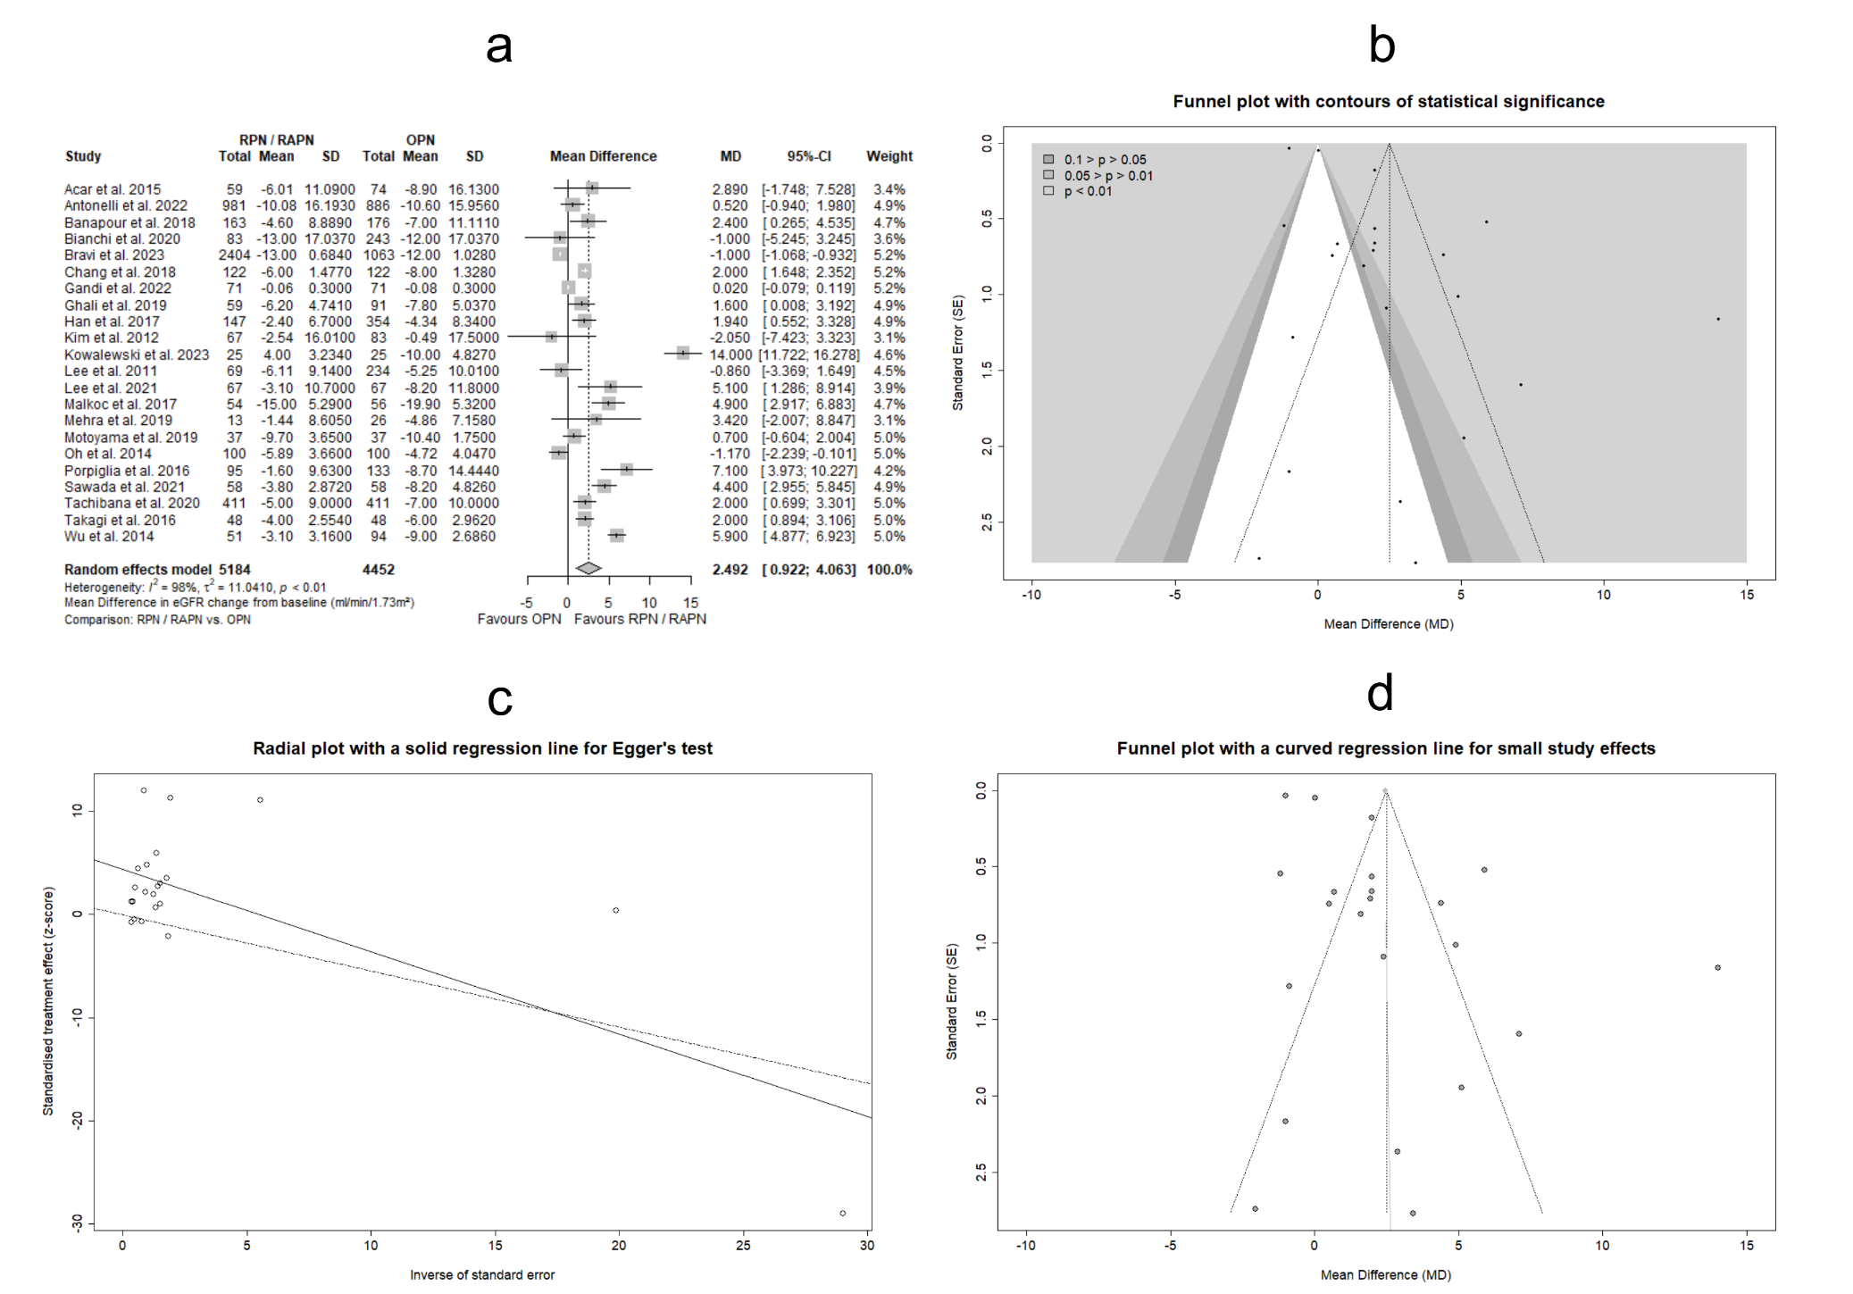
Supplementary Figure 56: Forest plot for estimating the MD_{ΔeGFR} in studies with enhanced accuracy in reported results (a). Funnel plot for evaluating PB in the aforementioned study subset, enriched with contours of distinct significance levels (b). Radial plot with integrated Egger’s test for the assessment of PB in estimating the MD_{ΔeGFR} in the above study set (c). Funnel plot with graphical display of SSEs for assessing PB (d). Abbreviations: MD: Mean Difference, ΔeGFR: Change (negative) from baseline in estimated Glomerular Filtration Rate, PB: Publication Bias, SSEs: Small Study Effects.

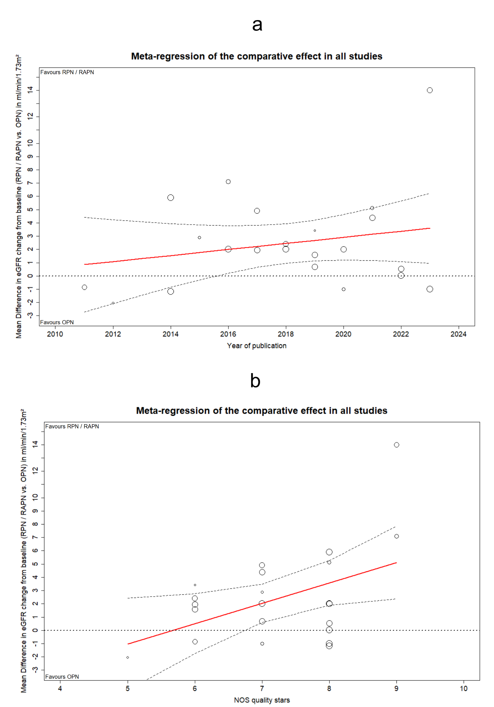
Supplementary Figure 57: MRA plots illustrating the evolution of MD_{ΔeGFR} in studies with enhanced accuracy in reported results, by publication year (a), and across the qualitative spectrum of NOS grading (b). Abbreviations: MRA: Meta-regression Analysis, MD: Mean Difference, ΔeGFR: Change (negative) from baseline in estimated Glomerular Filtration Rate, NOS: Newcastle-Ottawa Scale.

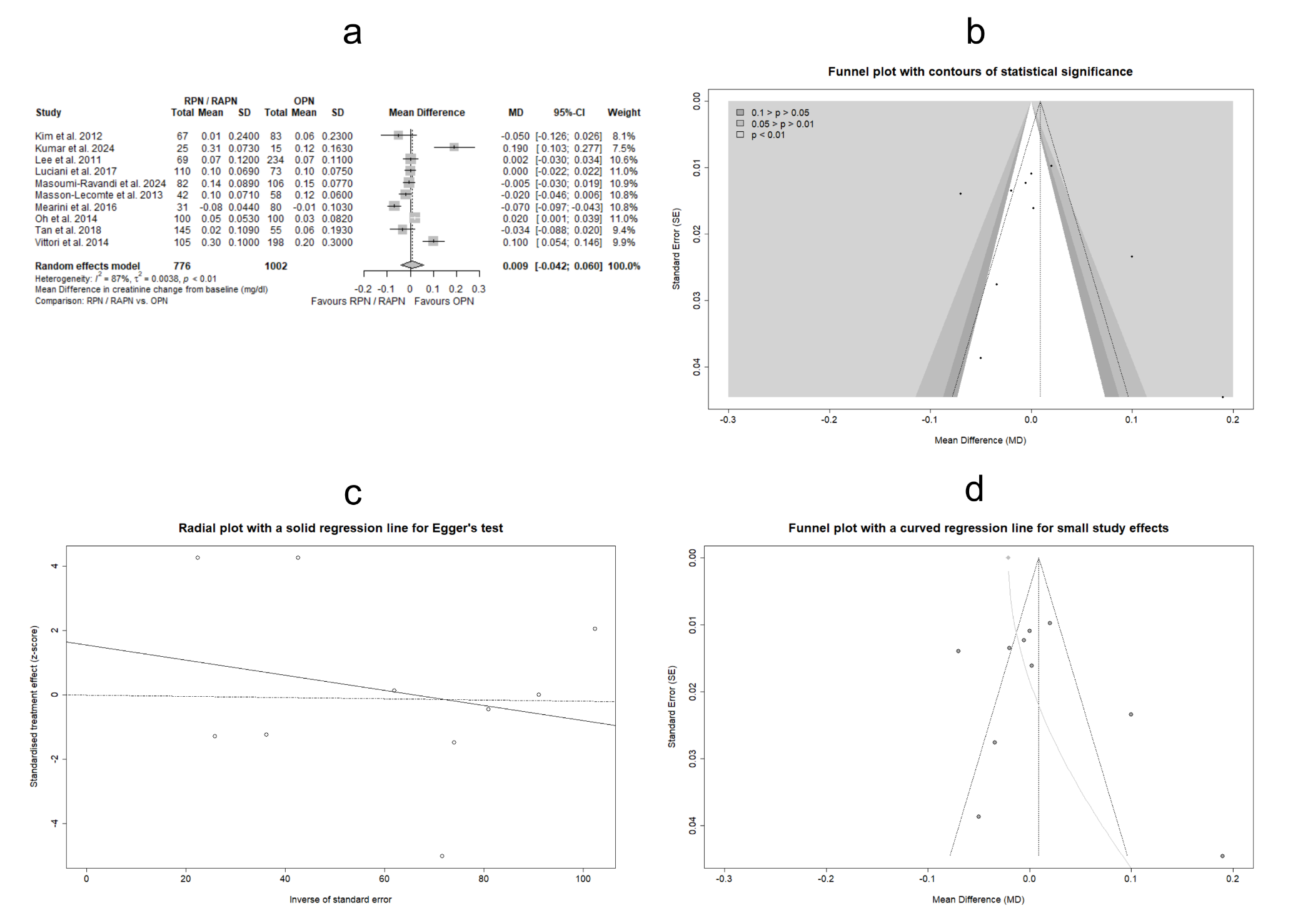
Supplementary Figure 58: Forest plot for estimating the MD_{ΔCr} in studies with enhanced accuracy in reported results (a). Funnel plot for evaluating PB in the aforementioned study subset, enriched with contours of distinct significance levels (b). Radial plot with integrated Egger’s test for the assessment of PB in estimating the MD_{ΔCr} in the above study set (c). Funnel plot with graphical display of SSEs for assessing PB (d). Abbreviations: MD: Mean Difference, ΔCr: Change (positive) from baseline in serum Creatinine levels, PB: Publication Bias, SSEs: Small Study Effects.

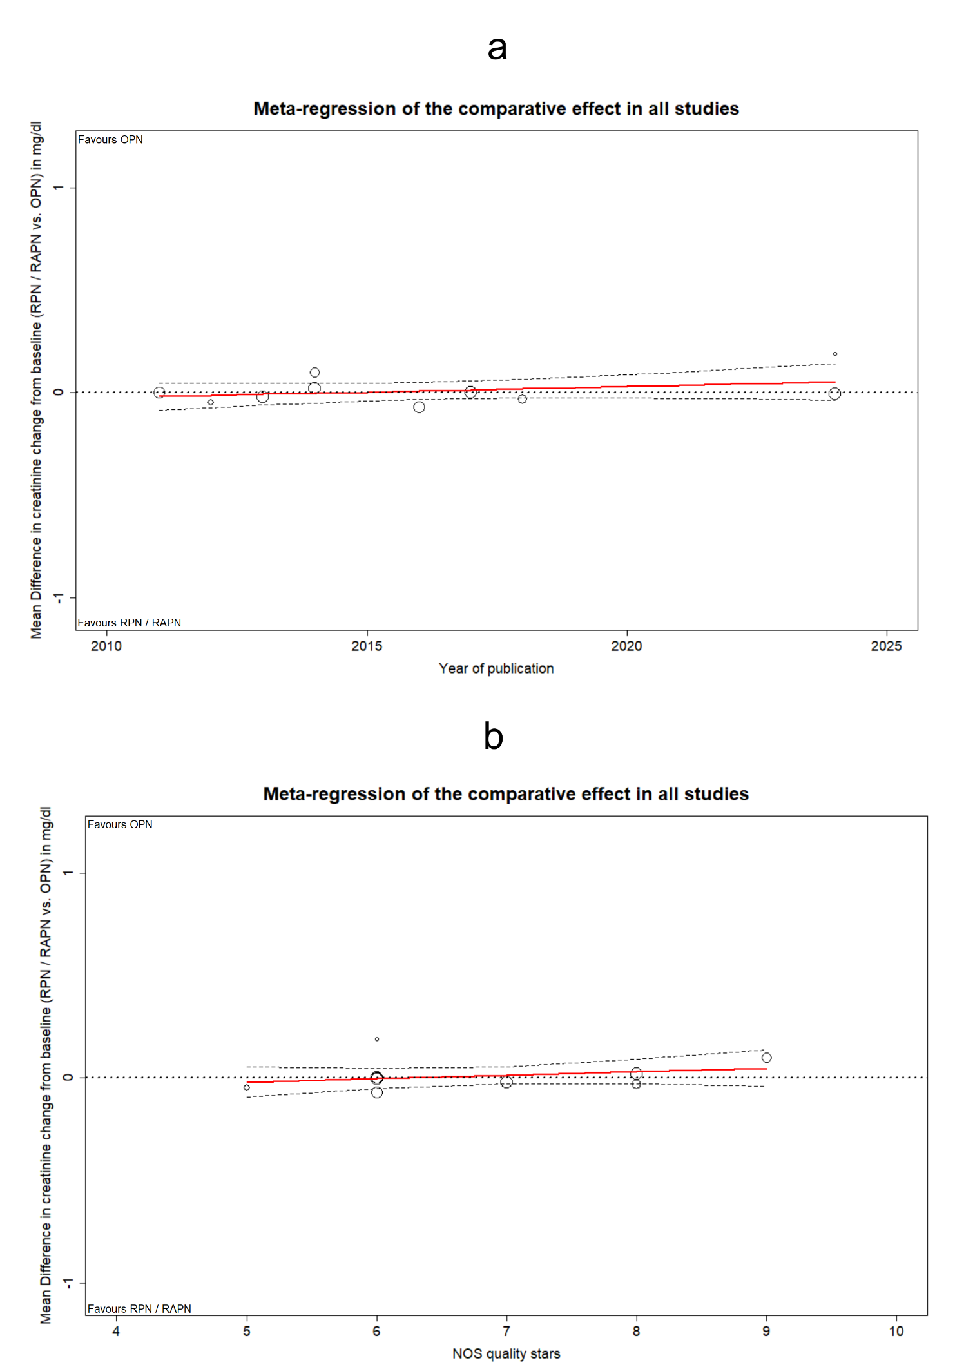
Supplementary Figure 59: MRA plots illustrating the evolution of MD_{ΔCr} in studies with enhanced accuracy in reported results, by publication year (a), and across the qualitative spectrum of NOS grading (b). Abbreviations: MRA: Meta-regression Analysis, MD: Mean Difference, ΔCr: Change (positive) from baseline in serum Creatinine levels, NOS: Newcastle-Ottawa Scale.

