Supplementary Materials for

Noncanonical Nf-κB activation by icariin-triggered CEBP-β/G-CSF axis confers neuroprotection in ischemic optic neuropathy
Tushar Dnyaneshwar Desai, Yao-Tseng Wen, Jayasimha Rayalu Daddam, Rong-Kung Tsai*
Correspondence to: rktsai@tzuchi.com.tw

This PDF file includes:

Figures. S1 to S3

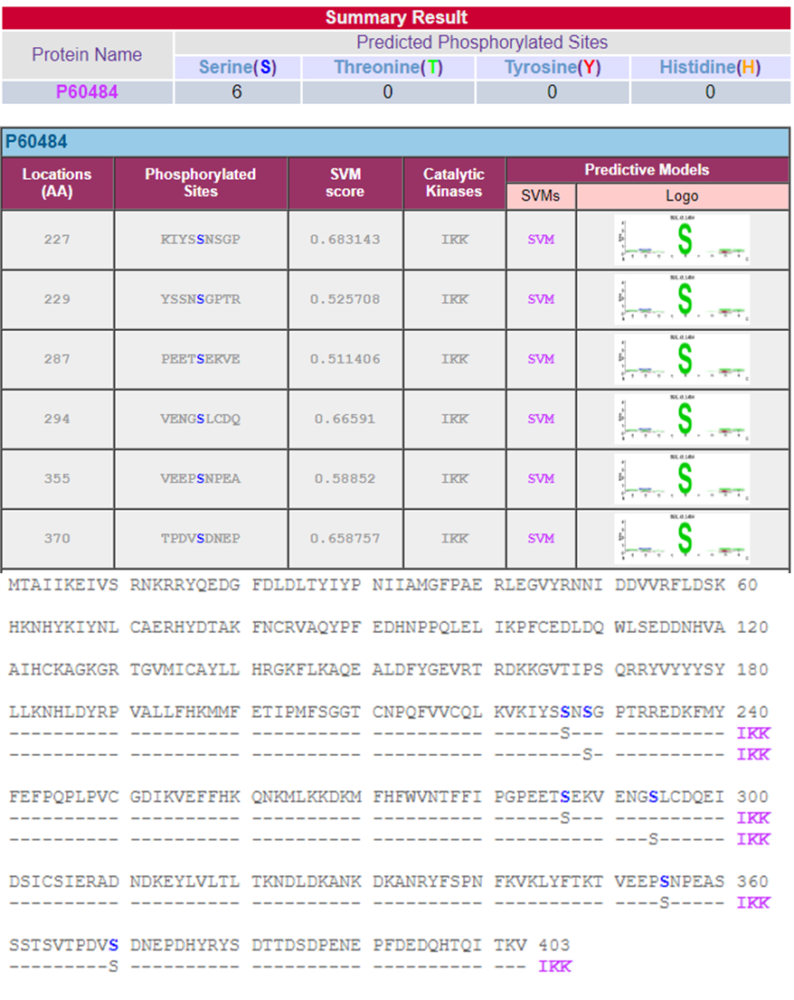
Figure S1: IKK-β is a potential kinase for PTEN.
Phosphorylation sites on PTEN by IKK-β predicted using the Kine Phos 2.0 prediction bioinformatics tool.

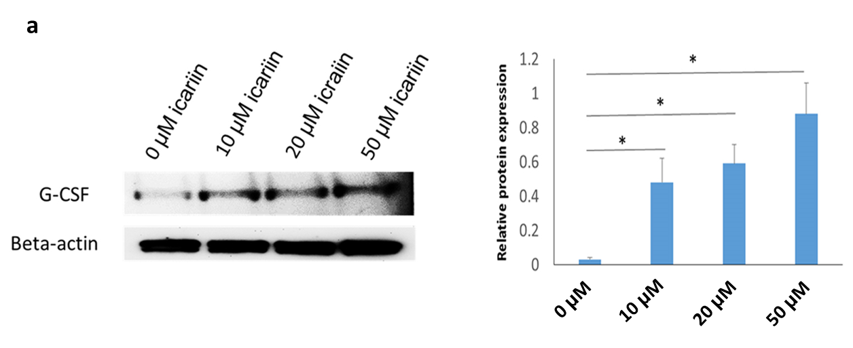
Figure S2: Icariin stimulates the G-CSF progression in dose dependent manner.
Immunoblot analysis for G-CSF expression of ARPE19 cells exposed to different doses of Icariin

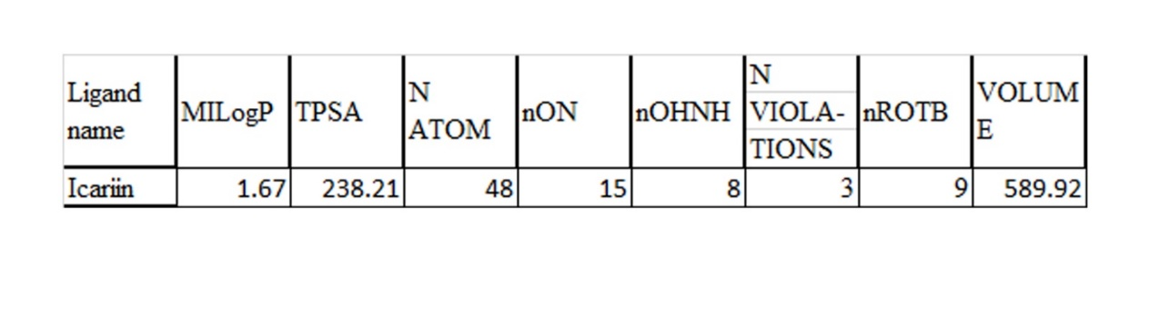
Figure S3: Icariin cannot pass the blood–retina barrier.
The characteristics of icariin were studied based on Lipinski’s rule of five.

