All Irradiance-Applicable, Perovskite Solar Cells-powered flexible Self-sustaining Sensor Nodes for Wireless Internet-of-Things

Wenqi Han¹, Ruicheng Nie², Bing Yin¹*, Jie Zhang¹, Sen Qiu², Jiazhen Wei¹, Mingzhu Pei³, Yuan Qin¹, Wen Wang¹, Xiangyang Zhang¹, Jiashuo Cheng¹, Lida Liu¹, Yantao Shi¹*
¹State Key Laboratory of Fine Chemicals, School of Chemistry, Dalian University of Technology, Dalian 116024, China.
²State Key Laboratory of Intelligent Control and Optimization, School of Control Science and Engineering, Dalian University of Technology, Dalian 116024, China.
³School of microelectronics, Dalian University of Technology, Dalian 116024, China.

Corresponding Authors:
E-mail address: BingYin@dlut.edu.cn (Bing Yin), Shiyantao@dlut.edu.cn (Yantao Shi).

Contents:
Supplementary Notes:
Supplementary Note 1. Accurate measurements of the PCE of the Perovskite Indoor Photovoltaics.
Supplementary Note 2. Optical characteristics of PSC under indoor low-light conditions.
Supplementary Note 3. Voltage conversion optimization design for SSN powered by FPSM.
Supplementary Note 4. Self-feedback Regulation control method for intelligent homes based on FPSM-SSN.

Supplementary Figures:
Supplementary Figure 1. FPSM-SSN physical assembly drawing.
Supplementary Figure 2. Cs_{0.05}(FA_{0.87}MA_{0.15})_{0.95}Pb(I_{0.87}Br_{0.13})₃ perovskite photoactive layer material characterization.
Supplementary Figure 3. Image of the encapsulated flexible large-area perovskite solar module.
Supplementary Figure 4. Schematic diagram of the SSN electronic system.
Supplementary Figure 5. Absorption spectrum and bandgap calculation of perovskite films.
Supplementary Figure 6. The J-V curves of FPSM under different indoor light intensities.
Supplementary Figure 7. Under AM1.5 sunlight, the photovoltaic performance of the FPSM was evaluated.
Supplementary Figure 8. Performance study of PSCs under different lighting conditions using warm-LED, simulated sunlight, and filters to control light intensity.
Supplementary Figure 9. The stabilized power output of the FPSM under 1000 lux LED illumination.
Supplementary Figure 10. Real-time voltage tracking of the FPSM under different light intensities.
Supplementary Figure 11. The proposed perovskite PV energy harvesting system.
Supplementary Figure 12. Power consumption of the boost and buck converters amplifies.
Supplementary Figure 13. Power consumption measurement of the SSN system.
Supplementary Figure 14. Crosstalk resistance testing of sensor arrays.
Supplementary Figure 15. I-V testing of sensor arrays in different temperature and humidity environments.
Supplementary Figure 16. FPSM-SSN 24h temperature network detection and analysis.
Supplementary Figure 17. FPSM-SSN 24h humidness network detection and analysis.
Supplementary Figure 18. Logic Instructions for self-feedback regulation in intelligent homes based on FPSM-SSN.
Supplementary Figure 19. Self-feedback control method of smart home based on FPSM-SSN.

Supplementary Tables:
Supplementary Table 1. Comparison of maximum indoor PCE among different photovoltaic technologies
Supplementary Table 2. List of discrete components used in the SSN.
Supplementary Table 3. Measured PV performance parameters of the FPSM under LED indoor light source (2700K @ 1000 lux).
Supplementary Table 4. PCE for the recently reported flexible perovskite modules

Supplementary Video:
Supplementary Video 1. Smart home self-feedback control video for FPSM-SSN.

Supplementary Note 1. Accurate measurements of the PCE of the Perovskite Indoor Photovoltaics.
First, as previously reported¹, the emission spectrum and power intensity of the LED indoor light source (Osram 4.9W/2700K-Warm light) are measured using a high-precision fiber optic spectrometer (Spectrilight ILT950) equipped with a cosine corrector (Ocean Optics, CC-3-UV-S). The results help in understanding the light distribution and intensity. Subsequently, treat with anti-reflective coatings. The use of anti-reflective coatings minimizes light loss due to reflection, ensuring the accuracy of light intensity detection.
For the detection of PCE, we conduct tests in a completely light-isolated environment. An integrated illuminance meter (DELIXI) is used to calibrate the light on a 25 cm² test platform. By adjusting the height between the LED light source and the test platform, we ensur that the light intensity over the 25 cm² area is 1000 lux. Subsequently, the FPSM is placed at the calibrated position, and a source meter (2450, Keithley, USA) is connected to the FPSM. A forward voltage of 0-3V and a reverse voltage are applied for forward and reverse scanning, respectively, to complete the measurement.
The power conversion efficiency of PSC can be calculated by the equation²: $\text{P}\text{CE}\text{=}\frac{{\text{P}}_{\text{out}}}{{\text{P}}_{\text{in}}}\text{×1}\text{00\%}$. The P_{out} can be calculated by the equation: ${\text{P}}_{\text{out}}\text{=}{\text{V}}_{\text{OC}}\text{×}\frac{{\text{J}}_{\text{SC}}}{\text{A}}\text{×FF}$. And the P_{in} is calculated by using the equation:$P_{in}=\int_{0}^{∞}{E_{λ}\left(λ\right)d_{λ}}$, $E(λ)=N_{λ}(λ)×hc/λ$，where h is the Planck constant, the c is the lightspeed, the λ is the wavelength of the photon and N_{λ} is the photon flux spectrum. In our work, the P_{in} can measure by a high-precision fiber-optics spectrometer (Spectrilight ILT950) equipped.

Supplementary Note 2. Optical characteristics of PSC under indoor low-light conditions.
PSCs exhibit significant variations in PCE when exposed to different light intensities, particularly between indoor and outdoor environments^{3, 4}. Notably, PSCs demonstrate higher PCE under low-light conditions, making them ideal for indoor applications. This phenomenon is primarily due to the fill factor ($\text{FF}$) and open-circuit voltage (V_{OC}) of PSCs being more dependent on the shunt resistance (R_{sh}) rather than the series resistance (Rs) under low light. According to the following equation⁵:${\text{V}}_{\text{OC}}\text{=}\frac{\text{nKT}}{\text{q}}\text{ln}\left[\frac{{\text{J}}_{\text{p}\text{h}}\text{(}{\text{V}}_{\text{OC}}\text{)}}{{\text{J}}_{\text{ds}}}\text{+1-}\frac{{\text{V}}_{\text{OC}}}{{\text{R}}_{\text{sh}}{\text{J}}_{\text{ds}}}\right]$. Where J_{ds} is the reverse dark saturation current, J_{ph} is the photocurrent, R_{sh} is the shunt resistance and n is the ideality factor. We found that the V_{OC} is proportional to R_{sh}, J_{ph}, and inversely proportional to J_{ds} Particularly, a large R_{sh} should lead to a reduced losing V_{OC}, and improved the V_{OC} of devices.
In addition, the impacts of R_{s} and R_{sh} on the FF can be separately expressed by the following equation⁶: ${\text{FF}}_{\text{0}}\text{=}\frac{{\text{V}}_{\text{OC}}\text{-ln(}{\text{V}}_{\text{OC}}\text{+0.72)}}{{\text{V}}_{\text{OC}}\text{+1}}$, ${\text{FF}}_{\text{sh}}\text{=}{\text{FF}}_{\text{0}}\text{(1-}{\text{r}}_{\text{s}}\text{)}$, ${\text{FF}}_{\text{sh}}\text{=}{\text{FF}}_{\text{0}}\text{[1-}\frac{\left({\text{V}}_{\text{OC}}\text{+0.7}\right)}{{\text{V}}_{\text{OC}}}\frac{{\text{FF}}_{\text{0}}}{{\text{r}}_{\text{sh}}}\text{]}$, $\text{FF=}{\text{FF}}_{\text{0}}\text{(1-}{\text{r}}_{\text{s}}\text{)[1-}\frac{\left({\text{V}}_{\text{OC}}\text{+0.7}\right)}{{\text{V}}_{\text{OC}}}\frac{{\text{FF}}_{\text{0}}}{{\text{r}}_{\text{sh}}}\text{]}$, Where ${\text{V}}_{\text{OC}}\text{=}{\text{V}}_{\text{OC}}\text{/(A}{\text{k}}_{\text{B}}\text{T)/q}$, ${\text{r}}_{\text{s}}\text{=}{\text{R}}_{\text{S}}\text{/(}\frac{{\text{V}}_{\text{OC}}}{{\text{J}}_{\text{SC}}}\text{)}$, ${\text{r}}_{\text{sh}}\text{=}{\text{R}}_{\text{Sh}}\text{/(}\frac{{\text{V}}_{\text{OC}}}{{\text{J}}_{\text{SC}}}\text{)}$, Several key factors contribute to this behavior⁷:
Leakage Current and Recombination Paths: Under low light, the generation rate of photogenerated carriers is lower, resulting in smaller currents. In such conditions, the performance of the cell is more affected by leakage currents. The shunt resistance (R_{sh}) represents the paths of leakage current within the device. A lower R_{sh} indicates more leakage paths, leading to a reduced FF. Conversely, a higher R_{sh} signifies fewer leakage paths and minimal leakage current, thereby improving the FF.
Photogenerated Current and Carrier Recombination: At low light intensities, the generated photogenerated current is minimal, and these carriers are more likely to recombine at bulk traps. A low R_{sh} exacerbates non-radiative recombination losses, decreasing both the V_{OC} and the FF.
Current Density and Voltage Relationship: In low light conditions, the current density is very low, and the device's output characteristics are primarily influenced by the open-circuit voltage and the shunt resistance. A high R_{sh} leads to a higher V_{OC}, which in turn increases the FF.
Reduced Impact of Series ${\text{R}}_{\text{S}}$: Under low light, the current is small, and the impact of the series resistance on device performance is relatively weak. Series resistance mainly affects power loss at higher currents, which is not significant under low light. Therefore, the FF is more influenced by the R_{sh}.
In summary, under low light conditions, the R_{sh} of a device is more reliant on the R_{sh} rather than the R_{s}. This dependency arises because the small currents in low light conditions make leakage currents and non-radiative recombination the main factors influencing device performance, both of which are primarily governed by the shunt resistance. A high R_{sh} can reduce leakage current and non-radiative recombination losses, thereby enhancing the FF and overall performance^{8, 9}.

Supplementary Note 3. Voltage conversion optimization design for SSN powered by FPSM.
The micro-power boost chargers and buck converters included in the SSN are a highly integrated solution designed for efficient energy extraction and power management from various high-impedance sources, such as PSCs under indoor low-light conditions. As detailed in the bq25570 datasheet, this device is specifically engineered to handle micro-watt to milli-watt power levels generated by sources like PSCs or thermoelectric generators without causing input source failure.
In the realm of voltage conversion optimization, the SSN employs an advanced Maximum Power Point Tracking (MPPT) algorithm to dynamically adjust the input impedance, ensuring maximal power extraction from the PSCs¹⁰. This feature is particularly critical under indoor lighting conditions where the light intensity and spectrum can vary significantly. By periodically sampling the V_{OC} and setting the operating point to approximately 80% of V_{OC}, the SSN maintains efficient energy harvesting, even with the fluctuating output characteristics of PSCs.
Key specifications of the bq25570 include: ①Ultra-low Power Boost Charger: Capable of cold starting at voltages as low as 600mV and operating continuously with input voltages as low as 100mV. ②High Efficiency: The DC-DC boost converter achieves up to 93% efficiency and supports peak output currents of up to 110mA. ③Energy Storage Flexibility: Supports various storage elements, including rechargeable Li-ion batteries, thin-film batteries, supercapacitors, or conventional capacitors, providing flexibility in system design. ④Robust Power Management: Features over-voltage protection, under-voltage lockout, and configurable charging profiles to ensure the longevity and reliability of the energy storage components.
The MPPT functionality of the SSN is instrumental in optimizing the voltage conversion process. The device periodically disables the charger to sample the V_{OC}, which informs the MPPT algorithm to adjust the operating point for optimal power extraction. This process ensures that the energy harvested from the PSCs is maximized, which is crucial for applications with strict power and operational requirements, such as wireless sensor networks and low-power monitoring systems.
In summary, the SSN's sophisticated MPPT algorithm, combined with its high efficiency and robust power management features, makes it an ideal choice for optimizing voltage conversion in systems powered by PSCs under indoor low-light conditions. This integration not only enhances the overall efficiency of the energy harvesting system but also ensures stable and reliable operation across various lighting environments.

Supplementary Note 4. Self-feedback Regulation control method for intelligent homes based on FPSM-SSN
When the monitoring device is operating normally, the upper computer outputs control instructions containing the set temperature threshold information. The coordinator Zigbee module on the upper computer sends these instructions, which are then received by the Zigbee module on the terminal device. The Microcontroller Unit of the monitoring device parses the received instructions to activate the appropriate control functions.
When the sensor output value exceeds (or falls below) the set temperature threshold, the monitoring device issues instructions to turn on (or off) the household power supply. These instructions are wirelessly transmitted via Zigbee.
The wireless receiving end of the household power control peripheral receives these control instructions. A simple control MCU on this end parses the instructions (either to turn on or off) and executes the corresponding function, thereby powering the device on or off. After executing the instructions, it sends an acknowledgment message back to the upper computer to update the status of the household device (Supplementary Fig. 17).

Supplementary Figure 1. FPSM-SSN physical assembly drawing. (a) Physical image of FPSM-SSN (12 cm × 4 cm). (b) Folding model of FPSM-SSN.

Supplementary Figure 2. Cs_{0.05}(FA_{0.87}MA_{0.15})_{0.95}Pb(I_{0.87}Br_{0.13})₃ perovskite photoactive layer material characterization. (a) XRD diffraction pattern showing sharp and narrow peaks at 14°, 19.8°, 24.3°, and 28.2° corresponding to (100), (110), (111), and (200) planes of perovskite structure. (b) Surface SEM image of Cs_{0.05}(FA_{0.87}MA_{0.15})_{0.95}Pb(I_{0.87}Br_{0.13})₃ perovskite photoactive layer, individual grains reaching the size of above 1 μm. Scale bar 1 μm.

Supplementary Figure 3. Image of the encapsulated flexible large-area perovskite solar module. (a) Image of the encapsulated FPSM, with an effective area of 15 cm², compose of three 5 cm² sub-cells connected in series. The reserved positive and negative electrodes will be integrated with the SSN using conductive adhesive in subsequent steps. (b) Demonstration of the bendable characteristics of the FPSM.

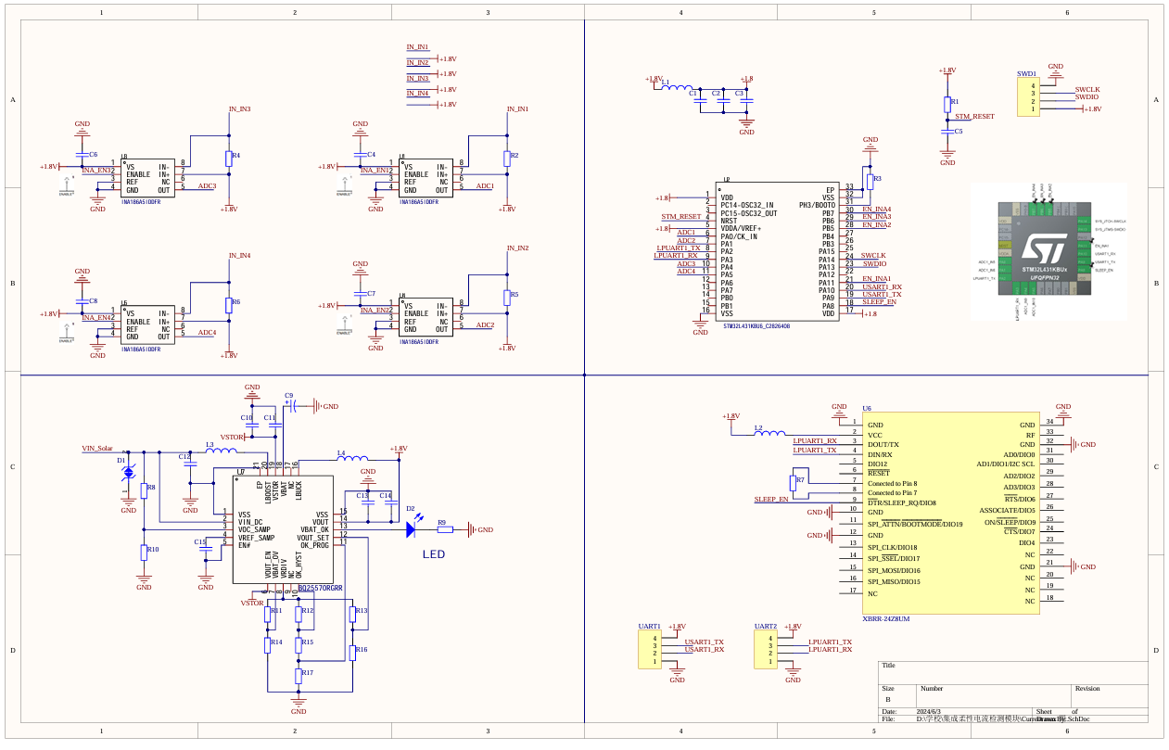
Supplementary Figure 4. Schematic diagram of the SSN electronic system. The schematic is divided into four main modules: information collection, wireless communication, power management, and data processing.
Supplementary Figure 5. Absorption spectrum and bandgap calculation of perovskite films. (a) UV-vis spectrum, showing the absorption edge of the Cs_{0.05}(FA_{0.87}MA_{0.15})_{0.95}Pb(I_{0.87}Br_{0.13})₃ perovskite film at 806 nm. (b) Bandgap of the Cs_{0.05}(FA_{0.87}MA_{0.15})_{0.95}Pb(I_{0.87}Br_{0.13})₃ perovskite film, determined using the equation${ \left(αhv\right)}^{1/n}=A(hv-E_{g})$, where α is the absorption coefficient, h is the Plank constant, v is the photon frequency, A is the constant associated with the material, $E_{g}$ is the band gap energy, n = 2 for indirect band gap and n = 1/2 for direct band gap.

Supplementary Figure 6. The J-V curves of FPSM under different indoor light intensities. The forward scan (FWD) applies a voltage from 0 to 3 V, while the backward scan (BWD) applies a voltage from 3 to 0 V. The figures represent J-V curves under (a)1000 lux, (b)500 lux, and (c)100 lux lighting conditions.

 | V_{OC} (V) | J_{SC} (mA·cm⁻²) | FF (%) | PCE (%)
FWD | 3.01 | 8.04 | 62.17 | 15.06
BWD | 3.02 | 8.03 | 62.64 | 15.24

Supplementary Figure 7. Under AM1.5 sunlight, the photovoltaic performance of the FPSM is evaluated. The V_{OC} is 3.02 V, J_{SC} is 8.03 mA·cm⁻², FF is 62.64%, and the PCE is 15.24%.

Supplementary Figure 8. Performance study of PSCs under different lighting conditions using warm-LED, simulated sunlight, and filters to control light intensity. To ensure more accurate test results, we use a PSC with an effective area of 0.049cm². (a) The trend of V_{OC} with varying light intensity. (b) The trend of J_{SC} with varying light intensity. (c) The trend of FF with varying light intensity. (d) Comparison of PSCs PCE under different light intensities and light sources. It can be observed that V_{OC} and J_{SC} both show a linear relationship with light intensity, with light intensity having a more significant impact on J_{SC}, indicating that light intensity greatly affects the photogenerated carrier density in perovskite. The FF is more related to the quality of the perovskite film and does not change significantly with light intensity. PCE under indoor light is significantly higher than under simulated sunlight.

Supplementary Figure 9. The stabilized power output of the FPSM under 1000 lux LED illumination.

Supplementary Figure 10. Real-time voltage tracking of the FPSM under different light intensities. (a) 1000 lux. (b) 500 lux and (c) 100 lux. The observed voltage fluctuations are due to the MPPT sampling process. During MPPT sampling, the system temporarily stops drawing current from the solar cell, causing the voltage to rise to its open-circuit value. After sampling, the charger reconnects, drawing current again and bringing the voltage back to its operating level. MPPT sampling occurs every 16s to update the maximum power point. Each sampling event causes a brief voltage spike followed by a return to the working voltage. These fluctuations are indicative of the MPPT function, ensuring the system operates near the maximum power point for optimal energy collection efficiency

Supplementary Figure 11. The proposed perovskite PV energy harvesting system. The output voltage of the FPSM is first converted to the maximum power point voltage through MPPT, then boosted by a boost module. Afterward, the power is divided into two parts: the first part is stepped down to 1.8 V via a buck converter and supplied to the load; the second part is stored in a capacitor module. When the FPSM output voltage is insufficient, the capacitor module's voltage is stepped down to 1.8 V via a buck converter to supply the load.

Supplementary Figure 12. Power consumption of the boost and buck converters amplifies. The boost and buck with an efficiency of up to 93%.

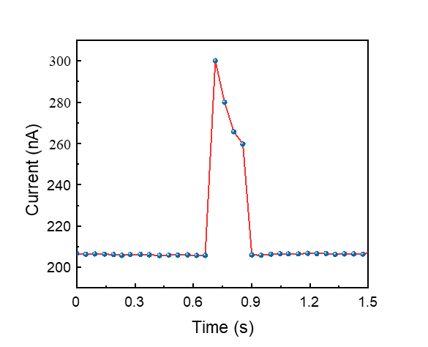
Supplementary Figure 13. Power consumption measurement of the SSN system. Operating at 1.8 V, the working current is 205 nA in sleep mode and 300 nA during communication, with a communication duration of 150 ms.

Supplementary Figure 14. Crosstalk resistance testing of sensor arrays. Crosstalk resistance testing of the PEDOT@ CNT temperature sensor array in different environments. To minimize the impact of humidity on temperature detection signals, the temperature sensor array is simply encapsulated with PET tape. The test results show that when the temperature increases by 20°C, the temperature sensor array's △R/R₀ value changes by 36%, while a 20% RH increase in humidity causes only a -1.6% change in the temperature sensor array's △R/R₀ value. This demonstrates that the PEDOT@ carbon nanotube temperature sensor array has high accuracy in temperature detection.

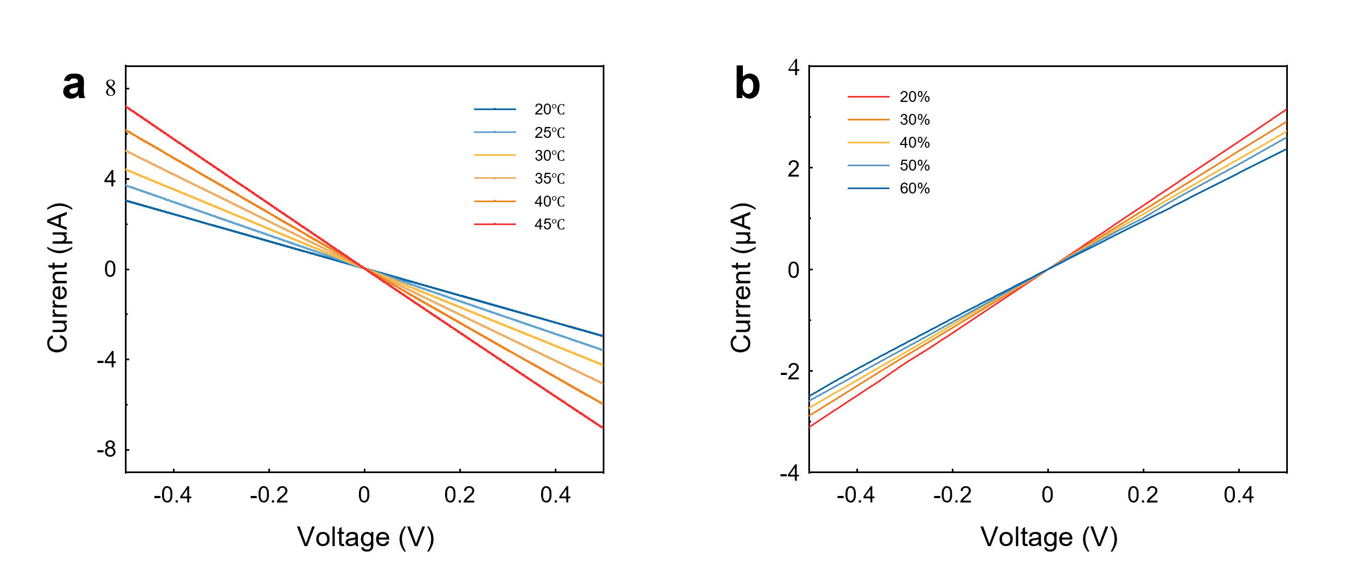
Supplementary Figure 15. I-V testing of sensor arrays in different temperature and humidity environments. The materials used in the study are resistive sensing materials, which exhibit changes in slope during I-V testing as the environment changes. (a) PEDOT@ carbon nanotube (CNT) temperature sensor array is tested for temperature response in the range of 20°C to 45°C. As the temperature increases, the sensor resistance decreases. (b) PEDOT@ Ti₃C₂T_{X} humidity sensor array is tested for humidity response in the range of 20% to 60% RH. As the humidity increases, the sensor resistance increases.

Supplementary Figure 16. FPSM-SSN 24h temperature network detection and analysis. 24-hour networked temperature collection results (△R/R₀).

Supplementary Figure 17. FPSM-SSN 24h humidness network detection and analysis. 24-hour networked humidness collection results (△R/R₀).

Supplementary Figure 18. Logic instructions for self-feedback regulation in intelligent homes based on FPSM-SSN. After connecting the signal receiver of the digital control switch to the household device, the upper computer sets the temperature detection threshold and sends it to the FPSM-SSN. The MCU module in the SSN parses the instruction and activates the control function. When the detected temperature exceeds the set threshold, a signal is sent to the digital control unit to turn on the digital control switch and start the household device.

Supplementary Figure 19. Self-feedback control method of smart home based on FPSM-SSN. (a) The self-feedback control experiment based on FPSM-SSN is designed to demonstrate intelligent power management. With the indoor temperature set to 27.8°C, the FPSM-SSN is alternately placed on a heating platform and an ice pack to adjust temperature changes. The red boxed area in the figure highlights the core module of the self-feedback control system. This module enables intelligent switching of a power strip based on signals received from the FPSM-SSN. In our setup, a fan is connected to the power strip, allowing for automated control of the fan. Additionally, the power strip can be connected to multiple electrical appliances, enabling automatic control of various smart home devices in response to environmental changes. (b) Detailed composition of the control unit includes: ① Zigbee communication receiver: Receives instructions sent by the FPSM-SSN. ② MCU module: Parses the received communication data. ③DC Relay: Activates the AC relay. ④AC Relay: Controls the power to household devices. This setup demonstrates the capability of FPSM-SSN to enhance smart home automation through responsive environmental monitoring and control.

Supplementary Table 1. Comparison of maximum indoor PCE among different photovoltaic technologies.
Photovoltaic cells | Active area (cm²) | Bandgap (eV) | PCE |  | Ref.
c-Si | 1 | 1.12 |  | 11.9 |  | ¹¹
α-Si | 1 | 1.63 |  | 29.9 |  | ¹²
DSSC | 2.8 | 1.72 |  | 34.5 |  | ¹³
OSC | 1 | 1.82 |  | 30.2 |  | ¹⁴
GaAs |  | 1.43 |  | 22.8 |  | ¹⁵
GaInP |  | 1.86 |  | 26.8
PSC | ~0.049 | 1.71 |  | 44.72 |  | ¹⁶
Summarized indoor PCE of the representative works of crystalline silicon (c-Si), amorphous silicon solar cell (a-Si), dye-sensitized solar cell (DSSC), organic solar cell (OSC), III-V solar cell (GaAs and GaInP) and PSC.

Supplementary Table 2. List of discrete components used in the SSN.
Designator | Description | Footprint/package | Value & Quantity
C1, C2, C3, C4, C5, C6, C7, C8, C11, C14 | Capacitor | LC-0201_C | 0.1uF*10
C9 | Polarized Capacitor (Radial) | CAP-TH_BD13.0-P5.00-D0.6-FD | 70F
C10, C12, C13 | Capacitor | LC-0201_C | 4.7uF*3
C15 | Capacitor | LC-0201_C | 10nF
D1 |  | LC-0603_L | TVS
D2 | Typical INFRARED GaAs LED | LED0603 | LED0
L1, L2 | Inductor | LC-0603_L | 120/100MHz*2
L3, L4 | Inductor | LC-0805_L | Inductor*2
R1, R3 | Resistor | LC-0201_R | 10K*2
R2, R4, R5, R6 | Resistor | R0603 | 100*4
R7 | Resistor | LC-0201_R | 4.7K
R8 | Resistor | LC-0201_R | 2M
R9 | Resistor | LC-0402_R | 510K
R10 | Resistor | LC-0201_R | 8M
R11 | Resistor | LC-0402_R | 6.81M
R12 | Resistor | LC-0402_R | 6.19M
R13, R17 | Resistor | LC-0402_R | 4.22M*2
R14 | Resistor | LC-0402_R | 6.34M
R15 | Resistor | LC-0402_R | 2.74M
R16 | Resistor | LC-0402_R | 8.66M
SWD1, UART1, UART2 | Header, 4-Pin | MHDR1X4 | Header 4*3
U1, U3, U4, U5 |  | TSOT-23-8_L2.9-W1.6-P0.65-LS2.8-TL | INA186A5IDDFR*4
U2 |  | QFN-32_L5.0-W5.0-P0.50-TL-EP3.5 | STM32L431KBU6_C2826408
U6 |  | XBee-34-SMD | XBRR-24Z8UM
U7 |  | LC-VQFN-20_5x5x065P | BQ25570RGRR

Supplementary Table 3. Measured PV performance parameters of the FPSM under LED indoor light source (2700K @ 1000 lux).
Light Intensity | Sweep  direction | V_{OC} (V) | J_{SC} (mA·cm⁻²) | FF (%) | PCE (%) | Pout (mW)
1000 lux | BWD | 2.55 | 0.757 | 67.82 | 30.54 | 1.131
1000 lux | FWD | 2.53 | 0.757 | 68.22 | 30.53 | 1.31
500 lux | BWD | 2.42 | 0.389 | 66.58 | 29.53 | 0.629
500 lux | FWD | 2.48 | 0.384 | 65.42 | 29.28 | 0.623
100lux | BWD | 2.22 | 0.091 | 59.8 | 28.29 | 0.121
100lux | FWD | 2.24 | 0.091 | 59.29 | 28.08 | 0.12

Supplementary Table 4. PCE for the recently reported flexible perovskite modules
Structure | Are (cm²) | PCE (%)
PEN/ITO/C60/PVK/  Spiro-OMeTAD/MoO₃/Au | 16 | 8.6 ¹⁸
PET/ITO/PTAA/PVK/C₆₀/BCP/Ag | 15.7 | 10.51 ¹⁹
PEN/ITO/PEDOT:PSS/NiOx/PVK/  PC₆₁BM/Ag | 15 | 16.15 ²⁰
PET/ITO/PEDOT:GO/PVK/PCBM/Ag | 15 | 10.26 ²¹
PET/ITO/2T-NATA/PVK/C₆₀/BCP/Ag | 16 | 13.15 ²²
PET/ITO/SnO₂/PVK/  Spiro-OMeTAD/Au | 16.07 | 15.22 ²³
PET/ITO/NiO_{X}/PVK/C₆₀/BCP/Ag | 16 | 15.24※

Supplementary References
- Cui Y. et al. Accurate photovoltaic measurement of organic cells for indoor applications. Joule 5, 1016-1023 (2021).
- Wang KL. et al. Ion-dipole interaction enabling highly efficient CsPbI₃ perovskite indoor photovoltaics. Adv Mater. 35, e2210106 (2023).
- Wang KL, Zhou YH, Lou YH & Wang ZK. Perovskite indoor photovoltaics: opportunity and challenges. Chem Sci. 12, 11936-11954 (2021).
- Dou D, Sun H, Li C, Gan S & Li L. Perovskite‐based indoor photovoltaics and their competitors. Adv. Funct. Mater. 34, 2314398 (2023).
- Yang W. et al. Leakage current induced by energetic disorder in organic bulk heterojunction solar cells: Comprehending the ultrahigh loss of open-circuit voltage at low temperatures. Phys. Rev. Appl. 7, 044017 (2017).
- Shen K. et al. CdTe solar cell performance under low-intensity light irradiance. Sol Energy Mat Sol C. 144, 472-480 (2016).
- Zhu X. et al. Perspectives for the conversion of perovskite indoor photovoltaics into IoT reality. Nanoscale 15, 5167-5180 (2023).
- Liu C. et al. Flexible Indoor Perovskite solar cells by in situ bottom-up crystallization modulation and interfacial passivation. Adv Mater. 36, e2311562 (2024).
- He X, et al. 40.1% Record Low-Light Solar-Cell Efficiency by Holistic Trap-Passivation using Micrometer-Thick Perovskite Film. Adv Mater. 33, e2100770 (2021).
- Olzhabay Y, Ng A & Ukaegbu IA. Perovskite PV energy harvesting system for uninterrupted IoT device applications. Energies 14, 7946 (2021).
- Pecunia V, Occhipinti LG & Hoye RLZ. Emerging indoor photovoltaic technologies for sustainable Internet of Things. Adv. Energy Mater. 11, 2100698 (2021).
- Agbo SN, Merdzhanova T, Rau U & Astakhov O. Illumination intensity and spectrum-dependent performance of thin-film silicon single and multijunction solar cells. Sol Energy Mat Sol C. 159, 427-434 (2017).
- Kim G. et al. Transparent thin-film silicon solar cells for indoor light harvesting with conversion efficiencies of 36% without photodegradation. ACS AppI. Mater. Interfaces. 12, 27122-27130 (2020).
- Zhang D. et al. A molecular photosensitizer achieves a Voc of 1.24 V enabling highly efficient and stable dye-sensitized solar cells with copper(II/I)-based electrolyte. Nat. Commun. 12, 1777 (2021).
- Zhang T. et al. A medium-bandgap nonfullerene acceptor enabling organic photovoltaic cells with 30% efficiency under indoor artificial light. Adv Mater. 34, e2207009 (2022).
- Shore A, Roller J, Bergeson J & Hamadani BH. Indoor light energy harvesting for battery-powered sensors using small photovoltaic modules. Energy Sci. Eng. 9, 2036-2043 (2021).
- Ma Q. et al. One-step dual-additive passivated wide-bandgap perovskites to realize 44.72%-efficient indoor photovoltaics. Energy Environ. Sci. 17, 1637-1644 (2024).
- Li K. et al. An efficient, flexible perovskite solar module exceeding 8% prepared with an ultrafast PbI₂ deposition rate. Sci. Rep. 8, 442 (2018).
- Castriotta LA. et al. Light-stable methylammonium-free inverted flexible perovskite solar modules on PET exceeding 10.5% on a 15.7 cm² active area. ACS AppI. Mater & Interfaces. 13, 29576-29584 (2021).
- Wang H. et al. An in situ bifacial passivation strategy for flexible perovskite solar module with mechanical robustness by roll-to-roll fabrication. J. Mater. Chem. A. 9, 5759-5768 (2021).
- Xue T. et al. Mechanically robust and flexible perovskite solar cells via a printable and gelatinous interface. ACS AppI. Mater & Interfaces. 13, 19959-19969 (2021).
- T. Lei. et al. Flexible perovskite solar modules with functional layers fully vacuum deposited. Solar RRL. 4, 2000292 (2020).
- Bu T. et al. Universal passivation strategy to slot-die printed SnO₂ for hysteresis-free efficient flexible perovskite solar module. Nat. Commun. 9, 4609 (2018).

