Supplementary information

A “Plug-n-Play” permeable brick-based microfluidic pump
Zhihao Chen^{‡,a}, Jiahao Liu^{‡,a}, Shuqiang Minª, Tonghuan Zhanª, Yange Huangª, Xianchang Wuª, Jianfeng Chen^{b,*}, Bing Xu^{a,*}
a School of Mechanical Engineering, Suzhou University of Science and Technology, Suzhou, 215009, China
b School of Advanced Manufacturing, Nanchang University, Nanchang, 330031, China
‡ Equal contributors
- mail: xb022@ustc.edu.cn & cjf@ncu.edu.cn

Fig. S1 The manufacturing process of microfluidic chips.

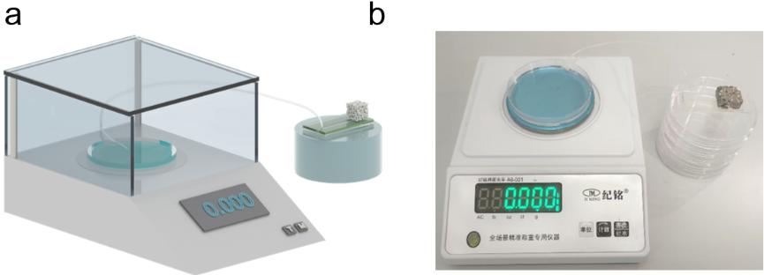
Fig. S2 Flow rate measurement. a) Schematic diagram and b) real image of instruments for measuring the pump flow rate.

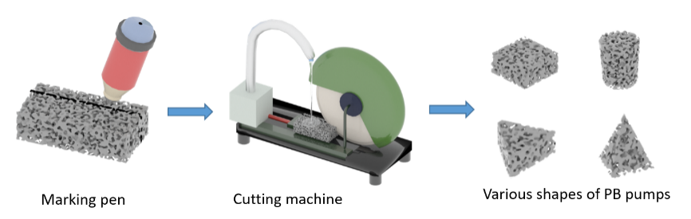
Fig. S3 Fabrication of PB pumps: write the cutting line by using a marker pen and cut the brick under the action of water flow.

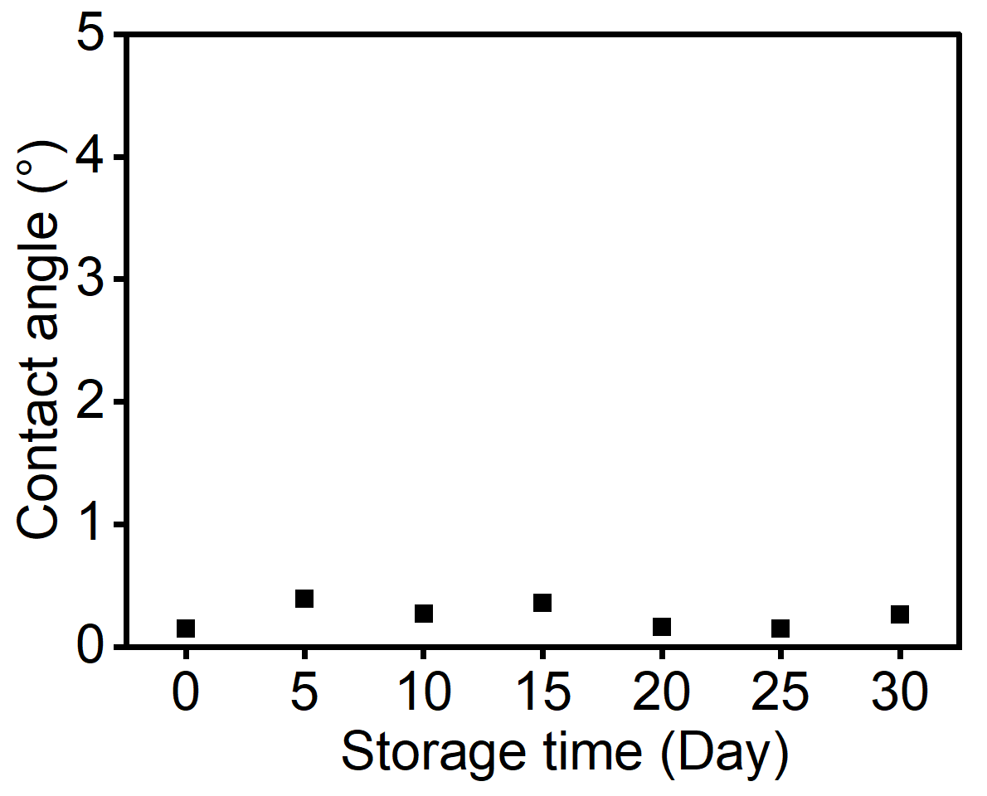
Fig. S4 Hydrophilicity characterization of PB pump within 30 days.

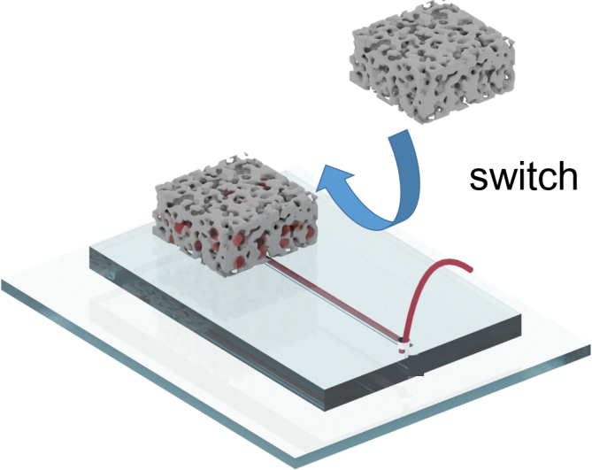
Fig. S5 Switching the loaded permeable brick pump with unloaded one.
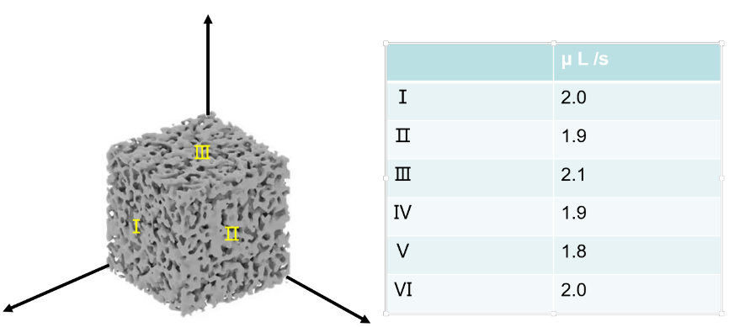
Fig. S6 A standard (2×2×2 cm³) PB pump with its six-face is firstly contacted the outlet of the microfluidic chips. Then, corresponding water flow rate are measured, respectively.

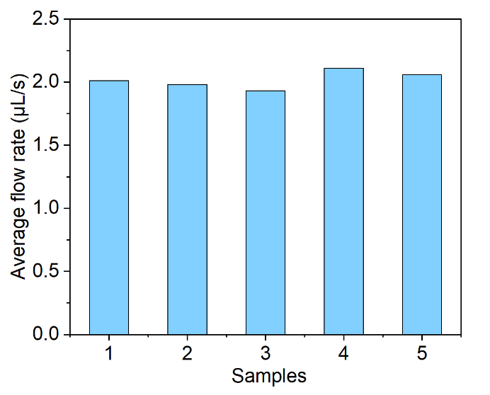
Fig. S7 Characterization the homogeneity of average flow rate of PM pump. We firstly slice bricks of the same size (2x2x2 cm³) from a same permeable brick, then the flow rates on the 5 samples are measured.

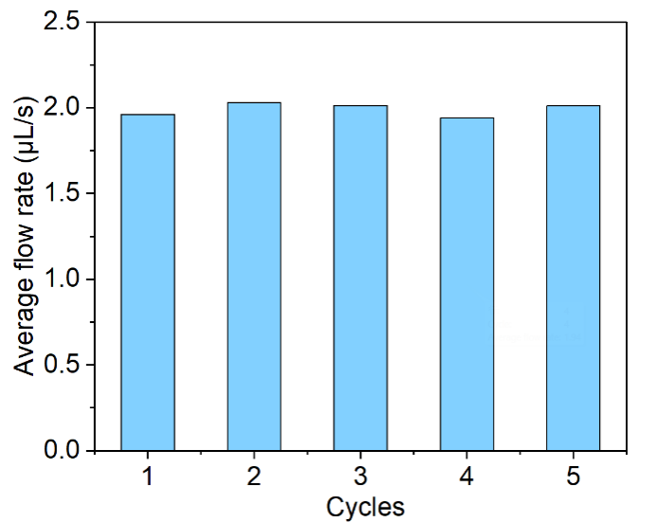
Fig. S8 Repeatability testing of PB pumps. The average flow rates of PB pumps remain unchanged after 5 usage cycles.

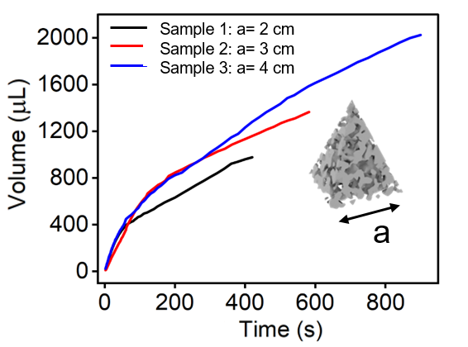
Fig. S9 The absorption volume of different bottom surface areas of the pyramid shaped PB pump (the same height).

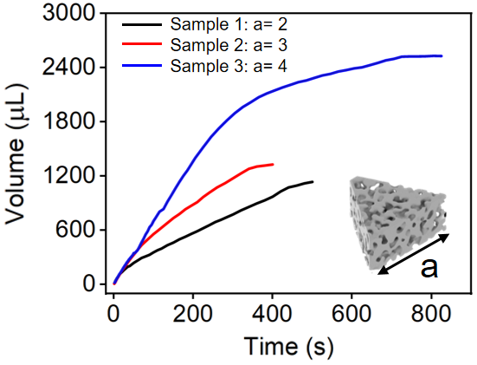
Fig. S10 The absorption volume of different surface parameters of the triangular prim shaped PB pump (the same height).

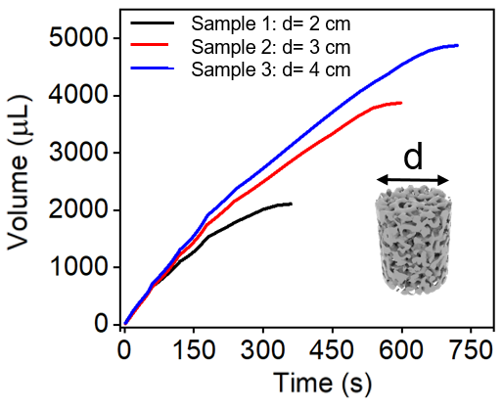
Fig. S11 The absorption volume of different surface parameters of the cylindrical shaped PB pump (the same height).

Table S1. Performance comparison with other pumps.
Reference | Flow rate | Active or  passive | flow control | Operating time | Price ($) | Fabrication  difficulty | Portable
Adv. Sci. 2017, 4, 1700028 | 15 µL min⁻¹ | passive | × | ~24 h | 3 | Moderate | √
Lab Chip, 2021, 21, 4772–4778 | 12 µL min⁻¹ | active | √ | hours | 5 | easy | ×
Sensors and Actuators B: Chemical, 2021, 342: 129991. | 0-4 µL min⁻¹ | passive | √ | minutes | 15 | Moderate | √
Lab on a Chip  2019，17  2885-2896 | 100-1000 µL min⁻¹ | active | √ | hours | 1 | easy | √
Lab on a Chip, 2013, 13, 1737–1742 | 4 µL min⁻¹ | passive | √ | minutes | 0.5 | Moderate | √
Lab on a chip, 2014, 14(21): 4213-4219. | 150-300 µL h⁻¹ | active | √ | hours | 1 | Easy | ×
Lab on a Chip, 2014, 14(22): 4319-4323. | 1-8 µL min⁻¹ | active | √ | minutes | 25 | difficulty | ×
Our group | 0-400 µL min⁻¹ | passive | √ | minutes | 0.1 | easy | √

