Supplementary Materials for
FABP4 as a critical mediator in osteoporosis: inhibition strategies and therapeutic potential
Qian Xie et al.

Corresponding author: Qian Xie, xqqx1996@163.com; Huiren Tao, huiren_tao@163.com; Yan Wang, yan.wang@siat.a.c.cn; Tailin Wu, tl_spine@163.com

This PDF file includes:
Materials and Methods
Table S1 to S2
Figs. S1 to S12
Un-cropped western blotting strips

Material and method
ELISA assay of serum PINP, CXT-1and FABP4
In brief, serum samples were obtained from human or mouse blood samples. The levels of Serum P1NP, CTX1, and FABP4 were quantified using specific ELISA kits: PINP ELISA kit (animaluni, cat#LV30683), CTX1 ELISA kit (animaluni, cat#LV30790), and FABP4 ELISA kit (Thermo Fisher, cat#EH177RB), respectively, following the instructions provided by the manufacturers.
Establishment of BMSCs stably transfected FABP4
The pLV2-CMV-FABP4(human)-3×FLAG-ZsGreen1-puro plasmid-packaged lentivirus (2×10^8 Tu/mL) was procured from DINGKE Biotech (Shenzhen, China). BMSC cells were cultured to 40%-60% confluency over 18-24 hours before being exposed to 8 μg/mL Polybrene to enhance transfection efficiency. Following a 6-hour viral infection period, the cells were switched to standard culture medium for an additional 48 hours. Positive cell clones were selected with 1 μg/mL Puromycin, ensuring continuous cell subculture and monitoring throughout the screening process. Subsequently, quantitative real-time RT-PCR and Western blot were conducted to assess FABP4 gene expression.
In vitro osteoblastic differentiation of BMSCs
Primary BMSCs were obtained from OriCell (Guangzhou, China) and plated in 6-well plates at a density of 5 × 10^5 cells/well. They were then cultured in osteogenic medium consisting of α-MEM with 10% FBS, 50 μg/mL ascorbic acid (Sigma, cat#PHR1008), 10 mM sodium β-glycerophosphate (Sigma, cat#G5422), and 10 nM dexamethasone (Sigma, cat#D1756) for a 14-day period. Upon the observation of ample calcium nodules using a microscope, the cells were fixed in 10% neutral formalin, stained with 1% Alizarin Red(Sigma, cat#A5533) in a dark environment, air-dried, and photographed. Subsequently, 400 μL of 10% cetylpyridinium chloride was added to each well, incubated at room temperature in the dark for 30 minutes, and the OD value was measured at 562 nm.
RT-qPCR and Western Blotting
RT-qPCR analysis was performed as previously described. The cells were lysed using TRIZOL (Thermo Fisher, US), reverse transcribed with PrimeScript RT Master Mix (TaKaRa, cat#RR036A), and underwent RT-qPCR analysis on a LightCycler96 machine with TB Green dye (TaKaRa, cat#RR820A), employing the primers detailed in Table S2.
Protein lysates from BMSC cells or BMMs were extracted using RIPA buffer (Thermo Fisher, US), separated by 10% SDS-PAGE, and transferred to a PVDF membrane (Millipore, GER). The membrane was blocked with 5% Bovine Serum Albumin in TBST and incubated overnight at 4°C with primary antibodies including FABP4, NFATc1 (Invitrogen, cat#PA5-79730), c-Fos (Abcam, cat#ab302667), TRAP (Abcam, cat#ab191406), PLCγ (Abcam, cat#ab302940), Calcineurin A (Abcam, cat#ab52761) and Calcineurin B (Abcam, cat#ab303562).
Histology and immunohistochemistry
After decalcification in EDTA (Aladdin, China) for 10 days following fixation of mouse tibiae and femurs, 6 μm sections were prepared post-dehydration and paraffin embedding. The sections underwent xylene dewaxing, ethanol rehydration, and staining with Hematoxylin and Eosin (H&E, Beyotime, China) or TRAP (Servicebio, cat#G1050) as per protocols. Subsequently, the sections were dehydrated, cleared, and mounted.
Following antigen retrieval with sodium citrate (Beyotime, China), sections were blocked with 10% BSA, incubated with FABP4 antibody (Abcam, cat#ab92501) overnight, washed with PBS, incubated with goat anti-rabbit IgG H&L (HRP) (Abcam, cat#ab6721), visualized with DAB (Abcam, cat#ab64238), counterstained with hematoxylin, dehydrated, cleared, and mounted for slide scanning.
Micro-CT scanning
Fixed but non-demineralized mouse femurs were subjected to micro-CT scanning using Brucker μCT (Skyscan 1276 Micro-CT, Kontich, Belgium). The scan parameters included a 6.5 μm voxel size at medium resolution, 70kV, 200 mA, 0.25mm Al filter, and an integration time of 350 ms. Three-dimensional images were generated from contoured two-dimensional images using techniques based on distance transformation of the original grayscale images (CTvox, version 3.3.0). Analysis in both 3D and 2D was conducted utilizing CT Analyser software (version 1.18.8.0). Evaluation of bone microarchitecture was carried out within a region of interest (ROI) of 1.5 mm in length, commencing 0.5 mm proximal to the distal growth plate for trabecular measurements.
Ca²⁺ concentration detection
After 4 days of culture with sRANKL and additional substances, the following groups were examined: OCs, OCs + FABP4, OCs + FABP4 + BMS309403 (30 μM or 10 μM), and OCs + BMS309403 (1 μM). The cells' intrinsic fluorescence was visualized using Fluo-4 AM (Beyotime, China) and a fluorescence microscope (Leica, DMI8, Japan), while the total fluorescence of the cells was quantified through flow cytometry (Easycell, China) analysis.
PLGA-PEG-Ald polymer synthesis
PLGA(50:50, 20K)-PEG2000-N₃ and PLGA(50:50, 20K)-PEG2000 were sourced from Hzxqbio (Hangzhou, China), while DBCO-Ald was procured from Confluore (Xi'an, China). The mixture containing one molar equivalent of PLGA(50:50, 20K)-PEG2000-N3 and 1.5 molar equivalents of DBCO-Ald was stirred at room temperature in DMSO for 3 hours. Following this, 75% ethanol was introduced to the solution, stirred, and the resulting solid was filtered, freeze-dried to yield PLGA(50:50, 20K)-PEG2000-Ald. The chemical structure was authenticated through FT-IR (Thermo Fisher IS50) and ¹H NMR analyses (Bruker AV600).
In vitro HA binding affinity
Mix Ald-BMS-NPs and PLGA-BMS-NPs with nano-hydroxyapatite (HA, Aladdin, China) by stirring at room temperature for 12 hours. Subsequently, centrifuge the mixture to remove unbound HA and collect the supernatant for TEM scanning.
In vivo biodistribution using IVIS and IVIM
Administer 100uL of Ald-BMS-Cy5-NPs and PLGA-BMS-Cy5-NPs into the peritoneal cavity of 10-week-old female C57/BL/6J mice. Post-injection, anesthetize the mice at 6 hours, 12 hours, and 24 hours for whole-body fluorescence distribution imaging using IVIS (IVIS Spectrum, Korea). Subsequently, while the mouse is still under anesthesia, dissect the tibia and capture the fluorescence within the bone marrow using IVIM (IVIM, Korea).
Metabolism marker testing of liver and kidney
Adjust the serum dilution accordingly, configure the necessary parameters on the automated biochemical analyzer (Chemray 240, Chemray 420, and Chemray 800), load the samples, and initiate the automated measurement process.

Table S1. Data and information collected from clinical patients, related to Figure 1.
Patients ID | Gender | Age | Lumbar Spine Bone Density  (g/cm²) | T value | Lipid profile |  |  |  | FABP4  (ng/mL)
 |  |  |  |  | TC | TG | HDL | LDL | FABP4  (ng/mL)
OP1 | Female | 63 | 0.796 | -3.2 | 5.25 | 3.35 | 1.01 | 2.43 | 30.40
OP2 | Female | 74 | 0.911 | -2.2 | 5.53 | 0.97 | 1.23 | 3.58 | 26.17
OP3 | Female | 75 | 0.750 | -3.6 | 4.587 | 1.16 | 0.912 | 3.26 | 49.67
OP4 | Female | 63 | 0.766 | -3.4 | 6.501 | 1.031 | 1.952 | 4.34 | 25.59
OP5 | Female | 78 | 0.794 | -3.2 | 4.09 | 2.42 | 0.88 | 2.13 | 24.49
OP6 | Female | 66 | 0.683 | -2.5 | 6.353 | 1.487 | 1.662 | 4.449 | 25.31
OP7 | Female | 69 | 0.809 | -3.1 | 4.257 | 1.124 | 1.464 | 2.118 | 20.98
OP8 | Female | 72 | 0.755 | -3.5 | 3.762 | 1.871 | 1.682 | 2.02 | 31.55
non-OP1 | Female | 40 | 1.121 | -0.5 | 4.26 | 1.06 | 0.96 | 2.81 | 17.86
non-OP2 | Female | 47 | 1.127 | 0.7 | 4.75 | 0.98 | 1.14 | 3.23 | 5.75
non-OP3 | Female | 34 | 1.722 | 0.4 | 5.445 | 2.513 | 1.256 | 4.103 | 21.89
non-OP4 | Female | 48 | 1.473 | 0.6 | 3.412 | 1.558 | 1.256 | 2.512 | 11.28
non-OP5 | Female | 38 | 1.596 | 0.8 | 4.4 | 0.8 | 1.42 | 2.68 | 15.05
non-OP6 | Female | 49 | 1.2687 | -0.1 | 4.073 | 1.017 | 1.306 | 2.694 | 5.03
non-OP7 | Female | 35 | 1.3215 | 0.9 | 4.76 | 1.22 | 1.13 | 2.95 | 18.10

Table S2. Primers used for quantitative PCR, related to Figure 4.
Gene | Primer Forward (5’ to 3’) | Primer Reverse (5’ to 3’)
Lilrb4a | GGACACCTTCCAAAGCCCATC | CCCTGACACCAGGTAATCACA
Fcgr4 | ATGTGGCAGCTACTACTACCA | ACCCACTTGGGGTCTAGGTTC
Pik3cb | CTATGGCAGACAACCTTGACAT | CTTCCCGAGGTACTTCCAACT
Oscar | CCTAGCCTCATACCCCCAG | CGTTGATCCCAGGAGTCACAA
Acp5 | CACTCCCACCCTGAGATTTGT | CATCGTCTGCACGGTTCTG
Fosl2 | CCAGCAGAAGTTCCGGGTAG | GTAGGGATGTGAGCGTGGATA
Fos | CGGGTTTCAACGCCGACTA | TTGGCACTAGAGACGGACAGA
Itgb3 | CCACACGAGGCGTGAACTC | CTTCAGGTTACATCGGGGTGA
Nfatc1 | GGAGAGTCCGAGAATCGAGAT | TTGCAGCTAGGAAGTACGTCT

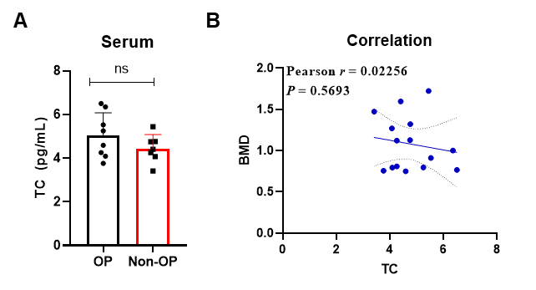
Figs. S1. The relationship between TC levels in patient serum and BMD, related to Figure 1. (A) Serum level of FABP4 was increased in OP patients and non-OP patients. (B) Pearson correlation analysis between BMD and TC in all clinical patients. ns = no significance. Paired t test.

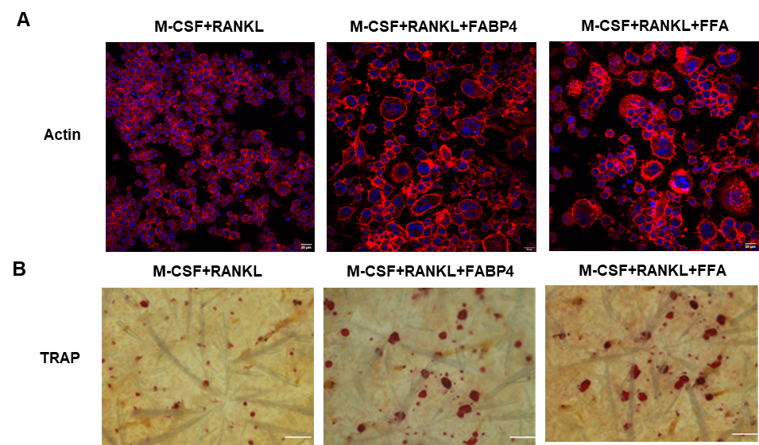
Figs. S2. The Impact of FABP4 on bone resorption, related to Figure 3. (A) F-actin staining of osteoclasts under stimulation of FABP4 and free FFA. Scale bar, 20 μm. (B) TRAP staining of osteoclasts on bovine bone slices under stimulation of FABP4 and free FFA. Scale bar, 200 μm.

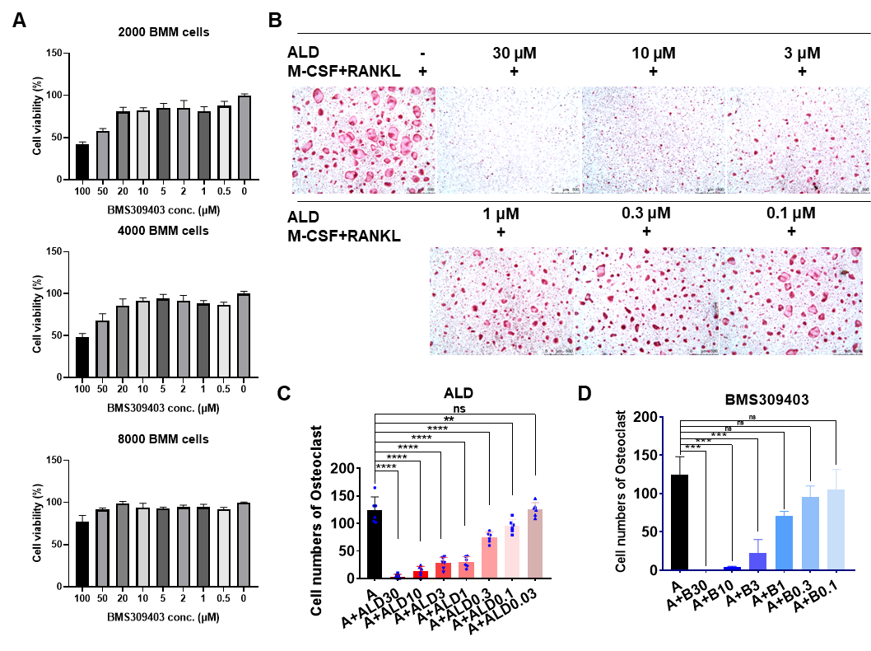
Figs. S3. Cytotoxicity of BMS309403 on BMMs and the impact of ALD on osteoclast differentiation, related to Figure 3. (A) Cytotoxicity of BMS309403 on different cell number of BMM cells. (B) TRAP staining of osteoclast differentiation under gradient concentrations of alendronate. Scale bar, 500 μm. (C) Quantitative results of osteoclast numbers in TRAP staining from (B). (D) Quantitative results of osteoclast numbers in TRAP staining from Figure 3H. ** p < 0.01, *** p < 0.001, **** p< 0.0001, ns = no significance. Data was analyzed by one-way ANOVA followed by Tukey's multiple comparisons test.

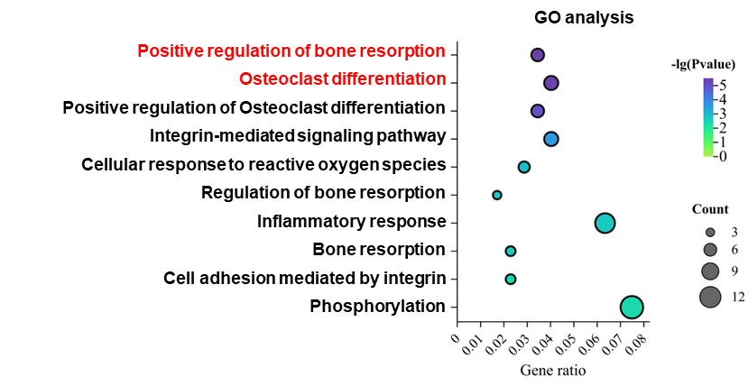
Figs. S4. GO analysis of intersecting genes from the Venn diagram, related to Figure 4.

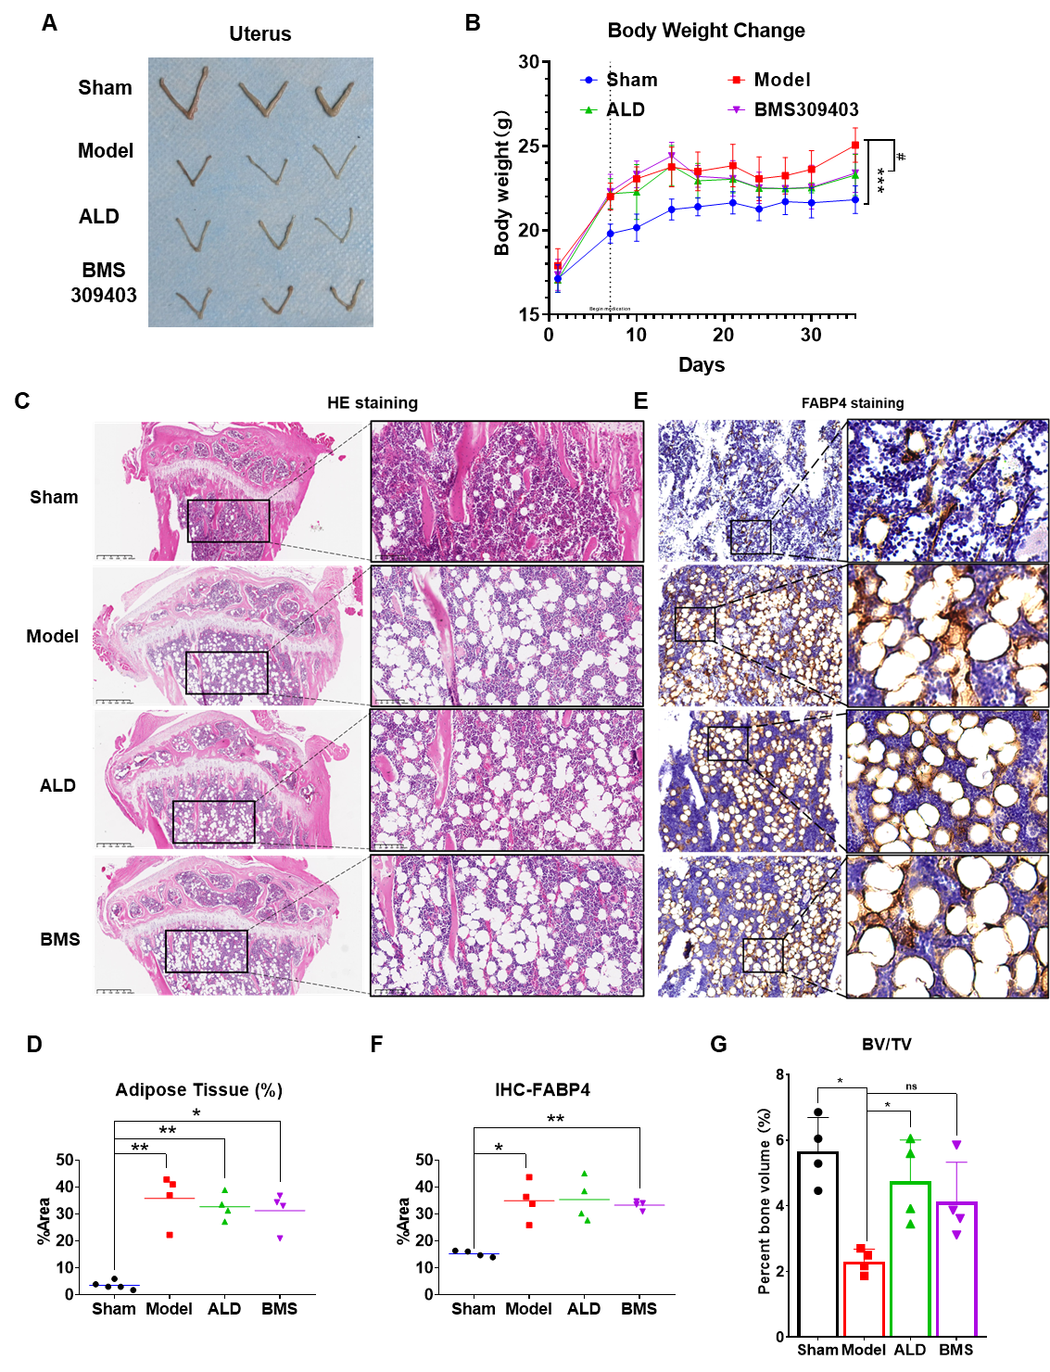
Figs. S5. The therapeutic effects of oral FABP4 inhibitors on OVX mice, related to Figure 5. (A) Anatomical illustration of the uterus in Sham group mice and OVX mice at the experimental endpoint, indicating severe uterine atrophy following OVX surgery, confirming a successful model establishment. (B) Body weight changes in mice from each group throughout the experimental period. (C) HE staining of tibial paraffin sections from mice in each group, along with localized magnified images of bone marrow regions. (D) Quantitative assessment of adipose tissue in bone marrow using HE staining in mice from (C). (E) Immunohistochemical staining results for FABP4 in tibial bone marrow paraffin sections from mice in different groups. (F) Quantitative analysis of FABP4 expression in bone marrow in mice from (E). (G) Three-dimensional reconstruction analysis of BV/TV in mice from each group using Micro-CT imaging.

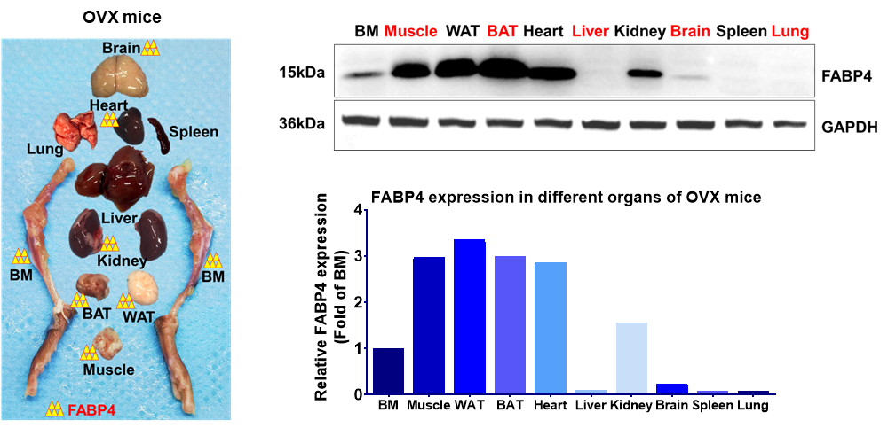
Figs. S6. Results of Western Blotting experiment on FABP4 expression in various organs of OVX mice, related to Figure 5.

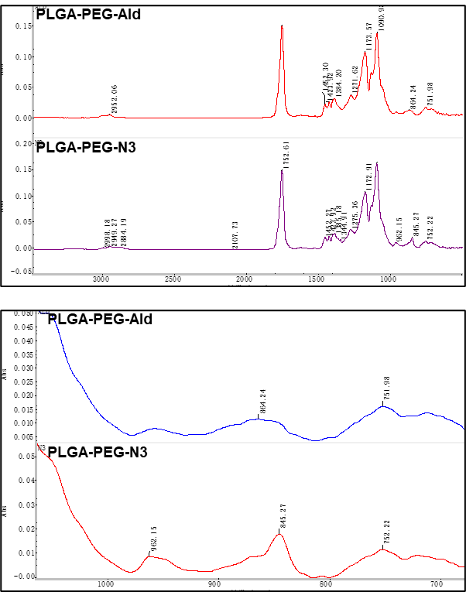
Figs. S7. FT-IR spectra of PLGA-PEG-Ald and PLGA-PEG-N3, related to Figure 6.

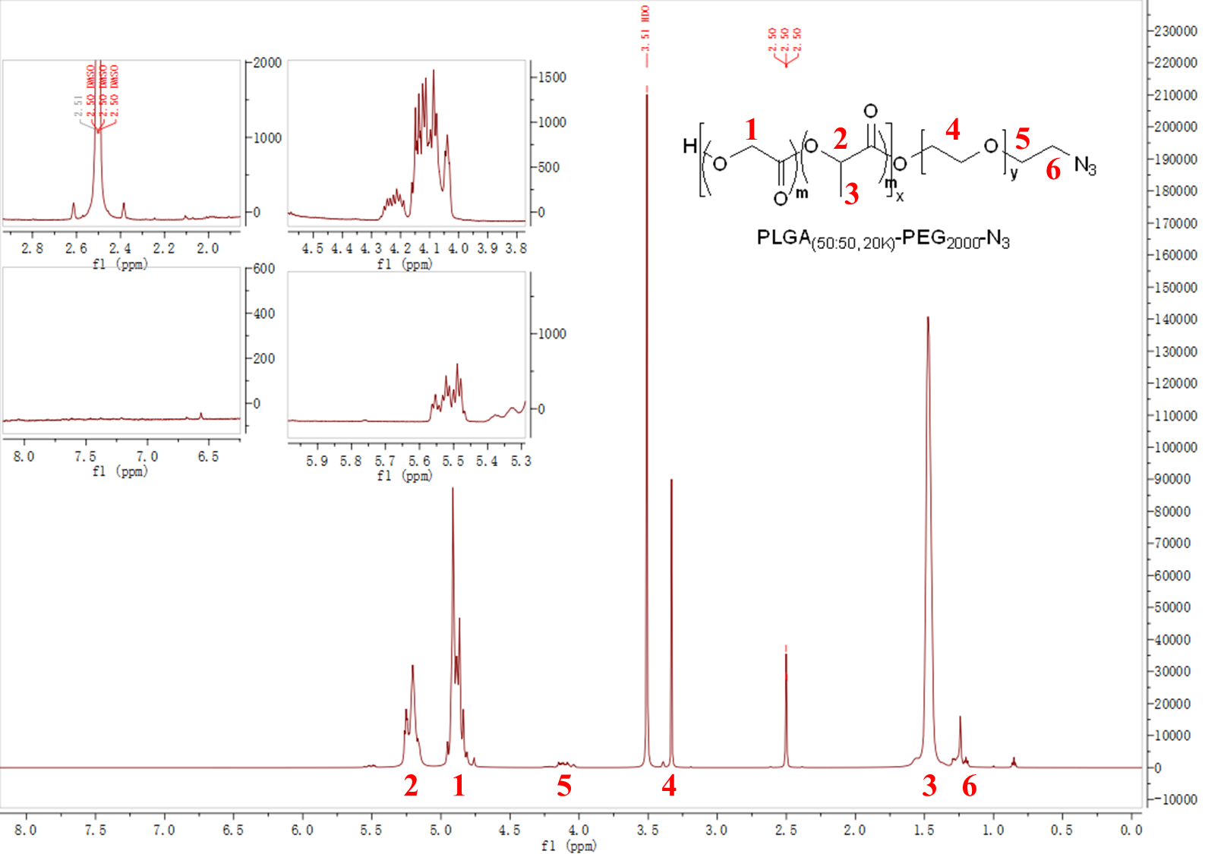
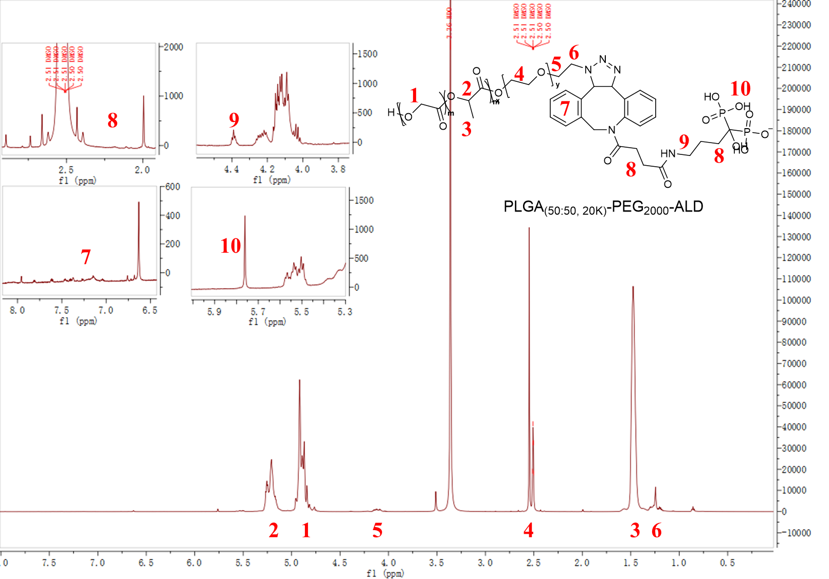
Figs. S8. ¹H-NMR spectra of PLGA-PEG-Ald and PLGA-PEG-N3, related to Figure 6.

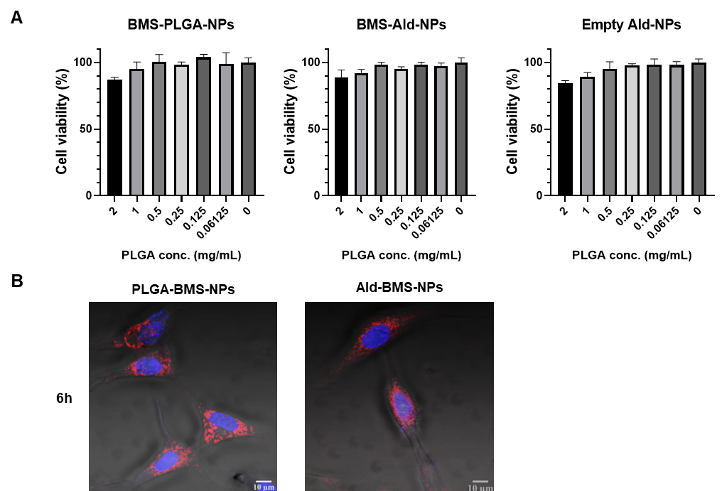
Figs. S9. The cytotoxicity and cellular uptake capabilities of PLGA-BMS-NPs, related to Figure 6. (A) Cytotoxicity of PLGA-BMS-NPs, Ald-BMS-NPs, and Ald-NPs on BMMs cells. (B) In situ fluorescence images of BMSC cells uptake of PLGA-BMS-NPs and Ald-BMS-NPs at 0.5h and 6h.

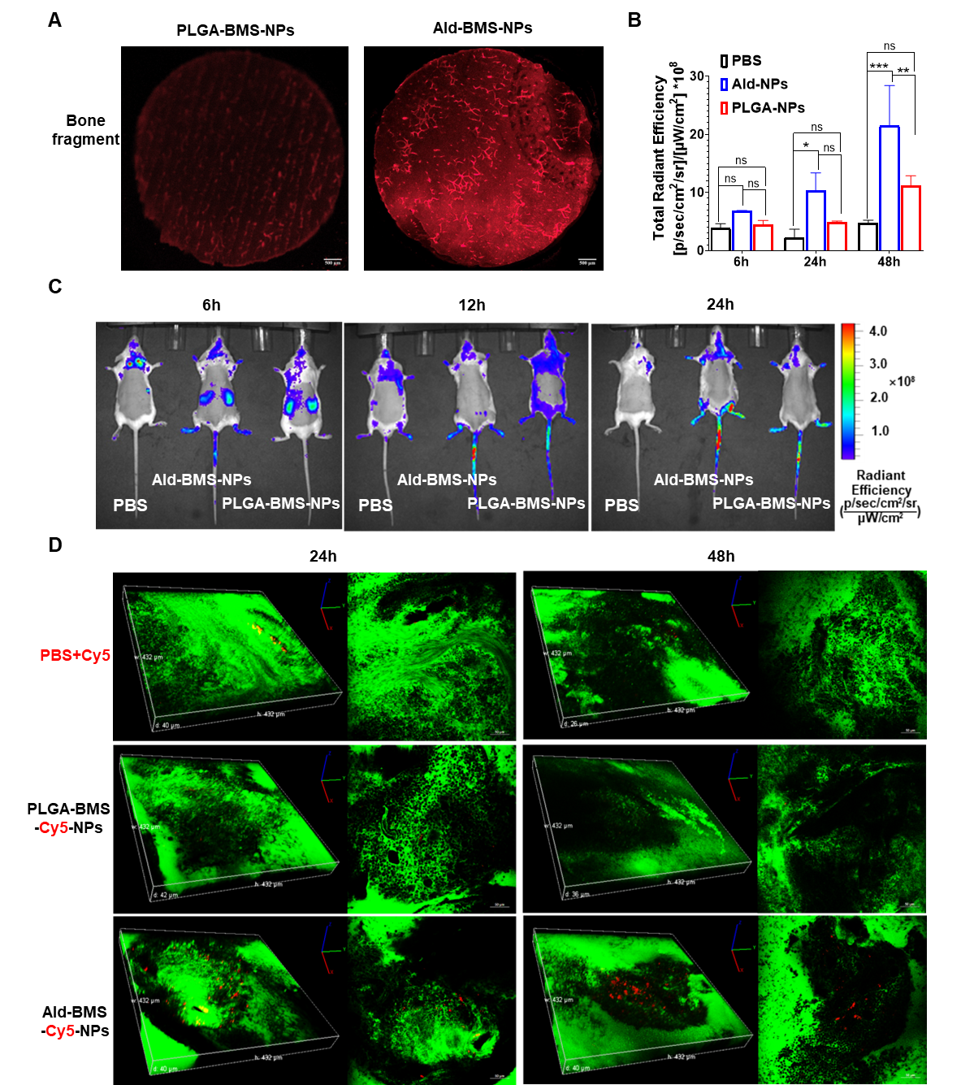
Figs. S10. The bone targeting ability of Ald-BMS-NPs, related to Figure 6. (A) Adsorption capacity of PLGA-BMS-NPs and Ald-BMS-NPs on bovine bone slices. (B) Fluorescence intensity in the long bones of mice from group G at various time points. (C) In vivo IVIS fluorescence images post intraperitoneal injection of Cy5-containing nanoparticles at 6h, 12h, and 24h. (D) In vivo IVIM fluorescence images of Cy5-containing Ald-NPs and PLGA-NPs in the bone marrow of live mice. Scale bar, 50 μm. * p < 0.05, ** p < 0.01, *** p < 0.001, ns = no significance. Data was analyzed by one-way ANOVA followed by Tukey's multiple comparisons test.

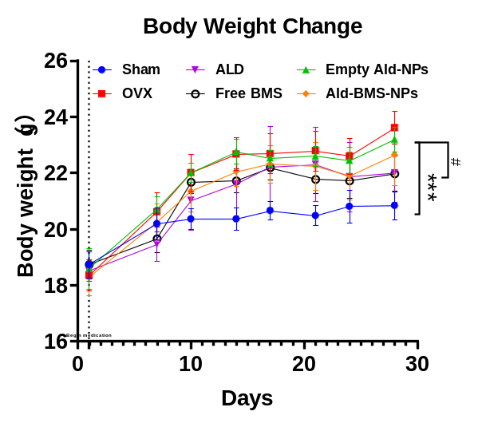
Figs. S11. Body weight changes in each group of mice during treatment with bone-targeted nanoparticles loaded with the FABP4 inhibitor, related to Figure 7.

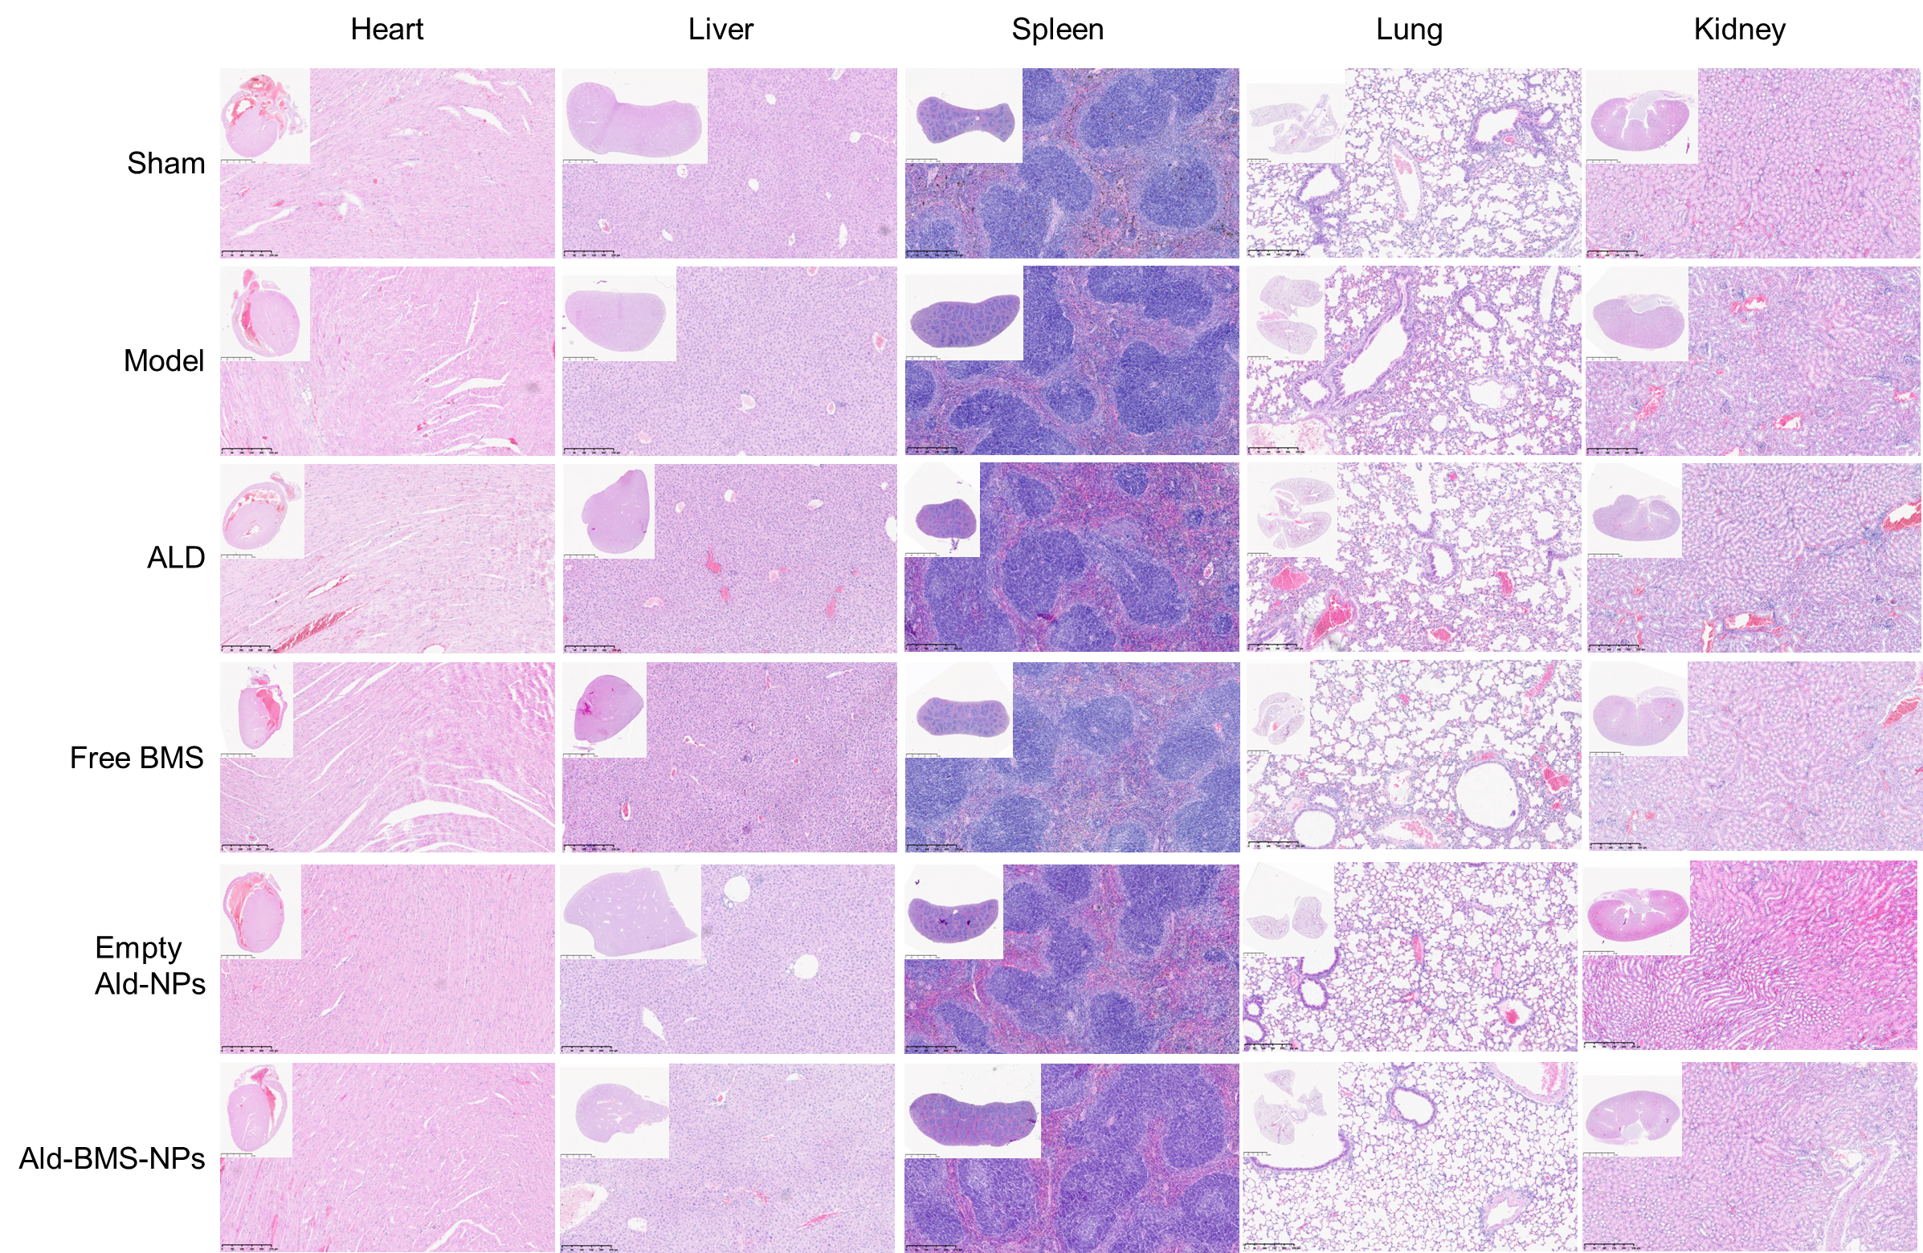
Figs. S12. The representative images of H&E staining of heart, liver, spleen, lung and kidney in each group of mice, related to Figure 7. Scale bar, 250 μm.

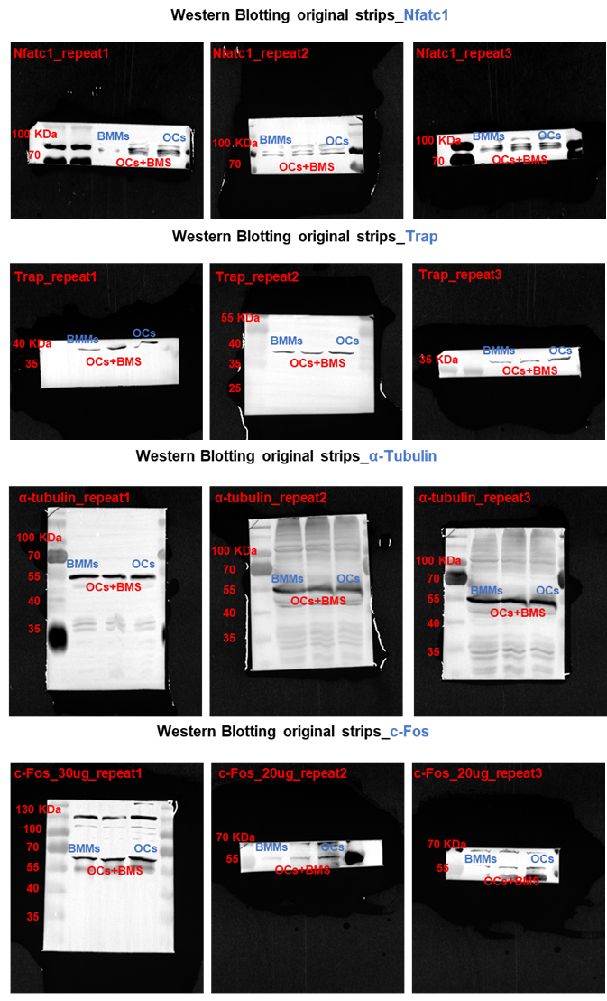
The whole un-cropped images of the original western blots from Figure 4F, related with Figure 4.

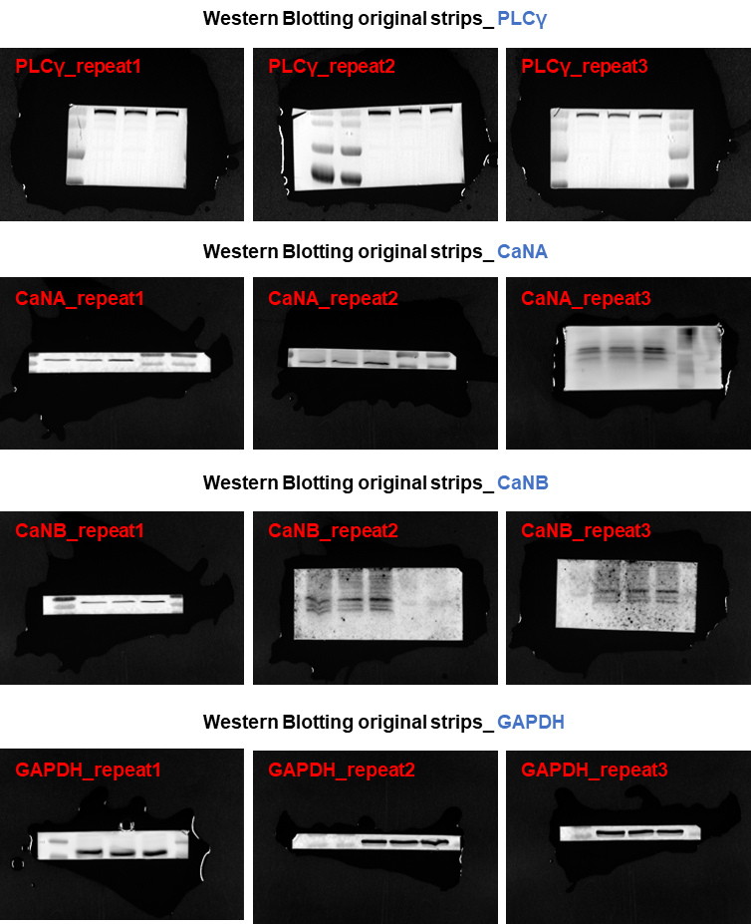
The whole un-cropped images of the original western blots from Figure 4J, related with Figure 4.

