Supplementary material

Graphene oxide/carbon-fiber composite structural supercapacitor with stable electrochemical performance under surface load bearing
Facing the development needs of lightweight/functionalization of aviation electric aircraft-eVTOL and cleaner/sustainable green energy, this study designed a graphene oxide (GO)-based carbon-fiber supercapacitor with integrated structure/energy storage.
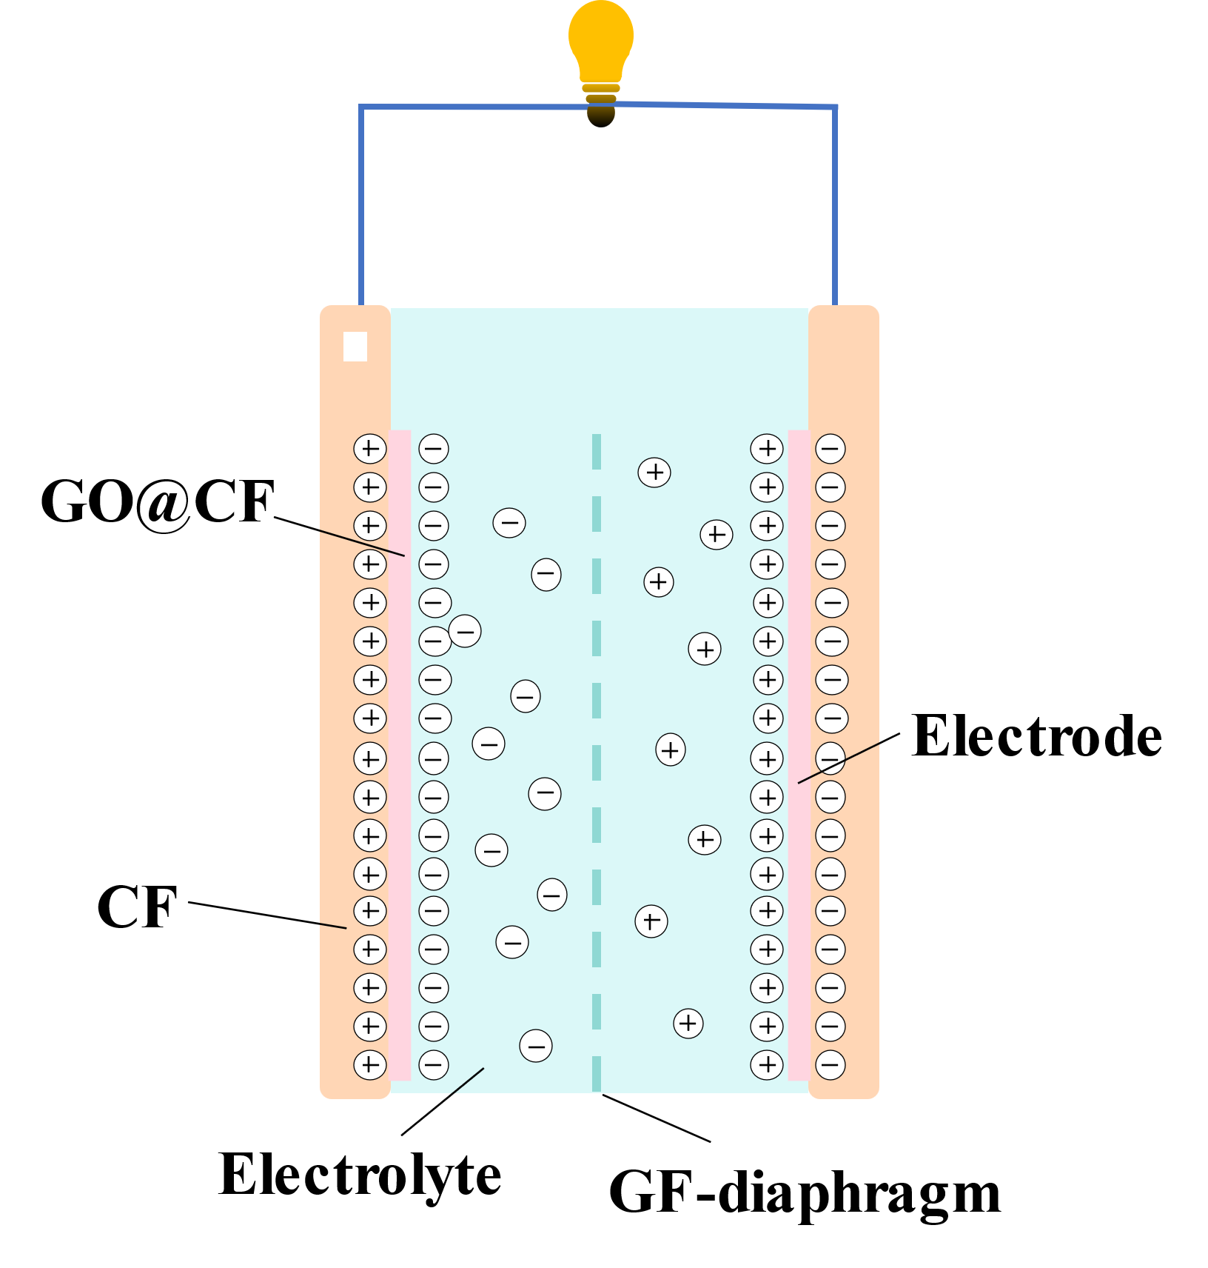
Fig.S1. Schematic diagram of ion adsorption/desorption reactions in EDLC supercapacitors

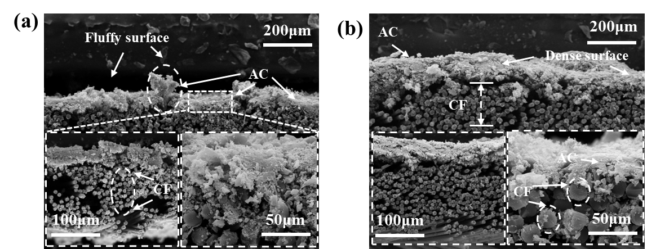
Fig. S2. Cross-sectional SEM microstructure of the AC@CF₁ structural electrode under no-load and load-bearing conditions
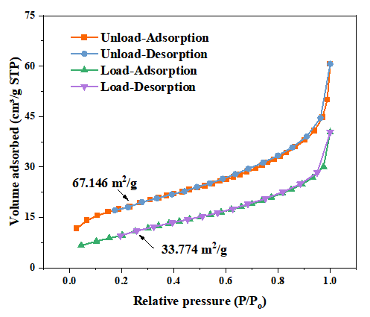
Fig. S3. The isotherms of BET for AC@CF structural electrodes under unload/load-bearing across the relative pressures range of p/p₀=0-1.

The activated carbon/CF (AC@CF₁) structural electrode was prepared as a comparative experiment, which was a previous study in the research group. It can more directly reveal the effect on the two types of morphology/characteristics by surface load bearing, as shown in Fig. S2 and S3. From the SEM morphology, the cross-section of the AC@CF₁ structural electrode under unload bearing was relatively fluffy with raised particles of activated materials, and the CF tows were loose with existing inter-fiber gap. Whereas under the surface load bearing, the cross-section showed flat with a smaller tow gap and the active material was uniformly loaded on the CF surface. And according to the BET under unload/load-bearing in Fig.S3, the specific surface area (SSA) of the AC@CF₁ structural electrode under load bearing greatly reduced by about 51.1% compared with that under unload bearing. Results showed that C_{A} capacitance retention was poorly maintained, and primarily because of the reduction of the SSA affected ionic adsorption/desorption on the electrode surface.
The comparative experiments of the AC@CF₁ and GO@CF₁ structural electrodes revealed that the GO had superior mechanical properties and GO@CF₁ structural electrode can maintain high retention of the C_{A} capacitance under load bearing.
Table. S1. Comparison of capacitance retention with references
Active material | Electrolyte | Cycle | C_{A}（%） | Ref.
GO@CF₁ | HADE+ PEGDGE+ LITFSI+IL | 10000  15000  under pressure | 99.99  （99.58） | This work
MnO₂-nanowhiskers | PEGDGE+IL | 10000 | 75 | [1]
MnOOH-nanowires | E51+PEGDGE+ LITFSI+IL | 10000 | 89.2 | [2]
Ni–Co-layered double  hydroxide | PVA+KOH | 3000 | 86 | [3]
Graphene nanoplatelets | PEGDGE +IL+Al₂O₃ | 150 | 99 | [4]
NiCo₂O₄ nanowires | Vinylester +MEKP+EMIM BF4 +LiTf | 5500 | 94 | [5]
Sulfonated hypercrosslinked polymer | PEGDGE  +EMIM BF4 | 3500 | 96 | [6]
V₂O₅/MWCNT | PVA+KOH | 4000 | 96 | [7]
SnO₂ nanorod | Polyester Resin+ LITFSI+IL | 3500 | 96 | [8]
rGO/ N₁C₁M-S₃’ nanosheets | PAM+KOH+  AM+APS | 5000 | 80.1 | [9]
Carbon fiber | Resin 5284 +LITFSI+IL | 10000 | 92 | [10]
Activated carbon | MF-4101H +  E 51/D400 +LITFS+PC | 2000 | 94 | [11]
Graphene aerogel | PEDGE +IL | 10000 | 98 | [12]
ZnO-nanotube | LSP-8020B  + IL + LiTf | 2500 | 93.2 | [13]
Activated carbon fiber -carbon fiber reinforced  polymer matrix | Westsystem 105 epoxy  + PVA | 3000  Under pressure | 75 | [14]
Activated carbon | IN2+ choline chloride +ethylene glycol | 2000 | 82.6 | [15]
Activated carbon | IN2+ choline chloride +ethylene glycol | 130  Under pressure | 95.3 | [15]
[1] K. Subhani, N. Hameed, A. Al-Qatatsheh, J. Ince, P.J. Mahon, A. Lau, N.V. Salim, Multifunctional structural composite supercapacitors based on MnO<sub>2</sub>-nanowhiskers decorated carbon fibers, Journal of Energy Storage 56 (2022).
[2] Y. Zhao, H. Xu, G. Cai, C. Yan, D. Liu, G. Chen, Y. Zhu, Multi-functional structural supercapacitor based on manganese oxide-hydroxide nanowires modified carbon fiber fabric electrodes, Polymer Composites 43(11) (2022) 8458-8470.
[3] H. Zhou, A. Duongthipthewa, J. Zhang, H. Li, L. Peng, Y. Fu, H. Huang, L. Zhou, A composite structural supercapacitor based on Ni-Co-layered double hydroxide-coated carbon cloth electrodes, Composites Science and Technology 240 (2023).
[4] J. Artigas-Arnaudas, X.F. Sánchez-Romate, M. Sánchez, A. Ureña, Effect of electrode surface treatment on carbon fiber based structural supercapacitors: Electrochemical analysis, mechanical performance and proof-of-concept, Journal of Energy Storage 59 (2023).
[5] H.D. Roh, B.K. Deka, H.W. Park, Y.B. Park, Multifunctional composite as a structural supercapacitor and self-sensing sensor using NiCo<sub>2</sub>O<sub>4</sub> nanowires and ionic liquid, Composites Science and Technology 213 (2021).
[6] O. Hubert, N. Todorovic, L.M.R. Gonzalez, E. Costagliola, A. Blocher, A. Mautner, R.T. Woodward, A. Bismarck, Sulfonated hypercrosslinked polymer enhanced structural composite supercapacitors, Composites Science and Technology 242 (2023).
[7] B. Pandit, D.P. Dubal, P. Gómez-Romero, B.B. Kale, B.R. Sankapal, V<sub>2</sub>O<sub>5</sub> encapsulated MWCNTs in 2D surface architecture: Complete solid-state bendable highly stabilized energy efficient supercapacitor device, Scientific Reports 7 (2017).
[8] O. Kwon, B.K. Deka, J. Kim, H.W. Park, Electrochemical performance evaluation of tin oxide nanorod-embedded woven carbon fiber composite supercapacitor, International Journal of Energy Research 42(2) (2018) 490-498.
[9] Y. Zhang, D. Zhang, Enhanced all-solid-state structural supercapacitor performance of rGO/N<sub>1</sub>C<sub>1</sub>M-S<sub>3</sub>′ nanosheets with high areal capacitance, Journal of Alloys and Compounds 968 (2023).
[10] J. Zhang, J. Yan, Y. Zhao, Q. Zhou, Y. Ma, Y. Zi, A. Zhou, S. Lin, L. Liao, X. Hu, H. Bai, High-strength and machinable load-bearing integrated electrochemical capacitors based on polymeric solid electrolyte, Nature Communications 14(1) (2023).
[11] G. Qi, J. Wu, B. Yao, Q. Cui, L. Ren, B. Zhang, S. Du, High modulus carbon fiber based composite structural supercapacitors towards reducing internal resistance and improving multifunctional performance, Composites Science and Technology 254 (2024) 110670.
[12] K. Subhani, X. Jin, P.J. Mahon, A.K.T. Lau, N.V. Salim, Graphene aerogel modified carbon fiber reinforced composite structural supercapacitors, Composites Communications 24 (2021).
[13] B.K. Deka, A. Hazarika, O. Kwon, D. Kim, Y.-B. Park, H.W. Park, Multifunctional enhancement of woven carbon fiber/ZnO nanotube-based structural supercapacitor and polyester resin-domain solid-polymer electrolytes, Chemical Engineering Journal 325 (2017) 672-680.
[14] H. Zhou, Y. Su, J. Zhang, H. Li, L. Zhou, H. Huang, A novel embedded all-solid-state composite structural supercapacitor based on activated carbon fiber electrode and carbon fiber reinforced polymer matrix, Chemical Engineering Journal 454 (2023).
[15] Y.S. Han, B.J. So, H.J. Kim, J.H. Kim, J.H. Lee, G. Shin, J.Y. Baek, H. Kim, M.W. Lee, S.K. Moon, K.B. Seo, S.Y. Park, J.G. Jeon, H. Shin, T.J. Kang, Current collectors of carbon fiber reinforced polymer for stackable energy storage composites, Energy Storage Materials 64 (2024).

