Supplementary Tables
Table 01: Relative clay abundance (weight percent) of samples based on XRD analysis
Clay Mineralogy
 |  | Relative clay abundance (< 4 Microns)
Sample | Depth (ft) | % I/S Expactibility | Smectite | Illite/Smectite | Illite | Kaolinite | Chlorite | Total clay
E1 | 7675.9 | 25 | 18 | 22 | 8 | 28 | 25 | 100
E2 | 7684.8 | 25 | 0 | 15 | 7 | 40 | 38 | 100
E3 | 7686.4 | 25 | 0 | 15 | 6 | 50 | 29 | 100
E4 | 7696.3 | 20 | 0 | 16 | 7 | 58 | 19 | 100
 |  |  | 4.5 | 17 | 7 | 44 | 27.75
E5 | 7610.4 | 50 | 5 | 58 | 14 | 17 | 6 | 100
E6 | 7668.1 | 50 | 3 | 46 | 15 | 25 | 12 | 100
Note: Samples E1- E4 are from the Coarse-grained Sandstone facies, E5 is from the Bioturbated Mudstone facies, and E6 is from the Fine-grained Sandstone facies * Data source: Ref. [9]

Supplementary Figures
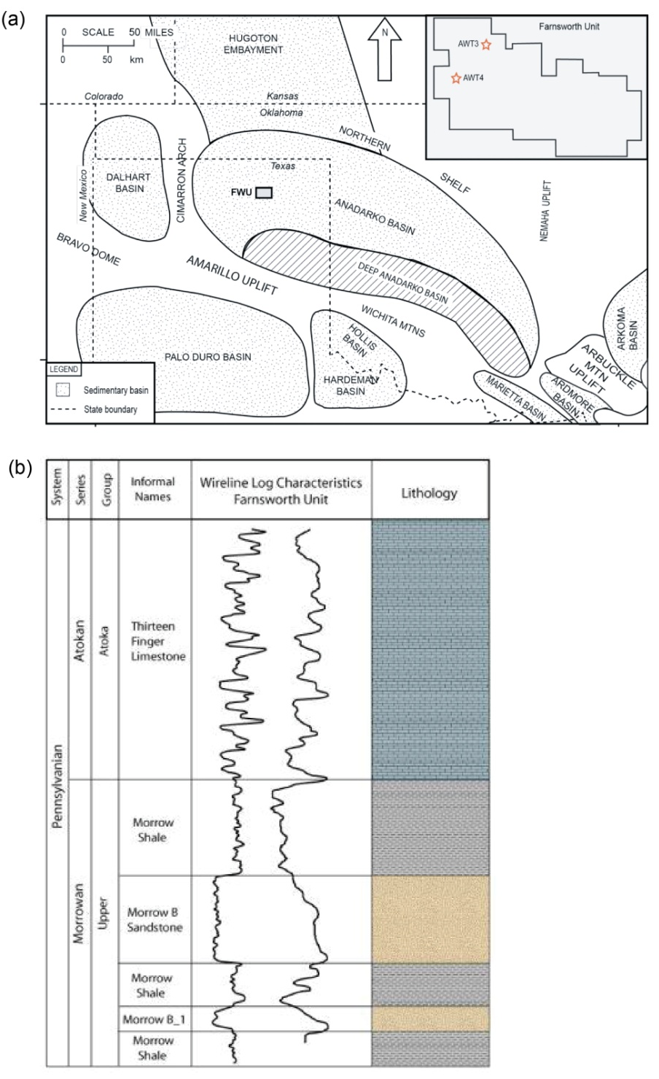

Figure 01: a) Major geological features and b) lithostratigraphy in and around the Farnsworth unit, USA. Source: Ref. [12]

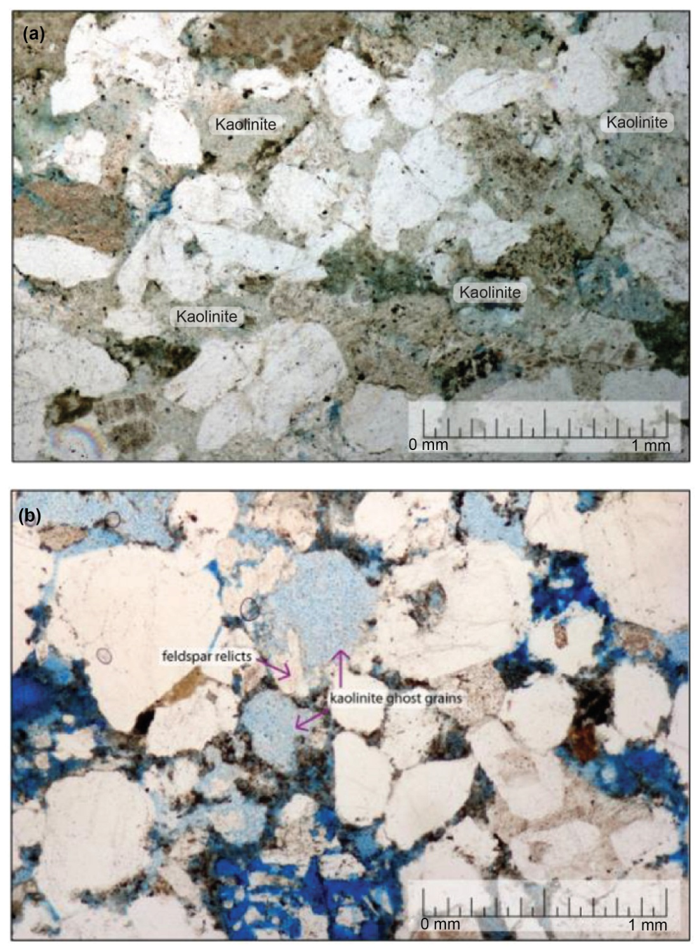
Figure 02: Photomicrograph showing a) Kaolinite ghost grains and kaolinite filling pores; b) microporous kaolinite ghost grains, some of which have feldspar relicts; and c) macroporosity surrounded by authigenic clay and cement. Source: Ref. [9]

