Article Research square
Title: Mechanism of recognition and binding of Ultrabithorax
Authors: xxxxxxxxxxxx
Affiliation: ^{1,2} Indian Institute of Science Education and Research, Pune India. * Correspondence savita.msu@gmail.com (email address of the corresponding author)

Supplementary

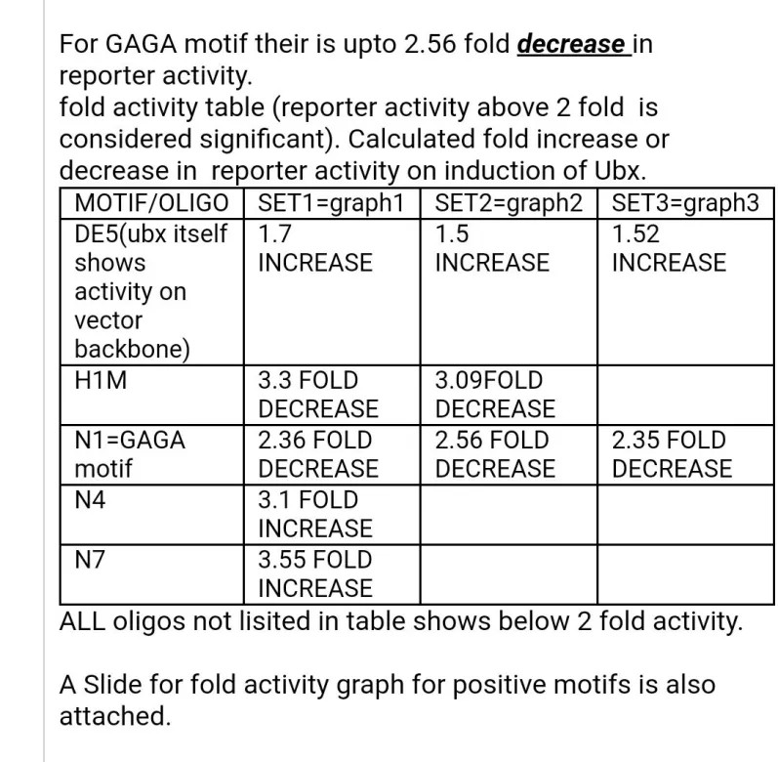
Figure 1 The first copy of data reported on 2011.
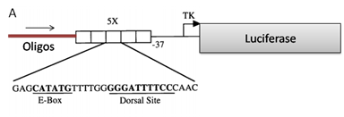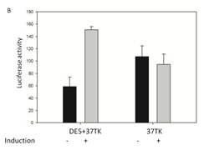
Figure 2: Ubx mediated activation of vector (A) 5copies of dorsa land twist binding element (DE5) were present upstream to basal-37TK promoter driving luciferase . All oligos required to be tested were cloned upstream to DE5B. (B) Ubx itself causes increase in reporter activity of vector backbone having dorsal and twist binding sites. Low level of dorsal and twist present in the system itself causes very low increase in reporter activity (DE5+37TK without induction (-) column1), induction of Ubx further causes approximately 1.5 fold increase in activity (DE5+37TK with induction (+) column2).Ubx itself with dorsal and twist binding element is not able to show its activity on vector backbone (37tk) with and without induction). Error bars indicate the standard deviation of the mean calculated for 3 wells of a data set.
3. Assay for Ubx binding on oligos from spalt (sal) gene which is repressed by Ubx.
Ubx directly regulates a flight appendage-specific cis-regulatory element of the spalt (sal) gene (Ron Galant 2002). They also found that multiple monomer Ubx-binding sites are required to completely repress the cis-element in the haltere, and that the individual Ubx-binding sites are sufficient to mediate its partial repression. 16 base pair double- stranded oligonucleotides containing individual sites centred within its native flanking DNA sequences which are already being tested by EMSA for sal were added to DE5-37tkluc vector and assayed for in vivo binding activity in S2 cells.
CGTCTTAATATGAT (SAL SITE 5) =C4
TTTTATAATGTGCC (SAL SITE 6) =C5
TTTTTTAATAAGTT (SAL SITE 7) =C6
Assay for Ubx binding on oligos from CG13222 gene which is activated by Ubx.
CG13222 cis-regulatory oligos which are checked by EMSA experiments (in literature) were added to DE5-37tkluc vector. There are two UBX binding sites present in the cis regulatory region of the gene.
CGCAGATAAATTACACTGGCC (SITE1) =C1
GCCCGCGAGATTACCATCGAG (SITE2) =C2
CGCAGATAAATTACACTGGCCGCCCGCGAGATTACCATCGAG =C3 (two binding sites present with a distance of 18bp). CGCAGATAAGGCCCACTGGCCGCCCGCGAGGGCCCCATCGAG = C3M
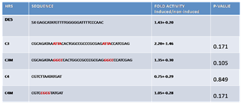

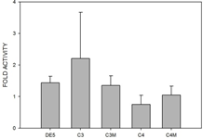
Fig3. C3 is responsive to Ubx mediated reporter activity. C3 ﬁreﬂy luciferase reporter vector was cotransfected into S2 cells along with full length Ubx expressing vector and an internal control reporter (pRL-TK) encoding Renilla luciferase. All ﬁreﬂy luciferase activities (measured by Promega’sdual-luciferase assay system and further normalized to Renilla luciferase activities).C3 showed further increse in activity while C3M mutant were not responsive to UBX. Each error bar represents +/- standard deviation cumulative of three independent experiments with three replications of each of them. The basal level of all constructs without Ubx is DE5. The bar represents the fold activity achieved by the expression of Ubx . All oligos, except the C3 were not responsive to Ubx. This assay was done 5 times to which only 1 time it showed reporter activity above 2 fold. Therefore the fold activity is not statistically significant. Therefore, the presence of multiple binding sequences (as C3 have two binding sites with flanking native) could be one of the reasons for its weak activity. (fig2)
4. Assay for Ubx binding on three copies of Ubx binding heptamers
As most of the cis-regulatory element to which Ubx binds have multiple Ubx binding elements and C3 showed some reporter activity. In this direction, multiple heptamer binding sequences without their flanking native sequences were tested for their Ubx mediated response. The DNA-binding sites may influence the regulatory activity of the bounded factors. For example, the quality of DNA-binding sites for both the glucocorticoid receptor and the NF-kB affect the regulatory output of the bound complexes, suggesting that small structural differences imposed on the protein by DNA binding affects the transcriptional output. Therefore, two different Ubx binding heptamers were added to test whether subtle differences in heptamer can make any difference in their activity. Adding Ubx binding heptamers without flanking sequences in three tandem copies showed no significant reporter activity.
HRS | SEQUENCE | FOLD ACTIVITY Induced/non-induced
Heptamer1=H1 | 3xTTAATAT | 1.47+-0.31
Mutant=HM | 3xTCGCGG | 1.21+-0.54
Heptamer=H2 | 3xAATTACA | 0.89+-0.06
Fig 4. Three copies of tandem sequences of two types of Ubx binding heptamer motifs are are not responsive to Ubx in S2 cell assay.(A) oligo constructs that is heptamers fused or mutant sequences (a) and the type of heptamer writen on graph itself that were cotransfected into S2 cells expressing one of the ﬁreﬂy luciferase reporters along with full length Ubx expressing vector and an internal control reporter (pRL-TK) encoding Renilla luciferase. All ﬁreﬂy luciferase activities (measured by Promega’sdual-luciferase assay system and further normalized to Renilla luciferase activities . DE5 is vector alone without any oligos addition. Transcriptional activities for each regulatory element +- SD are shown ( number of independent experiments (n) ≥3 ). The fold activity represents activity achieved by the expression of Ubx . Hox genes fulfill only a subset of their functions if taken out of context due to the lack of assisting transcription factors. No Ubx responsive reporter activity was observed for any of the heptamer can be because of the lack of factors or environment required by Ubx for its functionality on these heptamers.
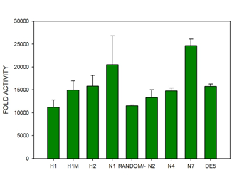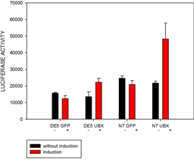
Figure : Tandem sequences of putative motifs/regulatory element of N1(GAGA factor binding element) and N7 are responsive to endogenously present factor in S2 cell assay.(Transient-transfection assays were conducted essentially as described with the reporter oligo added to DE5tkLuc and expression vector expressing PRM-GFP. (A) oligo constructs putative motif/regulatory element fused are listed in table and the type of oligo tested are writen on graph itself that were cotransfected into S2 . All ﬁreﬂy luciferase activities (measured by Promega’sdual-luciferase assay system and further normalized to Renilla luciferase activities). Each bar represents the +- standard deviation of three wells of a set of experiment. Among All the positive motifs tested in the assay N1 and N7 are responsive to endogenously present factors in the cell while one of the putative motif N4 is not responsive to endogenously present factor in cell. B) N7 is itself responsive to endogenously present factor in the cells so further how much additive increase in activity is obtained by the binding of Ubx on this motif is difficullt to measure.
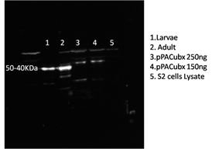A

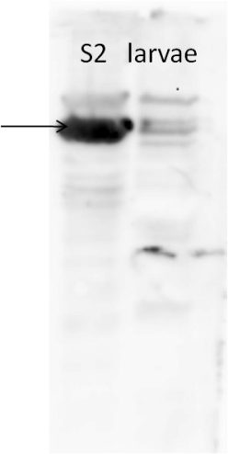 B

Figure: A western blot showing expression of Ubx in S cells. Transient transfection for Ubx expression was done using pPACflag Ubx expression vector
B Gaga factor is present in S2 cells. Two separate western blots showing expression of GAGA factor in S2 cells, immunoblotted with antibody against the polyclonal anti- GAGA factor.

