Supplementary content
Figures

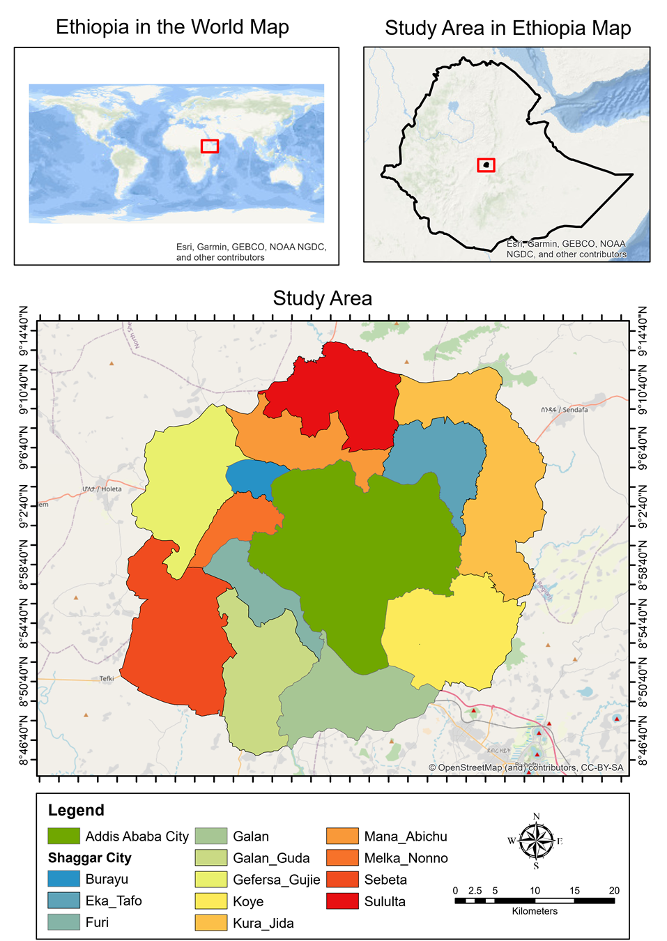
Fig. 1: Location map of the study area

Fig. 2: the presence of formal or informal institutions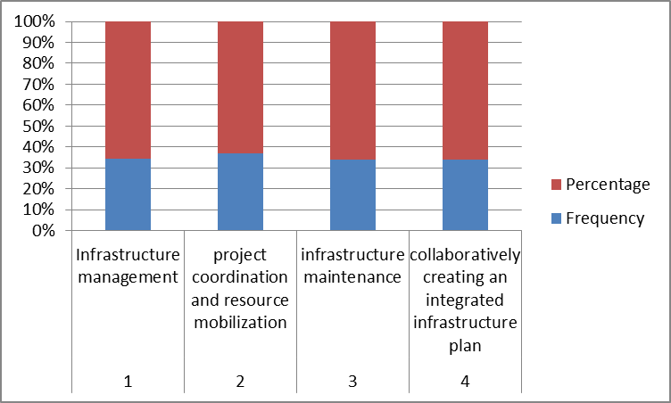
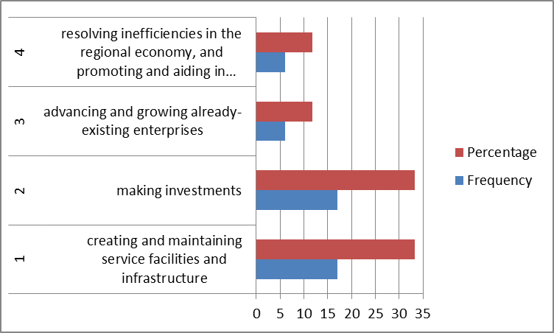
Fig. 3: the role of private sector in metropolitan governance

Fig.4: the Challenges of metropolitan governance
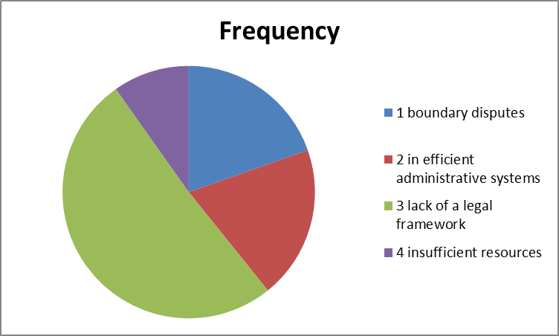
Tables
Table 1:- Number of FGDs conducted in Addis Ababa and in selected sub cities in Sheger city
No | Sub city | No. of FGD | Participant per FGD | Total number of participants
1 | Addis Ababa city | 2 | 10 | 20
2 | Sabata/Furi sub city | 1 | 9 | 9
3 | Gelan sub city | 1 | 8 | 8
4 | Burayu sub city | 1 | 10 | 10
 | Total | 6 | - | 47
Sour
(Source): FGDs survey, March, 2023

Table 2: socio-economic description of the respondents/participants
No | Sectors | Study Areas |  |  |  | Total
No | Sectors | Addis Ababa | Burayu | Galan | Sabata/Furi | Total
1 | Water and Sanitation Authority | 18 | 11 | 11 | 11 | 51
2 | Road Authority | 36 | 11 | 11 | 11 | 69
3 | Transport sector | 15 | 12 | 12 | 13 | 52
4 | Plan and Development Bureau | 35 | - | - | - | 35
5 | Municipality | 14 | 12 | 12 | 12 | 50
 | Total | 118 | 46 | 46 | 47 | 257
(Source): Expertise survey, March, 2023

Table 3 the presence of formal or informal institutions
No | Issues | Frequency | Percentage
1 | Infrastructure management | 5 | 9.6
2 | project coordination and resource mobilization | 4 | 6.8
3 | infrastructure maintenance | 2 | 3.9
4 | collaboratively creating an integrated infrastructure plan | 27 | 52.9
(Source): Expertise survey, March, 2023

Table 4: the role of private sector in metropolitan governance
No | Issues | Frequency | Percentage
1 | creating and maintaining service facilities and infrastructure | 17 | 33.3
2 | making investments | 17 | 33.3
3 | advancing and growing already-existing enterprises | 6 | 11.8
4 | resolving inefficiencies in the regional economy, and promoting and aiding in community development make up | 6 | 11.8
Source(s): Expertise survey, 2023

Table 5: the Challenges of metropolitan governance
No | Issues | Frequency | Percentage
1 | boundary disputes | 10 | 19.6
2 | in efficient administrative systems | 10 | 19.6
3 | lack of a legal framework | 26 | 51
4 | insufficient resources | 5 | 9.8
Source(s): Expertise survey, 2023

