Additional file

Table S1 Composition of the feed supplied to the chicken flocks
Items | Content
Items | Starter  (1-3 week) | Grower  (3 week - slaughter)
Ingredient (%)
Corn | 59.74 | 60.06
Wheat | — | 5.40
Soybean meal | 25.50 | 18.50
Cottonseed meal | 2.00 | 3.50
Meat and bone meal | — | 2.00
Fish meal | 1.50 | —
DDGS1 | — | 5.00
Limestone | 1.40 | 0.90
NaCl | 0.33 | 0.35
CaHPO4 | 1.50 | 0.60
DL-Methionine | 0.20 | —
L-Lysine | — | 0.40
HMA2 | 0.20 | 0.13
Threonine | 0.03 | 0.05
Middling | 5.00 | —
Oil | 1.00 | 1.60
Choline chloride | 0.10 | 0.10
Premix3 | 1.50 | 1.50
Total | 100.00 | 100.00
^{1.} Distillers dried grains with soluble.
^{2.} Methionine hydroxyl analogue.
^{3.} The premix provided the following per kg of diets: VA 9 200 IU, VD 3 000 IU, VE 38mg,VK₃ 3 mg, VB₁ 3 mg, VB₂ 10 mg, VB₆ 5 mg, VB₁₂ 0.04 mg, niacinaminde 40 mg, calcium pantothenate 16 mg, folic acid 2 mg, biotin 0.3 mg, Fe 66 mg, Cu 15 mg, Mn 95.4 mg, Zn 96.6 mg, I 0.38 mg, Se 0.41 mg.

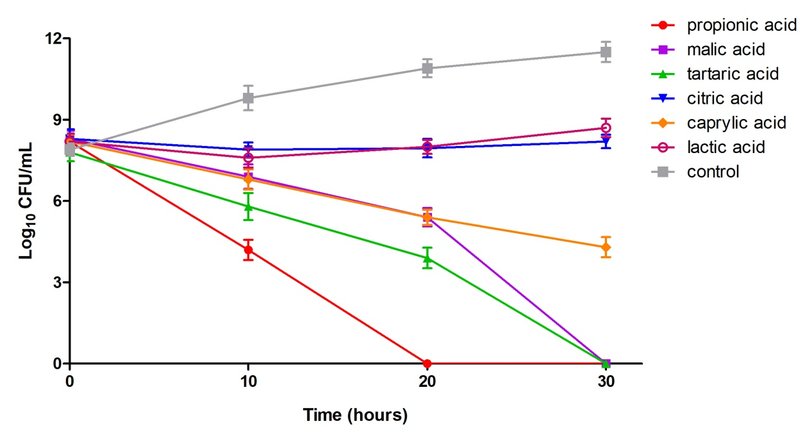
Figure S1. Inhibitory effects of organic acids on the growth of Campylobacter in MH broth. The organic acids were added to the MH broth, and the pH was adjusted to 4.0, with approximately 1 x 10⁸ CFU/mL C. jejuni cultured in this acidified broth for 30 h. Samples were taken at the indicated intervals to determine the bacterial counts. Propionic acid, tartaric acid and malic acid showed good bacteriostatic effects in vitro when compared to the other acids.
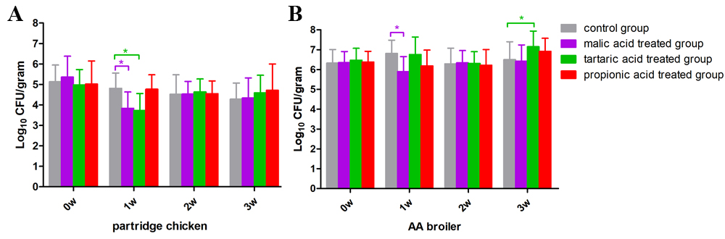
Figure S2. The decontamination effect on Campylobacter in chicken flocks by drinking the organic acid-supplemented water. The acids showing good bacteriostatic effects in vitro were supplemented into the drinking water of partridge chickens (A) and AA broilers (B). The acidified water was continuously provided for 3 weeks, and the Campylobacter carriage was detected by assaying the cloacal swabs. A stable decontamination effect was found in the malic acid-treated group after one week of use of the acidified drinking water. Twenty chickens were assayed in each group, the data are presented as the mean ± standard deviation (SD), and asterisks with color indicate a significant difference between the corresponding group to the control group (P < 0.05 *).

