Supplementary Information

Neutrophils Defensively Degrade Graphene Oxide in a Lateral Dimension Dependent Manner through Two Distinct Myeloperoxidase Mediated Mechanisms

Shiyi Huang¹, Sijie Li¹, Yanlei Liu², Behafarid Ghalandari¹, Ling Hao³, Chengjie Huang¹, Wenqiong Su¹, Yuqing Ke¹, Daxiang Cui², Xiao Zhi^{1*} and Xianting Ding^{1*}
¹ State Key laboratory of Oncogenes and Related Genes, Institute for Personalized Medicine, School of Biomedical Engineering, Shanghai Jiao Tong University, Shanghai 200030, China
² Shanghai Engineering Center for Intelligent Diagnosis and Treatment Instrument, School of Electronic Information and Electrical Engineering, Shanghai Jiao Tong University, Shanghai 200240, China
³ Department of Chemistry, George Washington University, Washington, D.C., 20052, USA.
* Correspondence to: Xiao Zhi, Ph.D. and Xianting Ding, Ph.D.

Table S1. Summary of physicochemical characterization of nGO and mGO.
 | Technique | nGO | mGO
Lateral dimension | Optical microscopy^{a)} | - | 2.572 – 8.128 μm
Lateral dimension | AFM^{b)} | 289.9 ± 111.7 nm | 4.683 ± 2.321 μm
Lateral dimension | TEM^{c)} | 249.0 ± 94.73 nm | 4.299 ± 0.824 μm
Number of layers | AFM | 1 layer (1~2 nm) | 1 layer (1~2 nm)
Surface charge | Zeta-potential | -31.14 mV | -32.90 mV
Degree of defects  (I_{D}/I_{G}) | Raman | 1.03 | 1.21
C/O atomic ratio | XPS | 2.47 | 2.37
Chemical composition | XPS | C: 71.17%,  O: 28.83% | C: 70.37%,  O: 29.63%
^{a)} data is based on 12 sites; ^{b)} data is based on 7 sites; ^{c)} data is based on 6 sites

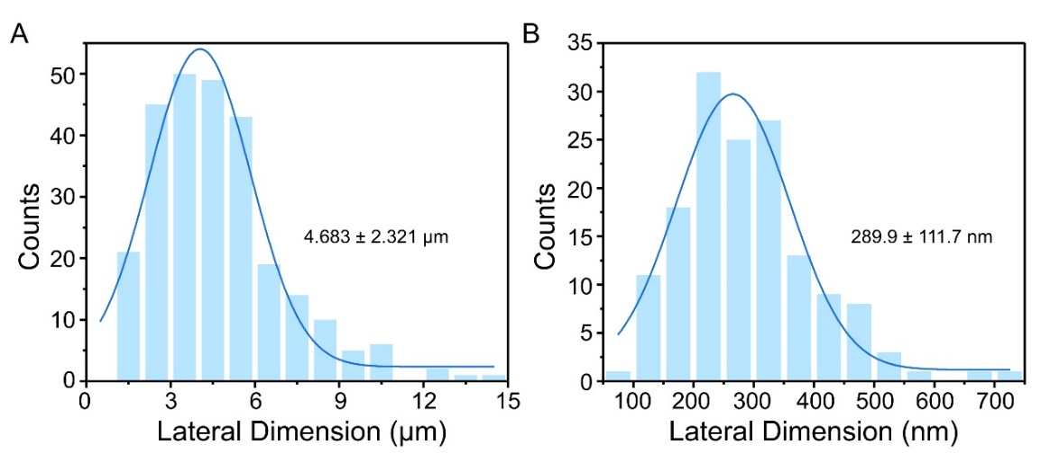
Supplementary Fig. 1: Lateral dimension distribution analysis of mGO (A) and nGO (B) by AFM.

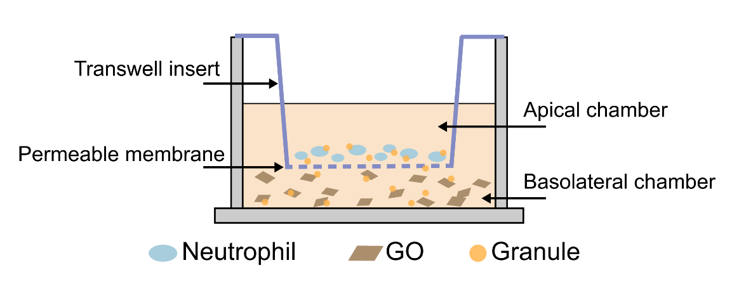
Supplementary Fig. 2: Schematic of the Transwell® used in GO biodegradation by neutrophils.

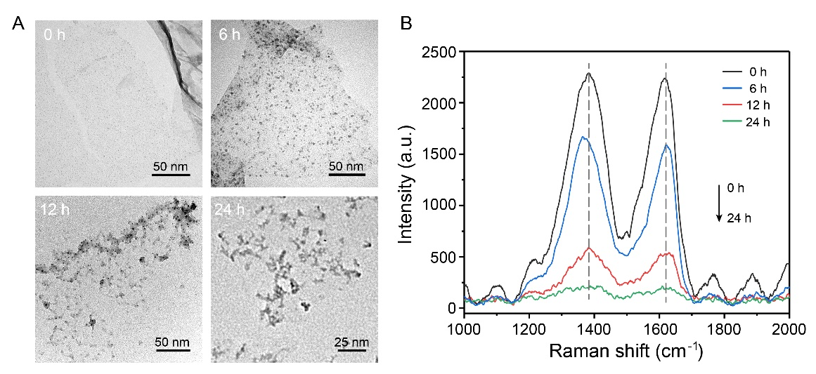
Supplementary Fig. 3: TEM images (A) and Raman spectra (B) of nGO sheets treated with neutrophils after 0, 6, 12, 24 h.

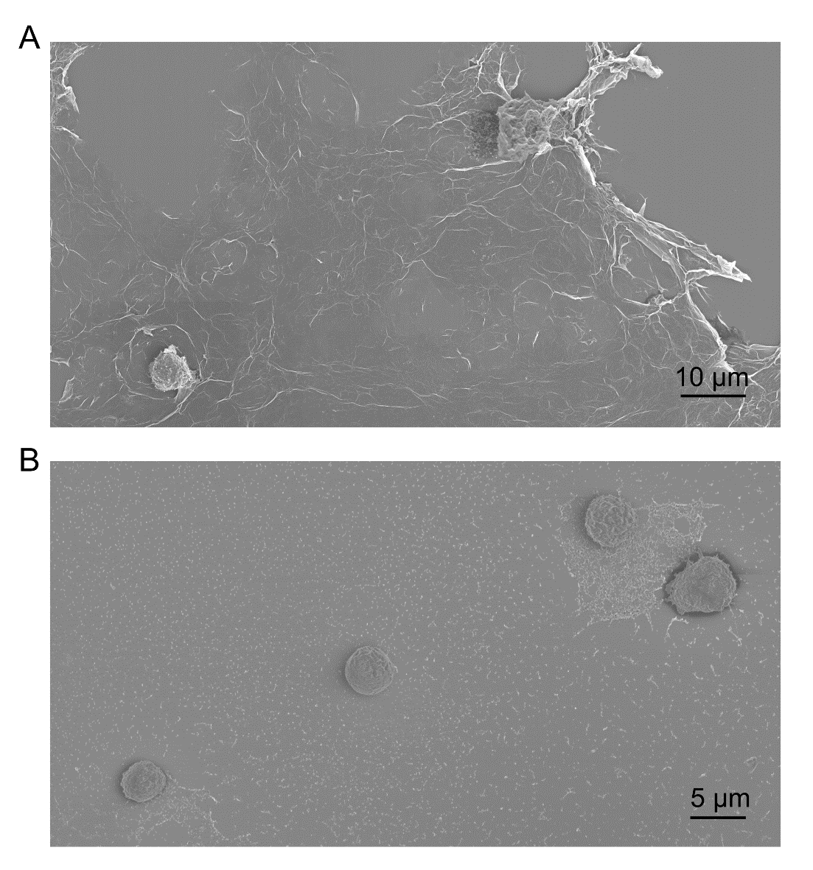
Supplementary Fig. 4: SEM images of mouse neutrophils after 3 h incubation with mGO (A) and nGO (B). Scale bars: (A) 10 μm, (B) 5 μm.

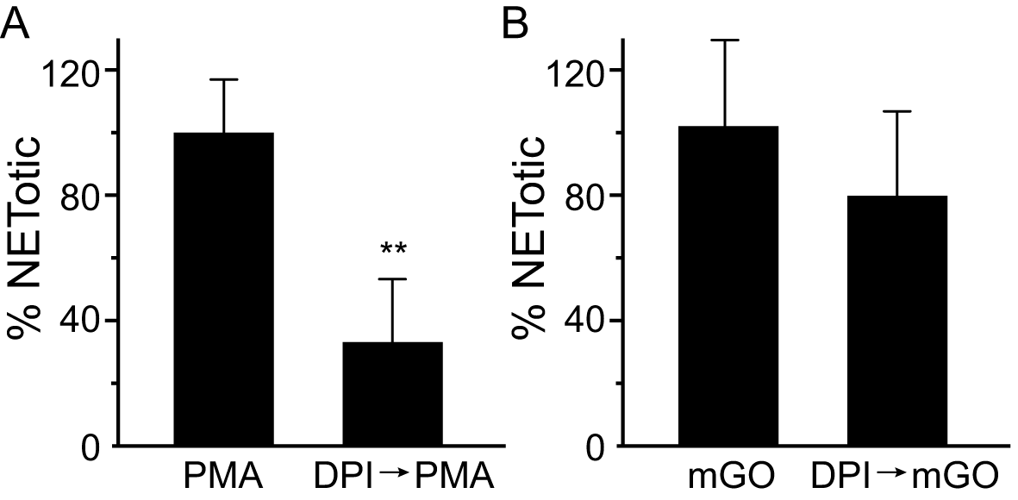
Supplementary Fig. 5: Quantification of the NETs release in neutrophils stimulated with PMA and mGO in the presence or absence of DPI (20 μM) for 2 h using a plate reader assay. The results are expressed as percentage of reduction in the presence of DPI compared with the activating agonist alone. DPIPMA, neutrophils preincubated with DPI and then activated with PMA; DPImGO, neutrophils preincubated with DPI and then activated with mGO. **P<0.01, Student’s t test.

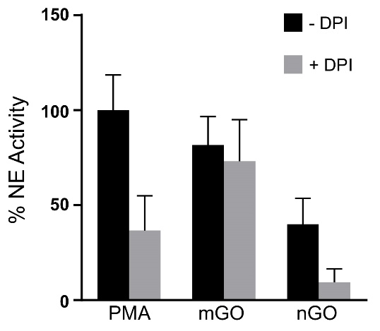
Supplementary Fig. 6: Quantification of NE activity in neutrophils stimulated with PMA, mGO and nGO which pre-treated with DPI (20 μM) or not.

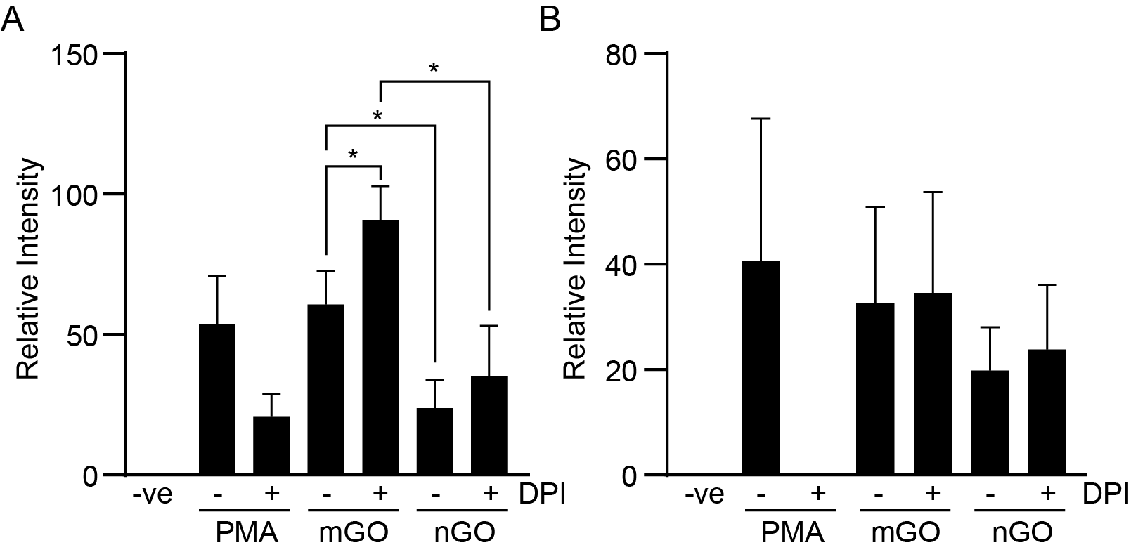
Supplementary Fig. 7: Densitometry analysis for the immunoblot analysis of p-ERK (A) and p-Akt (B). Data were normalized to total kinase. *P<0.05, Student t’s test.

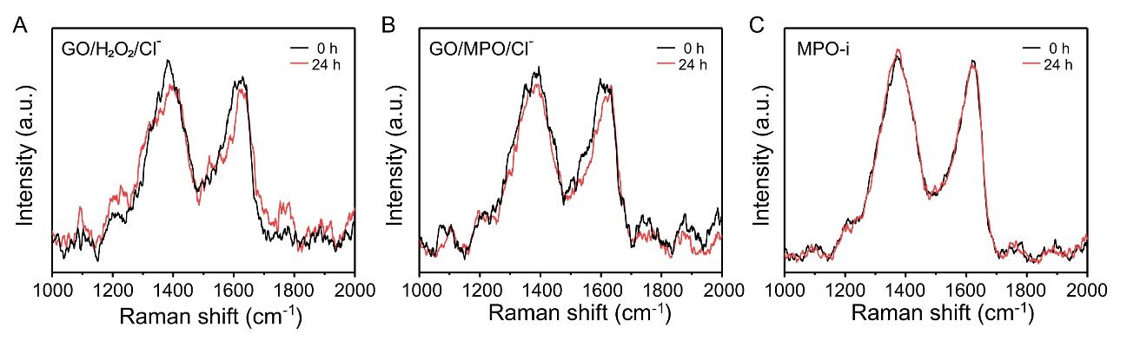
Supplementary Fig. 8: (A) Raman spectra of GO incubated with H₂O₂ + Cl⁻ (without MPO) after 0 and 24 h. (B) Raman spectra of GO incubated with MPO + Cl⁻ (without H₂O₂) after 0 and 24 h. (C) Raman spectra of GO sheets after 0 and 24 h in the presence of MPO inhibitor.

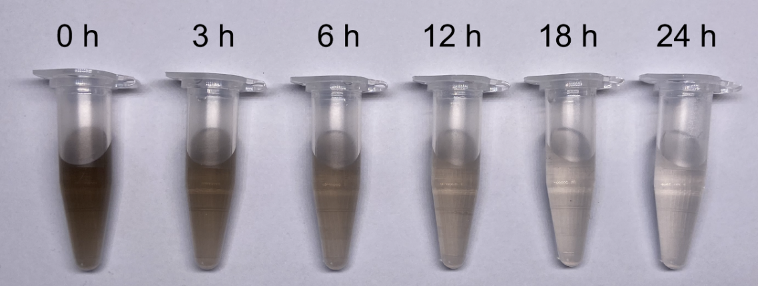
Supplementary Fig. 9: Photographs of GO samples before (0 h) and after (3, 6, 12, 18, and 24 h) the MPO-mediated biodegradation, where “0 h” represents the GO/MPO complex before adding H₂O₂.

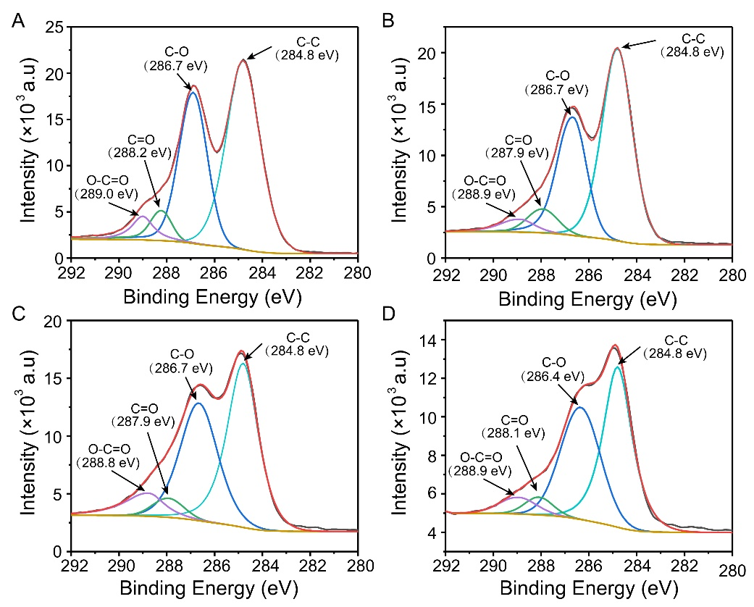
Supplementary Fig. 10: XPS spectra of C 1s of GO (A), and biodegradation samples by MPO for 0 h (B), 12 h (C), and 24 h (D), where “0 h” represents the GO/MPO complex before adding H₂O_{2,} while “12 h” and “24 h” are GO/MPO degrading with H₂O₂.

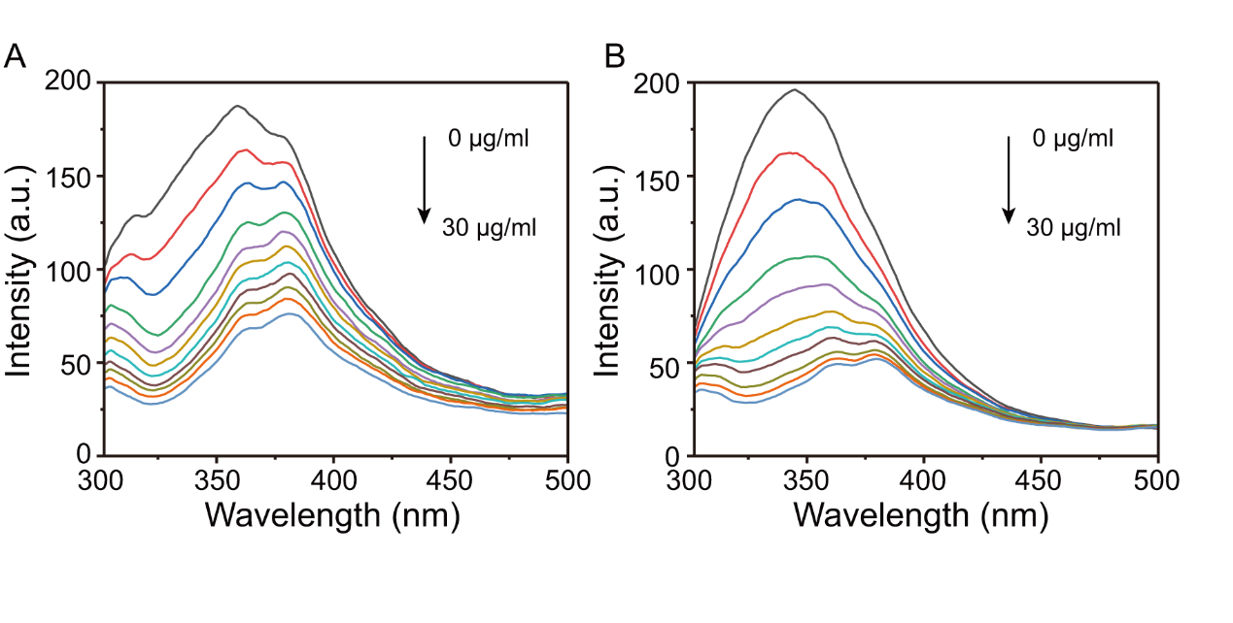
Supplementary Fig. 11: Fluorescent emission spectra of MPO (30 μg/ml) in the presence of various concentrations of GO (0 ~ 30 μg/ml) at temperature T₁ (A) and T₂ (B) in 5 mM PBS (pH = 7.0). T₁ equals 298.15 K, T₂ equals 310.15 K.

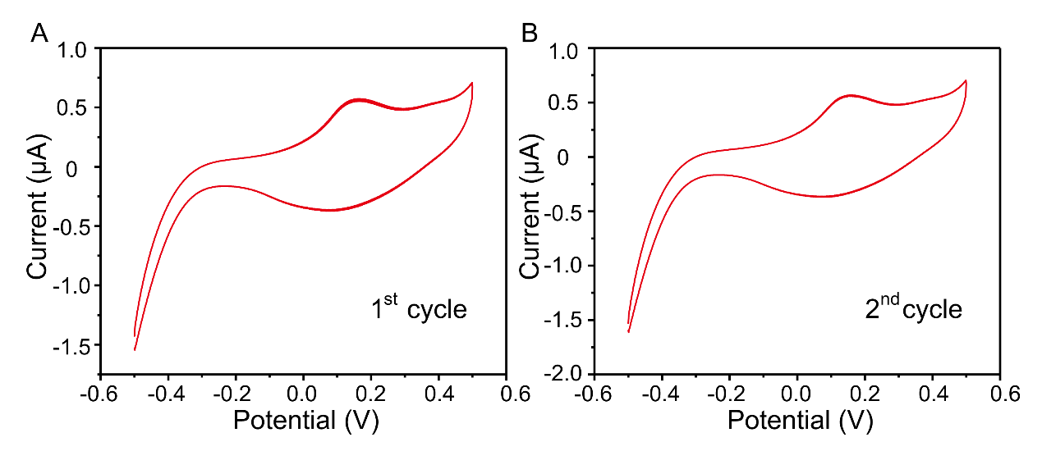
Supplementary Fig. 12: Inherent electrochemistry measured in 50 mM PBS.

