Supplementary information
In this supplementary document, we provide additional details and analyses regarding SIFAST.
• Section I: the fundamental optical setup of SIFAST is introduced and the selection of optical components is discussed, both of them should be considered during the optical design.
• Section II: the complete algorithmic process for reconstructing spatiotemporal fields is shown in detail, where the interferometric spectral images are collected by the imaging spectrometer.
• Section III: the method for the alignment of the optical path in SIFAST is shown, which also show reasons of easy alignment of SIFAST.
• Section IV: the performance and resolution of SIFAST are analyzed.
• Section V: The additional experimental validation results of SIFAST.
I. Optical setup of the SIFAST
The SIFAST optical setup consists of two interference arms. The key point to achieving single-shot measurement in SIFAST lies in ensuring that the reference beam is stronger than the test beam across the entire spatial and spectral range, and that it undergoes spectral interference with the test beam. Taking the test beam as a flat-top beam with a beam radius of $r_{unk}$ as an example, a small portion of the test beam is selected through an aperture with a radius of $r_{i}$ to produce a uniform reference beam.
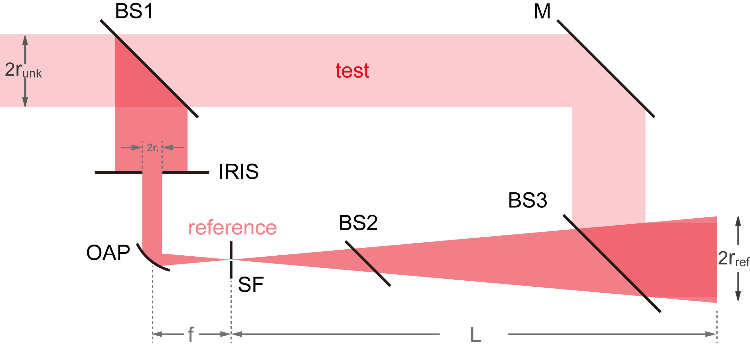
Figure S-1 Geometric schematic of SIFAST. BS: Beam Splitter, M: Mirror, OAP: Off-Axis Parabolic Mirror, SF: Spatial Filter.
1. The reference beam’s spot size needs to be spatially larger than that of the test beam. We achieve this by focusing the selected small-sized reference beam through a parabolic mirror with a focal length $f$. The beam is then propagated over a sufficiently long distance $L$, allowing the reference beam to expand sufficiently to exceed the size of the test beam. Using geometrical optics, we can roughly estimate that the radius of the diffused reference beam is: $r_{ref}=r_{i}L/f$. To ensure that the reference beam’s radius is larger than that of the test beam, the propagation distance must satisfy:
$$L>fr_{unk}/r_{i} .$$
2. The reference beam is a small fraction of the test beam, which results in its intensity being significantly lower after diffusion. Therefore, it is necessary to calculate and design the reflection-transmission energy ratios of the beam splitters to ensure that the reference beam is stronger than the test beam at the detection plane. Assume the reflectivity of the beam splitter BS1 is $R_{1}$, the reflectivity of the beam splitter BS2 for single-point temporal measurements is $R_{2}$, and BS3 is a 1:1 beam splitter. Let the intensity of the test beam be $I$. The intensity of the test beam at the detection point is $\left(1-R_{1}\right)I$. The intensity of the reference beam at the detection point is $R_{1}\left(1-R_{2}\right){\left(r_{i}/r_{ref}\right)}^{2}I$. Substituting the radius of the diffused reference beam, we derive:
$$R_{1}>\frac{L^{2}}{L^{2}+\left(1-R_{2}\right)f^{2}} .$$The reflectivity of BS2 must meet the energy requirements for single-point temporal measurements. Once the reflectivity of BS2 is determined, the reflectivity of BS1 can be further specified. It is important to note that the test beam passes through BS1, while the reference beam passes through both BS2 and BS3. To eliminate the phase impact on the pulse caused by transmission through the media, the thickness of BS1 should be equal to the combined thickness of BS2 and BS3.
3. The reference beam is selected through a hard-edged aperture, which results in the formation of dark rings at the detection end due to diffraction. To mitigate this, a spatial filter (SF) is used at the focal point to filter out the rings, leaving only the central spot. For a Gaussian beam at the diffraction limit, the spot radius can be approximately calculated using the formula: $r_{f}=λf/r_{unk}$. A spatial filter with a radius that is too small would block the central beam. Therefore, the radius of the selected spatial filter, $r_{sf}$, should be 130% of $r_{f}$:
$$r_{sf}=1.3×\frac{λf}{r_{unk}} .$$
This method is only for preliminary optical path design. More precise design requires calculations based on spatial intensity profiles and free-space diffraction propagation theory. Suppose the input field of the test beam is $E_{1}\left(r\right)$, and the field of the reference beam selected by the aperture is $E_{iris}\left(r,r_{i}\right)E_{1}\left(r\right)$, where the aperture function is defined as:
$$E_{iris}\left(r,r_{i}\right)=\left\{\begin{aligned}1 \left|r\right|<r_{i} \\ 0 \left|r\right|>r_{i}\end{aligned}\right. .$$
After passing through the parabolic mirror, the field can be expressed as:
$$E_{2}\left(r\right)=E_{iris}\left(r,r_{i}\right)E_{1}\left(r\right)\exp\left[-ik{\left|r\right|}^{2}/\left(2f\right)\right] ,$$where $k$ is the wave vector and $f$ is the focal length of the parabolic mirror. Based on the angular spectrum propagation diffraction theory, the field at the focal position can be calculated as:
$$E_{3}\left(r\right)=F^{-1}\left\{F\left[E_{2}\left(r\right)⋅H\left(f\right)\right]\right\} ,$$where $H\left(z\right)=\exp\left[ikz\sqrt{1-{\left(λf_{x}\right)}^{2}-{\left(λf_{y}\right)}^{2}}\right]$ is the transfer function for free space propagation over a distance z . Subsequently, the spatial filter removes the diffraction rings caused by the hard-edged aperture, the resulting field is $E_{iris}\left(r,r_{sf}\right)E_{3}\left(r\right)$. After propagating a distance $L$, the field of the reference beam can be expressed as:
$$E_{4}\left(r\right)=F^{-1}\left\{F\left[E_{iris}\left(r,r_{sf}\right)E_{3}\left(r\right)⋅H\left(L\right)\right]\right\} .$$Taking into account the energy distribution by the beam splitters, the intensity of the reference beam at the detection end is $I_{ref}\left(r\right)=R_{1}\left(1-R_{2}\right){\left|E_{4}\left(r\right)\right|}^{2}$ and the intensity of the test beam is $I_{unk}\left(r\right)=\left(1-R_{1}\right){|E}_{1}\left(r\right){\left.​\right|}^{2}$.
The table below presents a parameter selection case for a measurement of a flat-top beam with a diameter of 28 mm.
Table 1 Optical path design parameters for a flat-top beam with a diameter of 28 mm.
parameters | specifications
$$f$$ | 50.8 mm
$$r_{i}$$ | 1 mm
$$r_{sf}$$ | 25 $μm$
$$L$$ | 1000 mm
$$R_{1}$$ | 99.9%
$$R_{2}$$ | 30%
Figure S-2(a) illustrates the normalized light intensity of the test beam and reference beam at the detection end. Figure S-2(b) shows the energy ratio between the test and reference beams at the detection end, indicating that the reference beam is stronger than the test beam across the entire beam spot.
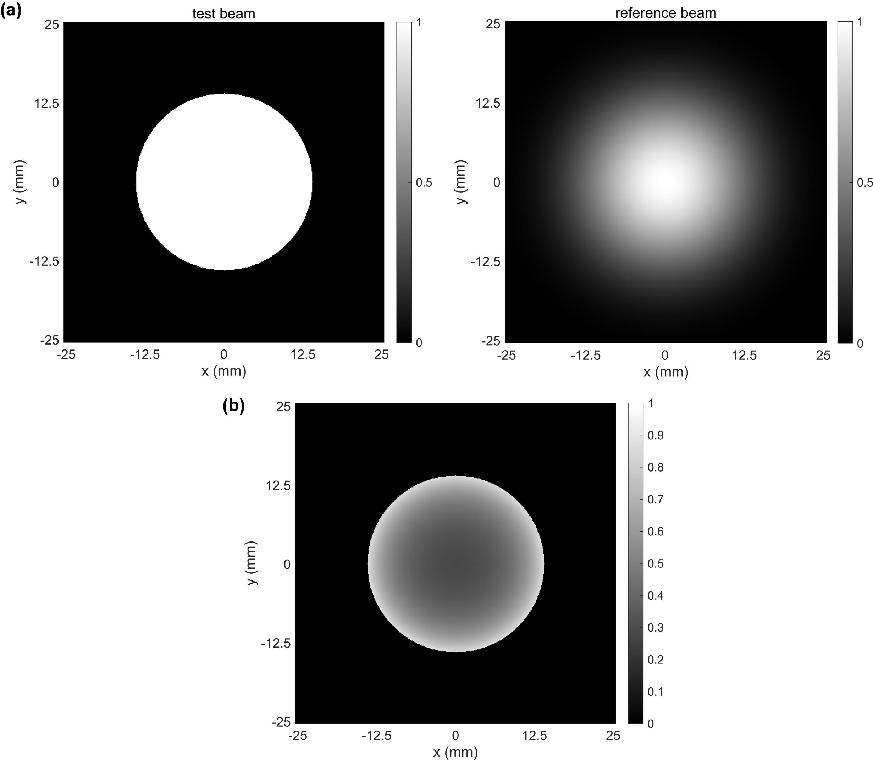
Figure S-2 (a) Normalized intensity of the test beam. (b) Normalized intensity of the reference beam. (c) Intensity ratio between the test beam and the reference beam.
II. Data Processing and Reconstruction Algorithm
Figure S-3 shows the interferometric spectral image collected by the imaging spectrometer from the fiber array. The first step in the process involves calculating the spatial position of each spectrum based on the pixel position $pixel_{0}$ corresponding to the first fiber on the CCD and the pixel intervals $Δpixel$ between the fibers. Assuming the fiber array is arranged in an $N ×N$ grid with a fiber spacing of $Δd$, the sequence corresponding to each spectrum is:
$$i_{y}=\left\lfloor \frac{pixel-pixel_{0}}{N×Δpixel}\right\rfloor \\ i_{x}=\left\lfloor \frac{pixel-pixel_{0}}{Δpixel}-N×i_{y}\right\rfloor$$where the symbol denotes the floor function (rounding down to the nearest integer). The corresponding coordinates are:
$$x=\left[i_{x}-\left(N-1\right)/2\right]×Δd \\ y=\left[i_{y}-\left(N-1\right)/2\right]×Δd$$This transforms the two-dimensional interferometric spectral image into a three-dimensional spatial spectral interferometric intensity $S\left(x,y,ω\right)$.
$S\left(x,y,ω\right)$ is given by:
$$S\left(x,y,ω\right)={\left|{\tilde{E}}_{u}\left(x,y,ω\right)+{\tilde{E}}_{r}\left(x,y,ω\right)e^{-iωτ_{0}}\right|}^{2} \\ ={\left|{\tilde{E}}_{u}^{\left(-1\right)}\left(x,y,ω\right)e^{-iωτ_{u}\left(x,y\right)}+{\tilde{E}}_{r}^{\left(-1\right)}\left(x,y,ω\right)e^{-iωτ_{r}\left(x,y\right)}e^{-iωτ_{0}}\right|}^{2} \\ =\left[I_{u}\left(x,y,ω\right)+I_{r}\left(x,y,ω\right)\right]+{\tilde{E}}_{u}^{*,\left(-1\right)}\left(x,y,ω\right){\tilde{E}}_{r}^{\left(-1\right)}\left(x,y,ω\right)e^{-iω\left[τ_{0}+τ_{r}\left(x,y\right)-τ_{u}\left(x,y\right)\right]}+c.c. ,$$where ${\tilde{E}}_{u}$ and ${\tilde{E}}_{r}$ are the complex spatial frequency domain fields of the test and reference beams, respectively. $τ_{0}$ is the delay introduced by the delay line between the reference and test beams. The superscript $\left(-1\right)$ indicates that the first-order phase is not included. $τ_{u}$ and $τ_{r}$ represent the pulse fronts of the test and reference beams, respectively.
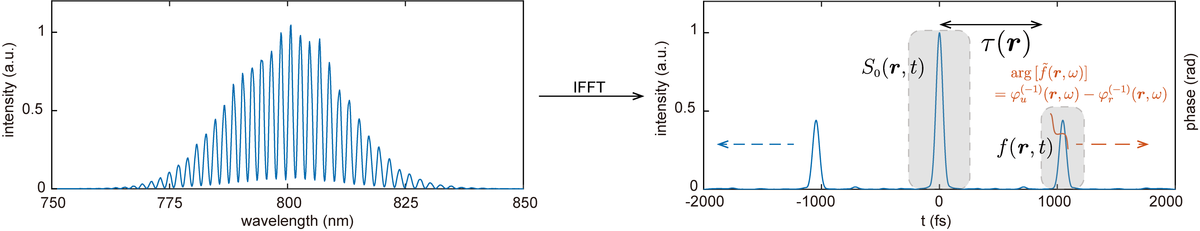
Figure S-3 FTSI algorithm for extracting spectral amplitude and phase.
1. Inverse Fourier Transform
$S\left(x,y,ω\right)$ comprises both a DC component and an AC component. The DC term is defined as $S_{0}\left(x,y,ω\right)=I_{u}\left(x,y,ω\right)+I_{r}\left(x,y,ω\right)$ and the AC term is $f\left(x,y,ω\right)={\tilde{E}}_{u}^{*,\left(-1\right)}\left(x,y,ω\right){\tilde{E}}_{r}^{\left(-1\right)}\left(x,y,ω\right)$. The phase of the AC term, $\arg\left[f\left(x,y,ω\right)\right]=φ_{r}^{\left(-1\right)}\left(x,y,ω\right)-φ_{u}^{\left(-1\right)}\left(x,y,ω\right)$, contains the phase difference information excluding the first-order phase. Performing the inverse Fourier transform on the frequency domain at each spatial point:
$$S\left(x,y,t\right)=S_{0}\left(x,y,t\right)+f\left(x,y,t-τ\right)+f^{*}\left(x,y,t+τ\right) .$$
Here, the DC term and the AC term containing phase difference information are separated in the time domain. The time interval in the spatial domain is given by $τ\left(x,y\right)=τ_{0}+τ_{r}\left(x,y\right)-τ_{u}\left(x,y\right)$.
2. Calibration of the Reference Pulse Front
Once the optical path configuration of the device is determined, the reference pulse will produce a fixed uniform spherical divergent pulse front at the measurement end. Suppose the propagation distance from the focal point to the detection end is $L$, and the offset distance of the focal point relative to the center of the measurement end is $x_{0}$ and $y_{0}$. The reference beam pulse front propagating to the measurement end can be expressed as:
$$τ_{r}\left(x,y\right)=\left(\sqrt{{\left(x-x_{0}\right)}^{2}+{\left(y-y_{0}\right)}^{2}+L^{2}}-\sqrt{x_{0}^{2}+y_{0}^{2}+L^{2}}\right)/c ,$$where $c$ is the speed of light. By fitting the expression for $τ_{r}$ to $τ$, we can obtain the fixed delay introduced by the delay line ($τ$), the relative offset of the focal point ($x_{0}$ and $y_{0}$), and the actual propagation distance of the reference beam ($L$).
Thus, the pulse front of the test pulse can be determined as:
$$τ_{u}\left(x,y\right)=τ_{0}+τ_{r}\left(x,y\right)-τ\left(x,y\right) .$$
The corresponding first-order spectral phase of the test pulse is:
$$φ_{u}^{\left(1\right)}\left(x,y,ω\right)=τ_{u}\left(x,y\right) .$$
Additionally, the wavefront effect of the reference pulse is:
$$φ_{r}^{\left(0\right)}\left(x,y\right)=τ_{r}\left(x,y\right)ω_{0} .$$
It is important to note that any pulse not containing pulse front curvature can be used for the calibration of the device. Pulse front tilt and higher-order spatiotemporal coupling do not affect the second-order fitting. Pulses output from a fiber laser are recommend using for instrument calibration, as fiber laser pulses typically have better beam quality. Once the device is calibrated, it can operate for extended periods without recalibration.
3. Extraction of the Spectral Phase of the Test Pulse
Using a super-Gaussian window $W\left(t-τ\right)$, we can isolate the AC component in the time domain. By shifting it back to the time-domain zero point, we obtain $f(x,y,t)$. Applying the Fourier transform to $f(x,y,t)$, we can derive $f\left(x,y,ω\right)$ in the frequency domain. The phase of $f\left(x,y,ω\right)$ represents the spectral phase difference between the reference pulse and the test pulse. This is the usual processing step in the Fourier Transform Spectral Interferometry (FTSI) algorithm. In single-point temporal measurements, the temporal position of the pulse is not a concern. However, in full spatial measurements, the temporal alignment of pulses at different spatial positions is crucial for ensuring that pulses can coincide temporally when focused.
Therefore, we adjust the AC component’s shift towards the time-domain zero point based on the reference pulse’s pulse front at different spatial positions. This yields $f\left(x,y,t-τ+τ_{0}+τ_{r}\right)$. Applying the Fourier transform to this function, the phase in the frequency domain is:
$$Δφ\left(x,y,ω\right)=\arg\left\{F\left[f\left(x,y,t+τ_{u}\right)\right]\right\}=φ_{u}\left(x,y,ω\right)-\left[φ_{r}^{\left(0\right)}\left(x,y\right)+φ_{r}^{\left(2,3,…\right)}\left(ω\right)\right].$$
This process retains the first-order phase of the test pulse at different spatial positions. The wavefront of the reference pulse is obtained during calibration. By using single-point temporal measurement techniques such as FROG, SRSI, SPIDER or TIPTOE (Nat. Photonics 16, 109), we can characterize the higher-order spectral phase of the reference pulse. This allows us to fully determine the complete phase information of the test pulse.
4. Spectral Amplitude Reconstruction
For the estimation of spectral amplitude, it employs the square root of the linear combination of $S_{0}\left(ω\right)$ and $f\left(ω\right)$. Similar to extracting the AC component, a super-Gaussian window $W\left(t\right)$ is applied in the time domain, followed by a Fourier transform, allowing the separate extraction of $S_{0}\left(ω\right)$ from the interferometric spectrum. The spectral amplitude of the test pulse can be calculated using the following expression:
$$\left|{\tilde{E}}_{u}\left(x,y,ω\right)\right|=\frac{1}{2}\left(\sqrt{S_{0}\left(x,y,ω\right)+2\left|f\left(x,y,ω\right)\right|}-\sqrt{S_{0}\left(x,y,ω\right)-2\left|f\left(x,y,ω\right)\right|}\right) .$$
Substituting the expressions for $S_{0}$ and $f$, we find:
$$\left|{\tilde{E}}_{u}\left(x,y,ω\right)\right|=\frac{1}{2}\left(\left|{\tilde{E}}_{u}\left(x,y,ω\right)\right|+\left|{\tilde{E}}_{r}\left(x,y,ω\right)\right|-\left|\left|{\tilde{E}}_{r}\left(x,y,ω\right)\right|-\left|{\tilde{E}}_{u}\left(x,y,ω\right)\right|\right|\right)$$
Therefore, to reconstruct the spectral amplitude from a single interferogram, the reference beam must be entirely stronger than the test beam. If this condition is not met, it is necessary to acquire the spectrum of the test beam separately, enabling two-shot reconstruction.
5. Implementation of Data Processing
The complete data processing procedure has been described in the preceding steps. The spectral images collected in the experiment are $2048×2048$ pixels in size, containing data from $14×14=196$ fibers. To enhance temporal resolution, the spectrum is zero-padded from $2^{11}$ points to $2^{16}$ points during the inverse Fourier transform. Since the entire algorithm involves only linear combinations and Fourier transforms, the processing time per instance on a PC with an Intel 10700 processor is within 3 seconds, with a significant portion of this time dedicated to data reading.
To meet the demands for improved spatial resolution, spatial scanning in X and Y can be employed. For a tenfold increase in spatial resolution, the total data processing time remains within 5 minutes.
III. Reasons and Methods for Easy Alignment
All interferometric setups require precise alignment, which involves not only aligning the centers of the test beam and the reference beam at the measurement end but also ensuring that the optical axis of the reference beam is parallel to that of the test beam. In the alignment process for SIFAST:
1. Centering the Beams: Position the beam spots of the test and reference beams at the center of the fiber array. A more accurate position offset can be obtained by fitting the intensity of the spots collected by the imaging spectrometer to a Gaussian function.
2. Extracting Time Intervals: Generate spectral interference and extract the time intervals $τ\left(x,y\right)$. Perform the calibration of the reference beam pulse front as described in Section II. The fitted reference beam pulse front will yield two key parameters: the offset distances $x_{0}$ and $y_{0}$ of the focal point relative to the center of the measurement end. Essentially, the tilt of the reference beam’s spherical wavefront reflects the misalignment between the optical axes of the reference and test beams.
3. Adjusting the Mirrors: Adjust the last two mirrors in the reference optical path to continuously correct the offset distances in the reference beam pulse front and the spot position until all offsets are zero.
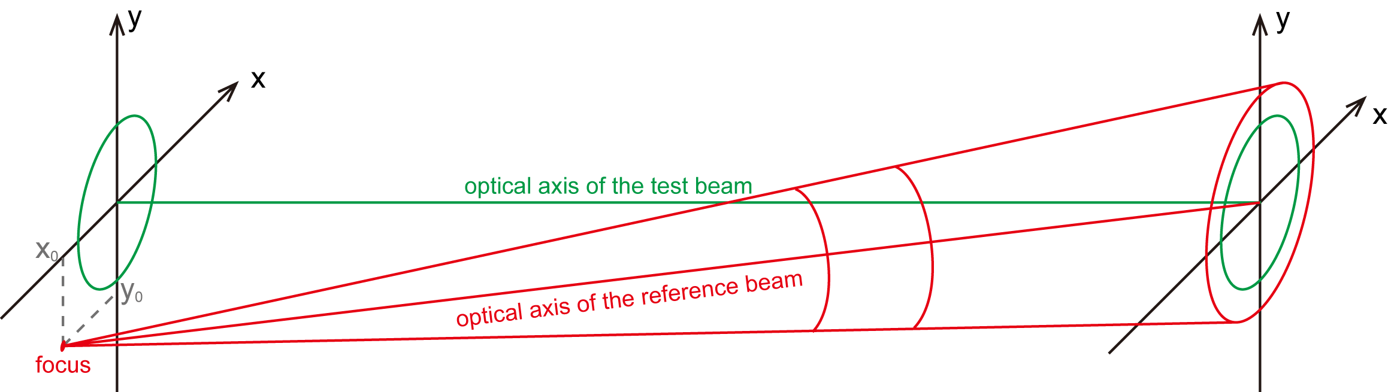
Figure S-4 Geometry of unaligned reference beam.
The primary reason that SIFAST is easier to align compared to other measurement methods is its ability to extract the spatial time intervals between the two beams before complete reconstruction, which inherently includes information about the misalignment of the optical axes.
IV. Performances of SIFAST
Spectral resolution and temporal window: The spectral resolution is determined by the resolution of the spectrometer, which, more specifically, is dictated by the linear dispersion capability of the grating and the pixel size of the CCD. In the experiment, the IsoPlane 320 imaging spectrometer (Teledyne Princeton Instruments) with a linear dispersion capability of 9.698 nm/mm was used. Combined with a CCD (PIXIS 2K) with a pixel size of 13.5 $μm$, the spectral resolution $δλ$ can reach 0.131 nm, corresponding to $δω$ of 0.385 THz. Due to the relationship between the time window and spectral resolution, $ΔT = 2π/δω$, this implies a time window width of approximately 16 ps. Since the FTSI algorithm requires transforming the interference signal into the temporal domain to extract the AC component, the AC component must reside within the measurement time window. By the width of the super-Gaussian window of $τ\left(r\right)$, the time window is divided into three parts by DC and AC. Consequently, the time interval $τ\left(r\right)$ must satisfy the inequality $3τ\left(r\right)<ΔT$. For pulses with a duration of 45 fs, considering the pulse front of the reference beam, the maximum measurable difference in pulse front is about 4 $ps$.
Spectral bandwidth and temporal resolution: In order to realize single-shot measurements, the spectrometer's bandwidth must exceed that of the test pulse, which constrains the choice of spectral resolution and precludes the unrestricted selection of high groove density diffraction gratings. The spectral bandwidth $Δω≈N_{pixel}δω$, where $N_{pixel}$ represents the number of CCD pixels. For 2K CCD (PIXIS), the measurable spectral bandwidth is 268 nm. The temporal resolution is given by $δt = 2π/Δω$, which can be artificially zero-padded at both ends of the spectrum during data processing to improve the resolution in the time domain.
Spatial resolution and maximum measurable wavefront (central wavelength): A single-mode fiber array (S630-HP, Thorlabs) was arranged in a $14×14$ matrix with a spacing of 1.1 mm (can be reducible to a minimum of 125 $μm$ by stripping the fiber coating). As for wavefront, the phase unwrapping may introduce ambiguities because it is unclear how many $2π$ phase jumps occur between each sampling point. To correctly unwrap the phase at each point, the maximum phase variation must satisfy $\max\left(\frac{\text{dφ}}{\text{d}x}\right)<πN_{x}/Δx$, where $N_{x}$ is the number of samples and $Δx$ is the sampling range. Consequently, this single-mode fiber array can measure a maximum phase change rate of 3.07 rad/mm. In the experiment, the pulse wavefront being characterized only has higher-order distortions. It is important to note that the maximum measurable phase change rate mentioned here pertains only to the spatial phase at the central wavelength. The large wavefront tilt caused by the pulse front are analyzed post-extraction of the pulse front distribution using the FTSI algorithm and are not limited by the maximum measurable wavefront specified here.
V. Additional Experimental Validation Results of SIFAST
1. Spatial chirp introduced by an asymmetric four-grating compressor (AFGC)
An AFGC was proposed to mitigate beam fluctuations without affecting the far-field on-axis focus intensity, but it introduces spatial dispersion. Based on the symmetric four-grating compressor, we realized this structure by changing the distance between the first and second pairs of parallel gratings, as shown in Fig. S-5(a), and characterized the introduced spatial dispersion using SIFAST. According to the Ref. (Opt. Commun., 557, 130317), for a beam with a central wavelength $λ_{0}$ incident at an angle $θ_{i}$ on an AFGC with a line density of $N$ and a spacing difference of $ΔL=L2-L1$ between the two pairs of gratings, the position at the rear end is given by:
$$x=\tan{θ_{d}}⋅\cos{θ_{i}}⋅ΔL ,$$where $θ_{d}$ is the diffraction angle. Thus, the spatial chirp is:
$$\text{SC}=\frac{\text{d}x}{\text{d}ω}=2πcN\cos{θ_{i}}ΔL{\left(1-\sin^{2}{θ_{d}}\right)}^{-\frac{3}{2}}/ω_{0}^{2} ,$$where $c$ is the speed of light, and $ω_{0}$ is the central frequency. According to theoretical calculations, the spatial chirp should be 0.0237 mm/THz. The measured compressed output pulses, as shown in the Fig. S-5(b), display the spatially normalized intensity fit for different wavelengths. As the wavelength increases, it gradually shifts along the x-axis. Taking the beam center spot as the spatial position of the wavelength, the spatial chirp was fitted to be 0.0225 mm/THz.
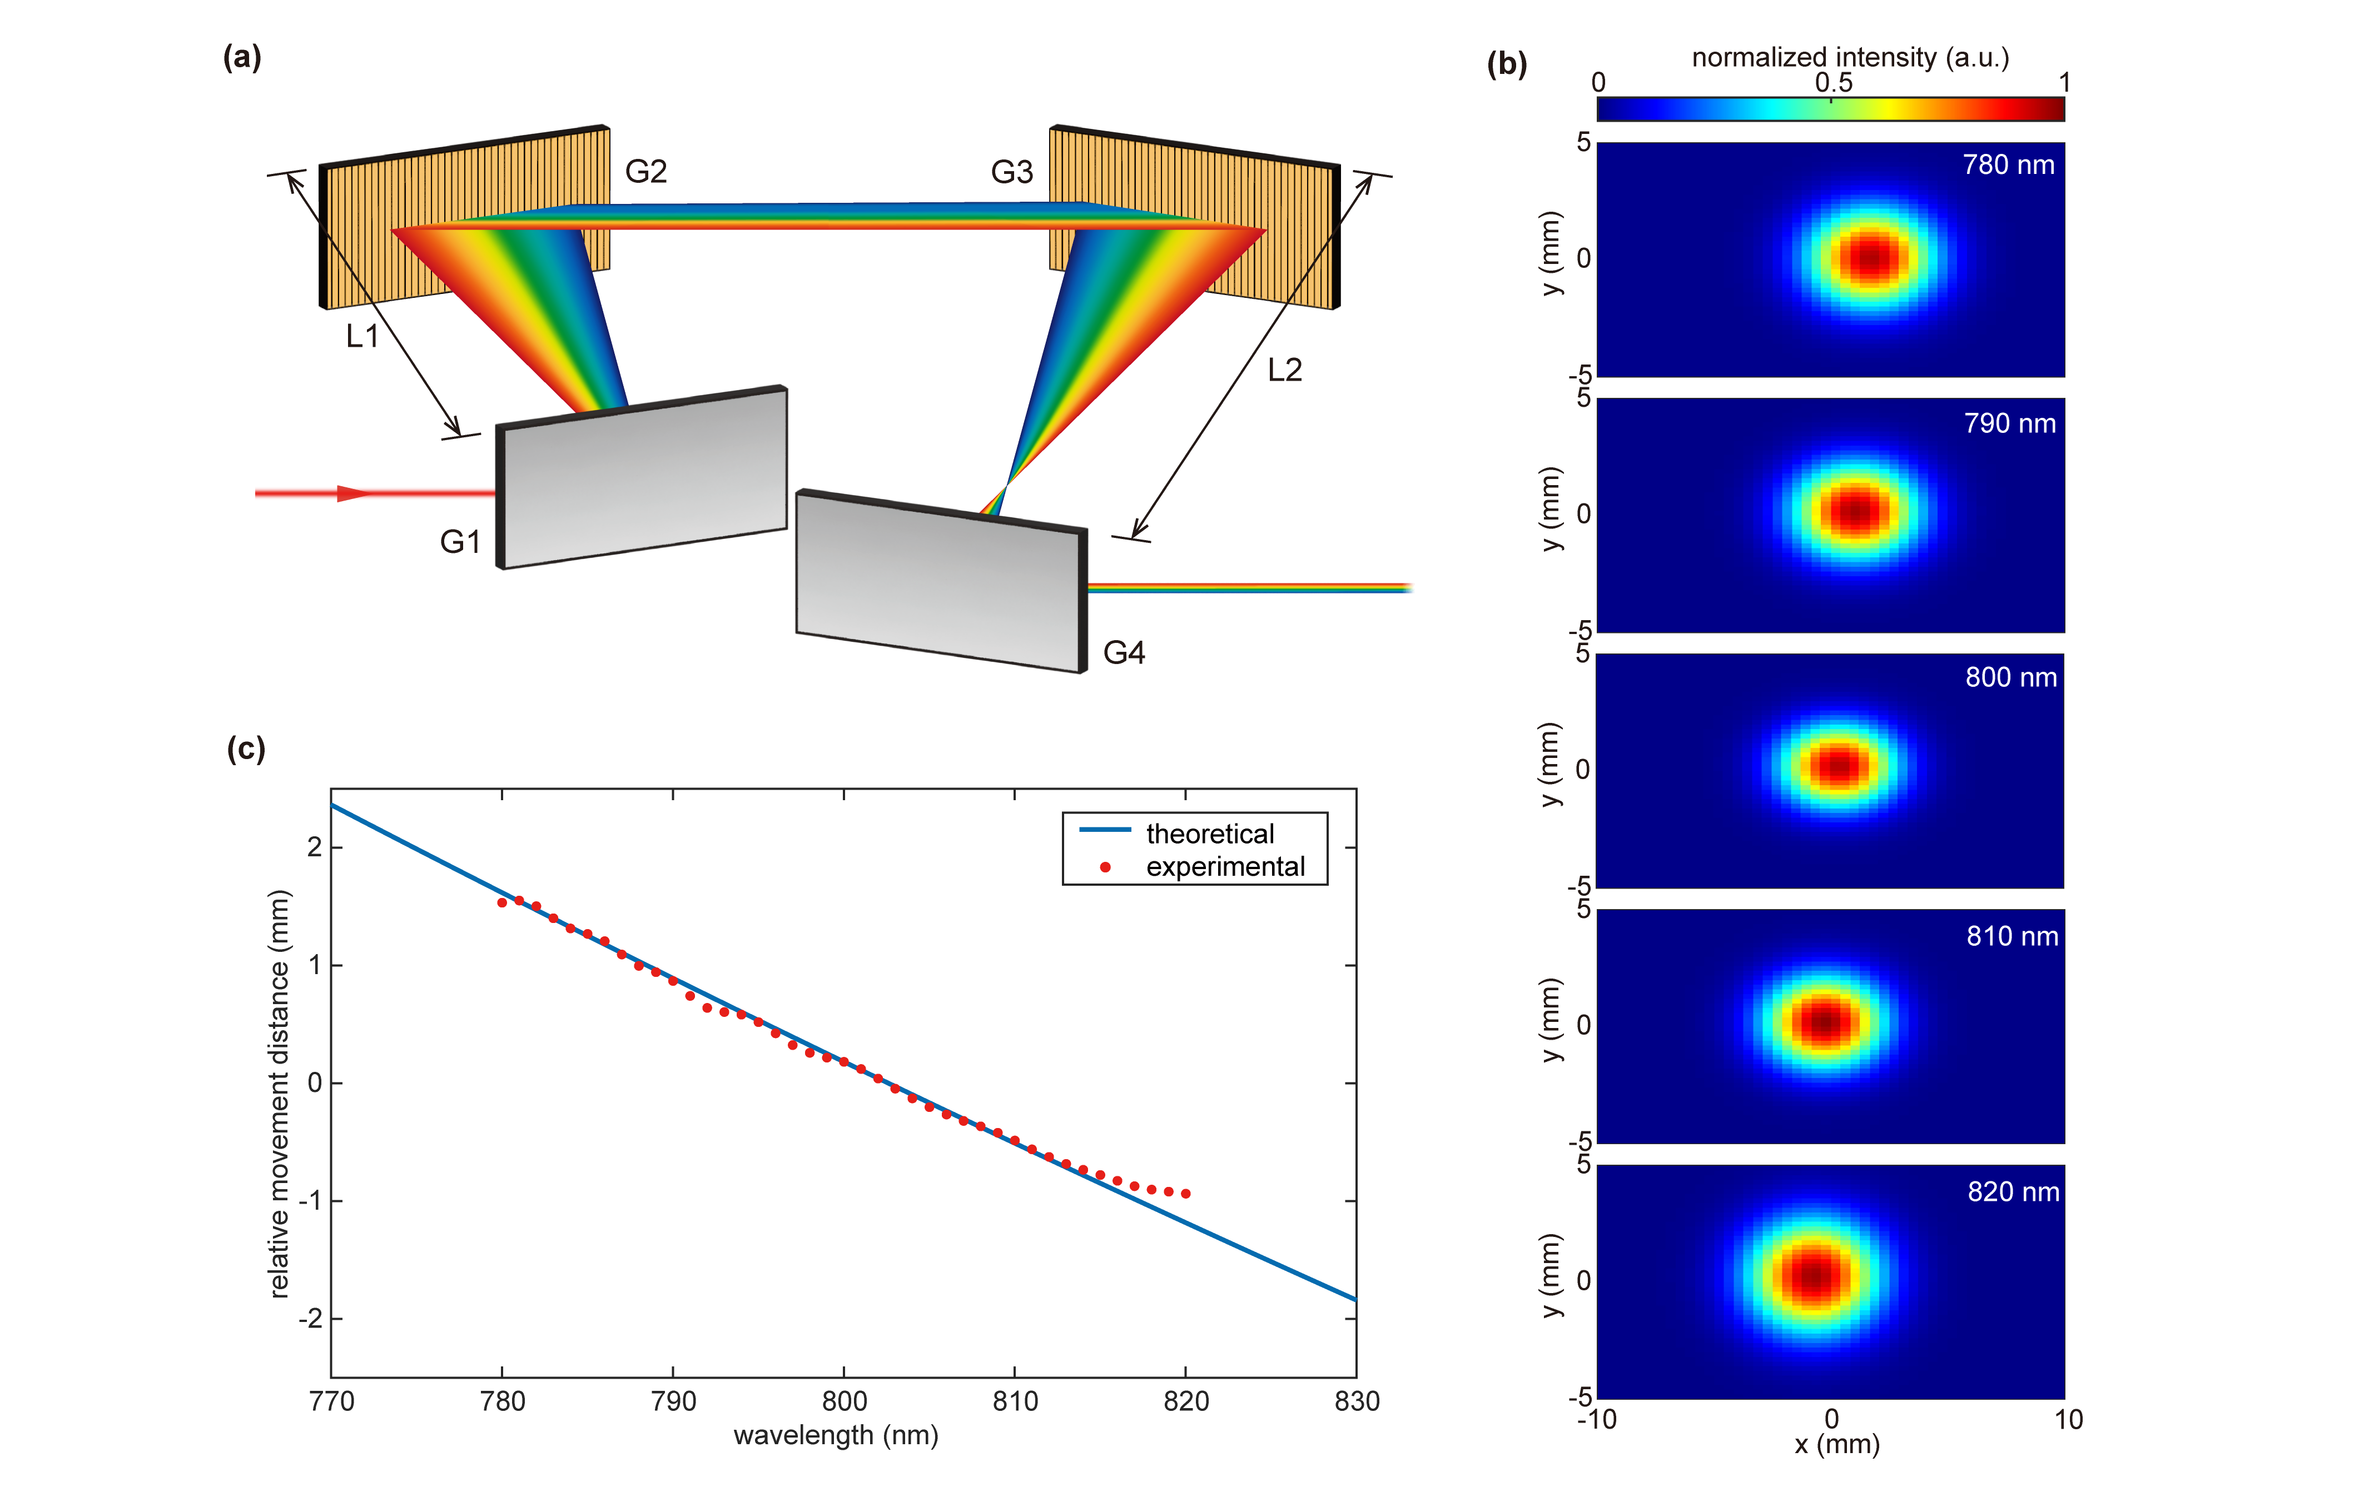
Figure S-5 Spatial chirp introduced by asymmetric four-grating compressor (AFGC). (a), AFGC scheme. (b), The normalized spatial intensities for wavelengths of 780, 790, 800, 810, and 820 nm, from top to bottom. (c), The relative distance moved in the x-direction for each wavelength.
2. Single-Shot Measurement of a PW Laser Facility
The beam output from a home-made PW laser facility was measured using SIFAST. This laser system produces a super-Gaussian flat-top beam with a diameter of 215 mm, a pulse duration of 28 fs, and a peak power of 1 PW. In the experiment, the output laser beam was demagnified to 14 mm using a multi-stage parabolic mirror set. Figure S-6 shows the measured pulse front of the PW laser system, which exhibits an upward curvature along one axis and a downward curvature along the perpendicular axis, resembling a saddle shape. The difference in the pulse front is approximately 100 fs. According to simulations by Z. Li in the Ref. (Opt. Express 26, 8453-8469) on PW-level laser systems, this type of pulse front curvature may caused by low spatial frequency wavefront distortions on the second and third meter-scale gratings of the compression system. It may due to the wavefront errors of current meter-sized compression gratings are far from ideal cases. After passes through the first grating, different spectral components are spatially dispersed and illuminate different regions of the second and third gratings. Due to the wavefront distortions, different spectral components experience varying spatially induced phase shifts, leading to spatial spectral phase distortion (SSPD). The spatially dependent group delay caused by SSPD is the primary reason for the observed spatiotemporal coupling, resulting in the pulse front curvature.
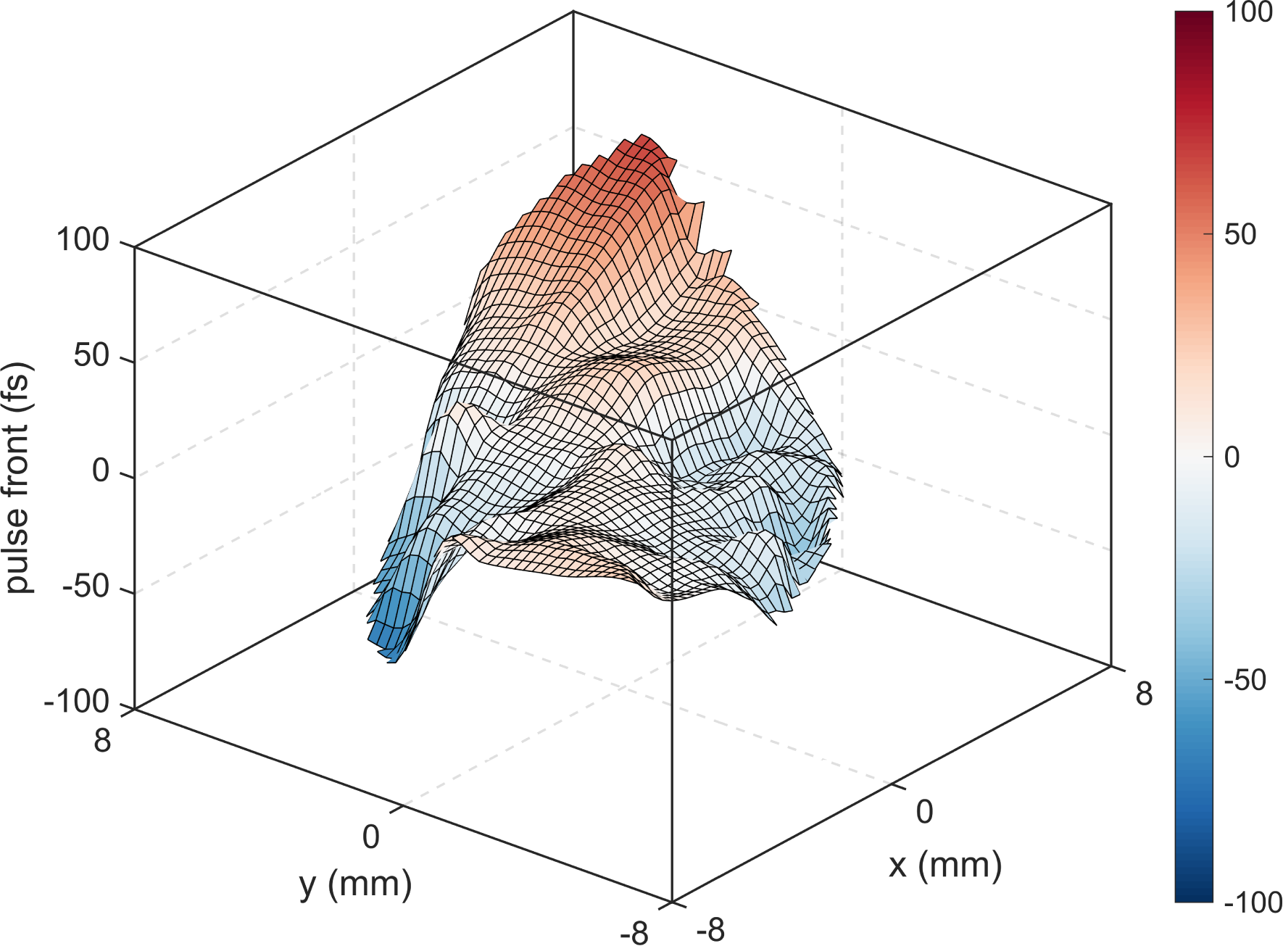
Figure S-6 The pulse front of the output pulse of the PW laser facility.

