Supplementary information for

Gridized polynanomer catalysis with atomically dispersed iron achieve the nearly 100% selective electroreduction of CO₂ to methanol

Tonglin Yang¹, Tao Wang¹, Weihao Zhang¹, Fu Deng¹, Chunxiao Zhong¹, Qian Peng¹, Chao Liu¹, Xin Chen¹, Zheng Zhang¹, Yang Li¹, Yang Feng¹, Xiaoyan Li^{1,2}, Kuande Wang¹, Chong Zhang¹, Ying Wei¹*, Fangqi Yang¹*, Linghai Xie^{1,2,3}* and Wei Huang^{1,2,3}*
¹Centre for Molecular Systems and Organic Devices, Key Laboratory for organic Electronics and Information Displays & Jiangsu Key Laboratory for Biosensors, Institute of Advanced Materials (IAM), Jiangsu National Synergetic Innovation Center for Advanced Materials (SICAM), Nanjing University of Posts & Telecommunications; Nanjing, 210023, China.
²Shaanxi Institute of Flexible Electronics (SIFE), Northwestern Polytechnical University (NPU); Xi'an, 710072, China.
³School of Flexible Electronics (SoFE) and Henan Institute of Flexible Electronics (HIFE), Henan University; Zhengzhou, 450046, China.
*Corresponding author, e-mail: iamywei@njupt.edu.cn, iamfqyang@njupt.edu.cn, iamlhxie@njupt.edu.cn, iamwhuang@nwpu.edu.cn

This PDF file includes:
- Experimental Details
- Supplementary Figures 1-9. MALDI-TOF-MS and NMR spectra
- Supplementary Figures 10-13. GPC, X-ray crystallography and XRD
- Supplementary Figures 14-25. Structure and CO₂RR performance
- Supplementary Figures 26-39. NMR spectra
- Supplementary Tables 1-4. CO₂RR performance and structure
- References
Experimental Details
Materials
All chemicals and solvents were purchased from commercial sources and used as received without further purification unless otherwise stated. Dichloromethane was dried using anhydrous sodium, while toluene and THF were dried over sodium benzophenone ketyl anion radical and distilled under a dry nitrogen atmosphere immediately prior to use. 2-bromo-9-phenyl-9H-fluoren-9-ol (3a)¹ and 2,7-dibromo-9-(4-(octyloxy)phenyl)-9H-fluoren-9-ol (5a)² were obtained according to the reported literatures.
Synthetic procedures
The synthesis of 3,6-dibromo-9-ethyl-9H-carbazole (1a)
3,6-dibromocarbazole (15 g, 46.2 mmol), bromoethane (5.0 g, 46.2 mmol), sodium hydroxide (1.8 g, 46.2 mmol), tetrabutylammonium bromide (1.5 g, 4.6 mmol) and acetone (308 mL) were added to a round-bottom flask. The reaction mixture was stirred at 65 ºC for 12 h and monitored by TLC. After completion of the reaction, the reaction mixture was quenched with water after cooling to room temperature and extracted with dichloromethane. The combined organic layers were washed with an aqueous saturated brine solution, and dried over anhydrous Na₂SO₄. The organic layer was concentrated in vacuo to obtain crude product. The crude product was purified by flash column chromatography on silica gel with petroleum ether as eluent to afford the product 1a (White flocculent powder, 14.7 g, yield: 90%). ¹H NMR (400 MHz, Chloroform-d) δ 8.12 (d, J = 1.9 Hz, 2H), 7.55 (dd, J = 8.7, 1.9 Hz, 2H), 7.27 (s, 1H), 7.25 (s, 1H), 4.29 (q, J = 7.2 Hz, 2H), 1.39 (t, J = 7.2 Hz, 3H). ¹³C{¹H} NMR (101 MHz, Chloroform-d) δ 138.7, 129.0, 123.5, 123.3, 111.9, 110.1, 37.8, 13.7.

The synthesis of 9-ethyl-3,6-bis(4,4,5,5-tetramethyl-1,3,2-dioxaborolan-2-yl)-9H-carbazole (2a)
To a three-necked flask was added 3,6-dibromo-9-ethyl-9H-carbazole 1a (10 g, 30.7 mmol), bis(pinacolato)diboron (23.5 g, 92.3 mmol), KOAc (12.0 g, 122.8 mmol), Pd(dppf)Cl₂ (1.1 g, 1.5 mmol), and 1,4-dioxane (153.5 mL) under the nitrogen atmosphere. The reaction mixture was stirred at 105 ºC for 8 h and monitored by TLC. After completion of the reaction, the reaction mixture was quenched with water after cooling to room temperature and extracted with dichloromethane. The combined organic layers were washed with an aqueous saturated brine solution, and dried over anhydrous Na₂SO₄. The organic layer was concentrated in vacuo to obtain crude product. The crude product was purified by flash column chromatography on silica gel with 2:1 petroleum ether/dichloromethane as eluent to afford the product 2a (White powder, 8 g, yield: 58%). ¹H NMR (400 MHz, Chloroform-d) δ 8.68 (s, 2H), 7.92 (d, J = 8.2 Hz, 2H), 7.40 (d, J = 8.2 Hz, 2H), 4.38 (q, J = 7.2 Hz, 2H), 1.45 – 1.42 (m, 3H), 1.39 (s, 24H). ¹³C{¹H} NMR (101 MHz, Chloroform-d) δ 142.1, 132.0, 128.1, 122.9, 107.8, 83.5, 37.6, 24.9, 13.7. MALDI-ToF-MS (m/z): calcd for C₂₆H₃₅B₂NO₄ 447.28, found 447.34.

The synthesis of 2-(9-ethyl-6-(9-hydroxy-9-phenyl-9H-fluoren-3-yl)-9H-carbazol-3-yl)-9-phenyl-9H-fluoren-9-ol (AOH)
In the nitrogen atmosphere, 9-ethyl-3,6-bis(4,4,5,5-tetramethyl-1,3,2-dioxaborolan-2-yl)-9H-carbazole 2a (3 g, 6.7 mmol), 2-bromo-9-phenyl-9H-fluoren-9-ol 3a (6.8 g, 20.2 mmol), Pd(PPh₃)₄ (0.77 g, 0.67 mmol), toluene/tetrahydrofuran mixture (1:1, v/v, 20.2 mL) and K₂CO₃/KF aqueous solution (1:1 molar ratio, 2 M, 13.4 mL) were added under the nitrogen atmosphere. The reaction mixture was stirred at 90 ºC for 2 days and monitored by TLC. After completion of the reaction, the reaction mixture was quenched with water after cooling to room temperature and extracted with dichloromethane. The combined organic layers were washed with an aqueous saturated brine solution, and dried over anhydrous Na₂SO₄. The organic layer was concentrated in vacuo to obtain crude product. The crude product was purified by flash column chromatography on silica gel with 6:1:1 petroleum ether/dichloromethane/ethyl acetate as eluent to afford the target product AOH (White powder, 3.4 g, yield: 72%). ¹H NMR (400 MHz, Chloroform-d) δ 8.32 (s, 2H), 7.75 (d, J = 1.1 Hz, 4H), 7.73 – 7.68 (m, 5H), 7.67 (d, J = 1.8 Hz, 1H), 7.50 (dt, J = 8.2, 1.5 Hz, 4H), 7.43 – 7.34 (m, 6H), 7.33 – 7.22 (m, 8H), 4.36 – 4.23 (m, 2H), 2.38 (s, 2H), 1.41 (t, J = 7.2 Hz, 3H). ¹³C{¹H} NMR (101 MHz, Chloroform-d) δ 151.1, 150.6, 143.2, 142.4, 142.3, 139.8, 139.4, 137.9, 131.9, 131.9, 129.1, 128.2, 128.2, 128.1, 128.1, 127.2, 125.5, 125.2, 125.2, 124.7, 123.5, 123.4, 120.4, 120.0, 118.9, 118.9, 108.7, 83.7, 37.7, 13.8. MALDI-ToF-MS m/z: calcd for C₅₂H₃₇NO₂ 707.28, found 707.70.

The synthesis of AG
4-methyl-N,N-diphenylaniline 4a (73.3 mg, 0.283 mmol), dichloromethane (142 mL), and BF₃·Et₂O (401.7 mg, 2.83 mmol) were added to a three-necked flask. AOH (200 mg, 0.283 mmol) dissolved in dichloromethane (142 mL) was dropped into the flask at room temperature, after which the reaction mixture was continuously stirred for 5 min. After completion of the reaction, the reaction mixture was quenched with water after cooling to room temperature and extracted with dichloromethane. The combined organic layers were washed with an aqueous saturated brine solution, and dried over anhydrous Na₂SO₄. The organic layer was concentrated in vacuo to obtain crude product. The crude product was purified by flash column chromatography on silica gel with 3:1 petroleum ether/dichloromethane/ as eluent to afford the product AG (White powder, 210 mg, yield: 80%). ¹H NMR (400 MHz, Chloroform-d) δ 8.19 (d, J = 1.9 Hz, 1H), 8.10 (d, J = 1.8 Hz, 1H), 7.88 – 7.72 (m, 8H), 7.63 (dd, J = 7.8, 1.6 Hz, 1H), 7.60 – 7.55 (m, 2H), 7.53 – 7.45 (m, 3H), 7.44 – 7.36 (m, 4H), 7.35 – 7.28 (m, 4H), 7.22 – 7.03 (m, 17H), 7.00 (d, J = 8.6 Hz, 1H), 4.50 – 4.35 (m, 2H), 2.30 (d, J = 3.5 Hz, 3H), 1.53 – 1.46 (m, 3H). ¹³C{¹H} NMR (101 MHz, Chloroform-d) δ 152.1, 151.7, 151.0, 150.9, 147.3, 147.2, 147.0, 146.8, 145.1, 145.0, 142.1, 142.0, 140.2, 140.2, 140.0, 139.8, 139.8, 138.5, 138.4, 133.3, 133.1, 131.5, 129.7, 129.6, 129.6, 129.4, 128.1, 128.1, 127.9, 127.6, 127.5, 127.4, 127.4, 127.4, 126.7, 126.4, 126.3, 125.8, 125.6, 125.2, 124.9, 124.7, 124.6, 123.5, 123.4, 123.0, 122.7, 122.7, 120.3, 120.3, 120.2, 120.1, 119.9, 119.8, 108.8, 108.8, 64.9, 37.9, 20.7, 13.9. MALDI-ToF-MS (m/z): calcd for C₇₁H₅₀N₂ 930.40, found 930.94.

The synthesis of FeAG
AG (100.0 mg, 0.108 mmol) dissolved in dichloromethane (50 mL) was added to a 150 mL flask and then FeCl₃ (35.0 mg, 0.216 mmol) dissolved in EtOH (25 mL) was added to the flask. The reaction mixture was stirred at room temperature for 12 h. After completion of the reaction, the solvent was removed under vacuum. Subsequently, the remaining solid was washed with deionized water and centrifuged to remove unreacted FeCl_{3,} resulting in crude product FeAG. The crude product FeAG was not subjected to further separation and purification.

The synthesis of DBrAOH
In a three-necked flask, 9-ethyl-3,6-bis(4,4,5,5-tetramethyl-1,3,2-dioxaborolan-2-yl)-9H-carbazole 2a (3 g, 6.7 mmol), 2,7-dibromo-9-(4-(octyloxy)phenyl)-9H-fluoren-9-ol 5a (11 g, 20.2 mmol), Pd(PPh₃)₄ (0.77 g, 0.67 mmol), toluene/tetrahydrofuran mixture (1:1, v/v, 20.2 mL) and K₂CO₃/KF aqueous solution (1:1 molar ratio, 2 M, 13.4 mL) were added under the nitrogen atmosphere. The reaction mixture was stirred at 90 ºC for 2 days and monitored by TLC. After completion of the reaction, the reaction mixture was quenched with water after cooling to room temperature and extracted with dichloromethane. The combined organic layers were washed with an aqueous saturated brine solution, and dried over anhydrous Na₂SO₄. The organic layer was concentrated in vacuo to obtain crude product. The crude product was purified by flash column chromatography on silica gel with 8:1:1 petroleum ether/dichloromethane/ethyl acetate as eluent to afford the product DBrAOH (Yellow powder, 600 mg, yield: 8%). ¹H NMR (400 MHz, Chloroform-d) δ 8.29 (d, J = 1.8 Hz, 2H), 7.80 – 7.60 (m, 8H), 7.54 – 7.43 (m, 6H), 7.41 – 7.29 (m, 6H), 6.81 (d, J = 8.5 Hz, 4H), 4.40 – 4.24 (m, 2H), 3.89 (t, J = 6.6 Hz, 4H), 2.58 (s, 2H), 1.79 – 1.67 (m, J = 6.8 Hz, 4H), 1.45 – 1.18 (m, 23H), 0.87 (t, J = 6.5 Hz, 6H). ¹³C{¹H} NMR (101 MHz, Chloroform-d) δ 158.6, 152.8, 150.9, 142.7, 142.6, 139.9, 138.1, 136.8, 134.2, 132.0, 131.8, 131.7, 128.2, 128.1, 128.1, 126.6, 125.2, 125.2, 123.5, 123.4, 123.4, 121.7, 121.3, 120.5, 118.9, 118.9, 114.3, 108.8, 83.3, 67.9, 37.7, 31.8, 29.3, 29.2, 29.2, 26.0, 22.6, 14.1, 13.8. MALDI-ToF-MS (m/z): calcd for C₆₈H₆₇Br₂NO₄ 1121.34, found 1121.69.

The synthesis of DBrAG
4-methyl-N,N-diphenylaniline 4a (69.4 mg, 0.268 mmol), dichloromethane (134 mL), and BF₃·Et₂O (401.7 mg, 2.83 mmol) were added to a three-necked flask. DBrAOH (300 mg, 0.268 mmol) dissolved in dichloromethane (134 mL) was dropped into the flask at room temperature, after which the reaction mixture was continuously stirred for 5 min. After completion of the reaction, the reaction mixture was quenched with water after cooling to room temperature and extracted with dichloromethane. The combined organic layers were washed with an aqueous saturated brine solution, and dried over anhydrous Na₂SO₄. The organic layer was concentrated in vacuo to obtain crude product. The crude product was purified by flash column chromatography on silica gel with 3:1 petroleum ether/dichloromethane as eluent to afford the product DBrAG (White powder, 89 mg, yield: 25%). ¹H NMR (400 MHz, Chloroform-d) δ 8.15 (s, 2H), 7.80 (d, J = 7.9 Hz, 2H), 7.78 – 7.71 (m, 4H), 7.66 (t, J = 8.3 Hz, 3H), 7.64 – 7.57 (m, 3H), 7.56 – 7.49 (m, 2H), 7.47 (d, J = 8.4 Hz, 2H), 7.31 (d, J = 8.6 Hz, 4H), 7.16 – 7.07 (m, 6H), 7.05 (d, J = 9.0 Hz, 6H), 6.68 (d, J = 9.0 Hz, 4H), 4.41 (q, J = 7.2 Hz, 2H), 3.81 (t, J = 6.6 Hz, 4H), 2.34 (s, 3H), 1.73 – 1.61 (m, 4H), 1.48 (t, J = 7.1 Hz, 3H), 1.38 – 1.18 (m, 20H), 0.84 (t, J = 6.7 Hz, 6H). ¹³C{¹H} NMR (101 MHz, Chloroform-d) δ 157.9, 153.3, 152.2, 147.3, 145.0, 142.4, 139.8, 139.3, 139.1, 137.7, 137.2, 132.9, 131.8, 130.7, 129.8, 129.5, 129.3, 128.9, 126.7, 125.6, 124.9, 124.7, 123.4, 123.2, 121.5, 121.1, 120.3, 119.8, 114.1, 108.8, 67.8, 64.3, 37.9, 31.7, 29.3, 29.2, 26.0, 22.6, 20.8, 14.0, 13.9. MALDI-ToF-MS (m/z): calcd for C₈₇H₈₀Br₂N₂O₂ 1344.46, found 1344.76.

The synthesis of PAG
In the nitrogen atmosphere, DBrAG (295.8 mg, 0.22 mmol), Ni(COD)₂ (550 mg, 2.0 mmol), 1,5-cyclooctadiene (119 mg, 1.1 mmol), and bipyridyl (156.2 mg, 1.0 mmol), DMF (as a cosolvent, 0.5 mL), and toluene (as the other part of cosolvent, 7 mL) are added to a Schlenk tube. The reaction mixture was stirred at 85 ºC for 5 days. Subsequently, bromobenzene (1 ml) was added to the solution for terminating the reaction, and the reaction was continued for 1 day. After completion of the reaction, the reaction mixture was quenched with THF and hytrazine hydrate after cooling to room temperature. The precipitate was separated by filtration. The crude product was further purified by the alumina (Al₂O₃) column chromatography with THF as eluent and Soxhlet extraction with acetone/THF mixture (9:1, v/v) to afford the product PAG (White powder, 144 mg, yield: 48%). ¹H NMR (400 MHz, Chloroform-d) δ 8.44 – 8.00 (2H), 7.94 – 7.72 (8H), 7.63 (5H), 7.49 (3H), 7.42 – 7.28 (4H), 7.18 – 6.88 (12H), 6.69 (4H), 4.43 (2H), 3.90 – 3.70 (4H), 2.25 (3H), 1.75 – 1.60 (4H), 1.51 (3H), 1.25 (20H), 0.87 – 0.78 (6H). The above integration only represented the integration ratio. ¹³C{¹H} NMR (101 MHz, Chloroform-d) 157.7, 152.8, 152.4, 147.2, 144.4, 141.9, 141.0, 139.8, 139.2, 138.5, 137.9, 133.1, 129.7, 129.3, 129.0, 127.4, 126.7, 125.6, 124.8, 123.4, 120.3, 119.9, 114.0, 108.8, 67.7, 64.3, 37.9, 31.7, 29.3, 29.3, 29.2, 26.0, 22.6, 20.8, 14.1, 14.0.

The synthesis of FePAG
PAG (100.0 mg) in dichloromethane (50 mL) was added to a 150 mL flask and then FeCl₃ (27.3 mg) in EtOH (25 mL) was added to the flask. The reaction mixture was stirred at room temperature for 12 h. After completion of the reaction, the solvent was removed under vacuum. Subsequently, the remaining solid was washed with deionized water and centrifuged to remove unreacted FeCl_{3,} resulting into crude product FePAG. The crude product FePAG cannot be further separation and purification.

Supplementary Table 1 | Comparison of catalytic performances of molecular catalysts for CO₂ electroreduction to CH₃OH in an H-cell.
Catalyst | Support | Electrolyte | FE_{CH3OH} (%) | Stability (h) | CH₃OH selectivity (%) | Reference
FeAG | CP | 0.5 M KHCO₃ | 49.4 | 20 | 96.8 | This work
FePAG | CP | 0.5 M KHCO₃ | 60.5 | 100 | 98.3 | This work
CoPc | CNT | 0.1 M KHCO₃ | 44 | 4 | 62 | (3)
CoTAPc | CNT | 0.1 M KHCO₃ | 32 | 12 | 48 | (3)
CoPc | CNT | 0.5 M KHCO₃ | 19.5 | - | 7.5 | (4)
Co corrole | CP | 0.1M NaClO₄ | 59 | - | 73 | (5)
CoPc | SWCNT | 0.5 M KHCO₃ | 53.4 | 10 | ~ 68 | (6)
iminium-CONs | CP | 0.5 M KHCO₃ | 43.4 | - | ~ 55 | (7)

Supplementary Fig. 1 | MALDI-TOF-MS of 2a.
Supplementary Fig. 2 | MALDI-TOF-MS of AOH.

Supplementary Fig. 3 | MALDI-TOF-MS of DBrAOH.

Supplementary Fig. 4 | MALDI-TOF-MS of AG.

Supplementary Fig. 5 | MALDI-TOF-MS of DBrAG.

Supplementary Fig. 6 | ¹H NMR spectra of AOH and AG. The proton signal at 2.38 ppm belonging to the protons of hydroxyl groups at the 9-position of AOH was not observed in AG. Furthermore, the detected peak at 2.3 ppm, corresponding to the protons of methyl group of 4-methyl-N,N-diphenylaniline, was observed in AG. These results indicated the successful synthesis of AG.

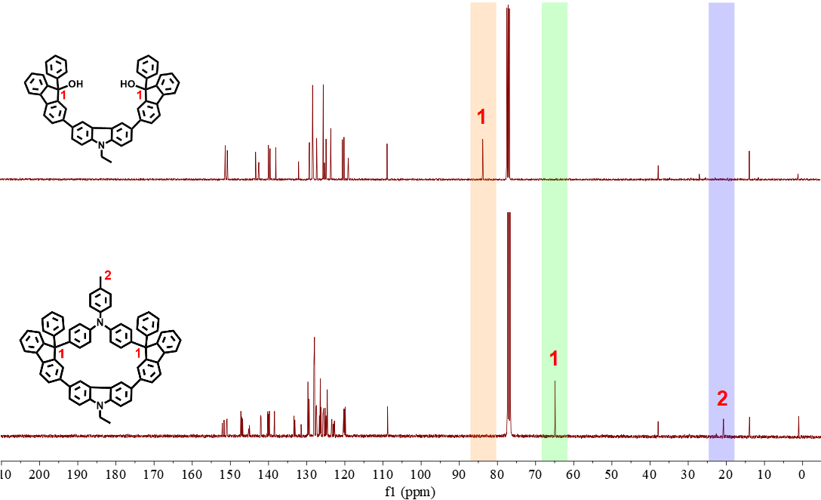
Supplementary Fig. 7 | ¹³C{¹H} NMR spectra of AOH and AG. A signal appeared at 64.9 ppm corresponding to the 9-position carbons in the fluorenyls of AG, instead of 83.7 ppm observed in the 9-position carbons of fluorenyls in AOH. Furthermore, the detected peak at 20.7 ppm, corresponding to the carbon of methyl group of 4-methyl-N,N-diphenylaniline, was observed in the spectra of AG. These results further verified the structure of AG.

Supplementary Fig. 8 | ¹H NMR spectra of DBrAOH, DBrAG, and PAG. The proton signal at 2.58 ppm belonging to the protons of hydroxyl groups at the 9-position of DBrAOH was not observed in DBrAG and PAG. The detected peaks at 2.34 and 2.26 ppm, corresponding to the protons of methyl group of 4-methyl-N,N-diphenylaniline, were observed in the spectra of DBrAG and PAG, respectively. These results indicated the successful synthesis of DBrAG and PAG.

Supplementary Fig. 9 | ¹³C{¹H} NMR spectra of DBrAOH, DBrAG, and PAG. The carbon signal appeared at 64.3 ppm corresponding to the 9-position carbons in the fluorenyls of DBrAG and PAG, instead of 83.3 ppm observed in the 9-position carbons of fluorenyls in DBrAOH. Furthermore, the detected peak at 20.8 ppm, corresponding to the carbon of methyl group of 4-methyl-N,N-diphenylaniline, was observed in the spectra of DBrAG and PAG. The carbon signals at aromatic region (170~100 ppm) were similar to each other for DBrAG and PAG. These results further verified the successful synthesis of DBrAG and PAG.

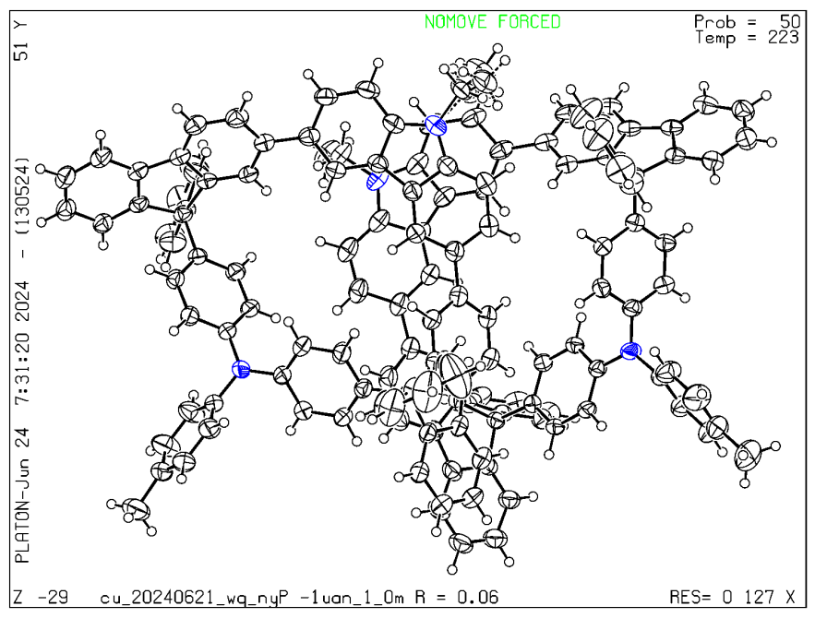
Supplementary Fig. 10 | Thermal ellipsoid plot obtained from crystals of compound AG (displacement ellipsoids are drawn at the 50% probability level). Single crystals suitable for X-ray analysis were obtained by slow evaporation of dichloromethane mixed with ethanol solvent (CCDC No. 2371387).

Supplementary Table 2 | X-ray crystallography data of AG
Bond precision: C-C = 0.0039 Å Wavelength = 1.54178
Cell: a = 12.8165 (2) b = 16.2335 (3) c = 29.0758 (5)
alpha = 86.233 (1) beta = 89.868 (1) gamma = 78.819 (1)
Temperature: 223 K
Calculated Reported
Volume 5921.44(18) 5921.44(18)
Space group P -1 P -1
Hall group -P 1 -P 1
Moiety formula C₇₁H₅₀N₂ [+ solvent] C₇₁H₅₀N₂
Sum formula: C₇₁H₅₀N₂ [+ solvent] C₇₁H₅₀N₂
Mr 931.13 931.13
Dx, g cm⁻³ 1.044 1.044
Z 4 4
Mu (mm⁻¹) 0.457 0.457
F000 1960.0 1960.0
F000’ 1965.11
h, k, lmax 15, 19, 35 15, 19, 35
Nref 21884 21712
Tmin, Tmax 0.942, 0.955 0.607, 0.753
Tmin’ 0.942
Correction method = # Reported T Limits: Tmin = 0.607 Tmax = 0.753
AbsCorr = MULTI-SCAN
Data completeness = 0.992 Theta (max)= 68.625
R (reflections) = 0.0622 (14658) wR2 (reflections)= 0.1945 (21712)
S = 1.065 Npar = 1338

Supplementary Fig. 11 | The GPC spectra and calibration curve equation of PAG oligomers.*
* The single-chain properties of the PAG backbone are significantly different from those of polystyrene (PS), prompting us to refit its calibration curve using the PAG oligomers as a reference system (29). Considering the large hydrodynamic volume of nanogrid units, distinct GPC peak separation is observed within the oligomers range (Supplementary Fig. 11). Therefore, we performed a linear regression using the molecular weights (M) of a mixed sample with degrees of polymerization DP = 1~5 and their corresponding elution times, both of which are listed in Supplementary Table 3 The calibration equation is as follows:
lg M_{NP} = -0.610 t + 8.950 (S2)
The calibration curve equation for polystyrene (PS) is as follows:
lg M_{PS} = -0.960 t + 12.008 (S3)
The relationship between the calibration curve equation and the Mark-Houwink exponent is as follows:
(S4)
where α_{NP} and α_{PS} are the Mark-Houwink constants for PAG and polystyrene, respectively, and k_{NP} and k_{PS} are the slopes of calibration equations for the formulas S2 and S3, respectively.
By substituting k_{NP} = -0.610, k_{PS} = -0.960, and α_{PS} = 0.714 into S4, the Mark-Houwink exponent of PAG (α_{NP} ) is calculated to be 1.70, indicating that PAG belongs to a rod-like linear framework.
Extend the calibration curve equation of PAG oligomers (S2) to obtain elution times for higher degrees of polymerization (Supplementary Table 4). Based on elution times corresponding to each degree of polymerization (DP), a complete signal peak of the sample was deconvoluted to obtain the proportion P_{i} for each DP. The P_{i} satisfy the formula:
(S5)
The calculation of the number-average molecular weight (M_{n}, S6) and weight-average molecular weight (M_{w}, S7) are as follows:
(S6)
(S7)
Supplementary Table 3 | The variation of exact mass of PAG oligomers as a function of elution time.

DP | Elution time (min) | Exact mass (M) | lg M
1 | 9.61 | 1187 | 3.07
2 | 9.17 | 2371 | 3.37
3 | 8.83 | 3556 | 3.55
5 | 8.48 | 5925 | 3.77

Supplementary Table 4 | The calculation of elution times for DP = 6~13.
DP | Exact mass (M) | lg M | Elution time (min)
6 | 7110 | 3.85 | 8.36
7 | 8294 | 3.92 | 8.25
8 | 9479 | 3.98 | 8.15
9 | 10664 | 4.03 | 8.07
10 | 11848 | 4.07 | 7.99
11 | 13033 | 4.12 | 7.93
12 | 14217 | 4.15 | 7.86
13 | 15402 | 4.19 | 7.81

Supplementary Fig. 12 | The GPC spectra and molecular weight calculation of PAG. According to the formula S6 and S7, the number-average molecular weight (M_{n}) of PAG is calculated to be 8539, with a number-average degree of polymerization (DP_{n}) of 7.21. The weight-average molecular weight (M_{w}) is calculated to be 10032, with a weight-average degree of polymerization (DP_{w}) of 8.47. The polydispersity index is calculated to be 1.17.

Supplementary Fig. 13 | XPS survey for FeAG, oxygen comes from the air.

Supplementary Table 5 | EXAFS fitting parameters at the Fe K-edge for various samples (Ѕ₀² = 0.80).
Sample | Shell | CNª | R(Å)^{b} | σ²(Å²)^{c} | ΔE₀(eV)^{d} | R factor
Fe foil | Fe-Fe1 | 8 | 2.46±0.01 | 0.0048 | 4.5 | 0.006
Fe foil | Fe-Fe2 | 6 | 2.84±0.02 | 0.0048 | 4.5 | 0.006
Fe₂O₃ | Fe-O | 5.8±0.2 | 1.96±0.01 | 0.0091 | 6.4 | 0.0080
Fe₂O₃ | Fe-Fe | 5.6±0.4 | 2.98±0.02 | 0.0082 | 6.4 | 0.0080
FeO | Fe-O | 5.8±0.2 | 2.14±0.01 | 0.0042 | 5.8 | 0.006
FeO | Fe-Fe | 12±0.1 | 3.02±0.02 | 0.0075 | 9.6 | 0.006
FeAG | Fe-N | 1.2±0.2 | 1.93±0.01 | 0.0098 | 9.7 | 0.009
FeAG | Fe-C | 2.7±0.1 | 1.95±0.01 | 0.0098 | 9.7 | 0.009
FeAG | Fe-Cl | 0.8±0.1 | 2.30±0.02 | 0.0098 | 9.7 | 0.009
ªCN: coordination numbers; ^{b}R: bond distance; ^{c}σ²: Debye-Waller factors; ^{d}ΔE₀: the inner potential correction; R factor: goodness of fit. Ѕ₀² was set to 0.8, according to the experimental EXAFS fit of Fe foil by fixing CN as the known crystallographic value.

Supplementary Fig. 14 | LSV curves for FeAG and AG in CO₂ and Ar -saturated 0.5 M KHCO₃ electrolyte. LSV displays significantly larger current densities in CO₂-saturated electrolyte for AG and FeAG, compared to those in Ar-saturated electrolyte, indicating the enhanced electrocatalytic activity towards CO₂RR over hydrogen evolution reactions (HER).
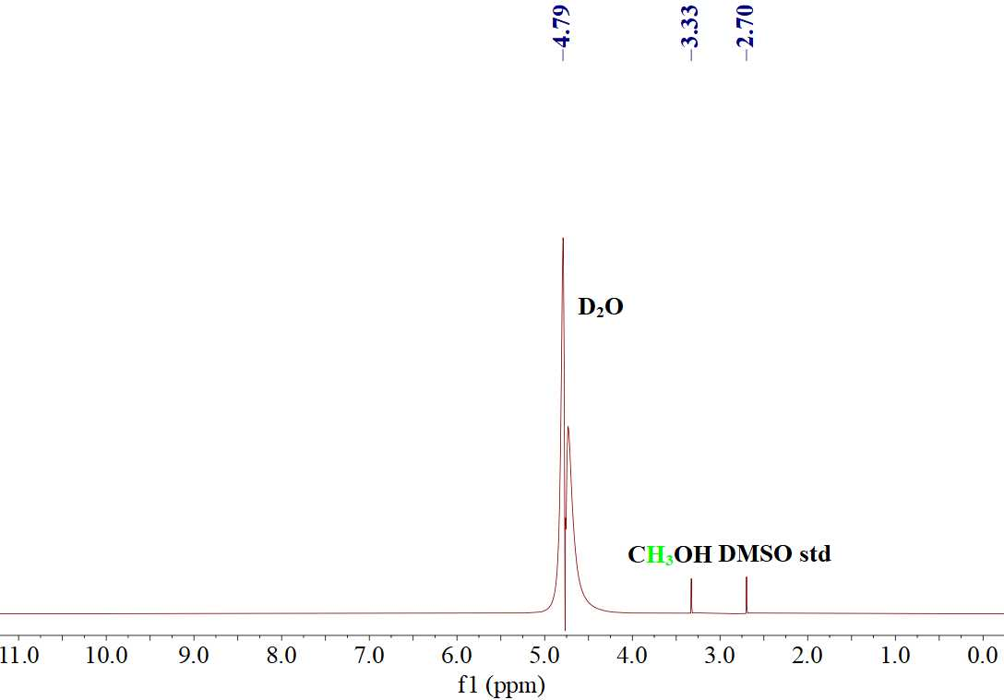
Supplementary Fig. 15 | ¹H NMR result of the liquid product on FeAG at -0.8 V vs. RHE in CO₂-saturated 0.5 M KHCO₃ electrolyte after 2 h electrolysis with DMSO as the internal standard.
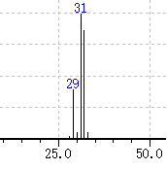
Supplementary Fig. 16∣GC-MS spectrum of the electrolyte after 2 h electrolysis at -0.8 V vs. RHE in CO₂-saturated 0.5 M KHCO₃ electrolyte.
Supplementary Fig. 17∣FEs of all products at different potentials on AG in an H-cell with CO₂-saturated 0.5 M KHCO₃ as electrolyte. CH₃OH could not be detected on AG, and CO was the only product from CO₂RR with FEs ranging from 9.4% to 24.3%.

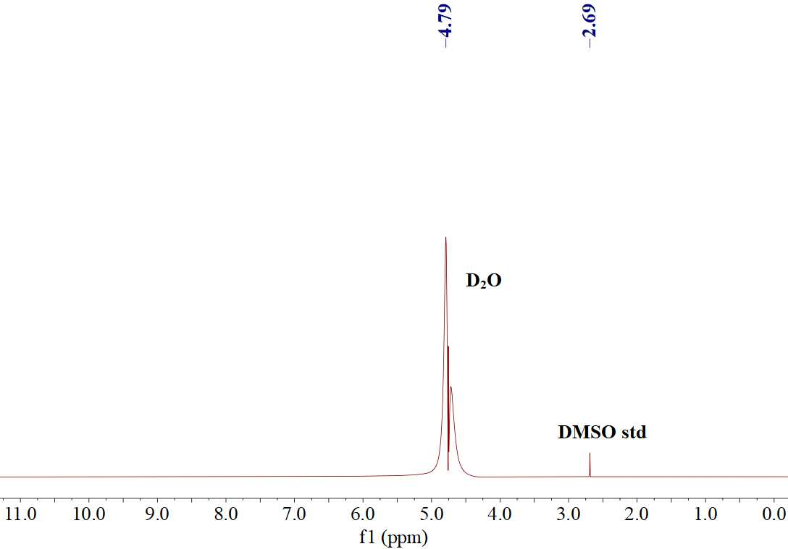
Supplementary Fig. 18∣¹H NMR results of the liquid product on FeAG at -0.8 V vs. RHE in Ar-saturated 0.5 M KHCO₃ electrolyte after 2 h electrolysis with DMSO as the internal standard. CH₃OH could not be detected, which thereby confirmed that the produced CH₃OH indeed originated from reduction of CO_{2 .}

Supplementary Fig. 19 | Morphology characterization of FeAG after duration test. a-c, TEM image (a), HAADF-STEM image (b), and EDS mapping images (c) for FeAG after 20 h duration test at -0.8 V vs. RHE in an H-cell with CO₂-saturated 0.5 M KHCO₃ as electrolyte. TEM images of FeAG after electrolysis ruled out reductive demetallation of FeAG and formation of Fe or FeOx nanoparticles, confirming the stability of the FeAG catalyst.

Supplementary Fig. 20∣CH₃OH partial current density (j_{CH3OH}) on FeAG and FePAG at different potentials in an H-cell with CO₂-saturated 0.5 M KHCO₃ as electrolyte.
Supplementary Fig. 21 | CH₃OH yields on FeAG and FePAG at different potentials in an H-cell with CO₂-saturated 0.5 M KHCO₃ as electrolyte.
.
Supplementary Fig. 22∣Cyclic voltammetry (CV) curves. a-b, CV curves of FeAG (a) and FePAG (b) at scanning rates of 20, 40, 60, 80, and 100 mV s⁻¹ with Ar-saturated 0.5 M H₂SO₄ as electrolyte.

Supplementary Fig. 23∣Charging current densities plotted against scan rates for FeAG and FePAG. The FePAG possessed a C_{dl} of 18.6 mF cm⁻², higher than that of FeAG (16.8 mF cm⁻²), indicating that FePAG has a more abundant electrochemical surface areas and active sites.

Supplementary Fig. 24∣Electrochemical impedance spectroscopy (EIS) of FeAG and FePAG. EIS showed a smaller diameter of the semicircle on FePAG compared to FeAG, indicating faster electron transfer between the FePAG and CO₂ molecules.

Supplementary Fig. 25∣FEs of all gaseous products at different potentials on FePAG in flow cell with 0.1 M KOH + 3 M KCl as electrolyte. CO is the only gaseous product from CO₂RR with FE less than 5% in the whole applied potential range.

Supplementary Fig. 26∣¹H NMR spectrum of 1a.

Supplementary Fig. 27∣¹³C{¹H} NMR spectrum of 1a.

Supplementary Fig. 28∣¹H NMR spectrum of 2a.

Supplementary Fig. 29∣¹³C{¹H} NMR spectrum of 2a.

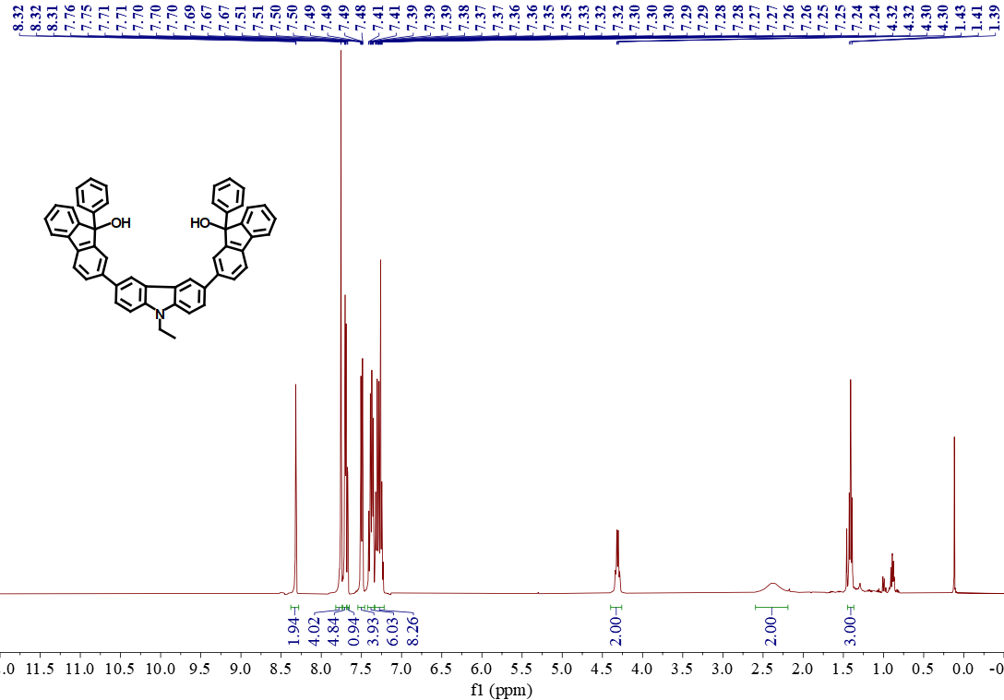
Supplementary Fig. 30 | ¹H NMR spectrum of AOH.

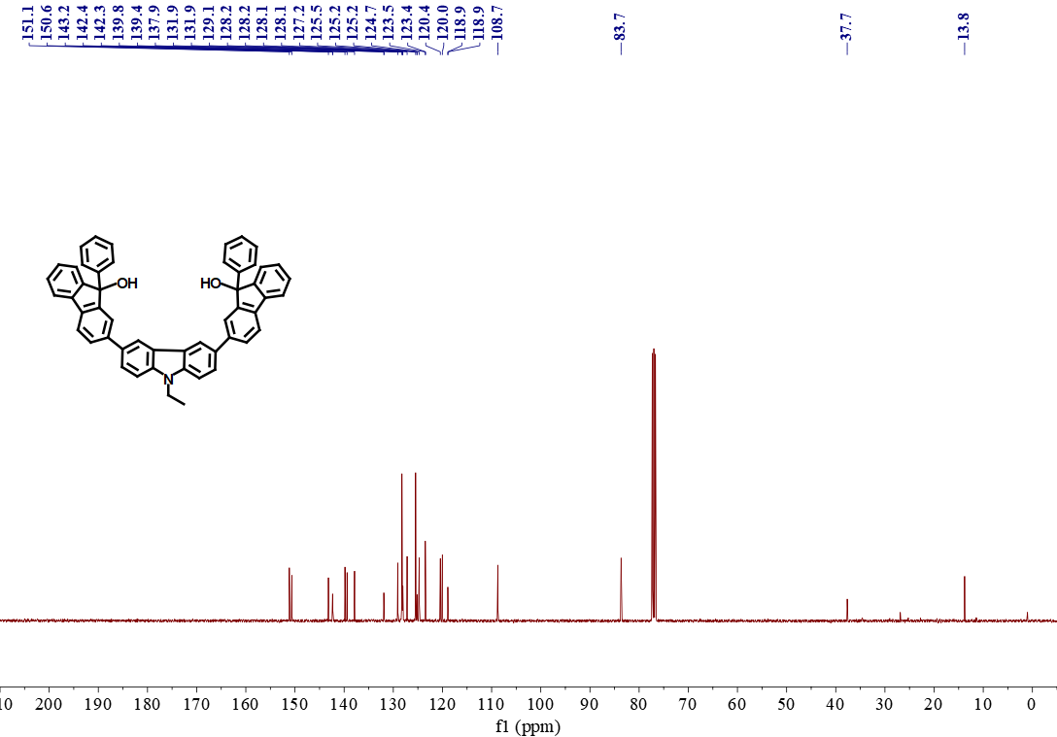
Supplementary Fig. 31 | ¹³C{¹H} NMR spectrum of AOH.

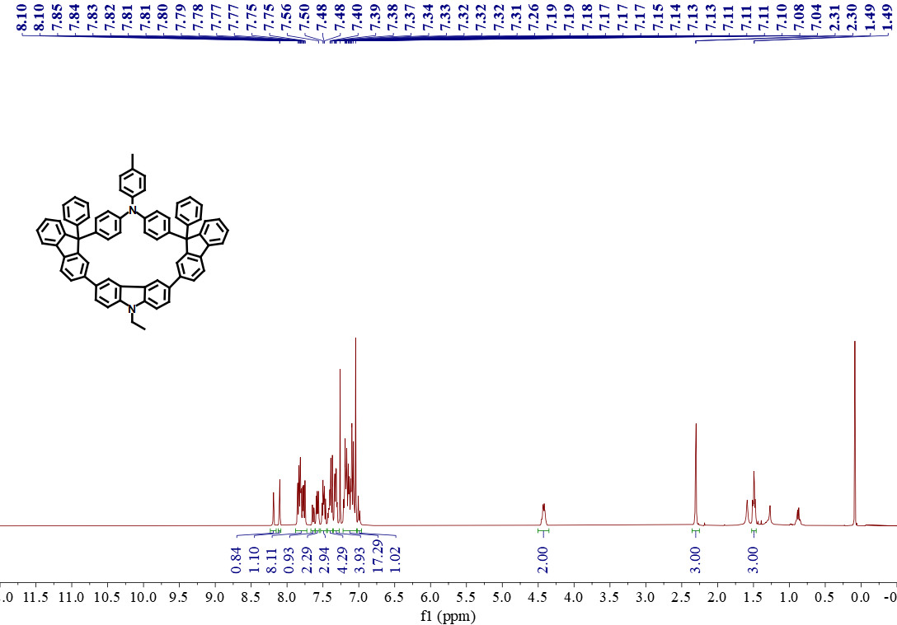
Supplementary Fig. 32 | ¹H NMR spectrum of AG.

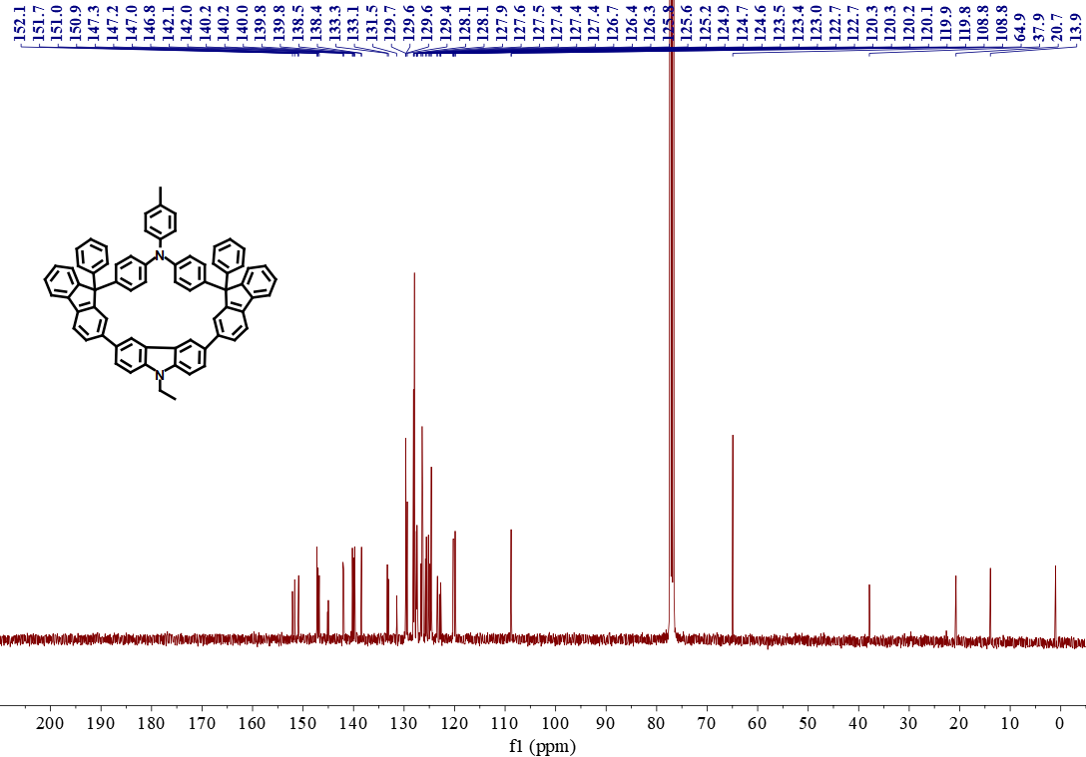
Supplementary Fig. 33 | ¹³C{¹H} NMR spectrum of AG.

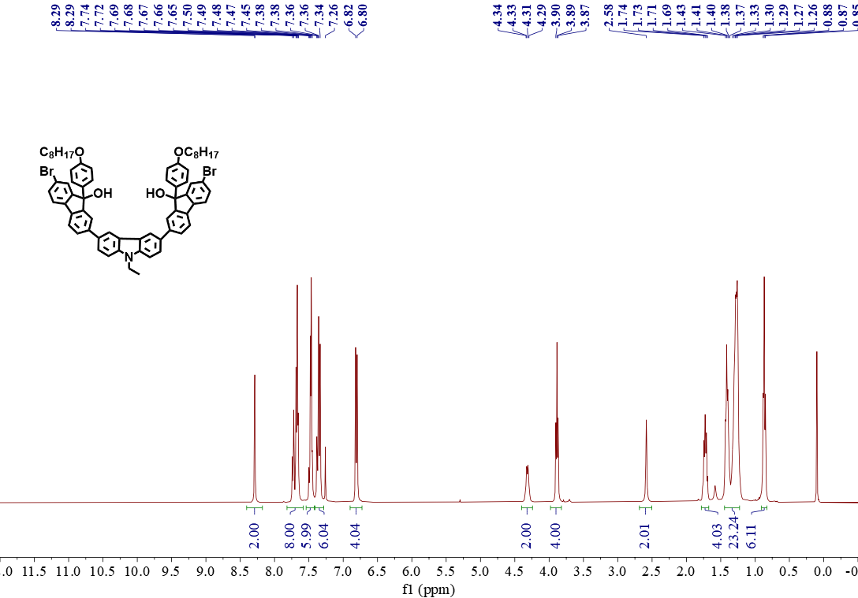
Supplementary Fig. 34 | ¹H NMR spectrum of DBrAOH.

Supplementary Fig. 35 | ¹³C{¹H} NMR spectrum of DBrAOH.

Supplementary Fig. 36 | ¹H NMR spectrum of DBrAG.

Supplementary Fig. 37 | ¹³C{¹H} NMR spectrum of DBrAG.

Supplementary Fig. 38 | ¹H NMR spectrum of PAG.

Supplementary Fig. 39 | ¹³C{¹H} NMR spectrum of PAG.

References
- Wang, S. S. et al. Supramolecular non-helical one-dimensional channels and microtubes assembled from enantiomers of difluorenol. Angew. Chem. Int. Ed. 60, 3979-3983 (2021).
- Feng, Q. et al. A robust and soluble nanopolymer based on molecular grid-based nanomonomer. Chinese J. of Polym. Sci. 35, 87-97 (2017).
- Wu, Y., Jiang, Z., Lu, X., Liang, Y., Wang, H. Domino electroreduction of CO₂ to methanol on a molecular catalyst. Nature 575, 639-642 (2019).
- Boutin, E. et al. Aqueous electrochemical reduction of carbon dioxide and carbon monoxide into methanol with cobalt phthalocyanine. Angew. Chem. Int. Ed. 58, 16172-16176 (2019).
- Gonglach, S. et al. Molecular cobalt corrole complex for the heterogeneous electrocatalytic reduction of carbon dioxide. Nat. Commun. 10, 3864 (2019).
- Su, J. et al. Strain enhances the activity of molecular electrocatalysts via carbon nanotube supports. Nat. Catal. 6, 818-828 (2023).
- Song, Y. et al. Ultrathin, cationic covalent organic nanosheets for enhanced CO₂ electroreduction to methanol. Adv. Mater. 36, 2310037 (2024).

