Supplementary Information

Chaos-Enhanced Manganese Electrolysis: Nodule Suppression and Improved Efficiency using Controllable Chaotic Electrical Signals

Jie Yang ^{a, 1}, Chunbiao Li ^{c, 1}, Qian Zhang ª, Zhihao Wu ª, Xin Zhang ^{c}, Peiqiao Liu ª, Zuohua Liu ^{a, b*}, Changyuan Tao ^{a, b}, Guocan Zheng ª, Yong Yang ^{a,} ^{d}, Hanke Wei ^{a, d}

ª School of Chemistry and Chemical Engineering, Chongqing University, Chongqing 400044, China.
^{b} State Key Laboratory of Coal Mine Disaster Dynamics and Control, Chongqing 400044, China.
^{c} School of Artificial Intelligence, Nanjing University of Information Science and Technology, Nanjing 210044, China.
^{d} South manganese group limited, 532315 Chongzuo, China.

* Corresponding auther at: School of Chemistry and Chemical Engineering, Chongqing University, Chongqing 400044, China.
E-mail address: liuzuohua@cqu.edu.cn (Z. Liu).
¹ Contributed in equal measure to this study.

The system signal waveform (Fig. S1a), frequency map (Fig. S1b) and attractor structure (Fig. S1c-f) provide additional evidence that the system is a typical chaotic system.

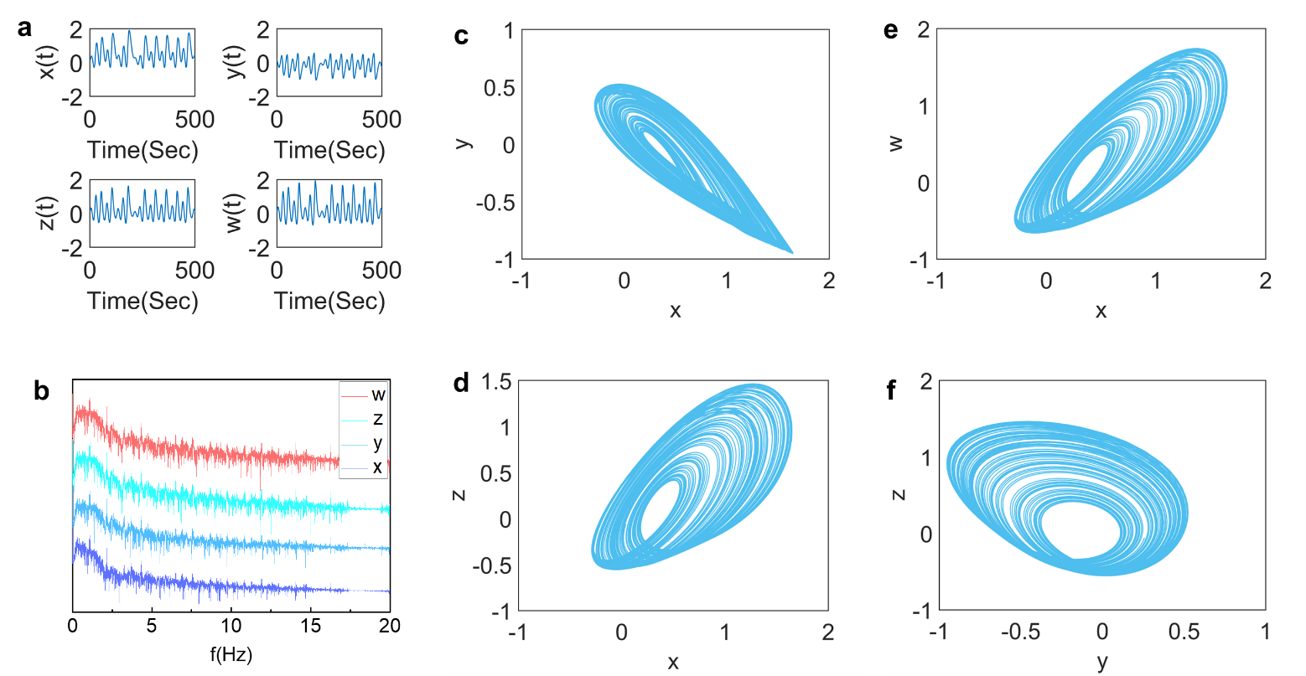
Fig. S1. Signal characteristics of chaotic system when a = 1, b = 2.75, c = 12 and d = 10. a Signal waveform. b Signal frequency distribution. c Attractor structure of the system on the x-y plane. d Attractor structure of the system on the x-z plane. e Attractor structure of the system on the x-w plane. f Attractor structure of the system on the y-z plane.

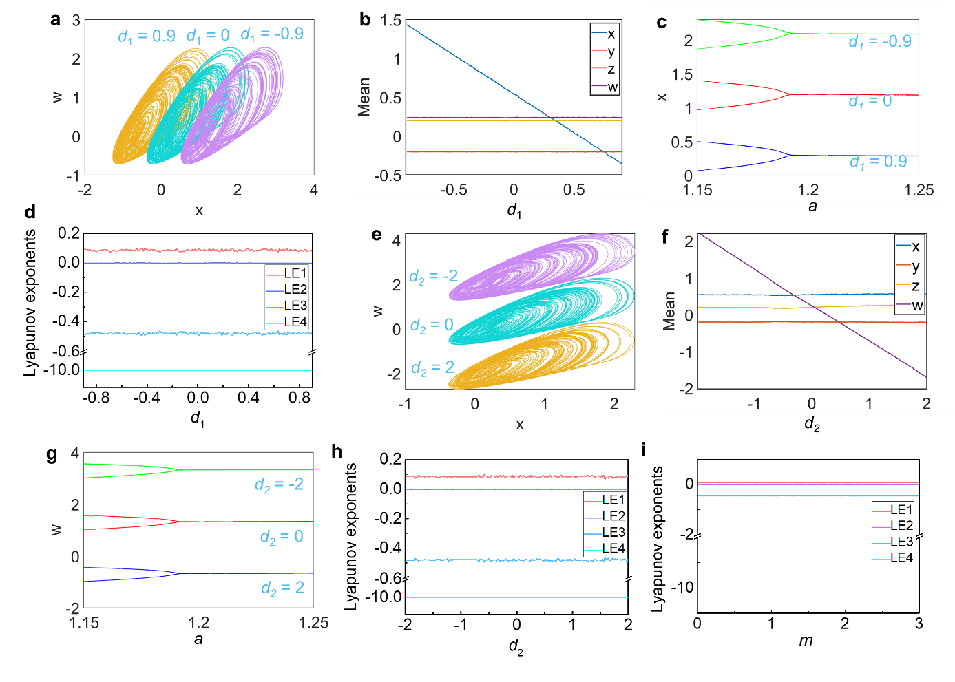
Fig. S2. Two-dimensional offset boosting of chaotic systems. a Directly offset boosting of the chaotic signals in the x direction. b Average value of the system signal changes with the parameter d₁. c Bifurcation diagram of x signal changing with parameter a after the offset boosting. d Lyapunov exponents variations with the parameter d₁. e Directly offset boosting of the chaotic signals in the w direction. f Average value of the system signal changes with the parameter d₂. g Bifurcation diagram of x signal changing with parameter a after the offset boosting. h Lyapunov exponents changes with the parameter d₂. i Lyapunov exponents with the variation of m.

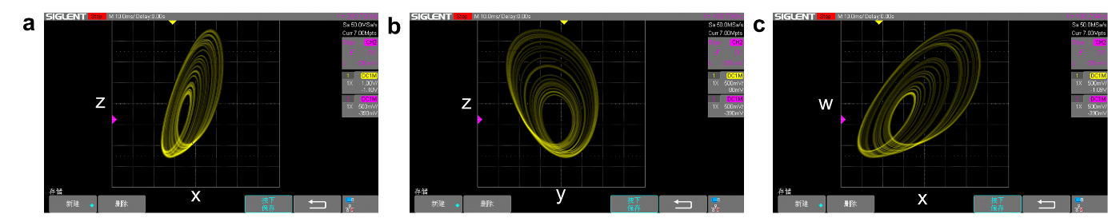
Fig. S3. Complete control of actual chaotic circuit electrical signal. a Chaotic attractor composed of the x-z signal monitored by the oscilloscope. b Chaotic attractor composed of the y-z signal. c Chaotic attractor composed of the x-w signal.

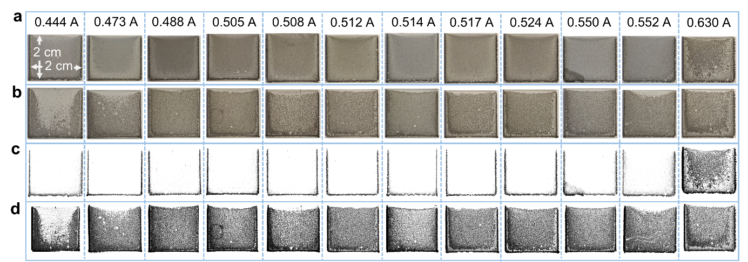
Fig. S4. Comparison of manganese dendrite distribution with various types of currents. a Apparent morphology of manganese metal with chaotic current. b Apparent morphology of manganese metal with direct current. c Distribution range of manganese nodules with chaotic current. d Distribution range of manganese nodules with DC.

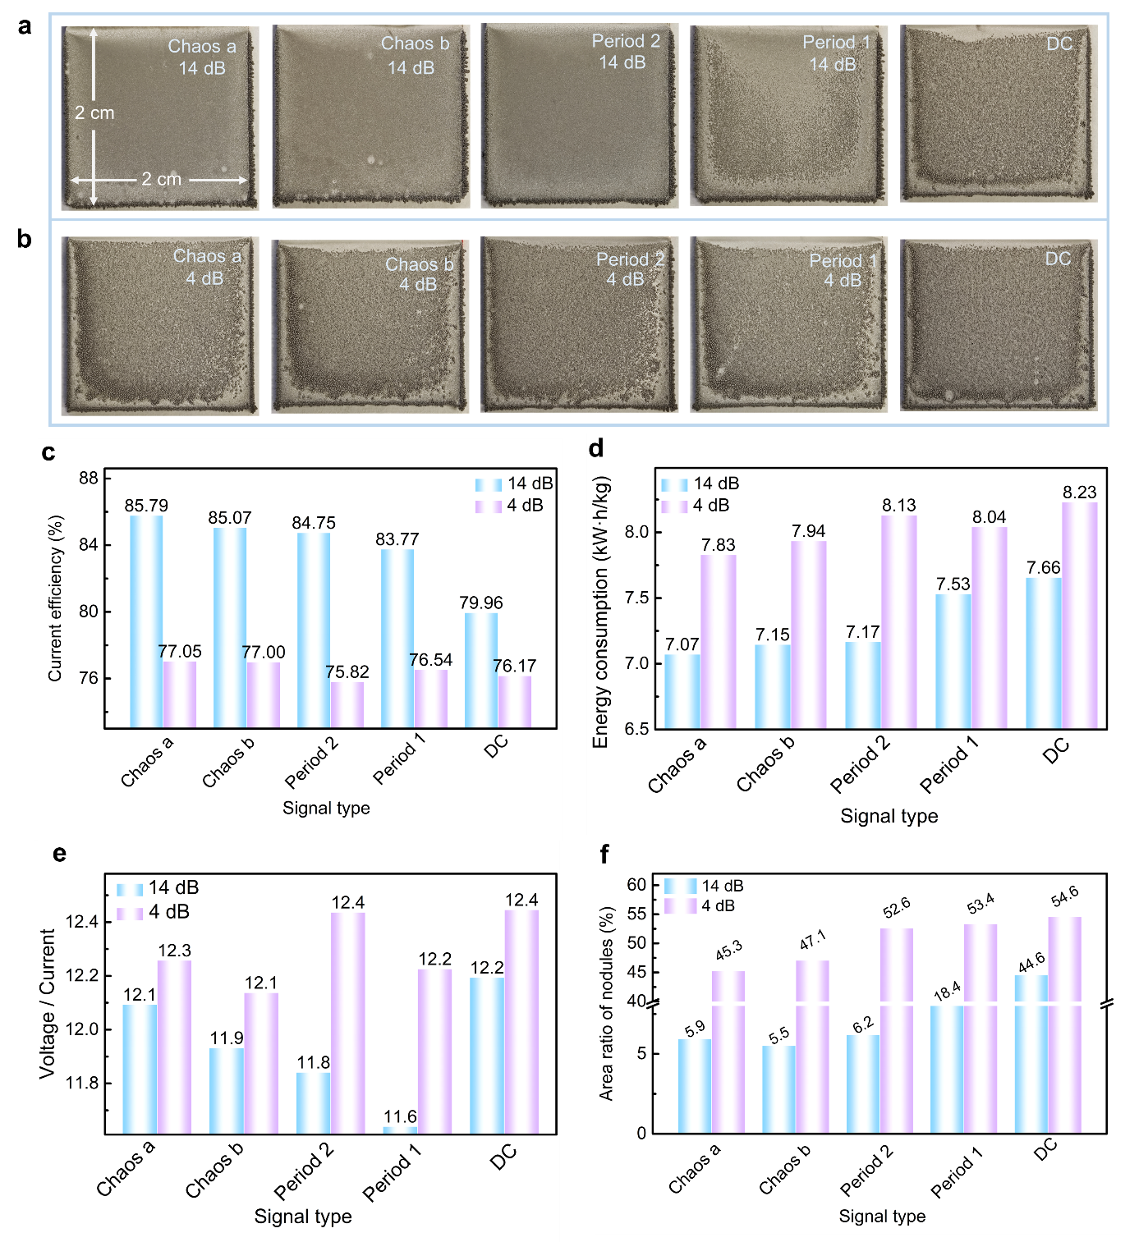
Fig. S5. Photographs and energy consumption of manganese metal deposited by different types of currents. a Apparent morphology of manganese metal with various types of current amplified to 14 dB. b Apparent morphology of manganese metal with various types of current amplified to 4 dB. c Corresponding current efficiency. d Corresponding energy consumption. e Corresponding ratio of voltage to current. f Corresponding area ratio of nodules.

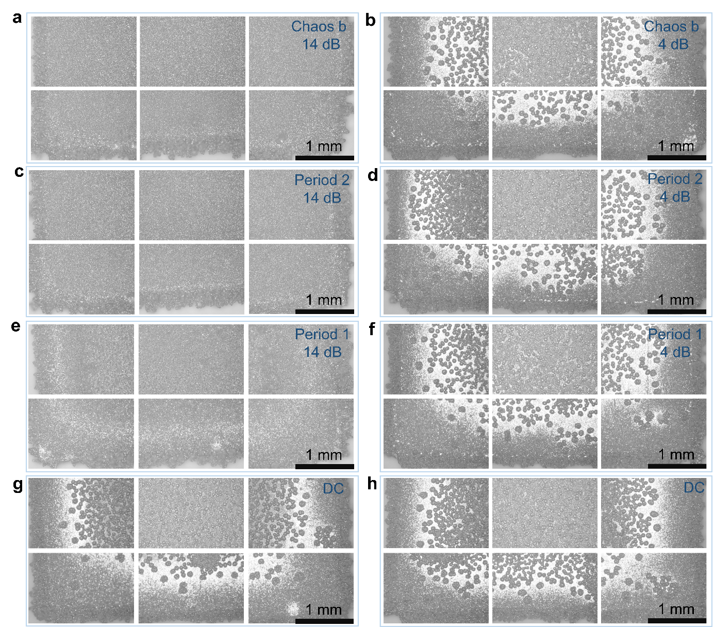
Fig. S6. Microscopic morphology of manganese metal detected by the optical microscope. a Microscopy of manganese metal with chaotic-b current enlarged to 14 dB. b Microscopy of manganese metal with chaotic-b current enlarged to 4 dB. c Microscopy of manganese metal with period 2 current enlarged to 14 dB. d Microscopy of manganese metal with period 2 current enlarged to 4 dB. e Microscopy of manganese metal with period 1 current enlarged to 14 dB. f Microscopy of manganese metal with period 1 current enlarged to 4 dB. g Microscopy of manganese metal with DC. h Microscopy of manganese metal with DC.

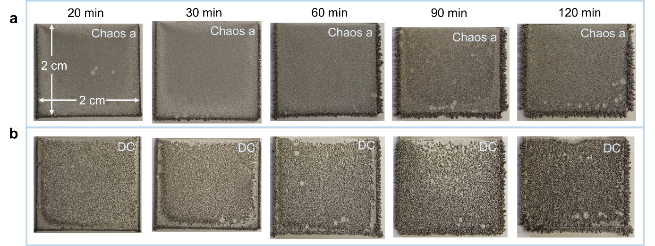
Fig. S7. Comparison of manganese dendrite distribution with various time. a Apparent morphology of manganese metal with various time use the chaotic current amplified with 14 dB. b Apparent morphology of manganese metal with various time use the direct current.

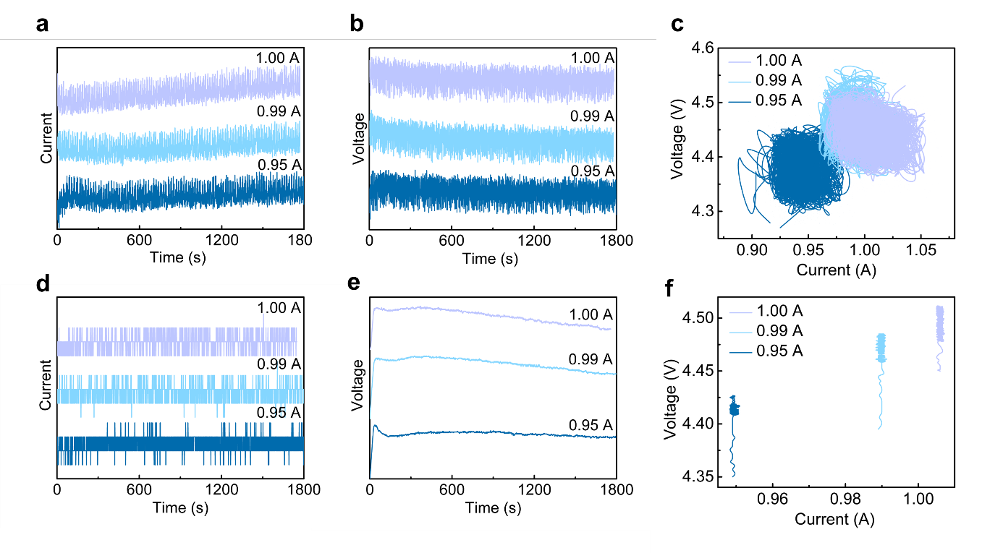
Fig. S8. Signal characteristics of currents in manganese metal electrodeposition systems with larger current scale amplified by the power amplifier (FPA 101). a Chaotic current signals. b Chaotic voltage signals. c Correlation of the current and voltage of chaotic power. d Direct current signals. e Direct voltage signals. f Correlation of the current and voltage.
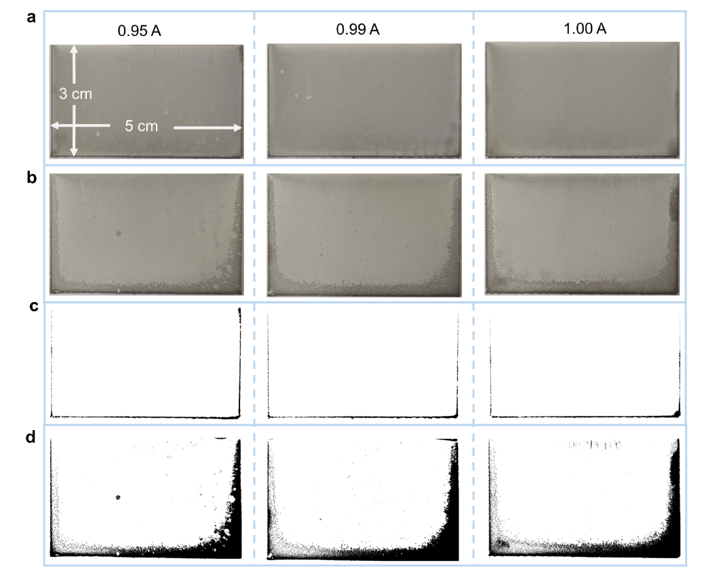
Fig. S9. Comparison of manganese dendrite distribution with large scale current and plate. a Apparent morphology of manganese metal with chaotic current. b Apparent morphology of manganese metal with direct current. c Distribution range of manganese nodules with chaotic current. d Distribution range of manganese nodules with DC.
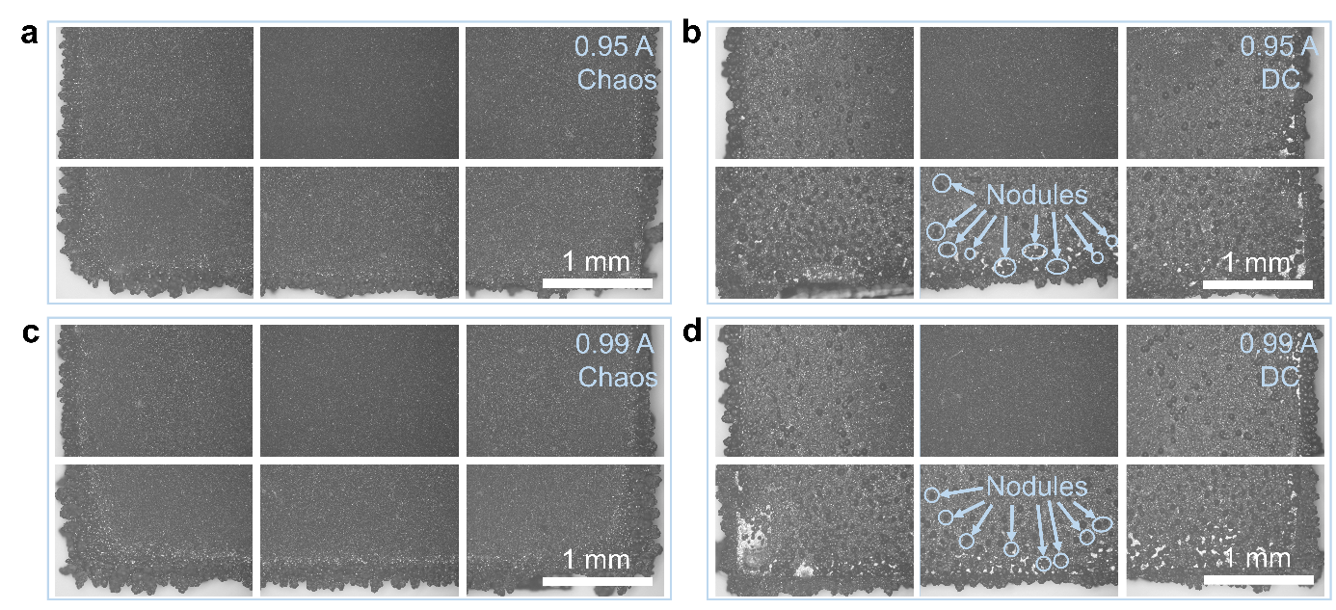
Fig. S10. Microscopic morphology of manganese metal detected by the optical microscope for 30 min. a Microscopy of manganese metal by the chaotic current with 0.95 A. b Microscopy of manganese metal by the DC with 0.95 A. c Microscopy of manganese metal by the chaotic current with 0.99 A. d Microscopy of manganese metal by the DC with 0.99 A.

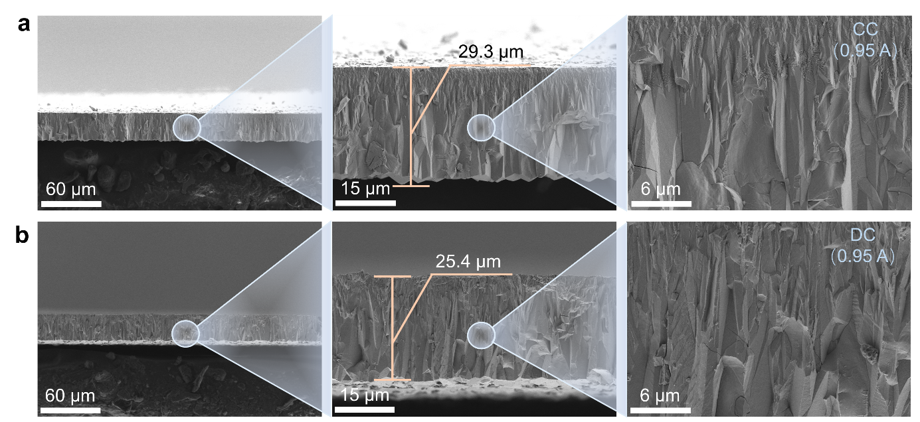
Fig. S11. Cross-section SEM images of manganese metal. a SEM images of manganese metal by the chaotic current with 0.95 A. b SEM images of manganese metal by the DC with 0.95 A.
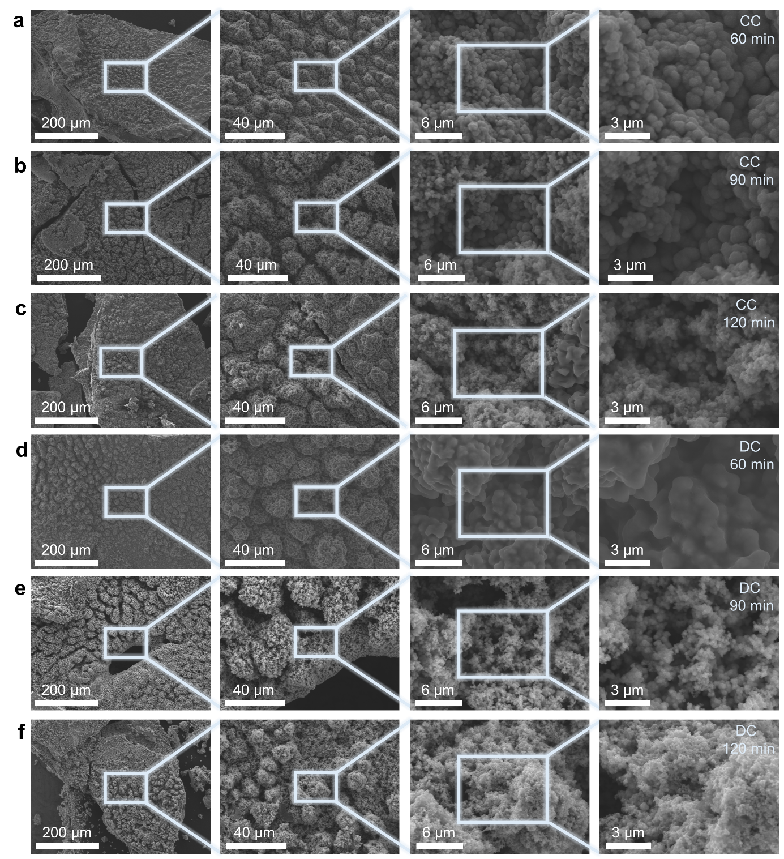
Fig. S12. Microstructures of the anode mud detected by the SEM with various time and current types. a SEM images of anode mud with chaotic current for 60 min. b SEM images of anode mud with chaotic current for 90 min. c SEM images of anode mud with chaotic current for 120 min. d SEM images of anode mud with DC for 60 min. e SEM images of anode mud with DC for 90 min. f SEM images of anode mud with DC for 120 min.

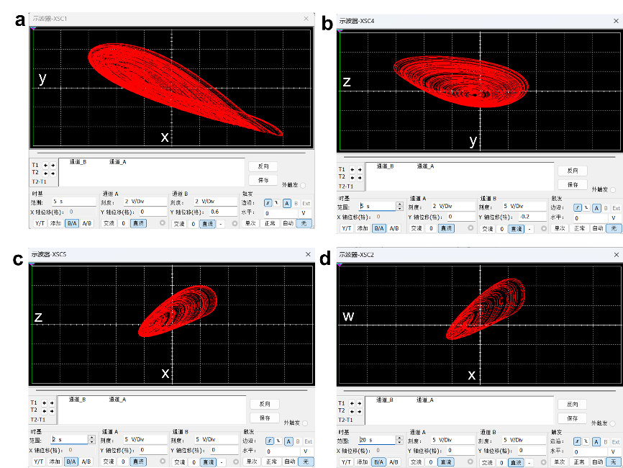
Fig. S13. Attractor diagram of simulation circuit output. a x-y; b y-z; c x-z; b x-w.

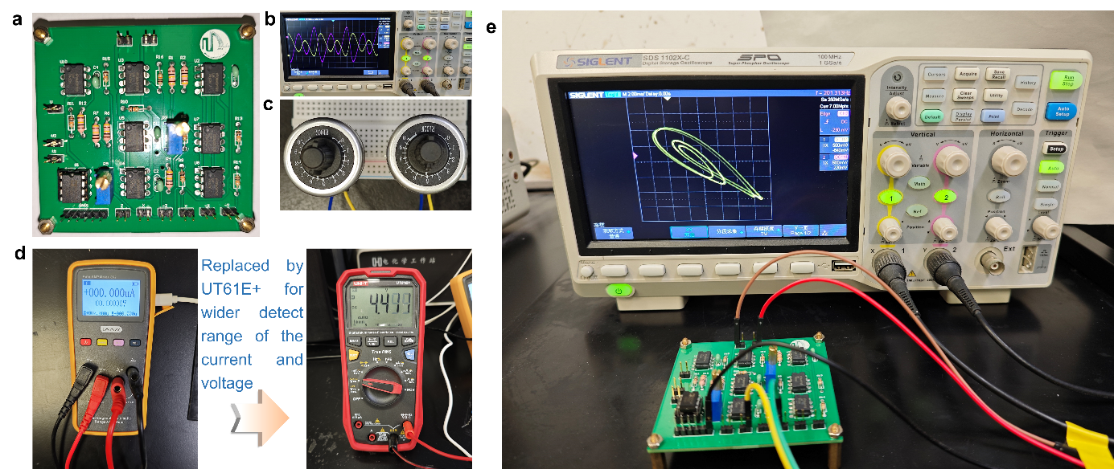
Fig. S14. Photos of some experimental devices. a Actual chaotic circuit board; b The electrical signal waveform structure of chaotic circuit output; c The current size adjustment device replaced by the offset boosting function; d Current and voltage meters replaced by a larger range multimeters; e Period 4 attractor generated by chaotic circuit.
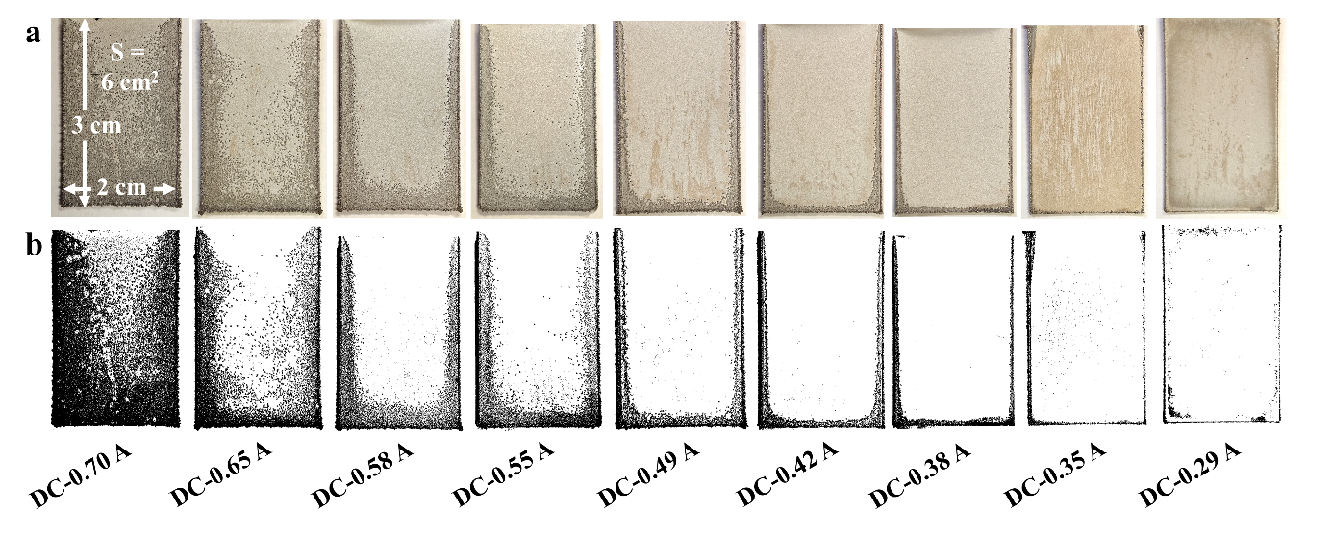
Fig. S15. Distribution of manganese metal spherical dendrites reported in the previous work [1]. a Macroscopic morphology of manganese metal deposited with DC current; b Distribution of dendrites extracted by means of binarization with DC current.

References
[1] J. Yang, C. Li, Q. Zhang, H. Zhong, Z. Wu, P. Liu, Z. Liu, K. Huang, C. Tao, G. Zheng, Y. Yang, H. Wei, Hyperchaotic power with wide current variation for efficient manganese electrodeposition, Chem. Eng. Sci. (2024) 120010, https://doi.org/10.1016/j.ces.2024.120010.

