Table 1 Catalytic performance of Mn₂O₃-supported Pd catalysts in selective oxidation of EBª.
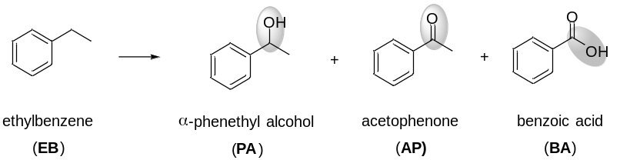
Entry | Catal. | Pd/EB (ppm) | Conv. of EB | Sel. of PA | Sel. of AP | Sel. of BA
1^{b} | Mn₂O₃ | 0 | 13% | 27% | 73% | 0%
2 | Pd-NP/Mn₂O₃ | 35 | 71% | 4% | 8% | 88%
3^{c} | Pd-NP/Mn₂O₃ | 35 | 55% | 10% | 68% | 22%
4 | Pd₁/Mn₂O₃ | 12 | 41% | 13% | 87% | 0%
5^{d} | Pd₁/Mn₂O₃ | 12 | 63% | 6% | 94% | 0%
ªReaction conditions: EB (2.2 mL), catalyst, O₂ (2 MPa), 120 ºC, 20 h. ^{b}10 mg Mn₂O₃. ^{c}8 h. ^{d}40 h.
Table 2. Selective C−H bond oxidation on Pd₁/Mn₂O₃ catalysts for diverse hydrocarbon substrates.
Entryª | Substrate | Products | Conv. (%) | Sel. (%)
1 | 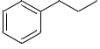 | 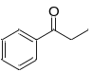 | 41 | 89
2 | 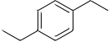 | 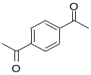 | 82 | 92
3 | 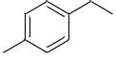 | 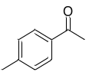 | 49 | 93
4 | 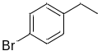 | 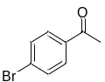 | 42 | 93
5 | 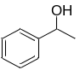 | 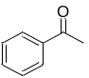 | 99 | 99
6 | 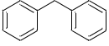 | 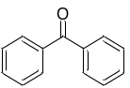 | 68 | 100
7^{b} |  |  | 90 | 100
8^{c} | 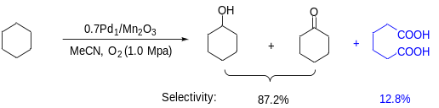
9^{c} | 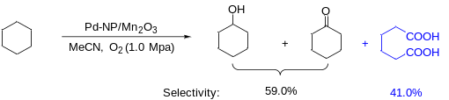
ªReaction conditions: substrate (2.2 mL), Pd₁/Mn₂O₃ (10 mg), O₂ (2.0 MPa), 120 °C; 20 h. ^{b}Pd-NP/Mn₂O₃ as the catalyst. ^{c}5 mmol of cyclohexane, 1 mol% of N-hydroxyphthalimide, 30 mg of the catalyst, 15 mL of acetonitrile as the solvent, 1.0 MPa of O₂, 120 °C; 12 h.

