Selective Aerobic Oxidation of C−H Bond over C−C Bond by Single-Atom Catalysts
Tianbo Li,^{1, 2,} ‡ Qian Zhang,^{2, ‡} Yalin Guo,³ Mingyang Qin,⁴ Hai Wang⁴, Xiang-Ting Min,^{2,} * Yi-Tao Cui,⁵ Shijian Lu,⁶ Liang Wang,⁴ Lin Li,² Botao Qiao,^{2,} * Tao Zhang²
- School of Chemical Engineering and Technology, China University of Mining and Technology, Xuzhou 221116, China.
- CAS Key Laboratory of Science and Technology on Applied Catalysis, Dalian Institute of Chemical Physics, Chinese Academy of Sciences, Dalian 116023, China.
- State Key Laboratory of Coal Mine Disaster Dynamics and Control, Institute of Advanced Interdisciplinary Studies, School of Chemistry and Chemical Engineering, Chongqing University, Chongqing 401331, China.
- Key Lab of Biomass Chemical Engineering of Ministry of Education, College of Chemical and Biological Engineering, Zhejiang University, Hangzhou 310027, China.
- Shenzhen Innovation Light-source Facility (SILF), Institute of Advanced Science Facilities (IASF), Shenzhen 518103, China.
- Carbon Neutrality Institute, Jiangsu Key Laboratory of Coal-based Greenhouse Gas Control and Utilization, China University of Mining and Technology, Xuzhou 221116, China.
Table of Contents
1. Catalyst preparation 2
2. Catalyst characterization 5
3. Catalytic activity testing and product analysis. 6
4. Control experiments and mechanism investigations. 7
5. Supplementary figures and tables 9
6. References 29

- Catalyst preparation
Materials
PdCl₂ (99.99%), RuCl₃•3H₂O (99.99%), HAuCl₄•4H₂O (99.99%) were purchased from Tianjin Fengchuan. 36% Hydrochloric acid was purchased from Tianjin Kemel. Polyethylene glycol (97%, molecular mass 1750 ± 50), ethanol (98%), ethylbenzene (99.8%), acetophenone (99%), MnO₂ (98.0%), MgSO₄ (98.0%), NaBH₄ (98%) were purchased from Sigma-Aldrich. Deionized water was obtained from a Millipore Autopure system. All reagents were used without further purification. Helium (99.999%), hydrogen (99.999%), oxygen (99.999%) and nitrogen (99.999%) were purchased from Dalian Special Gases Company. ¹⁸O₂ (96%) was purchased from Linde Gas NA (Shanghai).
Mn₂O₃ support
Mn₂O₃ support was prepared by a calcination and decomposing method. MnO₂ power was calcined at 500 ºC for 3 h in air. The XRD figures showed that after calcination α-MnO₂ would decompose to Mn₂O₃, same case with Pd₁/Mn₂O₃ catalyst (Figure S1).
Pd₁/Mn₂O₃ catalyst
Mn₂O₃ supported Pd single-atom catalysts (SACs) was prepared by impregnation on MnO₂ and a subsequent calcination in which MnO₂ decomposed to Mn₂O₃. Typically, 1 g MnO₂ powder was dispersed in 2 mL deionized water with rigorous stirring. Appropriate amount of PdCl₂·HCl solution (prepared by mixing 100 mg of PdCl₂, 4 mL concentrated HCl, and a certain amount of H₂O) was added into 3 mL deionized water. The diluted PdCl₂·HCl solution was added into the MnO₂ solution at one time for another 5 h under vigorous stirring. The solution was filtrated, and the obtained filter cake was washed for three times by deionized water followed by drying at 120 °C for 4 h and calcination at 500°C for 3 h in air, denoted as Pd₁/Mn₂O₃.
In addition, for preparation of a higher loading Pd SACs, the preliminary preparation was consistent with the above, except the obtained solution was stirred by glass rod meanwhile dried at 95 ºC water bath for 0.5 hours. After the stirring under water bath process, the solid power was calcined at 500 ºC for 3 h in air, denoted as 0.7Pd₁/Mn₂O₃.
The inductively coupled plasma optical emission spectrometry (ICP-OES) tests showed that the actual loading of the Pd₁/Mn₂O₃ and 0.7Pd₁/Mn₂O₃ were 0.09% and 0.69%, respectively.

Pd-NP/Mn₂O₃ catalysts
For comparison, a Pd-NP/Mn₂O₃ catalyst containing Pd nanoparticles (NPs) of 6-10 nm in size was prepared by deposing colloidal Pd NPs onto the Mn₂O₃ surface. The typical process used 1 g Mn₂O₃ powder (from 1. Mn₂O₃ support) dispersed in deionized water with rigorous stirring. Appropriate amount of colloidal Pd NPs solution were dropwise added into the Mn₂O₃ solution under stirring at 95 ºC and continued stirring until the ethanol was evaporated. Then the Mn₂O₃ supported Pd NPs were calcined at 300 ºC for 1 hours in air to remove the protection agent and the final catalyst was denoted as Pd-NP/Mn₂O₃. The actual loading of Pd NPs was 0.67% measured by ICP.
Colloidal Pd NPs were prepared according previous reported procedure.^{[1]} All operations were carried out under inert atmosphere (Ar). H₂PdCl₄ solution (2.0 mmol/L) was prepared by mixing 0.6 mmol of PdCl₂, 6.0 mL of 0.2 M HCl, and 294 mL of H₂O. A mixture of 15 mL of a 2.0 mmol H₂PdCl₄ solution, 21 mL of H₂O, 14 mL of ethanol (40 vol %), and 0.0333 g of PVP were refluxed for 3 h in air. The solution thus prepared had a dark brown color. The obtained Pd nanocluster solution was very stable and ready for deposition on Mn₂O₃ support.
Ru₁/Mn₂O₃ catalysts
Mn₂O₃ supported Ru₁ single-atom catalyst (SACs) was prepared by impregnation on MnO₂ and a subsequent calcination in which MnO₂ decomposed to Mn₂O₃. Typically, 1 g MnO₂ powder was dispersed in 2 mL deionized water with rigorous stirring. Appropriate amount of RuCl₃ solution (prepared by mixing 100 mg of RuCl₃.3H₂O, and a certain amount of H₂O) was added into 3 mL deionized water. The diluted RuCl₃ solution was added into the MnO₂ solution at one time for another 5 h under vigorous stirring. The solution was filtrated, and the obtained filter cake was washed for three times by deionized water followed by drying at 120°C for 4 h and calcination at 500°C for 3 h in air, denoted as 0.1Ru₁/Mn₂O₃.
Ru-NP/Mn₂O₃ catalysts
Ru-NP/Mn₂O₃ catalyst containing Ru NPs was prepared by deposing colloidal Ru NPs onto the Mn₂O₃ surface. The typical process used 1 g Mn₂O₃ powder (from 1. Mn₂O₃ support) dispersed in 2 mL deionized water with rigorous stirring. Appropriate amount of colloidal RuCl₃ solution (prepared by mixing 100 mg of RuCl₃.3H₂O, and a certain amount of H₂O) were dropwise added into the Mn₂O₃ solution under stirring at 95 ºC. Then added 5 times stoichiometric NaBH₄ solution (prepared by mixing 5 times stoichiometric NaBH₄ with 2 mL deionized water) at one time, and continued stirring until the H₂O was evaporated. The Mn₂O₃ supported Ru NPs were calcined at 300 ºC for 1 hours in air and the final catalyst was denoted as 0.7Ru-NP/Mn₂O₃.

Au₁/Mn₂O₃ catalysts
Mn₂O₃ supported Au₁ single-atom catalyst (SACs) was prepared by impregnation on MnO₂ and a subsequent calcination in which MnO₂ decomposed to Mn₂O₃. Typically, 1 g MnO₂ powder was dispersed in 2 mL deionized water with rigorous stirring. Appropriate amount of HAuCl₄ solution (prepared by mixing 100 mg of HAuCl₄•4H₂O, and a certain amount of H₂O) was added into 3 mL deionized water. The diluted HAuCl₄ solution was added into the MnO₂ solution at one time for another 5 h under vigorous stirring. The solution was filtrated, and the obtained filter cake was washed for three times by deionized water followed by drying at 120°C for 4 h and calcination at 500°C for 3 h in air, denoted as 0.1Au₁/Mn₂O₃.
Au-NP/Mn₂O₃ catalysts
Au-NP/Mn₂O₃ catalyst containing Au NPs was prepared by deposing colloidal Au NPs onto the Mn₂O₃ surface. The typical process used 1 g Mn₂O₃ powder (from 1. Mn₂O₃ support) dispersed in 2 mL deionized water with rigorous stirring. Appropriate amount of colloidal HAuCl₄ solution (prepared by mixing 100 mg of HAuCl₄.4H₂O, and a certain amount of H₂O) were dropwise added into the Mn₂O₃ solution under stirring at 95 ºC. Then added 5 times stoichiometric NaBH₄ solution (prepared by mixing 5 times stoichiometric NaBH₄ with 2 mL deionized water) at one time, and continued stirring until the H₂O was evaporated. The Mn₂O₃ supported Au NPs were calcined at 300 ºC for 1 hours in air and the final catalyst was denoted as 0.7Au-NP/Mn₂O₃.
In addition, catalysts 0.15Pd₁/TiO₂, 0.65Pd-NP/TiO₂ were prepared following the procedures developed in the literature.^{[2]}
Pd₁/Mn₂O₃-PM and Pd-NP/Mn₂O₃-PM catalyst.
Physically grind Mn₂O₃ (200 mg) with Pd₁/Mn₂O₃ (200 mg) to synthesis the Pd₁/Mn₂O₃-PM.
Physically grind Mn₂O₃ (200 mg) with Pd-NP/Mn₂O₃ (200 mg) to synthesis the Pd-NP/Mn₂O₃-PM.

- Catalyst characterization
Metal loadings of the catalysts were measured by inductively coupled plasma spectrometry-atomic emission spectrometry (ICP-AES) on an IRIS Intrepid II XSP instrument (Thermo Electron Corporation). X-ray diffraction (XRD) patterns were collected on a PW3040/60 X’ Pert PRO (PANalytical) diffractometer equipped with a Cu K_{α} radiation source (λ = 0.15432 nm), operating at 40 kv and 40 mA. A continuous mode was used for collecting data in the 2θ range from 20º to 90º at a scanning speed of 5º/min. High-angel annual dark-field scan transmission electron microscopy (HAADF-STEM) analyses were performed with a JEM-2100F microscope operated at 200 kV. And the abreaction-corrected HAADF-STEM images were obtained on a JEOL JEM ARM microscope. For all microscopy analysis the samples were ultrasonically dispersed in ethanol and then a drop of the solution was put onto microgrid carbon polymer supported on copper grid.

X-ray photoelectron spectroscopy (XPS). XPS was measured on a Thermo ESCALAB 250Xi spectrometer equipped with an Al anode (Al Kα = 1846.6 eV), operated at 15 kV and 10.8 mA. The background pressure in the analysis chamber was lower than 1×10⁻⁸ Pa, and the operating pressure was around 7.1×10⁻⁵ Pa. The survey and spectra were acquired at a pass-energy of 20 eV. Energy calibration was carried out using the C1s peak of adventitious C at 284.6 eV.

In situ diffuse reflectance infrared Fourier transform spectra (DRIFTS). CO-DRIFTS were recorded with a Bruker Vertex 70 FT-IR spectrometer equipped with a mercury cadmium telluride (MCT) detector cooled by liquid nitrogen at a 4 cm⁻¹ resolution over 32 scans. First, the samples were pretreated by 30 mL/min of 10 vol% H₂ /He at 200 °C/0.5 h for Pd-NP sample and 80 °C/10 min for Pd SAC, then cooled to room temperature to collect a background spectrum. Subsequently, a 2 vol% CO/He flow was introduced until saturation coverage before purged with flowing helium to remove gas phase CO on the catalysts. Spectra were recorded in Kubelka Munk (KM) pattern throughout the entirety of experiments.

In situ Fourier transform infrared technique (FTIR). FTIR for acetophenone absorption was performed on a VERTEX 70V infrared spectrometer equipped with a mercury cadmium telluride (MCT) detector. Prior to the adsorption, the sample was pretreated under in O₂/He for 0.5 h to remove water or trace impurities. The background spectrum was collected in ﬂowing O₂ and automatically subtracted from the tested sample spectrum. The adsorption tests were conducted under 120 ºC, in which the samples were exposed to mixed gases of acetophenone diluted in O₂ until reached adsorption saturation.

The X-ray absorption spectroscopy (XAS). The X-ray absorption spectroscopy study was performed at the BL08B2* of SPring-8 (8 GeV, 100 mA), Japan, in which, the X-ray beam was monochromatized with water-cooled Si (111) double-crystal monochromator and focused with two Rh coated focusing mirrors with the beam size of 2.0 mm in the horizontal direction and 0.5 mm in the vertical direction around sample position, to obtain X-ray adsorption fine structure (XAFS) spectra both in near and extended edge.1 Pd foil and PdO samples were used as references. The catalysts and standard samples were measured with fluorescence and transmission mode, respectively. The spectra were analyzed and fitted using an analysis program Demeter.2 Before measurement, the Pd/TiO2 sample was reduced under 10 vol% H_{2/}He at 200 and 600 °C for 0.5 h, followed by purging with pure He until cooled to room temperature.
Electron paramagnetic resonance (EPR). The measurements were carried out at 298 K using a Bruker A200 spectrometer.
- Catalytic activity testing and product analysis.
The ethylbenzene oxidation reactions were conducted in an autoclave equipped with a magnetic bar. In a typical procedure, a certain amount of catalyst, 2.2 mL substrate was subjected to the autoclave which was then flushed with 2 MPa O₂ for five times and charged successively with 2 MPa O₂. After the autoclave was sealed, it was heated to 120 ºC for 20 h. After reaction, 2.0 mL dodecane was added in to the reactor as inner standard and diluted with ethyl acetate. The product was qualitatively analyzed by a gas chromatography-mass spectrometry (GC-MS), and quantitatively analyzed on an Agilent 7890B instrument equipped with an on-column injector (260 ºC), an FID detector (325 ºC) and an HP-5 capillary column (30 m × 0.32 mm × 0.25 mm). The conversion and selectivity were calculated by gas chromatography.
The conversion of ethylbenzene was calculated as following:
$$C=\frac{N_{sa}\text{ + }N_{ap}\text{ + }N_{ba}}{N_{sa}\text{ + }N_{ap}\text{ + }N_{ba}\text{ +}N_{eb}}×100\%$$
where N_{sa}, N_{ap}, N_{ba}, and N_{eb} represent mole amount of α-phenethyl alcohol (styralyl alcohol), acetophenone, benzoic acid, and ethylbenzene, respectively.
The selectivity to acetophenone was calculated as following:
$S=\frac{N_{ap}}{N_{sa}\text{ + }N_{ap}\text{ + }N_{ba} }×100\%$
The conversion of acetophenone in acetophenone oxidation was calculated as following:
$$C_{ap}=\frac{ N_{ba}}{ N_{ap}\text{+ }N_{ba}} ×100\%$$
The conversion of acetophenone in acetophenone halogenation was calculated as following:
$C_{ap}^{'}=\frac{ N_{Ia}}{ N_{ap}\text{ + }N_{Ia}}×100\%$
where N_{Ia} represent mole amount of iodoacetophenone. This calculation method is same with reported work^{[3]}.
The specific rate was calculated as following:
$$Specific Rate =\frac{Conversion of ethylbenzene}{time ×Mole ratio of Pd/substrate }×100\%$$
- Control experiments and mechanism investigations.
Ethylbenzene oxidation reactions by lattice oxygen on Pd₁/Mn₂O₃ were conducted in a similar procedure except that the O₂ was replaced with highly pure N₂. Typically, 100 mg of Pd₁/ Mn₂O₃ and 200 μL ethylbenzene were subjected into the autoclave. Then, the autoclave was flushed with 2 MPa N₂ for five times and charged successively with 2 MPa N₂. After the autoclave was sealed, it was heated to 180 ºC for 20 h. After reaction, 2.0 mL dodecane was added in to the reactor as inner standard and diluted with ethyl acetate. The reaction was qualitatively analyzed by a GC-FID.

The ethylbenzene oxidation reactions by ¹⁸O₂ were conducted in a similar procedure except that the 2 MPa O₂ was replaced with 1 MPa ¹⁸O₂. In a typical procedure, 50 mg catalyst, 2.2 mL substrate was subjected to the autoclave which was then flushed with 0.15 MPa N₂ for five times and charged successively with 0.4 MPa ¹⁸O₂. After the autoclave was sealed, it was heated to 120 ºC for 12 h. After reaction, 2.0 mL dodecane was added in to the reactor as inner standard and diluted with ethyl acetate. The reaction was qualitatively analyzed by a GC-FID.

The acetophenone oxidation reactions by O₂ were conducted in an autoclave equipped with a magnetic bar. In a typical procedure, 10 mg catalyst, 2 mL acetophenone and 1ml t-butylhydroperoxide were subjected to the autoclave which was then flushed with 2 MPa O₂ for five times and charged successively with 2 MPa O₂. After the autoclave was sealed, it was heated to 120 ºC for 20 h. After reaction, 2.0 mL dodecane was added in to the reactor as inner standard and diluted with ethyl acetate. The reaction was qualitatively analyzed by a GC-FID.

The acetophenone halogenation reactions were conducted in an autoclave equipped with a magnetic bar. In a typical procedure, 150 mg catalyst, 2 g I₂, 1 g CuO, 0.5 mL acetophenone and 5 mL dioxane were subjected to the autoclave. After the autoclave was sealed, it was heated to 120 ºC for 8 h. 2.0 mL dodecane was added in to the reactor as inner standard and diluted with ethyl acetate. The reaction was qualitatively analyzed by a GC-MS and GC-FID.

The acetophenone deuterated reaction was conducted in a Sealed vessel equipped with a magnetic bar. In a typical procedure, 10 mg catalyst, 2.0 mmol AP and 2.0 mL CD₃OD were subjected to the Sealed vessel. After the Sealed vessel was sealed, it was heated to 90 ºC for 12 h. After reaction, the reaction mixture was subjected to centrifugation, the liquid was collected, and then subjected to rotary evaporation. The resulting products were analyzed using ¹H NMR directly.

- Supplementary figures and tables
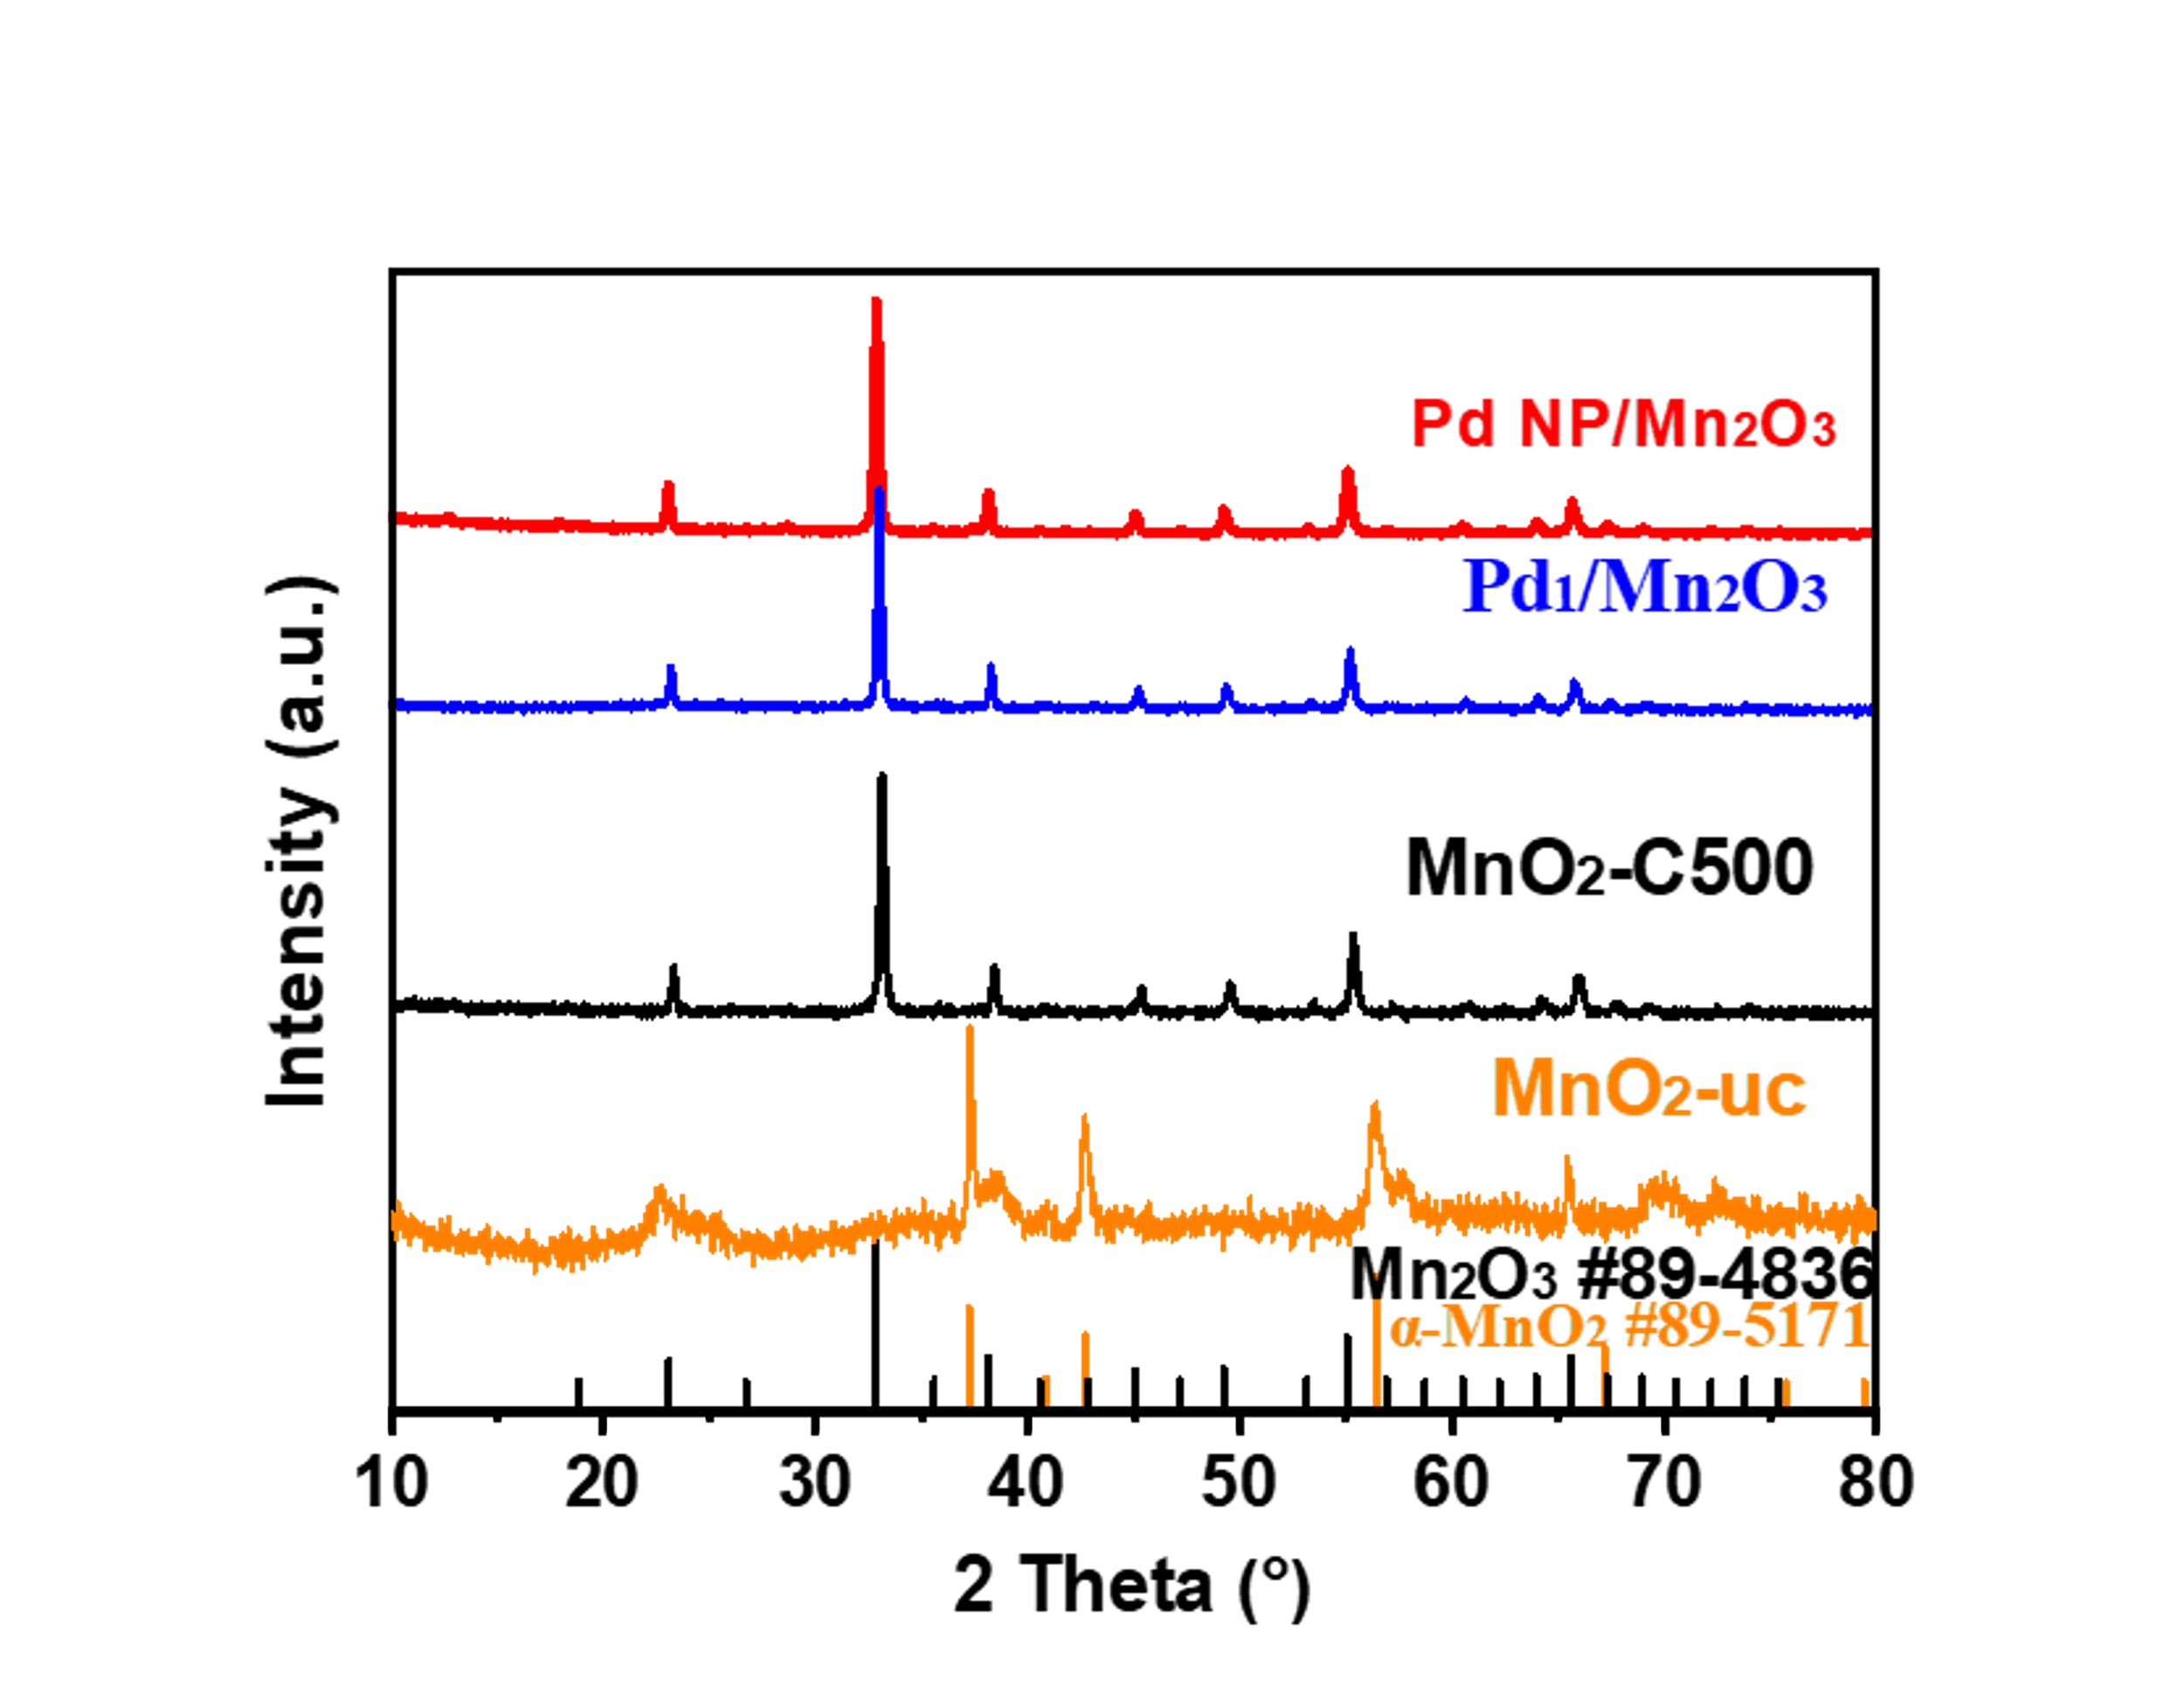
Figure S1. Powder XRD pattern of purchased uncalcined MnO₂ (black line, approximate to akhtenskite MnO₂, Jade card No.89-5171), calcined MnO₂ (orang line, approximate to bixbyite Mn₂O₃, Jade card No. 89-4836), calcined Pd₁/Mn₂O₃ (blue line) and Pd-NP/Mn₂O₃ (red line).
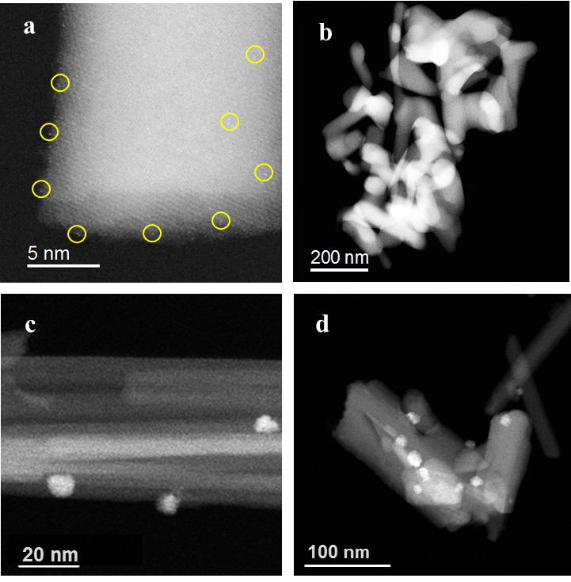
Figure S2. AC-HAADF-STEM images of Pd₁/Mn₂O₃ with different magnifications (a-b), and HAADF-STEM images of Pd-NP/Mn₂O₃ with different magnifications (c-d).
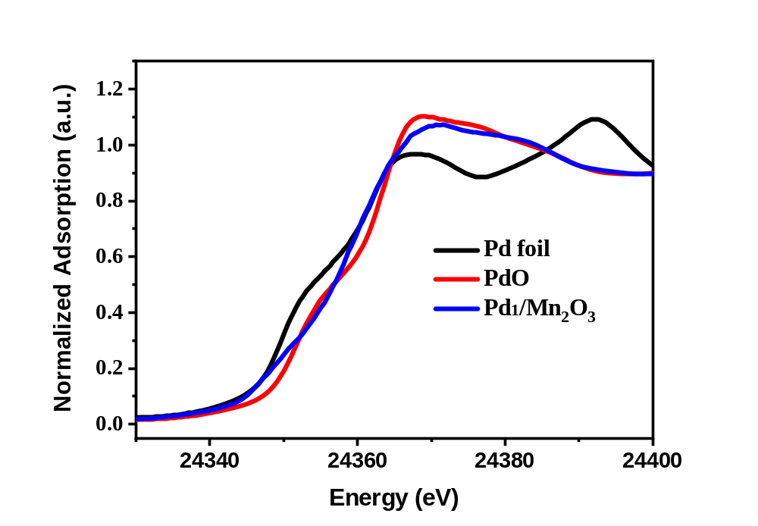
Figure S3. Pd K-edge XANES spectra of Pd₁/Mn₂O₃.

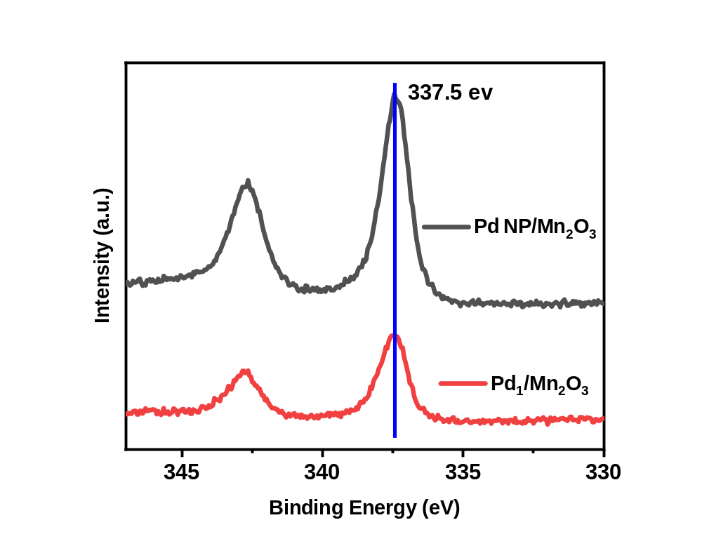
Figure S4. XPS of Pd₁/Mn₂O₃ (red line) and Pd-NP/Mn₂O₃ (black line). The Pd single atoms in Pd₁/Mn₂O₃ predominantly exists as Pd²⁺ (binding energy of 337.5 eV)
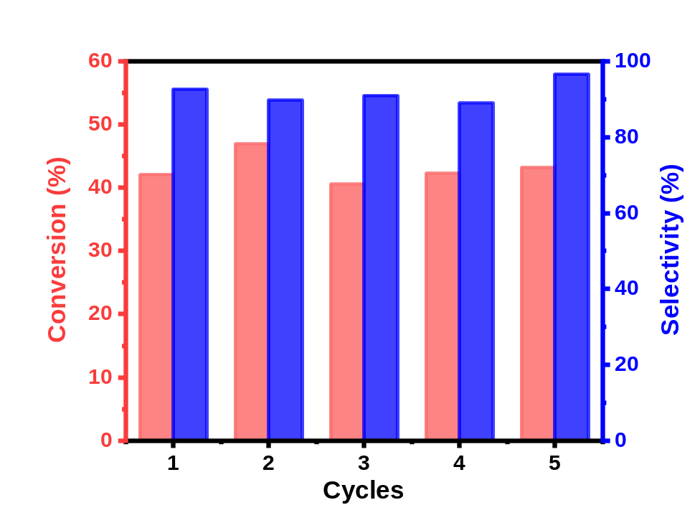
Figure S5. Catalyst recycling experiment for selective oxidation of EB on Pd₁/Mn₂O₃ catalyst. Reaction conditions: EB (2.2 mL), catalyst, O₂ (2 MPa), 120 ºC, 20 h.

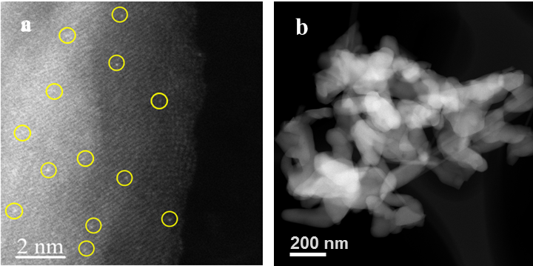
Figure S6. AC-HAADF-STEM images of 0.7Pd₁/Mn₂O₃ catalysts.

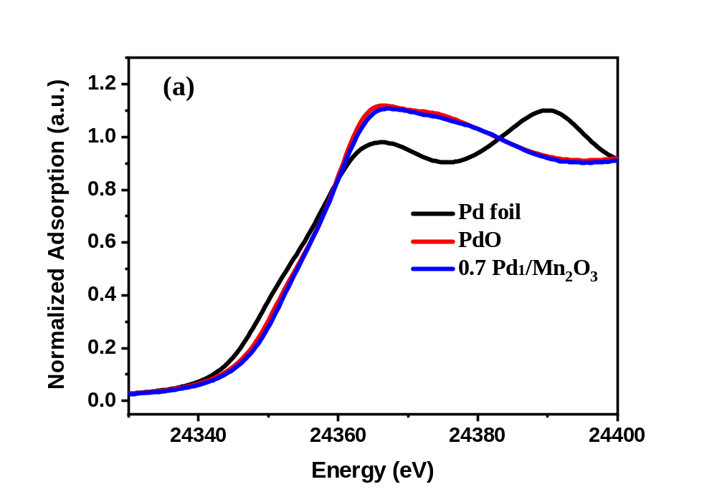
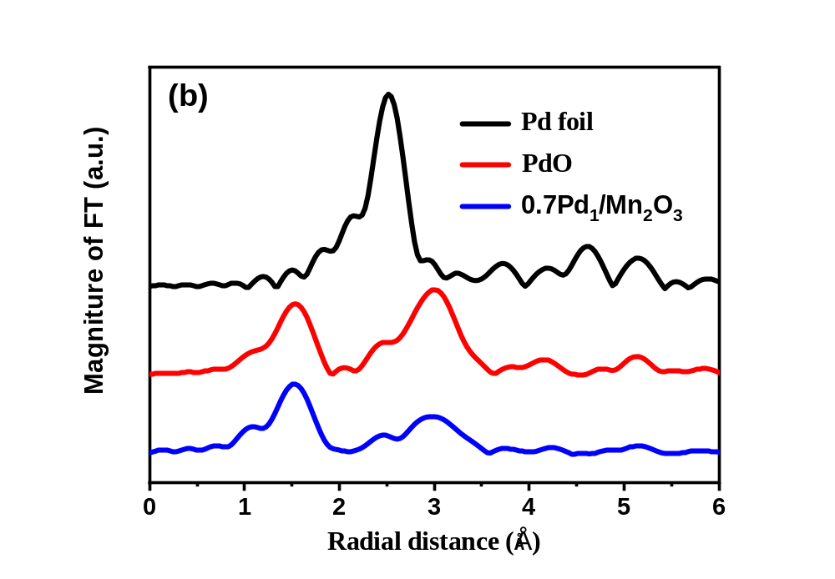
Figure S7. (a) Pd K-edge XANES spectra of 0.7Pd₁/Mn₂O₃, (b) The EXAFS spectra at the k²-weighted Fourier transform spectra of 0.7Pd₁/Mn₂O₃ catalyst and reference samples.
Figure S8. AC-HAADF-STEM images of 0.1Au₁/Mn₂O₃ (a-b), HR-STEM of 0.7AuNP/Mn₂O₃ (c-d), respectively.
Figure S9. AC-HAADF-STEM images of 0.1Ru₁/Mn₂O₃ (a-b), and HR-STEM of 0.7Ru NP/Mn₂O₃(c-d), respectively.

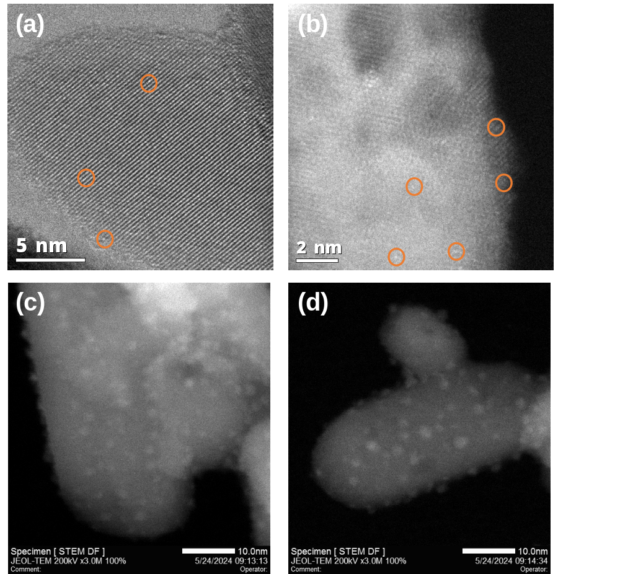
Figure S10. AC-HAADF-STEM of 0.15Pd₁/TiO₂ (a-b), HR-STEM of 0.65Pd NP/TiO₂ (c-d), respectively.

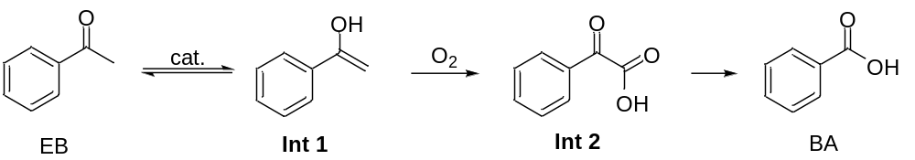
Figure S11. Proposed reaction mechanism of acetophenone to benzoic acid on Pd-NP/Mn₂O₃. Oxidation of enolate intermediate (Int 1) will produce ketoacid (Int 2), and decarboxylation on ketoacid (Int 2) is likely to react. Similar mechanism was reported in cyclohexane oxidation.^{[4]}

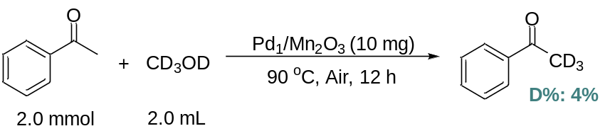
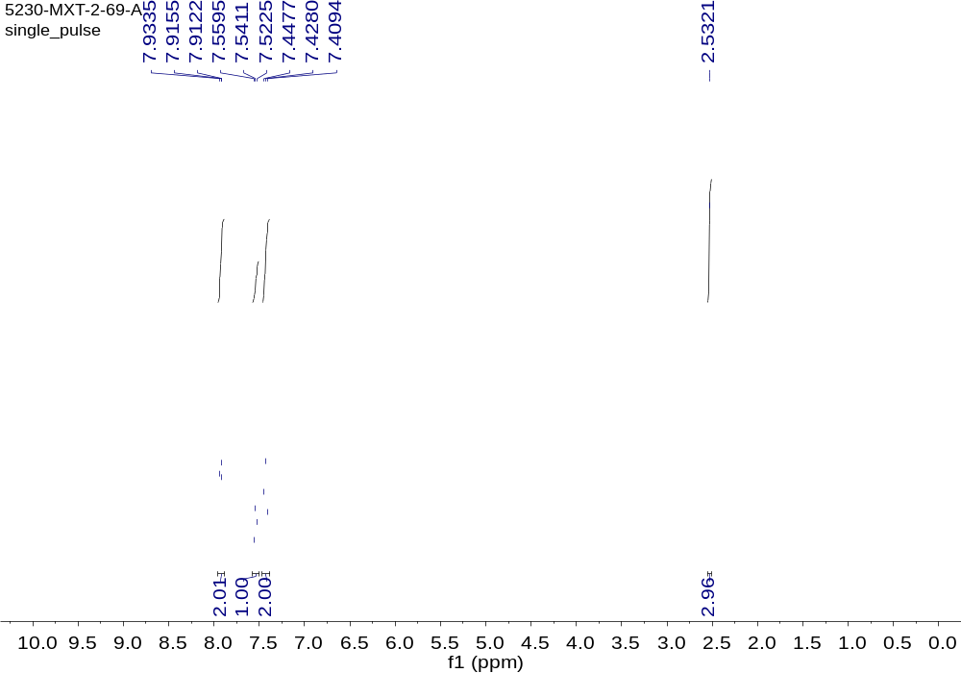
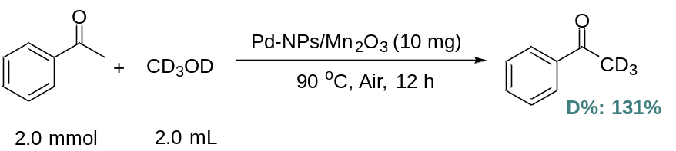
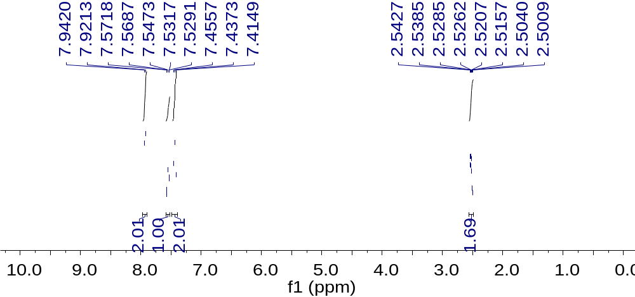
Figure S12. ¹H NMR for the AP deuterated reactions catalyzed by Pd₁/Mn₂O₃ and Pd-NP/Mn₂O_{3.}

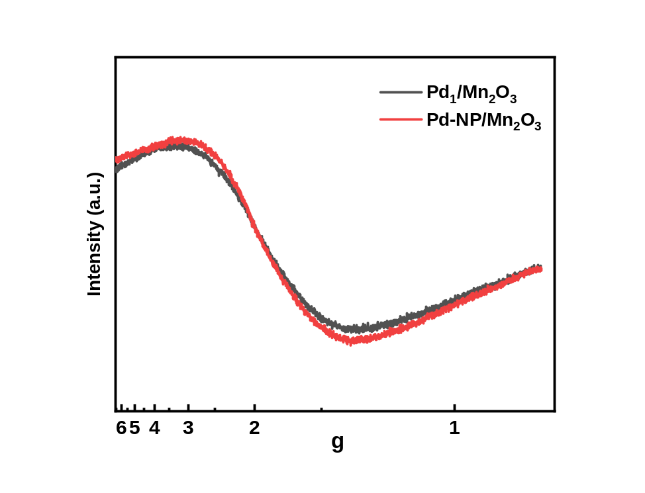
Figure S13. Electron Paramagnetic Resonance (EPR) of Pd₁/Mn₂O₃ and Pd-NP/Mn₂O_{3.}

Table S1. EXAFS data fitting results of Pd₁/Mn₂O₃.
Samples | Shell | N | R (Å) | σ²x10² (Å²) | ΔE₀ (eV) | r-factor (%)
Pd foil | Pd-Pd | 12.0 | 2.74 | 0.5 | 4.7 | 0.2
PdO | Pd-O | 4.0 | 2.02 | 0.1 | -6.8 | 0.6
PdO | Pd-Pd | 4.0 | 3.05 | 0.5 | -6.8
PdO | Pd-Pd | 8.0 | 3.44 | 0.4 | -6.8
Pd₁/Mn₂O₃ | Pd-O | 3.5 | 2.02 | 0.1 | 1.5 | 0.8
N, the coordination number for the absorber-backscatterer pair. R, the average absorber-backscatterer distance. σ², the Debye-Waller factor. ΔE₀, the inner potential correction. The accuracies of the above parameters were estimated as N, ±20%; R, ±1%; σ², ±20%.

Table S2. Performances of Pd/Mn₂O₃ catalyst compared with the active heterogenous catalysts reported for EB solvent-free oxidation by O₂.
Entry | Catalyst | Conv.(%) | Sel. of ketone (%) | Sel. of acid (%) | Specific rate (mol·mol_{metal}⁻¹·h⁻¹) | Ref.
1 | Pd₁/Mn₂O₃ | 15.6 | 66.2 | 0 | 6632^{[a]} | This work
2 | Pd-NP/Mn₂O₃ | 24.3 | 63.8 | 0 | 3469^{[a]} | This work
3^{[b]} | HMS-Co (III) complex | 76 | 94 | 6 | 208 | Ref ^{[5]}
4 | MnO₄⁻¹ exchanged Mg-Al hydrotalcite | 22.6 | 98.4 | --^{[c]} | 9 | Ref ^{[6]}
5 | NiAl hydrotalcite | 47 | 99.3 | -- | 0.4 | Ref ^{[7]}
6 | 0.5%Pd@C-GluA | 14.2 | 94 | -- | 245 | Ref ^{[8]}
7^{[d]} | Au/LDH hybrid | 32.5 | 91.9 | -- | 1446 | Ref ^{[9]}
8 | Mn-MgAl-hydrotalcite | 50.3 | 96.7 | -- | 25 | Ref ^{[10]}
9 | Co-N-C/CeO₂ | 33.1 | 74.8 | -- | 193 | Ref ^{[11]}
[a] Specific rate was measured under 2 h reaction time with a lower conversion, 15.6% for Pd₁/Mn₂O₃ and 24.3% for Pd-NP/Mn₂O₃, other reaction conditions are same with Table 1, Reaction conditions: EB (2.2 mL), catalyst, O₂ (2 MPa)); [b] catalysts cannot be reused; [c] Not noted; [d] t-butyl hydroperoxide (TBHP, 3 mol% based on substrate) was added as initiator, only 5.3% conversion observed without TBHP.^{[9]}

Table S3. EXAFS data fitting results of different 0.7Pd₁/Mn₂O₃ samples.
Samples | Shell | N | R (Å) | σ²x10² (Å²) | ΔE₀ (eV) | r-factor (%)
Pd foil | Pd-Pd | 12.0 | 2.74 | 0.5 | 0.7 | 0.04
PdO | Pd-O | 4.0 | 2.02 | 0.4 | -4.1 | 0.03
PdO | Pd-Pd | 8.0 | 3.07 | 0.8 | -4.9
PdO | Pd-Pd | 4.0 | 3.44 | 0.3 | -4.9
0.7Pd₁/Mn₂O₃ | Pd-O | 3.4 | 2.01 | 0.3 | -5.6 | 0.7
0.7Pd₁/Mn₂O₃ | Pd-Pd | 1.2 | 3.10 | 0.4 | 11.7
0.7Pd₁/Mn₂O₃ | Pd-Mn | 3.0 | 3.38 | 0.4 | 11.7
N, the coordination number for the absorber-backscatterer pair. R, the average absorber-backscatterer distance. σ², the Debye-Waller factor. ΔE₀, the inner potential correction. The accuracies of the above parameters were estimated as N, ±20%; R, ±1%; σ², ±20%.

Table S4. Low conversion rates experiment of EB and styralyl alcohol using O¹⁸ as the oxygen source.
Entry | Catalyst | Substrate | Sel. of styralyl alcohol (%) | Sel. of AP (%) | Conv.  (%) | ¹⁸O AP product | H₂¹⁶O
1 ^{[a]} | Pd₁/Mn₂O₃ | 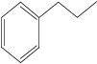 | 100 | N.D. | <1 | 96 ^{[c]} | --
2 ^{[a]} | Pd-NP/Mn₂O₃ |  | 100 | N.D. | <1 | 96 ^{[c]} | --
3 ^{[b]} | Pd₁/Mn₂O₃ | 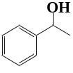 | - | 100 | <1 | N.D. ^{[c]} | 40% ^{[d]}
[a] Reaction conditions: ethylbenzene, 2.2 mL; catalyst, 50 mg; P¹⁸O₂ = 0.4 MPa; temperature, 120 °C; reaction time, 12 h. [b] Styralyl alcohol, 2.2 mL; P¹⁸O₂ = 0.25 MPa. N.D.= not detected. [c] For organic products. [d] For H₂O. In entry 1 and 2, styralyl alcohol marked by ¹⁸O were detected as the main production, while trace amount ¹⁶O styralyl alcohol were detected which might be ascribe to the impurity of ¹⁸O₂ (96%). As a comparison, styralyl alcohol oxidation in entry 3, which has been generally regarded to follow Mars-van-Krevelen mechanism,^{[12]} was detected unnegligible amount of H₂¹⁶O (about two-fifths of H₂O). All substrates were treated with Magnesium sulfate anhydrous to remove H₂¹⁶O before reaction.

Table S5. Direct oxidation experiments of acetophenone with or without TBHP.
Entry | Catalyst | Catalyst (mg) | TBHP (mL) | AP  (mL) | Benzoic Acid (%)
1ª | Pd₁/Mn₂O₃ | 50 | 0 | 0.5 | 0
2ª | Pd-NP/Mn₂O₃ | 50 | 0 | 0.5 | 0
3ª | Pd₁/Mn₂O₃ | 10 | 1.0 | 1.0 | 2.1
4^{b} | Pd-NP/Mn₂O₃ | 10 | 1.0 | 1.0 | 85.4
5^{b} | Pd₁/Mn₂O₃ | 10 | 2.0 | 0.1 | 0
6^{b} | Pd-NP/Mn₂O₃ | 10 | 2.0 | 0.1 | 0
ªReaction conditions: PO₂=2 MPa; temperature, 120 °C; reaction time, 12 h. ^{b}1 atm air.

Table S6. Performance of various SACs in ethylbenzene oxidation.
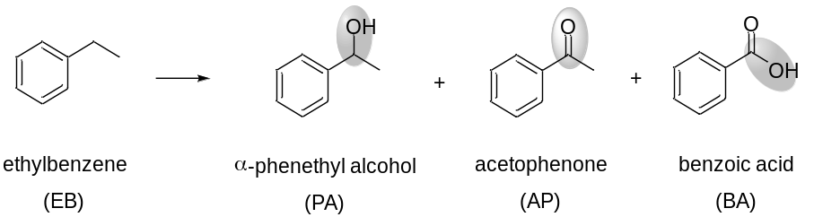
Entry | Catalyst | Conv. (%) | Sel. Of PA (%) | Sel. Of AP (%) | Sel. Of BA (%)
1ª | 0.1Au₁/Mn₂O₃ | 46 | 7 | 93 | 0
2ª | 0.7Au_{NPs}/Mn₂O₃ | 48 | 5 | 86 | 8
3ª | 0.1Ru₁/Mn₂O₃ | 50 | 5 | 95 | 0
4ª | 0.7Ru_{NPs}/Mn₂O₃ | 45 | 4 | 85 | 11
5^{b} | 0.15Pd₁/TiO₂ | 16% | 18 | 82 | 0
6^{b} | 0.65Pd_{NPs}/TiO₂ | 45% | 2 | 32 | 63
ªReaction conditions: ªEB (2.2 mL), catalyst (10 mg), O₂ (2 MPa), 120 ºC, 20 h. ^{b} EB (2.0 mmol), catalyst (20 mg), O₂ (1.0 MPa), MeCN (5.0 mL), 120 ºC, 20 h.

Table S7. Performance of Pd₁/Mn₂O₃-PM and Pd-NP/Mn₂O₃-PM in ethylbenzene oxidation.
Entry | Catalyst (Pd/EB) | Conv. | Sel. of PA | Sel. of AP | Sel. of BA
1ª | Pd₁/Mn₂O₃-PM (12 ppm) | 43% | 11% | 89% | 0%
2^{b} | Pd-NP/Mn₂O₃-PM (35 ppm) | 69% | 3% | 9% | 88%
Reaction conditions: ªEB (2.2 mL), Pd₁/Mn₂O₃-PM (60 mg), Mn₂O₃ (20 mg), O₂ (2.0 MPa), 120 ºC, 20 h. ^{b}EB (2.2 mL), catalyst, O₂ (2.0 MPa), 120 ºC, 20 h. ^{b}Pd-NP/Mn₂O₃-PM (20 mg).

- References
[1] a) Y. Wang, J. W. Ren, K. Deng, L. L. Gui, Y. Q. Tang, Chemistry of Materials 2000, 12, 1622-1627; b) L. Yin, M. A. El-Sayed, J.phys.chem.b 2001, 105.
[2] Y. Guo, Y. Huang, B. Zeng, B. Han, M. Akri, M. Shi, Y. Zhao, Q. Li, Y. Su, L. Li, Q. Jiang, Y.-T. Cui, L. Li, R. Li, B. Qiao, T. Zhang, Nature Communications 2022, 13, 2648.
[3] M. M. Peng, M. Ganesh, R. Vinodh, M. Palanichamy, H. T. Jang, Arab. J. Chem. 2019, 12, 1358-1364.
[4] D. Pan, G. Li, Y. Su, H. Wei, Z. Luo, Chinese Journal of Chemical Engineering 2021, 29, 183-189.
[5] B. K. Das, J. H. Clark, Chemical Communications 2000, 605-606.
[6] V. Choudhary, J. Indurkar, V. Narkhede, R. Jha, Journal of Catalysis 2004, 227, 257-261.
[7] S. K. Jana, P. Wu, T. Tatsumi, Journal of Catalysis 2006, 240, 268-274.
[8] P. Zhang, Y. Gong, H. Li, Z. Chen, Y. Wang, Nature Communications 2013, 4, 1593.
[9] L. Wang, Y. Zhu, J. Q. Wang, F. Liu, J. Huang, X. Meng, J. M. Basset, Y. Han, F. S. Xiao, Nat Commun 2015, 6, 6957.
[10] S. K. Jana, Y. Kubota, T. Tatsumi, Journal of Catalysis 2007, 247, 214-222.
[11] Y. Chen, S. Zhao, Z. Liu, Physical Chemistry Chemical Physics 2015, 17.
[12] T. Li, F. Liu, Y. Tang, L. Li, S. Miao, Y. Su, J. Zhang, J. Huang, H. Sun, M. Haruta, Angewandte Chemie International Edition 2018.

