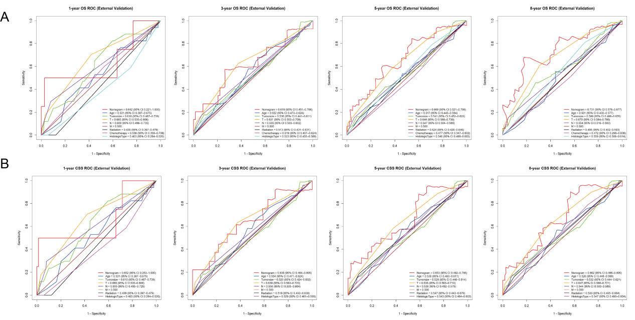
Supplementary Fig. 1 ROC curves for the external validation cohort of1-,3- 5-, and8-year (A OS;B CSS )(Nomogram, Age, Tumorsize,TNM,Histologic_Type,Radiotherapy,Chemotherapy).

