Supporting Material 1: Comparison of Depth-to-Diameter Ratios of Craters
A comparative analysis of the depth-to-diameter ratios of craters of various scales within the CE-4, CE-5, and CE-6 landing areas was conducted. The data for craters with the same diameter scale are presented in the Table S1.
Table s1
average depth-to-diameter ratios for craters of different scales within the CE-4, CE-5, and CE-6 landing areas
Diameter of Small Craters (m): >2 | CE-6 Average Depth-to-Diameter Ratio | CE-4 Average Depth-to-Diameter Ratio | CE-5 Average Depth-to-Diameter Ratio
<5 | 0.131 | 0.293 | 0.121
5~10 | 0.12 | 0.285 | 0.123
10~15 | 0.104 | 0.299 | 0.129
15~20 | 0.102 | 0.177 | 0.142
20~25 | 0.062 | 0.211 | 0.136
>25 | 0.075 | 0.171 | 0.099
Fresh craters | 0.214 | 0.325 | 0.183
Total | 0.129 | 0.287 | 0.124
Diameter of Small Craters (m): >80 | CE-6 Average Depth-to-Diameter Ratio | CE-4 Average Depth-to-Diameter Ratio | CE-5 Average Depth-to-Diameter Ratio
<100 | 0.047 | 0.053 | 0.037
100~150 | 0.049 | 0.057 | 0.039
150~200 | 0.046 | 0.052 | 0.04
200~250 | 0.042 | 0.052 | 0.033
250~300 | 0.067 | 0.062 | 0.035
>300 | 0.034 | 0.064 | 0.078
fresh craters | 0.050 | 0.064 | 0.059
Total | 0.048 | 0.055 | 0.039

Supporting Material 2: Lunar regolith Thickness Empirical Formula
The empirical formula for lunar regolith thickness (Quaide and Oberbeck, 1968; Bart et al., 2011) is given by:
$t=\left(k-\frac{D_{f}}{D_{a}}\right)D_{a}*\tan{(α)/2}$
where: t represents the lunar regolith thickness, k is an empirically derived constant, typically taken as 0.86, D_{f} is the diameter of the inner rim of the crater, D_{a} is the diameter of the outer rim of the crater, α is the slope angle of the fresh crater walls, usually taken as 31°±2°; in this study, α is taken as 31°. The locations and corresponding parameters of the concentric craters compiled in this study are provided in Table S2.
Table S2
locations and statistical parameters of the concentric craters
NO. | Outer-Longitude(°) | Outer-Latitude(°) | Inner-Longitude(°) | Inner-Latitude(°) | Thickness(m) | D_{f}(m) | D_{a}(m)
1 | -154.08613 | -42.36344 | -154.08650 | -42.36336 | 9.23 | 83.30 | 132.58
2 | -154.08576 | -41.97679 | -154.08553 | -41.97674 | 9.31 | 65.30 | 111.95
3 | -154.11327 | -41.79769 | -154.11337 | -41.79763 | 7.00 | 51.16 | 86.59
4 | -154.13710 | -41.77382 | -154.13685 | -41.77385 | 6.85 | 65.07 | 102.16
5 | -154.07945 | -41.79268 | -154.07957 | -41.79267 | 7.41 | 33.56 | 67.71
6 | -153.76469 | -42.10988 | -153.76476 | -42.11008 | 6.78 | 62.42 | 98.83
7 | -153.88361 | -41.62803 | -153.88371 | -41.62813 | 9.12 | 93.56 | 144.08
8 | -153.84212 | -41.46704 | -153.84217 | -41.46701 | 3.78 | 23.00 | 41.39
9 | -153.86919 | -41.60281 | -153.86907 | -41.60285 | 3.41 | 29.88 | 47.93
10 | -153.99379 | -42.25027 | -153.99399 | -42.25042 | 8.91 | 50.31 | 92.96
11 | -154.05695 | -42.13959 | -154.05691 | -42.13943 | 8.05 | 29.71 | 65.70
12 | -153.91735 | -41.61885 | -153.91739 | -41.61877 | 3.93 | 19.54 | 37.93
13 | -153.78905 | -41.51238 | -153.78905 | -41.51236 | 4.64 | 15.47 | 35.95
14 | -154.10743 | -41.98925 | -154.10751 | -41.98924 | 9.40 | 35.63 | 77.82
15 | -153.99495 | -42.00110 | -153.99497 | -42.00110 | 10.07 | 137.40 | 198.73
16 | -153.65458 | -41.17071 | -153.65484 | -41.17068 | 17.41 | 60.95 | 138.24
17 | -154.13911 | -42.35000 | -154.13914 | -42.34998 | 10.34 | 66.97 | 117.90
18 | -153.92023 | -42.34659 | -153.92028 | -42.34650 | 4.72 | 25.29 | 47.65
19 | -154.05025 | -42.15212 | -154.05041 | -42.15214 | 9.13 | 46.59 | 89.51
20 | -154.03797 | -42.13428 | -154.03795 | -42.13418 | 6.04 | 32.26 | 60.89
21 | -154.03539 | -42.05533 | -154.03528 | -42.05529 | 5.15 | 36.36 | 62.22
22 | -154.01662 | -42.04206 | -154.01651 | -42.04209 | 4.49 | 32.72 | 55.43
23 | -154.08712 | -42.00038 | -154.08712 | -42.00039 | 3.02 | 26.76 | 42.79
24 | -154.08569 | -41.99040 | -154.08569 | -41.99040 | 6.00 | 35.42 | 64.42
25 | -154.02639 | -41.93210 | -154.02635 | -41.93206 | 8.99 | 60.38 | 105.01
26 | -153.92008 | -41.92658 | -153.92020 | -41.92661 | 8.53 | 39.26 | 78.67
27 | -154.09476 | -41.87113 | -154.09486 | -41.87116 | 7.92 | 30.19 | 65.77
28 | -154.06075 | -41.89556 | -154.06080 | -41.89558 | 4.00 | 21.09 | 40.01
29 | -153.88061 | -41.84724 | -153.88053 | -41.84711 | 5.80 | 36.88 | 65.32
30 | -153.77881 | -41.82952 | -153.77887 | -41.82947 | 6.01 | 50.76 | 82.29
31 | -153.92928 | -41.77806 | -153.92925 | -41.77804 | 6.07 | 26.93 | 54.80
32 | -153.71048 | -41.75922 | -153.71035 | -41.75929 | 8.85 | 36.58 | 76.78
33 | -153.70253 | -41.75719 | -153.70245 | -41.75720 | 5.22 | 31.48 | 56.79
34 | -153.69415 | -41.70451 | -153.69422 | -41.70466 | 7.06 | 21.81 | 52.67
35 | -153.76316 | -41.63923 | -153.76322 | -41.63917 | 4.39 | 22.36 | 42.98
36 | -153.76933 | -41.67761 | -153.76931 | -41.67768 | 7.82 | 33.67 | 69.42
37 | -153.93961 | -41.46070 | -153.93962 | -41.46064 | 6.30 | 39.08 | 69.83
38 | -153.99490 | -41.69675 | -153.99504 | -41.69680 | 6.82 | 34.47 | 66.48
39 | -153.72237 | -41.54512 | -153.72246 | -41.54512 | 7.28 | 19.07 | 50.35
40 | -153.67454 | -41.53747 | -153.67459 | -41.53744 | 8.82 | 29.13 | 68.00
41 | -153.73594 | -41.64028 | -153.73623 | -41.64030 | 11.51 | 48.86 | 101.35
42 | -153.87142 | -41.81040 | -153.87165 | -41.81036 | 9.22 | 58.22 | 103.36
43 | -153.94238 | -41.58897 | -153.94235 | -41.58870 | 6.48 | 61.52 | 96.62
44 | -153.87135 | -41.56811 | -153.87150 | -41.56823 | 5.40 | 25.10 | 50.08
45 | -153.82070 | -41.77607 | -153.82078 | -41.77619 | 8.23 | 39.54 | 77.83
46 | -154.30955 | -41.36978 | -154.30946 | -41.36951 | 8.45 | 75.87 | 120.93
47 | -154.16955 | -41.72471 | -154.16963 | -41.72465 | 7.26 | 32.33 | 65.70
48 | -154.03622 | -41.52469 | -154.03606 | -41.52455 | 16.89 | 54.94 | 129.24
49 | -153.99623 | -41.36544 | -153.99634 | -41.36540 | 3.16 | 65.04 | 87.84
50 | -153.74435 | -41.28944 | -153.74416 | -41.28943 | 7.52 | 73.26 | 114.30
51 | -154.80053 | -42.14272 | -154.80055 | -42.14280 | 7.40 | 63.34 | 102.29
52 | -154.67434 | -42.16407 | -154.67399 | -42.16390 | 10.32 | 60.39 | 110.15
53 | -154.56909 | -41.18723 | -154.56882 | -41.18724 | 15.05 | 103.65 | 178.76
54 | -154.07562 | -40.87291 | -154.07579 | -40.87294 | 8.36 | 60.40 | 102.60
55 | -154.09597 | -41.29797 | -154.09593 | -41.29803 | 6.16 | 59.43 | 92.93
56 | -153.84597 | -42.23800 | -153.84583 | -42.23788 | 20.07 | 176.76 | 283.20
57 | -153.97802 | -41.62527 | -153.97801 | -41.62527 | 0.40 | 2.92 | 4.94
58 | -153.97737 | -41.62514 | -153.97737 | -41.62514 | 0.38 | 0.68 | 2.28
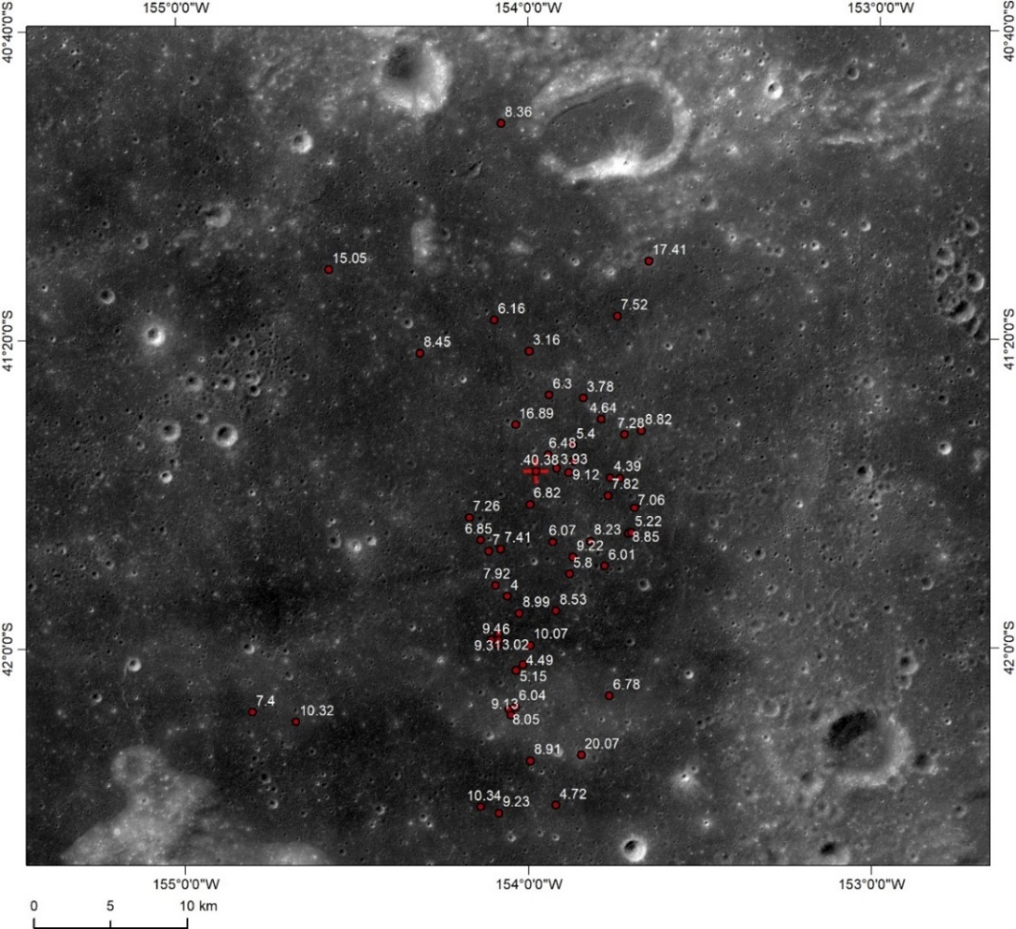
Fig. S1 The location of the concentric craters and the corresponding regolith thickness (unit in meters)

Supporting Material 3: Fitting Function for Rock Abundance
The fitting function for rock abundance (Li and Wu, 2018) is given by:
$F_{k}\left(D\right)=k*e^{-\left(0.5648+\frac{0.01258}{k}\right)*D}$
where: D represents the diameter of the rocks, k is the rock abundance, F_{k}(D) represents the proportion of the area covered by rocks with a diameter greater than a certain 𝐷. The distribution and abundance fitting of the selected rocks from CE-6 area are shown in Fig. S2.
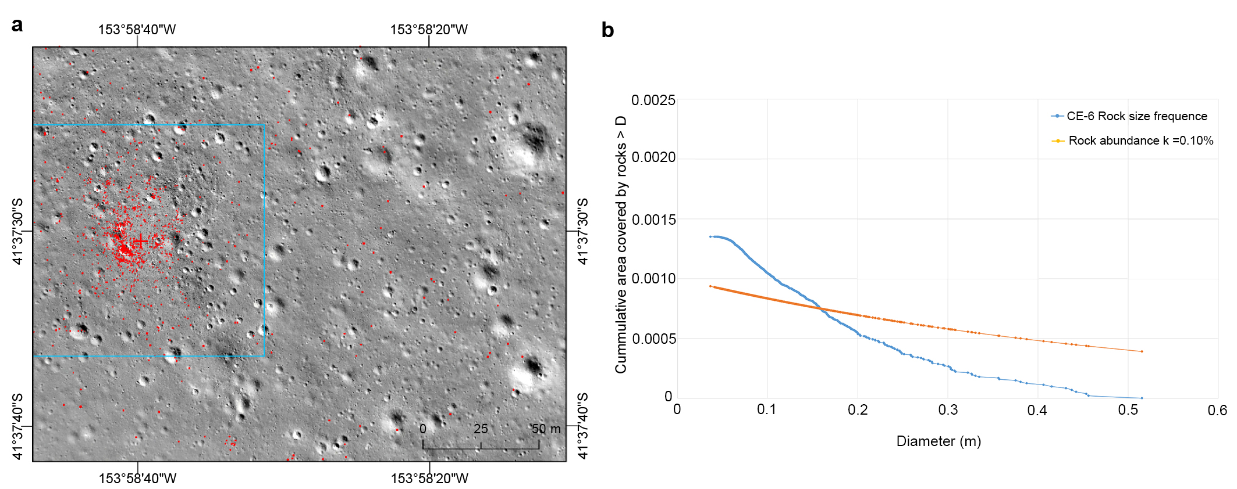
Fig. S2: Distribution of rock abundance at the CE-6 landing area. (a) shows the rock distribution map for the CE-6 landing area, with the statistical region indicated by the blue box; (b) is the abundance fitting diagram of rocks at the Chang’e-6 landing area.

Supporting Material 4: Ejecta Thickness Calculation Formula and Results
The formula for calculating the thickness of ejecta (Pike et al., 1974) is given by:
$e = 0.033R_{t}{(r/R_{t})}^{-3.0}$
where: e represents the ejecta thickness, r is the distance from the center of the crater, R_{t} is the instantaneous radius of the crater. For craters with a diameter greater than 15 km, the formula for the instantaneous crater radius R_{t} is:
$R_{t}=\sqrt[1.07]{R_{c}/0.86}$
For craters with a diameter less than 15 km, the formula for the instantaneous crater radius R_{t} is:
$$R_{t}=0.84R_{c}$$
where: R_{c} is the rim-to-rim radius of the crater.
Using these formulas, the possible thickness of the ejecta for the craters identified in this study was calculated and ranked. The specific location data for the top ten thicknesses are detailed in Table S3.
Table s3
Top Ten Craters with Maximum Potential Ejecta Thickness at the Chang'e-6 Landing Site
Name | x_coord(°) | y_coord(°) | Diam(km) | Distance(m) | Ejecta_Depth(m)
C1 | -153.9771 | -41.6245 | 0.0509 | 24.2330 | 0.4861
White | -159.0127 | -44.8247 | 40.6643 | 147514.74740 | 0.2303
C8 | -153.6215 | -43.6678 | 11.9888 | 62443.68750 | 0.0871
Hausen | -88.4911 | -65.3059 | 163.7090 | 1269105.4386 | 0.0660
Chaffee S | -157.4834 | -39.7518 | 19.9336 | 98587.9674 | 0.0537
Finsen | -177.6808 | -42.3151 | 74.2323 | 530945.9393 | 0.0469
C7 | -153.0134 | -42.2152 | 5.3321 | 28169.1172 | 0.0372
C6 | -154.3126 | -40.7686 | 5.0810 | 27071.8811 | 0.0345
C10 | -156.9314 | -44.0026 | 17.3713 | 97512.9556 | 0.0332
C9 | -157.5642 | -43.5246 | 12.9363 | 98618.3524 | 0.0300

Supporting Material 5: Geological age of crater Chaffee S
Based on CE2TMap2015 DOM, circular craters were extracted from the ejecta blanket around Chaffee S using the “Crater Tools” in ArcMap software. Craters with a diameter of 300 m or more were used for calculated the geological age of crater Chaffee S, and the results are shown in Fig. S3.
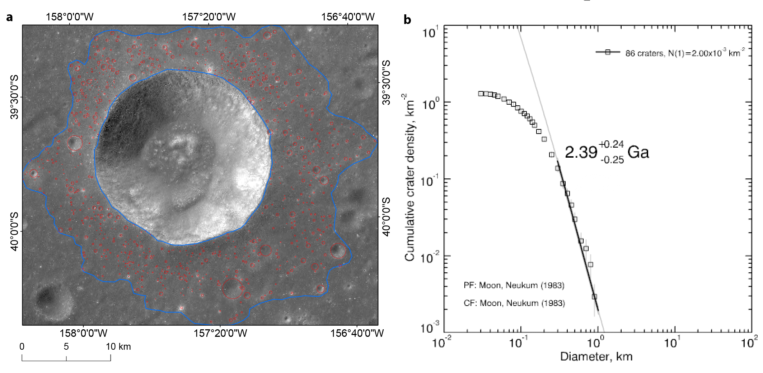
Figure S3: Geological age of crater Chaffee S. (a) shows the selected extracted circular craters for age calculation; (b) displays the CSFD (Crater Size-Frequency Distribution) results.

