Supplementary Materials:
Sex differences in the functional network underpinnings
of psychotic-like experiences in children

Authors:
Elvisha Dhamala, PhD^{1-2,*}, Sidhant Chopra, PhD³⁻⁴, Leon Q.R. Ooi, PhD⁵⁻⁹, Jose M. Rubio, MD¹⁻², B.T. Thomas Yeo, PhD⁵⁻¹⁰, Anil K. Malhotra, MD¹⁻², Avram J. Holmes, PhD⁴

Affiliations:
¹ Institute of Behavioral Sciences, Feinstein Institutes for Medical Research, Manhasset, USA
² Donald and Barbara Zucker School of Medicine at Hofstra/Northwell, Uniondale, USA
³ Department of Psychology, Yale University, New Haven, USA
⁴ Department of Psychiatry, Brain Health Institute, Rutgers University, Piscataway, USA
⁵ Centre for Sleep & Cognition & Centre for Translational Magnetic Resonance Research, Yong Loo Lin School of Medicine, Singapore, National University of Singapore, Singapore, Singapore
⁶ Department of Electrical and Computer Engineering, National University of Singapore, Singapore, Singapore
⁷ N.1 Institute for Health, National University of Singapore, Singapore, Singapore
⁸ Integrative Sciences and Engineering Programme (ISEP), National University of Singapore, Singapore, Singapore
⁹ Department of Medicine, Healthy Longevity Research Programme, Human Potential Translational Research Programme & Institute for Digital Medicine (WisDM), Yong Loo Lin School of Medicine, National University of Singapore, Singapore
¹⁰ Martinos Center for Biomedical Imaging, Massachusetts General Hospital, Charlestown, USA
* Corresponding author: Elvisha Dhamala (elvisha@gmail.com)

Keywords: neuroimaging, functional connectivity, brain-based predictive modeling, sex differences, psychotic-like experiences, prediction psychiatry, children

Supplementary Methods
Dataset: Detailed demographic information on participants who were included and excluded from this sample can be found in [1].
Neuroimaging Data: Magnetic resonance (MR) images were acquired across 21 sites in the United States of America using harmonized protocols for GE and Siemens scanners. In line with our prior work[2, 3], exclusion criteria were used to ensure quality control. As recommended by the ABCD consortium, we excluded individuals who were scanned using Philips scanners due to incorrect preprocessing (https://github.com/ABCD-STUDY/fMRI-cleanup). For the T1 data, individuals who did not pass recon-all quality control[4] were removed. For the functional connectivity data, functional runs with boundary-based registration (BBR) costs greater than 0.6 were excluded. Further, volumes with framewise displacement (FD)>0.3 mm or voxel-wise differentiated signal variance (DVARS)>50, along with one volume before and two volumes after, were marked as outliers and subsequently censored. Uncensored segments of data containing fewer than five contiguous volumes were also censored[5, 6]. Functional runs with over half of their volumes censored and/or max FD>5mm were removed. Individuals who did not have at least 4 minutes of data were also excluded. Individuals who did not have all of the relevant behavioral data were also excluded. Finally, we excluded siblings to prevent unintended biases due to inherent heritability in neurobiological and/or behavioral measures.
Image Acquisition and Processing: The minimally preprocessed MRI data were processed as previously described[3, 7]. Briefly, minimally preprocessed T1 data were further processed using FreeSurfer 5.3.0[8-11] to generate cortical surface meshes for each individual, which were then registered to a common spherical coordinate system[10, 11]. Minimally preprocessed fMRI data were further processed with the following steps: (1) removal of initial frames, with the number of frames removed depending on the type of scanner[4] and (2) alignment with the T1 images using boundary-based registration[12] with FsFast. Framewise displacement (FD)[13] and voxel-wise differentiated signal variance (DVARS)[14] were computed using fsl_motion_outliers. Respiratory pseudomotion was filtered out using a bandstop filter (0.31-0.43 Hz) before computing FD[15-17]. A total of 18 nuisance covariates were also regressed out of the fMRI time series: global signal, six motion correction parameters, averaged ventricular signal, averaged white matter signal, and their temporal derivatives. Regression coefficients were estimated from the non-censored volumes. Global signal regression was performed as it has been shown to improve behavioral prediction performance[18, 19]. Finally, the brain scans were interpolated across censored frames using least squares spectral estimation[20], band-pass filtered (0.009 Hz ≤ f ≤ 0.08 Hz), projected onto FreeSurfer fsaverage6 surface space, and smoothed using a 6 mm full-width half maximum kernel. Once processed, we extracted regional time series for 400 cortical[21] and 19 non-cortical[22] parcels. We computed full correlations between those time series yielding a 419x419 pairwise regional functional connectivity matrix. All processing as described was completed on a local server.
Prodromal Questionnaire–Brief Child Version: The questionnaire includes 21 questions pertaining to psychotic-like experiences. For each question, participants were first asked if they previously had that experience (1=Yes, 0=No). If they answered yes, they were then asked if the experience bothered them (1=Yes, 0=No). If they again answered yes, they were asked the extent to which the experience had bothered them (1=Not very bothered, 2=Slightly bothered, 3=Moderately bothered, 4=Very much bothered, 5=Extremely bothered). The sum of the endorsed questions corresponding to each PLE (range 0 to 21) was used to compute the Total score, and the total number of endorsed questions was weighted by the level of distress to compute the Distress score (range 0 to 126).
Predictive Modeling: For each sex, we randomly shuffled and split the data into 100 distinct train and test sets (at approximately a 2:1 ratio) without replacement. Imaging site was considered when splitting the data such that we placed all participants from a given site either in the train or test set but not split across the two. Within each train set, we optimized the regularization parameter using three-fold cross-validation while similarly accounting for imaging site as in the initial train-test split. Once optimized, we evaluated models on the corresponding test set. We repeated this process for each of 100 distinct train-test splits to obtain a distribution of prediction accuracy measures. To evaluate model significance, for each set of predictive models, a corresponding set of null models was generated as follows: the output variable was randomly permuted 1000 times within each site, and each permutation was used to train and test a null model using a randomly selected regularization parameter from the set of selected parameters from the original model. Prediction accuracy from each of the null models was then compared to the average accuracy from the corresponding distribution of model accuracies of the original models.
Feature Weights: For each train split, we used feature weights obtained from the model, $W$, the covariance of the input data (functional connectivity), $Σ_{x}$, and the covariance of the predicted output data (behavioral score), $Σ_{y}$, to compute the Haufe-transformed feature weights, $A$, as follows: $A= Σ_{x}WΣ_{y}^{-1}.$ We then averaged the Haufe-transformed feature weights across the 100 splits to obtain a mean feature importance value. We computed cosine distances between each set of pairwise feature weights obtained from the sex-specific models to evaluate whether they relied on shared or unique features to predict PLEs. For all models, we also summarized pairwise regional feature importance at a network-level. To do so, cortical parcels were assigned to one of 17 networks from the Yeo 17-network parcellation[23], and subcortical, brainstem, and cerebellar parcels were assigned to a single non-cortical network for convenience. Absolute regional pairwise feature weights were averaged to yield network-level estimates of associations between functional connectivity and psychotic-like experiences for each sex. Finally, pairwise network-level were summarized to a network-level by taking the sum across the pairwise network connections.

Table S1: Head motion is not related to PLEs.
Spearman rank-order correlation coefficients were calculated to evaluate associations between PLE scores and mean framewise displacement for each sex. Spearman’s rho values and p-values (corrected for multiple comparisons using the BH-FDR procedure) are shown.
PLE Score | Males | Females
Total | -0.02 (p>0.05) | 0.03 (p>0.05)
Distress | -0.02 (p>0.05) | 0.03 (p>0.05)

Table S2: Age is not related to PLEs.
Spearman rank-order correlation coefficients were calculated to evaluate associations between PLE scores and age for each sex. Spearman’s rho values and p-values (corrected for multiple comparisons using the BH-FDR procedure) are shown.
PLE Score | Males | Females
Total | 0.02 (p>0.05) | 0.03 (p>0.05)
Distress | 0.02 (p>0.05) | 0.03 (p>0.05)

Table S3: Race/ethnicity is not related to PLEs.
Kruskal-Wallis H-tests were used to evaluate race/ethnicity differences in PLE scores for each sex. ABCD-recommended race/ethnicity groups were used (‘Asian’, ‘Black’, ‘Hispanic’, ‘Other’, ‘White’). Kruskal-Wallis H statistic values and p-values (corrected for multiple comparisons using the BH-FDR procedure) are shown.
PLE Score | Males | Females
Total | 10.29 (p>0.05) | 4.46 (p>0.05)
Distress | 8.45 (p>0.05) | 4.01 (p>0.05)

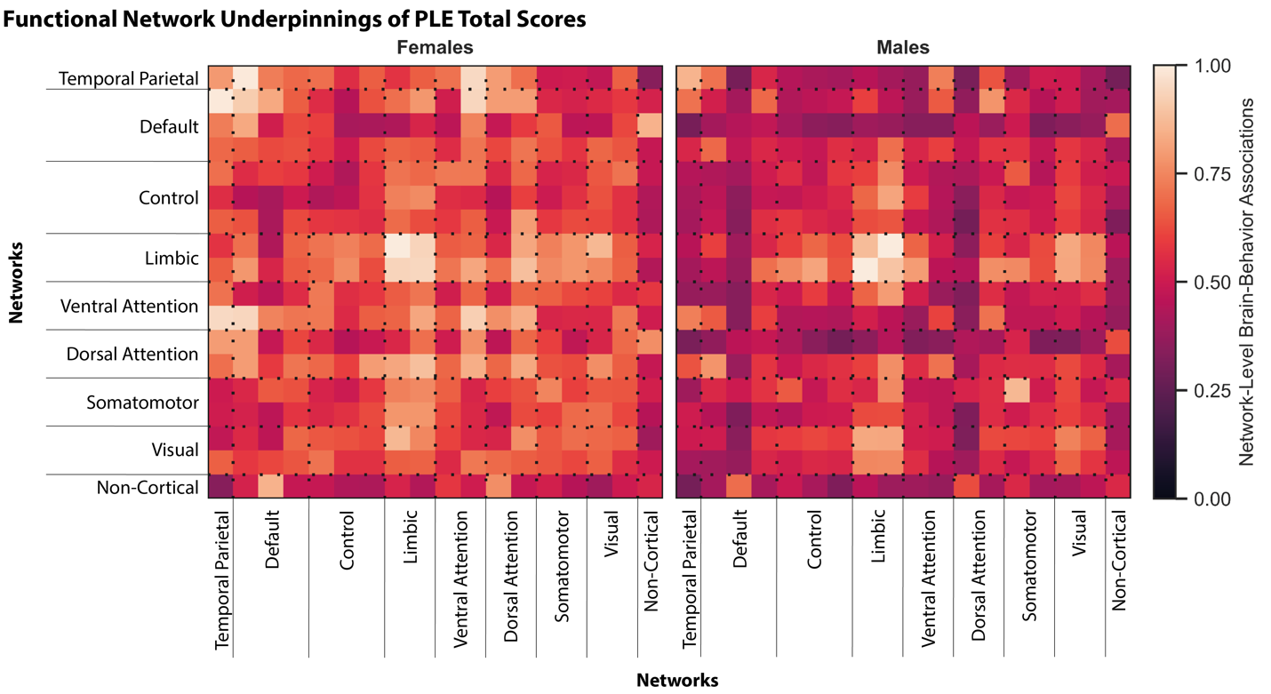
Figure S1: Overlapping and distinct functional networks underlie PLEs across the sexes.
Absolute associations between functional network connectivity and PLE Total scores in assigned females (left) and males (right) are shown as per the colormap. To facilitate visualization, values within each matrix were divided by the maximum value within that matrix.

References

1. Dhamala, E., et al., Brain-based predictions of psychiatric illness-linked behaviors across the sexes. Biological Psychiatry, 2023.
2. Ooi, L.Q.R., et al., Comparison of individualized behavioral predictions across anatomical, diffusion and functional connectivity MRI. BioRxiv, 2022.
3. Chen, J., et al., Shared and unique brain network features predict cognitive, personality, and mental health scores in the ABCD study. Nature communications, 2022. 13(1): p. 2217.
4. Hagler, D.J., Jr., et al., Image processing and analysis methods for the Adolescent Brain Cognitive Development Study. Neuroimage, 2019. 202: p. 116091.
5. Gordon, E.M., et al., Generation and evaluation of a cortical area parcellation from resting-state correlations. Cerebral cortex, 2016. 26(1): p. 288-303.
6. Kong, R., et al., Spatial Topography of Individual-Specific Cortical Networks Predicts Human Cognition, Personality, and Emotion. Cerebral Cortex, 2018. 29(6): p. 2533-2551.
7. Chen, J., et al., There is no fundamental trade-off between prediction accuracy and feature importance reliability. bioRxiv, 2022.
8. Dale, A.M., B. Fischl, and M.I. Sereno, Cortical surface-based analysis. I. Segmentation and surface reconstruction. Neuroimage, 1999. 9(2): p. 179-94.
9. Fischl, B., A. Liu, and A.M. Dale, Automated manifold surgery: constructing geometrically accurate and topologically correct models of the human cerebral cortex. IEEE Trans Med Imaging, 2001. 20(1): p. 70-80.
10. Fischl, B., M.I. Sereno, and A.M. Dale, Cortical surface-based analysis. II: Inflation, flattening, and a surface-based coordinate system. Neuroimage, 1999. 9(2): p. 195-207.
11. Fischl, B., et al., High-resolution intersubject averaging and a coordinate system for the cortical surface. Hum Brain Mapp, 1999. 8(4): p. 272-84.
12. Greve, D.N. and B. Fischl, Accurate and robust brain image alignment using boundary-based registration. Neuroimage, 2009. 48(1): p. 63-72.
13. Jenkinson, M., et al., Improved optimization for the robust and accurate linear registration and motion correction of brain images. Neuroimage, 2002. 17(2): p. 825-841.
14. Power, J.D., et al., Spurious but systematic correlations in functional connectivity MRI networks arise from subject motion. Neuroimage, 2012. 59(3): p. 2142-54.
15. Power, J.D., et al., Distinctions among real and apparent respiratory motions in human fMRI data. NeuroImage, 2019. 201: p. 116041.
16. Fair, D.A., et al., Correction of respiratory artifacts in MRI head motion estimates. Neuroimage, 2020. 208: p. 116400.
17. Gratton, C., et al., Removal of high frequency contamination from motion estimates in single-band fMRI saves data without biasing functional connectivity. Neuroimage, 2020. 217: p. 116866.
18. Greene, A.S., et al., Task-induced brain state manipulation improves prediction of individual traits. Nature communications, 2018. 9(1): p. 1-13.
19. Li, J.W., et al., Global signal regression strengthens association between resting-state functional connectivity and behavior. Neuroimage, 2019. 196: p. 126-141.
20. Power, J.D., et al., Methods to detect, characterize, and remove motion artifact in resting state fMRI. Neuroimage, 2014. 84: p. 320-41.
21. Schaefer, A., et al., Local-global parcellation of the human cerebral cortex from intrinsic functional connectivity MRI. Cerebral cortex, 2018. 28(9): p. 3095-3114.
22. Fischl, B., et al., Whole brain segmentation: automated labeling of neuroanatomical structures in the human brain. Neuron, 2002. 33(3): p. 341-55.
23. Yeo, B.T., et al., The organization of the human cerebral cortex estimated by intrinsic functional connectivity. Journal of neurophysiology, 2011. 106(3): p. 1125-1165.

