Figure S 2:
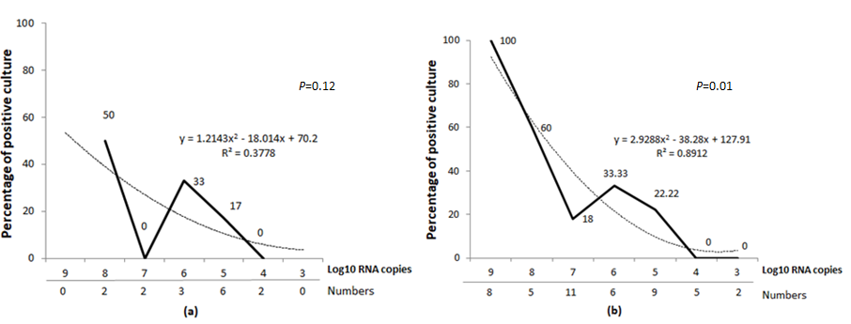
The numbers below the dash line on x-axis indicates total number of samples cultured. The dash curve indicates polynomial regression curve.
The direction and strength of correlation coefficient value (r) were characterized as follows: -1 as perfectly negative; -0.8, -0.5, -0.2 as strongly, moderately and weakly negative; 0 as no association; 0.2, 0.5, 0.8 as weakly, moderately and strongly positive and 1 as perfectly positive

