Figure S1:
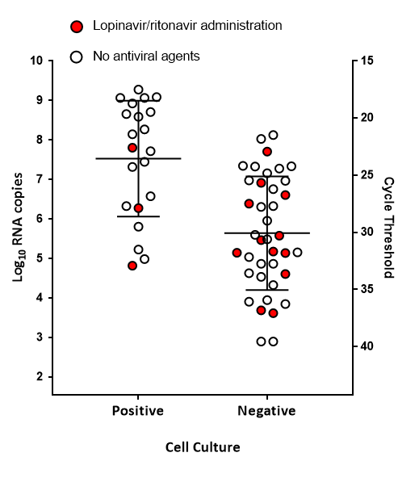
The SARS-CoV-2 cell culture tested specimens are plotted by log10 RNA copies/mL (y-axis) and are stratified by patients samples (n=15) who were administered with Lopinavir/ritonavir (red data points) with patients samples (n=45) who did not receive any antiviral agents (open circles). The lines indicates mean with standard deviation.

