Large-scale Plasma Proteomic Profiling Unveils Novel Diagnostic Biomarkers and Pathways for Alzheimer's Disease

Gyujin Heo^{1,2}*, Ying Xu^{1,2}*, Muhammad Ali^{1,2}, Hamilton Se-Hwee Oh^{3,4,5}, Patricia Moran Losada^{4,5,6}, Federica Anastasi^{7,8,9}, Armand González Escalante^{7,8,10}, Raquel Puerta^{11,12}, Erming Wang^{13,14}, Soomin Song^{1,2}, Jigyasha Timsina^{1,2}, Menghan Liu^{1,2}, Daniel Western^{1,2}, Katherine Gong^{1,2}, Yike Chen^{1,2}, Pat Kohlfeld^{1,2}, Allison Flynn^{1,2}, Alvin G. Thomas^{1,2}, Joseph Lowery^{1,2}, John C. Morris¹⁵, David M. Holtzman^{15,16,17}, Joel S. Perlmutter¹⁸, Suzanne E. Schindler¹⁵, Natalia Vilor-Tejedor^{7,8,9,19}, Marc Suárez-Calvet^{7,8,20}, Pablo García-González^{11,21}, Marta Marquié^{11,21}, Maria Victoria Fernández^{11,21}, Mercè Boada^{11,21}, Amanda Cano^{11,21}, Agustín Ruiz^{11,21,22}, Bin Zhang^{13,14,23,24,25}, David A. Bennett²⁶, Tammie Benzinger¹⁸, Tony Wyss-Coray⁵, Laura Ibanez^{1,2,15}, Yun Ju Sung^{1,2,27}, Carlos Cruchaga^{1,2,15,16,17}

* These authors contributed equally

Author Affiliations:
¹Department of Psychiatry, Washington University School of Medicine, St. Louis, MO, USA.
²NeuroGenomics and Informatics Center, Washington University, St. Louis, MO, USA.
³Graduate Program in Stem Cell and Regenerative Medicine, Stanford University, Stanford, CA, USA.
⁴The Phil and Penny Knight Initiative for Brain Resilience, Stanford University, Stanford, CA, USA.
⁵Wu Tsai Neurosciences Institute, Stanford University, Stanford, CA, USA.
⁶Department of Neurology and Neurological Sciences, Stanford University School of Medicine, Stanford, CA, USA.
⁷Barcelonaβeta Brain Research Center (BBRC), Pasqual Maragall Foundation, Barcelona, Spain.
⁸Hospital del Mar Research Institute, Barcelona, Spain.
⁹Centre for Genomic Regulation (CRG), Barcelona Institute of Science and Technology (BIST), Barcelona, Spain.
¹⁰Department of Medicine and Life Sciences, Universitat Pompeu Fabra, Barcelona, Spain.
¹¹Ace Alzheimer Center Barcelona, Universitat Internacional de Catalunya, Barcelona, Spain.
¹²PhD Program in Biotecnology, Faculty of Pharmacy and Food Sciences, University of Barcelona, Barcelona, Spain.
¹³Department of Genetics and Genomic Sciences, Icahn School of Medicine at Mount Sinai, New York, NY, USA.
¹⁴Mount Sinai Center for Transformative Disease Modeling, Icahn School of Medicine at Mount Sinai, New York, NY, USA.
¹⁵Department of Neurology, Washington University School of Medicine, St. Louis, MO, USA.
¹⁶Hope Center for Neurologic Diseases, Washington University, St. Louis, MO, USA.
¹⁷Knight Alzheimer's Disease Research Center, Washington University, St. Louis, MO, USA.
¹⁸Department of Radiology, Washington University School of Medicine, St. Louis, MO, USA.
¹⁹Department of Genetics, Radboud UMC, Nijmegen, Netherlands.
²⁰Servei de Neurologia, Hospital del Mar, Barcelona.
²¹Biomedical Research Networking Centre in Neurodegenerative Diseases (CIBERNED), National Institute of Health Carlos III, Madrid, Spain.
²²Glenn Biggs Institute for Alzheimer’s & Neurodegenerative Diseases, University of Texas Health Science Center, San Antonio, TX, USA.
²³Department of Pharmacological Sciences, Icahn School of Medicine at Mount Sinai, New York, NY, USA.
²⁴Department of Artificial Intelligence and Human Health, Icahn School of Medicine at Mount Sinai, New York, NY, USA.
²⁵Icahn Genomics Institute, Icahn School of Medicine at Mount Sinai, New York, NY, USA.
²⁶Rush Alzheimer’s Disease Center, Rush University Medical Center, Chicago, IL, USA.
²⁷Division of Biostatistics, Washington University School of Medicine, St. Louis, MO, USA.

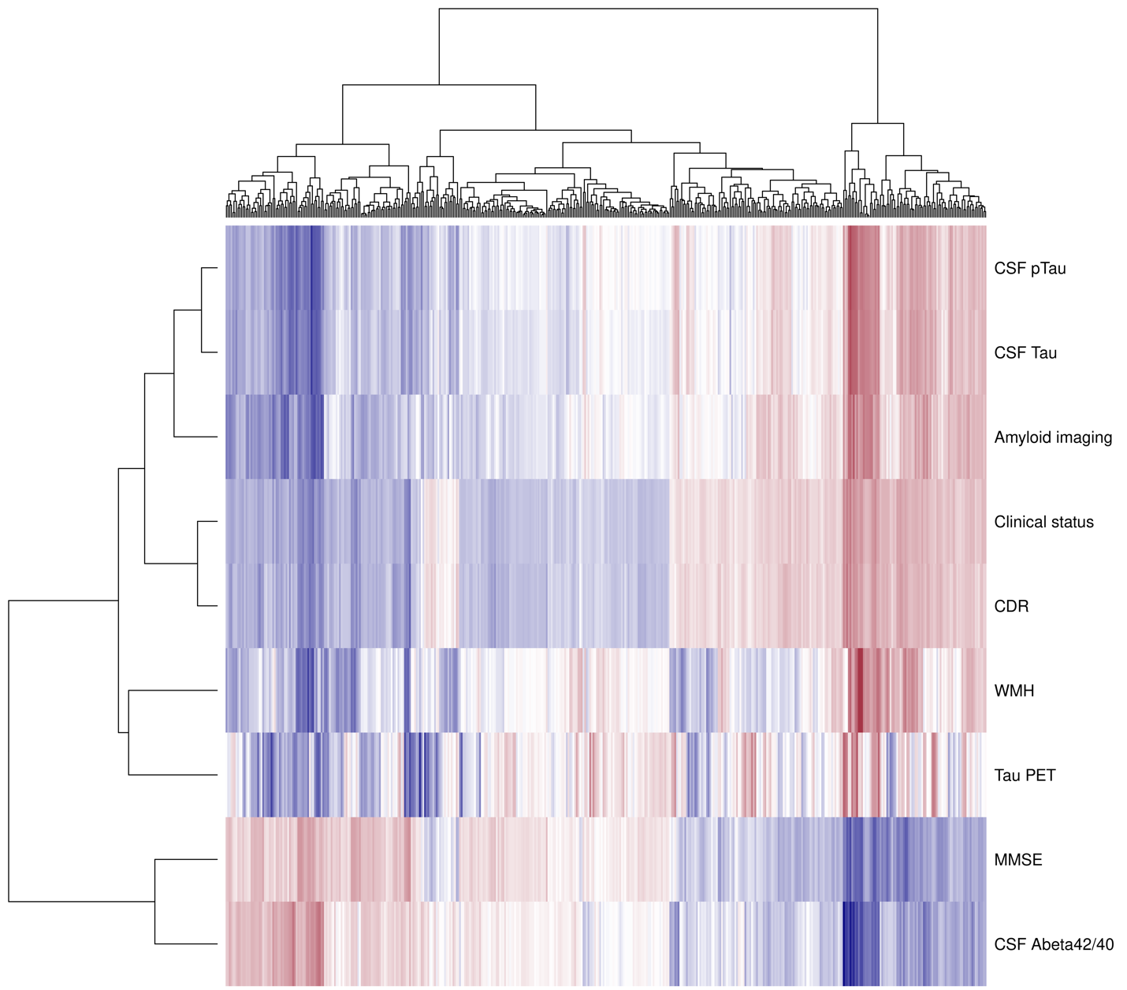

Supplementary Figure 1. Correlation between proteins and AD-related phenotypes. Heatmap showing correlations between 456 significant aptamers and AD-related phenotypes.
Abbreviations: CSF, Cerebrospinal fluid; pTau, Phosphorylated tau; CDR, Clinical Dementia Rating; WMH, White matter hyperintensities; PET, Positron emission tomography; MMSE, Mini-Mental State Examination; Abeta, amyloid beta.
Supplementary Figure 2. Odd Ratio (OR) Analyses of 456 Significant Proteins. (A) Histogram showing the distribution of transformed Odds Ratios (OR) across 456 significant proteins. (B) Violin plot of Odds Ratios (OR) for the same 456 significant proteins. The red (upper) and blue (lower) sections highlight proteins with OR > 1 and OR < 1, respectively. The dashed line represents an OR of 1.

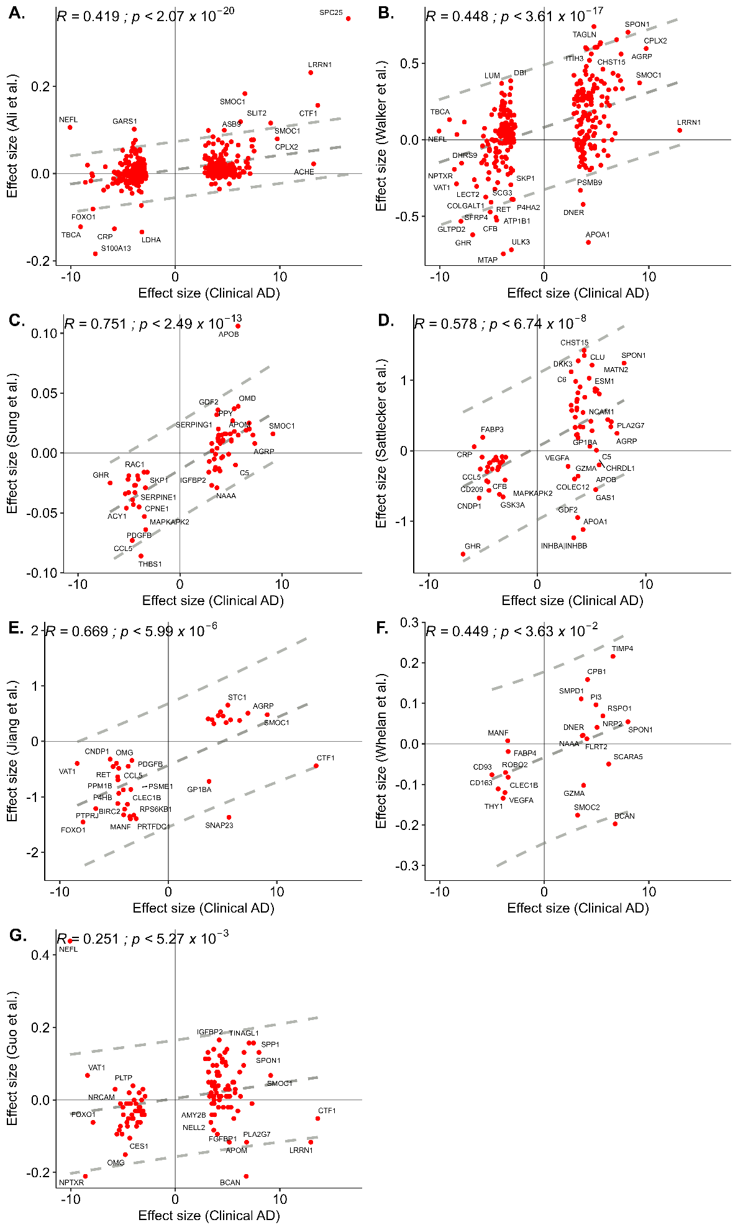
Supplementary Figure 3. Effect Size Comparisons with Other Studies. Effect size comparisons between the current study and other previous studies are shown for overlapping proteins. Pearson correlation coefficient and p-value across studies are noted in each panel. (A) Comparison with Ali et al. (B) Comparison with Walker et al. (C) Comparison with Sung et al. (D) Comparison with Sattlecker et al. (E) Comparison with Jiang et al. (F) Comparison with Whelan et al. (G) Comparison with Guo et al.
Abbreviations: R, correlation.
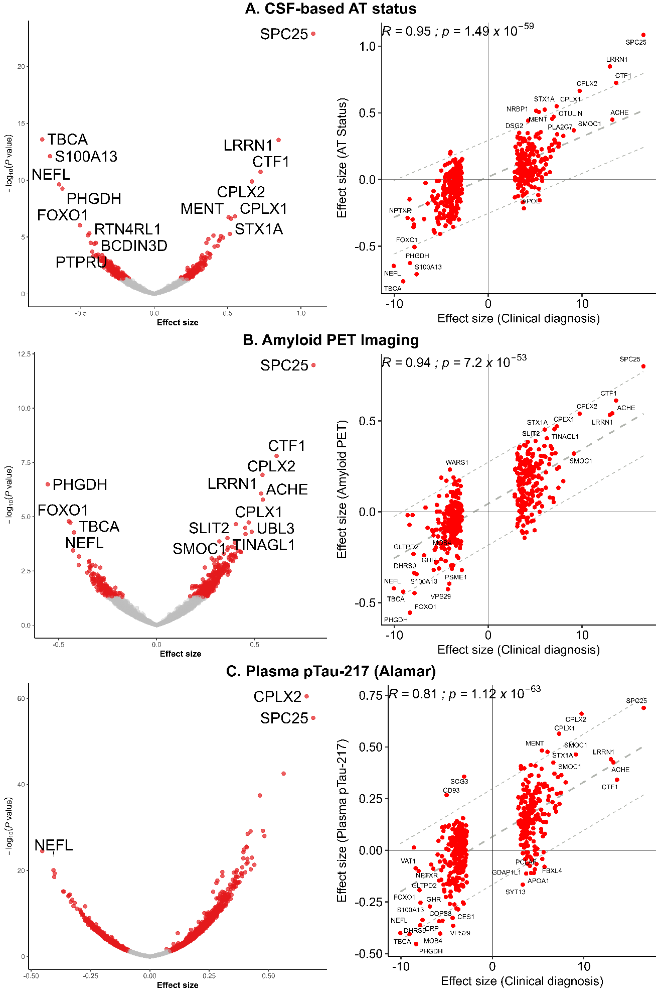
Supplementary Figure 4. Analysis of AD Biomarkers. Volcano plots and scatter plots illustrate the differences in protein abundances across key AD biomarkers. For each biomarker analysis, volcano plots highlight proteins with significantly different abundances between comparison groups, and scatter plots compare effect sizes with those from the meta-analysis of clinical status of AD. The central dotted line in the dashed plots represents the comparison pattern, while the outer lines mark the 95% confidence interval. (A) CSF-based AT status: Proteins with differing abundances between AT- and AT+ groups. (B) Amyloid PET imaging: Proteins with differing abundances between A- and A+ groups. (C) Plasma p-tau217: Proteins with differing abundances between T- and T+ groups.
Abbreviations: CSF, Cerebrospinal fluid; pTau, Phosphorylated tau; R, Correlation; PET, Positron emission tomography; AT, Amyloid-Tau.

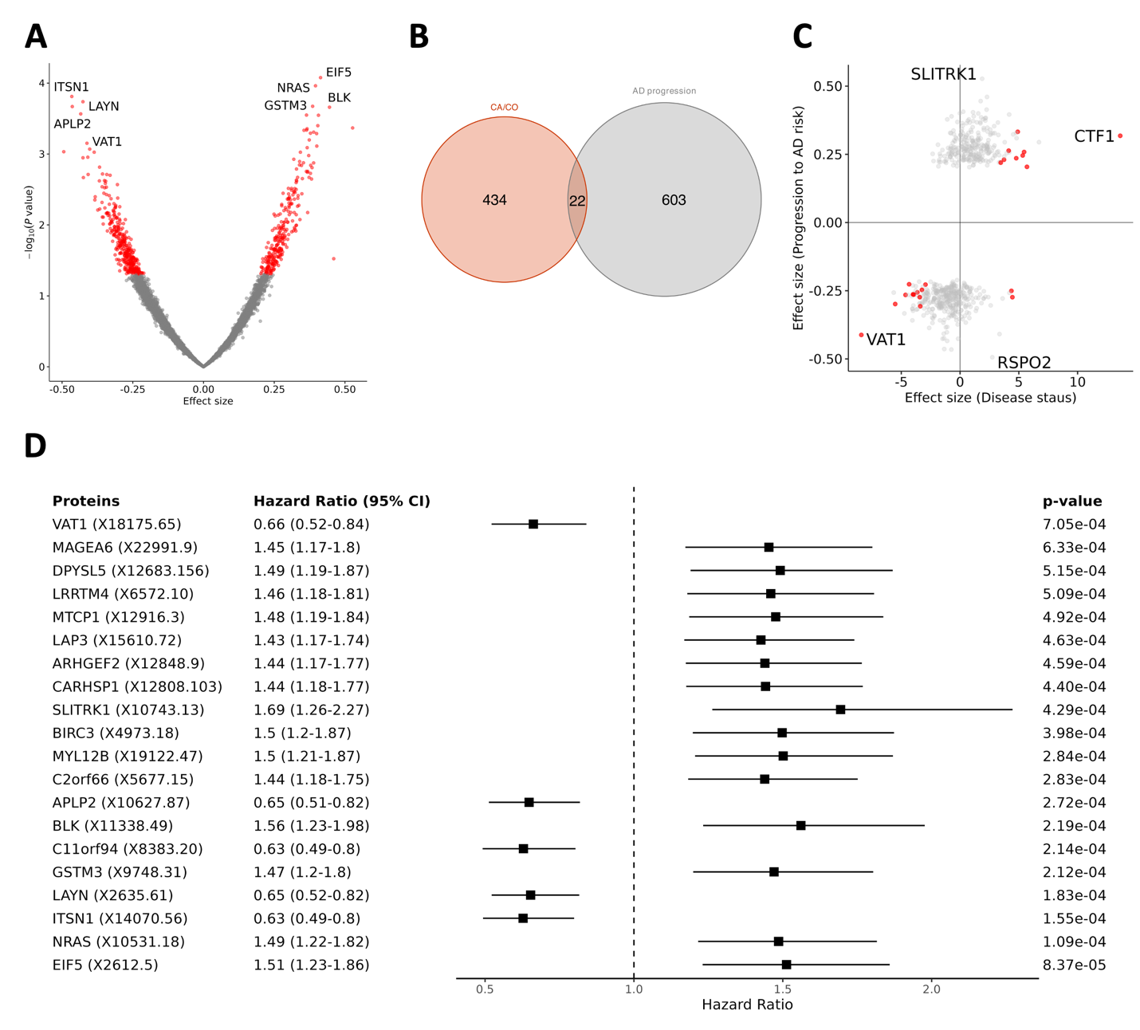
Supplementary Figure 5. Analysis of progression to symptomatic Alzheimer’s Disease with single aptamers. (A) Volcano plot displaying protein associations with progression to symptomatic Alzheimer’s disease (AD). Proteins in red were nominally significant (p < 0.05). (B) Venn diagram showing the overlap between proteins significant in the clinical diagnosis of AD (orange) and those significant in progression to symptomatic AD (gray). (C) Scatter plot comparing effect sizes between the meta-analysis (x-axis) and the analysis of progression to symptomatic AD (y-axis) for proteins significant in the progression to symptomatic AD analysis. Points in red are significant proteins in both analyses. (D) Forest plot showing the hazard ratios of the top 20 aptamers from the progression to symptomatic AD with Cox proportional hazards model.
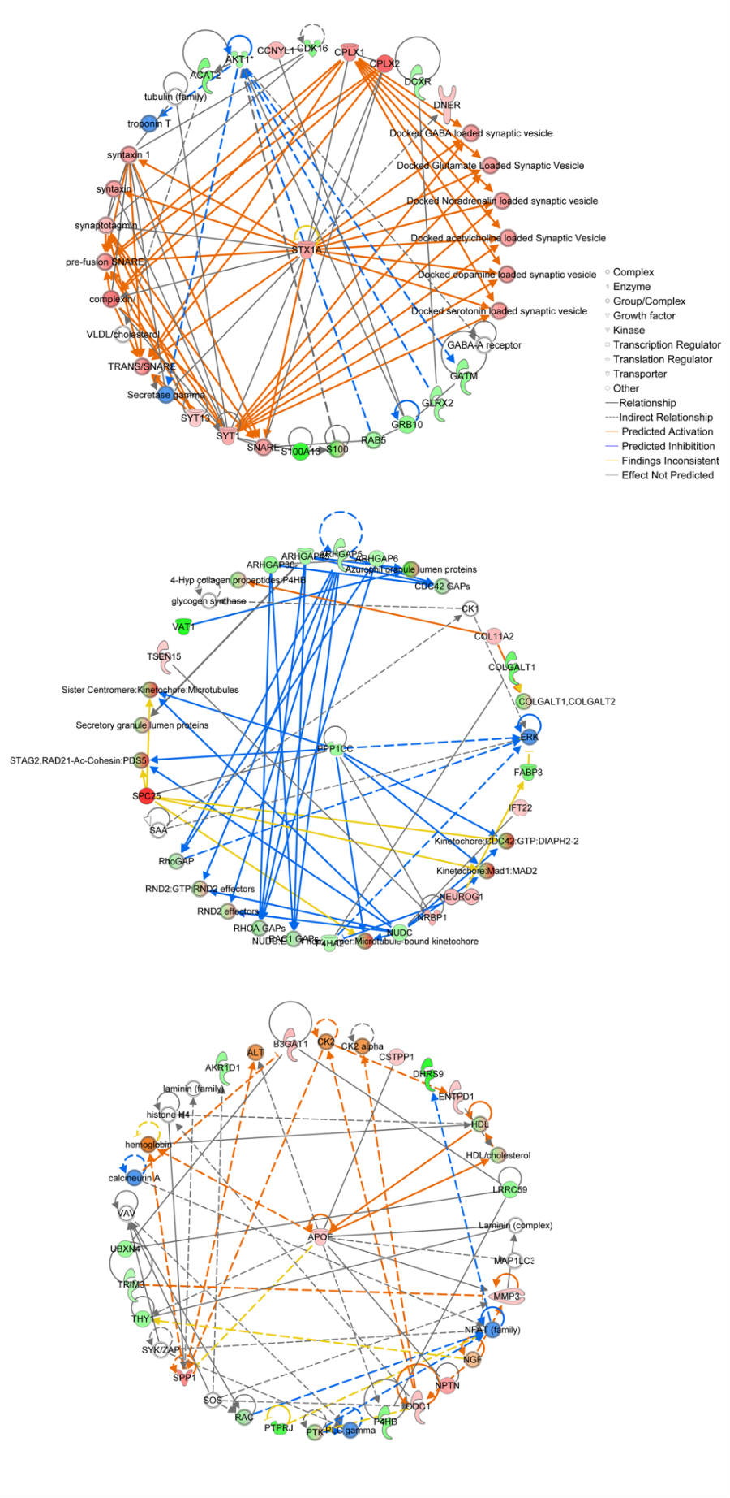
Supplementary Figure 6. Interaction Networks Identified by IPA Analysis Three interaction networks identified using Ingenuity Pathway Analysis (IPA). The color-coded nodes represent various types of molecules and edges indicate predicted interactions between them.
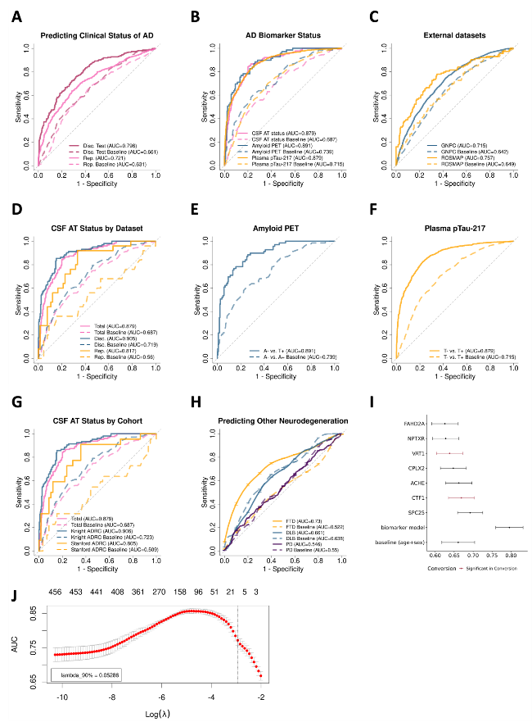
Supplementary Figure 7. Evaluation of the Model’s Predictive Performance. (A) Receiver Operating Characteristic (ROC) curves evaluating the predictive power in classifying clinical Alzheimer’s disease (AD). The following datasets were used: test set from the Discovery dataset with the proteomic model (solid black) and baseline model (dashed black), and the Replication dataset with the proteomic model (solid orange), baseline model (dashed orange), and baseline model including APOE ε4 genotype (pink).
(B) ROC curves evaluating the model's predictive power in classifying AD biomarkers. The biomarkers included: CSF-based AT status with the proteomic model (solid orange) and baseline model (dashed orange), amyloid PET imaging with the proteomic model (solid pink) and baseline model (dashed pink), and plasma p-tau217 with the proteomic model (solid blue) and baseline model (dashed blue).
(C) ROC curves evaluating the model's predictive power external datasets. ROSMAP (solid orange) and baseline model (dashed orange), GNPC (solid blue) and baseline model (dashed blue).
(D) ROC curves evaluating the model's predictive power for CSF-based AT status (AT- vs. AT+) by dataset. The following datasets were used: both datasets with the proteomic model (solid orange) and baseline model (dashed orange), discovery dataset with the proteomic model (solid pink) and baseline model (dashed pink), and replication dataset with the proteomic model (solid blue) and baseline model (dashed blue).
(E) ROC curves evaluating the model's predictive power in classifying amyloid PET imaging status (A- vs. A+) with the proteomic model (solid pink) and baseline model (dashed pink).
(F) ROC curves assessing the model's predictive power in classifying plasma p-tau217 status (T- vs. T+) with the proteomic model (solid blue) and baseline model (dashed blue).
(G) ROC curves evaluating the model's predictive power in classifying CSF-based AT status (AT- vs. AT+) by cohort. The following cohorts were analyzed: both cohorts with the proteomic model (solid orange) and baseline model (dashed orange), Knight ADRC with the proteomic model (solid pink) and baseline model (dashed pink), and Stanford ADRC with the proteomic model (solid blue) and baseline model (dashed blue).
(H) ROC curves evaluating the predictive power in classifying other neurodegenerative diseases. The following diseases were analyzed: DLB with the proteomic model (solid orange) and baseline model (dashed orange), FTD with the proteomic model (solid pink) and baseline model (dashed pink), and PD with the proteomic model (solid blue) and baseline model (dashed blue).
(I) Whisker plot illustrating the Area Under the Curve (AUC) for 7 aptamers used in the predictive model, along with the AUCs for both the baseline and proteomic models.
(J) Plot illustrating the change in mean AUC from cross-validation as the lambda value for lasso regression changes. The numbers on the upper x-axis indicate the number of selected variables in lasso regression, with the selected lambda value marked by a dotted line.
Abbreviations: AD, Alzheimer's disease; Disc, Discovery; Rep, Replication; CSF, Cerebrospinal fluid; PET, Positron emission tomography; pTau, Phosphorylated tau; FTD, Frontotemporal dementia; DLB, Dementia with Lewy bodies; PD, Parkinson's disease; Lambda_90%, 90th percentile of the lambda distribution.

Supplementary Figure 8. AUCs with prediction models using different biomarkers. (A) The plot provides a comparison of Receiver Operating Characteristic curves for various aptamers in Alamar platform (pTau-217, pTau-181, NEFL, Aβ40, Aβ42, and GFAP) in distinguishing Alzheimer's Disease (AD) from cognitively normal (CO) controls. The curves were generated by fitting logistic regression models that include age and sex as covariates. The SomaLogic Analysis represents the model used in our study. (B) The whisker plot displays the AUC values for different aptamers, showing the performance of each in terms of classification ability (as evaluated by AUC). Horizontal lines (whiskers) indicate the confidence intervals for each AUC value. pTau-217 and our model both show relatively high AUC values (0.798 and 0.794, respectively), suggesting strong classification performance.

Supplementary Figure 9. Orthogonal validation of the SomaLogic-based model on the Alamar and Olink platforms. (A) Demographic information for the Knight ADRC and Stanford ADRC cohorts, including details on age (with standard deviation), percentage of males, and proportion of APOE4+ individuals for each group. (B–D) Comparison of the predictive power of proteins between SomaLogic and Alamar platforms. (B) ROC curves showing the predictive power of single-protein models, adjusted for sex and age. (C) ROC curves for two-protein models, adjusted for sex and age. (D) Whisker plot showing AUC values for two-protein models in predicting CSF AT status, amyloid PET status, and pTau217 positivity, with adjustments for sex and age. The whisker plot includes 95% confidence intervals. (E–G) Comparison of the predictive power of proteins between SomaLogic and Olink platforms. (E) ROC curves comparing single-protein models, adjusted for sex, age, and plate ID. (F) ROC curves for four-protein models, adjusted for sex, age, and plate ID. (G) Whisker plot showing AUC values for single-protein models, adjusted for sex, age, and plate ID, with 95% confidence intervals. (H) Statistical metrics from the replication analysis, including AUC, positive predictive value (PPV), negative predictive value (NPV), specificity, sensitivity, and accuracy, are provided for each model. Abbreviations: AUC, Area under the curve; PPV, Positive predictive value; NPV, Negative predictive value.
Supplementary Figure 10. Orthogonal validation of the SomaLogic-based model on the Olink platform in Stanford ADRC cohort. (A) Demographic information for the Olink platform data in the Stanford ADRC cohort, including age (with standard deviation), percentage of males, and proportion of APOE4+ individuals for each group. (B) ROC curves of individual aptamers in distinguishing AD from CO, with all models adjusted for sex, age, and Plate ID. (C) ROC curves of a four-protein model on the Olink platform, adjusted for sex, age, and Plate ID. (D) Whisker plot showing AUCs of individual-protein and four-protein models across platforms for predicting clinical status of AD with 95% confidence intervals. (E) Statistical metrics from the replication analysis, including AUC, positive predictive value (PPV), negative predictive value (NPV), specificity, sensitivity, and accuracy, are provided for each model.
Abbreviations: AUC, Area under the curve; PPV, Positive predictive value; NPV, Negative predictive value.
Supplementary Figure 11. Orthogonal validation of the SomaLogic-based model on the Olink platform in BBRC & FACE cohort. (A) Demographic information for the Olink platform data in the BBRC cohort, including age (with standard deviation) and percentage of males. (B) ROC curves of a four-protein model on both the Soma and Olink platform, adjusted for sex and age. (C) ROC curves of a seven-protein model on the Soma platform, adjusted for sex and age. (D) Demographic information for the Olink platform data in the FACE cohort, including age (with standard deviation) and percentage of males. (E, F) ROC curves of single-protein model on both the Soma and Olink platform, adjusted for sex and age. (G) Statistical metrics from the replication analysis, including AUC, positive predictive value (PPV), negative predictive value (NPV), specificity, sensitivity, and accuracy, are provided for each model. Abbreviations: AUC, Area under the curve; PPV, Positive predictive value; NPV, Negative predictive value.
Supplementary Figure 12. Progression Analysis Based on Different Biomarkers. Kaplan-Meier survival curves illustrate the progression to AD after the initial blood draw based on different biomarker groups, illustrating the proportion of participants from each group remaining cognitively normal over the follow-up period. (A) Predicted negative group (green line) and predicted positive group (red line). (B) T- group (blue line) and T+ group (orange line) from plasma pTau-217. (C) A merged plot displaying all four groups (predicted negative, predicted positive, T-, and T+) for a comprehensive comparison of progression patterns. (D) ROC curves evaluating the model's predictive power in classifying progression to symptomatic AD, with three follow-up periods: 5-year (orange), 10-year (pink), and 15-year (blue).
Abbreviations: pTau, Phosphorylated tau.

Supplementary Figure 13. Analysis of progression in cognitive impairment and progression to symptomatic AD with predictive mode. (A-C) Changes in Cognitive Dementia Rating-Sum of Boxes (CDR-SB) scores (y-axis) over time (x-axis) in (A) both groups, (B) the Alzheimer's disease (AD) group, and (C) the cognitively normal group, as categorized by the prediction model. (D-F) Boxplots showing the rate of CDR-SB changes per year in (D) both groups, (E) the AD group, and (F) the cognitively normal group, categorized by the prediction model.
Abbreviations: CDR-SB, Clinical Dementia Rating Scale-Sum of Boxes; CO, Control; AD, Alzheimer's disease.
Supplementary Figure 14. Validation of technical and biological variance. (A) Upset plot showing overlap across multiple batches (Batch_1, Batch_2, Batch_3). (B) Distribution of correction factors for duplicated samples. (C) Distribution of correction factors across 7k proteins. (D) Top 5 significant correction factors at both the duplicated sample level and protein level.

