Hematopoietic cell transplantation for inborn errors of immunity other than severe combined immunodeficiency in Japan: Retrospective analysis for 1985–2016

Satoshi Miyamoto, Katsutsugu Umeda, Mio Kurata, Masakatsu Yanagimachi, Akihiro Iguchi, Yoji Sasahara, Keiko Okada, Takashi Koike, Reo Tanoshima, Masataka Ishimura, Masafumi Yamada, Maho Sato, Yoshiyuki Takahashi, Michiko Kajiwara, Hiroshi Kawaguchi, Masami Inoue, Yoshiko Hashii, Hiromasa Yabe, Koji Kato, Yoshiko Atsuta, Kohsuke Imai, Tomohiro Morio

*Corresponding Author:
Kohsuke Imai, MD, PhD
Department of Community Pediatrics, Perinatal, and Maternal Medicine, Tokyo Medical and Dental University (TMDU)
1–5–45, Yushima, Bunkyo-ku, Tokyo 113–8519, Japan
Phone: +81–3–5803–5249; Fax: +81–3–5803–0378; Email: kimai.ped@tmd.ac.jp

Table S1: Association between disease category and other factors
Characteristics (Number of patients evaluated) | Overall | CID | WAS | HPS | PCD | others | P value
Age at Diagnosis (n=552) |  |  |  |  |  |  | < 0.001ª
0 years | 315 (57%) | 21 (47%) | 78 (70%) | 77 (60%) | 121 (61%) | 18 (26%)
1~4 years | 144 (26%) | 19 (42%) | 21 (19%) | 24 (19%) | 54 (27%) | 26 (38%)
5~9 years | 49 (9%) | 4 (9%) | 10 (9%) | 8 (6%) | 11 (6%) | 16 (23%)
10~19 years | 36 (7%) | 1 (2%) | 2 2%) | 14 (11%) | 12 (6%) | 7 (10%)
20~ years | 8 (1%) | 0 (0%) | 1 (1%) | 5 (4%) | 0 (0%) | 2 (3%)
Median years old | 0 (0-64) | 1 (0–12) | 0 (0–22) | 0 (0-64) | 0 (0–19) | 2 (0–44)
Age at HCT (n=567) |  |  |  |  |  |  | < 0.001ª
0 years | 100 (18%) | 5 (11%) | 30 (25%) | 46 (36%) | 12 (6%) | 7 (10%)
1~4 years | 205 (36%) | 19 (40%) | 63 (53%) | 47 (36%) | 58 (29%) | 18 (25%)
5~9 years | 89 (16%) | 5 (11%) | 9 (8%) | 14 (11%) | 42 (21%) | 19 (26%)
10~19 years | 115 (20%) | 17 (36%) | 11 (9%) | 15 (12%) | 57 (28%) | 15 (21%)
20~ years | 58 (10%) | 1 (2%) | 5 (4%) | 7 (5%) | 32 (16%) | 13 (18%)
Median years old | 4 (0-69) | 4 (0–20) | 1 (0-29) | 1 (0-69) | 7 (0–39) | 6.5 (0–44)
Respiratory impairment at HCT (n=443) |  |  |  |  |  |  | < 0.001^{b}
Yes | 41 (9%) | 4 (11%) | 1 (1%) | 4 (4%) | 23 (14%) | 9 (16%)
No | 402 (91%) | 31 (89%) | 85 (99%) | 92 (96%) | 147 (86%) | 47 (84%)
Bacterial or Fungal Infection at HCT (n=443) |  |  |  |  |  |  | < 0.001^{b}
Yes | 95 (21%) | 4 (11%) | 16 (19%) | 8 (8%) | 56 (33%) | 11 (19%)
No | 348 (79%) | 31 (89%) | 69 (81%) | 90 (92%) | 112 (67%) | 46 (81%)
Conditioning (n=543) |  |  |  |  |  |  | < 0.001^{b}
MAC | 222 (41%) | 24 (56%) | 73 (69%) | 48 (38%) | 62 (31%) | 15 (21%)
RIC | 321 (59%) | 19 (44%) | 33 (31%) | 77 (62%) | 137 (69%) | 55 (79%)
Donor Type (n=566) |  |  |  |  |  |  | < 0.001^{b}
MSD | 129 (23%) | 15 (32%) | 16 (14%) | 20 (16%) | 60 (30%) | 18 (25%)
URCB | 157 (28%) | 13 (28%) | 35 (30%) | 69 (53%) | 24 (12%) | 16 (23%)
ORD | 61 (11%) | 2 (4%) | 19 (16%) | 9 (7%) | 21 (10%) | 10 (14%)
URBM | 219 (39%) | 17 (36%) | 48 (41%) | 31 (24%) | 96 (48%) | 27 (38%)
ªKruskal–Wallis test; ^{b}Fisher’s exact test
WAS, Wiskott–Aldrich syndrome; CID, combined immunodeficiency; HPS, hemophagocytic syndrome; PCD, phagocytic disorder; HCT, Hematopoietic cell transplantation; MAC, myeloablative conditioning; RIC, reduced-intensity conditioning; MSD, matched sibling donor; URCB, unrelated cord blood; ORD, other related donor; URBM, unrelated bone marrow
Characteristics (Number of patients evaluated) | Overall | ~2005 | 2006~ | P value | Characteristics (Number of patients evaluated) | Overall | ~2005 | 2006~ | P value
Age at Diagnosis (n=552) |  |  |  | 0.10ª | GVHD prophylaxis (n=565) |  |  |  | < 0.001^{b}
0 years | 315 (57%) | 116 (62%) | 199 (54%) |  | Cyclosporine | 213 (38%) | 138 (70%) | 75 (20%)
1~4 years | 144 (26%) | 42 (22%) | 102 (28%) |  | Tacrolimus | 329 (58%) | 49 (25%) | 280 (76%)
5~9 years | 49 (9%) | 18 (10%) | 31 (8%) |  | None | 6 (1%) | 5 (3%) | 1 (0.3%)
10~19 years | 36 (7%) | 10 (5%) | 26 (7%) |  | Other | 17 (3%) | 6 (3%) | 11 (3%)
20~ years | 8 (1%) | 0 (0%) | 8 (2%) |  | Donor Type (n=567) |  |  |  | < 0.001^{c}
Median years old (range) | 0 (0-64) | 0 (0–18) | 0 (0–64) |  | Bone marrow | 383 (68%) | 134 (67%) | 249 (68%)
Age at HCT (n=567) |  |  |  | 0.38ª | MSD | 117 (21%) | 45 (34%) | 62 (25%)
0 years | 100 (18%) | 30 (15%) | 70 (19%) |  | MORD | 7 (1%) | 3 (2%) | 4 (2%)
1~4 years | 205 (36%) | 82 (41%) | 123 (34%) |  | mMORD | 40 (7%) | 24 (18%) | 16 (6%)
5~9 years | 89 (16%) | 34 (17%) | 55 (15%) |  | URBM | 219 (39%) | 52 (26%) | 167 (67%)
10~19 years | 115 (20%) | 42 (21%) | 73 (20%) |  | Cord blood | 160 (28%) | 55 (28%) | 105 (29%)
20~ years | 58 (10%) | 12 (6%) | 46 (13%) |  | URCB | 157 (28%) | 53 (27%) | 104 (28%)
Median years old (range) | 4 (0-69) | 4 (0–38) | 4 (0–69) |  | MSD | 2 (0.4%) | 1 (0.5%) | 1 (0.3%)
Time from diagnosis to HCT (n=552) |  |  |  | 0.73ª | mMORD | 1 (0.2%) | 1 (0.5%) | 0 (0%)
~1 year | 223 (40%) | 71 (38%) | 152 (42%) |  | Peripheral blood | 24 (4%) | 11 (6%) | 13 (4%)
1~3 years | 112 (20%) | 46 (25%) | 66 (18%) |  | MSD | 11 (2%) | 4 (2%) | 7 (2%)
3~6 years | 76 (14%) | 23 (12%) | 53 (14%) |  | mMORD | 13 (2%) | 7 (4%) | 6 (2%)
6~10years | 42 (8%) | 15 (8%) | 27 (7%) |  | Disease category (n=567) |  |  |  | < 0.001^{b}
10 years~ | 99 (18%) | 31 (17%) | 68 (19%) |  | Combined immunodeficiency | 47 (8%) | 19 (10%) | 28 (8%)
Median years (range) | 1.7 (0-36.8) | 1.4 (0–31.0) | 1.8 (0–36.8) |  | Wiskott-Aldrich syndrome | 118 (21%) | 60 (30%) | 58 (16%)
Conditioning (n=543) |  |  |  | < 0.001^{b} | Hemophagocytic syndrome | 129 (23%) | 47 (24%) | 82 (22%)
MAC | 222 (41%) | 123 (70%) | 99 (27%) |  | Phagocytic disorder | 201 (35%) | 54 (27%) | 147 (40%)
RIC | 321 (59%) | 53 (30%) | 268 (73%) |  | others | 72 (13%) | 20 (10%) | 52 (14%)
Table S2: Comparisons of pre-transplant condition of the patients by the period of HCT
ªMann–Whitney U test; ^{b}Fisher’s exact test; ^{c}Fisher’s exact test was performed with the following variables: MSD, URCB, other related donor (MORD + mMORD), and URBM.
HCT, Hematopoietic cell transplantation; MAC, myeloablative conditioning; RIC, reduced-intensity conditioning; GVHD, graft-versus-host-disease; MSD, matched sibling donor; MORD, matched other related donor; mMORD, mismatched other related donor; URBM, unrelated bone marrow; URCB, unrelated cord blood

Table S3: Factors affecting the incidence of retransplantation
Factors |  | Univariate analysis |  |  | Multivariate analysis
Factors |  | Cumulative incidence at 10-year (95% CI) | P value |  | HR (95% CI) | P value
Donor Type |  |  | < 0.001
MSD | 129 | 11% (5–18%) |  |  | 1
URCB | 157 | 21% (14–29%) |  |  | 3.8 (1.8–7.9) | < 0.001
ORD | 61 | 20% (10–31%) |  |  | 3.0 (1.3–6.9) | 0.01
URBM | 219 | 6% (3–10%) |  |  | 0.8 (0.4–1.8) | 0.58
Disease category |  |  | 0.25
Wiskott-Aldrich syndrome | 118 | 10% (5–16%) |  |  | 1
Combined immunodeficiency | 47 | 14% (5–26%) |  |  | 1.7 (0.6–4.6) | 0.30
Hemophagocytic syndrome | 129 | 11% (6–19%) |  |  | 0.8 (0.4–1.9) | 0.68
Phagocytic disorder | 201 | 19% (13–27%) |  |  | 2.5 (1.2–5.1) | 0.02
Others | 72 | 6% (2–13%) |  |  | 0.8 (0.2–2.5) | 0.66
CI, confidence interval; HR, hazard ratio; MSD, matched sibling donor; URCB, unrelated cord blood; ORD, other related donor; URBM, unrelated bone marrow.

Table S4: Association of post-HCT infection and donor type
Infectious events | MSD | URCB | URBM | ORD | P valueª
CMV infection (n=444)
CMV infection after HCT^{b} | 4 (5%) | 6 (4%) | 6 (3%) | 0 (0%) | 0.78
CMV infection (−) | 78 (95%) | 147 (96%) | 172 (97%) | 31 (100%)
Other viral infection (n=442)
Other viral infection after HCT^{b} | 14 (17%) | 12 (8%) | 46 (26%) | 5 (21%) | < 0.001
Other viral infection (−) | 67 (83%) | 140 (92%) | 134 (74%) | 24 (79%)
Fungal infection (n=496)
Fungal infection after HCT^{b} | 5 (4%) | 9 (6%) | 17 (10%) | 4 (7%) | 0.25
Fungal infection (−) | 116 (96%) | 139 (94%) | 150 (90%) | 56 (93%)
Bacterial infection (n=422)
Bacterial infection after HCT^{b} | 20 (25%) | 63 (42%) | 50 (30%) | 9 (39%) | 0.03
Bacterial infection (−) | 61 (75%) | 87 (58%) | 118 (70%) | 14 (61%)
ªFisher’s exact test
^{b}The patients who lack the date of diagnosis of infection were excluded.
MSD, matched sibling donor; URCB, unrelated cord blood; URBM, unrelated bone marrow; ORD, other related donor; CMV, cytomegalovirus; HCT, hematopoietic cell transplantation.

Table S5: Association between cause of death and conditioning regimen in the deceased patients
Cause of death | MAC | RIC | P value
 | n=55 | n=71 | 0.0496ª
Infection | 24 (44%) | 18 (25%)
Pulmonary (non-infection) | 14 (25%) | 17 (24%)
Others (non-infection) | 17 (31%) | 36 (51%)
ªFisher’s exact test
MAC, myeloablative conditioning; RIC, reduced-intensity conditioning

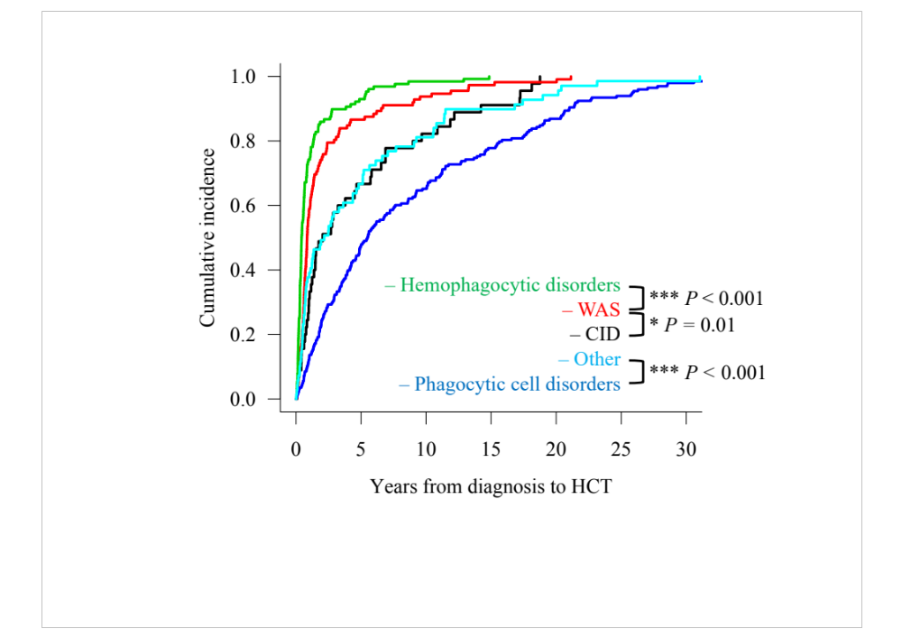
Fig. S1 Years from diagnosis to HCT according to the disease category
The cumulative incidences of HCT according to the disease category are shown. P values were calculated by Mann–Whitney U tests with Bonferroni adjustment for pairwise comparisons. HCT, hematopoietic cell transplantation; WAS, Wiskott–Aldrich syndrome, CID, combined immunodeficiency.

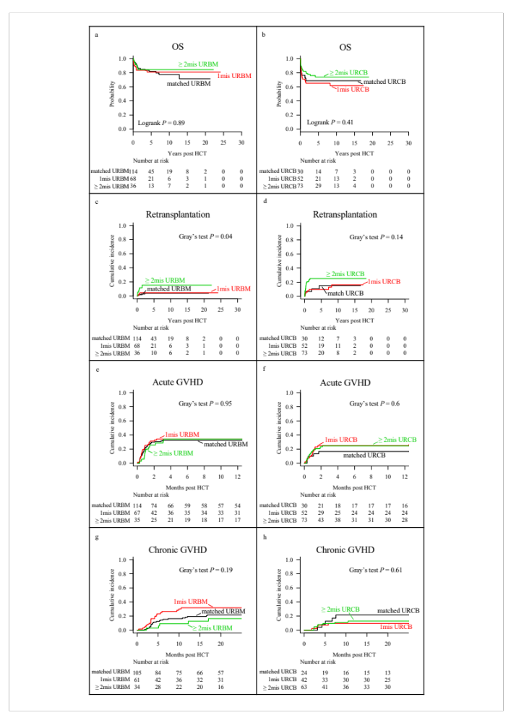
Fig. S2 The outcome of the HCT from unrelated donors according to HLA disparity
Patients who received transplantation from 7/8 or 5/6 antigen-matched donor were classified as “1mis” and HLA disparity more than 1mis was classified as “≥2mis”. According to the HLA disparities in URBM and URCB, we analyzed the following outcomes: (a and b, respectively) Kaplan–Meyer survival curves for OS, (c and d, respectively) the cumulative incidences of retransplantation, (e and f, respectively) the cumulative incidences of grade II–IV acute GVHD, and (g and h, respectively) the cumulative incidences of chronic GVHD. OS, overall survival; HCT, hematopoietic cell transplantation; URBM, unrelated bone marrow; URCB, unrelated cord blood; GVHD, graft-versus-host disease.
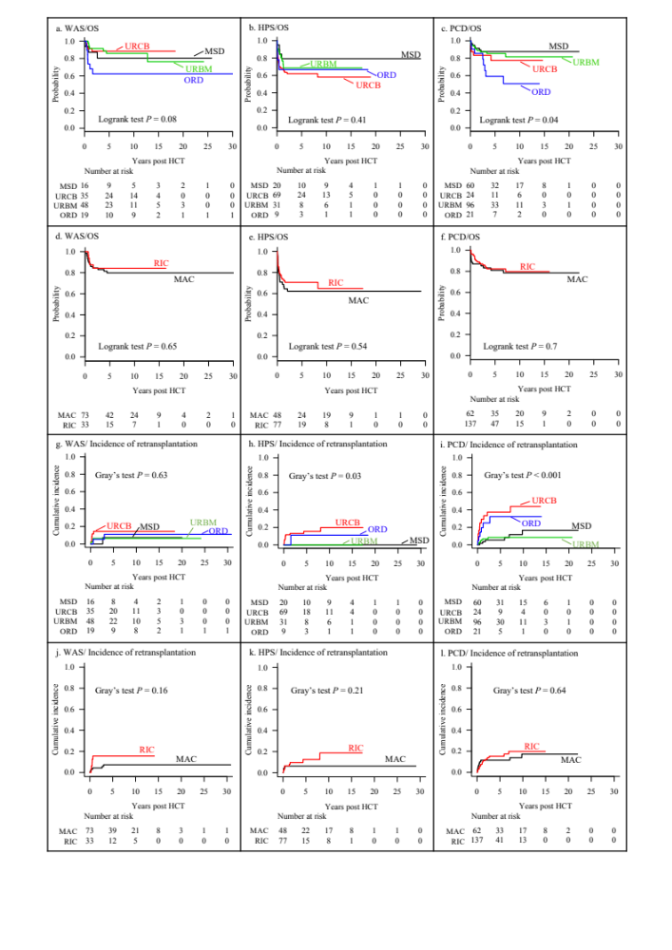
Fig. S3 Univariate analysis for each disease category
The OS according to donor type for the patients with (a) WAS, (b) HPS, and (c) PCD, and the OS according to conditioning regimen for patients with (d) WAS, (e) HPS, and (f) PCD are shown. The cumulative incidences of retransplantation according to donor type for the patients with (g) WAS, (h) HPS, and (i) PCD, and the cumulative incidences of retransplantation according to conditioning regimen for the patients with (j) WAS, (k) HPS, and (l) PCD are shown. WAS, Wiskott–Aldrich syndrome; OS, overall survival; HCT, hematopoietic cell transplantation; MSD, matched sibling donor; URCB, unrelated cord blood; URBM, unrelated bone marrow; ORD, other related donor; HPS, hemophagocytic syndrome; PCD, phagocytic disorder.
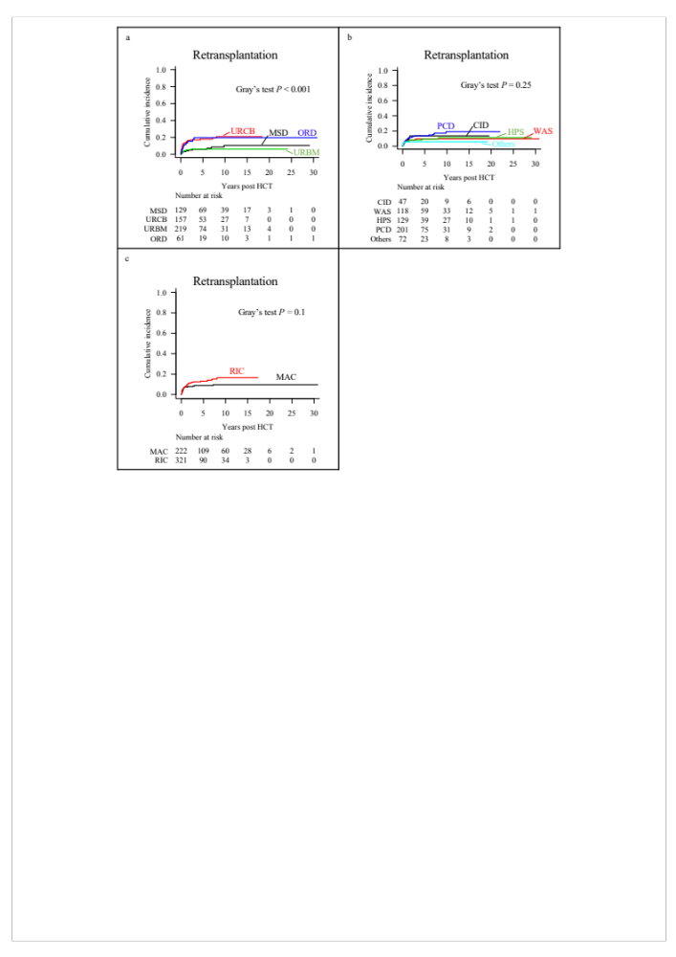
Fig. S4 The cumulative incidences of retransplantation
The cumulative incidences of retransplantation according to (a) donor type, (b) disease category, and (c) conditioning regimen are shown. HCT, hematopoietic cell transplantation; MSD, matched sibling donor; URCB, unrelated cord blood; URBM, unrelated bone marrow; ORD, mismatched related donor; CID, combined immunodeficiency; WAS, Wiskott–Aldrich syndrome; HPS, hemophagocytic syndrome; PCD, phagocytic disorder; MAC, myeloablative conditioning; RIC, reduced-intensity conditioning.

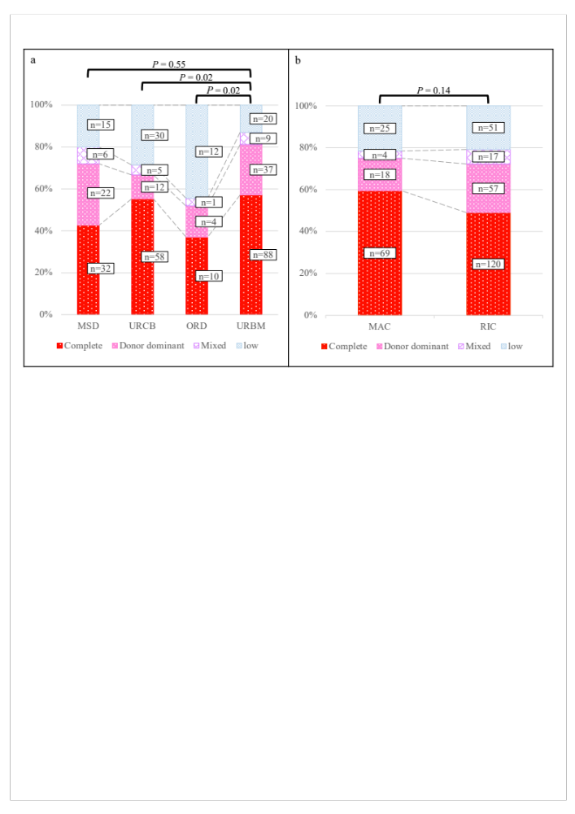
Fig. S5 Donor type chimerism
Donor type chimerism is classified into four groups: “complete,” “donor dominant,” “mixed,” and “low,” which is also described in “Methods.” Each column represents the percentage of patients in each chimerism group according to (a) donor type and (b) conditioning regimen. The actual numbers of the patients are represented in the box. The pairwise comparisons were calculated by Fisher’s exact test with Bonferroni adjustment. MSD, matched sibling donor; URCB, unrelated cord blood; ORD, other related donor; URBM, unrelated bone marrow; MAC, myeloablative conditioning; RIC, reduced-intensity conditioning.

