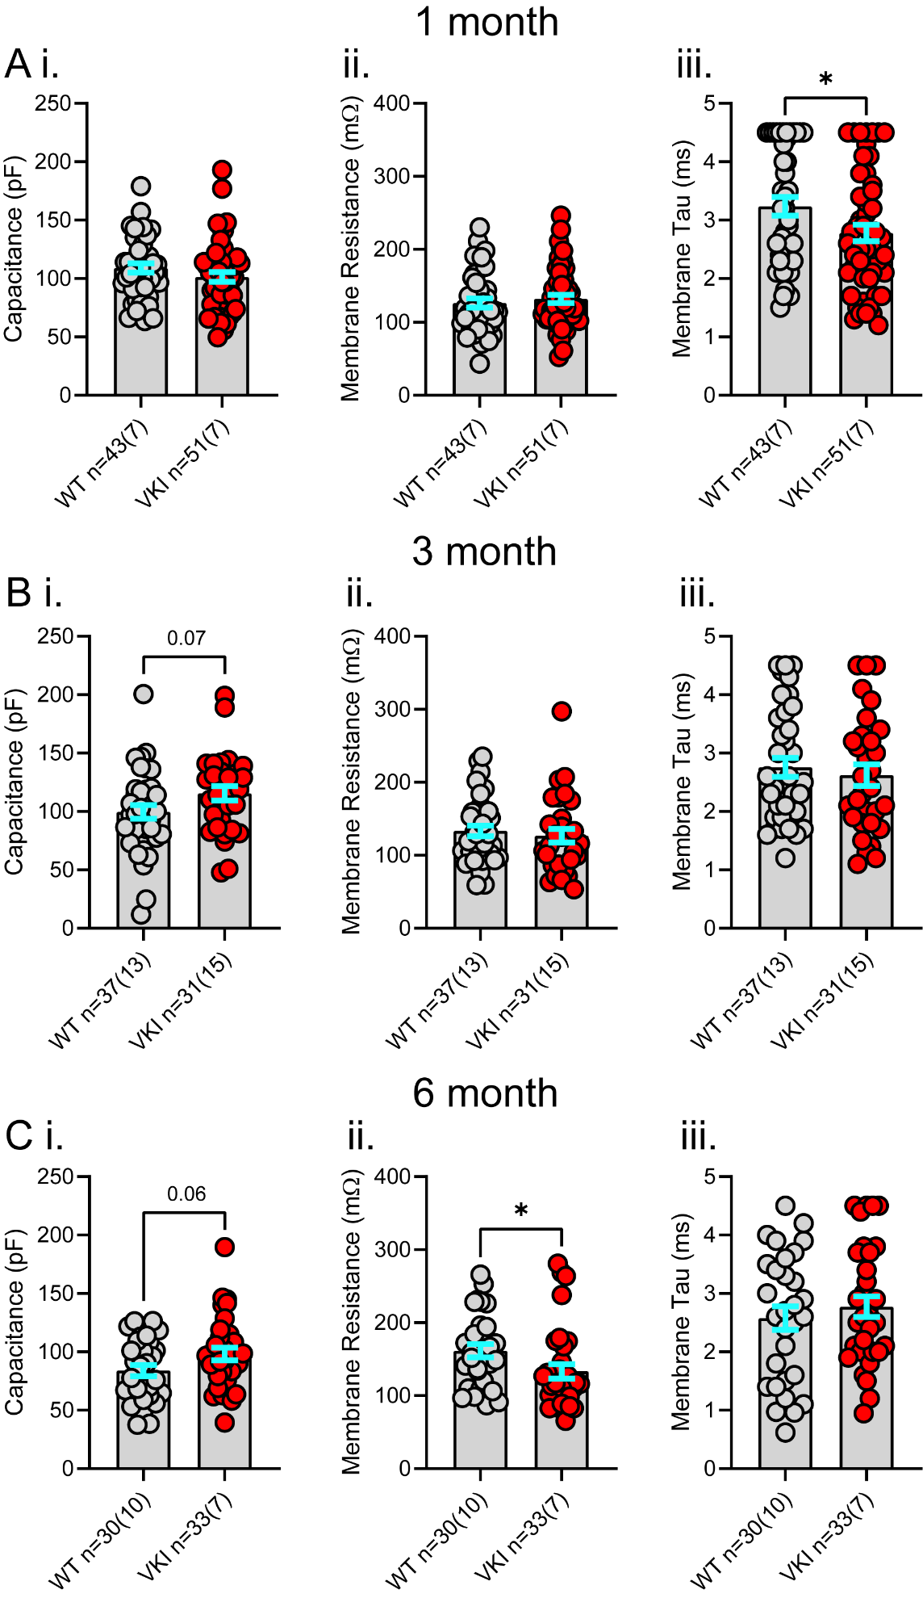
Supplementary
Figure S1. Membrane properties of dorsolateral striatum spiny projection neurons (SPNs) are altered in VKI mice in an age-dependent manner.

Table S1. Additional post-hoc analyses of WT vs VKI measures
Measure | Test Type | Significance | Post-Hoc Test Type (if p<0.10) | Post-Hoc Significance (if p<0.10)
1m sEPSC Amplitude | 2-way ANOVA | Interaction p=0.9996  Genotype p=0.2162 | - | -
3m sEPSC Amplitude | 2-way ANOVA | Interaction p=0.0202  Genotype p=0.2050 | Šídák's multiple  comparisons test | 8-11pA – ns  12pA – 0.0378  >13 – ns
6m sEPSC Amplitude | 2-way ANOVA | Interaction p<0.0001  Genotype p=0.0188 | Šídák's multiple  comparisons test | 8-10pA – ns  11pA – 0.0710  12pA – 0.0005  13-15pA – <0.0001  16-17pA – <0.001  18pA – 0.0157  >19pA – ns
1m sEPSC Inter-event Interval | 2-way ANOVA | Interaction p=0.9933  Genotype p=0.9261 | - | -
3m sEPSC Inter-event Interval | 2-way ANOVA | Interaction p=0.1003  Genotype p=0.9492 | Šídák's multiple  comparisons test | ns
6m sEPSC Inter-event Interval | 2-way ANOVA | Interaction p<0.0001  Genotype p=0.0565 | Šídák's multiple  comparisons test | ns
3m ChR2 Paired-Pulse Ratio | 2-way ANOVA | Interaction p=0.3415  Genotype p=0.2185 | - | -
6m ChR2 Paired-Pulse Ratio | 2-way ANOVA | Interaction p=0.0011  Genotype p=0.0376 | Šídák's multiple  comparisons test | P2/P1 – ns  P3/P1 – 0.0700  P4/P1 – 0.0399
3m iGluSnFR ΔF/F (%) | 2-way ANOVA | Interaction p<0.0001  Genotype p=0.0070 | Šídák's multiple  comparisons test | P1 – 0.0767  P2 – 0.0591  P3 – 0.0739  P4 – 0.0762  P5 – 0.0784  P6 – 0.0764  P7 – 0.0865  P8 – 0.0850  P9 – ns  P10 – ns
6m iGluSnFR ΔF/F (%) | 2-way ANOVA | Interaction p=0.9036  Genotype p=0.3989 | - | -
3m iGluSnFR ΔF/F (Norm. P1) | 2-way ANOVA | Interaction p=0.0063  Genotype p=0.9951 | Šídák's multiple  comparisons test | ns
6m iGluSnFR ΔF/F (Norm. P1) | 2-way ANOVA | Interaction p=0.7749  Genotype p=0.8681 | - | -
3m iGluSnFR Recovery ΔF/F (Norm. P1) | 2-way ANOVA | Interaction p=0.8390  Genotype p=0.4979 | - | -
6m iGluSnFR Recovery ΔF/F (Norm. P1) | 2-way ANOVA | Interaction p=0.6251  Genotype p=0.1239 | - | -
3m dLight 2-Pulse ΔF/F (%) | 2-way ANOVA | Interaction p=0.6921  Genotype p=0.8337 | - | -
6m dLight 2-Pulse ΔF/F (%) | 2-way ANOVA | Interaction p=0.0003  Genotype p=0.0001 | Šídák's multiple  comparisons test | WT veh vs VKI veh  50µA – ns  100µA – 0.0043  200µA – 0.0058  300µA – 0.0177  400µA – 0.0192 | WT veh vs WT MLi-2 – ns | VKI veh vs VKI MLi-2  50µA – 0.0740  100µA – 0.0261  200µA – 0.0192  300µA – 0.0192  400µA – 0.0141
6m dLight 2-Pulse P1 Decay | Kruskal-Wallis | 0.6588 | - | - | - | -
6m dLight 2-Pulse Repeated Release Capacity | 1-way ANOVA | 0.6581 | - | - | - | -
3m dLight Pulse Train ΔF/F (%) | 2-way ANOVA | Interaction p=0.9944  Genotype p=0.8450 | - | -
6m dLight Pulse Train ΔF/F (%) | 2-way ANOVA | Interaction p<0.0001  Genotype p=0.0025 | Šídák's multiple  comparisons test | WT veh vs VKI veh –  P1 – 0.0108  P2 – 0.0113  P3 – 0.0148  P4- 0.0286  P5 – 0.0595  P6-P10 – ns | WT veh vs WT MLi-2 – ns | VKI veh vs VKI MLi-2 –  P1 – 0.0361  P2 – 0.0409  P3 – 0.0452  P4 – 0.0451  P5 – 0.0413  P6 – 0.0398  P7 – 0.0379  P8 – 0.0342  P9 – 0.0331  P10 – 0.0324
3m dLight Pulse Train ΔF/F (Norm. P1) | 2-way ANOVA | Interaction p=0.6877  Genotype p=0.4482 | - | -
6m dLight Pulse Train ΔF/F (Norm. P1) | 2-way ANOVA | Interaction p<0.0001  Genotype p=0.6198 | Šídák's multiple  comparisons test | WT veh vs VKI veh – ns | WT veh vs WT MLi-2 – ns | VKI veh vs VKI MLi-2 –  ns
3m dLight Pulse Train Recovery ΔF/F (Norm. P1) | 2-way ANOVA | Interaction p=0.8149  Genotype p=0.0594 | Šídák's multiple  comparisons test | 500ms – 0.0297  1000-5000ms – ns
6m dLight Pulse Train Recovery ΔF/F (Norm. P1) | 2-way ANOVA | Interaction p=0.0205  Genotype p=0.1890 | Šídák's multiple  comparisons test | WT veh vs VKI veh –  500ms – 0.0446  >1000ms – ns | WT veh vs WT MLi-2 – ns | VKI veh vs VKI MLi-2 – ns
6m dLight Pulse Train Decay Tau | 1-way ANOVA | 0.2052 | - | - | - | -

Table S2. Additional analyses of 3m vs 6m effects on WT and VKI measures
Measure | Test Type | Significance | Post-Hoc Test Type (if p<0.10) | Post-Hoc Comparison | Post-Hoc Significance (if p<0.10)
SPN Membrane Capacitance | Kruskal-Wallis test | 0.0023 | Dunn’s multiple comparisons test | 1m WT vs 3m WT | ns
 |  |  |  | 1m VKI vs 3m VKI | ns
 |  |  |  | 1m WT vs 6m WT | 0.0115
 |  |  |  | 1m VKI vs 6m VKI | ns
 |  |  |  | 3m WT vs 6m WT | ns
 |  |  |  | 3m VKI vs 6m VKI | ns
SPN Membrane Resistance | Kruskal-Wallis test | 0.0432 | Dunn’s multiple comparisons test | 1m WT vs 3m WT | ns
 |  |  |  | 1m VKI vs 3m VKI | ns
 |  |  |  | 1m WT vs 6m WT | 0.0616
 |  |  |  | 1m VKI vs 6m VKI | ns
 |  |  |  | 3m WT vs 6m WT | ns
 |  |  |  | 3m VKI vs 6m VKI | ns
SPN Membrane Tau | Kruskal-Wallis test | 0.1099 | - | - | -
sEPSC Amplitude | 2-way ANOVA | Interaction p<0.0001  Genotype/Age p<0.0001 | Šídák's multiple  comparisons test | 1m WT vs 3m WT | <10pA – ns  11-17pA – <0.0001  18-19pA – 0.0007  20pA – 0.0027  21pA – 0.0088  22pA- 0.0509  >23pA – ns
 |  |  |  | 1m VKI vs 3m VKI | ns
 |  |  |  | 1m WT vs 6m WT | 8pA – ns  9pA – 0.0109  10-21pA - <0.0001  22pA – 0.0004  23pA – 0.0011  24pA – 0.0199  >25pA – ns
 |  |  |  | 1m VKI vs 6m VKI | ns
 |  |  |  | 3m WT vs 6m WT | ns
 |  |  |  | 3m VKI vs 6m VKI | ns
sEPSC Inter-event Interval | 2-way ANOVA | Interaction p<0.0001  Genotype/Age p<0.0001 | Šídák's multiple  comparisons test | 1m WT vs 3m WT | <200pA – ns  250pA – 0.0212  300-400pA – <0.01  450-500pA – <0.001  550pA -650pA - <0.01  700-850pA - <0.05  900pA – 0.0559  >950pA - ns
 |  |  |  | 1m VKI vs 3m VKI | ns
 |  |  |  | 1m WT vs 6m WT | <100pA – ns  150pA – 0.0300  200pA – 0.0018  250-750pA – <0.0001  800-850pA – <0.001  900-1050pA – <0.01  1100-1200 - <0.05  1250-1300 - <0.10  >1350pA - ns
 |  |  |  | 1m VKI vs 6m VKI | ns
 |  |  |  | 3m WT vs 6m WT | ns
 |  |  |  | 3m VKI vs 6m VKI | ns
sEPSC Decay Tau | Kruskal-Wallis test | 0.0075 | Dunn’s multiple comparisons test | 1m WT vs 3m WT | ns
 |  |  |  | 1m VKI vs 3m VKI | 0.0319
 |  |  |  | 1m WT vs 6m WT | ns
 |  |  |  | 1m VKI vs 6m VKI | ns
 |  |  |  | 3m WT vs 6m WT | ns
 |  |  |  | 3m VKI vs 6m VKI | 0.0181
ChR2-PSC Paired-Pulse Ratio | 2-way ANOVA | Interaction p<0.0001  Genotype/Age p=0.0022 | Šídák's multiple  comparisons test | 3m WT vs 6m WT | ns
 |  |  |  | 3m VKI vs 6m VKI | P2/P1 – ns  P3/P1 – 0.0005  P4/P1 – 0.0002
AMPA Current | 1-way ANOVA | 0.0829 | Tukey’s multiple comparisons test | 3m WT vs 6m WT | ns
 |  |  |  | 3m VKI vs 6m VKI | ns
NMDA Current | 1-way ANOVA | 0.0647 | Tukey’s multiple comparisons test | 3m WT vs 6m WT | ns
 |  |  |  | 3m VKI vs 6m VKI | ns
NMDA/AMPA Ratio | 1-way ANOVA | 0.0290 | Dunn’s multiple comparisons test | 3m WT vs 6m WT | ns
 |  |  |  | 3m VKI vs 6m VKI | ns
AMPA Rectification Index | 1-way ANOVA | 0.2455 | - | - | -
iGluSnFR ΔF/F (%) | 2-way ANOVA | Interaction p<0.0001  Genotype/Age p<0.0001 | Šídák's multiple  comparisons test | 3m WT vs 6m WT | P1 – 0.0091  P2 – 0.0136  P3 – 0.0162  P4 – 0.0165  P5 – 0.0175  P6 – 0.0157  P7 – 0.0169  P8 – 0.0151  P9 – 0.0171  P10 – 0.0165
 |  |  |  | 3m VKI vs 6m VKI | ns
iGluSnFR ΔF/F (Norm. P1) | 2-way ANOVA | Interaction p=0.1313  Genotype/Age p=0.8747 | - | - | -
iGluSnFR Recovery ΔF/F (Norm. P1) | 2-way ANOVA | Interaction p=0.8714  Genotype/Age p=0.1635 | - | - | -
iGluSnFR Decay Tau | Kruskal-Wallis test | 0.0009 | Dunn’s multiple comparisons test | 3m WT vs 6m WT | ns
 |  |  |  | 3m VKI vs 6m VKI | 0.0046
dLight 2-Pulse ΔF/F | 2-way ANOVA | Interaction p<0.0001  Genotype/Age p=0.0006 | Šídák's multiple  comparisons test | 3m WT vs 6m WT | 50 µA – 0.0189  100µA – 0.0050  200µA – 0.0017  300µA – 0.0023  400µA – 0.0020
 |  |  |  | 3m VKI vs 6m VKI | ns
dLight 2-Pulse P1 Decay Tau | 1-way ANOVA | 0.6617 | - | - | -
dLight 2-Pulse Repeated Release Capacity | 1-way ANOVA | 0.5397 | - | - | -
dLight Pulse Train ΔF/F | 2-way ANOVA | Interaction p<0.0001  Genotype/Age p=0.0050 | Šídák's multiple  comparisons test | 3m WT vs 6m WT | P1 – 0.0013  P2 – 0.0010  P3 – 0.0013  P4 – 0.0024  P5 – 0.0049  P6 – 0.0087  P7 – 0.0131  P8 – 0.0171  P9 – 0.0201  P10 – 0.0230
 |  |  |  | 3m VKI vs 6m VKI | ns
dLight Pulse Train ΔF/F (Norm. P1) | 2-way ANOVA | Interaction p=0.0011  Genotype/Age p=0.0961 | Šídák's multiple  comparisons test | 3m WT vs 6m WT | P2 – 0.0368  P3 – 0.0459  P4 – 0.0615  P5 – 0.0705  P6 – 0.0730  P7 – 0.0716  P8 – 0.0656  P9 – 0.0688  P10 – 0.0669
 |  |  |  | 3m VKI vs 6m VKI | ns
dLight Pulse Train Recovery ΔF/F (Norm. P1) | 2-way ANOVA | Interaction p=0.0003  Genotype/Age p=0.0882 | Šídák's multiple  comparisons test | 3m WT vs 6m WT | ns
 |  |  |  | 3m VKI vs 6m VKI | 500-2500ms – ns  5000ms – 0.0133
dLight Pulse Train Decay Tau | 1-way ANOVA | 0.3062 | - | - | -

Supplementary Figure Legends
Figure S1. Membrane properties of dorsolateral striatum spiny projection neurons (SPNs) are altered in VKI mice in an age-dependent manner.
A At 1 month, i) VKI SPNs do not show differences in membrane capacitance compared to WT neurons (Mann-Whitney U-test p=0.18). ii) Membrane resistance is similar between VKI and WT SPNs (Unpaired t-test p=0.50), iii) Membrane tau is significantly reduced in VKI SPNs vs WT SPNs (Mann-Whitney U-test p=0.04). B At 3 months, i) VKI neurons trend towards significantly higher membrane capacitance measures vs WT neurons (Unpaired t-test p=0.07). ii) Membrane resistance of neurons is not different between genotypes (Mann-Whitney U-test p=0.39). iii) Membrane tau is not significantly different between genotypes (Mann-Whitney U-test p=0.61). C At 6 months, i) VKI neurons trend towards significantly higher membrane capacitance measures (Unpaired t-test p=0.06). ii) Membrane resistance is significantly lower in VKI vs WT neurons (Mann-Whitney U-test p=0.01). iii) Membrane tau of neurons is not significantly different between genotypes (Unpaired t-test p=0.47). Experimental n = x(y), where x = # of recordings and y = # of mice. Single asterisks denote 0.05>p>0.01 and p value included where 0.10>p>0.05.

