Supplementary Materials for

Active adhesion improves adaptive flight for feathered wings
Kevin PT Haughn, Jeff T Auletta, John T Hrynuk, Todd C Henry
Corresponding author: kevin.p.haughn.civ@army.mil

The PDF file includes:

Supplementary Text
Figs. S1 to S7

Supplementary Text
Metrics and Statistical Modeling
We defined performance metrics that fell into two categories, maximums (C_{L max} and L/D_{max}) and α-relationships (C_{Lα} and C_{mα}). The maximum-based metrics were derived from a maximum average value at a single angle of attack. However, for each wing, the angle of attack was not always consistent between each sweep direction (upward and downward) and iteration. Therefore, after determining the max-value angle of attack for each respective sweep direction and iteration, we incorporated all collected measurements from the appropriate individual angles of attack for each iteration and sweep direction for statistical analysis.

The α-relationship based metrics required force and moment measurements from several angles of attack for each sweep direction and iteration. We limited the definition of these metrics to fall within the linear flight regime (α ≤ 10°), and for C_{mα}, measurements were bound at α ≥ 0° as well.

We used the linear mixed effects (LME) model function in the statsmodels Python library to perform statistical analyses on our experimentally measured performance metrics while accounting for the random measurement behavior that naturally occurred between experimental sweep directions (upward and downward) and four measurement iterations. The statsmodels package uses the equation format,

$$\begin{aligned}Y_{ij}= β_{0}+ β_{1}X_{ij}+ w_{0i}+ w_{1i}X_{ij}+ϵ_{ij}, \#(eqn. S1)\end{aligned}$$

to solve for fixed effect parameters, $β_{0}$ and $β_{1}$, and random effect parameters, $w_{0i }$and $w_{1i}$, where $X_{ij}$ is a covariate for the $j^{th}$ measured response, $Y_{ij}$, of subject $i$, with independent errors, $ϵ_{ij}$.

LME follows the assumption of linearity that can be satisfied analyzing models’ residual distributions for normality. We fit LME models beginning with greatest comprehensive inclusion of data, containing all wing conditions and velocities, and reduced complexity when residual normality wasn’t met. We found that using the most simplified LME models for analyzing C_{Lmax}, producing individual models for each wing (baseline, plate, passive, and active) and velocity (10 m/s, 12.5 m/s, 15 m/s) that achieved approximately normal residual distributions (fig. S2) and therefore we accepted the predictions and 95% confidence intervals as trustworthy (Fig. 2D). Calculating the relationship between C_{Lmax} and velocity required the inclusion of C_{Lmax}-velocity interactions within the LME, thus increasing complexity and resulting in non-normal residual distributions (fig. S3). However, the respective slope-intercept combinations and 95% confidence intervals predicted by the LMEs appeared to accurately fit the individually calculated wing-velocity combinations (Fig. 2D), and therefore we trust the slope comparisons (Fig. 2E).

The C_{Lα} LME produced approximately normal residual distributions while including all wing types at each individual velocity, and while including all wing-velocity interactions (fig. S4). Therefore, we trust the CL_{α} predictions and the predicted slopes referring to the relationship between C_{Lα} and velocity (Fig. 2F-G).

Again, we found that using the most simplified LME model, individually considering each wing-velocity combination, produced approximately normal residual distributions for the L/D_{max} metric (fig. S5). Incorporating interactions between L/D_{max} and velocity maintained approximately normal residual distributions for the baseline, passive, and active EA feathered wings, but failed to produce normally distributed residuals (fig. S6). Still, the approximated slope-intercept combinations and 95% confidence intervals appeared to appropriately fit the predicted individual L/D_{max} values (Fig. 3B).

Finally, the C_{mα} LME produced approximately normal residual distributions while including all wing types at each individual velocity, and while including all wing-velocity interactions (fig. S7). Therefore, we trust the C_{mα} predictions and the predicted slopes referring to the relationship between C_{mα} and velocity (Fig. 2F-G).

Fig S1.

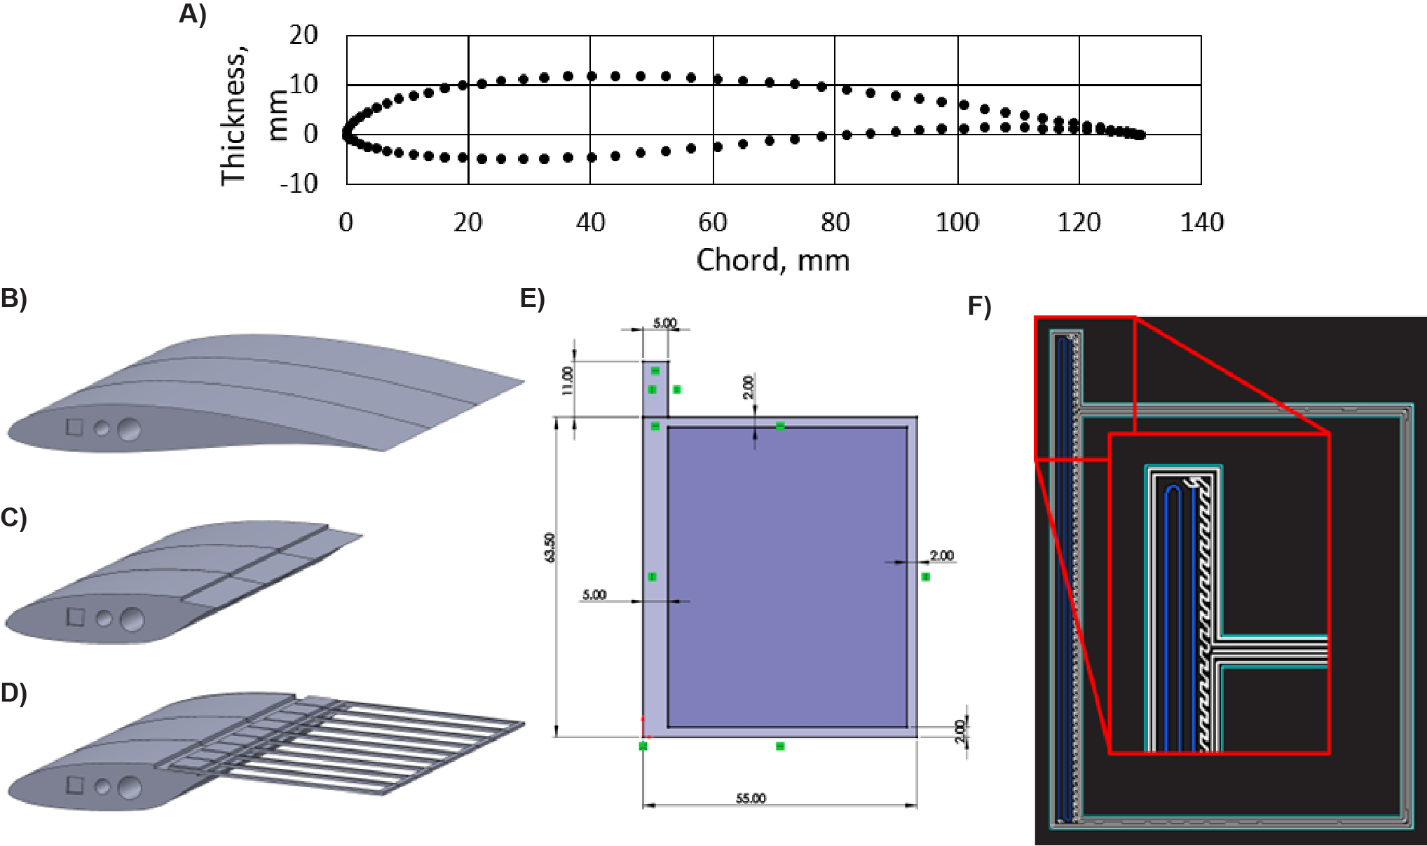
Each wing was constructed using a Markforged X7 3D printer. (A) We used a Wortmann FX 60-126 as the initial airfoil shape for each wing. (B) The baseline wing was entirely 3D printed, whereas the (C) rigid plate wing and (D) feathered wing included only the leading portion of the baseline airfoil shape, using an aluminum plate or 3D printed feathers for the respective trailing edges. (E) Each feather was printed using a nylon base material in a flag-like construction with a 55 mm X 63.5 mm planform shape. (F) The rigidity of the feathers was tuned using continuous carbon fiber (blue), including three paths within the rachis to increase stiffness.

Fig. S2.

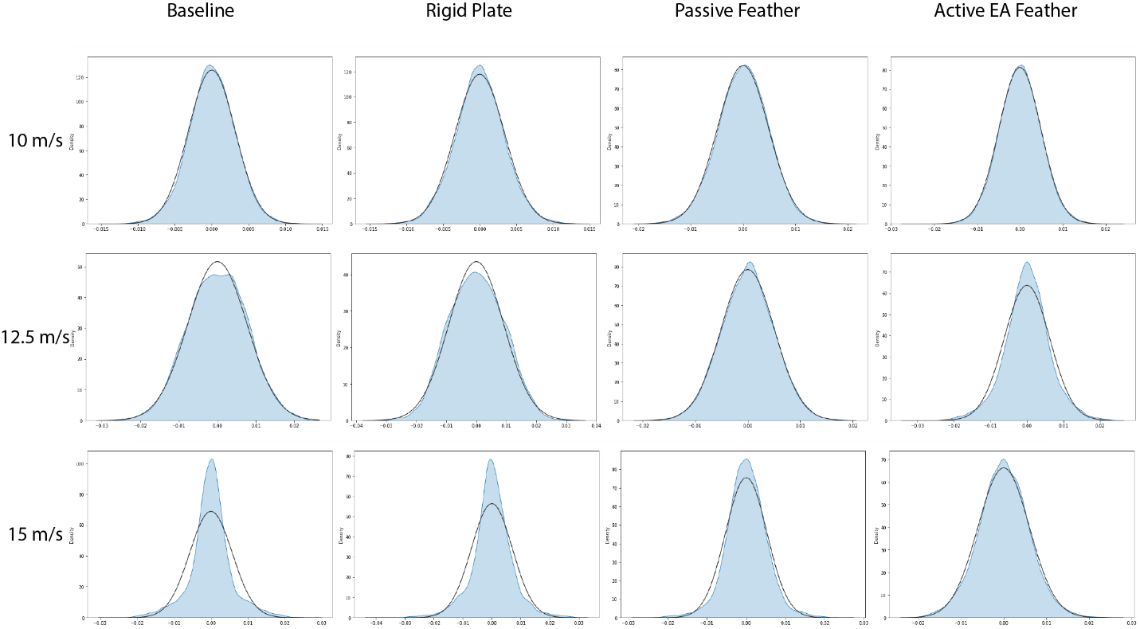
The linear mixed effects models used to estimate the maximum C_{L} for individual wing-velocity combinations produced approximately normal residual distributions, suggesting results can be trusted.

Fig. S3.
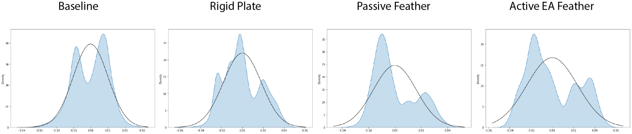
The linear mixed effects models used to consider the CL_{max}-velocity interaction relationship did not produce approximately normal residuals. However, the slopes produced appropriately fit the individual CL_{max} values in Figure 2D.

Fig. S4.

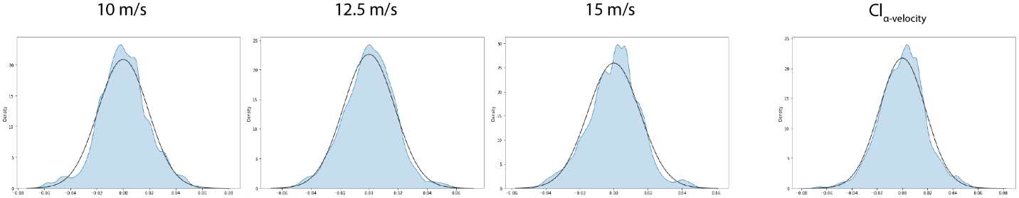
The linear mixed effects models combining each wing type at individual velocities produced approximately normal residuals, suggesting trustworthy results for the CL-α relationships. Additionally the linear mixed effects model used to consider the interaction terms between the CL_{α} and velocity produced normal residuals, suggesting the slopes are trustworthy as well.

Fig. S5.
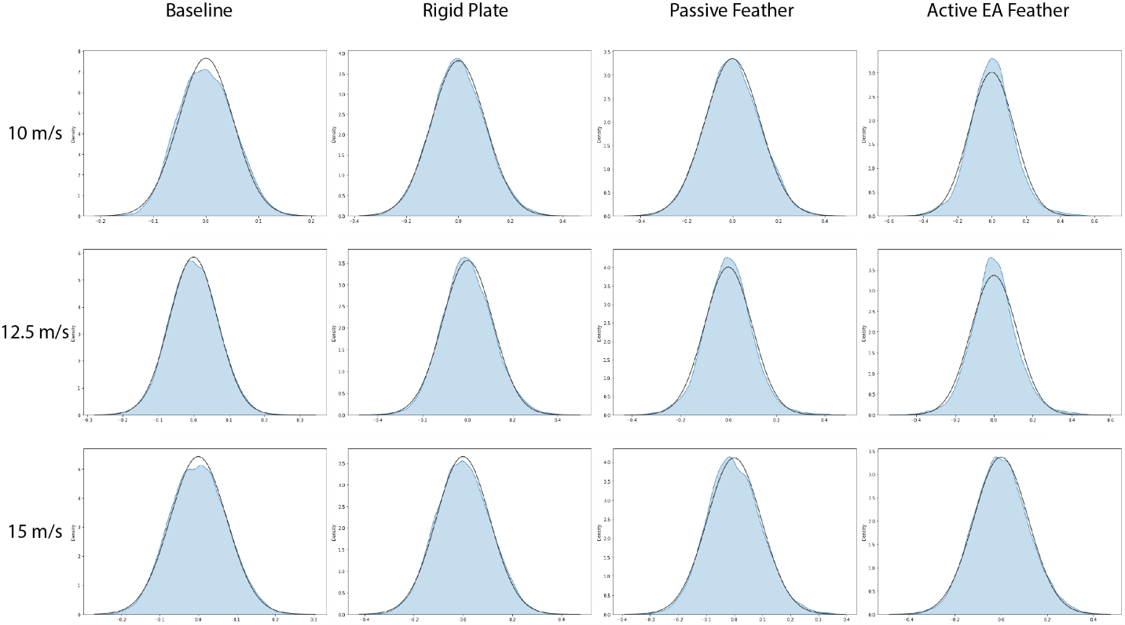
The linear mixed effects models used to estimate the maximum L/D ratio for individual wing-velocity combinations produced approximately normal residual distributions, suggesting results can be trusted.

Fig. S6.
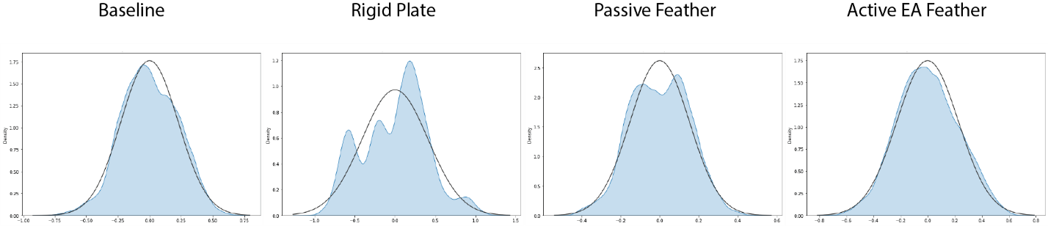
The linear mixed effects models used to consider the L/D_{max}-velocity interaction relationship produced approximately normal residuals for the baseline, passive feather, and active EA feathered wings, but not for the rigid plate wing. However, the slopes produced appropriately fit the individual CL_{max} values in Figure 3B.

Fig. S7.
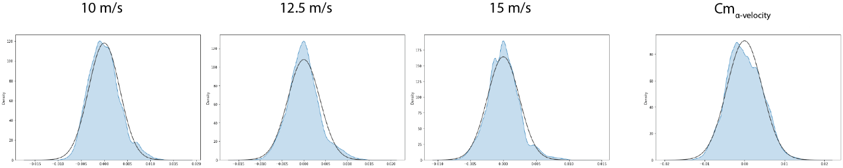
The linear mixed effects models combining each wing type at individual velocities produced approximately normal residuals, suggesting trustworthy results regarding the Cm-α relationships. Additionally the linear mixed effects model used to consider the interaction terms between the CL_{α} and velocity produced normal residuals, suggesting the slopes are trustworthy as well.

