pyOpenMS-viz: Streamlining Mass Spectrometry Data Visualization with pandas
Justin Cyril Sing†^{1,2}, Joshua Charkow†^{1,2}, Axel Walter†^{4,5}, Mingxuan Gao¹, Tom David Müller⁴ , Wout Bittremieux⁶, Timo Sachsenberg*^{4,5}, Hannes Luc Röst*^{1,2,3}
* corresponding authors timo.sachsenberg@uni-tuebingen.de, hannes.rost@utoronto.ca
† Equal Contribution
- Donnelly Centre for Cellular and Biomolecular Research, University of Toronto, Toronto, Canada
- Department of Molecular Genetics, University of Toronto, Toronto, Canada
- Department of Computer Science, University of Toronto, Toronto, Canada
- Applied Bioinformatics, Department of Computer Science, University of Tuebingen, Tübingen, Germany
- Institute for Bioinformatics and Medical Informatics, University of Tuebingen, Tübingen, Germany
- Department of Computer Science, University of Antwerp, 2020 Antwerp, Belgium

Supplementary Figures
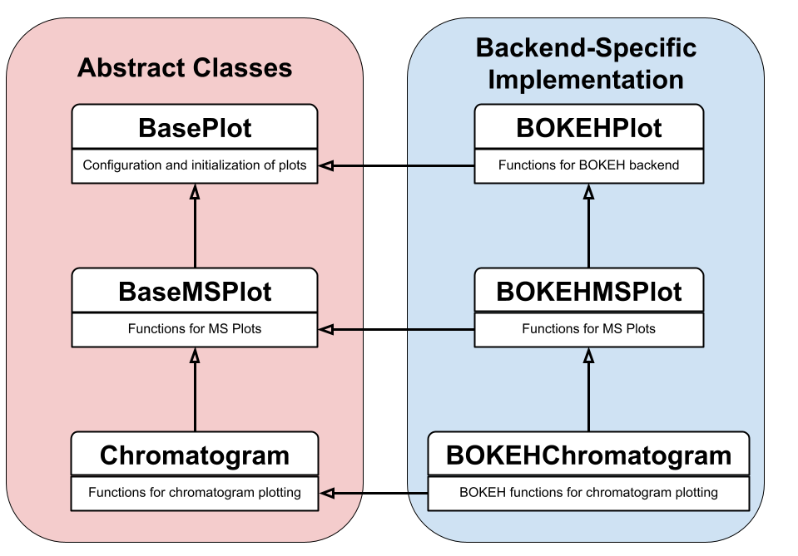Figure S1. pyOpenMS-viz implements an abstract architecture to support different backends. pyOpenMS-viz is implemented in a strongly object-oriented programming approach enabling standardized implementation across different plotting backends. To illustrate this, the inheritance diagram of the BOKEHChromatogram is shown. On the left side (red) are abstract classes which contain generic plotting functions not specific to any of the supported backends. The right side (blue) illustrates backend-specific classes. As an example, the BOKEH backend classes are shown but the same structure exists with the other supported backends.

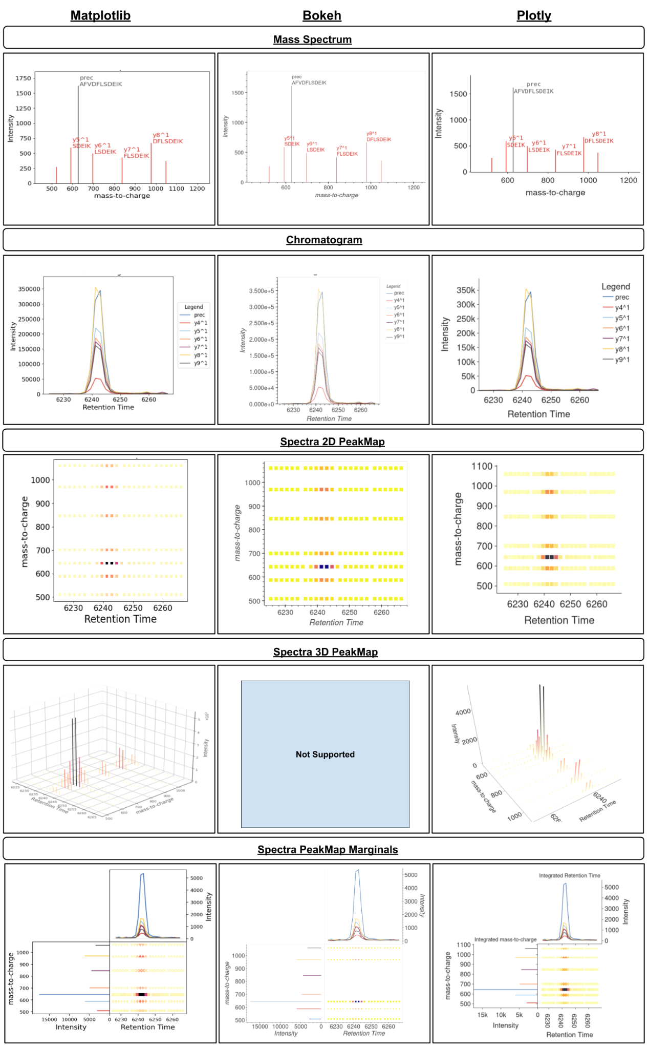

Figure S2. Overview of pyOpenMS-viz plots across different backends. Backends include (from left to right) Matplotlib, Bokeh, and Plotly. Currently, the spectra 3D plot is not supported for the Bokeh backend because Bokeh has limited support for 3D plots.

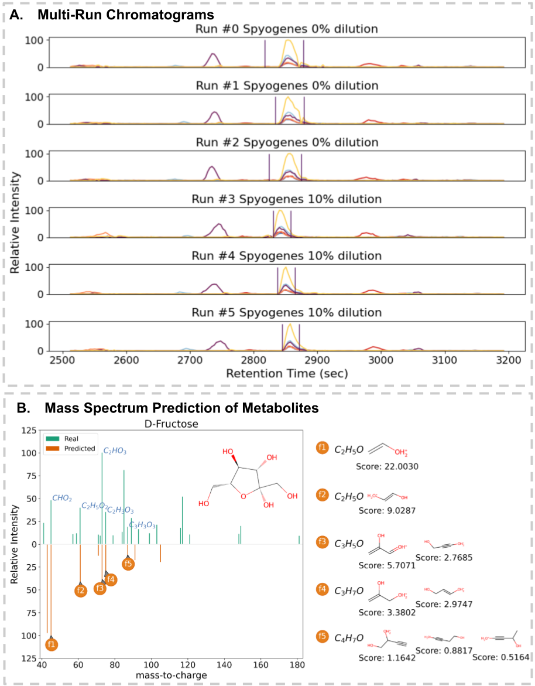
Figure S3. Creating Complex Publication Quality Figures with pyOpenMS-viz. A) Extracted ion chromatograms for peptide AADGQTVSGGSILYR with charge state 3 across six different DIA runs, annotated with peak boundaries. Extracted ion chromatogram data for the 6 runs were retrieved from the gold standard S. pyogenes dataset, available on PeptideAtlas (PASS01508). B) Predicted spectrum for D-Fructose using competitive fragmentation modeling for metabolite identification (CFM-ID). The real spectrum mzML data and annotation data was retrieved from HMBD (HMDB0000660). The predicted spectrum and fragment scores was retrieved from CFM-ID v4.0 (https://cfmid.wishartlab.com/) using the SMILES representation, OC[C@H]1O[C@](O)(CO)[C@@H](O)[C@@H]1O. The corresponding code to generate these plots can be found in the nbs/manuscript_spyogenes_subplots.ipynb and nbs/manuscript_d_fructose_spectrum_prediction.ipynb jupyter notebooks at https://github.com/OpenMS/pyopenms_viz.

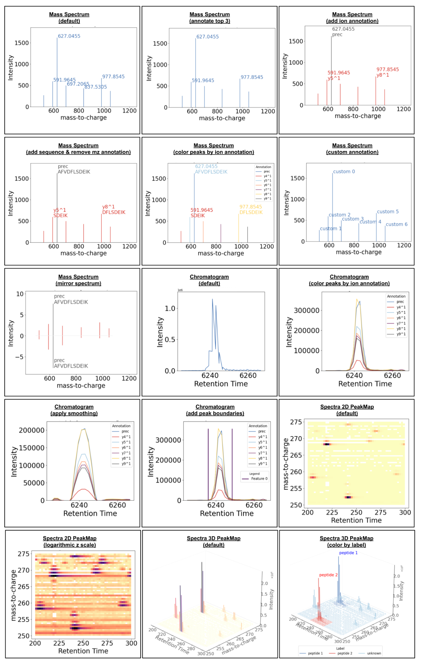
Figure S4. Gallery Showcasing Figure Customizability. Galley of mass spectrum, chromatogram and peak map plots showcasing different customizability options using pyOpenMS-viz. The corresponding code to generate this plot is shown in the nbs/manuscript_supp_config_gallery.ipynb jupyter notebook at https://github.com/OpenMS/pyopenms_viz.

Code Listings
Listing 1. Loading mzML data with pyopenms and plotting. The following code demonstrates loading data from an mzML using pyopenms, converting the data to an pandas DataFrame object and using pyOpenMS-viz for plotting.
import pandas as pd
import pyopenms as poms
# Globally set pandas plotting backend
pd.options.plotting.backend = "ms_bokeh" # one of: "ms_bokeh" "ms_matplotlib" "ms_plotly"
# Initialize an MSExperiment object to store MS data
exp = poms.MSExperiment()
# Load the data from the input mzML into the exp object
poms.MzMLFile().load( "input.mzML" , exp)
# Convert the MSExperiment object into a pandas DataFrame
df = exp.get_df(long=True)
# Plot a mass spectrum plot
df.plot(kind="spectrum", x="mz", y="inty")

Listing 2. Loading mzML data with pyteomics and plotting. The following code demonstrates loading data from an mzML using pyteomics, storing the data to a pandas DataFrame object and using pyOpenMS-viz for plotting.
import pandas as pd
from pyteomics import mzml
# Globally set pandas plotting backend
pd.options.plotting.backend = "ms_bokeh" # one of: "ms_bokeh" "ms_matplotlib" "ms_plotly"
# Iterate over file using the mzML reader and store rt, mz and intensity
rt, mz, intens = [], [], [], []
with mzml.MzML("input.mzML", decode_binary=False) as reader:
for scan in reader:
rt.append(scan['scanList']['scan'][0]['scan start time'])
mz.append(scan['m/z array'].decode())
intens.append(scan['intensity array'].decode())
df = pd.DataFrame({'ms_level':ms_level, 'rt':rt, 'mz':mz, 'int':intens})
# Explode mz and int columns to make the DataFrame long
df = df.explode(['mz', 'int'])
# Plot a mass spectrum plot
df.plot(kind="spectrum", x="mz", y="int")

Listing 3. Loading mzML data with pymzml and plotting. The following code demonstrates loading data from an mzML using pymzml, storing the data to a pandas DataFrame object and using pyOpenMS-viz for plotting.
import pandas as pd
import pymzml
# Globally set pandas plotting backend
pd.options.plotting.backend = "ms_bokeh" # one of: "ms_bokeh" "ms_matplotlib" "ms_plotly"
# Read in mzML file
run = pymzml.run.Reader("input.mzML")
# Get the first spectrum
spec = run.next()
# Convert to pandas DataFrame
df = pd.DataFrame(spec.centroidedPeaks).rename(columns={0:'mz', 1:'int'})
# Plot a mass spectrum plot
df.plot(kind="spectrum", x="mz", y="int")

Listing 4. Loading Bruker .d data with alphatims and plotting. The following code demonstrates loading data from a Bruker .d file using alphatims and using pyOpenMS-viz for plotting.
import pandas as pd
import alphatims.bruker
# Globally set pandas plotting backend
pd.options.plotting.backend = "ms_bokeh" # one of: "ms_bokeh" "ms_matplotlib" "ms_plotly"
# Load data from Bruker .d file
dia_data = alphatims.bruker.TimsTOF("bruker_input.d")
# Assuming you have an array of indices to extract specific data coordinates from the MS data
# This example just extracts the first 100
indices = range(100)
df = dia_data.as_dataframe(indices)
# Plot a mass spectrum plot
df.plot(kind="spectrum", x="mz_values", y="intensity_values")

Listing 5. Versatility of Integrated pyOpenMS-viz and pandas Plotting. The following code demonstrates how easy it is to switch between generating different kinds of mass spectrometry plots using the same pandas DataFrame object.
import pandas as pd
# Globally set pandas plotting backend
pd.options.plotting.backend = "ms_bokeh" # one of: "ms_bokeh" "ms_matplotlib" "ms_plotly"
# Read data into a pandas DataFrame from a TSV file
df = pd.read_csv("input_dia_ms_experiment.tsv", sep="\t")
# Plot a 2D Spectra peak map using columns 'rt' and 'mz'
df.plot(kind="peak map", x="rt", y="mz", z="int")
# Plot a mass spectrum
df.plot(kind="spectrum", x="mz", y="int")
# Plot a chromatogram
df.plot(kind="chromatogram", x="rt", y="int")
# Easily switch between different plotting library backends
df.plot(kind="chromatogram", x="rt", y="int", backend="ms_matplotlib")
df.plot(kind="chromatogram", x="rt", y="int", backend="ms_plotly")

Listing 6 Flexibility and Configurability. The following code demonstrates setting and changing parameters for plot aesthetics and attributes.
import pandas as pd
# Globally set pandas plotting backend
pd.options.plotting.backend = "ms_bokeh" # one of: "ms_bokeh" "ms_matplotlib" "ms_plotly"
# Read data into a pandas DataFrame from a TSV file
df = pd.read_csv("input_dia_ms_experiment.tsv", sep="\t")
# Plot a mass spectrum and remove the major and minor grid lines from the plot
df.plot(kind="spectrum", x="mz", y="int", grid=False)
# Change the size of the plot
df.plot(kind="spectrum", x="mz", y="int", height=400, width=650)
# Add custom titles and axis labels
df.plot(kind="spectrum", x="mz", y="int", title="Peptide @RT=500.049", xlabel="m/z", ylabel="Peak Intensity")
# Adjust font sizes
df.plot(kind="spectrum", x="mz", y="int", title_font_size = 18, xaxis_label_font_size = 16, yaxis_label_font_size = 16)
# Save figure to a variable and turn off plot rendering. This is useful if you don't want to see the plot straight away and want to use the underlying figure for additional plotting or editing
p = df.plot(kind="spectrum", x="mz", y="int", show_plot=False)
# Directly set backend to use for plotting
df.plot(kind="spectrum", x="mz", y="int", backend="ms_plotly")
# Adjust legend attributes
df.plot(kind="spectrum", x="mz", y="int", legend={'loc':'below', 'fontsize
':12, 'title':'Transition', 'show':True)
# Color peaks by an annotation column in the df object
df.plot(kind="spectrum", x="mz", y="int", by="ms_level")
df.plot(kind="spectrum", x="mz", y="int", by="ion_annotation")
# Add ion and sequence annotations from columns in the df object, and turn off mz peak text annotation
df.plot(kind="spectrum", x="mz", y="int", annotate_mz=False, ion_annotation="ion_annotation", sequence_annotation="sequence")

Listing 7. Data Processing and Plotting. The following code demonstrates optional internal data processing done within pyOpenMS-viz as well as user-end data processing.
import pandas as pd
from scipy.signal import savgol_filter
# Globally set pandas plotting backend
pd.options.plotting.backend = "ms_bokeh" # one of: "ms_bokeh" "ms_matplotlib" "ms_plotly"
# Read data into a pandas DataFrame from a TSV file
df = pd.read_csv("input_dia_ms_experiment.tsv", sep="\t")
# Plot a Spectra peak map, and change how much data gets binned in the x and y dimensions
df.plot(kind="peak map", x="rt", y="mz", z="int", num_x_bins=100, num_y_bins=100)
# Plot a mass spectrum and change the binning method
df.plot(kind="spectrum", x="mz", y="int", bin_method
="sturges")
# Plot a mass spectrum and transform intensity to relative intensity
df.plot(kind="spectrum", x="mz", y="int", relative_intensity=True)
# Plot a chromatogram by integrating across the RT dimension and apply Savitzky-Golay smoothing to the intensity values
def apply_sgolay(group, along_col='rt', window_length=11, polyorder=4):
group = group.sort_values(along_col)
group['smoothed_int'] = savgol_filter(group['int'], window_length=window_length, polyorder=polyorder)
return group
group_cols=['ms_level', 'ion_annotation', 'rt']
integrate_col = 'int'
df.groupby(group_cols)[integrate_col] \
.sum() \ # Integrate across retention time ("rt")
.reset_index() \
.groupby(['ion_annotation', 'ms_level'])[group_cols + [integrate_col]] \
.apply(apply_sgolay, window_length=9, polyorder=3) \ # Apply Savitzsky-Golay smoothing
.reset_index(drop=True) \
.plot(kind="chromatogram", x="rt", y="smoothed_int")
Listing 8. Advanced Plotting Features. The following code demonstrates advanced plotting features integrated into pyOpenMS-viz.
import pandas as pd
# Globally set pandas plotting backend
pd.options.plotting.backend = "ms_bokeh" # one of: "ms_bokeh" "ms_matplotlib" "ms_plotly"
# Read data into a pandas DataFrame from a TSV file
df = pd.read_csv("input_dia_ms_experiment.tsv", sep="\t")
################
# Peak Map 3D
################
# Plot a 3D Spectra peak map using columns 'rt' and 'mz'
df.plot(kind="peak map", x="rt", y="mz", z="int", plot3d=True)
################
# Peak Map 2D Marginal
################
# Plot a 2D Spectra peak map and add marginals of integrated 1D data.
# Note: specify the integrated y-dimension marginal is a spectrum plot
df.plot(kind="peak map", x="rt", y="mz", z="int", add_marginals=True, y_kind = "spectrum")
################
# Mirror Spectrum
################
# Plot a mass spectrum plot, and provide a reference df for adding a mirror spectrum
ref_spec_df = pd.read_csv("theoretical_spectrum.tsv", sep="\t")
df.plot(kind="spectrum", x="mz", y="int", reference_spectrum=ref_spec_df, mirror_spectrum=True)
################
# Chromatogram Peak Boundaries
################
# Plot a chromatogram, and provide an additional DataFrame that contains feature annotation, such as peak boundaries (i.e. RTStart, RTEnd)
df_feat = pd.read_csv("peak_boundaries.tsv", sep="\t")
df.plot(kind="chromatogram", x="rt", y="int", by="ion_annotation", annotation_data=df_feat)
################
# Grid subplots with bokeh
################
# Save the figure objects for creating subplots
from bokeh.io import show
from bokeh.layouts import column
files = ["ms_data1.tsv", "ms_data2.tsv", "ms_data3.tsv"]
df_list = [pd.read_csv(f, sep="\t") for f in files]
figs = []
for filename, file_df in zip(df_list, df_list):
p = file_df.plot(kind="chromatogram",x='rt', y='intensity',
by="annotation", title=filename, show_plot=False)
figs.append(p.fig)
# Plot the chromatogram plots for the 3 runs in a single column subplot
show(column(*figs))

