Compound information
Compound name Molecular Structure | Molecular formula
Sitosteryl acetate  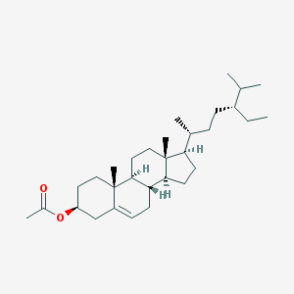 | C₃₁H₅₂O₂
Aureusidin  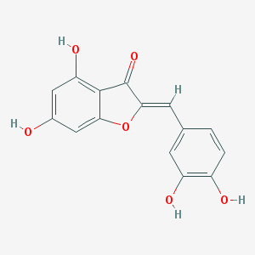 | C₁₅H₁₀O₆
LAN  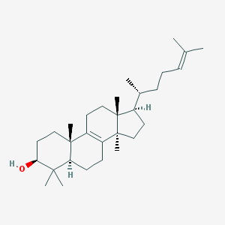 | C₃₀H₅₀O
ZINC01615307  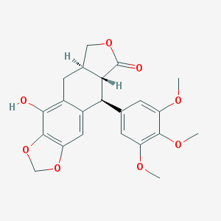 | C₂₂H₂₂O₈
β-sitosterol  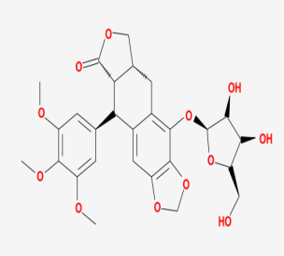 | C₂₂H₂₂O₈
Mairin  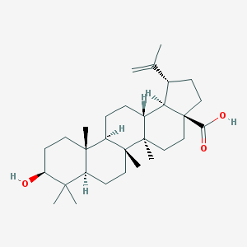 | C₃₀H₄₈O₃
isorhamnetin  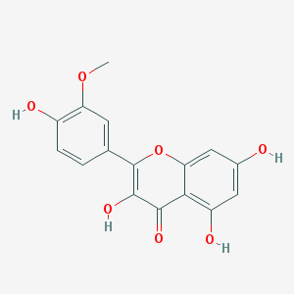 | C₁₆H₁₂O₇
beta-sitosterol  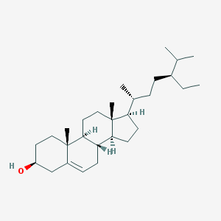 | C₂₉H₅₀O
Stigmasterol  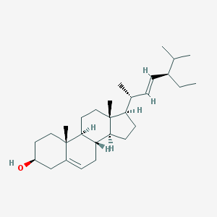 | C₂₉H₄₈O

Table 1 Active compound ingredient information

