Suppl. Table 1. Details of experiment on planting of papaya at different months

Treatment details
Treatment | Month of Planting
T₁ | 1st week of June
T₂ | 1st week of July
T₃ | 1st week of August
T₄ | 1st week of September
T₅ | 1st week of October
T₆ | 1st week of November
T₇ | 1st week of December
T₈ | 1st week of January
T₉ | 1st week of February
T₁₀ | 1st week of March
Experiment details
Location | Haveli Farm, COH, Bagalkot
Year | 2019-20 and 2020-21
Design | Randomized Block Design (RBD)
Crop | Papaya
Cultivar | Red Lady
Number of treatments | 10
Number of replications | 03
Number of plants per replications | 12
Plot size | 4.5 m x 3 m
Spacing | 1.5 m x 1.5 m

Suppl. Table 2. Details of the experiment on identification of susceptible stage of papaya for PRSV infection

Treatment details
Treatment | Stage of plant growth at which inoculated
T₁ | 30 DAT
T₂ | 60 DAT
T₃ | 90 DAT
T₄ | 120 DAT
T₅ | 150 DAT
T₆ | 180 DAT
T₇ | 210 DAT
T₈ | 240 DAT
T₉ | 270 DAT
T₁₀ | Control (Un inoculated)
Experiment details
Location | Net house, Haveli Farm, COH, Bagalkot
Year | 2019 to 2020
Design | Randomized Block Design (RBD)
Crop | Papaya
Cultivars | Red Lady
Date of planting | 15.06.2019
Number of treatments | 10
Number of replications | 03
Number of plants per replications | 04
Plot size | 2 x 2 m2
Spacing | 1.5 m x 1.5 m

Suppl. Table 3. Influence of different month of planting on PRSD incidence at different crop growth stages

Disease incidence (%) at
Treatment | 30 DAT* | 60 DAT | 90 DAT | 120 DAT | 150 DAT | 180 DAT | 210 DAT | 240 DAT | 270 DAT
T₁-1st week of June | 0.00  (0.00)** | 0.00  (0.00) | 0.00  (0.00) | 8.33  (13.62) | 19.44  (26.06) | 38.89  (38.56) | 66.67  (54.84) | 100  (90.00) | 100  (90.00)
T₂-1st week of July | 0.00  (0.00) | 0.00  (0.00) | 11.11  (19.22) | 22.22  (28.03) | 44.44  (41.75) | 77.78  (62.18) | 100  (90.00) | 100  (90.00) | 100  (90.00)
T₃-1st week of August | 0.00  (0.00) | 25.93  (30.48) | 58.33  (49.84) | 61.04  (55.89) | 83.33  (66.38) | 100  (90.00) | 100  (90.00) | 100  (90.00) | 100  (90.00)
T₄-1st week of September | 47.22  (43.40) | 69.44  (56.81) | 88.89  (73.94) | 100  (90.00) | 100  (90.00) | 100  (90.00) | 100  (90.00) | 100  (90.00) | 100  (90.00)
T₅-1st week of October | 52.78  (46.60) | 94.44  (78.81) | 100  (90.00) | 100  (90.00) | 100  (90.00) | 100  (90.00) | 100  (90.00) | 100  (90.00) | 100  (90.00)
T₆-1st week of November | 58.33  (49.84) | 94.44  (78.81) | 100  (90.00) | 100  (90.00) | 100  (90.00) | 100  (90.00) | 100  (90.00) | 100  (90.00) | 100  (90.00)
T₇-1st week of December | 77.78  (61.97) | 100  (90.00) | 100  (90.00) | 100  (90.00) | 100  (90.00) | 100  (90.00) | 100  (90.00) | 100  (90.00) | 100  (90.00)
T₈-1st week of January | 55.56  (48.40) | 97.22  (84.41) | 100  (90.00) | 100  (90.00) | 100  (90.00) | 100  (90.00) | 100  (90.00) | 100  (90.00) | 100  (90.00)
T₉-1st week of February | 19.44  (26.06) | 44.44  (41.75) | 63.89  (53.20) | 83.33  (67.06) | 97.22  (84.41) | 100  (90.00) | 100  (90.00) | 100  (90.00) | 100  (90.00)
T₁₀-1st week of March | 0.00  (0.00) | 5.56  (11.19) | 13.89  (21.66) | 16.67  (24.09) | 19.44  (26.06) | 30.56  (33.51) | 72.22  (59.41) | 97.22  84.41 | 100  (90.00)
S Em ± | 2.30 | 4.24 | 3.24 | 5.80 | 2.66 | 1.43 | 2.69 | 1.77 | 0.00
C D @ 5 % | 6.83 | 12.59 | 9.62 | 17.22 | 7.90 | 4.25 | 7.99 | 5.25 | NS
*DAT-Days After Transplanting; ** Figures in parentheses are arc sine transformed values

Suppl. Table 4. Influence of different month of planting on plant height at different crop growth stages

Plant height (cm) at
Treatment | 30 DAT* | 60 DAT | 90 DAT | 120 DAT | 150 DAT | 180 DAT | 210 DAT | 240 DAT | 270 DAT
T₁-1st week of June | 38.13 | 71.11 | 90.86 | 120.86 | 156.27 | 181.36 | 215.97 | 221.77 | 224.37
T₂-1st week of July | 37.39 | 69.94 | 89.46 | 118.83 | 154.91 | 179.30 | 214.36 | 216.50 | 218.91
T₃-1st week of August | 37.52 | 69.80 | 89.41 | 118.94 | 154.08 | 178.33 | 187.50 | 196.41 | 206.25
T₄-1st week of September | 38.27 | 69.93 | 89.91 | 118.41 | 141.00 | 164.47 | 175.55 | 186.11 | 194.91
T₅-1st week of October | 38.75 | 58.97 | 78.61 | 97.97 | 119.20 | 138.00 | 143.52 | 156.58 | 171.11
T₆-1st week of November | 38.66 | 58.86 | 77.30 | 96.77 | 118.69 | 137.86 | 143.00 | 154.02 | 162.77
T₇-1st week of December | 34.73 | 40.33 | 57.56 | 78.22 | 86.72 | 94.38 | 119.30 | 125.36 | 132.91
T₈-1st week of January | 33.39 | 38.90 | 55.73 | 77.36 | 85.72 | 93.38 | 114.69 | 123.72 | 132.13
T₉-1st week of February | 37.80 | 61.77 | 80.77 | 99.72 | 125.76 | 144.77 | 165.12 | 176.12 | 180.36
T₁₀-1st week of March | 40.50 | 74.75 | 94.66 | 125.77 | 161.94 | 186.83 | 221.91 | 226.37 | 227.19
S Em ± | 0.37 | 0.69 | 0.53 | 0.98 | 0.91 | 1.01 | 17.50 | 0.99 | 1.15
C D @ 5 % | 1.10 | 2.06 | 1.57 | 2.90 | 2.70 | 3.01 | 52.01 | 2.96 | 3.41
*DAT-Days After Transplanting

Suppl. Table 5. Influence of different month of planting on plant internode length at different crop growth stages of papaya

Internode length (cm) at
Treatment | 30 DAT* | 60 DAT | 90 DAT | 120 DAT | 150 DAT | 180 DAT | 210 DAT | 240 DAT | 270 DAT
T₁-1st week of June | 5.33 | 6.11 | 7.29 | 10.29 | 10.12 | 8.45 | 6.22 | 4.13 | 4.09
T₂-1st week of July | 5.30 | 6.11 | 7.27 | 10.24 | 10.11 | 8.33 | 6.20 | 4.08 | 4.05
T₃-1st week of August | 5.32 | 6.11 | 7.24 | 10.23 | 10.10 | 8.31 | 5.92 | 3.98 | 3.95
T₄-1st week of September | 5.31 | 6.11 | 7.23 | 10.14 | 10.10 | 8.28 | 5.91 | 3.96 | 3.96
T₅-1st week of October | 5.30 | 6.10 | 7.22 | 10.12 | 10.10 | 8.27 | 5.90 | 3.92 | 3.92
T₆-1st week of November | 5.29 | 6.09 | 7.21 | 10.10 | 10.10 | 8.27 | 5.89 | 3.91 | 3.91
T₇-1st week of December | 5.09 | 6.04 | 7.09 | 10.00 | 10.03 | 8.13 | 5.92 | 3.86 | 3.86
T₈-1st week of January | 5.00 | 5.94 | 7.04 | 9.97 | 10.02 | 8.08 | 5.92 | 3.86 | 3.85
T₉-1st week of February | 5.33 | 6.12 | 7.30 | 10.29 | 10.14 | 8.41 | 5.92 | 4.13 | 4.13
T₁₀-1st week of March | 5.52 | 6.33 | 7.38 | 10.35 | 10.30 | 9.14 | 6.91 | 4.22 | 4.09
S Em ± | 0.03 | 0.02 | 0.01 | 0.01 | 0.01 | 0.03 | 0.01 | 0.01 | 0.01
C D @ 5 % | 0.10 | 0.05 | 0.04 | 0.04 | 0.04 | 0.10 | 0.03 | 0.04 | 0.04
*DAT-Days After Transplanting

Suppl. Table 6. Influence of different month of planting on plant girth at different crop growth stages papaya

Plant girth (cm) at
Treatment | 30 DAT* | 60 DAT | 90 DAT | 120 DAT | 150 DAT | 180 DAT | 210 DAT | 240 DAT | 270 DAT
T₁-1st week of June | 7.55 | 15.33 | 25.56 | 35.58 | 37.85 | 39.22 | 40.30 | 40.30 | 40.30
T₂-1st week of July | 7.56 | 15.30 | 25.44 | 35.39 | 37.21 | 38.58 | 39.66 | 39.66 | 39.66
T₃-1st week of August | 7.55 | 15.28 | 25.27 | 35.35 | 37.11 | 38.49 | 39.56 | 39.56 | 39.56
T₄-1st week of September | 7.56 | 15.25 | 25.17 | 34.95 | 36.76 | 38.13 | 39.21 | 39.21 | 39.21
T₅-1st week of October | 7.55 | 15.11 | 24.91 | 34.06 | 36.37 | 37.75 | 38.79 | 38.79 | 38.79
T₆-1st week of November | 7.54 | 15.08 | 23.61 | 33.96 | 36.27 | 37.65 | 38.73 | 38.73 | 38.73
T₇-1st week of December | 7.55 | 15.06 | 23.34 | 33.09 | 34.47 | 35.38 | 36.19 | 36.19 | 36.19
T₈-1st week of January | 7.55 | 14.83 | 22.15 | 32.50 | 33.71 | 34.42 | 34.57 | 34.57 | 34.57
T₉-1st week of February | 7.57 | 15.33 | 25.74 | 35.76 | 38.07 | 39.45 | 40.53 | 40.53 | 40.53
T₁₀-1st week of March | 7.56 | 15.35 | 26.59 | 36.61 | 39.02 | 40.39 | 41.47 | 41.47 | 41.47
S Em ± | 0.01 | 0.02 | 0.10 | 0.21 | 0.19 | 0.21 | 0.20 | 0.20 | 0.20
C D @ 5 % | 0.02 | 0.07 | 0.28 | 0.62 | 0.58 | 0.63 | 0.60 | 0.60 | 0.60
*DAT-Days After Transplanting

Suppl. Table 7. Influence of different month of planting on number of leaves per plant at different crop growth stages of papaya

Number of leaves per plant at
Treatment | 30 DAT* | 60 DAT | 90 DAT | 120 DAT | 150 DAT | 180 DAT | 210 DAT | 240 DAT | 270 DAT
T₁-1st week of June | 6.43 | 14.52 | 19.75 | 22.41 | 24.27 | 25.13 | 28.41 | 28.63 | 29.41
T₂-1st week of July | 6.38 | 14.51 | 19.69 | 22.33 | 24.19 | 25.11 | 28.38 | 28.61 | 29.39
T₃-1st week of August | 6.28 | 14.37 | 19.51 | 22.23 | 24.06 | 24.98 | 28.25 | 28.47 | 29.35
T₄-1st week of September | 6.13 | 14.23 | 19.35 | 22.07 | 23.94 | 24.79 | 28.07 | 28.29 | 29.27
T₅-1st week of October | 6.00 | 14.10 | 19.15 | 21.94 | 23.81 | 24.66 | 27.94 | 28.16 | 29.24
T₆-1st week of November | 5.75 | 13.58 | 19.07 | 21.66 | 23.52 | 24.38 | 27.66 | 27.88 | 29.16
T₇-1st week of December | 5.21 | 12.70 | 17.44 | 20.83 | 22.69 | 23.55 | 26.83 | 27.05 | 29.13
T₈-1st week of January | 5.19 | 12.54 | 17.02 | 20.58 | 22.44 | 23.30 | 26.57 | 26.80 | 29.08
T₉-1st week of February | 6.43 | 14.52 | 19.75 | 22.44 | 24.27 | 25.16 | 28.44 | 28.66 | 29.44
T₁₀-1st week of March | 6.80 | 14.90 | 20.12 | 22.82 | 24.55 | 25.52 | 28.71 | 28.94 | 29.72
S Em ± | 0.10 | 0.16 | 0.20 | 0.08 | 0.08 | 0.08 | 0.07 | 0.07 | 0.07
C D @ 5 % | 0.30 | 0.46 | 0.60 | 0.23 | 0.23 | 0.23 | 0.22 | 0.22 | 0.22
*DAT-Days After Transplanting

Suppl. Table 8. Influence of different month of planting on yield and yield parameters of papaya

Treatment | No. of days taken for first flowering | No. of days taken from flowering to first fruit set | No. of days taken for first fruit set to harvest | No. of fruits per plant | Fruit diameter (cm) | Fruit length (cm) | Fruit breadth (cm) | Fruit cavity diameter (cm) | Yield per plant (kg) | Yield per hectare (t)
T₁-1st week of June | 91.11 | 92.64 | 121.14 | 24.67 | 12.27 | 29.72 | 14.59 | 6.90 | 55.46 | 171.15
T₂-1st week of July | 91.56 | 93.97 | 120.64 | 23.33 | 11.89 | 27.78 | 14.12 | 6.56 | 51.23 | 158.09
T₃-1st week of August | 92.75 | 94.14 | 120.72 | 20.83 | 11.28 | 26.97 | 12.62 | 6.44 | 48.20 | 148.75
T₄-1st week of September | 93.56 | 95.81 | 117.89 | 17.28 | 11.16 | 24.50 | 12.53 | 6.43 | 41.20 | 127.16
T₅-1st week of October | 94.39 | 96.86 | 112.03 | 12.78 | 10.33 | 23.00 | 10.75 | 6.32 | 25.30 | 78.08
T₆-1st week of November | 94.72 | 97.03 | 110.64 | 12.47 | 10.44 | 22.33 | 10.19 | 6.77 | 23.82 | 73.51
T₇-1st week of December | 98.58 | 98.64 | 108.72 | 8.42 | 8.52 | 20.47 | 9.70 | 6.03 | 15.40 | 47.53
T₈-1st week of January | 101.89 | 99.39 | 106.06 | 7.86 | 8.14 | 19.75 | 9.14 | 5.91 | 13.84 | 42.70
T₉-1st week of February | 92.06 | 94.58 | 120.64 | 19.47 | 11.23 | 24.97 | 12.63 | 6.38 | 43.76 | 135.04
T₁₀-1st week of March | 89.33 | 91.97 | 122.41 | 25.92 | 12.31 | 29.92 | 14.63 | 6.97 | 60.12 | 185.54
S Em ± | 0.11 | 0.14 | 0.11 | 0.12 | 0.10 | 0.29 | 0.07 | 0.11 | 0.24 | 0.74
C D @ 5 % | 0.31 | 0.42 | 0.33 | 0.36 | 0.29 | 0.86 | 0.21 | 0.32 | 0.71 | 2.19

Suppl. Table 9. Influence of different month of planting on number of flowers per plant at different crop growth stages of papaya

Number of flowers per plant at
Treatment | 150 DAT* | 180 DAT | 210 DAT | 240 DAT | 270 DAT | 300 DAT | 330 DAT
T₁-1st week of June | 4.41 | 19.39 | 84.25 | 72.44 | 48.86 | 20.86 | 18.86
T₂-1st week of July | 4.39 | 18.86 | 83.91 | 72.22 | 47.55 | 19.55 | 17.63
T₃-1st week of August | 4.30 | 17.08 | 83.08 | 71.54 | 46.63 | 18.66 | 16.91
T₄-1st week of September | 4.27 | 16.55 | 80.94 | 70.75 | 44.00 | 15.97 | 14.22
T₅-1st week of October | 4.16 | 15.94 | 78.66 | 70.08 | 42.36 | 14.38 | 12.47
T₆-1st week of November | 4.05 | 14.02 | 77.38 | 65.47 | 41.66 | 13.69 | 11.86
T₇-1st week of December | 3.89 | 13.94 | 76.77 | 53.38 | 39.64 | 11.64 | 9.89
T₈-1st week of January | 3.11 | 11.11 | 74.91 | 47.02 | 33.94 | 6.94 | 5.19
T₉-1st week of February | 4.44 | 19.55 | 81.36 | 72.64 | 48.94 | 20.91 | 19.16
T₁₀-1st week of March | 4.89 | 20.02 | 86.38 | 74.11 | 51.66 | 24.13 | 22.13
S Em ± | 0.08 | 0.19 | 0.79 | 0.47 | 0.50 | 0.50 | 0.47
C D @ 5 % | 0.23 | 0.58 | 2.34 | 1.40 | 1.49 | 1.48 | 1.39
*DAT-Days After Transplanting

Suppl. Table 10. Population dynamics of aphids (cumulative) at different crop growth stages

Treatment | Aphid population (cumulative) after
Treatment | 30 DAT* | 60 DAT | 90 DAT | 120 DAT | 150 DAT | 180 DAT | 210 DAT | 240 DAT | 270 DAT | 300 DAT
T₁-1st week of June | 0 | 0 | 0 | 30 | 124 | 235 | 427 | 771 | 1100 | 1131
T₂-1st week of July | 0 | 0 | 30 | 124 | 235 | 427 | 771 | 1100 | 1131 | 1139
T₃-1st week of August | 0 | 30 | 124 | 235 | 427 | 771 | 1100 | 1131 | 1139 | 1145
T₄-1st week of September | 30 | 124 | 235 | 427 | 771 | 1100 | 1131 | 1139 | 1145 | 1148
T₅-1st week of October | 94 | 205 | 397 | 741 | 1070 | 1101 | 1109 | 1115 | 1118 | 1119
T₆-1st week of November | 111 | 303 | 647 | 976 | 1007 | 1015 | 1021 | 1024 | 1025 | 1027
T₇-1st week of December | 192 | 536 | 865 | 896 | 904 | 910 | 913 | 914 | 916 | 930
T₈-1st week of January | 344 | 673 | 704 | 712 | 718 | 721 | 722 | 724 | 738 | 833
T₉-1st week of February | 329 | 360 | 368 | 374 | 377 | 378 | 380 | 394 | 489 | 617
T₁₀-1st week of March | 31 | 39 | 45 | 48 | 49 | 51 | 65 | 160 | 288 | 490
Note: Cumulative aphid population is presented at different time period, *DAT-Days After Transplanting

Suppl. Table 11. Effect of inoculation of PRSV at different growth stages on growth, yield and yield parameters of papaya

Treatment  (Stage of inoculation) | Plant height (cm) at 270 DAT* | Plant internode length (cm) at 270 DAT | Plants girth (cm) at 270 DAT | No. of leaves per plant at 270 DAT | No. of Days taken for First flowering | No. of flowers per plant at 270 DAT | No. of days taken from flowering to first fruit set | No. of days taken to first fruit set to harvest | No. of fruits per plant | Fruit diameter (cm) | Fruit length (cm) | Fruit breadth (cm) | Fruit cavity diameter (cm) | Yield per plant (kg) | Yield per hectare (t)
T₁-30 DAT* | 145.69 | 4.03 | 33.74 | 28.70 | 105.04 | 9.21 | 91.56 | 102.86 | 1.75 | 8.95 | 21.21 | 9.73 | 6.11 | 1.92 | 5.94
T₂-60 DAT | 168.58 | 4.04 | 35.70 | 28.83 | 101.71 | 13.91 | 90.72 | 105.64 | 1.92 | 9.33 | 21.93 | 10.30 | 6.41 | 2.22 | 6.84
T₃-90 DAT | 193.25 | 4.09 | 36.90 | 29.86 | 97.88 | 15.96 | 89.11 | 107.56 | 3.58 | 11.13 | 23.79 | 10.79 | 6.51 | 5.06 | 15.62
T₄-120 DAT | 194.91 | 4.10 | 40.96 | 29.61 | 97.57 | 16.65 | 88.94 | 108.94 | 10.86 | 11.24 | 24.46 | 11.35 | 6.63 | 19.43 | 59.96
T₅-150 DAT | 219.52 | 4.14 | 42.51 | 30.64 | 96.74 | 18.24 | 87.89 | 114.81 | 21.72 | 12.08 | 25.96 | 13.13 | 6.64 | 29.12 | 89.86
T₆-180 DAT | 230.44 | 4.13 | 42.73 | 31.39 | 95.93 | 20.93 | 86.89 | 117.64 | 33.58 | 12.69 | 28.43 | 13.22 | 6.76 | 46.66 | 144.00
T₇-210 DAT | 236.25 | 4.13 | 42.70 | 31.75 | 95.18 | 21.82 | 86.67 | 117.72 | 35.33 | 12.93 | 29.24 | 14.71 | 7.10 | 54.68 | 168.75
T₈-240 DAT | 239.79 | 4.22 | 42.47 | 32.11 | 94.63 | 23.13 | 86.06 | 119.31 | 37.03 | 13.03 | 31.18 | 15.16 | 7.20 | 57.52 | 177.51
T₉-270 DAT | 241.72 | 4.26 | 42.70 | 32.14 | 94.24 | 23.18 | 85.75 | 119.17 | 37.67 | 13.07 | 31.57 | 15.28 | 7.25 | 58.64 | 180.95
T₁₀-Un inoculated | 242.07 | 4.26 | 43.64 | 32.13 | 93.68 | 23.49 | 85.81 | 119.72 | 38.50 | 13.07 | 31.78 | 15.18 | 7.30 | 59.39 | 183.28
S Em ± | 0.78 | 0.01 | 0.15 | 0.19 | 0.14 | 0.49 | 0.04 | 0.09 | 0.25 | 0.09 | 0.22 | 0.08 | 0.04 | 0.96 | 2.97
C D @ 5 % | 2.32 | 0.04 | 0.45 | 0.56 | 0.43 | 1.46 | 0.12 | 0.28 | 0.76 | 0.27 | 0.65 | 0.23 | 0.12 | 2.86 | 8.83
*DAT-Days After Transplanting

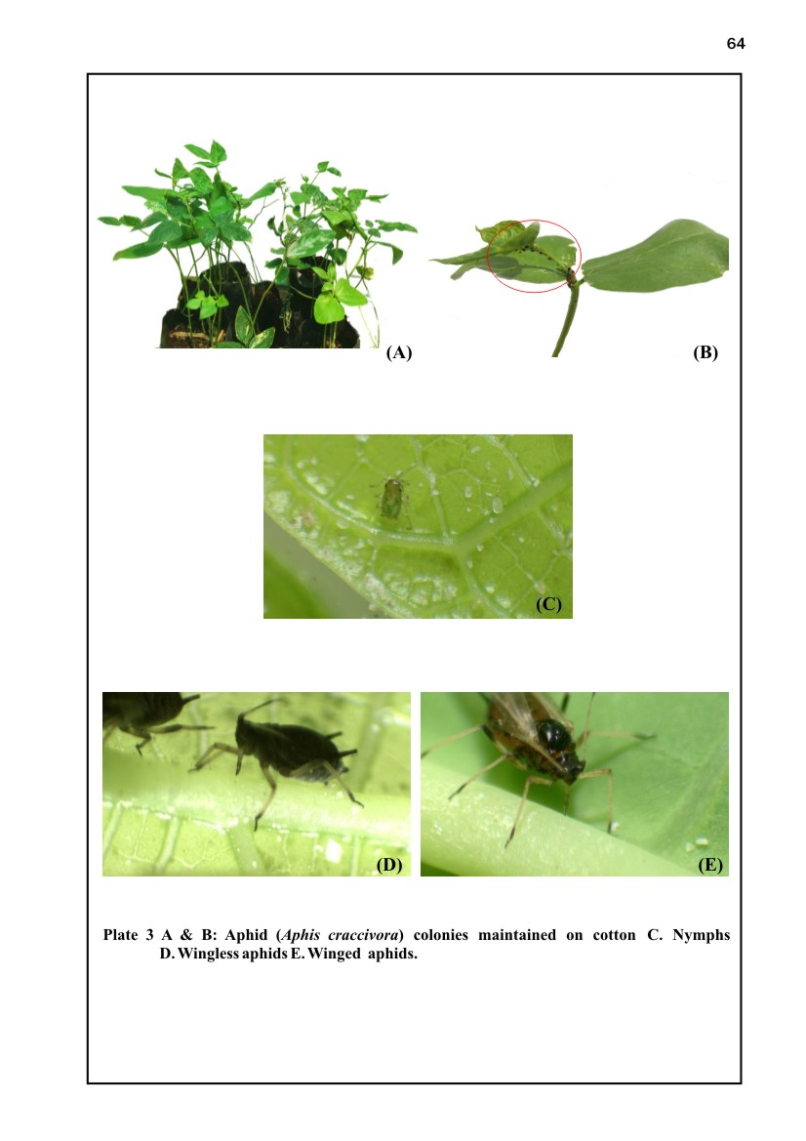

Suppl. Fig 1. Aphid (Aphis craccivora) colonies mantained on cotton (A & B), (C) Nymphs, (D) Wingless aphids and (E) Winged aphids.

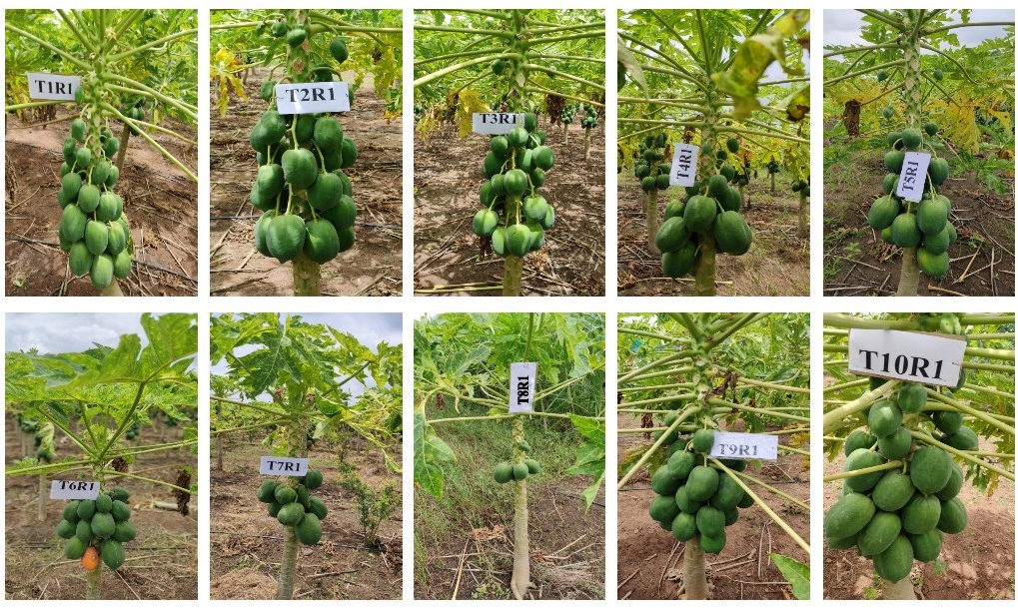

Suppl. Fig 2. Fruits on papaya plants planted at different months

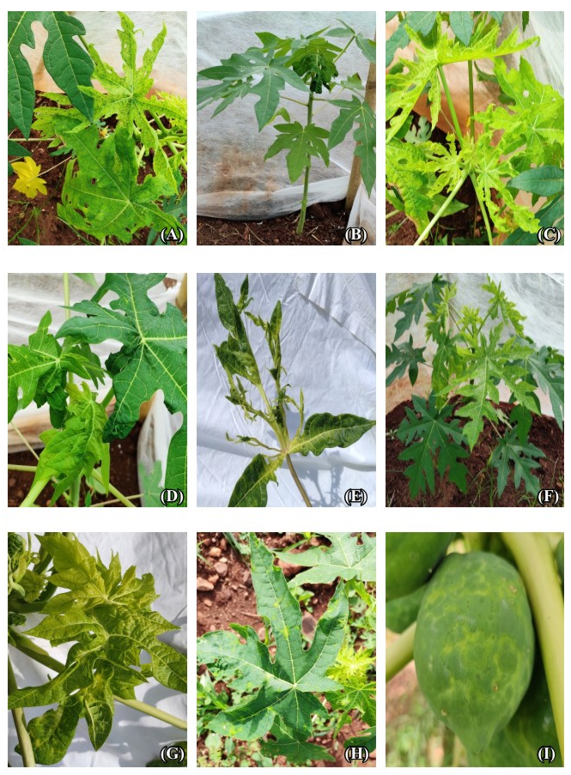

Suppl. Fig 3.. Different symptoms expressed by papaya plants after artificial inoculation with PRSV. Vein Clearing(A); Mosaic Symptom(B); Leaf Reduction (C); Leaf Distortion (D); Shoe String (E); Stunted Growth ); (F); Mottling (G); Chlorotic Ring (H); Chlorotic Spot on fruits (I).

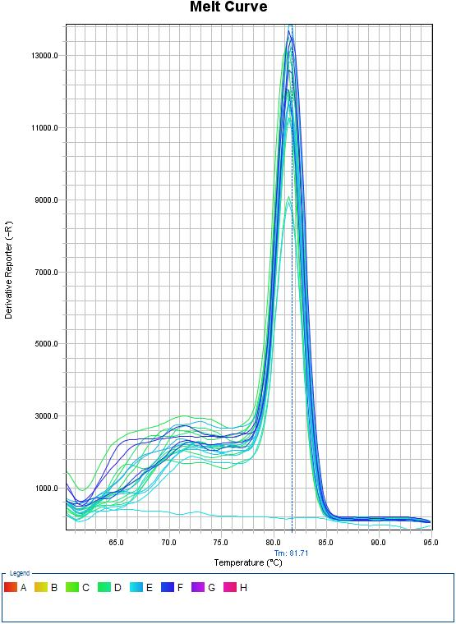
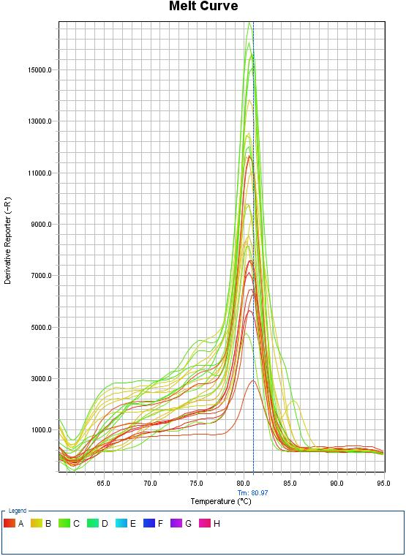
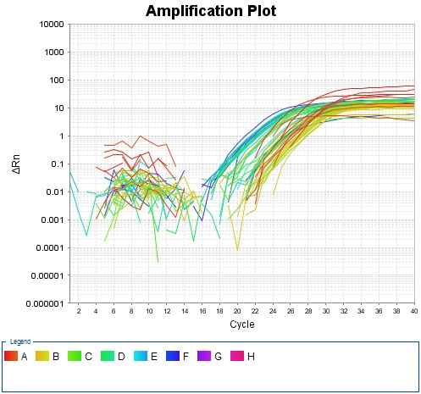
Suppl. Fig 4. Melt curve for (qRT-PCR) TATA-binding protein-2 (House keeping gene)

Suppl. Fig 5. Melt curve for PRSV viral titer (qRT-PCR) from papaya plants inoculated at months

Suppl. Fig 6. Amplification plot (qRT-PCR) of TATA-binding protein-2 (House keeping gene) and PRSV viral titer from papaya plants inoculated at months

