An assessment of climate change impacts on stream phosphorus using a climate model ensemble and Bayesian Belief Networks
Authors: Negri C.^{1,2,3,4}(0000-0001-8917-5322), Cowdery E.²(0000-0002-6538-6296), Schurch N.⁴(0000-0001-9068-9654), Wade A. J.³(0000-0002-5296-8350), Mellander P.-E.¹(0000-0002-7261-6758), Glendell M.²(0000-0003-0110-9879)

Authors’ Affiliations: ¹Agricultural Catchments Programme, Teagasc Environment Research Centre, Johnstown Castle, Co. Wexford Y35 Y521, ²The James Hutton Institute, Craigiebuckler, Aberdeen AB15 8QH, ³University of Reading, Department of Geography and Environmental Science, Whiteknights, Reading, RG6 6AB, ⁴Biomathematics and Statistics Scotland, Craigiebuckler, Aberdeen AB15 8QH
Corresponding Author: Camilla Negri, email: c.negri@pgr.reading.ac.uk, address: University of Reading, Department of Geography and Environmental Science, Whiteknights, Reading, RG6 6AB.

Supplementary Information

Figure captions
Fig. 1 BBN Sensitivity to changes in mean and standard deviation in the discharge (Q) node across the four catchments, from top left to bottom rights: Timoleague, Ballycanew, Castledockrell, and Dunleer. The effect is shown on the median log10(TRP) concentration (mg l⁻¹). For all catchments, sensitivity is visible along changes in the January mean Q (along the x axis), but not for changes in the January standard deviation of Q (along the y axis). 5
Fig. 2 Mean monthly TRP concentrations (mg l⁻¹) in the four catchments. The predictions for the BBN baseline are shown in black while the observations (2009-2016) are shown in dark green. Predicted TRP concentrations were log-transformed before calculating the statistics, and then converted back to normal values. Results are shown for the NSE calibration of the SMART model only. 6

Table captions
Table 1 Mean log₁₀(TRP) (mg l⁻¹) predicted with model ensemble against the mean observed TRP at the catchment outlet. All concentrations have been filtered by the instrument’s detection limit (0.01-5.00 mg l⁻¹). 1
Table 2 Mean monthly TRP concentration (mg l⁻¹) in the four catchments as predicted by each model in September using the RCP 8.5 scenarios. Predicted TRP concentrations were log-transformed before calculating the statistics, and then converted back to normal values. Results are shown for the NSE calibration of the SMART model only. Concentrations are shown for the observations (obs) and the BBN (BBN baseline) in the reference period (2009-2016). 2

Table 1 Mean log₁₀(TRP) (mg l⁻¹) predicted with model ensemble against the mean observed TRP at the catchment outlet. All concentrations have been filtered by the instrument’s detection limit (0.01-5.00 mg l⁻¹).
Timoleague
 | RCP 4.5  (NSE) | RCP 4.5 (logNSE) | RCP 8.5  (NSE) | RCP 8.5 (log NSE) | obs | BBN baseline [1]
2009-2016 | - | - | - | - | -1.27±0.24 | 1.28±0.18
2010-2039 | 1.29±0.17 | 1.29±0.17 | 1.29±0.17 | 1.29±0.17 | - | -
2040-2069 | 1.29±0.17 | 1.28±0.18 | 1.29±0.17 | 1.28±0.18 | - | -
2070-2099 | 1.29±0.17 | 1.28±0.18 | 1.29±0.17 | 1.28±0.18 | - | -
Ballycanew
 | RCP 4.5  (NSE) | RCP 4.5 (log NSE) | RCP 8.5  (NSE) | RCP 8.5 (log NSE) | obs | BBN baseline [1]
2009-2016 | - | - | - | - | -1.20±0.24 | 1.15±0.38
2010-2039 | 1.15±0.38 | 1.15±0.38 | 1.15±0.38 | 1.15±0.38 | - | -
2040-2069 | 1.15±0.38 | 1.15±0.38 | 1.15±0.38 | 1.15±0.38 | - | -
2070-2099 | 1.15±0.38 | 1.15±0.38 | 1.15±0.38 | 1.15±0.38 | - | -
Castledockrell
 | RCP 4.5  (NSE) | RCP 4.5 (log NSE) | RCP 8.5  (NSE) | RCP 8.5 (log NSE) | obs | BBN baseline [1]
2009-2016 | - | - | - | - | 1.62±0.28 | -1.61±0.29
2010-2039 | 1.60±0.28 | 1.60±0.28 | 1.60±0.29 | 1.60±0.29 | - | -
2040-2069 | 1.60±0.29 | 1.60±0.29 | 1.60±0.28 | 1.60±0.28 | - | -
2070-2099 | 1.60±0.29 | 1.60±0.29 | 1.61±0.29 | 1.61±0.29 | - | -
Dunleer
 | RCP 4.5  (NSE) | RCP 4.5 (log NSE) | RCP 8.5  (NSE) | RCP 8.5 (log NSE) | obs | BBN baseline [1]
2009-2016 | - | - | - | - | -1.02±0.22 | 1.05±0.49
2010-2039 | 1.04±0.49 | 1.05±0.49 | 1.05±0.48 | 1.05±0.49 | - | -
2040-2069 | 1.04±0.49 | 1.05±0.49 | 1.05±0.49 | 1.05±0.49 | - | -
2070-2099 | 1.04±0.49 | 1.05±0.48 | 1.04±0.49 | 1.04±0.49 | - | -

Table 2 Mean monthly TRP concentration (mg l⁻¹) in the four catchments as predicted by each model in September using the RCP 8.5 scenarios. Predicted TRP concentrations were log-transformed before calculating the statistics, and then converted back to normal values. Results are shown for the NSE calibration of the SMART model only. Concentrations are shown for the observations (obs) and the BBN (BBN baseline) in the reference period (2009-2016).
Timoleague
 | CNRM-CM5 | EC-EARTH | HadGEM2 | MIROC5 | MPI-ESM-LR | model ensemble | obs | BBN baseline [1]
2009-2016 | - | - |  | - |  | - | 0.05 | 0.07
2010-2039 | 0.06 | 0.06 | 0.07 | 0.06 | 0.06 | 0.06 | - | -
2040-2069 | 0.06 | 0.07 | 0.08 | 0.06 | 0.06 | 0.06 | - | -
2070-2099 | 0.06 | 0.07 | 0.08 | 0.06 | 0.06 | 0.06 | - | -
Ballycanew
 | CNRM-CM5 | EC-EARTH | HadGEM2 | MIROC5 | MPI-ESM-LR | model ensemble | obs | BBN baseline [1]
2009-2016 | - | - |  | - |  | - | 0.07 | 0.08
2010-2039 | 0.07 | 0.07 | 0.08 | 0.07 | 0.07 | 0.07 | - | -
2040-2069 | 0.07 | 0.07 | 0.09 | 0.07 | 0.07 | 0.07 | - | -
2070-2099 | 0.07 | 0.07 | 0.09 | 0.07 | 0.07 | 0.07 | - | -
Castledockrell
 | CNRM-CM5 | EC-EARTH | HadGEM2 | MIROC5 | MPI-ESM-LR | model ensemble | obs | BBN baseline [1]
2009-2016 | - | - |  | - |  | - | 0.03 | 0.03
2010-2039 | 0.03 | 0.04 | 0.08 | 0.02 | 0.02 | 0.03 | - | -
2040-2069 | 0.03 | 0.03 | 0.07 | 0.02 | 0.02 | 0.02 | - | -
2070-2099 | 0.03 | 0.04 | 0.07 | 0.02 | 0.02 | 0.02 | - | -
Dunleer
 | CNRM-CM5 | EC-EARTH | HadGEM2 | MIROC5 | MPI-ESM-LR | model ensemble | obs | BBN baseline [1]
2009-2016 | - | - |  | - |  | - | 0.15 | 0.09
2010-2039 | 0.09 | 0.09 | 0.11 | 0.09 | 0.09 | 0.09 | - | -
2040-2069 | 0.09 | 0.09 | 0.11 | 0.09 | 0.09 | 0.09 | - | -
2070-2099 | 0.09 | 0.09 | 0.11 | 0.09 | 0.09 | 0.09 | - | -

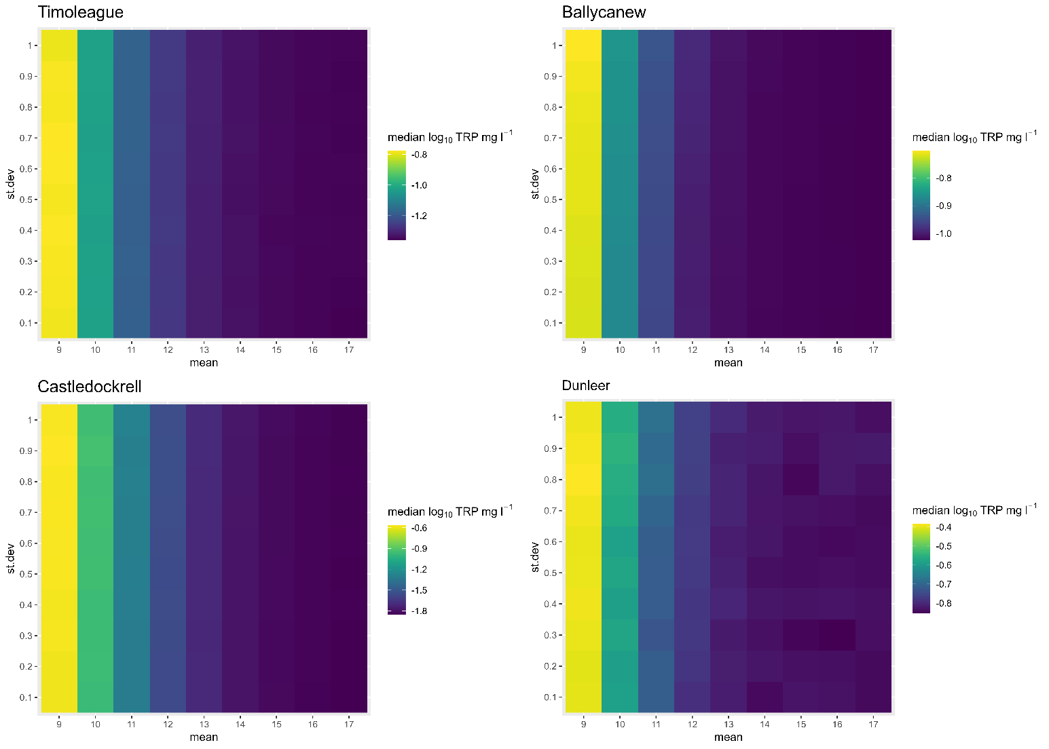
Fig. 1 BBN Sensitivity to changes in mean and standard deviation in the discharge (Q) node across the four catchments, from top left to bottom rights: Timoleague, Ballycanew, Castledockrell, and Dunleer. The effect is shown on the median log10(TRP) concentration (mg l⁻¹). For all catchments, sensitivity is visible along changes in the January mean Q (along the x axis), but not for changes in the January standard deviation of Q (along the y axis).

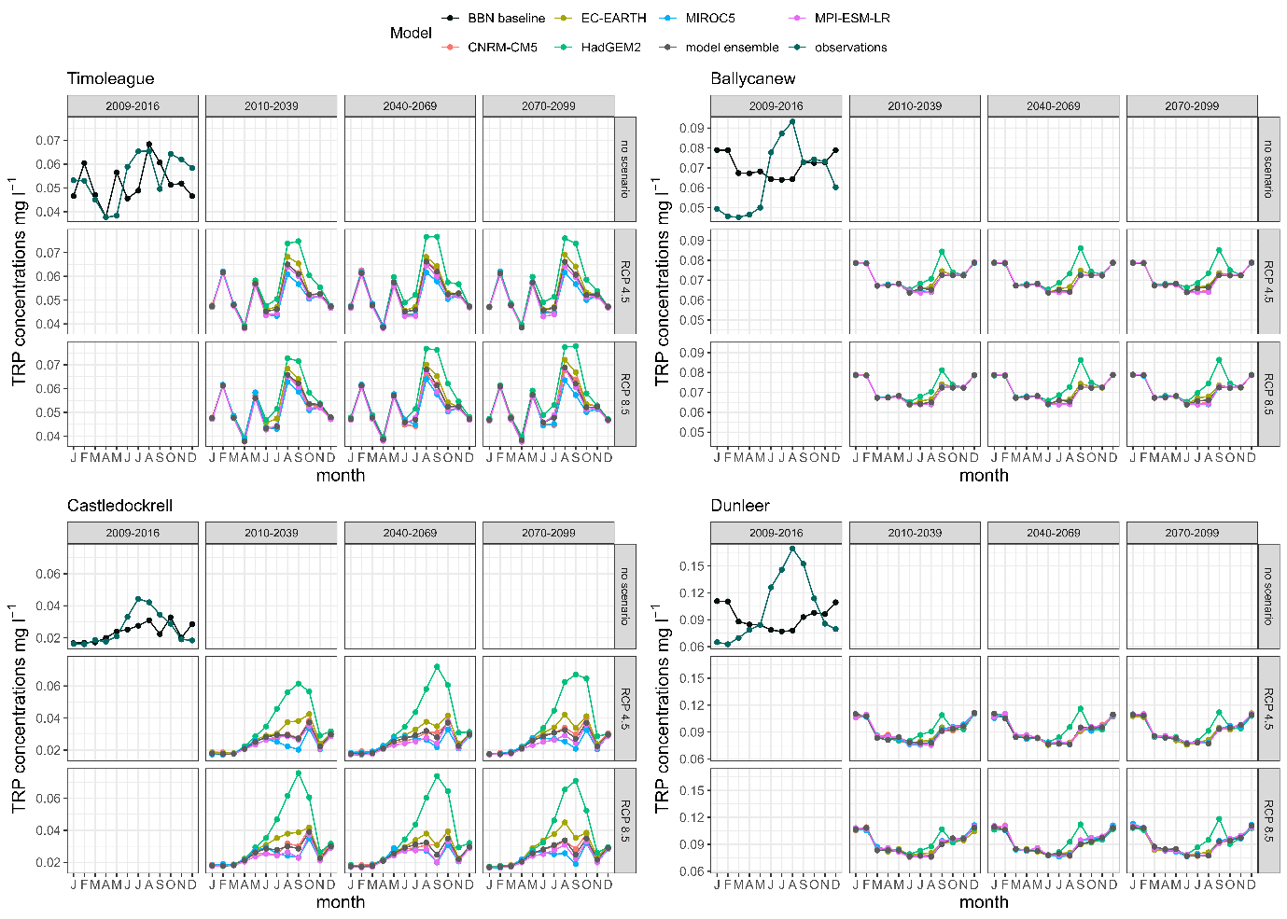
Fig. 2 Mean monthly TRP concentrations (mg l⁻¹) in the four catchments. The predictions for the BBN baseline are shown in black while the observations (2009-2016) are shown in dark green. Predicted TRP concentrations were log-transformed before calculating the statistics, and then converted back to normal values. Results are shown for the NSE calibration of the SMART model only.

Bibliography
[1] Negri C, Schurch N, Wade AJ, Mellander P-E, Stutter M, Bowes MJ, et al. Transferability of a Bayesian Belief Network across diverse agricultural catchments using high-frequency hydrochemistry and land management data. Sci Total Environ 2024;949:174926. https://doi.org/10.1016/j.scitotenv.2024.174926.

