Extended Data
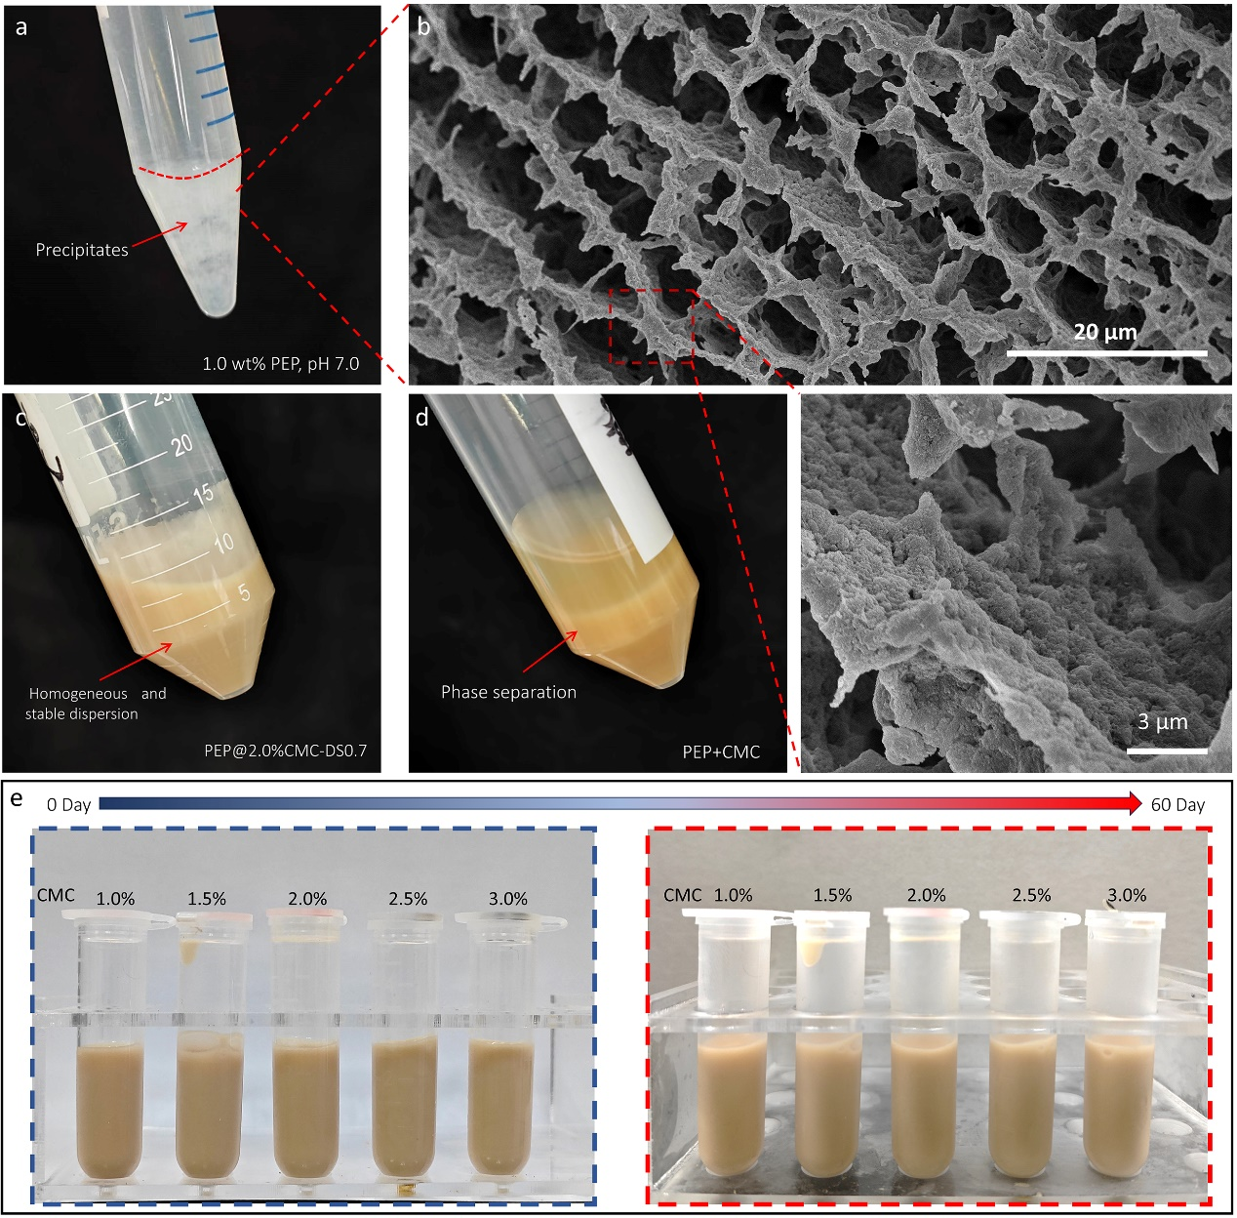
Extended Data Fig. 1│ Stability of different PEP dispersions. a, Photograph of a PEP dispersion (1.0 wt.%, pH 7.0) with the red dotted line separating the clear liquid from the precipitate. b, Cryo-SEM image of gel structure of PEP sediment. c, Photograph of a homogeneous and stable PEP@CMC dispersion after centrifuging at 4,000 g for 10 min. d, Photograph of a mixture of 15.0 wt.% PEP and 2.0 wt.% CMC which enabled solid-liquid phase separation of PEP after centrifuging at 4,000 g for 10 min. e, Long-term stability of PEP@CMC with different CMC concentrations with no phase separation occurring after 60 days of storage at 4 °C. Except a, b and d, all PEP@CMC dispersions had a PEP concentration of 15.0 wt.% based on CMC with a DS of 0.7 and MW of 250 kDa which were heated to 90 °C for 30 min before testing.

Extended Data Fig. 2│ Rheological properties of CMC, PEP and PEP+CMC dispersions. a, Steady state shear tests of CMC solutions with different DS. b, Frequency sweep tests of CMC solutions with different DS. c, Strain sweep tests of CMC solutions with different DS. d, Steady state shear tests of a PEP dispersion. e, Frequency sweep test of a PEP dispersion. f, Strain sweep test of a PEP dispersion. g, Extensional rheology of dispersions showing diameter of dispersion filaments vs time. h, Comparison of the maximum stretching time for different preparations. All PEP dispersions have a 15.0 wt.% protein content and the concentration of CMC solution (MW of 250 kDa) was 2.0 wt.%. The characterizations were performed after heat treatment at 90 °C for 30 min.

Extended Data Fig. 3│ Oral tribological properties. a–e, Lubrication curves of PEP@CMC dispersions with CMC additions of 1.0, 1.5, 2.0, 2.5 and 3.0 wt.% respectively. Different phases of lubrication are assigned different colors. All PEP@CMC dispersions have a PEP concentration of 15.0 wt.% based on CMC with a DS of 0.7 and MW of 250 kDa. The characterizations were performed after heat treatment at 90 °C for 30 min.

Extended Data Fig. 4│ Ashby plot of this work compared with similar work in terms of maximum protein content and integrated environmental impact. The integrated environmental impact is a weighted average of 40%, 30% and 30% of the greenhouse gas emissions (GHG), land use and water use respectively of different proteins as a proportion of the maximum value of each (maximum emission is 100) and reflects the overall environmental impact during the acquisition of a protein. The maximum protein content data are derived from previous studies (soy^{45,46}, pea⁴⁷, nut⁴⁸, grain⁴⁹, milk⁵⁰, egg⁵¹ and fish⁵²).

Extended Data Fig. 5│ Morphologies and analysis of pore areas of CMC networks. a–e, Cryo-SEM images and corresponding network profiles of PEP@CMC dispersions with CMC additions of 1.0, 1.5, 2.0, 2.5 and 3.0 wt.% respectively. f, Average pore area calculated from a–e. All PEP@CMC dispersions have a PEP concentration of 15.0 wt.% based on CMC with a DS of 0.7 and MW of 250 kDa. The characterizations were performed after heat treatment of PEP@CMC dispersions at 90 °C for 30 min.
Extended Data Fig. 6│ Spatial ordering analysis of PEP@CMC dispersions using CMC with different DS. a, Azimuthal average of 2D FFT analysis of the cryo-SEM images (Fig. 4d). b–d, Fractal box count fit of CLSM images (insets) with CMC of DS (b) 0.7, (c) 0.9 and (d) 1.2. e–g, Statistical data of (e) λ*, (f) D_{f} and (g) porosity from analysis of FFT (Fig. 4d), fractal box count fit and nano-CT (Fig. 4), respectively. All PEP@CMC dispersions have a PEP concentration of 15.0 wt.% with 1.5 wt.% CMC (MW of 250 kDa). The characterizations were performed after heat treatment of PEP@CMC dispersions at 90 °C for 30 min.

Extended Data Fig. 7│ Stability of PEP@CMC dispersions. a–l, Transmission profiles of PEP@CMC dispersions with CMC of different DS and concentration simulating the stability of samples after 2 months of storage. m, Phase diagram of stability coefficient (a lower stability coefficient indicates a higher stability) of PEP@CMC (DS 0.7) at different pH (2.0–7.0) and CMC additions (1.5–3.0 wt.%). All PEP@CMC dispersions have a PEP concentration of 15.0 wt.%. The characterizations were performed after heat treatment of PEP@CMC dispersions at 90 °C for 30 min.

Extended Data Fig. 8│ Temperature creep properties of PEP@CMC dispersions. a, Temperature-dependent storage modulus (G’) and loss modulus (G’’) curves of PEP@CMC dispersions with CMC (DS 0.7) of different additions (2.0, 2.5 and 3.0 wt.%). b, Temperature-dependent storage modulus (G’) and loss modulus (G’’) curves of PEP@CMC dispersions with 1.5 wt.% CMC of different DS. The sol-gel transition points of the dispersions are marked using colored lines. All PEP@CMC dispersions have a PEP concentration of 15.0 wt.%. The characterizations were performed after heat treatment of PEP@CMC dispersions at 90 °C for 30 min.

Extended Data Fig. 9│ Rheological and friction properties of dispersions with walnut protein (WP) or soybean protein (SP) as a substitute for PEP. a, Photo’ of a WP@CMC dispersion. b, Photo’ of a SP@CMC dispersion. c, Lubrication curves of WP@CMC and SP@CMC dispersions in a–b. d, Frequency sweep tests of WP@CMC and SP@CMC of dispersions in a–b. e, Strain sweep tests of WP@CMC and SP@CMC dispersions in a–b. f, Steady state shear tests of WP@CMC and SP@CMC dispersions in a–b. g, Extensional rheology of WP@CMC and SP@CMC dispersions in a–b. All dispersions have a protein concentration of 15.0 wt.% based on 2.0 wt.% CMC of DS of 0.7 and MW of 250 kDa. The characterizations were performed after heat treatment at 90 °C for 30 min.

Extended Data Fig. 10│ Rheological and friction properties of dispersions with xanthan gum (XG) or sodium alginate (SA) as a substitute for CMC. a, Photo’ of a PEP@XG dispersion. b, Photo’ of a PEP@SA dispersion. c, Lubrication curves of PEP@XG and PEP@SA dispersions in a–b. d, Frequency sweep tests of PEP@XG and PEP@SA dispersions in a–b. e, Strain sweep tests of PEP@XG and PEP@SA dispersions in a–b. f, Steady state shear tests of PEP@XG and PEP@SA dispersions in a–b. g, Extensional rheology of PEP@XG and PEP@SA dispersions in a–b. All dispersions have a protein concentration of 15.0 wt.% based on 2.0 wt.% polysaccharides. The characterizations were performed after heat treatment at 90 °C for 30 min.

Extended References
- Lan T, Shi J, Dong Y, Wang B, Xu Z, Jiang L, et al. Optimizing texture and mechanical properties: The impact of pH-modulated metal-phenolic networks on soy protein isolate gels. Food Hydrocolloids 153, 110011 (2024).
- Patra, T., Rinnan, Å. & Olsen, K. The physical stability of plant-based drinks and the analysis methods thereof. Food Hydrocolloids 118, 106770 (2021).
- Li C, Dai T, Jiang D, Geng Q, Deng L, Li T, et al. Acid-induced pea protein gels pretreated with media milling: Gelling properties and the formation mechanism. Food Chem. 449, 139110 (2024).
- Kim, D.-S., Iida, F. & Joo, N. Comparison of the nutritional composition of raw, boiled, roasted Macadamia (F. Muell. Macadamieae) and its application as an elder-friendly food. Int J Gastron Food S. 30, 100592 (2022).
- Lian, Y., Li, Y., Lv, R., Wang, L. & Xiong, W. The mechanism of alkali-induced rice protein gel formation: Effect of alkali concentration and temperature. Food Hydrocolloids 147, 109335 (2024).
- Fan, J., Li, Y., Yao, Y., Wang, L. & Xiong, W. Tailoring the high-protein texture-modified foods for the dysphagia elderly by heating whey protein isolate-pectin complexes. Food Hydrocolloids 154, 110070 (2024).
- Xiong W, Li Y, Li B, Geng F. Relationship between gel properties and water holding of ovalbumin-carboxymethylcellulose electrostatic complex hydrogels. Int. J. Biol. Macromol. 167: 1230-1240 (2021).
- Fei, S. et al. Salmon protein gel enhancement for dysphagia diets: Konjac glucomannan and composite emulsions as texture modifiers. Int J Biol Macromol. 258, 128805 (2024).

