Appendix Table 1.
Results of the Probabilistic Sensitivity Analysis-1,000 individuals with 1,000 Monte Carlo Simulations
Population |  | Interval | QALY | Incremental QALY | Cost ($) | Incremental cost ($) | ICER ($/QALY)
Age | BMI group
30-44 | Underweight | Annual | 30.15 | ― | 2,464.40 | ― | Dominated
30-44 | Underweight | 3-year | 30.15 | ― | 976.09 | ― | Dominated
30-44 | Underweight | 10-year | 30.16 | ― | 426.58 | ― | Dominant
30-44 | Normal | Annual | 30.13 | ― | 2,495.39 | ― | Dominated
30-44 | Normal | 3-year | 30.14 | 0.002 | 1,117.75 | 395.94 | 181,321.36  (vs 6-year)
30-44 | Normal | 6-year | 30.14 | ― | 721.81 | ― | ―
30-44 | Overweight | Annual | 29.87 | ― | 2,873.92 | ― | Dominated
30-44 | Overweight | 3-year | 29.94 | ― | 2,720.52 | ― | Dominated
30-44 | Overweight | 4-year | 29.94 | ― | 2,466.16 | ― | Dominant
30-44 | Obese | Annual | 28.88 | ― | 4,360.47 | ― | ―
30-44 | Obese | 2-year | 29.18 | ― | 9,013.37 | ― | Dominated
30-44 | Obese | 3-year | 29.21 | 0.33 | 9,014.82 | 4,654.30 | 14,035.31  (vs Annual)
45-59 | Underweight | Annual | 23.56 | ― | 195,290.60 | ― | Dominated
45-59 | Underweight | 3-year | 23.57 | 0.003 | 86,842.28 | 459.46 | 182,263.40  (vs 10-year)
45-59 | Underweight | 10-year | 23.56 | ― | 40,896.47 | ― | ―
45-59 | Normal | Annual | 23.42 | ― | 2,055.86 | ― | Dominated
45-59 | Normal | 3-year | 23.46 | ― | 1,491.09 | ― | Dominated
45-59 | Normal | 6-year | 23.46 | ― | 1,137.62 | ― | Dominant
45-59 | Overweight | Annual | 23.16 | ― | 2,790.12 | ― | ―
45-59 | Overweight | 3-year | 23.26 | 0.01 | 3,098.03 | 235.80 | 26,771.81  (vs 4-year)
45-59 | Overweight | 4-year | 23.25 | 0.09 | 2,862.22 | 72.10 | 802.17  (vs Annual)
45-59 | Obese | Annual | 22.27 | ― | 3,068.62 | ― | ―
45-59 | Obese | 3-year | 22.67 | 0.01 | 7,555.49 | 262.53 | 28,842.73  (vs 4-year)
45-59 | Obese | 4-year | 22.66 | 0.38 | 7,292.96 | 4,224.34 | 11,000.99  (vs Annual)
60-74 | Underweight | Annual | 15.75 | ― | 1330.28 | ― | Dominated
60-74 | Underweight | 3-year | 15.76 | 0.004 | 661.71 | 194.53 | 47,742.19  (vs 6-year)
60-74 | Underweight | 6-year | 15.76 | ― | 467.18 | ― | ―
60-74 | Normal | Annual | 15.65 | ― | 1366.64 | ― | Dominated
60-74 | Normal | 3-year | 15.70 |  | 1008.83 | 294.71 | 44026.83  (vs 7-year)
60-74 | Normal | 7-year | 15.69 | ― | 714.11 | ― | ―
60-74 | Overweight | Annual | 15.45 | ― | 1,453.632 | ― | ―
60-74 | Overweight | 3-year | 15.54 | 0.01 | 1,810.007 | 246.61 | 30,620.69  (vs 5-year)
60-74 | Overweight | 5-year | 15.53 | 0.08 | 1,563.397 | 109.7649 | 1,347.50  (vs Annual)
60-74 | Obese | Annual | 15.02 | ― | 1,629.16 | ― | ―
60-74 | Obese | 3-year | 15.25 | 0.004 | 3,606.67 | 176.59 | 40,588.01  (vs 4-year)
60-74 | Obese | 4-year | 15.25 | 0.22 | 3,430.09 | 1,800.93 | 8,108.36  (vs annual)
Underlined intervals are found to be the most cost effective strategies with a willingness-to-pay threshold of $50,000. Units of costs, incremental costs and ICER is in USD$.

Appendix Figure 1: Age 30-44 years old: Outcomes of 1000 simulations from the societal perspective
Underweight |  | 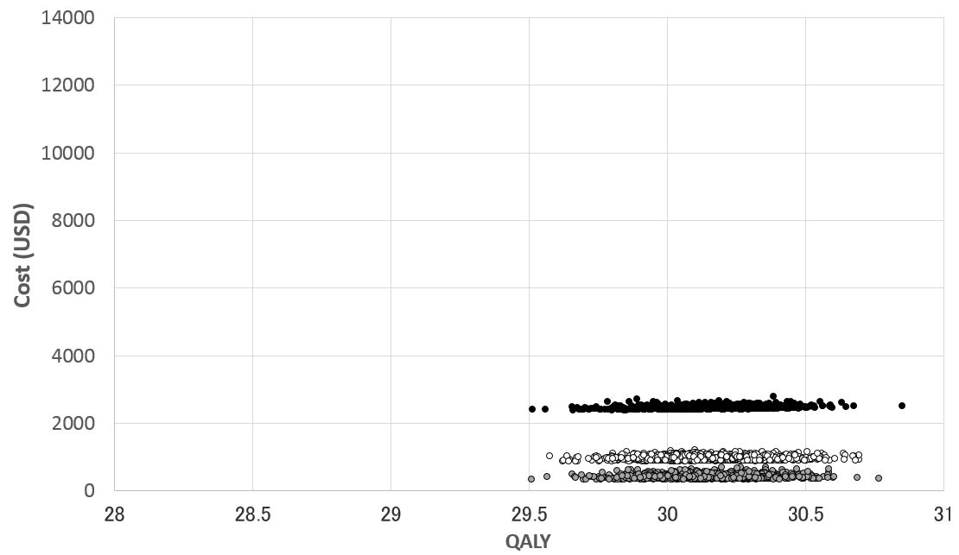
○ | Annual interval
● | Every 3 years
○ | Every 10 years
Normal |  | 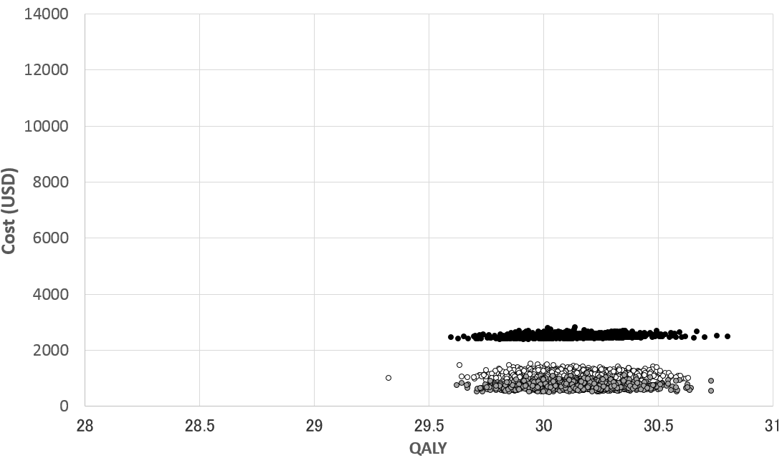
○ | Annual interval
● | Every 3 years
○ | Every 6 years
Overweight |  | 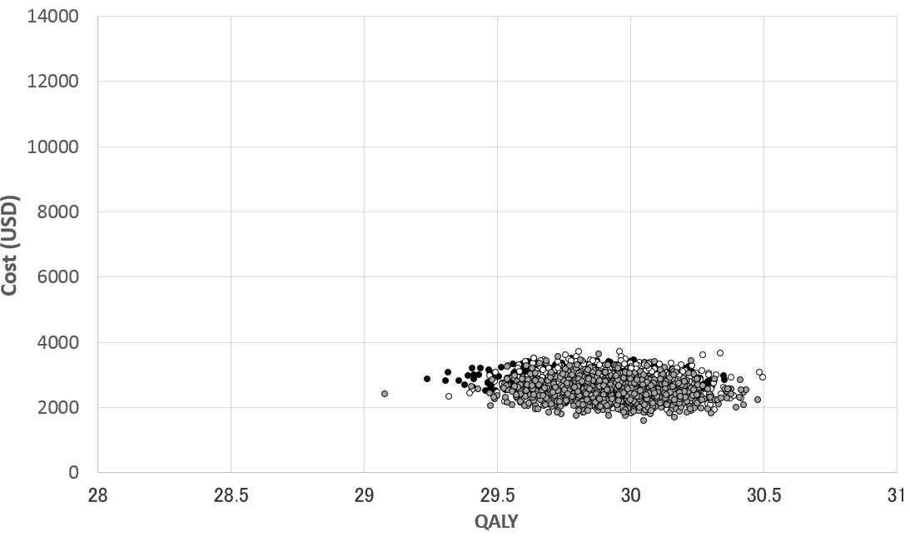
○ | Annual interval
● | Every 3 years
○ | Every 6 years
Obese |  | 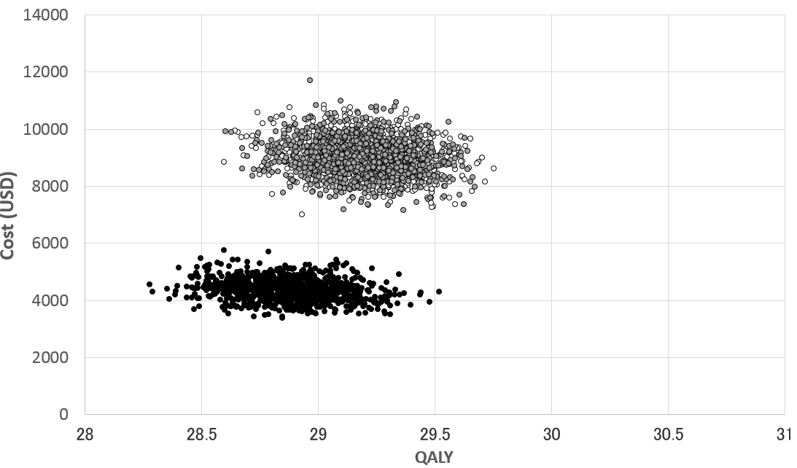
○ | Annual interval
● | Every 3 years
○ | Every 2 years
Appendix Figure 2: Age 45-59 years old: Outcomes of 1000 simulations from the societal perspective
Underweight |  | 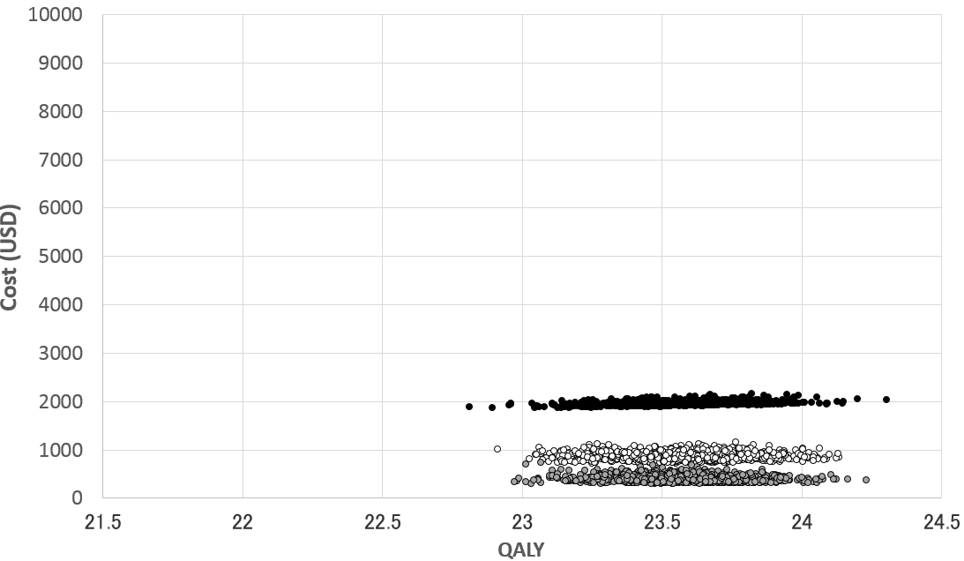
○ | Annual interval
● | Every 3 years
○ | Every 10 years
Normal |  | 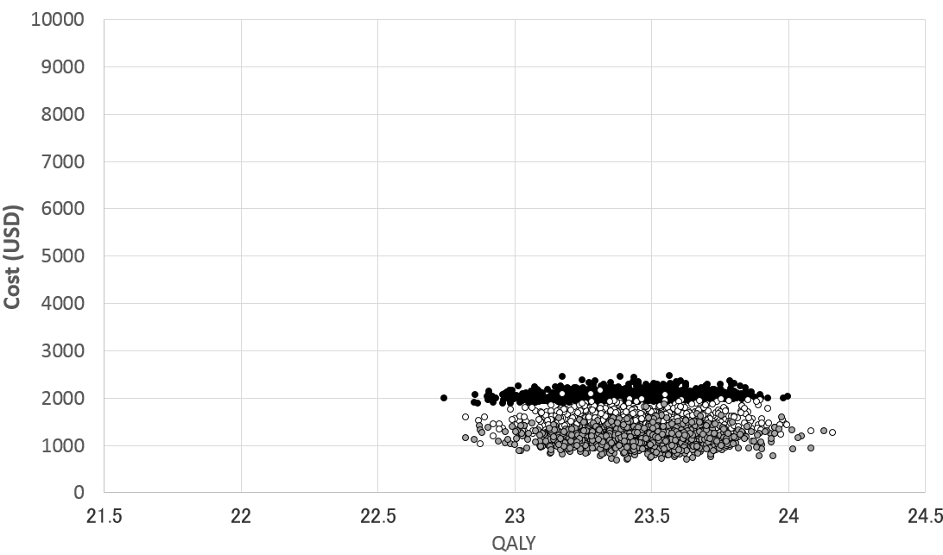
○ | Annual interval
● | Every 3 years
○ | Every 6 years
Overweight |  | 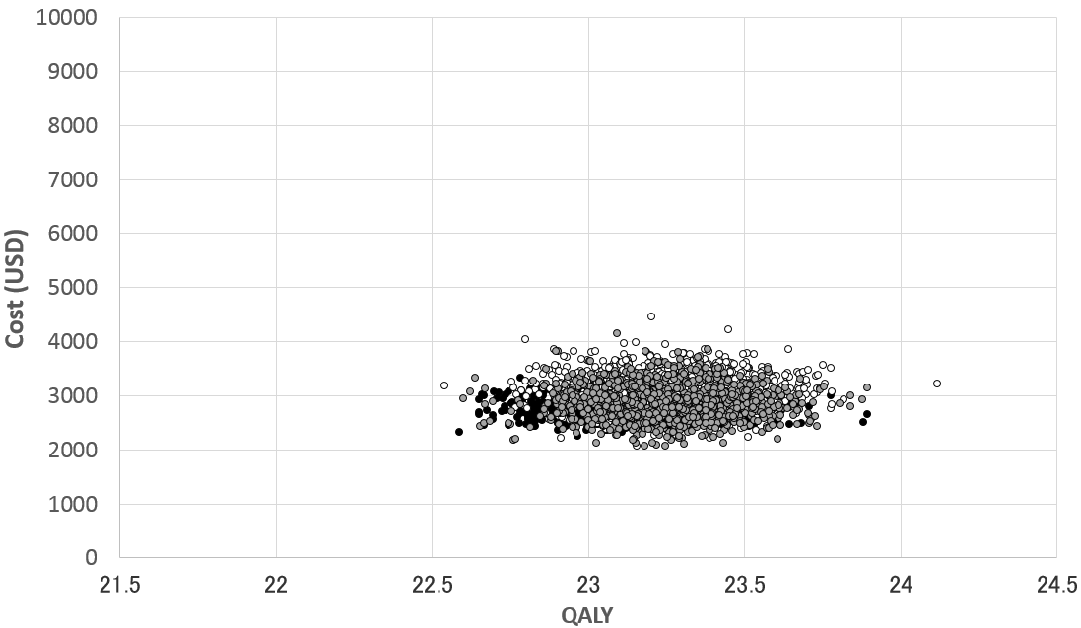
○ | Annual interval
● | Every 3 years
○ | Every 4 years
Obese |  | 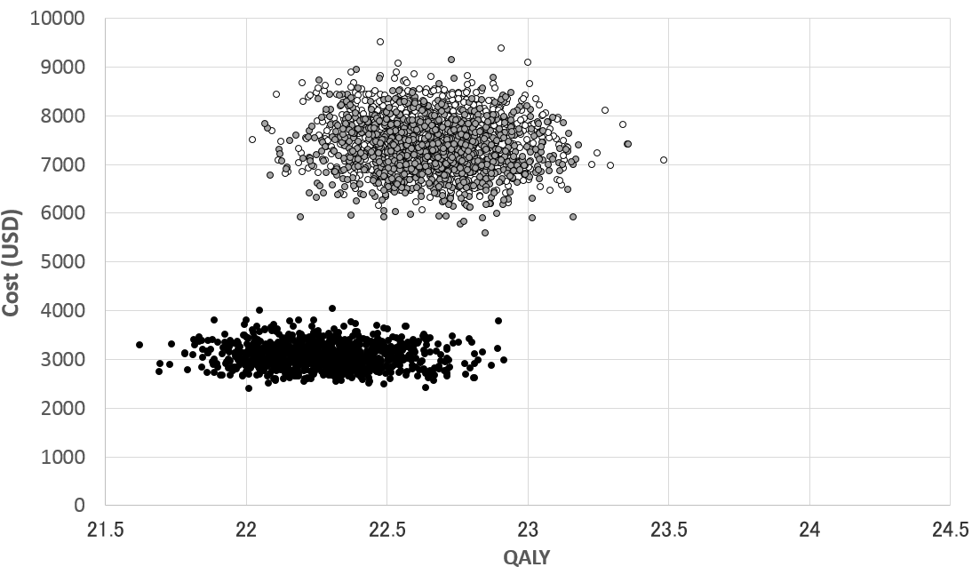
○ | Annual interval
● | Every 3 years
○ | Every 4 years
Appendix Figure 3: Age 60-74 years old: Outcomes of 1000 simulations from the societal perspective
Underweight |  | 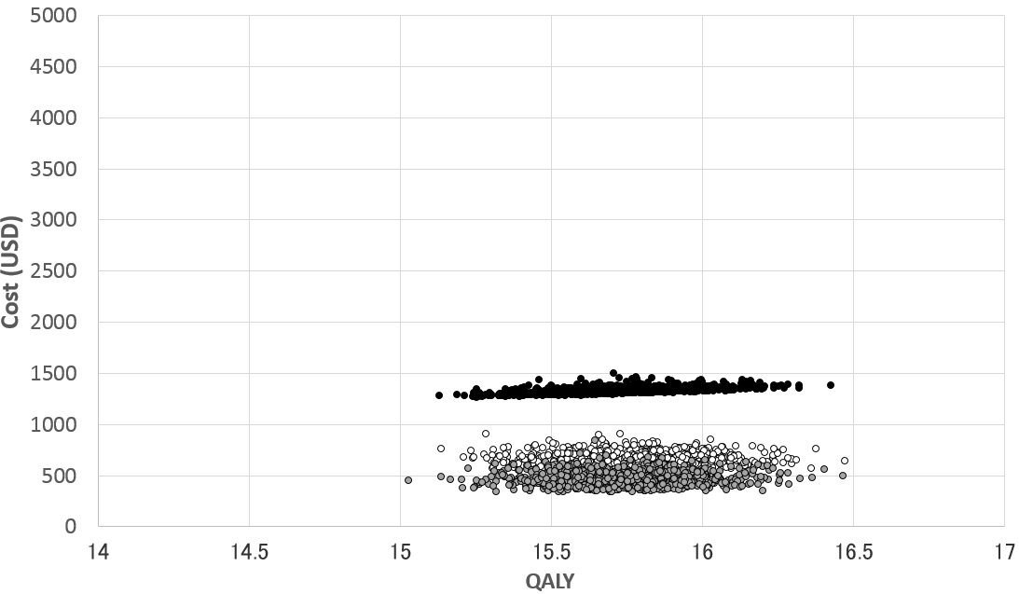
○ | Annual interval
● | Every 3 years
○ | Every 6 years
Normal |  | 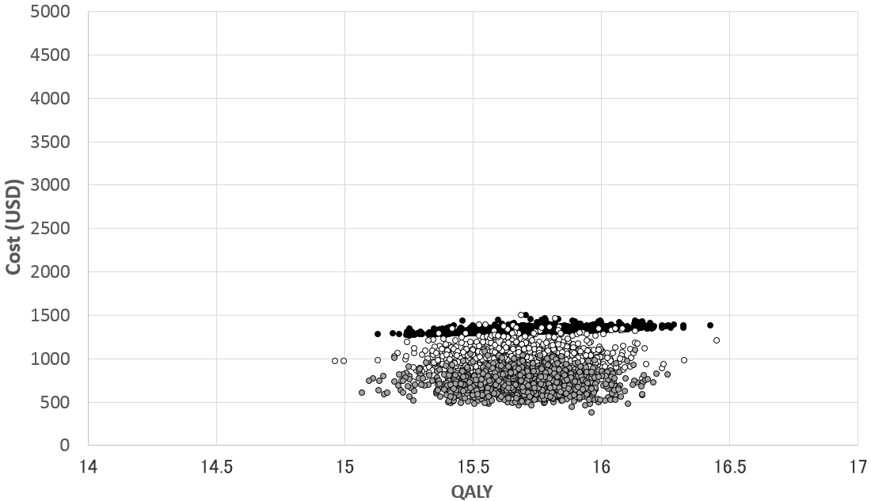
○ | Annual interval
● | Every 3 years
○ | Every 7 years
Overweight |  | 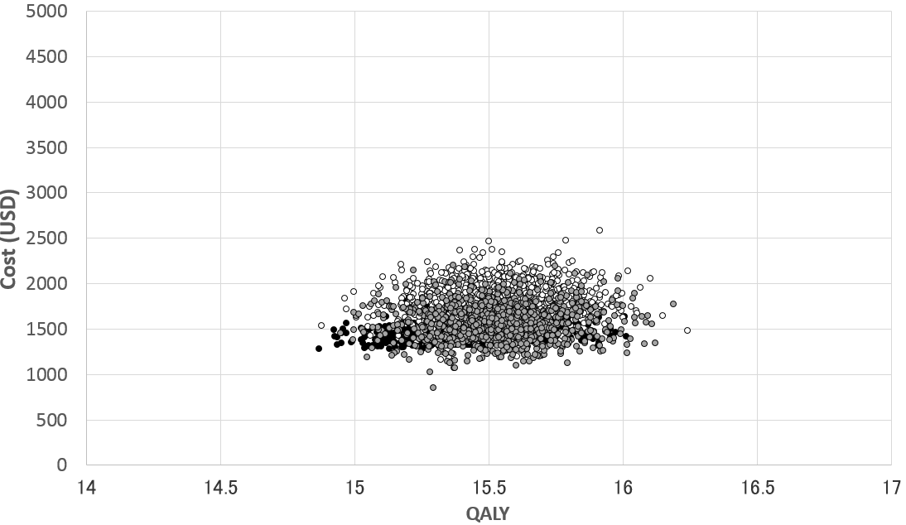
○ | Annual interval
● | Every 3 years
○ | Every 5 years
Obese |  | 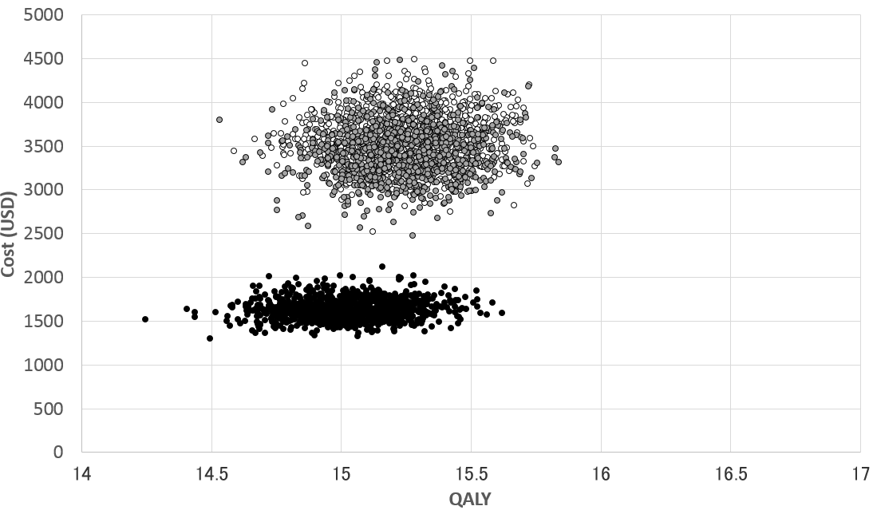
○ | Annual interval
● | Every 3 years
○ | Every 4 years
Appendix Figure 4: Age 30-44 years old: Monte Carlo Simulation % cost effectiveness strategies
Underweight |  | 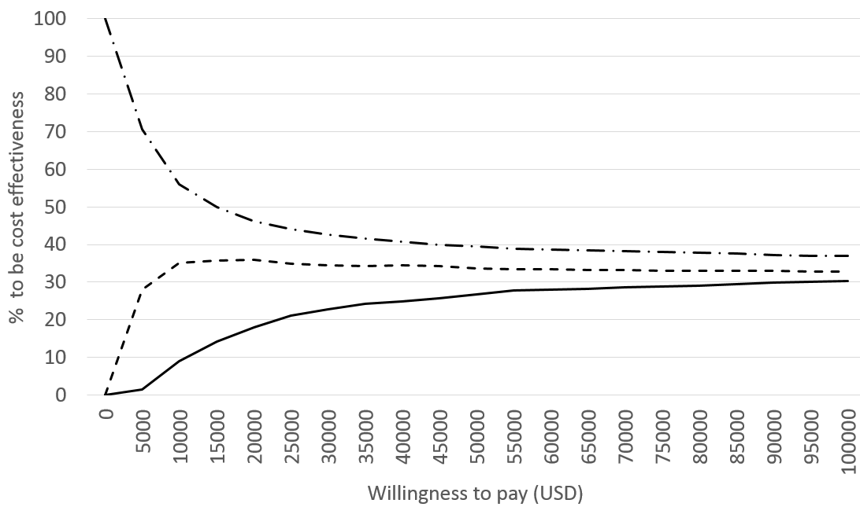
 | Annual interval
 | Every 3 years
 | Every 10 years
Normal |  | 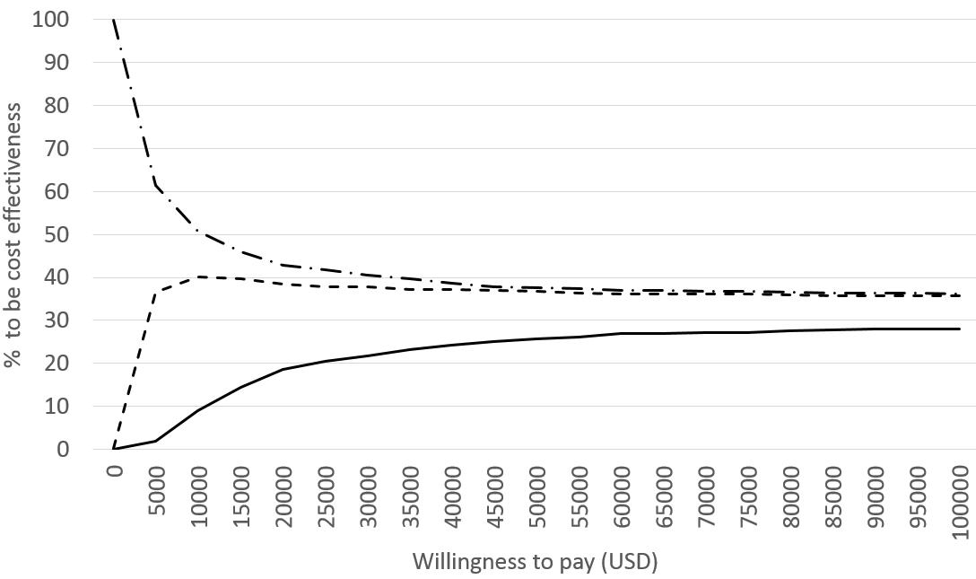
 | Annual interval
 | Every 3 years
 | Every 6 years
Overweight |  | 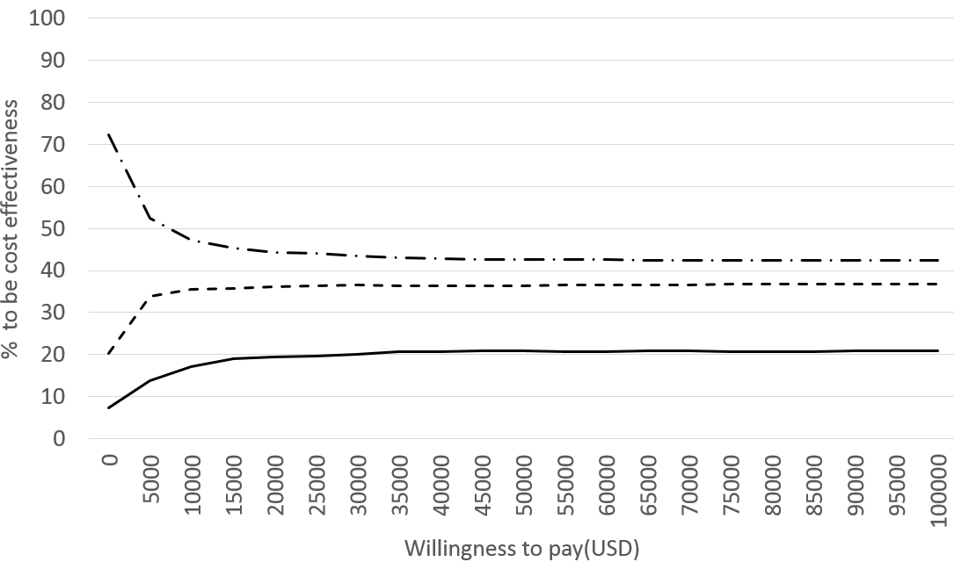
 | Annual interval
 | Every 3 years
 | Every 6 years
Obese |  | 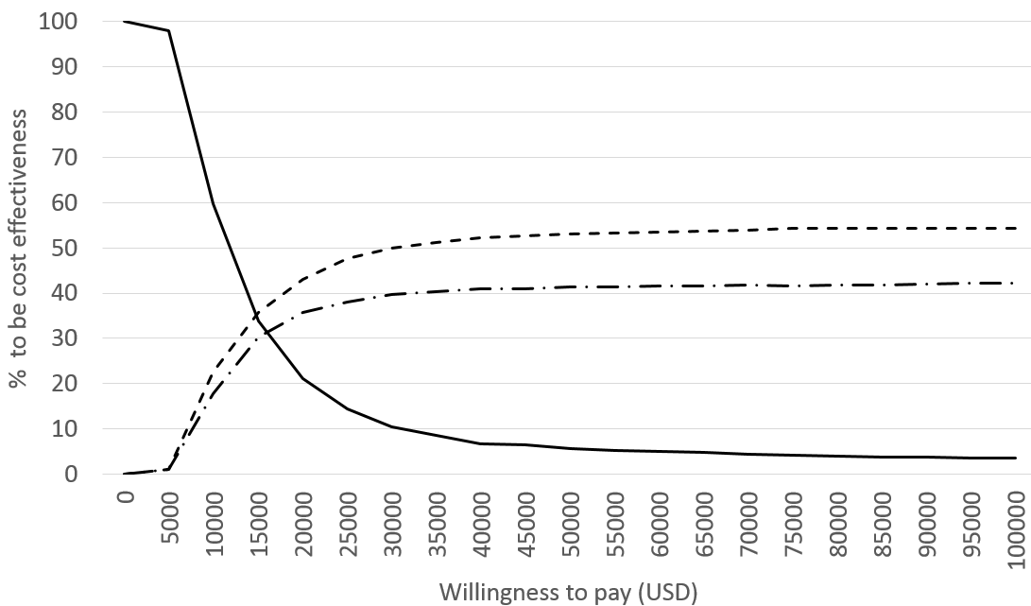
 | Annual interval
 | Every 3 years
 | Every 2 years

Appendix Figure 5: Age 45-59 years old: Monte Carlo Simulation % cost effectiveness strategies
Underweight |  | 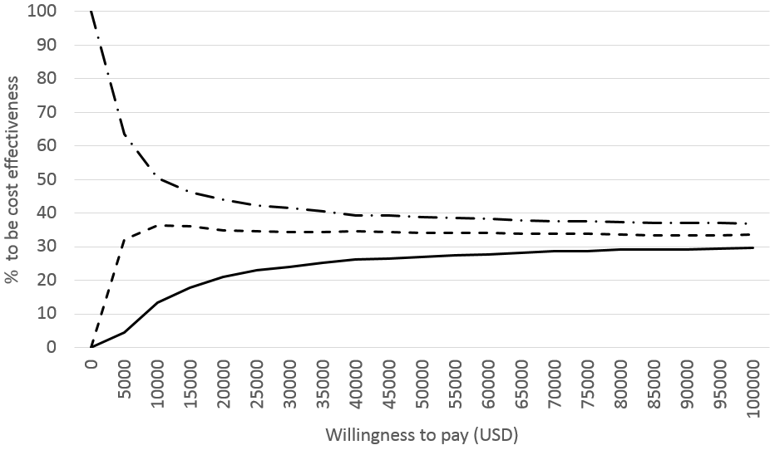
 | Annual interval
 | Every 3 years
 | Every 10 years
Normal |  | 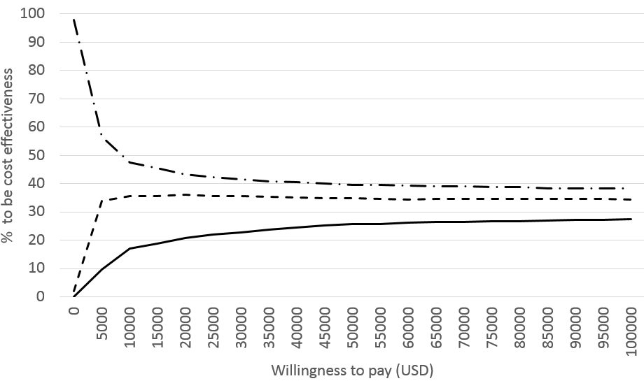
 | Annual interval
 | Every 3 years
 | Every 6 years
Overweight |  | 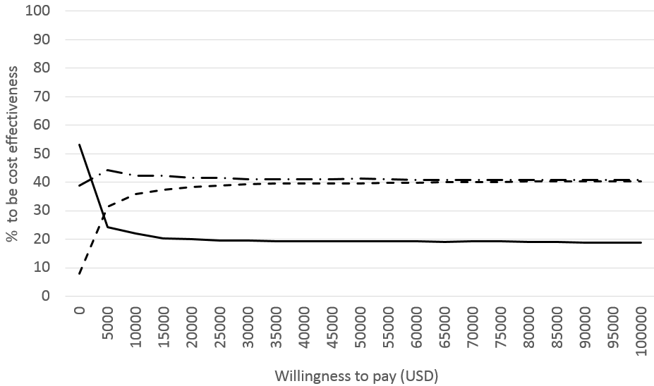
 | Annual interval
 | Every 3 years
 | Every 4 years
Obese |  | 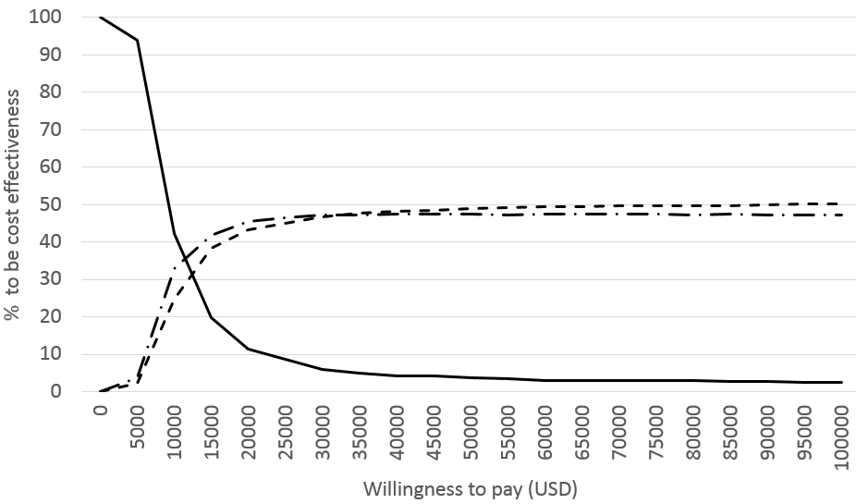
 | Annual interval
 | Every 3 years
 | Every 4 years
Appendix Figure 6: Age 60-74 years old: Monte Carlo Simulation % cost effectiveness strategies
Underweight |  | 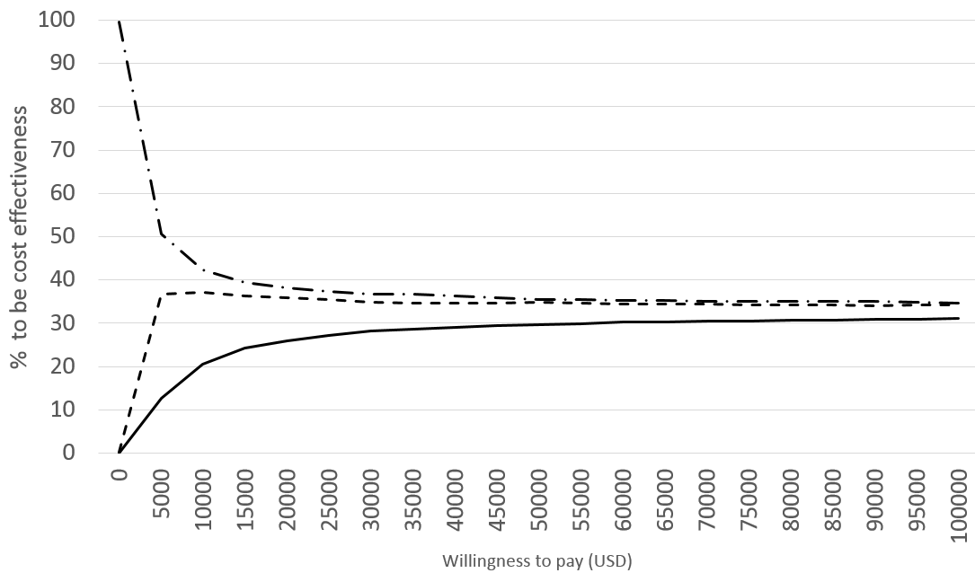
 | Annual interval
 | Every 3 years
 | Every 6 years
Normal |  | 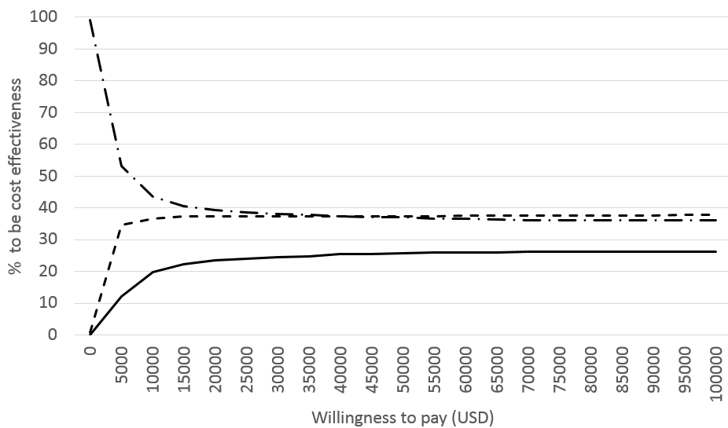
 | Annual interval
 | Every 3 years
 | Every 7 years
Overweight |  | 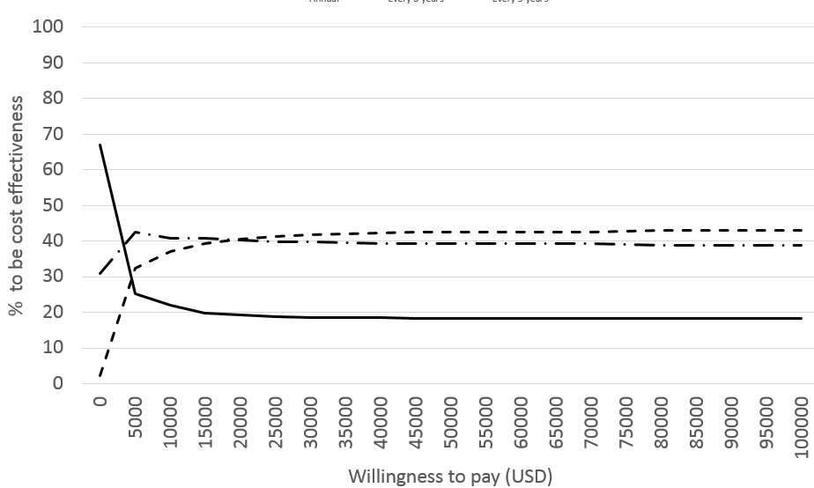
 | Annual interval
 | Every 3 years
 | Every 5 years
Obese |  | 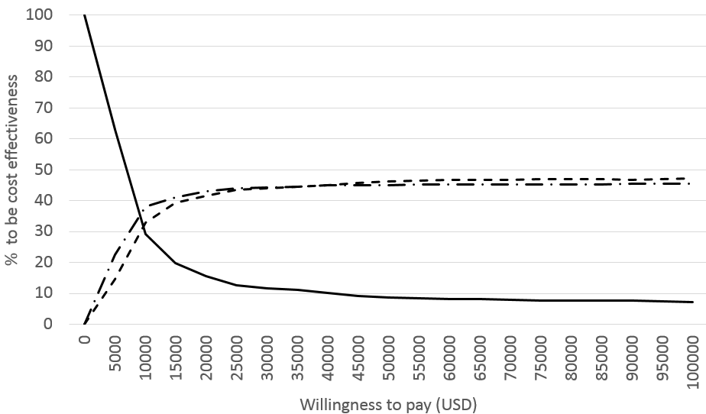
 | Annual interval
 | Every 3 years
 | Every 4 years

