Overexpression of CYP6CY1 is involved in imidacloprid resistance in Sitobion miscanthi (Takahashi) (Homoptera: Aphidae)
Yun-Shan Xiong^{1†}, Ling-Ling Cui^{2†}, Gui-Lei Hu^{2†}, Pei Zhang², Jin-Song Zheng¹, Bai-Zhong Zhang^{1,2*}, Run-Qiang Liu²
1 Hebi Institute of Engineering and Technology, Henan Polytechnic University, Hebi 458030, China
2 College of Resources and Environment, Henan engineering research center of biological pesticide & fertilizer development and synergistic application, Henan Institute of Science and Technology, Xinxiang 453003, China
* Corresponding author:
E-mail:baizhongok@163.com
†: these authors contributed equally to this work.
Abstract
Sitobion miscanthi is the dominant species and can damage seriously agricultural production. The effective management of wheat aphids was depended on chemical insecticides. However, their wide application has led to severe resistance of wheat aphids to some insecticides, and cytochrome P450 as a detoxifying enzyme plays a crucial role in the insecticide resistance. In this study, CYP6CY1, a new P450 gene was isolated and overexpressed in the resistant strain to imidacloprid. The increased sensitivity to imidacloprid after silencing of CYP6CY1 indicated that it could be participated in imidacloprid resistance. Subsequently, CYP6CY1 within the 3′ UTR targeted by miR-3047-3p was confirmed at the posttranscriptional regulatory level, and involved in the resistance to imidacloprid. These results provide opportunities for understanding the roles of P450 in insecticide resistance of pests.
Keywords: Sitobion miscanthi; imidacloprid; CYP6CY1; RNAi; miR-3047-3p

1 Introduction
Wheat aphids as the mainly pests can damage crops by feeding on plant juice and spreading virus, and lead major losses to the wheat production (George and Gair, 2010; Luo et al., 2022 ). Sitobion miscanthi (Hemiptera: Aphididae) is the main species worldwide and threatens wheat production by pillaging nutrition from the host, transmitting pathogenic plant viruses, and defecating sticky honeydew that further obstructs photosynthesis and reduces wheat quality (Jiang et al., 2019). Taken together its highly specialized host range, simple parasitic life cycle, pleomorphism, and alternation of complete and incomplete life cycles make it significant for both basic and applied research (Zhang et al., 2020; Sun et al., 2022).
The management of wheat aphids was mainly depended on chemical insecticides. Neonicotinoid insecticides including imidacloprid have been widely used in controlling aphids and other stinging pests as their high efficacy, and low toxicity to non-target organisms and effective duration (Cui et al., 2012; Kim et al., 2015). However, the resistant pests to neonicotinoid insecticides have appeared with their frequent and long-term application (Liu et al., 2003). The resistance to imidacloprid in Musca domestica (Kavi et al., 2014), Bemisia tabaci (Wang et al., 2009), Nilaparvata lugens (Wen et al., 2009), and so on have been widely reported.
Sensitivity reduce of insecticide target sites and activity enhance of detoxification enzymes were be identified as the most important causes in the resistance to insecticides. The target mutation sites of the nicotinic acetylcholine receptors (nAChR), V101I and R81T confers neonicotinoid resistance to aphids (Myzus persicae and Aphis gossypii ) (Mezei et al., 2020; Sial et al., 2020; Xu et al., 2022). A target site mutation of nAChR (Y151S) was known as the main factor of target-site insensitivity to imidacloprid in N. lugens (Hirata et al., 2009; Shao et al., 2011).

The increased detoxification regulated by P450 overexpression is a crucial characteristic in the resistance to insecticides (Mohammed et al., 2014; Liu et al., 2015; Zhang et al., 2020). It showed that neonicotinoid insecticide resistance was regulated in part by CYP6CM1 in B. tabaci (Jones et al., 2011). CYP6CM1 overexpression confers imidacloprid resistance to B. tabaci (Karunker et al., 2008; Yang et al., 2013); CYP6AY1 and CYP6ER1 overexpression confers imidacloprid resistance to N. lugens (Ding et al., 2013; Bao et al., 2016); Drosophila melanogaster CYP6G1 and B. tabaci CYP6CM1vQ confers to imidacloprid resistance by metabolizing approach (Rand et al., 2012; Sparksen et al., 2012; Fusetto et al., 2017). The changes of P450 gene expression could be mediated by both transcriptional and posttranscriptional regulation. microRNAs (miRNAs) could regulate gene expression of P450 by combining to coding sequences, or 3′/5′ UTRs at the posttranscriptional level (Tamasi et al., 2011; Pritchard et al., 2012). Many studies showed that posttranscriptional regulation of P450 genes occured when some miRNAs combined to their 3'UTRs or coding sequences (Hong et al., 2014; Peng et al., 2016; Ma et al., 2019). CYP325BG3 expression mediated by miR-71 (Hong et al., 2014), CYP6AG11 expression mediated by miR-278-3p in Culex pipiens (Lei et al., 2015), CYP4CJ6 expression mediated by miR-316 (Hu et al., 2022) confer to insecticide resistance.
In our previous study, 77 miRNAs were significantly differentially expressed under imidacloprid exposure based on high-throughput sequencing of short RNA libraries, suggesting that differentially expressed miRNAs (including miR-3047-3p) could participate in the resistance to insecticides in S. miscanthi (Zhang et al., 2021). At the same time, CYP6CY1 could be regulated by miR-3047-3p acting on the 3′ UTR based on correlation analysis. Thus, CYP6CY1 expression mediated by miR-3047-3p was explored at the posttranscriptional regulation level. It is critical to understand the molecular mechanism of P450s in insecticide resistance in the aphids.
2 Materials and methods
2.1 Insects
The aphid as the susceptible strain (SM-S) originated from Xihua County (Coordinates, N23.16 E113.23) of Henan Province of China in May 2003, which has been raised for over 20 years without any insecticide exposure. The leaf-dipping method was used to screen for resistance in each generation. The imidacloprid-susceptible strain (SM-S) was obtained from the SM-S strain by continual selection with gradually increased concentrations of imidacloprid based on the LC₅₀ values in the laboratory (Table S1). They were fed on wheat seedlings at 23°C, 60-70% relative humidity, and a photoperiod of 16:8 h (light:dark) under standard conditions (Lu and Gao 2009).
2.2 Biological assay
Insecticide toxicity to the aphids was determined by using the leaf-dipping method of Zhang et al (2021). Insecticides were dissolved in acetone, and then diluted to serial concentrations with 0.05% (v/v) Triton X-100 in water. Wheat leaves were cut into 20mm long pieces. The leaves with aphids were dipped into 0.05% (v/v) Triton X-100 water with insecticides for 10 s, or dipped into 0.05% (v/v) Triton X-100 water without insecticides as a control. The leaves with treated aphids were put into a glass tube (6 cm in length, 2 cm diameter) with the open end covered with cotton to prevent insect escape. Each concentration had 3 biological repeats, each with 20 healthy apterous aphids. Mortality was recorded after insecticide exposure at 24 h.
The rearing and the artificial diet used were mentioned previously to process the dsRNA feeding experiments (Gong et al., 2014; Zhang et al., 2019). dsCYP6CY1 was added to 0.5 mol/L sterile sucrose solution (the artificial diet) at a final concentration of 50 ng/μL. dsGFP was also mixed into 0.5 mol/L sterile sucrose solution (the artificial diet) at a final concentration of 50 ng/μL as the control. The experiments were performed in three independent biological replicates. Primers with the T7 polymerase promoter sequence to amplify the green fluorescent protein (GFP) and CYP6CY1 genes were listed in Table 1.
To investigate the silencing efficiency of CYP6CY1, aphids were collected at 24 h post-feeding for qPCR.
The susceptibility of aphids to insecticides was investigated after silencing CYP6CY1.
The aphids dsCYP6CY1-fed for 24 h were treated by the LC₂₅ imidacloprid, and the aphids dsGFP-fed for 24 h were treated by the LC₂₅ imidacloprid as the control with the leaf-dipping method (Zhang et al., 2021).
2.3 Cloning and quantitative real-time PCR (qPCR)
The 3′/5′-RACE first-strand cDNAs were synthesized, and the 2 gene-specific primers (GSPs) were used to amplify the full-length cDNAs based on CYP6A13-like fragement sequence. The primers tested are listed in Table 1. The thermal cycling was carried out by using touchdown PCR as Zhang et al (2020).
Total RNA for mRNA expression was extracted using the TRIzol kit (Invitrogen, Carlsbad, CA) following the manufacturer’s protocol. For miRNA expression analysis, total RNA was extracted using the miRNeasy Mini Kit (Qiagen, Germany) as per the manufacturer’s instructions. Each sample was measured in triplicate on an Applied Biosystems 7500 Real-Time PCR system (Applied Biosystems, Foster city, CA, USA). The miR-3047-3p expression were normalized to U6 snRNA (small nuclear RNA) (Karamipour et al., 2019; Zhang et al., 2021), and CYP6CY1 expression were normalized to Actin (Xu et al., 2014) and 18S rRNA (Broackes-Carter et al., 2002) with three biological replications, respectively. The expression of miR-3047-3p and CYP6CY1 was calculated based on the 2^{–ΔΔCt} method (Pfaffl 2001). The primers used were listed in Table 1.
2.4 Homology modelling and molecular docking
The 3-dimensional structure of CYP6CY1 protein was carried out by Alphafold. The P450 from Aphis craccivora (PDB ID: A0A7T7DL49.1.A) with 75.15% sequence similarity was used standard model. ChemDraw 20.0 and Chem3D for the 3-dimensional structure of imidacloprid, Autodock 4.2 for the default parameters of molecular docking and the combining free energy and interaction, and PLIP (Protein-Ligand Interaction Profiler) for the interaction of protein and ligand were conducted. The docking and modelling were presented by PyMOL.
2.4 miRNA target studies of CYP6CY1
Three miRNA target prediction software programs, the Miranda, RNAhybrid, and Target Scan programs (Enright et al., 2003; Rehmsmeier et al., 2004; Betel et al., 2008), were applied with default arguments to speculate miRNAs that target CYP6CY1 sequences within the 3'UTRs of transcripts. A 121-bp fragment of the 3’ UTR of CYP6CY1 containing a predicted target site of miR-3047-3p was inserted into the pmirGLO vector downstream of the luciferase gene with Xba I and Xho I restriction sites, generating the pmirGLO-CYP6CY1-UTR target construct. The mutated miR-3047-3p target DNA sequence was synthesized by GenePharm Co., Ltd. and inserted into the pmirGLO vector to generate the pmir GLO-CYP6CY1-Mut target construct. The luciferase reporter plasmid was constructed through inserting the wild-type (WT) or mutated (MT) target sequence of CYP6CY1 between the firefly luciferase 3’UTR and SV40 poly (A) on pmirGLO vector (Promega, Leiden, Netherlands). The mutated target sequences were provided by Shanghai Sangon Biotechnology Co. Ltd. (Shanghai, China), and the mutated target sequences of FAA were synthesized using a QuickMutation™ Site-Directed Mutagenesis Kit (Beyotime, Nanjing, China) according to the manufacturer's instruction.
For luciferase assay, HEK293T cells were cultured in a 96-well plate and transfected with the reporter plasmids and miRNA agomir or NC agomir (a dsRNA formed with the miRNA and its complimentary sequence) using Calcium Phosphate Cell Transfection Kit (Beyotime) according to the manufacturer's instruction. Each well contained 0.2 μg plasmid and 90 nM miRNA agomir. Luciferase assays were performed by using the Dual-Glo® Luciferase Assay System (Promega) 24 h post-transfection. Normalized firefly luciferase activity (firefly luciferase activity/Renilla luciferase activity) was compared to the control groups. For each transfection, luciferase activity was averaged from the results of six replicates.
2.5 miRNA feeding and subsequent impact on the expression of CYP6CY1
An antagomir/agomir of miR-3047-3p were synthesized by GenePharma to feed aphids. The artificial diet method used were conducted (Gong et al., 2014; Zhang et al., 2019).
The miR-3047-3p antagomir/agomir was added to the artificial diet (final 2.5 mmol/L concentration) to feed aphids tested. The NC antagomir/NC agomir was also added to the artificial diet (final 2.5 mmol/L concentration) to feed aphids tested as the control. Then, the expression of CYP6CY1 was carried out by qPCR. Furthermore, the sensitivity of aphids fed-miR-3047-3p agomir/antagomir to imidacloprid was also determined. The aphids fed- miR-3047-3p agomir/antagomir were treated by the LC₅₀ of imidacloprid for 24 h. The aphids fed- NC antagomir/NC agomir for 24 h were treated by the LC₅₀ of imidacloprid as the control (Zhang et al., 2021).
2.6 Statistical analyses
The GraphPad InStat 3.0 software (GraphPad Software, San Diego, CA, USA) was used to analyze the data by an unpaired t-test using and Tukey's HSD multiple comparison test.

3 Results
3.1 Cloning, and expression of CYP6CY1
The 3′/5′-RACE technique was used to amplify full-length sequence of this P450 gene from S. miscanthi according to fragment sequence of CYP6a13-like with a 1527-bp open reading frame (ORF) coding for 509 amino acid residues and a 121-bp 3′ UTR, named CYP6CY1 and submitted to NCBI (Accession No: OR962259). The hypothetical miRNA target sequences of CYP6CY1 within the 3′ UTRs transcripts was conducted by 3 software programs, showing that miR-3047-3p can target for 3′ UTRs of CYP6CY1.
To understand miR-3047-3p and CYP6CY1 function in the resistance to imidacloprid, miR-3047-3p and CYP6CY1 expression between SM-R and SM-S was carried out by qPCR. It showed that miR-3047-3p was downregulated obviously by 45.0% (Fig. 1A), while CYP6CY1 expression was upregulated obviously by 2.23-fold in SM-R compared with SM-S (Fig. 1B). This indicated CYP6CY1 and miR-3047-3p could be involved in the resistance to imidacloprid.

3.2 Molecular docking of CYP6CY1 with imidacloprid
The 3D structure of CYP6CY1 contained 24 α-helixes, 7 β-sheets and linked by several loops. Pyridine ring can combine to the residue THR316, and form hydrogen bond with a distance of 2.0Å. Oxygen molecule on the nitro side of the imidazole ring can bind to the residue ILE453 with a distance of 1.7 Å. Another hydrogen bond can bind to the residues ARG108, ARG450, and ILE451 with a distance of 2.2Å, 3.2Å, and 3.3Å, respectively. Binding energy of CYP6CY1 with imidacloprid is -5.15 kcal/mol (Fig. 2).
3.3 Increased imidacloprid susceptibility after silencing CYP6CY1
To determine CYP6CY1 knockdown efficiency by qPCR analysis, it showed effective suppression of dsCYP6CY1 (Fig. 3A). CYP6CY1 expression was reduced obviously in dsCYP6CY1-fed aphids by 43.5% compared with controls (dsGFP-fed aphids) for 48 h. The mortality was increased obviously in dsCYP6CY1-fed aphids (50.5%) by 1.97-fold compared to that in controls (dsGFP-fed aphids) (25.6%) for 24 h after aphids were exposed to by the LC₂₅ of imidacloprid for 24 h (Fig. 3B).
3.4 miR-3047-3p regulating CYP6CY1 expression
A binding site of miR-3047-3p was predicted in the 3′ UTR of CYP6CY1 with 3 software programs described obove (Fig. 4A). To examine if miR-3047-3p could mediate expression of CYP6CY1, the combining site of miR-3047-3p within 3′ UTRs of CYP6CY1 was transferred into a pmirGLO vector to construct the pmirGLO-miR-3047-3p-Target. The luciferase activity was downregulated obviously by 36.8% compared with the control (NC agomir) when cotransfection of the pmirGLO-miR-3047-3p-target with miR-3047-3p agomir was conducted. While the luciferase activity did not change obviously when cotransfection of pmirGLO-CYP6CY1-Mut ( the target mutated plasmid) with the miR-3047-3p agomir was carried out (Fig.4B).
3.5 The impact of miR-3047-3p regulation on CYP6CY1 expression and imidacloprid susceptibility
To verify CYP6CY1 regulation by miR-3047-3p, miR-3047-3p agomir was fed by the aphids. The abundance of miR-3047-3p was upregulated obviously by 6.99-fold in the aphids-fed miR-3047-3p agomir compared with the control (48 h the aphids-fed NC agomir) (Fig. 5A); Then, CYP6CY1 expression in the aphids-fed miR-3047-3p agomir was downregulated obviously by 73.5% (48 h aphids-fed) compared with the control (48 h the aphids-fed NC agomir) (Fig. 5B); Forthermore, the mortality in the aphids-fed miR-3047-3p agomir for 24 h (80.7%) was upregulated obviously 1.66-fold compared with the control (48.7%) (the aphids-fed NC agomir for 24 h) when they were treated by the LC₅₀ of imidacloprid (Fig. 5C). In contrast, miR-3047-3p abundance in the aphids-fed miR-3047-3p antagomir for 48 h was downregulated obviously by 82.0% compared with the control (the aphids-fed NC antagomir for 48 h) (Fig. 5D); Then, CYP6CY1 expression in the aphids-fed miR-3047-3p antagomir was upregulated obviously by 1.73-fold (48 h aphids-fed) (Fig. 5E); Forthermore, the mortality when miR-3047-3p antagomir aphids-fed for 24 h (29.3%) was downregulated obviously by 37.3% compared with the control (the aphids-fed NC antagomir 24 h) (47.3%) when they were treated by the LC₅₀ of imidacloprid for 24 h (Fig. 5F).
4 Discussion
Imidacloprid is a neonicotinoid insecticide, silencing insect nicotinic acetylcholine receptors (nAChRs) to cause the death of paralysis (Buckingham et al., 1997; Roat et al., 2020). It has high efficacy in controlling piercing-sucking pests (including aphids) correlated positively with temperature possess many advantages, high efficiency, long duration, broad spectrum, and low toxicity to mammals, and can be absorbed quickly by plants after application (Tomizawa and Casida, 2003; Kundoo et al., 2018). However, imidacloprid resistance is becoming increasingly severe in insect pests as its wide, unreasonable, and a great application (Chen et al., 2020; Cheng et al., 2023; Liu et al., 2023).
Increased detoxification enzyme gene expression plays a crucial role in insecticide resistance including P450 genes (Liu et al., 2015; Zhang et al., 2020). The increase of CYP303A1, CYP4C62, and CYP6BD5 expression confers their detoxification of imidacloprid in Diaphorina citri (Tian et al., 2019); Overexpression of P450s plays a crucial role in the resistance to insecticides in insects (Liu et al., 2015; Li et al., 2007; Puinean et al., 2010); Overexpression of CYP4G68 (Wang et al., 2022), CYP6DW3 (Xue et al, 2023) and CYP306A1 (Liu et al, 2023) confer resistance to imidacloprid in B. tabaci.
Our previous studies showed that overexpression of CYP6DD1 and CYP4CJ6 confers imidacloprid resistance to S. miscanthi(Lu et al., 2021; Hu et al., 2022). Similarly, our current study indicated that overexpression of CYP6CY1 in the resistant strain to imidacloprid was carried out by qPCR. Subsequent RNAi tests by feeding technology in the resistant aphids showed that silencing CYP6CY1 could obviously improve imidacloprid susceptibility; The RNAi method by feeding in the aphids has been studied successfully in many reports (Ma et al., 2019; Zhang et al., 2020, 2021). So, CYP6CY1 could play a crucial role in the resistance to imidacloprid.
The regulation of P450 genes contained transcriptional and posttranscriptional regulation, and miRNAs as crucial factors could regulate gene expression by DNA methylation of insecticides and posttranscriptional inhibition (Tamasi et al., 2011). miRNAs could bind to the sites of target genes regulating gene expression at the posttranscriptional level involved in insecticide resistance (Sun et al., 2012; Jiang et al., 2023). It has been reported CYP4CJ1 mediated by miR-4133-3p was participated in gossypol and tannic acid resistance in A. gossypii (Ma et al., 2019); In C. pipiens, CYP6N23 targeted by miR-285 was participated in the resistance to pyrethroid; CYP417A2 targeted by microRNA PC‐5p‐3991‐515 could mediate triflumezopyrim sensitivity in Laodelphax striatellus.
In our study, a lot of miRNAs including miR-3047-3p could be response to imidacloprid in S. miscanthi (Zhang et al., 2021). Forthermore, the experiments of feeding miR-3047-3p antagomir/agomir in vitro and dual luciferase reporter assay indicated that CYP6CY1 expression could be mediated by miR-3047-3p by targeting for the 3′ UTRs to regulate imidacloprid resistance. This indicated that miR-3047-3p could be participated in the resistance to imidacloprid by targeting for CYP6CY1 expression in S. miscanthi.
Acknowledgements: This work is supported by the Key Science and Technology Program of Henan (Agriculture) (212102110441), and the key Scientific and Technological Research Project of Henan Province (232102111012).
Conflict of Interest: The authors declare that they have no conflict of interest.

References
Bao, H., Gao, H., Zhang, Y., Fan, D., Fang, J., Liu, Z., 2016. The roles of CYP6AY1 and CYP6ER1 in imidacloprid resistance in the brown planthopper: Expression levels and detoxification efficiency. Pesticide Biochemistry and Physiology, 129, 70-74.
Betel, D., Wilson, M., Gabow, A., Marks, D.S., Sander, C., 2008. The microRNA.org resource: targets and expression. Nucleic Acids Research, 36, 149-153.
Broackes-Carter, F.C., Nathalie, M., Deborah, G., Stephen, H., John, B., Ann, H., 2002. Temporal regulation of CFTR expression during ovine lung development: implications for cf gene therapy. Human Molecular Genetics, 2, 125.
Chen, X.D., Ebert, T.A., Pelz-Stelinski, K.S., Stelinski, L.L., 2020. Fitness costs associated with thiamethoxam and imidacloprid resistance in three field populations of Diaphorina citri (Hemiptera: Liviidae) from Florida. Bulletin of Entomological Research, 110, 512-520.
Chen, X., Xia, X., Wang, H., Qiao, K., Wang, K., 2013. Cross–resistance to clothianidin and acetamiprid in the imidacloprid resistant strain of Aphis gossypii (Hemiptera: Aphididae) and the related enzyme mechanisms. Acta Entomologica Sinica, 56, 1143–1151.
Cui, L., Sun, L., Yang, D., Yan, X., Yuan, H., 2012. Effects of cycloxaprid, a novel cis–nitromethylene neonicotinoid insecticide, on the feeding behaviour of Sitobion avenae. Pest Management Science, 68, 1484-1491.
Ding, Z., Wen, Y., Yang, B., Zhang, Y., Liu, S., Liu, Z., Han, Z., 2013. Biochemical mechanisms of imidacloprid resistance in Nilaparvata lugens: over-expression of cytochrome P450 CYP6AY1. Insect Biochemistry and Molecular Biology, 43(11), 1021-1027.
Enright, A.J., John, B., Gaul, U., Tuschl, T., Sander, C., Marks, D.S., 2003. MicroRNA targets in Drosophila. Genome Biology, 5, R1.
Fusetto, R., Denecke, S., Perry, T., O’Hair, R. A., Batterham, P., 2017. Partitioning the roles of CYP6G1 and gut microbes in the metabolism of the insecticide imidacloprid in Drosophila melanogaster. Scientific Reports, 7(1), 11339.
George, K.S., Gair, R., 2010. Crop loss assessment on winter wheat attacked by the grain aphid, Sitobion avenae (F.). Plant Pathology, 28, 143–149.
Gong, P. P., Wei, X. G., Liu, S. N., Yang, J., Fu, B. L., Liang, J. J., Huang, M.J., Du, T.H., Yin, C., Ji, Y., He, C., Hu, J.Y., Xue, H., Wang, C., Zhang, R., Du, H., Zhang, C.J., Yang, X., Zhang, Y. J., 2023. Novel_miR-1517 mediates CYP6CM1 to regulate imidacloprid resistance in Bemisia tabaci (Hemiptera: Gennadius). Pesticide Biochemistry and Physiology, 194, 105469.
Gong, Y.H., Yu, X.R., Shang, Q.L., Shi, X.Y., Gao, X.W., 2014. Oral delivery mediated RNA interference of a carboxylesterase gene results in reduced resistance to organophosphorus insecticides in the cotton aphid, Aphis gossypii glover. PLoS One, 9, e102823.
Hirata, K., Jouraku, A., Kuwazaki, S., Kanazawa, J., Iwasa, T., 2017. The R81T mutation in the nicotinic acetylcholine receptor of Aphis gossypii is associated with neonicotinoid insecticide resistance with differential effects for cyano-and nitro-substituted neonicotinoids. Pesticide Biochemistry and Physiology, 143, 57-65.
Hu, G. L., Lu, L. Y., Li, Y. S., Su, X., Dong, W. Y., Zhang, B. Z., Liu R.Q., Shi, M.W., Wang, H.L., Chen, X. L., 2022. CYP4CJ6-mediated resistance to two neonicotinoid insecticides in Sitobion miscanthi (Takahashi). Bulletin of Entomological Research, 112(5), 646-655.
Hong, S., Guo, Q., Wang, W., Hu, S., Fang, F., Lv, Y., Yu, J., Zou, F., Lei, Z., Ma, K., Ma, L., Zhou, D., Sun, Y., Zhang, D., Shen, B., Zhu, C., 2014. Identification of differentially expressed microRNAs in Culex pipiens and their potential roles in pyrethroid resistance. Insect Biochemistry and Molecular Biology, 55, 39-50.
Ihara, M., D Buckingham, S., Matsuda, K., B Sattelle, D., 2017. Modes of action, resistance and toxicity of insecticides targeting nicotinic acetylcholine receptors. Current Medicinal Chemistry, 24(27), 2925-2934.
Jiang, X., Zhang, Q., Qin, Y., Yin, H., Zhang, S., Li, Q., Zhang, Y., Fan, J., Chen, J., 2019. A chromosome-level draft genome of the grain aphid Sitobion miscanthi. Gigascience, 8(8), giz101.
Jiang, Y. T., Kong, F. B., Zhang, P., Zhang, M. Y., Su, X., Zhang, B. Z., Ji, X., Wang, H. L, 2023. MicroRNA-23a changes chlorantraniliprole susceptibility by targeting CYP9F1 in Spodoptera frugiperda. Entomologia Generalis, 43(5): 1041-1049.
Jones, C.M., Daniels, M., Andrews, M., Slater, R., Lind, R.J., Gorman, K., Denholm, I., 2011. Age-specific expression of a P450 monooxygenase (CYP6CM1) correlates with neonicotinoid resistance in Bemisia tabaci. Pesticide Biochemistry and Physiology, 101, 53-58.
Karamipour, N., Fathipour, Y., Talebi, A.A., Asgari, S., Mehrabadi, M., 2019. The microRNA pathway is involved in Spodoptera frugiperda (Sf9) cells antiviral immunedefense against Autographa californica multiple nucleopolyhedrovirus infection. Insect Biochemistry and Molecular Biology, 112, 103202.
Karunker, I., Benting, J., Lueke, B., Ponge, T., Nauen, R., Roditakis, E., Morin, S., 2008. Over-expression of cytochrome P450 CYP6CM1 is associated with high resistance to imidacloprid in the B and Q biotypes of Bemisia tabaci (Hemiptera:Aleyrodidae). Insect Biochemistry and Molecular Biology, 38, 634-644.
Kundoo, A. A., Dar, S. A., Mushtaq, M., Bashir, Z., Dar, M. S., Gul, S.,Ali, M.T., Gulzar, S., 2018. Role of neonicotinoids in insect pest management: A review. Journal of Entomology and Zoology Studies, 6(1), 333-339.
Lei, Z., Lv, Y., Wang, W., Guo, Q., Zou, F., Hu, S., Fang, F., Tian, M., Liu, B., Liu, X., Ma, K., Ma, L., Zhou, D., Zhang, D., Sun, Y., Shen, B., Zhu, C., 2015. MiR-278-3p regulates pyrethroid resistance in Culex pipiens pallens. Parasitology Research, 114, 699-706.
Li, Y., Xu, Z., Shi, L., Shen, G., He, L., 2016. Insecticide resistance monitoring and metabolic
mechanism study of the green peach aphid, Myzus persicae (Sulzer) (Hemiptera: Aphididae), in Chongqing, China. Pesticide Biochemistry and Physiology, 132, 21-28.
Li, X.C., Schuler, M.A., Berenbaum, M.R., 2007. Molecular mechanisms of metabolic resistance to synthetic and natural xenobiotics. Annual Review of Entomology, 52, 231-253.
Liu, N., Li, M., Gong, Y., Liu, F., Li, T., 2015. Cytochrome P450s-their expression, regulation, and role in insecticide resistance. Pesticide Biochemistry and Physiology, 120, 77-81.
Liu, S., Fu, B., Zhang, C., He, C., Gong, P., Huang, M., Du,T., Liang, J., Wei, X., Yang, J., Yin,C., Ji, Y., Xue, H., Hu, J., Wang,C., Zhang, R., Du, H., Yang, X., Zhang, Y., 2023. 20E biosynthesis gene CYP306A1 confers resistance to imidacloprid in the nymph stage of Bemisia tabaci by detoxification metabolism. Pest Management Science, 79(10), 3883-3892.
Liu, Z.W., Han, Z.J., Wang, Y., Zhang, L., Zhang, H., Liu, C., 2003. Selection for imidacloprid resistance in Nilaparvata lugens: cross–resistance patterns and possible mechanisms. Pest Management Science, 59, 770-775.
Lu, L. Y., Li, Y. S., Hu, G. L., Su, X., Dong, W. Y., Zhang, B. Z., Gao, X. W., 2021. Promoters of the two novel cytochrome P450 genes, CYP6DD1 and CYP307A2 from Sitobion miscanthi and their mediation under insecticide exposure. Crop Protection, 147, 105687.
Luo, K., Zhao, H., Wang, X., Kang, Z., 2022. Prevalent pest management strategies for grain aphids: Opportunities and challenges. Frontiers in Plant Science, 12, 790919.
Lu, Y., Gao, X., 2009. Multiple mechanisms responsible for differential susceptibilities of Sitobion avenae (Fabricius) and Rhopalosiphum padi (Linnaeus) to pirimicarb. Bulletin of Entomological Research, 99, 611-617.
Ma, K., Li, F., Liu, Y., Liang, P., Chen, X., Gao, X., 2017. Identification of microRNAs and their response to the stress of plant allelochemicals in Aphis gossypii (Hemiptera: Aphididae). BMC Molecular Biology, 18, 5.
Ma, K., Li, F., Tang, Q., Liang, P., Liu, Y., Zhang, B., Gao, X., 2019. CYP4CJ1-mediated gossypol and tannic acid tolerance in Aphis gossypii glover. Chemosphere, 219, 961-970.
Ma, K., Tang, Q., Zhang, B., Liang, P., Wang, B., Gao, X., 2019. Overexpression of multiple cytochrome P450 genes associated with sulfoxaflor resistance in Aphis gossypii Glover. Pesticide Biochemistry and Physiology, 157, 204-210.
Mezei, I., Bielza, P., Siebert, M. W., Torne, M., Gomez, L. E., Valverde-Garcia, P., Belando, A., Moreno, I., Grávalos, C., Cifuentes, D., Sparks, T. C., 2020. Sulfoxaflor efficacy in the laboratory against imidacloprid-resistant and susceptible populations of the green peach aphid, Myzus persicae: Impact of the R81T mutation in the nicotinic acetylcholine receptor. Pesticide Biochemistry and Physiology, 166, 104582.
Mohammed, B.R., Wilding, C.S., Collier, P.J., Deeni, Y.Y., 2014. Cloning of Anopheles gambiae CYP6M2 gene promoter and construction of its luciferase reporter system. International Journal of Energy Research, 3, 259-264.
Oliveira, E. E., Schleicher, S., Büschges, A., Schmidt, J., Kloppenburg, P., Salgado, V. L., 2011. Desensitization of nicotinic acetylcholine receptors in central nervous system neurons of the stick insect (Carausius morosus) by imidacloprid and sulfoximine insecticides. Insect Biochemistry and Molecular Biology, 41(11), 872-880.
Peng, T.F., Pan, Y.O., Gao, X.W., Xi, J.H., Zhang, L., Ma, K.S., Wu, Y., Zhang, J., Shang, Q.L., 2016. Reduced abundance of the CYP6CY3-targeting let-7 and miR-100 miRNAs accounts for host adaptation of Myzus persicae nicotianae. Insect Biochemistry and Molecular Biology, 75, 89-97.
Pfaffl, M.W., 2001. A new mathematical model for relative quantification in real–time RT–PCR. Nucleic Acids Research, 29, 45-45.
Pritchard, C.C., Cheng, H.H., Tewari, M., 2012. MicroRNA profifiling: approaches and considerations. Nature Reviews Genetics, 13, 358-369.
Puinean, A.M., Foster, S.P., Oliphant, L., Denholm, I., Field, L.M., Millar, N.S., Williamson, M.S., Bass, C., 2010. Amplification of a cytochrome P450 gene is associated with resistance to neonicotinoid insecticides in the aphid Myzus persicae. PLoS Genetics, 6, 1000999.
Rand, M. D., Lowe, J. A., Mahapatra, C. T., 2012. Drosophila CYP6g1 and its human homolog CYP3A4 confer tolerance to methylmercury during development. Toxicology, 300(1-2), 75-82.
Rehmsmeier, M., Steffen, P., Hochsmann, M., Giegerich, R., 2004. Fast and effective prediction of microRNA/target duplexes. RNA, 10, 1507-1517.
Schuler, M.A., 2012. Insect P450s: mounted for battle in their war against toxins. Molecular Ecology, 21, 4157-4159.
Schuler, M.A., 2011. P450s in plant-insect interactions. BBA-Proteins Proteom, 1814, 36-45.
Shao, X., Lu, H., Bao, H., Xu, X., Liu, Z., Li, Z., 2011. The mode of action of a nitroconjugated neonicotinoid and the effects of target site mutation Y151S on its potency. Insect Biochemistry and Molecular Biology, 41(7), 440-445.
Sial, M. U., Zhao, Z., Zhang, L., Zhang, Y., Mao, L., Jiang, H., 2020. Loop-mediated isothermal amplification for the detection of R81T mutation in nAChR with crude genomic DNA extracted from individual Myzus persicae. Journal of Pest Science, 93(1), 531-541.
Sun, X. H., Xu, N., Xu, Y., Zhou, D., Sun, Y., Wang, W. J., Ma, L., Zhu,C.L., Shen, B. (2019). A novel miRNA, miR-13664, targets CpCYP314A1 to regulate deltamethrin resistance in Culex pipiens pallens. Parasitology, 146(2), 197-205.
Tamasi, V., Monostory, K., Prough, R.A., Falus, A., 2011. Role of xenobiotic metabolism in cancer: involvement of transcriptional and miRNA regulation of P450s. Cellular and Molecular Life Sciences, 68, 1131-1146.
Tian, F., Li, C., Wang, Z., Liu, J., Zeng, X., 2019. Identification of detoxification genes in imidacloprid-resistant asian Citrus psyllid (Hemiptera:Lividae) and their expression patterns under stress of eight insecticides. Pest Management Science, 75, 1400-1410.
Tomizawa, M., Casida, J. E., 2003. Selective toxicity of neonicotinoids attributable to specificity of insect and mammalian nicotinic receptors. Annual Review of Entomology, 48, 339-364.
Wang, R., Che, W., Qu, C., Wang, J., Luo, C., 2022. Identification and detection of CYP4G68 overexpression associated with cyantraniliprole resistance in Bemisia tabaci from China. Frontiers in Environmental Science, 10, 914636.
Xue, H., Fu, B., Huang, M., He, C., Liang, J., Yang, J.,Wei, X., Liu, S., Du,T., Ji, Y., Yin,C., Gong, P., Hu, J., Du, H., Zhang, R., Khajehali, J., Su, Q., Yang, X., Wang,C., Zhang, Y., 2023. CYP6DW3 metabolizes imidacloprid to imidacloprid-urea in whitefly (Bemisia tabaci). Journal of Agricultural and Food Chemistry, 71(5), 2333-2343.
Xu, L., Wu, M., Han, Z.J., 2014. Biochemical and molecular characterisation and cross–resistance in field and laboratory chlorpyrifos–resistant strains of Laodelphax striatellus (Hemiptera: Delphacidae) from eastern China. Pest Management Science, 70, 1118-1129.
Yang, X., Xie, W., Wang, S. L., Wu, Q. J., Pan, H. P., Li, R. M., Yang, N.N., Liu, B.M., Xu, B.Y., Zhou, X.M., Zhang, Y. J., 2013. Two cytochrome P450 genes are involved in imidacloprid resistance in field populations of the whitefly, Bemisia tabaci, in China. Pesticide Biochemistry and Physiology, 107(3), 343-350.
Zhang, B., Su, X., Xie, L., Zhen, C., Hu, G., Jiang, K., Huang, Z.Y., Liu, R., Gao, Y., Chen, X., Gao, X., 2020. Multiple detoxification genes confer imidacloprid resistance to Sitobion avenae Fabricius. Crop Protection, 128, 105014.
Zhang, B., Hu, G., Lu, L., Hu, S., Li, Y., Su, X., Dong, W., Zhen, C., Liu, R., Kong, F., Shi, M. Chen, X., 2021. Identification of differentially expressed microRNAs under imidacloprid exposure in Sitobion miscanthi. Pesticide Biochemistry and Physiology, 177, 104885.
Zhang, B. Z., Ma, K. S., Liu, J. J., Lu, L. Y., Chen, X. L., Zhang, S. P., Gao, X. W., 2019. Differential expression of genes in greenbug (Schizaphis graminum Rondani) treated by imidacloprid and RNA interference. Pest Management Science, 75, 1726-1733.
Zhang, T., Li, K., Chen, X., Zhong, C., Luo, B., Grijalva, I., McCornack, B., Flippo, D., Sharda A., Wang, G., 2023. Aphid cluster recognition and detection in the wild using deep learning models. Scientific Reports, 13(1), 13410.

Table 1. List of primers used for qPCR and dsRNA synthesis
Application | Gene name | Sequence (5´–3´) | Product length (bp)
cDNA isolation (PCR) | CYP6CY1 | F:ATGTTCACCGCAAATTGGTGG | 1253
 |  | R:TCAATTAATTCTTTTAAACGTTAGC
5′ and 3′ cDNA end isolation (rapid amplification of cDNA ends) | 3′GPS1 | CCGAGATGGAAATGAAACTGGC | –
 | 3′GPS2 | TGGTATTTATCTTCCGTTTGGTG | –
 | 3'RACE Inner Primer | CGCGGATCCTCCACTAGTGATTTCACTATAGG | –
 | 3'RACE Outer Primer | TACCGTCGTTCCACTAGTGATTT | –
dsRNA synthesis | dsCYP6CY1 | taatacgactcactatagggTCTGCGTGTCGACGTTTAAG | 494
 |  | taatacgactcactatagggGTCCGTCGAATACTTTCCCA
 | dsGFP | taatacgactcactatagggTGACCACCCTGACCTAC | 288
 |  | taatacgactcactatagggTTGATGCCGTTCTTCTGC
qPCR of miRNA | miR-3047-3p | F: TTTGGTGTCTTTTTCCGCTTTG
 |  | R: GTGCAGGGTCCGAGGT
 | U6 | F: CAGCACATATACTAAAATTGGAACG | 76
 |  | R: ACGAATTTGCGTGTCATCC
qPCR | CYP6CY1 | F: CTGCGTGTCGACGTTTAAGA | 103
 |  | R: GTGGACTTTCCCCAGTGCTA
 | 18S rRNA | F: CGGCTACCACATCCAAGGAA | 128
 |  | R: GCTGGAATTACCGCGGCT
 | Actin | F: CCGAAAAGCTGTCATAATGAAGACCGAAGACC | 231
 |  | R: GGTGAAACCTTGTCTACTGTTACATCTTG
CYP6CY1-UTR | 3′ UTR | F: ccgCTCGAGCCAAGGATTATATAGCTATGGA
 |  | R: gcTCTAGACTCAGGTTAAATAGTTATATACAGA
 | miR-3047-3p-agomir | CAAAACAUUCAAAACUCCCUAC
 | miR-3047-3p-antagomir | GUAGGGAGUUUUGAAUGUUUUG
 | NC-agomir | UUCUCCGAACGUGUCACGUTT
 | NC-antagomir | CAGUACUUUUGUGUAGUACAA
Note: F: forward primer, R: reverse primer; the sequence of the T7 promotor is represented by small letters; the restriction sites are represented by red letters.

Figure legends
Fig. 1. Relative expression of miR-3047-3p and CYP6CY1 in vivo in Sitobion miscanthi.
Fig. 2. The interactions of CYP6CY1 with imidacloprid.
Fig. 3. Relative expression of CYP6CY1 and and the mortality rate of Sitobion miscanthi exposed to the LC₂₅ imidacloprid in vivo.
Fig. 4. Regulation of CYP6CY1 by miR-3047-3p by dual luciferase reporter assay.
Fig. 5. Relative expression of CYP6CY1 regulated by miR-3047-3p in vitro.

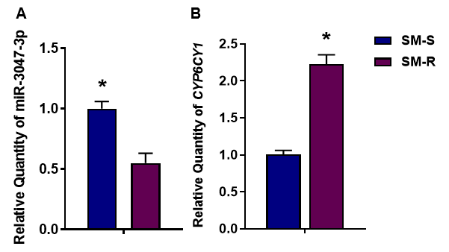
Fig. 1. Relative expression of miR-3047-3p and CYP6CY1 in vivo in Sitobion miscanthi. The results are shown as means ± S.E. for three independent biological replicates. (A) miR-3047-3p expression; (B) CYP6CY1 expression. The significant differences between the treatment and control are represented by asterisks (*) (Student's t-test, P < 0.05).

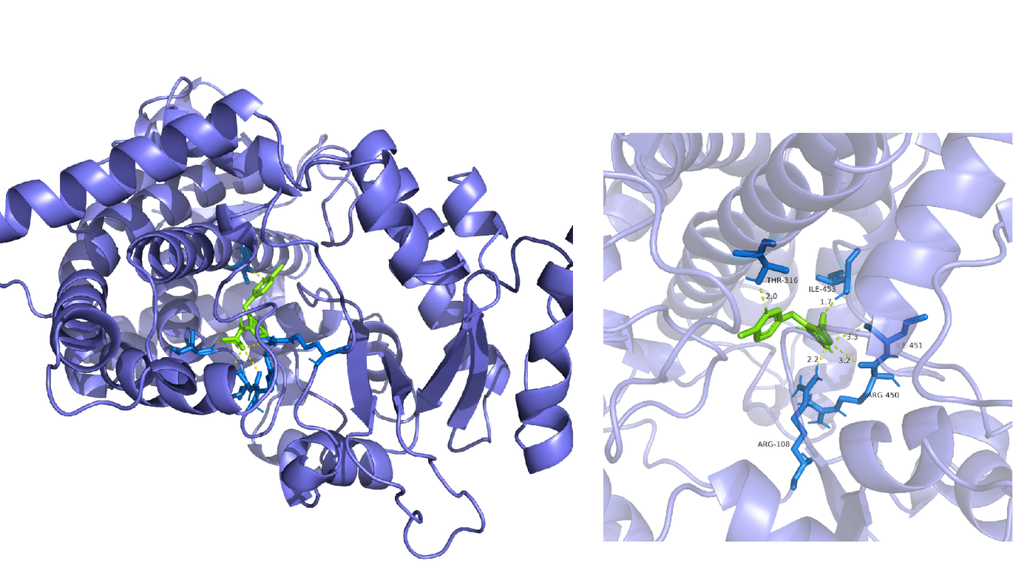
Fig. 2. The interactions of CYP6CY1 with imidacloprid. The yellow dotted lines indicate the hydrogen bond.

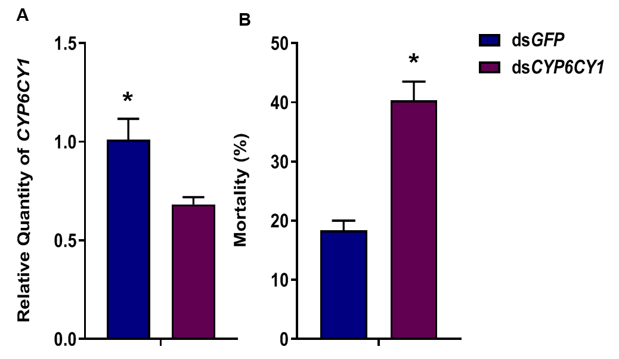
Fig. 3. Relative expression of CYP6CY1 and the mortality rate of Sitobion miscanthi exposed to LC₂₅ of imidacloprid in vivo. (A) Relative expression of CYP6CY1. (B) Mortality rate (%) of S. miscanthi exposed to the LC₂₅ imidacloprid. The results are shown as the means ± S. E. for three independent biological replicates. The significant differences between the treatment and control are represented by asterisks (*). (Student's t-test, P < 0.05).

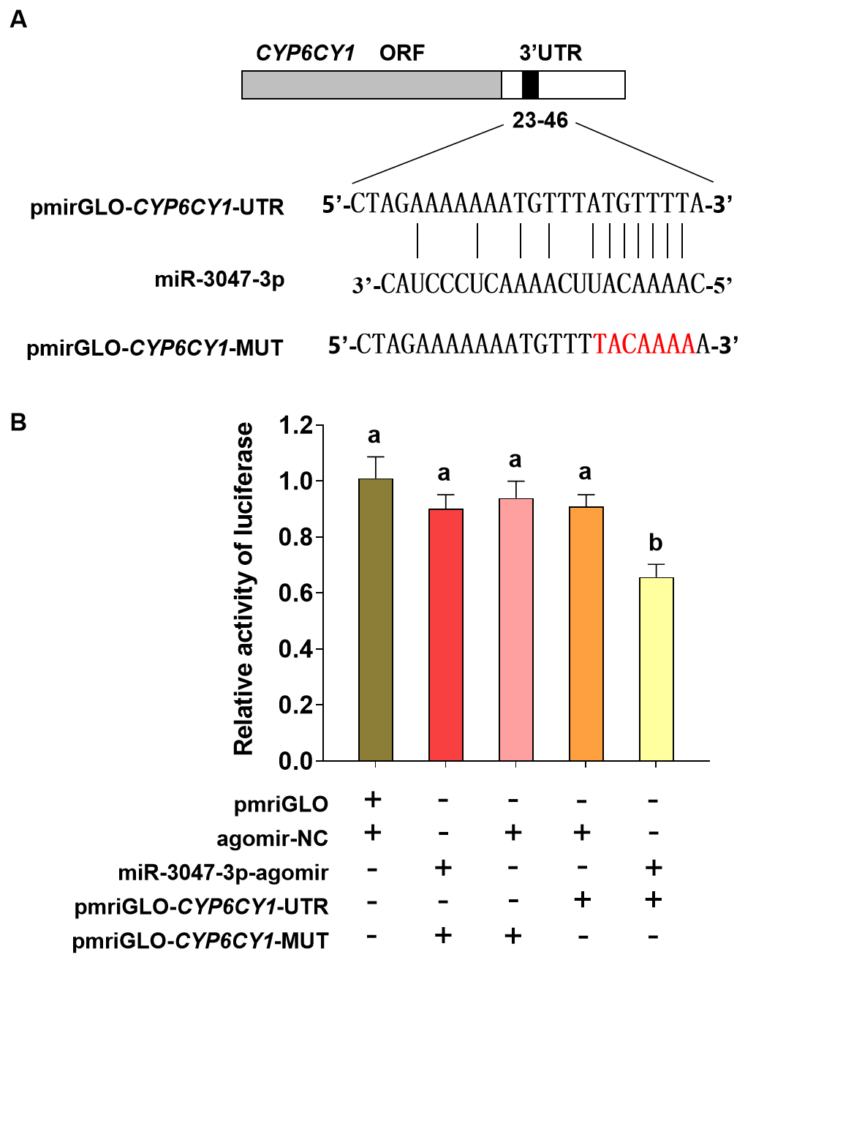
Fig. 4. Regulation of CYP6CY1 by miR-3047-3p by dual luciferase reporter assay. (A) The binding sites of miR-3047-3p predicted by software in the 3′ UTRs of CYP6CY1. (B) Luciferase reporter assays performed by cotransfection of the miR-3047-3p agomir with a luciferase reporter gene linked to the 3′ UTR of CYP6CY1. The mathematical symbols “+” and “-” are used to indicate that a component was added or not added. The bars represented by different letters indicate significant differences based on ANOVA followed by Tukey's HSD multiple comparison test (P < 0.05).
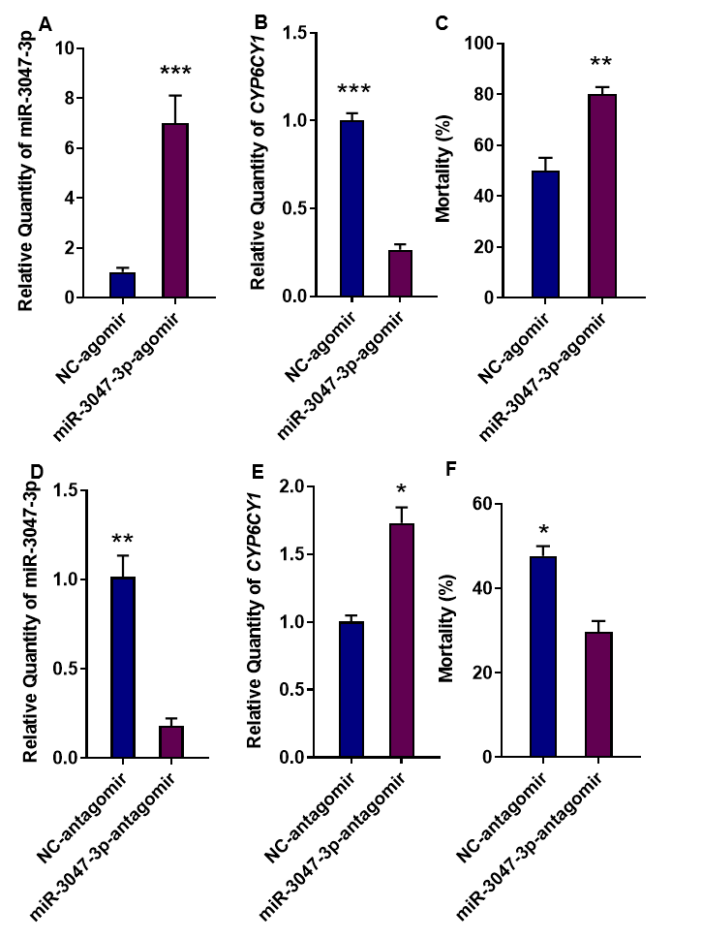
Fig. 5. The impacts of miR-3047-3p abundance on CYP6CY12 expression and imidacloprid susceptibility in Sitobion miscanthi. A, D: miR-3047-3p expression in the aphids fed miR-3047-3p agomir (A) or antagomir (D) (48 h of aphid feeding). B, E: CYP6CY1 expression in the aphids fed miR-3047-3p agomir (B) or antagomir (E) (48 h of aphid feeding). C, F: Mortality in the aphids fed miR-3047-3p agomir (C) or antagomir (F) when exposed to the LC₅₀ of imidacloprid. * indicated significant variations (* P <0.05, **P < 0.01,***P < 0.001).

