Supplementary data:

Materials and methods:
Supplementary table 1:

Leukemia cell lines | Mutations found
HEL | JAK2p.(Val617Phe)  TP53 p.(Met133Lys)
HL60 | NRAS p.(Gln61Leu)
K562 | ASXL1 p.(Tyr591*)  TP53 p.(Gln136Profs*13)
KG1 | TP53 c.672+1G>A splicing variant
OCI-AML3 | NPM1 p.(Trp288Cysfs*?)  DNMT3A p.(Arg882Cys)  NRAS p.(Gln61Leu)
The 43 genes (94,84 kb) analyzed are listed behind :
ASXL1 (NM_015338 ; exons 11-12), ASXL2 (NM_018263 ; exons 11-12), BCOR (NM_001123385 ; exons 3-16), BCORL1 (NM_001184772 ; exons 1-13), CALR (NM_004343 ; exon 9), CBL (NM_005188 ; exons 8-9), CEBPA (NM_001287424 ; exon 1), CREBBP (NM_004380 ; exons 1-31), CSF3R (NM_156039 ; exons 14-17), CUX1 (NM_001202543 ; exons 1-24), DNMT3A (NM_022552 ; exons 2-23), ETNK1 (NM_018638 ; exon 3), ETV6 (NM_001987 ; exons 1-8), EZH2 (NM_004456 ; exons 2-20), FLT3 (NM_004119 ; exons 8-21), GATA2 (NM_032638 ; exons 2-6), HRAS (NM_005343 ; exons 2-3, codon 117 exon 4), IDH1 (NM_005896 ; exon 4), IDH2 (NM_002168 ; exon 4), JAK2 (NM_004972 ; exons 3-25), KDM6A (NM_001291415 ; exons 1-30), KIT (NM_000222 ; exons 4-11, 17), KRAS (NM_033360 ; exons 2-4), MPL (NM_005373 ; exons 1-12), NPM1 (NM_002520 ; exon 11), NRAS (NM_002524 ; exons 2-3), PHF6 (NM_001015877 ; exons 2-10), PPM1D (NM_003620 ; exons 5-6), PTPN11 (NM_002834 ; exons 3 et 13), RAD21 (NM_006265 ; exons 2-14), RUNX1 (NM_001001890 ; exons 1-6), SETBP1 (NM_015559 ; exon 4), SF3B1 (NM_012433 ; exons 13-16), SH2B3 (NM_005475 ; exons 2-8), SMC1A (NM_006306 ; exons 1-25), SMC3 (NM_005445 ; exons 1-29), SRSF2 (NM_003016 ; exon 1), STAG2 (NM_001042749 ; exons 3-35), TET2 (NM_001127208 ; exons 3-11), TP53 (NM_001126112 ; exons 2-11), U2AF1 (NM_006758 ; exon 2 codon 34 et exon 6 codon 157), WT1 (NM_024426 ; exons 7 et 9), ZRSR2 (NM_005089, exons 1-11).
Library preparation was carried with Myeloid Custom Solution v1.1 kit (Sophia Genetics), analyzed on Illumina NextSeq 500/550 (Mid Output Kit, 2 * 150bp) Sequencer. Bioinformatics analysis was done though Sophia DDM analytical platform aligned with GRCh37 / hg19reference genome. Classification of variants and interpretation was performed according to international recommendations (1) and the Ensembl, ClinVar, COSMIC, IARC TP53, dbSNP databases, depending on the current data available. Only non-polymorphic variants with an allelic frequency (VAF) greater than 2% are reported.

Reference:
1. Li MM, Datto M, Duncavage EJ, Kulkarni S, Lindeman NI, Roy S, et al. Standards and Guidelines for the Interpretation and Reporting of Sequence Variants in Cancer: A Joint Consensus Recommendation of the Association for Molecular Pathology, American Society of Clinical Oncology, and College of American Pathologists. J Mol Diagn JMD. 2017;19(1):4‑23.

Supplementary figure 1:
An example of the mitochondrial parameters. The red outline allowed to calculate the mitochondrial area with the iTEM software, * represents each crista, and the space between the two arrows-head represents the cristae diameter.
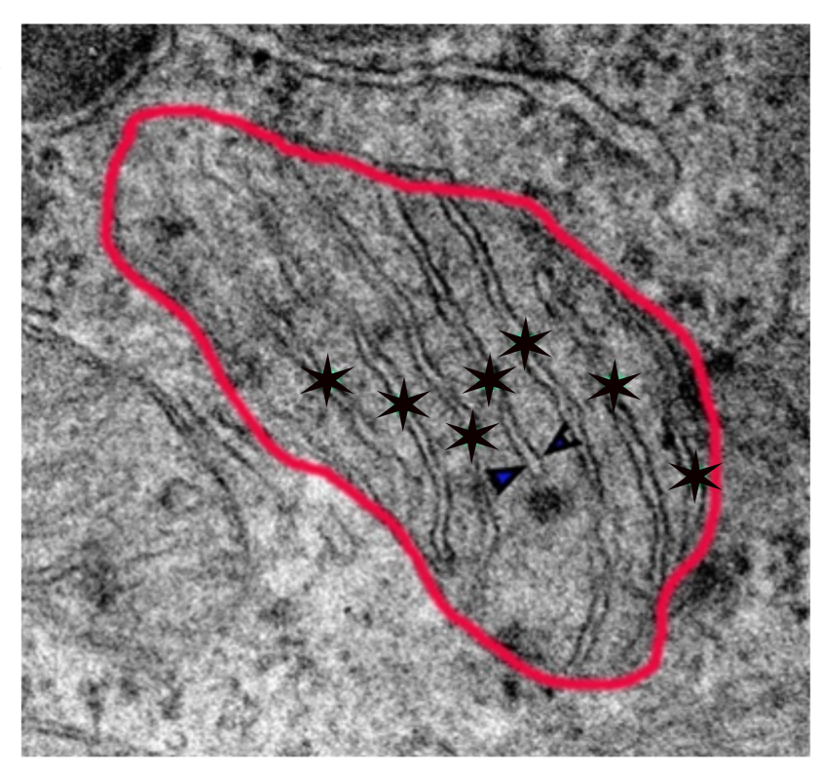

Supplementary figure 2:
Ultrastructural photographs of K562s’mitochondria with “messy” aspects
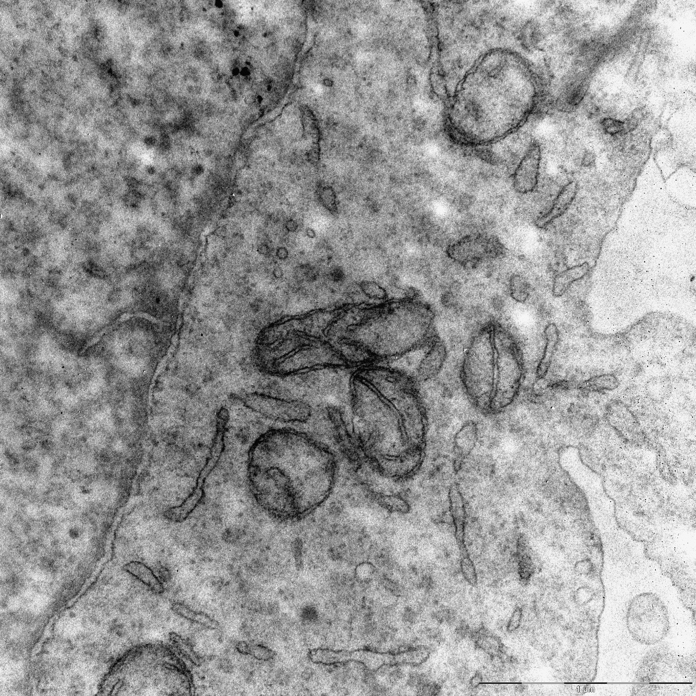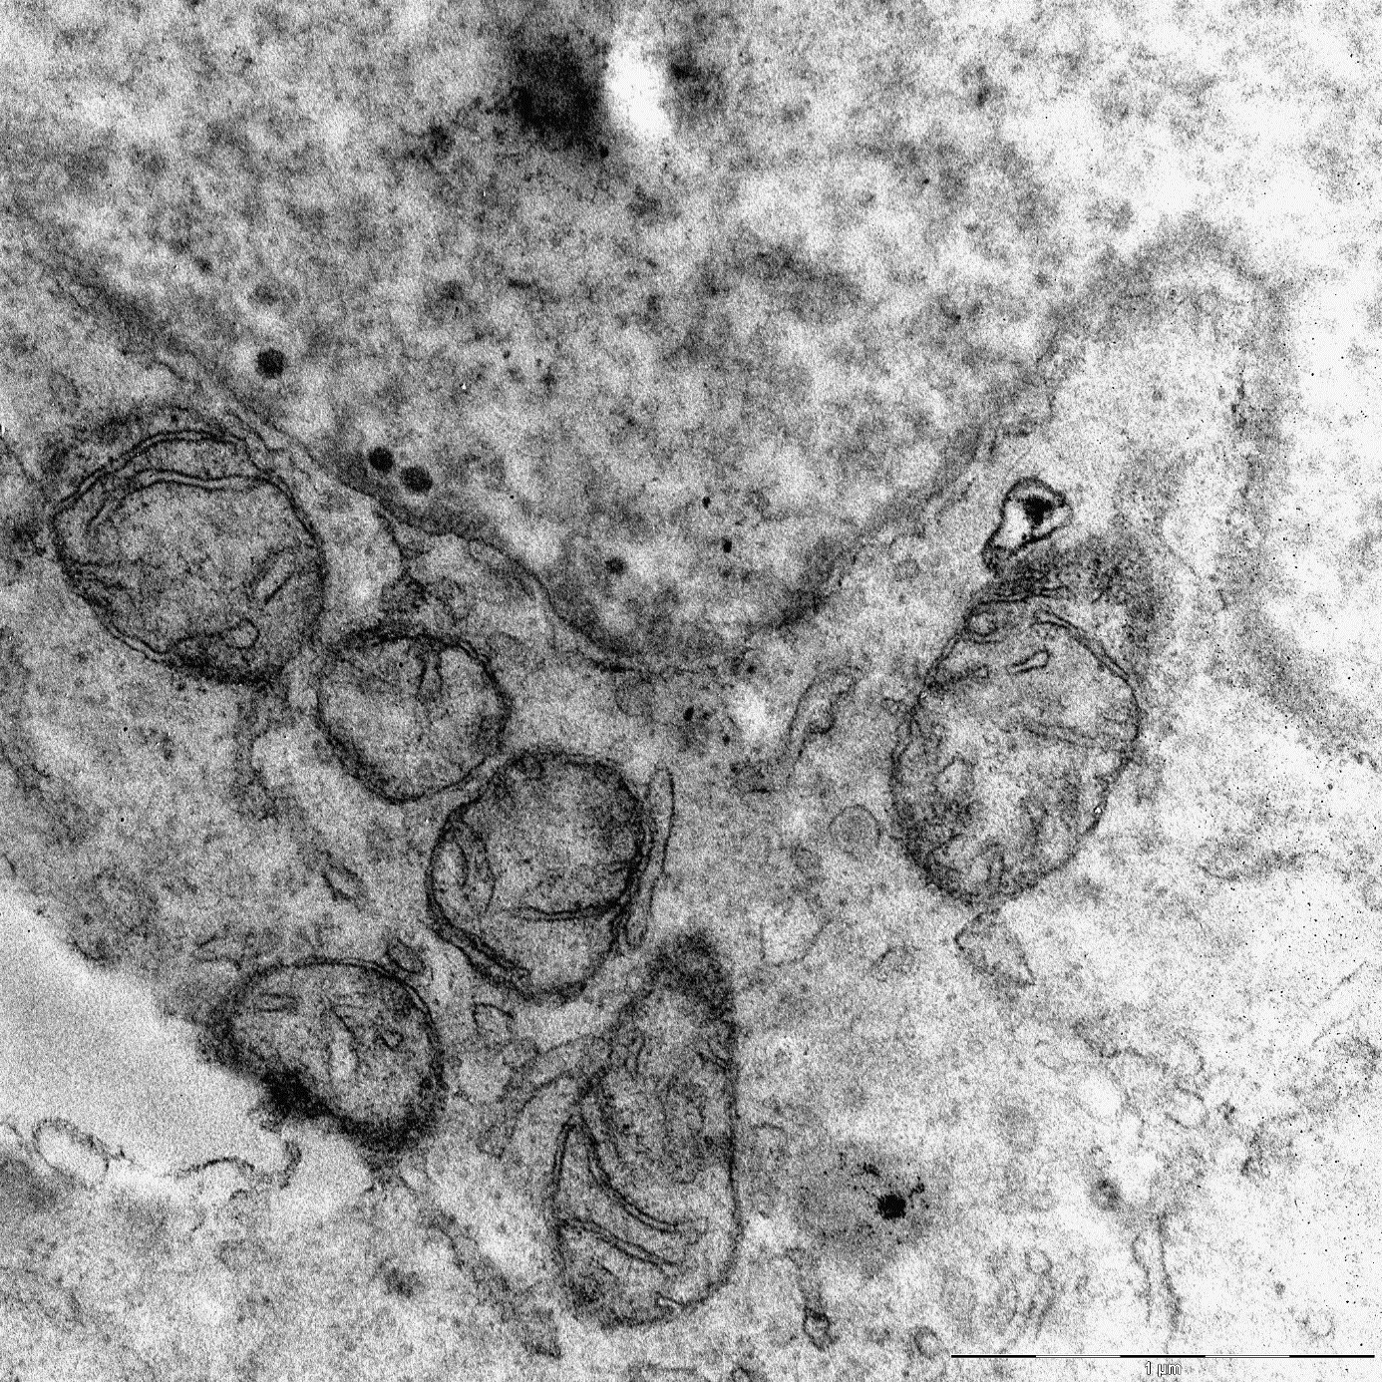
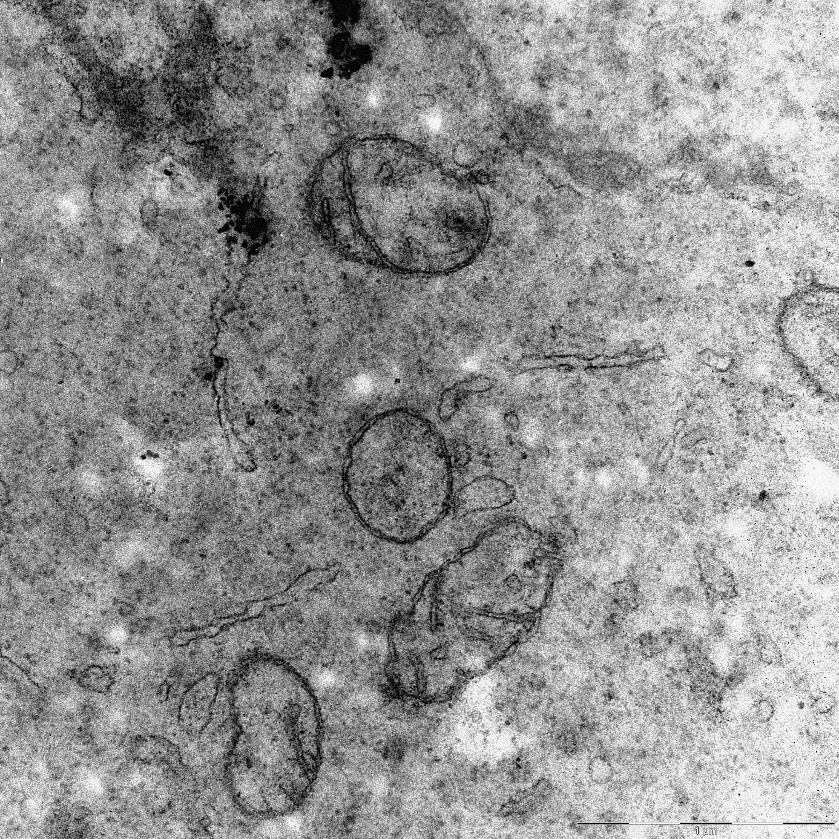

Supplementary data figure 4:
Percentage of mitochondria close to endoplasmic reticulum according to cell lines. Distance between mitochondria and endoplasmic reticulum under 0,1µm was defined as close. Chi-square test used, *** means p-value<0,001
