SUPPLEMENTALS:
Supplement 1: Kaplan-Meier plot showing overall survival of patients with PSA non progression (blue line) and PSA progression (red line) after ALCT. There was no significant difference in overall survival between the two groups (p=0.316).
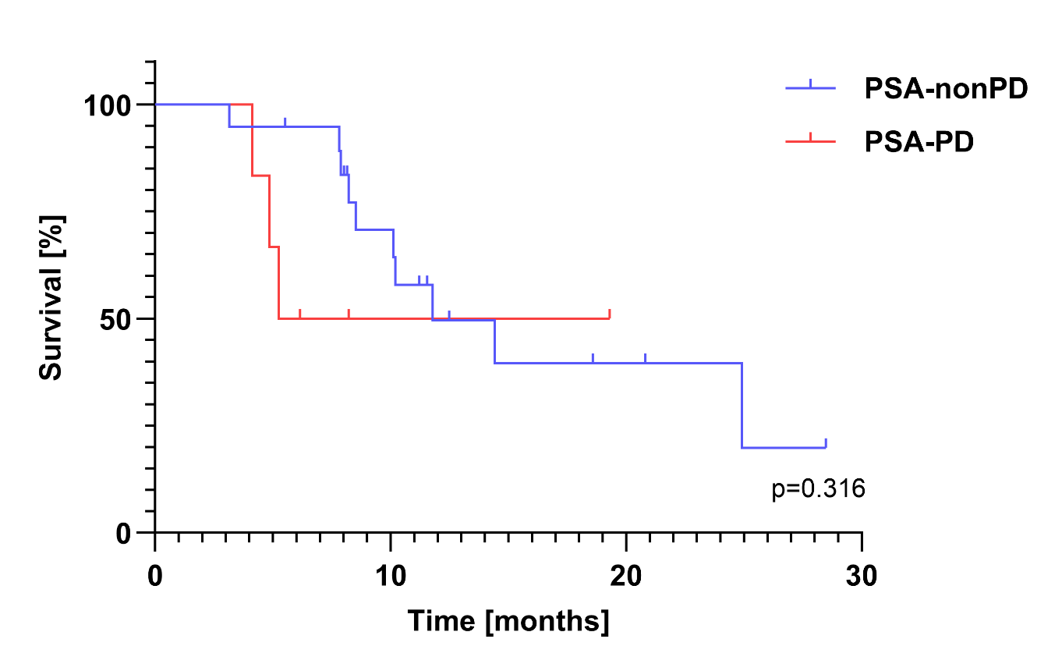

Supplement 2: Kaplan-Meier plot showing overall survival of patients with RECIP 1.0 partial response (blue line), stable disease (green line) progressive disease (red line) after ALCT. There was no significant difference in overall survival between the two groups (p=0.314).