Supplemental Material

Methods to evaluate the twin formation energy: comparative studies of the atomic simulations and in-situ TEM tensile tests
Hong-Kyu Kim¹, Sung-Hoon Kim^{1,2}, Jae-Pyoung Ahn^{1,*}
¹Advanced Analysis Center, Korea Institute of Science and Technology, Seoul 136-791, Republic of Korea
²Mechanical R&D Group, Samsung Electronics, Gyeonggi-do 16677, Republic of Korea

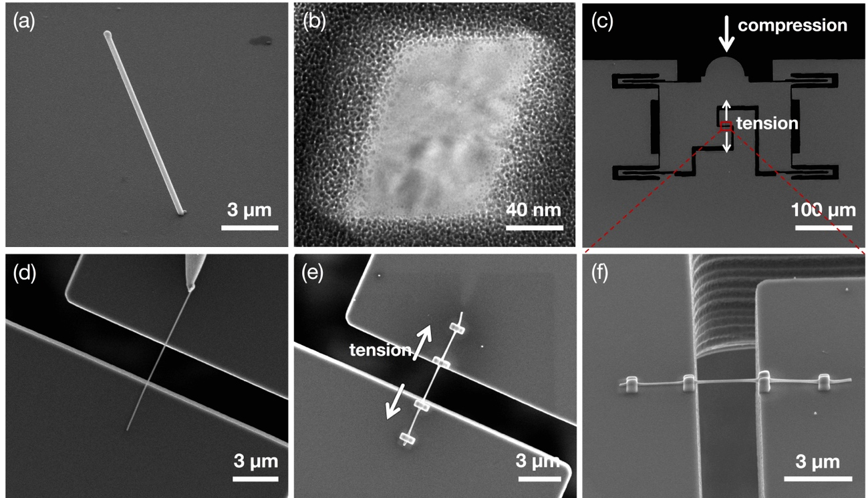
Fig. S1. Micrographs of (a) Al NW grown on the SiO₂ substrate and (b) its cross-sectional view. (c) Secondary electron image showing the push-to-pull (PTP) loading device, which converts a compressive load to a tensile load. (d-f) Magnified views of the rectangle denoted in (c); (d) The Al NW transported to the PTP loading device by picking up with the W tip of the nanomanipulator. The NW welded to the PTP device using e-beam assisted Pt deposition viewed from the (e) top and (f) side.

Shown in Fig. S1(a) is the Al NW grown on the SiO₂ substrate by the stress-induced method reported elsewhere (Lee et al., 2010). NWs used for in-situ TEM tensile tests were oriented along <110> and had the diameter of 100-200 nm, the length of 5-20 μm, and a rhombic cross-section with four {111} side facets with an acute angle of 70°, as shown in Fig. S1(b). TEM investigations confirmed that these NWs are single crystalline and nearly defect-free, but covered with a thin oxide layer with a thickness of ~5 nm. When the NW is welded to the push-to-pull (PTP) loading device, as shown in Fig. S1(c), this device converts a compressive force to a tensile force, enabling the tensile test of NWs in TEM. Before mounting the Al NW to the PTP device, one end of the Al NW sample was first attached using e-beam assisted Pt deposition to a W tip of the nanomanipulator (MM3A, Kleindeck) installed in a FIB system (Quanta 3D, FEI), as shown in Fig. S1(d). This NW was again welded to the upper and lower jigs of the PTP device using e-beam assisted Pt deposition (Figures S1(e) and (f)). At this stage, a special care is necessary so that its long axis aligns to the tensile direction. The PTP device was then mounted to a picoindenter (PI-95 TEM, Hysitron) capable of measuring the load and displacement. Tensile test was conducted on the Al NW samples at an initial strain rate of 1.2 × 10⁻³ s⁻¹ at ambient temperature, while the load-displacement data was recorded by simultaneously observing real-time images of the microstructure evolution.

Reference
Lee, J.W., Kang, M.G., Kim, B.S., Hong, B.H., Whang, D., Hwang, S.W., 2010. Single crystalline aluminum nanowires with ideal resistivity. Scripta Mater 63, 1009–1012. https://doi.org/10.1016/j.scriptamat.2010.07.026

