Supporting Information
Electrochemical Sensing System based on Coordination Bond Connected Porphyrin-MOFs@MXenes Hybrids for in situ and Real-Time Monitoring of H₂O₂ Released from Cells
Shiquan Xu ^{1†}, Zhaojie Su ^{1†}, Rong Jiang ², Xia Wu ¹, Jie Wang ¹, Ying Wang ¹, Xiyue Cao ², Jianfei Xia ^{2*}, He Shi ^{3*}, Weiqiang Tan ^{1*}
¹ Organ Transplantation Clinical Medical Center of Xiamen University, Department of Organ Transplantation, Xiang'an Hospital of Xiamen University, School of Medicine, Xiamen University, Xiamen 361102, China
² College of Chemistry and Chemical Engineering, Shandong Sino-Japanese Center for Collaborative Research of Carbon Nanomaterials, Instrumental Analysis Center of Qingdao University, Qingdao University, Qingdao 266071, PR China
³ Orthopedics and Sports Medicine Center, Qingdao Municipal Hospital, 266011, Qingdao, China.

Contents
Reagents and Material.------------------------------------------------------------------------3
Experimental Apparatus. ---------------------------------------------------------------------4
Synthesis of MXenes.---------------------------------------------------------------------------5
Figure S1. CV curves of (MXenes-FeP)n-MOF/ITO electrode with different concentrations of composites in H₂O₂ solutions.--------------------------------------------6
Figure S2. Current response of (MXenes-FeP)n-MOF/ITO electrode in H₂O₂ solutions at different voltages.-----------------------------------------------------------------------------7
Figure S3. (A) CV curves of the (MXenes-FeP)n-MOF/ITO electrode in 0.1 M PBS solution containing 5mM H₂O₂ at different scan rates. (B) Calibration plot of the cathode peak current versus the square root of scan rate.---------------------------------8
Figure S4. Current responses of six parallel (MXenes-FeP)n-MOF/ITO electrodes in 0.1 M PBS solution containing H₂O₂ for reproducibility testing.--------------------------9
Figure S5. The relative current changes of the same electrode in 10 days for stability testing.--------------------------------------------------------------------------------------------10

Reagents and Material
4-Mercaptopyridine (4-PySH), meso-tetra(4-carboxyphenyl)porphine (H₂TCPP), hydroquinone (HQ), lactic acid (Lac), lithium fluoride (LiF), catechol (CT), sodium chloride (NaCl), potassium chloride (KCl), glucose (Glu), sucrose (Suc), fructose (Fru), anhydrous ethanol, Iron(III) chloride hexahydrate (FeCl₃·6H₂O), N,N-Dimethylformamide (DMF) and hydrogen peroxide (H₂O₂) were purchased from Aladdin Reagent Co., Ltd. (Shanghai, China). The high-glucose DMEM medium was obtained from Yamei Biomedical Technology Co., Ltd. (Shanghai, China). Penicillin and streptomycin were purchased from Kangsai Biotechnology Co., Ltd. (Beijing, China). Fetal bovine serum was purchased from Wokawei Biotechnology Co., Ltd. (Beijing, China). The CCK-8 kit, phorbol 12-myristate 13-acetate (PMA), calcin-AM, and propidium iodide (PI) were acquired from Yisheng Biotech Co., Ltd. (Shanghai, China). Ultra-pure water (18.0 MΩcm) was prepared using a Millipore Milli-Q system and used throughout the experiments. All chemicals used were of analytical grade.

Experimental Apparatus
The morphology of the materials was tested using a Field Emission Scanning Electron Microscope (SEM, Regulus 8100). The crystallinity of the materials was analyzed and measured using an X-ray Diffractometer (XRD, Smart Lab 3KW). Fourier Transform Infrared Spectroscopy (FTIR, Nicolet is50) was used to obtain spectra of the materials in the range of 2500-3000 cm⁻¹. UV-Visible spectrophotometry (UV-2500, LabTech) was employed to analyze the UV absorption spectra of the materials. The electrochemical performance of the sensing system was characterized using a Princeton Applied Research Electrochemical Workstation (PARSTAT 40001, USA). Cell experiments were conducted using a Multifunctional Microplate Reader (SpectraMax i3x, USA) and a Fluorescence Microscope (EchoRevolve, USA).

Synthesis of MXenes
MXenes were prepared according to the previously reported synthesis method [Anal. Chem. 2020, 92, 7, 5546-5553]. Specifically, 0.8 g of lithium fluoride was dissolved in 10 mL of 9 M hydrochloric acid solution under magnetic stirring for 5 minutes. Then, 0.5 g of MXenes was slowly added to the solution with vigorous stirring, and the mixture was heated and stirred at 35 °C for 24 hours. Afterward, the solution was centrifuged at 3500 r/min for 5 minutes, and the precipitate was washed with double-distilled water. This washing step was repeated several times until no further precipitate could be centrifuged. Subsequently, the solution was centrifuged at 6000 r/min for 15 minutes, washed with double-distilled water, and centrifuged again until the pH was greater than or equal to 6. The precipitate was collected, mixed with double-distilled water, and sonicated under nitrogen for 1 hour. Then, the solution was centrifuged at 3500 r/min for 1 hour, and the supernatant was flushed with nitrogen, sealed, and stored in a refrigerator for future use. The concentration of the MXenes solution was determined by freeze-drying a certain volume of the solution and calculating the mass.

.

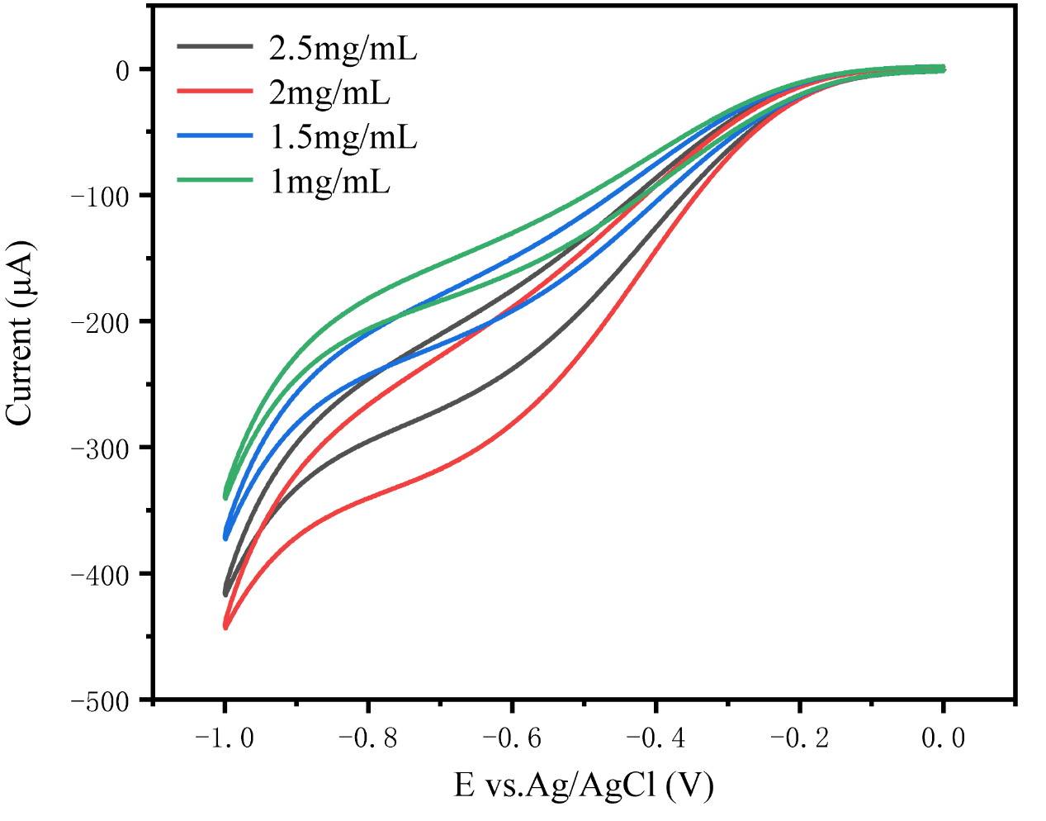

Figure S1. CV curves of (MXenes-FeP)n-MOF/ITO electrode with different concentrations of composites in H₂O₂ solutions.

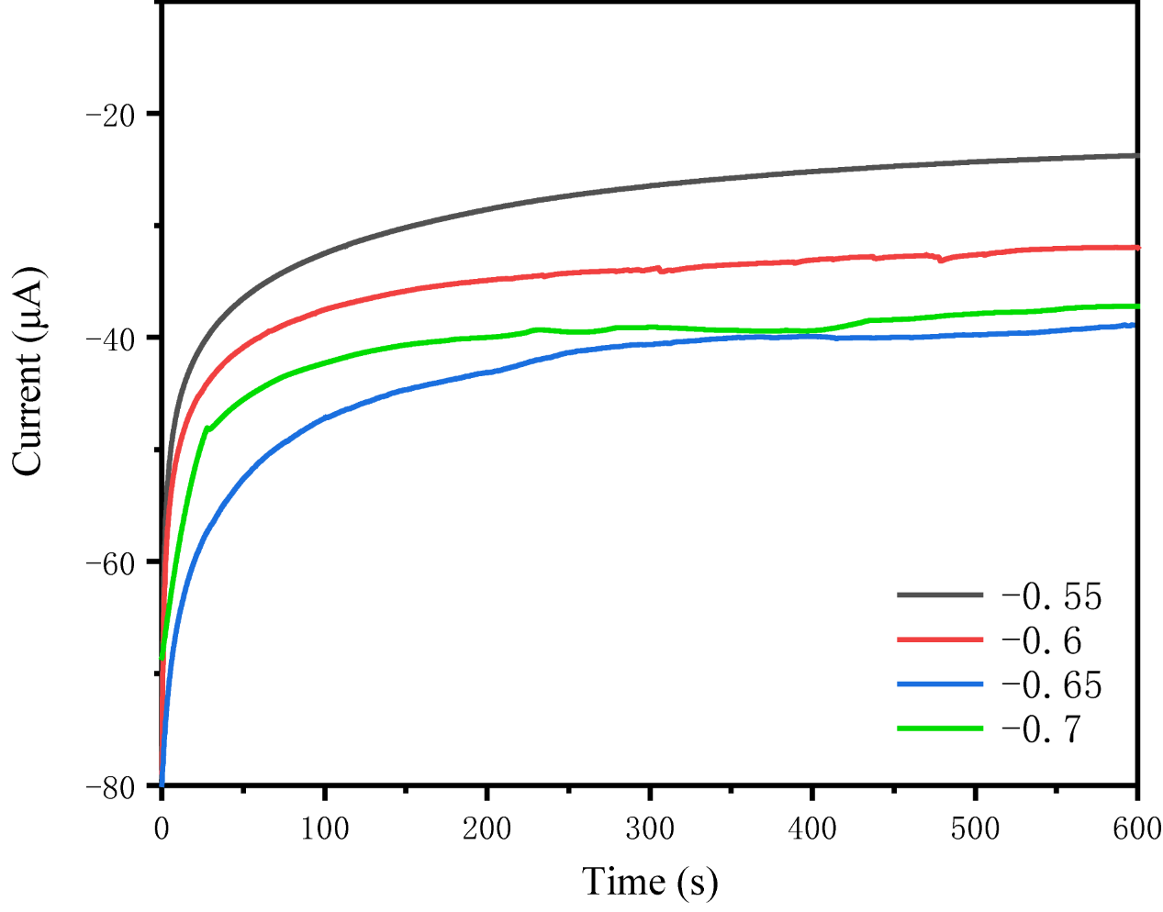

Figure S2. Current response of (MXenes-FeP)n-MOF/ITO electrode in H₂O₂ solutions at different voltages.

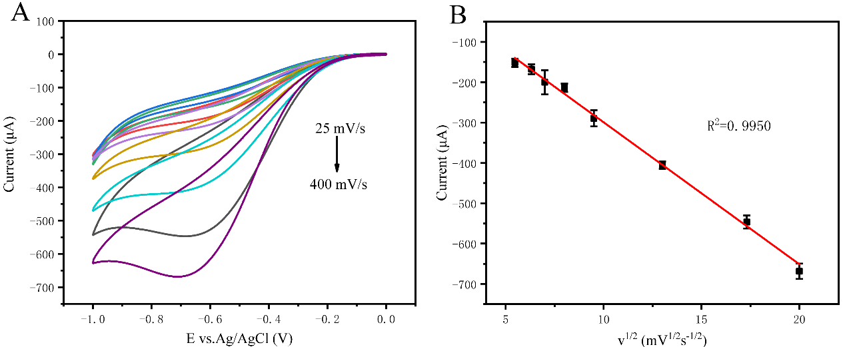

Figure S3. (A) CV curves of the (MXenes-FeP)n-MOF/ITO electrode in 0.1 M PBS solution containing 5mM H₂O₂ at different scan rates. (B) Calibration plot of the cathode peak current versus the square root of scan rate.

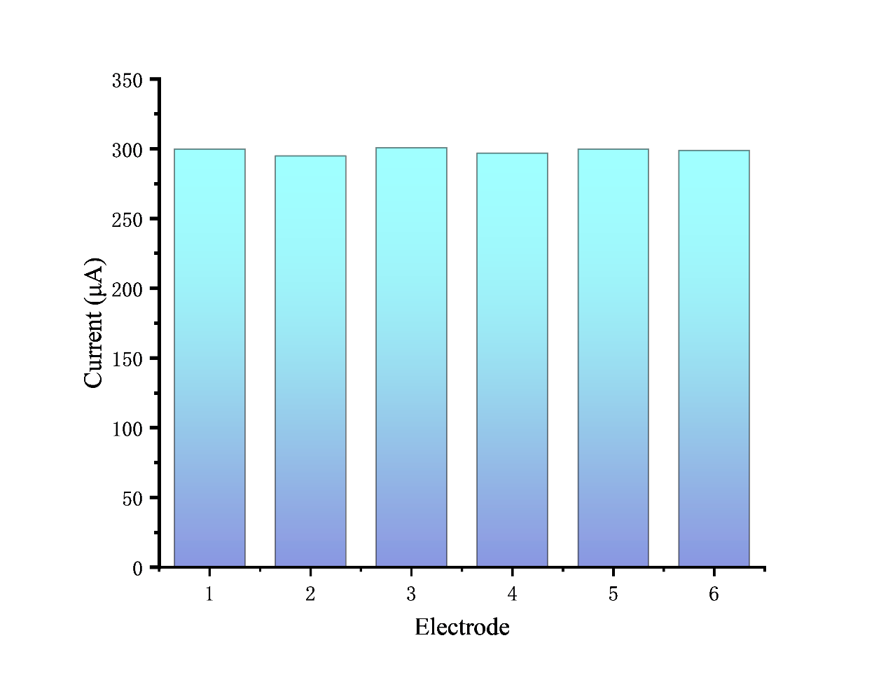
Figure S4. Current responses of six parallel (MXenes-FeP)n-MOF/ITO electrodes in 0.1 M PBS solution containing H₂O₂ for reproducibility testing.

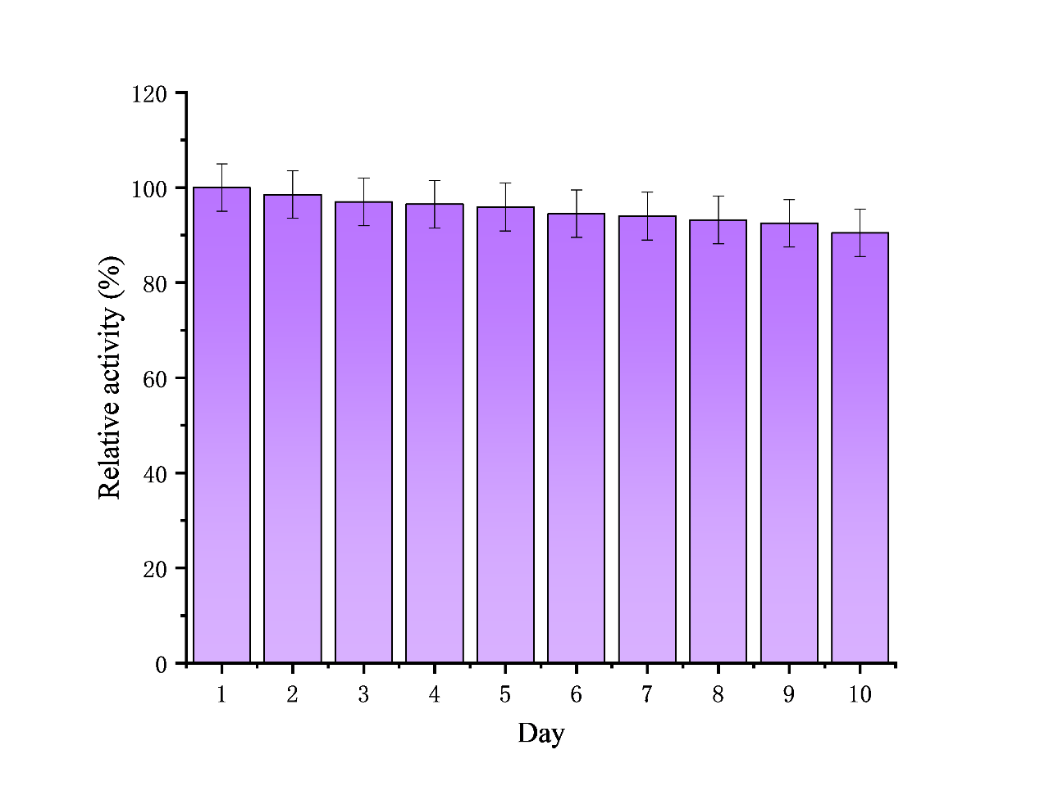

Figure S5. The relative current changes of the same electrode in 10 days for stability testing.

