Repairing the retinal ischemic microenvironment with an engineered exosome-loaded dehydroepiandrosterone peptide hydrogel
Shengjun Peng^{1, 7}, Ying Zhang^{2, 7}, Mengjia Zhang^{1, 7}, Wen Zhang¹, Lu Wang¹, Yating Zhang¹, Feng Jiang³, Jiacheng Zhang⁴, Chang Yang⁵, Wenxuan Ji¹, Wenyan Zhang⁶, Jiakuo Gu¹, Zhimou Yang^{2*}, Jie Gao^{2*} & Zhuhong Zhang^{1*}
Figure S1. Mass spectrometry (MS) spectrum of DHEA-^{D}F^{D}FGSSSR and SA-^{D}F^{D}FGSSSR.

Figure S2. Safety evaluation of BBR-hExos@DHEA-Pep and other compounds. High concentration of BBR-hExos@DHEA-Pep showed no toxicity based on cellular ATP a) and LDH release b). The data are presented as the mean ± SD of n = 3. Statistical significance was determined using one-way ANOVA with Dunnett's post hoc test; *P< 0.05; **P< 0.01; ***P< 0.001; and ****P< 0.0001.

Figure S3. BBR-hExos@DHEA-Pep regulates the level of inflammatory factors in vivo. Representative CLSM images of retinal cryosections stained for inflammatory factors iNOS a) and IL-10 b).

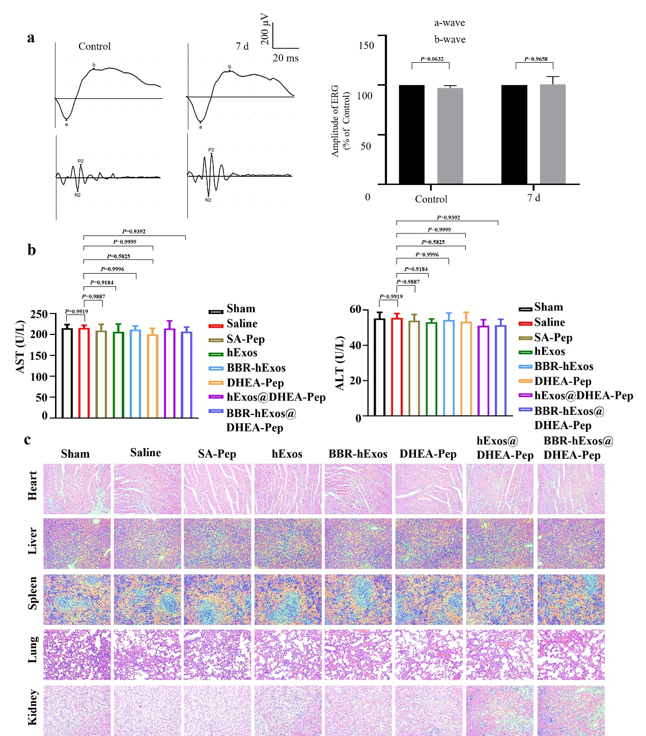
Figure S4. Safety evaluation of BBR-hExos@DHEA-Pep. a) Representative ERG traces of normal rats treated with BBR-hExos@DHEA-Pep after 7 days (lighting intensity = 3.00 cd∙s∙m⁻²), Amplitudes of the scotopic ERG a and b waves amplitudes at the light intensity of 3.00 cd∙s∙m⁻². The data were presented as the mean ± SD of n = 6. Statistical significance was determined using one-way ANOVA with Dunnett's post hoc test; *P< 0.05; **P< 0.01; ***P< 0.001; and ****P< 0.0001. b) Measurement of serum aspartate aminotransferase (AST) and alanine aminotransferase (ALT) activity in rats after intravitreal injection BBR-hExos@DHEA-Pep for 7 days. The data were presented as the mean ± SD of n = 6. Statistical significance was determined using one-way ANOVA with Dunnett's post hoc test; *P< 0.05; **P< 0.01; ***P< 0.001; and ****P< 0.0001. c) H&E staining of main organs of heart, liver, spleen, lung, kidney.

Figure S5. Regulation of canonical and non-canonical Wnt signaling pathways and PI3K/Akt/mTOR signaling pathway by BBR-hExos@DHEA-Pep following intravitreal injection a) Representative immunofluorescence images of Wnt5a, Rac1, p-NFκB p65, IL-6, p-STAT3, β-catenin, p-LRP6 and p-GSK3β in retinal cryosections indicating that BBR-hExos@DHEA-Pep-mediated reduction in the level of Wnt5a, Rac1, p-NFκB p65, IL-6, p-STAT3, β-catenin, p-LRP6 and p-GSK3β in RIR-injuried retina compared to Saline group. Scale bar = 50 μm. b) Representative immunofluorescence images of p-PI3K, p-AKT and p-mTOR in retinal cryosections indicating that BBR-hExos@DHEA-Pep-mediated reduction in the level of p-PI3K, p-AKT and p-mTOR in RIR-injuried retina compared to Saline group. Scale bar = 50 μm

Figure S6. BBR-hExos@DHEA-Pep regulates angiogenesis and extracellular matrix fibrosis induced by RIR. a) Representative immunofluorescence images of extracellular matrix fibrosis associated proteins (fibronectin and collagen type IV), and b) angiogenesis associated proteins (CD105 and VEGF) in retinal cryosections indicating that BBR-hExos@DHEA-Pep-mediated inhibition in angiogenesis and extracellular matrix fibrosis in RIR-injuried retina compared to Saline group. Scale bar = 50 μm.

