Supplementary Information
Detailed discussion of entry points considered in the EU case study.
In developing this assertion we begin with consideration of the 2021 European Climate Law, which explicitly describes ‘Polluter Pays’, ‘Precaution’ and ‘Do no harm’ as key foundational principles (Regulation (EU) 2021/1119 of the European Parliament and of the Council of 30 June 2021 Establishing the Framework for Achieving Climate Neutrality and Amending Regulations (EC) No 401/2009 and (EU) 2018/1999 (‘European Climate Law’), 2021). Countries in the European Union are also signatories to the Paris Agreement, thereby acknowledging the principle of ‘common but differentiated responsibilities and respective capabilities, in the light of different national circumstances’ (CBDR-RC) contained therein. We consider this set of principles to be complementary to one another.
Following the long-term temperature goal of the Paris Agreement to keep global warming well- below 2°C and pursue efforts to limit it to 1.5°C relative to preindustrial levels as well as the ‘do no harm’ and ‘precautionary’ principles, we select a remaining carbon budget consistent with limiting global warming to 1.5°C with a 50% likelihood. This remaining carbon budget is estimated to be 247 Gt CO₂ starting from 2023 (Lamboll et al., 2023). We recognise that this is a value judgement and note that higher likelihoods (e.g. 67% or 90%) may be better aligned with the referenced principles. We convert this to a budget from the year 2020 by adding in all CO₂ emissions 2020-2022 (117 GtCO₂), resulting in a remaining budget in the year 2020 of 364 GtCO₂, a substantial downward revision from the original budget for the equivalent temperature threshold and likelihood provided in the IPCC AR6 (500 GtCO₂).
In line with the C1 set of scenarios in the IPCC’s AR6, we conservatively assume Land Use, Land Use Change and Forestry (LULUCF) CO₂ emissions are cumulatively net zero in the period 2020-2050. Thus, we do not consider future allocations to this sector (or sinks arising through this sector), nor do we consider historical contributions through this sector. The latter decision is based on the uncertainty in quantifying and attributing historical anthropogenic LULUCF CO₂ emissions, which remains subject to active discussion (Ellis, 2021; Friedlingstein et al., 2022). Historical and recent non-CO₂ emissions are also not considered. Here, we refer to the ongoing active academic debate regarding fair sectoral emissions floors (e.g., in the agricultural sector) and how to include warming contributions of non- CO₂ GHGs (in particular, when they have life spans shorter than CO₂), a complex topic subject to active scientific discussion (Cain et al., 2021; Dhakal et al., 2022; Meinshausen & Nicholls, 2022; Reisinger et al., 2021; Rogelj & Schleussner, 2019, 2021). While ‘fair share’ studies employing the Global Warming Potential (GWP) metric to include non-CO₂ GHGs exist, the evolving debate surrounding this issue cautions against relying on this for near-term fairness calculations (from 1990). Consequently, we concentrate solely on historical and remaining CO₂ budgets, where the literature is more established. Finally, as our work draws on national estimates provided by the Global Carbon Budget project, it excludes emissions attributable to international bunkers (Friedlingstein et al., 2022). To address this, we subtract projected median international bunker emissions CO₂ emissions across C1 scenarios assessed under the IPCC AR6 (~46 GtCO₂) from the remaining carbon budget as a first approximation.
We subsequently consider two allocation approaches aligned to different degrees with our stated foundational principles, shown in Table 2, motivated by the year of the first IPCC report (1990) where the relationship between CO₂ emissions and global mean temperature was systematically communicated. In our first allocation approach we consider responsibility alone, neglecting quantitative assessment of capability. In our second allocation approach we scale the first cumulative per capita allocation in proportion to the relative cumulative per capita GDP in market exchange rates over the period 1990-2019 (the last year of consistently available global GDP data in our dataset). The use of relative cumulative per capita GDP proxies changing national capabilities over the period for which data is available and could be updated with each new year of data. Both approaches represent operationalisations of the selected principles to different degrees in terms of the period of relevance and the consideration of capabilities. They are not intended to provide a ‘range’ and do not cover all possible interpretations. The mathematical formulations of these allocation approaches and decisions taken on the inverse transformation are provided in the next section.
To operationalise these allocation approaches we define a total remaining carbon budget from the year of allocation (1990). We add the estimated historical global fossil-fuel and industry carbon dioxide emissions (CO₂-FFI) emissions over the period 1990-2019 (inclusive) to the estimated remaining carbon budget from the year 2020. We then proceed by allocating this total remaining carbon budget to each party as defined in Table 2. From these allocations in the year 1990, we subtract estimated cumulative national CO₂-FFI emissions to the year 2022 (inclusive). This results in our estimate of a remaining national carbon budget for each party from 2023 onwards. We aggregate this to the level of the EU27 in Table 2 and provide further results for member countries and other regions in the supplementary information.

Mathematical formulation of the allocation approaches considered in the EU case study
Allocation approach 1 allocates emissions equally per capita from the year 1990 to the year 2050, subtracting from the resulting country-level allocations over this period their respective known consumption-based CO₂-FFI emissions from 1990 to 2022, the year before which estimated remaining carbon budgets are defined (2023). This approach disregards cumulative emissions prior to 1990 and does not capture distinct regional capabilities, thus not necessarily aligning with interpretations of the CBDR&RC and ‘do no harm’ principles. Equation (1) describes the allocation approach in mathematical terms, where y indicates the starting year of allocation (1990), p indicates the year from which the remaining carbon budget is determined (2020), z indicates the final year of allocation (2050), c designates the study country of total countries n, and p-1 denotes the year before the remaining carbon budget is calculated (2019).
 | $${RemainingBudget}_{p,z,c}=\frac{{CumulativePopulation}_{y,z,c}}{\sum_{c}^{n}{\left({CumulativePopulation}_{y,z,c}\right)}}×{GlobalBudget}_{y,z}- {CO2}_{y,p-1,c}$$ | (1)
Allocation approach 2 scales a per capita allocation in inverse proportion to the relative cumulative per capita GDP from 1990-2019, the last available year with consistent data for the analysis countries. This is shown in Equation (2), where $\hat{x_{y,p-1,c}}$ reflects an inverse transformation of the cumulative GDP over cumulative population for country c from 1990-2019. In contrast to other studies using the per capita GDP indicator in a single year of allocation, we consider cumulative GDP over cumulative population to update capabilities changing over this period. Here a set of substitutable inverse transformations can be applied, each reflecting a distinct value judgement on the desired relationship between the range of the original indicator value and the corresponding inverse range. We suggest F(x) = 1/sqrt(x) in this work, taking this as the middle ground between the more severe F(x) = 1/x and more lenient F(x) = 1/asinh(x) alternatives amongst other normative approaches that may set upper bounds on the maximum adjustment.
 | $${RemainingBudget}_{p,z,c}=\frac{\hat{x_{y,p-1,c}}× {CumulativePopulation}_{y,z,c}}{\sum_{c}^{n}{\left(\hat{x_{y,p-1,c}}×{CumulativePopulation}_{y,z,c}\right)}}×{GlobalBudget}_{y,z}- {CO2}_{y,p-1,c}$$ | (2)

Illustrative findings from the EU case study
Figure 1a describes how the EU’s ‘fair’ share of the remaining carbon budget has been consumed since the inaugural IPCC report in 1990, reaching net-negative allocations of -35.4 GtCO₂-FFI (1_ECPC1990) in the year 2023. This overconsumption reflects the steady accrual of ‘carbon debt’ (see Matthews (2016)). These aggregate trends subsume important intraregional differences that may result in some countries within a given region allocated a budget while others allocated a debt, as shown in Figure 1c. Implications for other illustrative regions are shown in Figure 1b, here we see that in contrast to the EU27, countries grouped into the African region remain endowed with a carbon budget in 2023 of 142 GtCO₂-FFI under the same approach. The steadily depleting regional carbon budget and subsequent growth of carbon debt in recent years highlights that the situation today is not a sudden turn of events, but rather, is the result of cumulative decisions made over time since the year 1990.
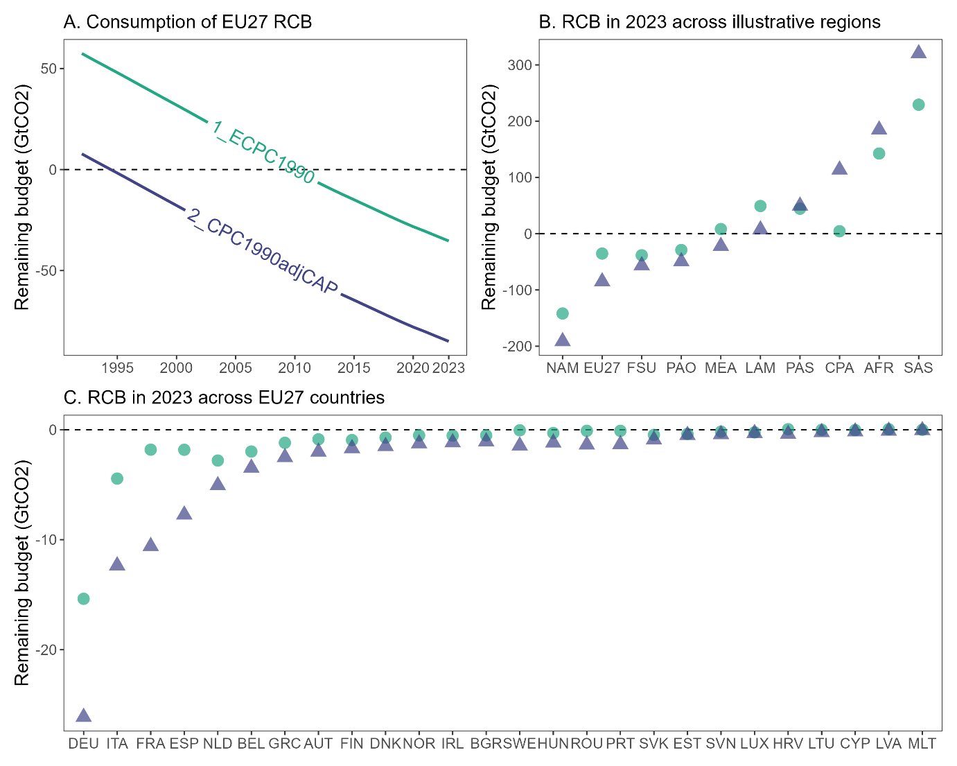
Figure SI 1 - Estimated remaining carbon budgets in GtCO₂-FFI.

These pathways limit warming to 1.5C in 2100 with a likelihood of greater than 50% and reach or exceed warming of 1.5C during the 21st century with a likelihood of 67% or less (Chapter 3, IPCC, 2022).

