Supplementary Tables

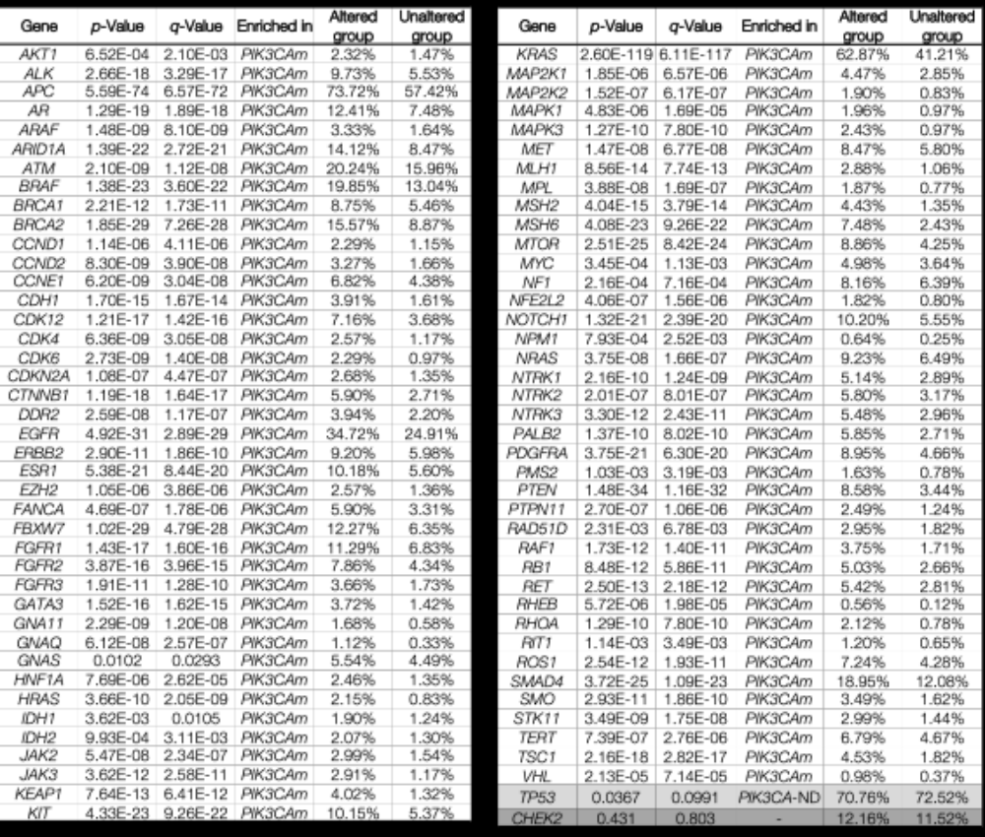

Supplementary Table S1. Statistical significance of co-occurring gene mutations between PIK3CAm and PIK3CA-ND. Altered group refers to PIK3CAm samples and Unaltered group refers to PIK3CA-ND samples. TP53 highlighted because it was enriched in the unaltered group. CHEK2 highlighted because it was not significantly enriched in PIK3CAm group.

