Supplementary Material
Risks of microplastics in different land-use types of soil in a typical petrochemical city in China
Yuting Guo^{a,b,1}, Linlin Wu^{a,c,1}, Changsheng Guo^{a,c}, Rongshan Wu^{a,c}, Jian Xu^{a,c*}
- State Key Laboratory of Environmental Criteria and Risk Assessment, Chinese Research Academy of Environmental Sciences, Beijing 100012, China
- School of Ecology and Environment, Zhengzhou University, Zhengzhou 450066, China
- State Environmental Protection Key Laboratory of Ecological Effect and Risk Assessment of Chemicals, Chinese Research Academy of Environmental Sciences, Beijing 100012, China
*: To whom all correspondence should be addressed. E-mail: xujian@craes.org.cn
¹: Equal contribution as first author.

Table S1 Summary of abundances of microplastics (MPs) in soils collected from Daqing, China.
Table S2 Parameter values of different genders and age groups
Table S3 Socio-economic data of the study areas in Daqing City

Table S1 Summary of abundances of microplastics (MPs) in soils collected from Daqing, China.
Sample ID | Y（Latitude） | X（Longitude） | Abundance (items/kg)
IL1 | 46.748624 | 124.974804 | 1224.49
IL2 | 46.701123 | 124.800150 | 6734.69
IL3 | 46.566114 | 124.809923 | 3673.47
IL4 | 46.554728 | 124.950942 | 2346.94
IL5 | 46.538524 | 125.091919 | 1224.49
IL6 | 46.442204 | 125.227253 | 1428.57
IL7 | 46.344587 | 124.721002 | 1530.61
 | Average |  | 2594.75
 | Std Dev |  | 2025.33
 | SUM |  | 18163.27
WL1 | 46.757175 | 125.093180 | 4693.88
WL2 | 46.672292 | 125.236244 | 1632.65
WL3 | 46.637120 | 125.133419 | 1122.45
WL4 | 46.594807 | 124.864484 | 1530.61
WL5 | 46.509094 | 125.027321 | 2142.86
 | Average |  | 2224.49
 | Std Dev |  | 1427.48
 | SUM |  | 11122.45
FL1 | 46.744682 | 125.134327 | 2346.94
FL2 | 46.713046 | 124.859825 | 1938.78
FL3 | 46.671585 | 124.958496 | 2142.86
FL4 | 46.629399 | 125.040550 | 7346.94
FL5 | 46.303881 | 124.891097 | 714.29
FL6 | 46.160615 | 124.805514 | 2346.94
 | Average |  | 2806.12
 | Std Dev |  | 2306.89
 | SUM |  | 16836.73
PG1 | 46.728301 | 124.932060 | 1224.49
PG2 | 46.668758 | 125.086212 | 2142.86
PG3 | 46.612608 | 124.914354 | 1632.65
PG4 | 46.605247 | 124.990037 | 2346.94
PG5 | 46.535912 | 124.880261 | 714.29
PG6 | 46.508671 | 125.087242 | 1836.73
 | Average |  | 1649.66
 | Std Dev |  | 603.39
 | SUM |  | 9897.96
EL1 | 46.675442 | 124.860649 | 1938.78
EL2 | 46.670642 | 125.023963 | 1326.53
EL3 | 46.631737 | 125.180094 | 1734.69
EL4 | 46.581164 | 125.160627 | 1224.49
EL5 | 46.485495 | 124.852001 | 11122.45
 | Average |  | 3469.39
 | Std Dev |  | 4288.14
 | SUM |  | 17346.94
RDL1 | 46.625480 | 124.847087 | 1734.69
RDL2 | 46.564343 | 124.896734 | 8571.43
RDL3 | 46.495792 | 124.933433 | 1530.61
RDL4 | 46.444836 | 125.174875 | 1224.49
RDL5 | 46.402444 | 124.881463 | 1020.41
RDL6 | 46.031023 | 124.805136 | 1734.69
 | Average |  | 2636.05
 | Std Dev |  | 2921.59
 | SUM |  | 15816.33
RL1 | 46.847277 | 125.062866 | 2244.90
RL2 | 46.690193 | 125.153846 | 1326.53
RL3 | 46.599331 | 125.131359 | 3163.27
RL4 | 46.483266 | 125.170805 | 1224.49
RL5 | 46.127746 | 124.584617 | 2142.86
 | Average |  | 2020.41
 | Std Dev |  | 788.43
 | SUM |  | 10102.04
Average (total MPs) |  |  | 2482.14
Std Dev (total MPs) |  |  | 2214.17
SUM (total MPs) |  |  | 99285.71

Table S2 Parameter values of different genders and age groups
 |  | Age groups
Gender | Parameter | Toddler | Preschool children | School children | Adolescent | Prime of life | Middle-aged | The elderly | The aged
 |  | 0-3 | 3-6 | 6-12 | 12-18 | 18-44 | 44-60 | 60-80 | >80
Male | BW/(kg) | 9.95 | 17.87 | 32.98 | 53.09 | 65.3 | 66.0 | 62.4 | 59.1
Male | mingestion/(mg/d) | 60 | 76 | 108 | 99 | 50 | 50 | 50 | 50
Female | BW/(kg) | 9.28 | 17.3 | 30.88 | 48.39 | 56.8 | 59.5 | 56.6 | 51.0
Female | mingestion/(mg/d) | 60 | 68 | 99 | 75 | 50 | 50 | 50 | 50
Obtained from (MEEC, 2013; 2018)

Table S3 Socio-economic data of the study areas in Daqing City
 | Ranghulu | Sartu | Datong | Longfeng | Honggang
Population (10⁴ person) | 59.26 | 33.8 | 18.03 | 29.08 | 13.00
Population density(person/km²) | 425.11 | 616.79 | 76.04 | 699.37 | 208.67
Land area (km²) | 1394 | 548 | 2371 | 415.8 | 623
Urbanization rate (%) | 94.90% | 100.00% | 50.43% | 93.21% | 84.79%
GDP (10⁸ CNY) | 181.2 | 132.5 | 78.46 | 86.12 | 35.6
Per capita GDP (CNY) | 30577.12 | 39201.18 | 42729.00 | 29614.86 | 27384.62
Primary industry(CNY) | 4.4 | 2.1 | 43.58 | 2.1 | 3.7
Secondary industry(10⁸ CNY) | 38.7 | 66.0 | 7.59 | 16.4 | 11.65
Tertiary industry(10⁸ CNY) | 138.1 | 132.27 | 27.3 | 59.22 | 20.19

Fig. S1 The distribution of microplastics in land use types (A) and administrative districts (B) in the region
Fig. S2 Values of pollution and risk index at each sampling point
Fig. S3 Heat map of correlation between socioeconomic factors and microplastics risk index

Fig. S4 Daily intake of MPs of different genders in different age groups under land use types (A: 0-1mm, B: 1-5mm)

Fig. S5 Daily average intake of MPs of different genders in different age groups under administrative regions (A: 0-1mm, B: 1-5mm)
Fig. S6 Comparison of EDI values of different age groups under different land use types (0-1mm)

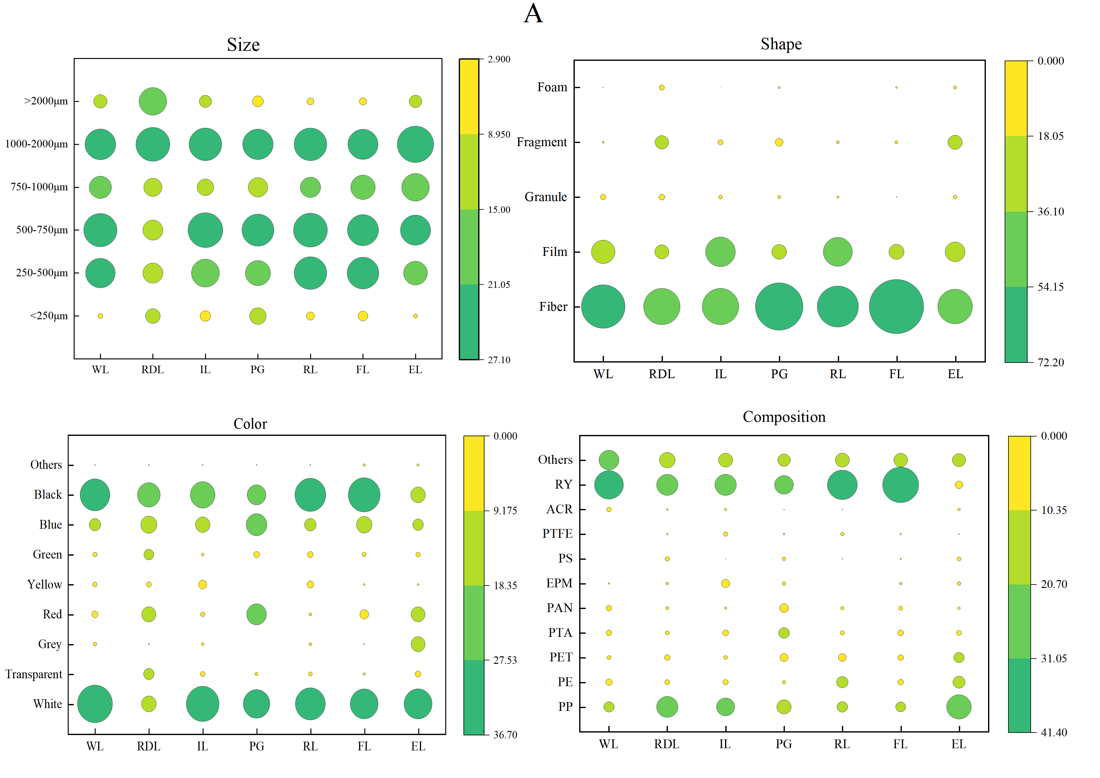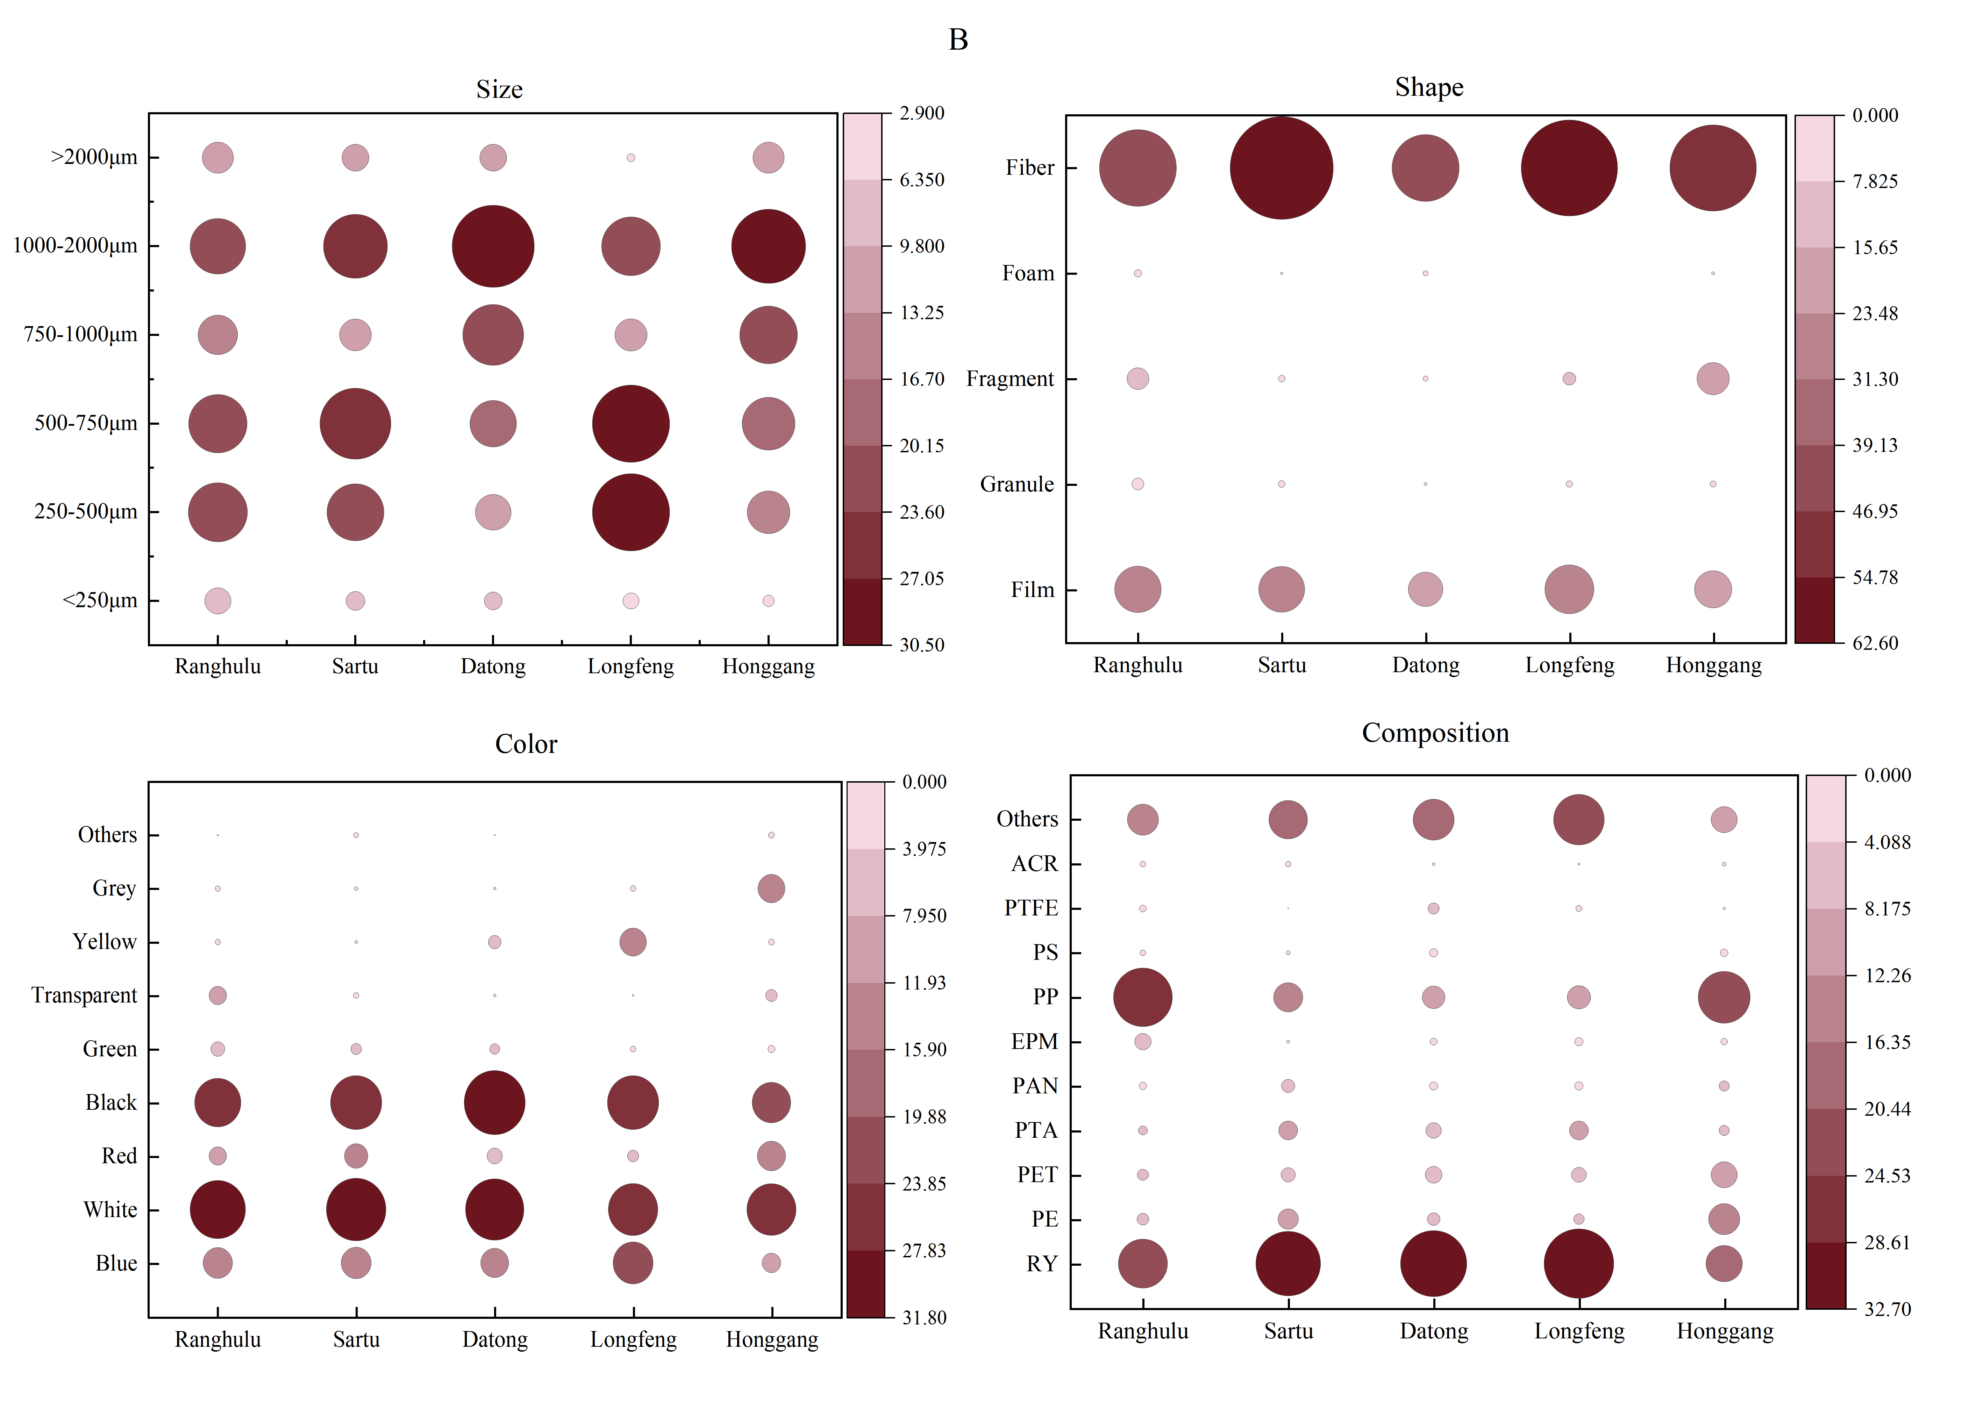
Fig. S1 The distribution of microplastics in land use types (A) and administrative districts (B) in the region
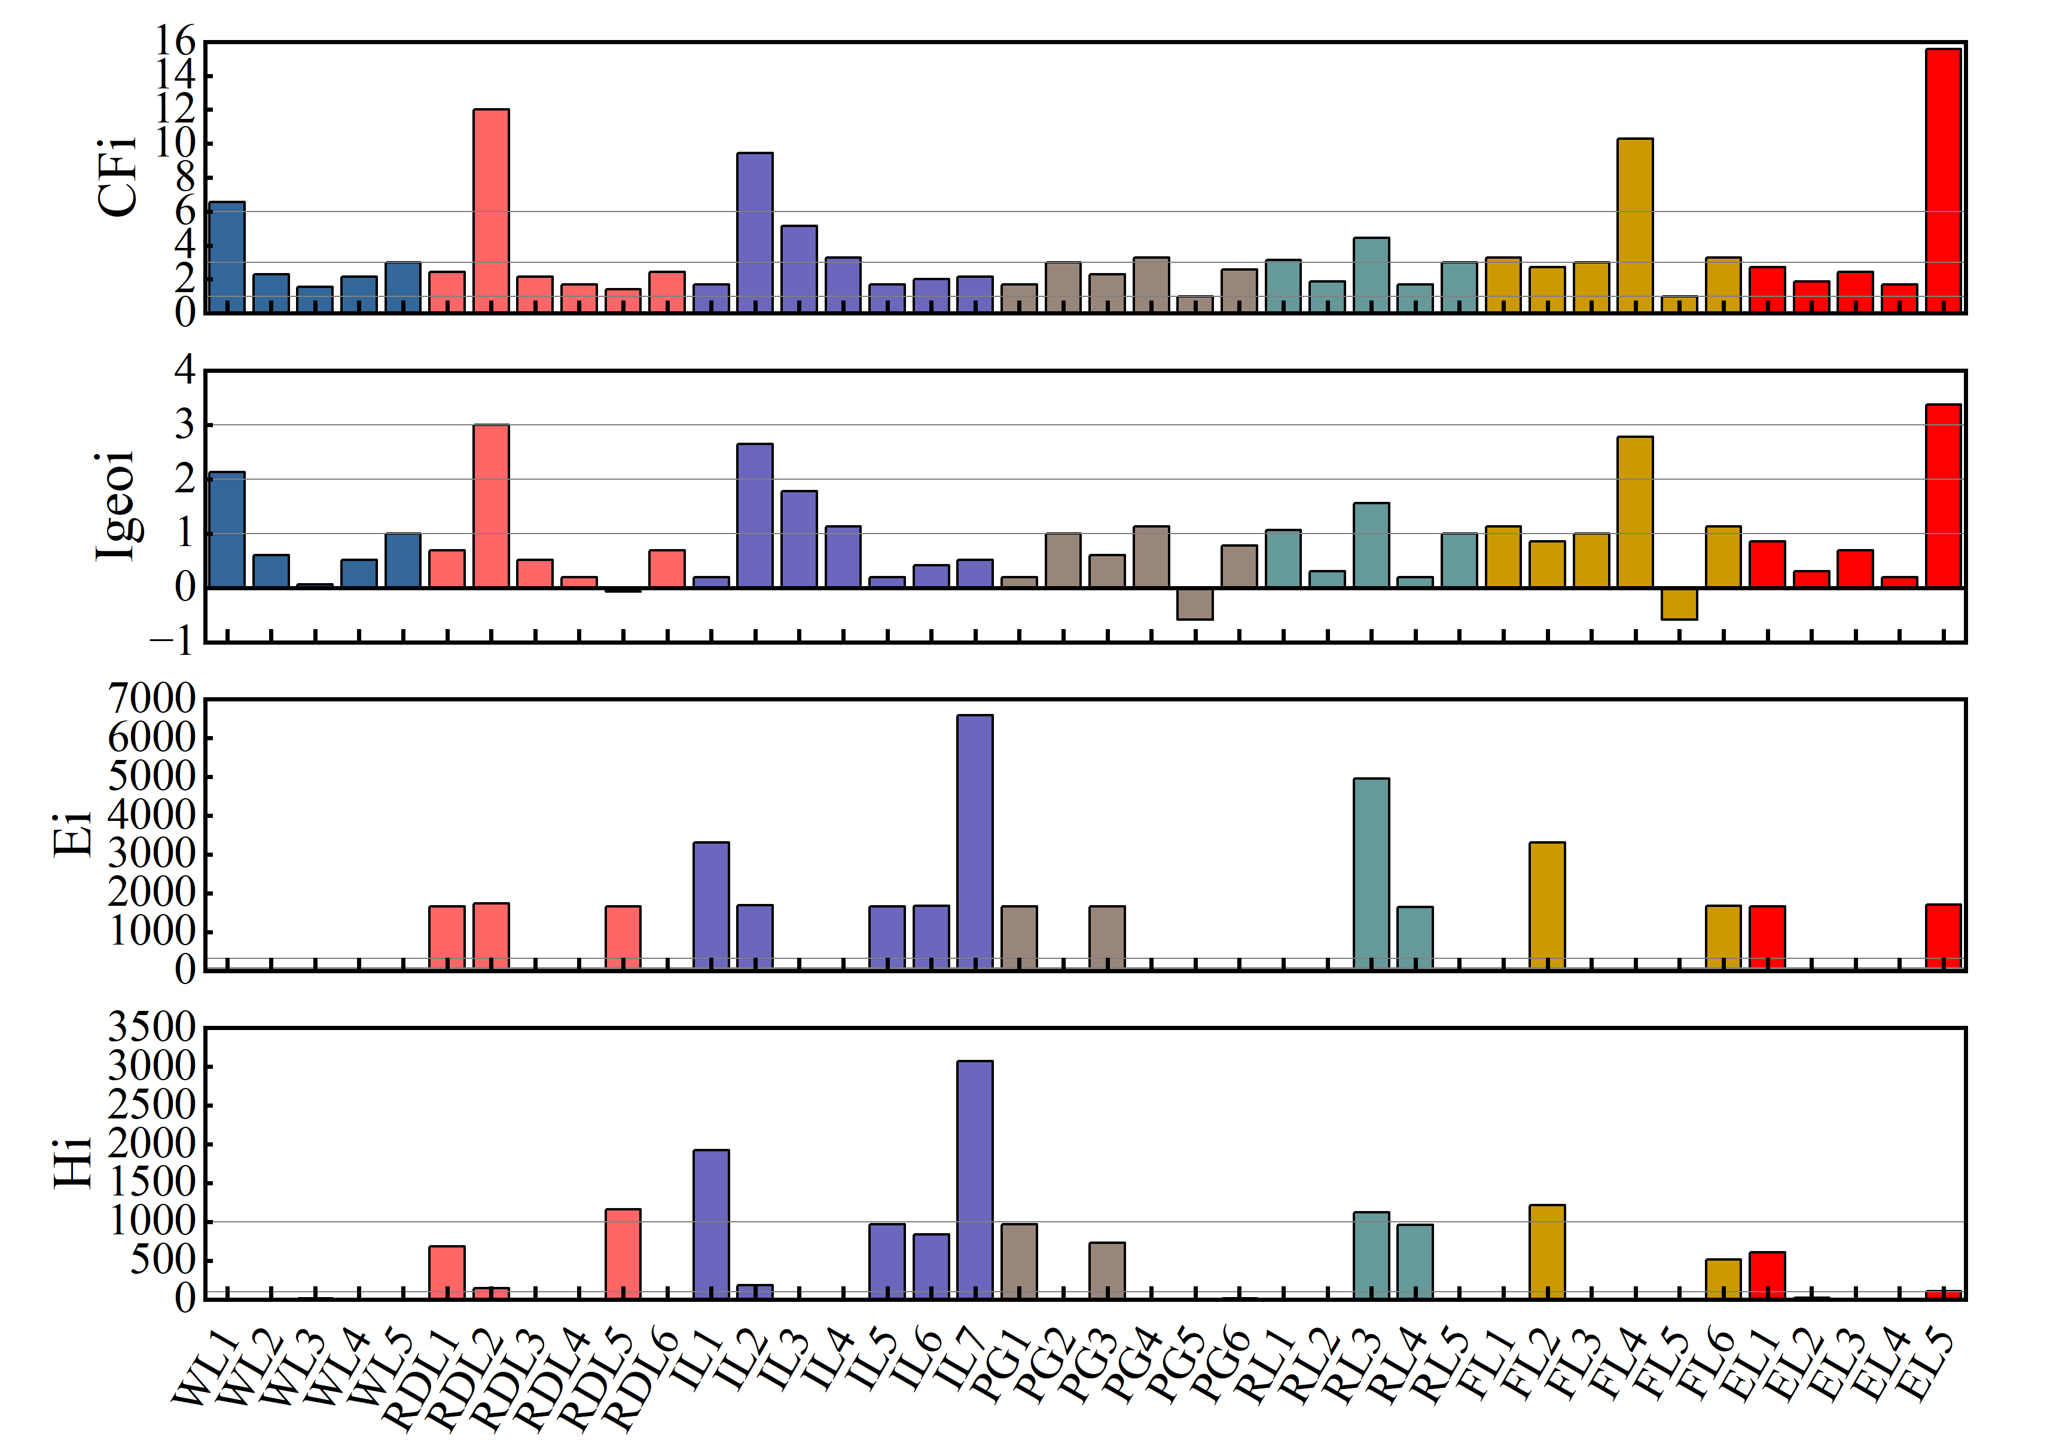
Fig. S2 Values of pollution and risk index at each sampling point

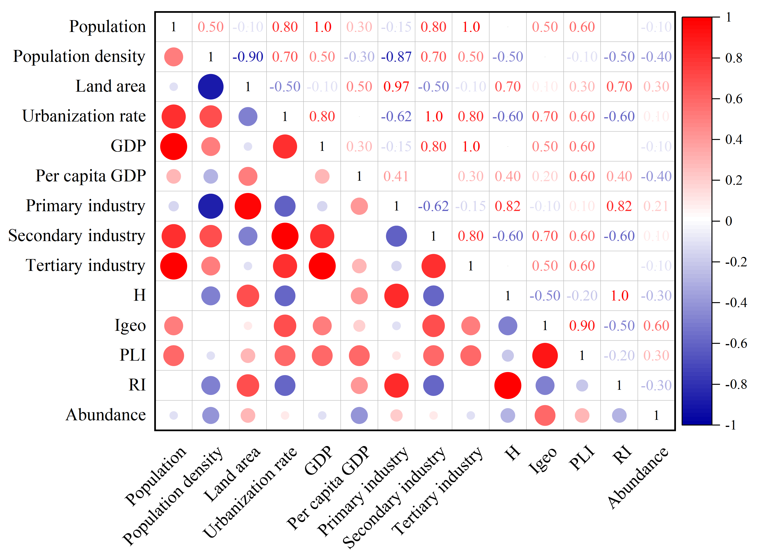Fig. S3 Heat map of correlation between socioeconomic factors and microplastics risk index

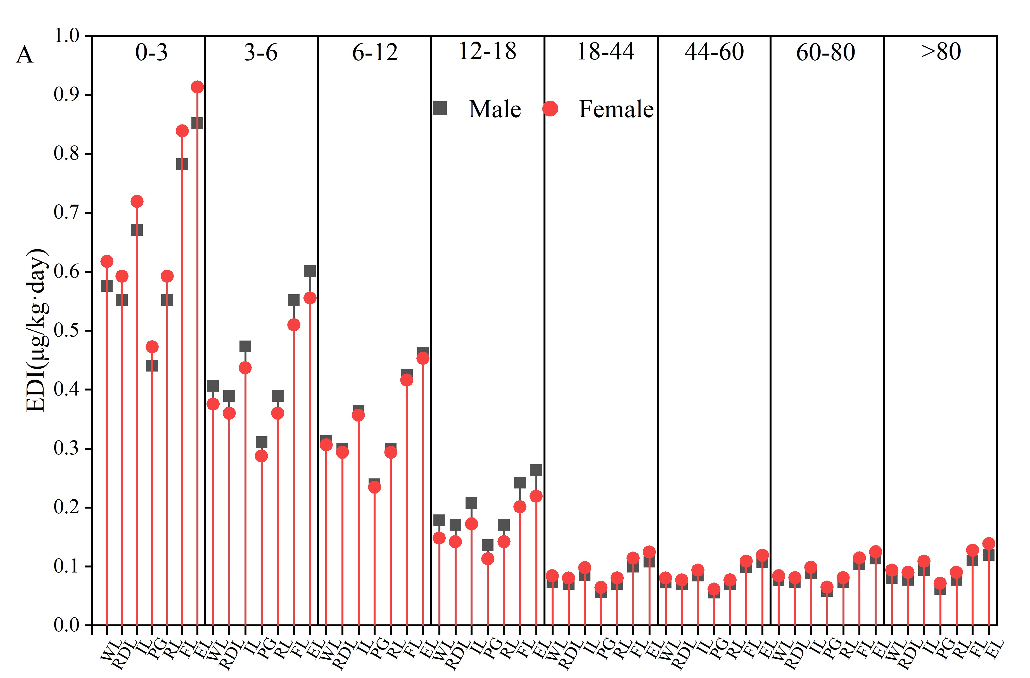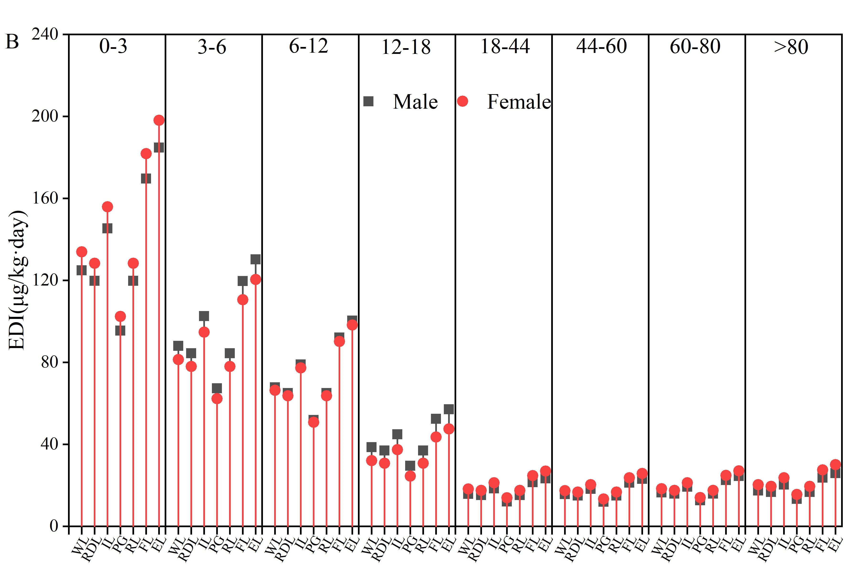

Fig. S4 Daily intake of MPs of different genders in different age groups under land use types (A: 0-1mm, B: 1-5mm)

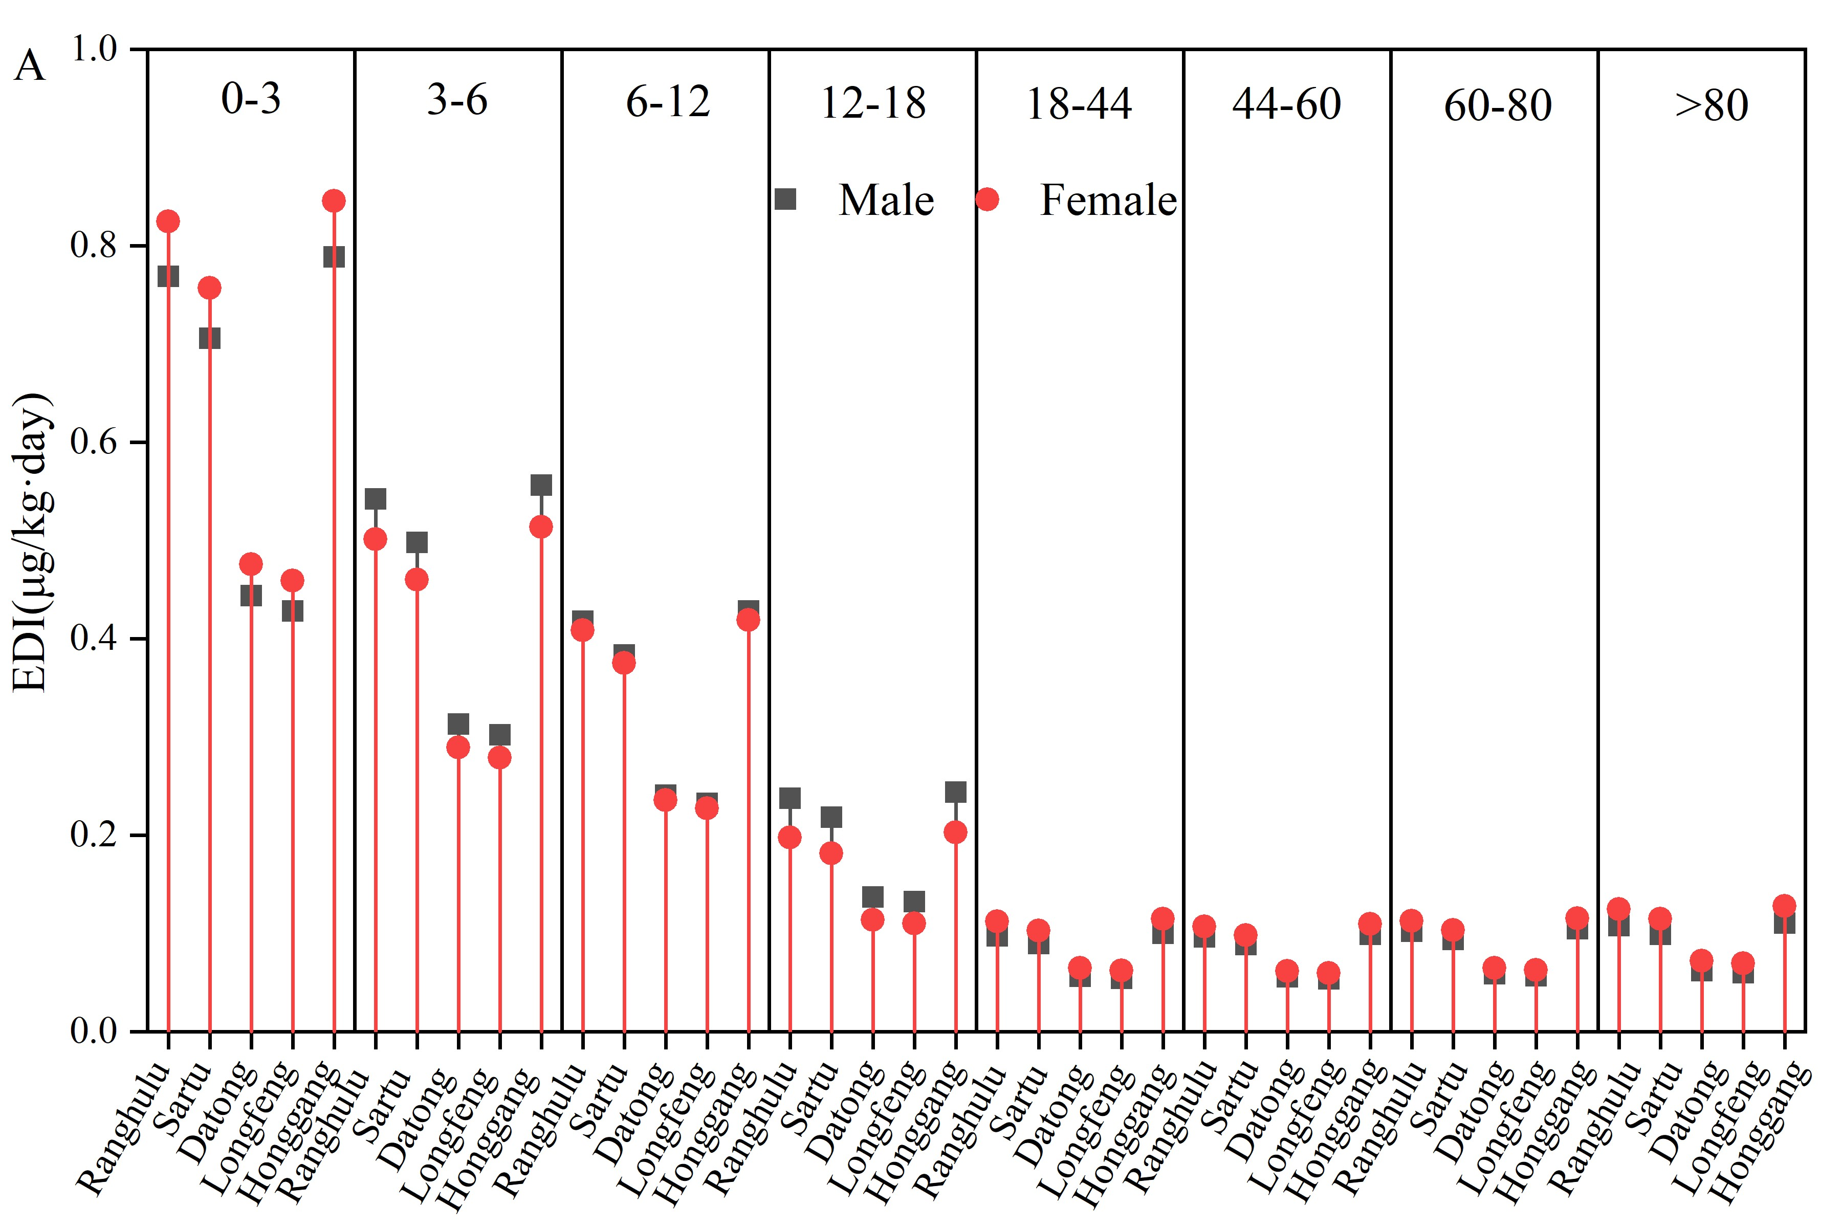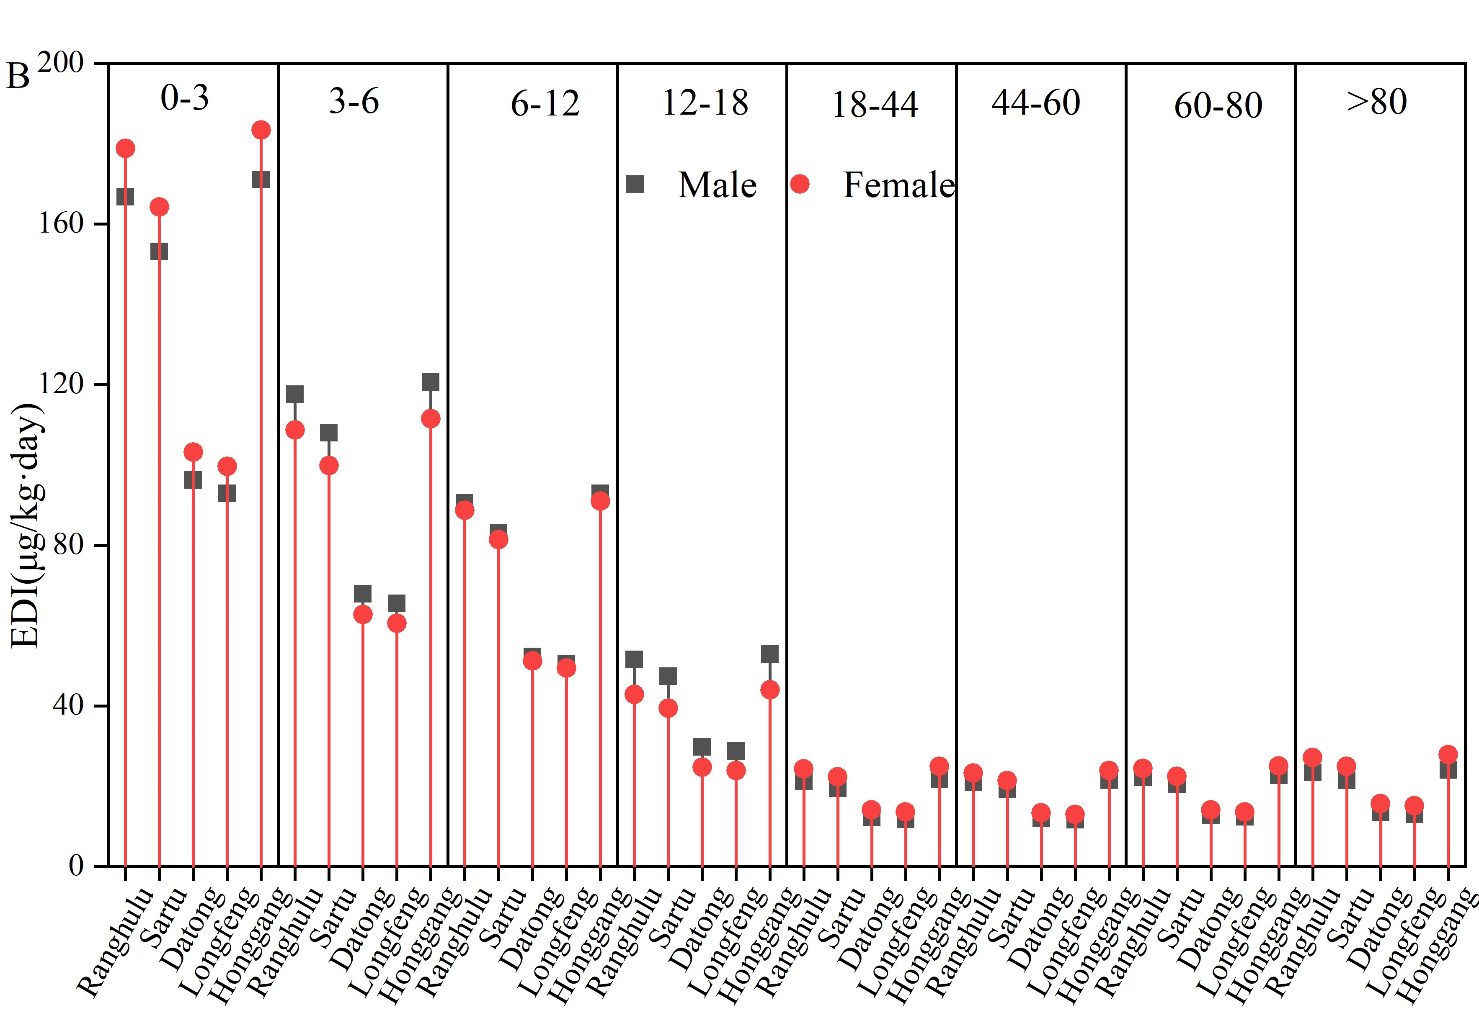

Fig. S5 Daily average intake of MPs of different genders in different age groups under administrative regions (A: 0-1mm, B: 1-5mm)

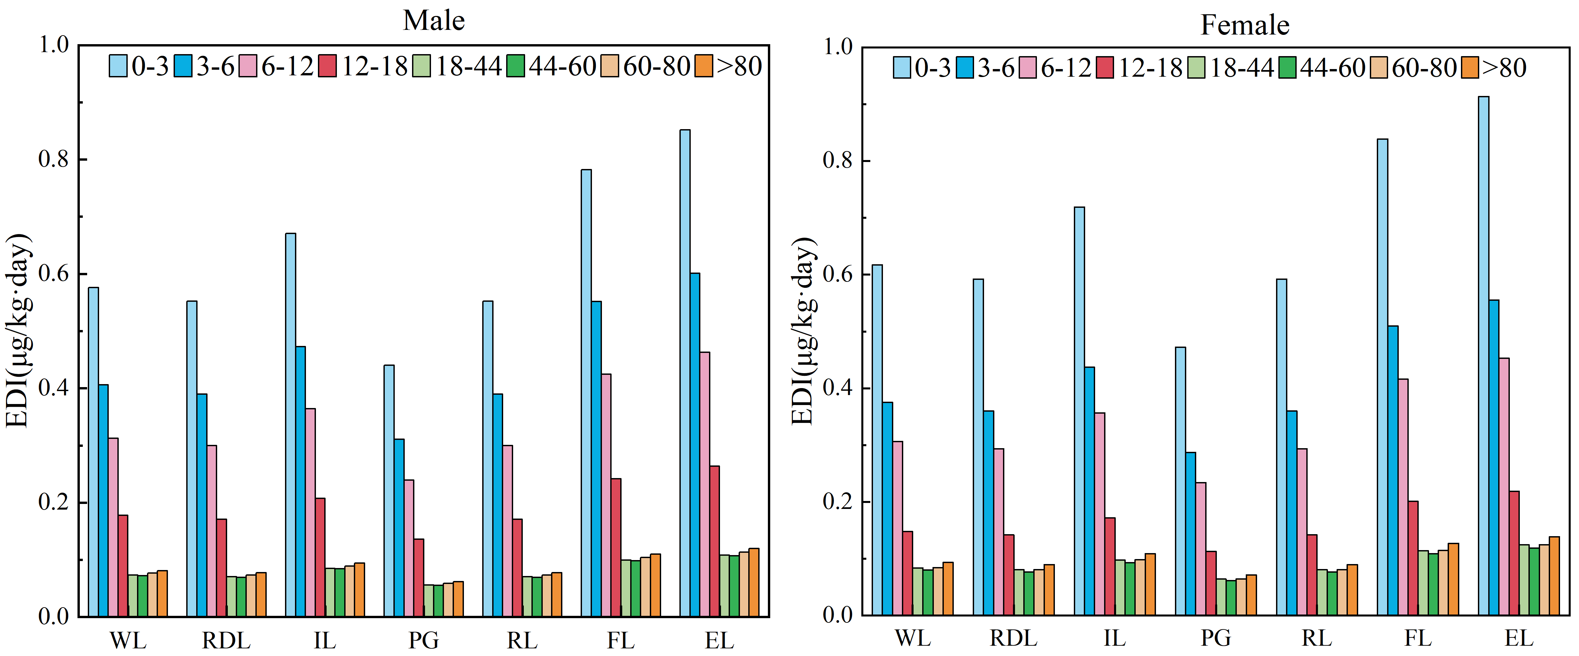
Fig. S6 Comparison of EDI values of different age groups under different land use types (0-1mm)

