Supplementary Information
Femto-joule threshold reconfigurable all-optical nonlinear activators for picosecond spiking neural networks
Ruizhe Liu^{1,†}, Zijia Wang^{1,†}, Chuyu Zhong^{1,†}, Yan Chen^{1,3,†}, Boshu Sun^{2,3}, Jialing Jian^{2,3}, Hui Ma¹, Dawei Gao⁴, Jianyi Yang¹, Lan Li^{2,3, 6,*}, Kaihui Liu^{5,*}, Xiaoyong Hu^{5,*}, Hongtao Lin^{1,*}
¹ The State Key Lab of Brain-Machine Intelligence, Key Laboratory of Micro-Nano Electronics and Smart System of Zhejiang Province, College of Information Science and Electronic Engineering, Zhejiang University, Hangzhou 310027, China
² Zhejiang Key Laboratory of 3D Micro/Nano Fabrication and Characterization, School of Engineering, Westlake University, Hangzhou, Zhejiang 310030, China
³Zhejiang Key Laboratory of 3D Micro/Nano Fabrication and Characterization, Westlake Institute for Optoelectronics, Fuyang, Hangzhou, Zhejiang 311421, China
⁴College of Integrated Circuits, Zhejiang University, Hangzhou 310027, China
⁵State Key Laboratory for Mesoscopic Physics, Frontiers Science Center for Nano-optoelectronics, School of Physics, Peking University, Beijing 100871, China
⁶Institute of Advanced Technology, Westlake Institute for Advanced Study, Hangzhou, Zhejiang 310024, China

This Supplementary Information comprises the following sections:
Section I - Performance estimation of the on-chip picosecond spiking optical neural network
Section Ⅱ - Measurement setups
Section III - Design of the transmittance of photonic crystal cavity devices
Section Ⅳ- Optical resonant cavity model of a silicon all-optical nonlinear activation function device
Section Ⅴ - Fabrication process flow, morphology of our devices and material properties of the graphene
Section VI - Details of the reconfiguration of the graphene-silicon device
Section Ⅶ - Details of the picosecond pulse optical fully connected neural network architecture
Section Ⅷ - Details of the optical activation functions
Section Ⅸ - Details of the optical neural network and datasets
Section X - Results comparison of the networks using different activation functions
Section Ⅺ - Computational efficiency estimation of the ONN architecture in MINST datasets
Section Ⅰ - Performance estimation of the on-chip picosecond spiking optical neural network
In this section, we theoretically develop the performance of our ONN architecture. The picosecond spiking ONN is combined with multiple single neurons, which consists of two inverse design WDMs, sixteen nonvolatile PCM integrated waveguides, and one nonlinear activation function device in a 30×25 μm² area. Thus, a single optical neuron can perform 16 weight operations and one nonlinear activation. Under the assumption that our picosecond spiking optical neural network has a 100 GHz clock rate and 16 wavelengths, it can operate on the signal at a speed of 1.6 Tops. Consequently, the computing power density of our single optical neuron can be given as 1.6 Tops/(30×25 μm²), which equals 2.13×10³ Tops/mm².
Furthermore, owing to the near-zero power consumption in the linear weighting operation by the nonvolatile phase change materials, assuming that the insert loss could be neglected by optimizing device design and manufacturing, the energy consumption almost hinges on ANA, which could achieve an ultralow threshold power at 10 fJ. Thus, a single neuron needs at least a 10-fJ energy pulse as the activation pump light and another 10-fJ light pulse as the signal to be activated and transported to the next layer neuron. Owing to the 100 GHz clock rate, we can calculate the power consumption of the neuron as 10 fJ×100 GHz, which equals 10⁻⁻³ W. Thus, the ultimate computing power energy efficiency density of a single neuron can be evaluated as 2.13×10⁶ Tops/W/mm².

Section Ⅱ - Measurement setups
The characterization setup is shown in detail in Fig. S1. The femtosecond pulse source at a central wavelength of 1550 nm is shipped with the FLS1950F-CUSTOM laser (pulse width: ∼100 fs, repetition rate: 50 MHz) and amplified with EDFA100P. The continuous wavelength source at a central wavelength of 1550 nm was an Agilent 8164A measurement system. Fig. S1. (a) shows the transmission spectrum and saturable absorption measurement system, where the power of incident and outgoing waves is measured by means of two optical power meters (PMs), and then the transmission of the device $T=\frac{P_{out}}{P_{in}}$ is determined, resulting in the experimental nonlinear transmission curve as a function of input power, as shown in Fig. S1. (c) shows. More specifically, we first obtain the grating coupling efficiency $η$ from the spectrum of the reference device by 10log ($η^{2}$)=dB, and DAQ provides a voltage to control the change in VOA, modulating $P_{in}$, where $P_{in}=PM1*η$. Additionally, $P_{out}=\frac{PM2}{η}$.
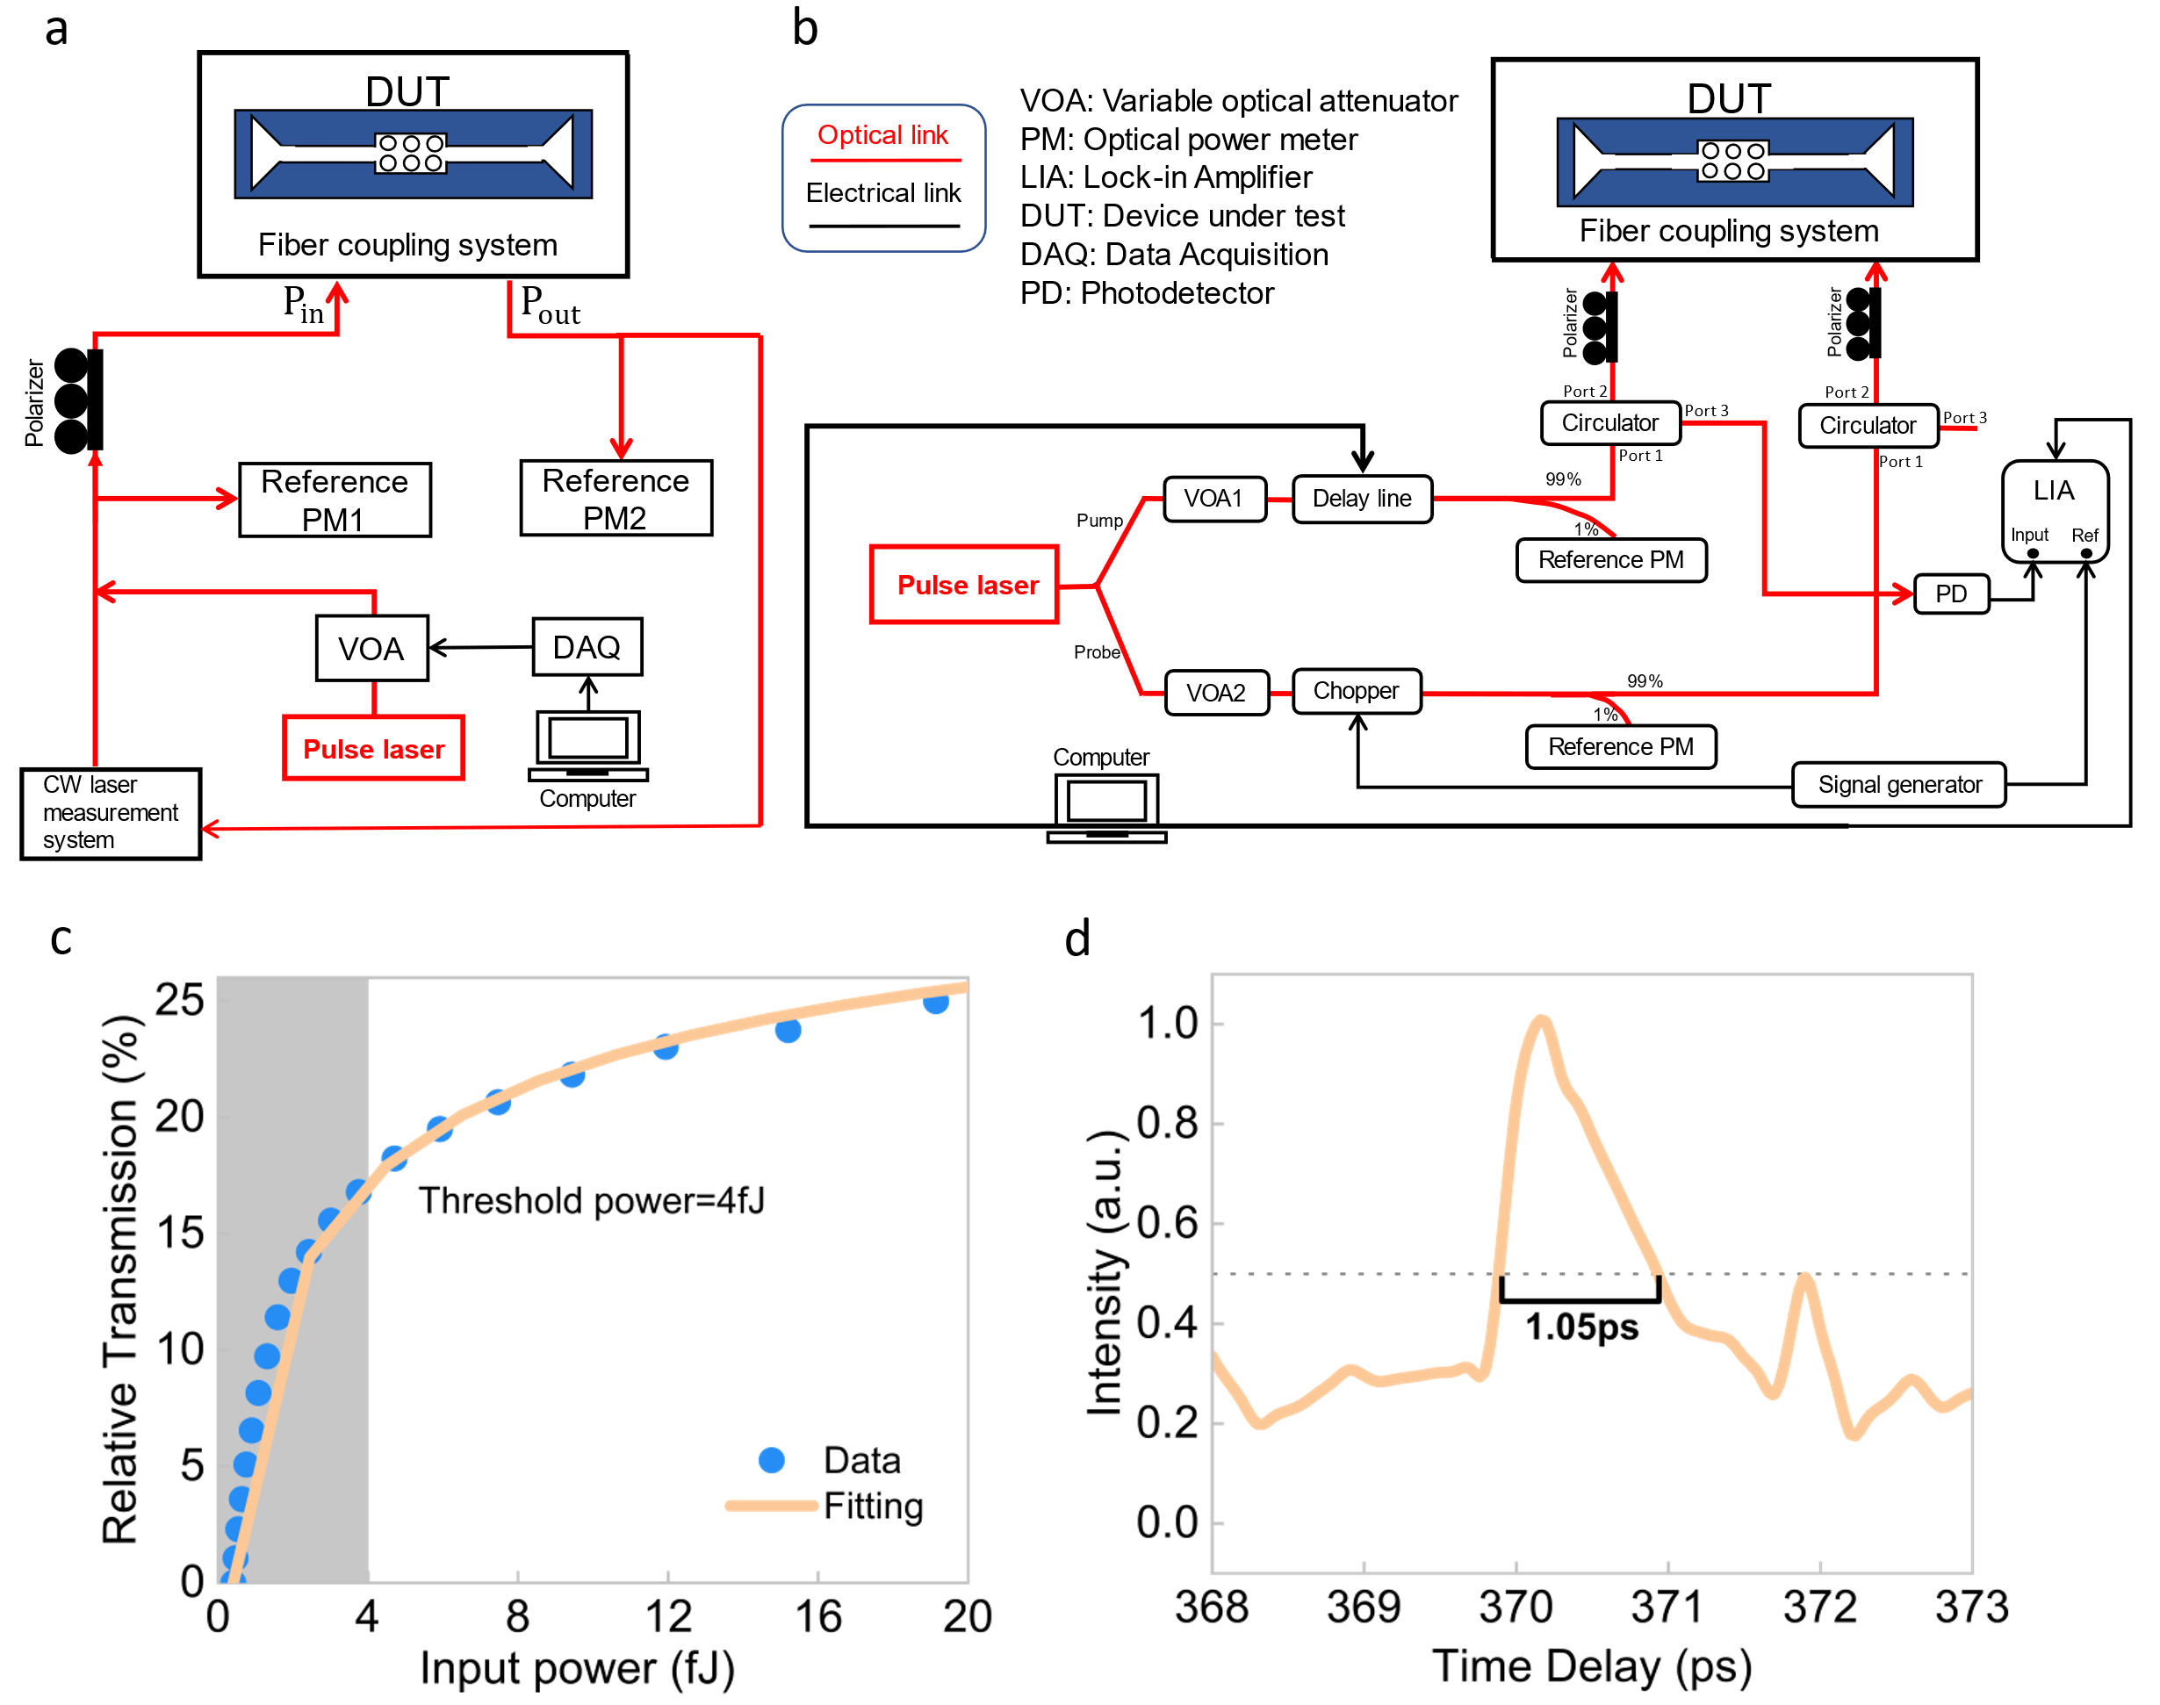
Fig. S1. Schematic of our measurement setup. (a) Schematic of the saturable absorption measurement system. (b) Schematic of the pump-probe measurement system. The 1550 nm femtosecond laser is divided into two paths (pump light and probe light). VOA: Variable optical attenuator, PM: Optical power meter, DUT: device under test. (c) Example of saturable absorption measurement. (d) Example of a pump-probe measurement.
We also explore devices with the pump-probe measurement setup shown in Fig. S1. (b). The femtosecond laser is divided into two paths (pump light and probe light). The pump light is modulated by a time delay line, which supplies a strong signal for exciting electrons and causes the photobleaching effect in graphene, whereas the probe light is weak, which is modulated by a chopper to be easily detected by a lock-in amplifier. Two signals illuminate the same area of the device with a time delay. If the time delay exceeds the relaxation time of the device, the excited electrons return to the valence band from the conduction band, and the probe light is subsequently absorbed by the graphene and changes the band structure. However, if it is within the relaxation time, the probe light will cross the band directly without exciting electrons, leading to enhanced transmission. The response time is obtained by fitting the peak read from the lock-in amplifier, as shown in Fig. S1. (d). To gain a deeper understanding of these properties at different wavelengths, a filter is added after the laser, converting femtosecond light sources into picosecond light sources with specific input bandwidth wavelengths.
Section III - Design of the transmittance of photonic crystal cavity devices
The parameter design and simulation of the transmittance of photonic crystal cavity devices are demonstrated in this section. We demonstrate two different kinds of photonic crystal devices, one of which is a silicon resonant cavity device^{1,} and the other is a graphene-silicon hybrid device. The silicon device’s photonic crystal has a period of 0.35 μm and a duty cycle of 0.34 and is arranged in a triangular lattice. The width of the line defect is 0.38 μm. Fig. S2 shows the normalized transmission spectrum of the PhC waveguide. Four resonance peaks are shown in the transmission spectrum.
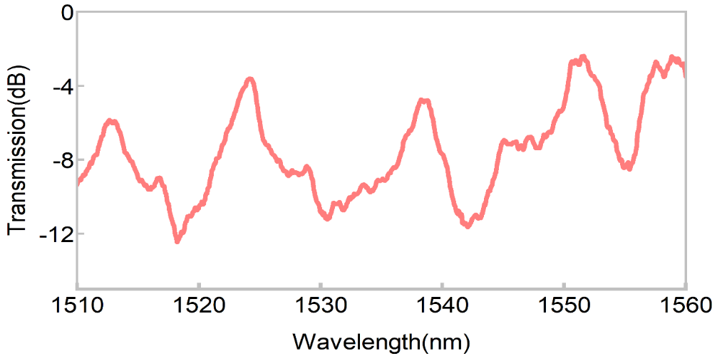
Fig. S2. Normalized transmission spectrum of PhC cavities: We designed specific resonant peaks to enhance the interaction between the pump light and our silicon photonic crystal cavities.

Section Ⅳ - Optical resonant cavity model of a silicon all-optical nonlinear activation function device
Here, we develop a simple analytical model of an optical resonant cavity to describe our nonlinear activation device. The repetition rate of our laser is labeled $f$, the pulse width is $τ$, and the energy of a single pulse is $E_{pulse}$. When our average input power is denoted as $P_{average}$, the peak input power is therefore:
$$\begin{aligned}P_{peak} = \frac{E_{pulse}}{τ}=\frac{P_{average}}{fτ}\#\left(S.1\right)\end{aligned}$$
Moreover, the shift in the probe resonance wavelength of our photonic crystal cavity follows classical cavity perturbation theory³:
$$\begin{aligned}∆λ_{kerr}=λ_{0}∙\frac{\int_{c}^{ }{ n_{2}\left(r\right){{\left|E_{0}\left(r\right)\right|}^{2}n\left(r\right)ε}_{0}{\left|E_{0}\left(r\right)\right|}^{2}dV}}{\int_{c}^{ }{ }ε_{c}{\left|E_{0}\left(r\right)\right|}^{2}dV}\#\left(S.2\right)\end{aligned}$$
where $r$ represents the position vector, $λ_{0}$ represents the probe resonant wavelength, $n$ corresponds to the refractive index, and $n_{2}$ represents the third-order nonlinear coefficient of the cavity material. $ε_{0}$ is the vacuum permittivity, and $ε_{c}$ is the spatially dependent cavity dielectric constant distribution. $E_{0}$ is the electric field complex amplitude of the cavity mode.
Additionally, when we assume that the photonic crystal resonant cavity has a quality factor $Q$, the total energy stored in the cavity that inputs the cavity is given by⁴:
$$\begin{aligned}W=\frac{ε_{0}}{2}\int_{c}^{ }{ ε_{c}{\left|E_{0}\right|}^{2}dV=\frac{QP_{peak}}{2ω}}\int_{c}^{ }{ ε_{c}{\left|E_{N}\right|}^{2}dV}\#\left(S.3\right)\end{aligned}$$
where $P_{peak}$ is the pump pulse peak power coupled into the cavity, $ω$ is the angular frequency of the pump light, and $E_{N}$ represents the dimensionless eigenmode of the photonic crystal cavity, which is normalized so that $\int_{c}^{ }{{\left|E_{N}\right|}^{2}dV}=1$, where the integration is carried out through the whole cavity. When the pump light is coupled into the cavity, the total energy can be calculated as the power being magnified Q times.
The next part is concerned with the Kerr optic resonance detuning of our cavity. According to cavity perturbation theory, considering the optic resonance detuning corresponding to the refractive index shift caused by the Kerr effect, a simplified expression can be correlated with the waveguide effective index change and group index, which can be calculated as^{3,5}:
$$\begin{aligned}∆λ=\frac{∆n_{eff}}{n_{g}}∙λ_{0}.\#\left(S.4\right)\end{aligned}$$
where $∆n_{eff}$ denotes the waveguide effective index change due to the change in the material index caused by the Kerr effect and where $n_{g}$ denotes the model group index. According to the definition of the third-order nonlinear refractive index⁶:
$$∆n=n_{2}{\left|E_{0}\right|}^{2}$$
We can determine the effective index change of our cavity, which is influenced by the electric field in the cavity, as follows:
$$\begin{aligned}∆n_{eff}=\sum_{j}{{n_{2}}_{j}{{\left|E_{0}\right|}^{2}}_{j}Γ_{j}}={n_{2}}_{eff}∙QP_{peak}∙n_{g}\#\left(S.6\right)\end{aligned}$$
where $j$ denotes different parts of the waveguide, $Γ$ represents the confinement factor of the waveguide⁷, and ${n_{2}}_{eff}$ is the effective third-order nonlinear coefficient of the waveguide calculated by combining the weighted average of the third-order nonlinear coefficients of the waveguide material and Eq. S.3:
$$\begin{aligned}{n_{2}}_{eff}∙QP_{peak}=\sum_{j}{{n_{2}}_{j}∙\frac{γ_{j}}{n_{j}}∙{{\left|E_{0}\right|}^{2}}_{j}}\#\left(S.7\right)\end{aligned}$$
where $γ$ represents the spatial confinement of energy density⁷.
Finally, we can derive a simplified equation that depicts the resonance detuning of the cavity:
$$∆λ=\frac{∆n_{eff}}{n_{g}}∙λ_{0}={n_{2}}_{eff}∙QP_{peak}∙λ_{0}$$

Section Ⅴ - Fabrication process flow, morphology of our devices and material properties of the graphene
Device fabrication was based on the SOI platform. Our devices were fabricated on an SOI wafer with a 220 nm thick device layer and a 2 µm thick SiO2 box layer. The main steps are illustrated in Fig. S3. First, the photonic crystal line defect waveguide structures were patterned via electron beam lithography (EBL) and etched via an inductive coupling plasma (ICP) process to a full depth of 220 nm (steps ⅰ-ⅳ). Second, the CVD graphene on the copper substrate was transferred onto the devices via the wet-transfer method² (step ⅴ). The loaded graphene was then patterned via EBL, and the unwanted part was etched via oxygen plasma (steps ⅵ-ⅷ). Finally, a graphene‒silicon hybrid device was fabricated.
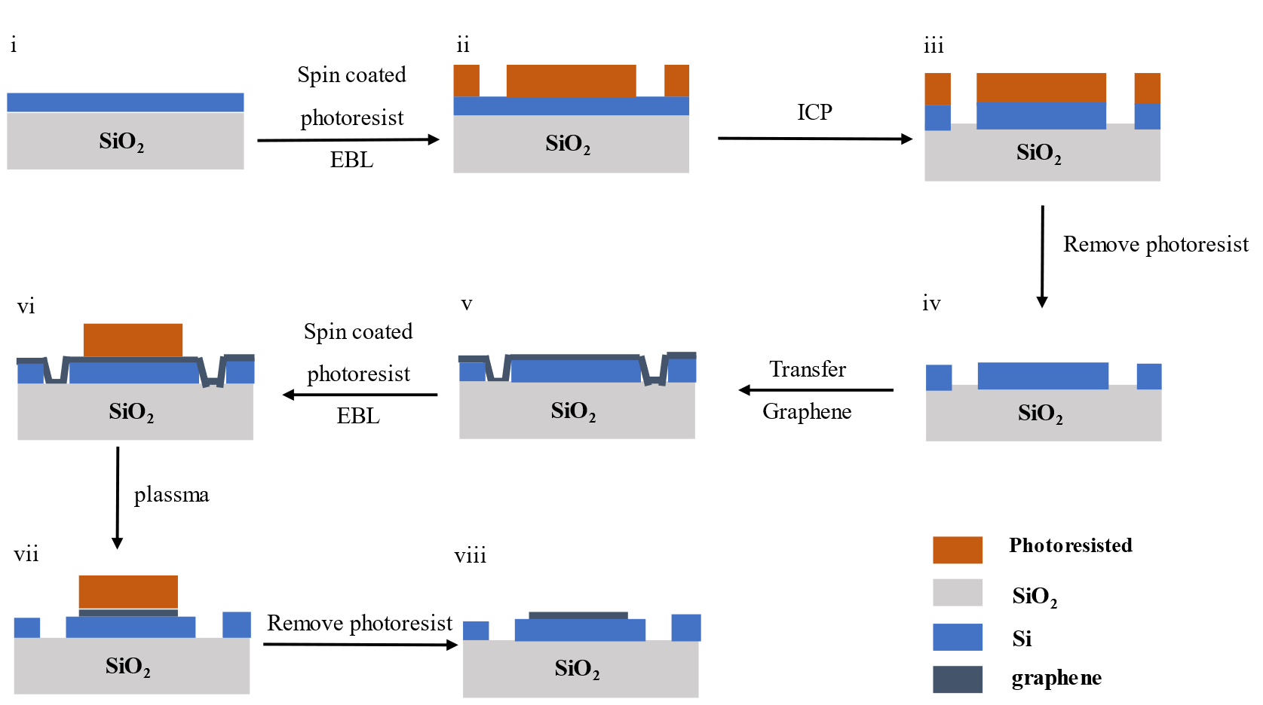
Fig. S3. Fabrication process flow. i: original sample, ii-iv: waveguide fabrication, v: graphene transfer, vi-vii: graphene pattern, viii: final device after graphene patterning.

The material properties of the graphene samples used in our devices were characterized and demonstrated in this section. We performed Hall effect measurements (Ecopia HMS-5000) and Raman spectroscopy (Witec alpha300R). Graphene transferred to 300 nm thick silicon dioxide substrates and graphene on devices with photoresist cladding were characterized.
We used the van der Pauw method to perform Hall effect measurements under a magnetic field intensity of 0.535 T. The electric properties of the graphene on the silicon dioxide substrate are listed in Table S1. Low resistivity and high mobility were obtained. The sign of the sheet concentration indicates p-type doping of our sample.

Table S1. Electrical properties of the graphene.
Sheet Concentration  (cm⁻³) | Sheet Resistance  (Ω/□) | Resistivity  (Ω·cm) | Conductivity  (S·cm) | Mobility  (cm²/Vs)
4.933×10¹² | 1.1459×10³ | 1.1459×10⁻⁴ | 8.7271×10³ | 1.1043×10³

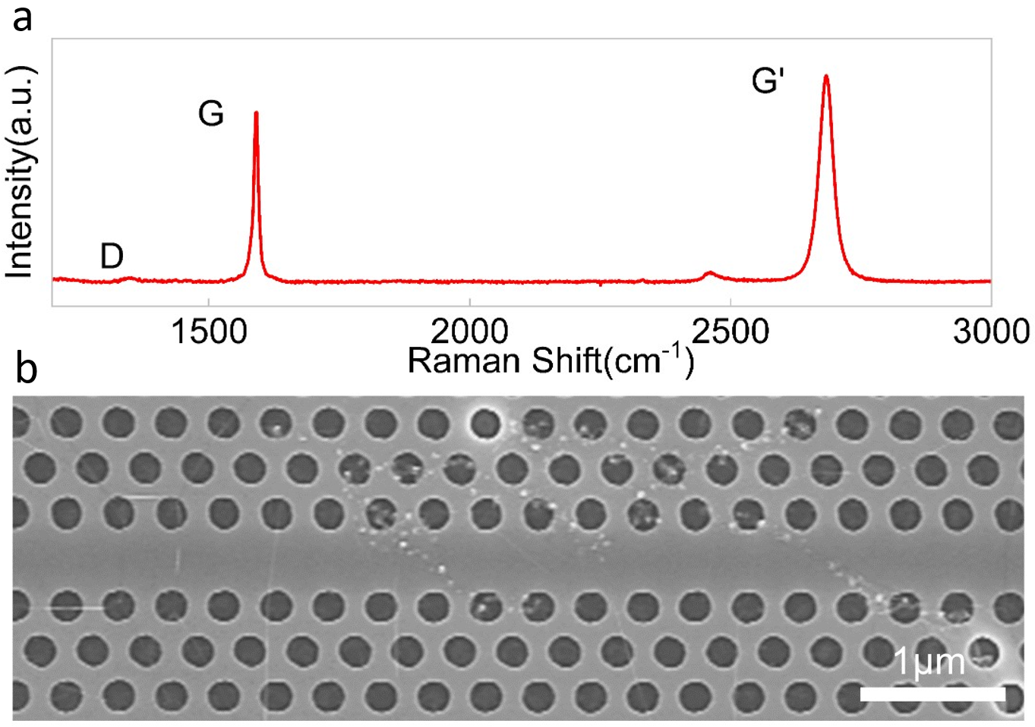
Fig. S4. Material properties of the graphene and morphology of the devices. (a) Raman spectra of graphene samples on the silicon oxide substrate, where different peaks are indicated. (b) SEM image of the device with graphene.

As Fig. S4. (a) shows that the intensities of the D peaks are very low, indicating that our graphene samples have few defects. In addition, the shape of the 2D peak is the most effective way to identify a single layer, indicating that our sample has only one layer. Here, we illustrate the morphology of our device shown in Fig. S4. (b). Clearly, graphene covers the photonic crystal and line defects on the device surface.

Section Ⅵ - Details of the reconfiguration of the graphene-silicon device
We measured the optical response of the graphene PhC device at different wavelengths. Taking advantage of silicon Kerr third-order nonlinearity effects, as discussed above, the nonlinear response of the graphene PhC device can be reconfigured. When a wavelength near 1520 nm is selected on the basis of the spectrum, the device exhibits a downward-type activation function. The transmittance at 1522.5 nm gradually decreases with the redshift of the transmission spectrum, forming a downward-type activation function. When a wavelength near 1534 nm is selected, the device is reconfigured into an upward-type activation function. This is because the transmittance at 1534 nm is relatively stable, with a gradual redshift in the transmission spectrum, leading to a minimal impact on the transmittance from the redshift of the transmission spectrum after pulse light is injected. This indicates that the saturable absorption of graphene remains the primary influencing factor, resulting in an upward-type activation function. When a wavelength near 1541 nm is selected, the device is reconfigured into a ReLU-type activation function. This is because the transmittance at 1541 nm first gradually decreases and then counteracts the increasing trend of saturable absorption. After reaching the minimum value, it gradually increases and superimposes with the upward trend of saturable absorption, forming a ReLU-type activation function. Pump-probe measurements of the response speed of various activation functions were also conducted, with full width at half maximum response times of 4.38 ps, 4.03 ps, and 4.32 ps for the three activation functions.
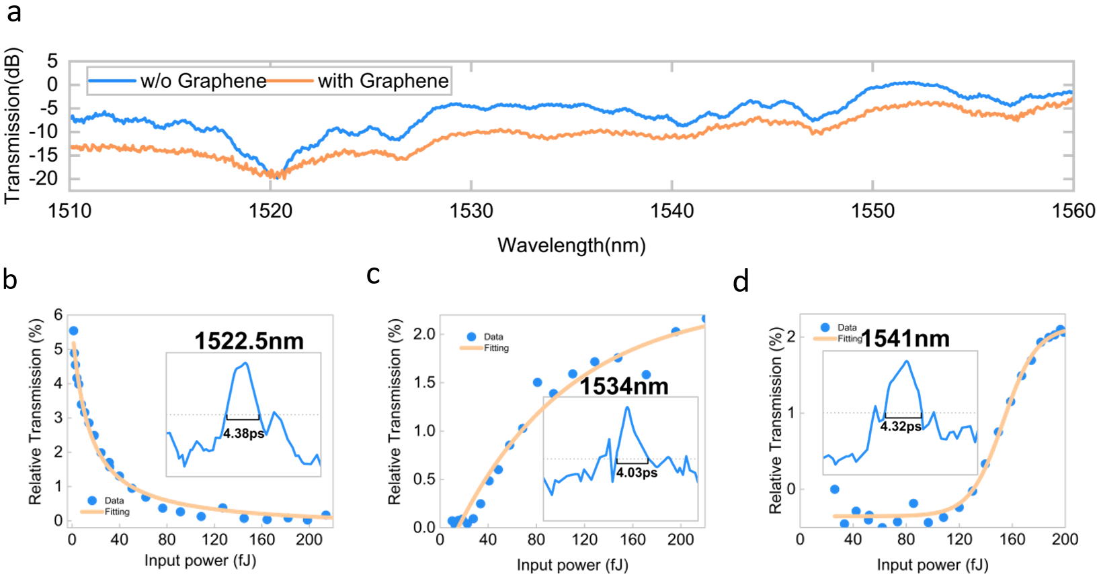
Fig. S5. Supplementary properties and performance of the graphene-silicon integrated NAF device. (a) Normalized transmission spectra of a PhC ANA without graphene (blue curve) and with graphene (orange curve). (b)-(d) Reconfiguration activation functions at different wavelengths. The inset shows the time delay measurement for the response time at different wavelengths.

Section Ⅶ - Details of the picosecond pulse optical fully connected neural network architecture
The entire fully connected binary classification optical neural network consists of a 4-channel signal loading layer, three 4×4 fully connected layers with picosecond-response nonlinear activation capability, and an output layer, as shown in Fig. S6. First, a picosecond light source is generated by a femtosecond laser in the four-channel signal loading layer and then coupled into the on-chip system. The pulses are next split into four beams with different wavelengths through an ID-WDM device and then encoded by four high-speed modulators. Then, the pulses are combined through an ID-WDM into a waveguide and sent to the next 4×4 fully connected layer. In the next layer, the pulses are distributed to four different neurons for processing. Each neuron is divided into synapses and activations. The pulses are sent to the ID-WDM and split into different wavelengths, weighted differently and finally combined into one channel. Next, the pulses pass through an ANA, and new pulses are nonlinearly activated to be combined with other neurons’ output pulses through an ID-WDM. The pulses are transmitted to the next fully connected layer of the network. After three fully connected layers, the pulses are sent to the output layer for the last weight operations and activations and then sent directly to a high-speed detector for signal output.
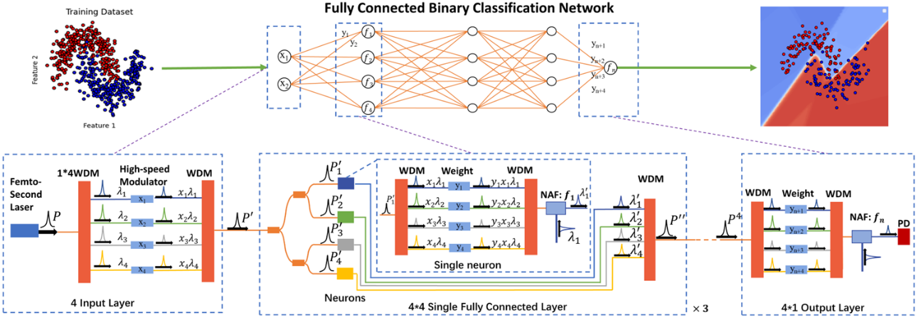
Fig. S6. General block diagram of a fully connected binary classification optical neural network, which consists of a 4-channel signal loading layer, three 4×4 fully connected layers with picosecond-response nonlinear activation capability, and an output layer.
Section Ⅷ - Details of the optical activation functions
According to the network structure and device that have already been constructed, it is necessary to generate a nonlinear activation function with the reconfigurable silicon-graphene ANA.
First, the nonlinear response generated by our ANA is fitted into an NAF curve through a linear fitting method. For the activation functions, as the data come in discrete points that are not continuous, an interpolation has to be made to allow for network training. However, the points are more than necessary to obtain a well-fit interpolated piecewise function, and a piecewise function with too many points slows neural network training by a significant portion; thus, some optimization is needed. As cubic spline interpolation was unable to adequately capture the trend of points, we adopted a linear interpolation method to fit the curve. This decision, while unconventional, was made with the understanding that linear interpolation would result in a fitted curve that is not differentiable everywhere. However, the experimental results (in Section X) demonstrated that this approach had minimal impact on the model's backpropagation process. Remarkably, the model incorporating the linearly interpolated activation function still exhibited excellent classification performance. Consequently, we retained this method for function fitting.
The fitted curves were subsequently processed, including normalization and zero-point adjustment. Normalizing and adjusting the zero point of the fitted curve are performed to make its characteristics more similar to those of classic activation functions, such as ReLU or sigmoid. This process helps improve the model's performance and stability. The normalization operation scales the output range of the curve to a standard interval to help prevent the explosion or vanishing of activation values, thereby increasing the stability of network training. Zero-point adjustment can help the network better handle positive and negative inputs and produce ReLU-type or sigmoid-type sparse activation characteristics near x=0. Through these processes, our custom activation function can maintain its unique nonlinear characteristics while also possessing some advantageous features of classic activation functions, thus performing better in neural networks. The expressions of the five optical activation functions are shown below.
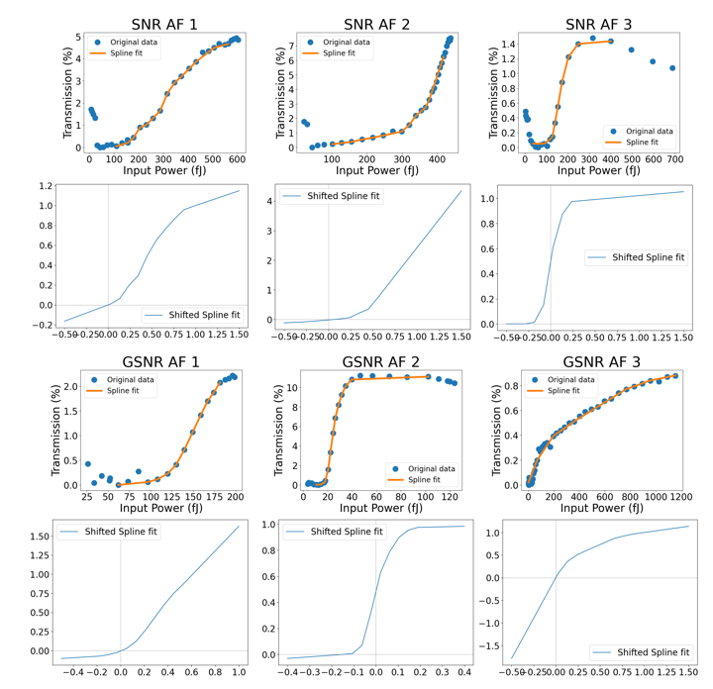
Fig. S7. Original data and fitted and calibrated curves for reconfigurable silicon/silicon-graphene ANAs. For each subplot, the blue dots represent the original data points; the red dashed lines represent the fitted curves; and the green solid lines represent the calibrated curves after normalization and zero-point adjustment.

Section Ⅸ - Details of the optical neural network and datasets
In this work, a total of 5 datasets and 3 network architectures are employed, as depicted in Fig. S8, to investigate the efficacy of activation functions when facing different tasks and models. Among these, 3 binary classification datasets are generated utilizing the make-moons, make-circles, and make-classification functions from the sklearn library. Each of these datasets is classified by the fully connected network, and the architecture is depicted in Fig. S8. (a). The MNIST dataset is classified by the convolutional neural network (CNN), as illustrated in Fig. S8. (b). The CIFAR-10 dataset is classified by the residual network (ResNet), as illustrated in Fig. S8. (c). Furthermore, in acknowledging the transmission constraints inherent to optical neural networks, we have constrained the floating-point numbers to a precision of four decimal places.

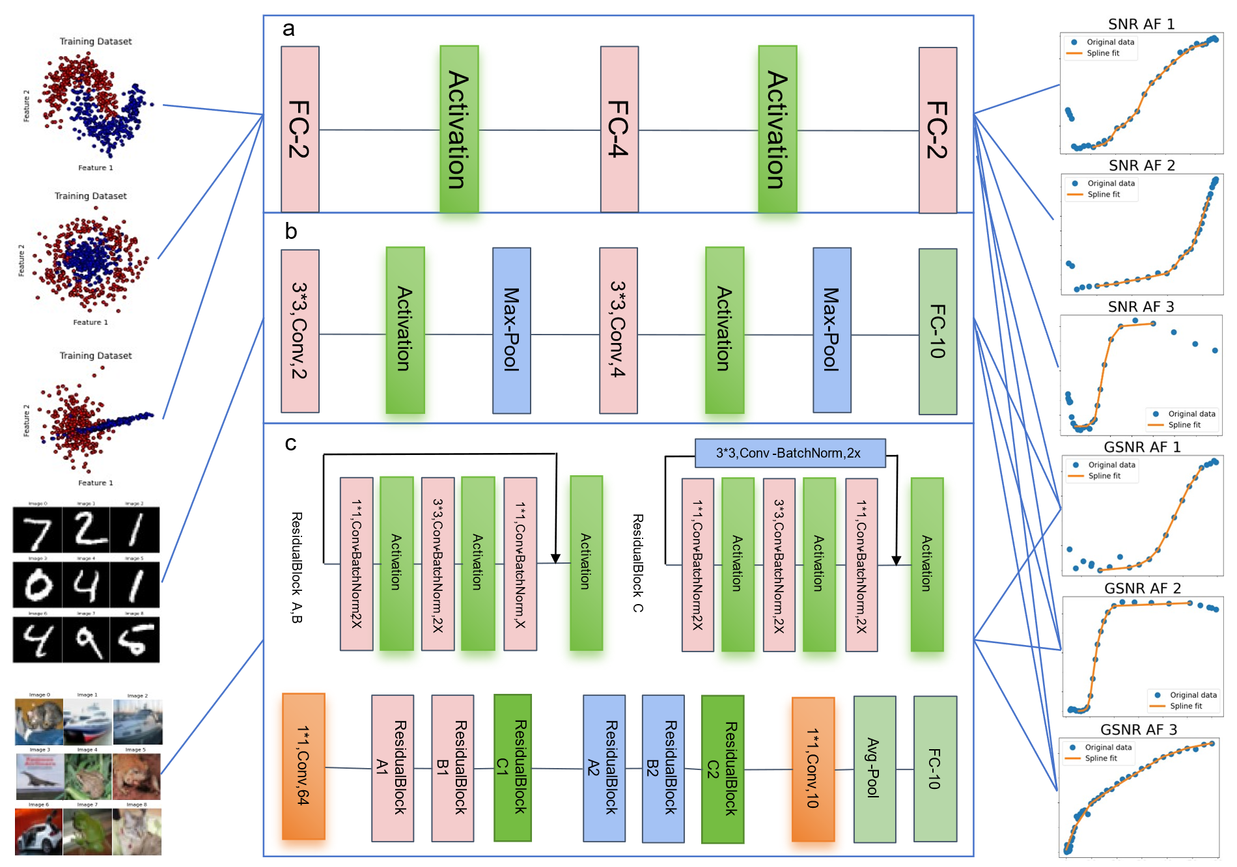
Fig. S8. Architectures of the models with their respective datasets and activation functions. (a) Binary classification datasets classified by the fully connected network via silicon nonlinear response activation functions (SNRs AFs). (b) MNIST dataset classified by the CNN via graphene/silicon heterojunction nonlinear response activation functions (GSNR AFs). (c) CIFAR-10 dataset classified by ResNet via graphene/silicon heterojunction nonlinear response activation functions.

To evaluate the performance of different activation functions, we replace the activation function in the model accordingly. Initially, fitting the nonlinear responses generated by optical devices on the basis of experimentally collected data is essential. While several fitting techniques are available, such as linear fitting, polynomial fitting, and cubic spline fitting, this study opts for linear fitting due to the large number of data points used, aiming to approximate the nonlinear curves accurately. Moreover, to enhance convergence and improve performance during the training process, normalization was applied to the sampling points, and the relative reference point was adjusted. In practical applications within optical networks, this adjustment can be achieved by modulating the phase and amplitude of the light.
For the fully connected network used for binary classification, the proportions of the training, testing, and validation sets are 6:2:2, respectively. Training commences with a 0.01 learning rate, the Adam optimizer, the BCELoss function and the network trained on the entire dataset for 100 epochs. For the CNN utilized for the MNIST dataset, the training of the model started at a 0.001 learning rate, Adam optimizer, cross-entropy loss function and 100 batch size. The CNN trained for 10 epochs. For ResNet applied to the CIFAR-10 dataset, the training of the model started with a 0.001 learning rate, the Adam optimizer, the cross-entropy loss function and a 128 batch size. ResNet was trained for 10 epochs. Both the MNIST and CIFAR-10 datasets comprise ten classes with a standard class-balanced 40,000 training, 10,000 validation, and 10,000 test images. All the above models are trained on a single NVIDIA RTX 4090 GPU.

Section X - Results comparison of the networks using different activation functions
In this work, we involved five datasets and three networks, providing detailed experimental results. The extensive use of various datasets and network architectures to evaluate the performance of activation functions aims, on the one hand, to emphasize the wide applicability of activation functions generated by optical devices and, on the other hand, to highlight the importance of the reconfigurability of the devices. This implies that in practical optical neural networks, our devices are not only capable of accommodating multiple classification tasks but can also generate a variety of responses through the special design of the transmission spectra of silicon devices and the transfer of graphene materials, enhancing the practicality of the design.
Initially, we explored the impact of different activation functions on the classification results of binary datasets. To compare the effects of the activation functions, we included a network without any activation function and visualized all the results. As illustrated in Fig. S9, the classification effectiveness of the models integrated with the activation functions surpasses that of the model without any activation functions. This advantage seems to be due to the model's capacity to map learned complex target functions into high dimensions via nonlinear activation functions. Without the activation functions, the model can only linearly divide the datasets or even fail to converge (as shown on the far right side of Fig. S9). Different activation functions exhibit varying activation effects, thereby affecting the final model performance differently. For binary classification tasks, activation functions with a sigmoid-like shape exhibit better classification effectiveness; for more complex classification tasks, ReLU-type activation functions offer stronger capabilities to counteract gradient vanishing in deep models.
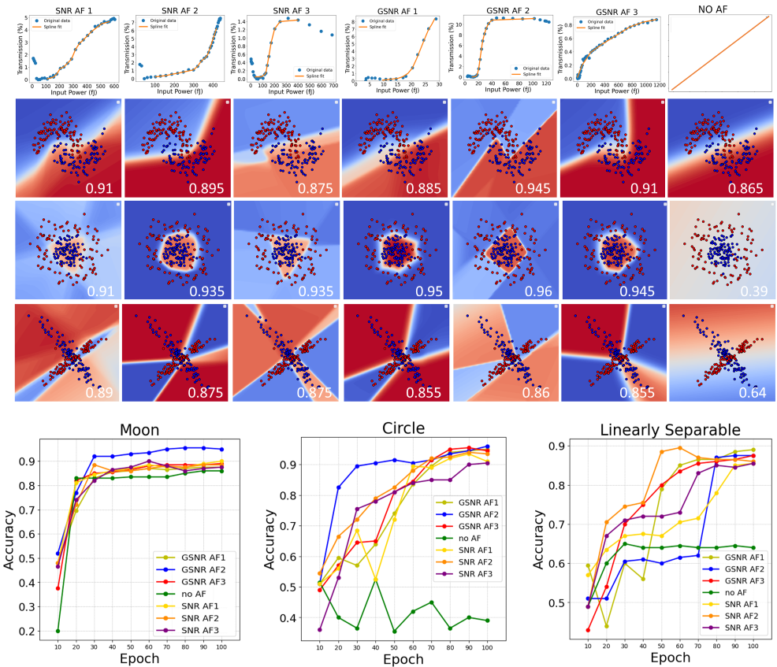
Fig. S9. Performance of NAFs on Three Binary Classification Datasets

For the two classic image datasets, MNIST and CIFAR-10, we compared the performances of the models using graphene-silicon integrated ANA nonlinear response activation functions (GSNR AFs). MNIST is a classic dataset used for validating the performance of optical neural networks (ONNs). As shown in Fig. S10, all the activation functions demonstrate commendable performance on the MNIST dataset. Interestingly, the models also perform well without any activation functions. This is attributed to the strong linear separability of the MNIST dataset, allowing for the recognition and classification of numeric features even in the absence of activation functions. Therefore, to further investigate the performance of optical activation functions, it is essential to test their performance on more complex datasets that are closer to real application challenges.
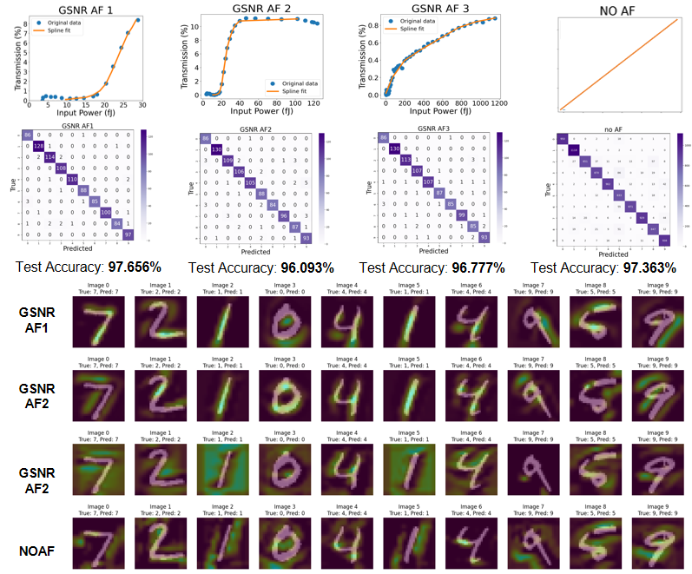
Fig. S10. Performance of OAFs on MNIST

Consequently, we trained and tested models incorporating optical activation functions on the CIFAR-10 dataset. The CIFAR-10 dataset provides more complex images with higher background noise, demanding more robust feature extraction capabilities from the model. As illustrated in Fig. S11, the model employing the GSNR AF1 activation function exhibits significantly superior feature extraction capabilities compared with models integrating other activation functions, enabling the identification of more detailed and accurate features. The test accuracy reached 83%, even surpassing a series of traditional mathematical activation functions (such as tanh, sigmoid, etc.).
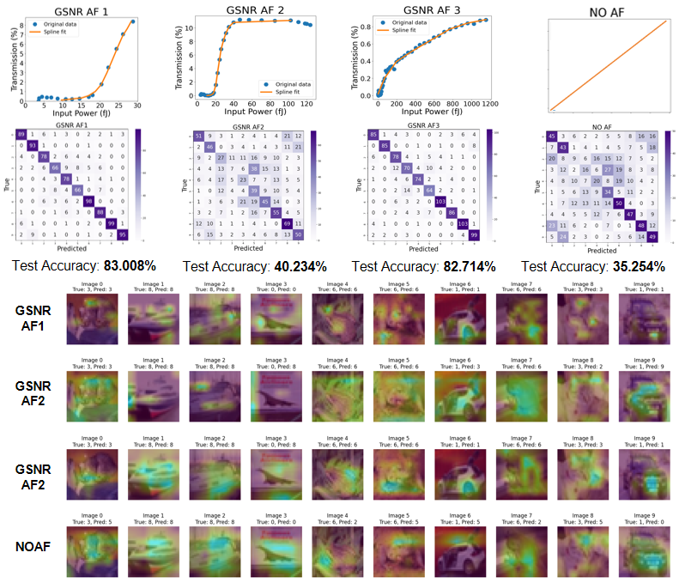
Fig. S11. Performance of OAFs on CIFAR-10

Section Ⅺ - Computational efficiency estimation of the ONN architecture in MINST datasets
Here, we estimated the area required to achieve recognition of the MNIST dataset via ONN. As shown in Fig. S12, light is first split into 16 beams through the WDM, then modulated with weight by phase change materials, and finally converged and output by the reverse WDM. Therefore, within one-time unit, a device can perform 16 multiplication operations. Thus, we need to calculate only the number of multiplication operations required for the entire CNN process to estimate the required number and area for the ONN. Here, we did not implement the fully connected part and only calculated the resources required for the convolutional part.
The structure of the CNN is shown in Fig. S11, and we sequentially calculate the number of multiplication operations required for each convolutional layer:
1. Convolutional layer 1 CONV_1:
Input size: 28 × 28 × 1
Convolutional kernel: 3×3
Output channel: 4
Multiplication times=28 × 28 × 1 × 3 × 3 × 4=28224
2. Convolutional layer 2 CONV_2:
Input size: 14 × 14 × 4
Convolutional kernel: 3×3
Output channel: 8
Multiplication times=14 × 14 × 4 × 3 × 3 × 8=56448
3. Fully connected layer FC
Input size: 7 × 7 × 8
Output channel: 10
Multiplication times=7 × 7 × 8 × 10=3920
4. Total multiplication times for all layers
CONV_1+CONV_2+FC = 28224+56448+3920 = 88592
5. The required number of photon devices can be obtained by multiplying the total number of times by 16:
88592/16=5537
6. Multiplying the required area of the photon device yields the required area of the CNN:
5537 × 30 μm × 25 μm ≈ 4.15 mm²

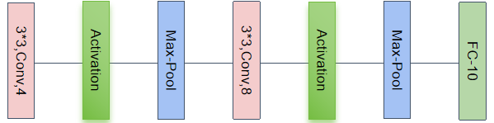
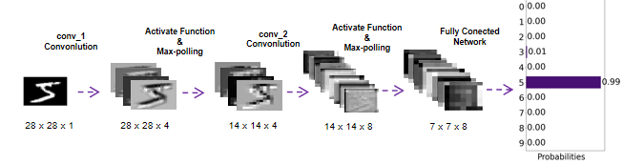
Fig. S12. The structure of ONN architecture

References
1. Hu, J. Planar chalcogenide glass materials and devices. (Massachusetts Institute of Technology, 2009).
2. Ullah, S. et al. Graphene transfer methods: A review. Nano Res. 14, 3756–3772 (2021).
3. Joannopoulos, J. D., Johnson, S. G., Winn, J. N. & Meade, R. D. Photonic Crystals: Molding the Flow of Light - Second Edition. in (Princeton University Press, 2011). doi:10.2307/j.ctvcm4gz9.
4. Hu, J. Ultrasensitive chemical vapor detection using microcavity photothermal spectroscopy. Opt. Express, OE 18, 22174–22186 (2010).
5. Lin, H. et al. Chalcogenide glass-on-graphene photonics. Nature Photon 11, 798–805 (2017).
6. Boyd, R. W. Chapter 2 - Wave-Equation Description of Nonlinear Optical Interactions. in Nonlinear Optics (Third Edition) (ed. Boyd, R. W.) 69–133 (Academic Press, Burlington, 2008). doi:10.1016/B978-0-12-369470-6.00002-2.
7. Robinson, J. T., Preston, K., Painter, O. & Lipson, M. First-principle derivation of gain in high-index-contrast waveguides. Opt Express 16, 16659–16669 (2008).

